

SRI LANKA INSTITUTE OF INFORMATION TECHNOLOGY

[**Enterprise Standards and Best Practices for IT Infrastructure**](http://courseweb.sliit.lk/course/view.php?id=137)

**4th Year 1st Semester 2016**

Name: Sathsarani M.H.I

SLIIT ID: IT 13138882

Group Number:

Practical Session: WE Monday (June batch)

Practical Number : Lab1 , Lab2, Lab3

Date of Submission: 30/07/2016

Date of Evaluation : _____________________

Evaluators Signature : _____________________

**Table of contents**

Purpose…………………………………………………………………………………………..03

What is AWS? ..............................................................................................................................03 1. How to create Amazon EC2 Windows instances? ...................................................................03

2. How to create Amazon EC2 Linux instance? ..........................................................................14

3. How to create a DB Instance using AWS? ...............................................................................19

4. References……………………………………………………………………………………..25

**Purpose**

This report covers the process of how to create virtual operating system instances in AWS.

**What is AWS?**

Amazon Web Services (AWS) helps us to work with virtual computing, using AWS console we can create and work with operating system instances in a virtual way. First we need to have a AWS account which is you have to provide your details alongside with your credit card number, after setting up your account you can start your projects in the virtual domain.

**1. How to create Amazon EC2 Windows instances?**

* Prerequisites
* Open up the browser and go to <http://aws.amazon.com/>, and then choose create an AWS account.
* Complete all the tasks to get setup to use Amazon EC2.

**Step 1: Launch an instance**

1. Open up the browser and sign-in to the AWS server by using your username and password.

Then select EC2 component under COMPUTE category.

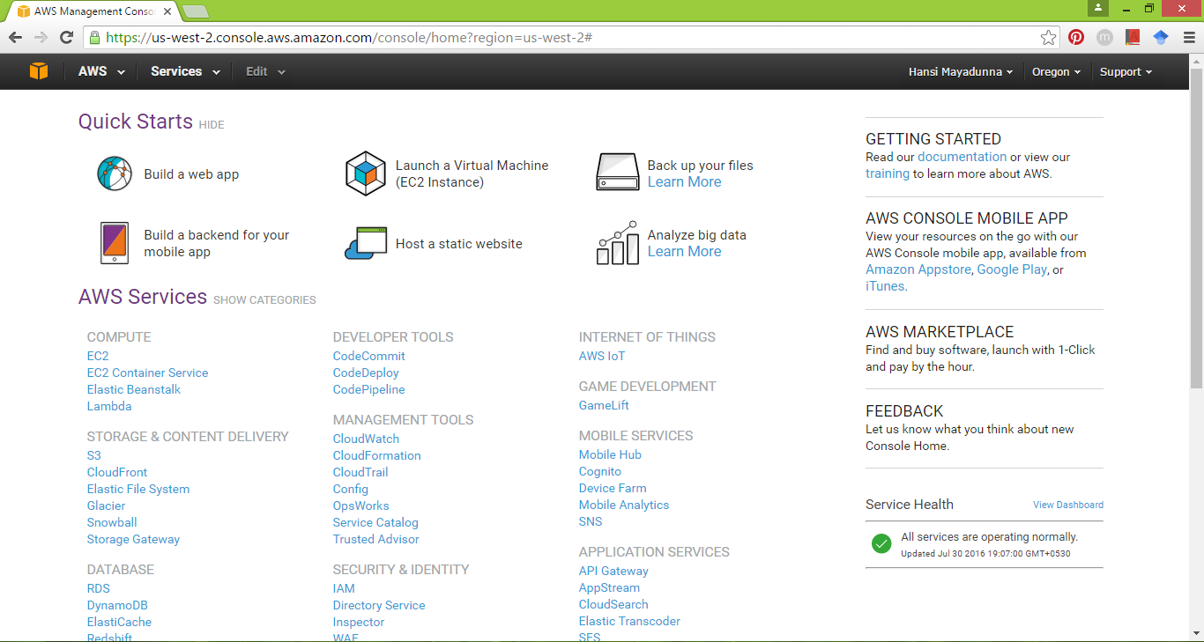

2. Click ‘Launch instance’ to launch a virtual server.

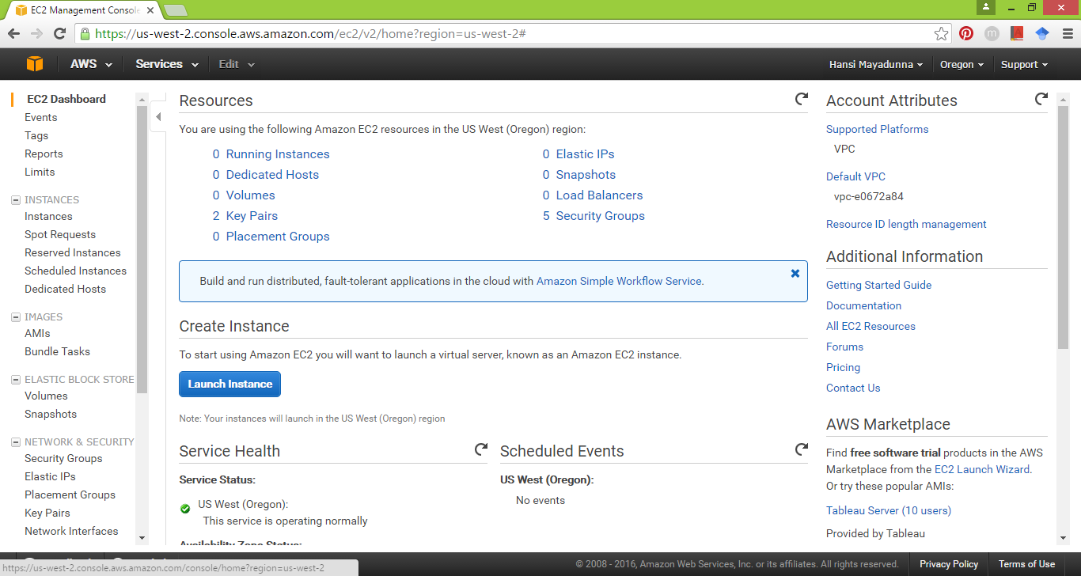

3. Then you will get a new page which will have a list of Amazon Machine Images (AMIs). This AMI serve as a template for your instance.  
You need to select Microsoft Windows Server 2012 R2 Base which is a free AMI.

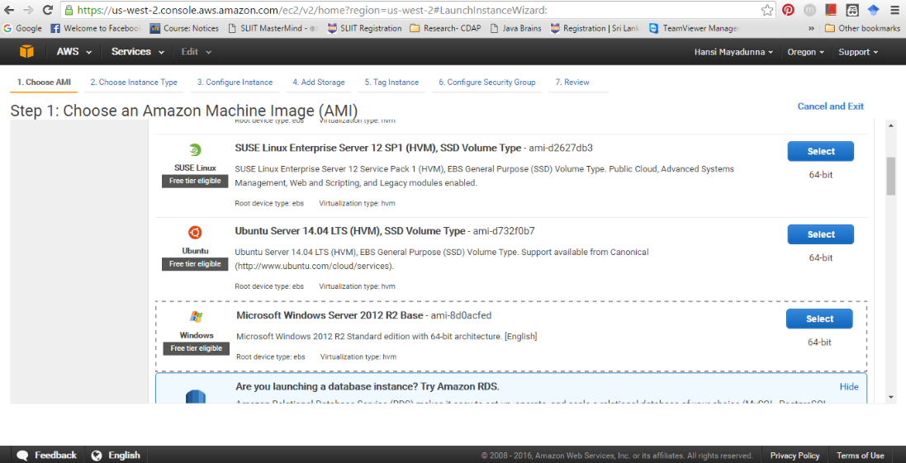

4. On the ‘Choose an instance type’ page which is provided to select hardware configuration on your instance, select the ‘t2.micro’ type.

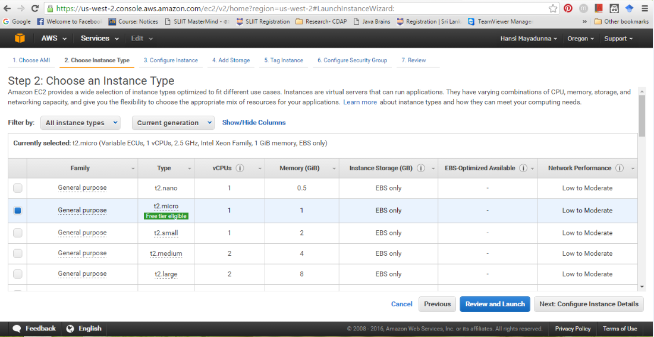

5. Then you can launch your instance by choosing ‘Launch’ button.

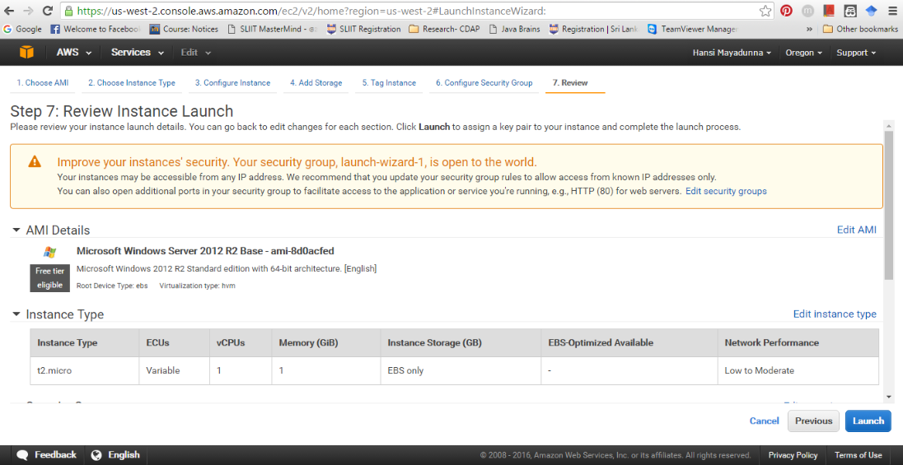

6. Before launch you need to create and download a key pair, in the key pair you will get a private key and AWS stores a public key, together they allow you to connect to your instance.

(Note: When prompted for a key pair, you can decide whether you want to create a new key pair or use an existing key pair)

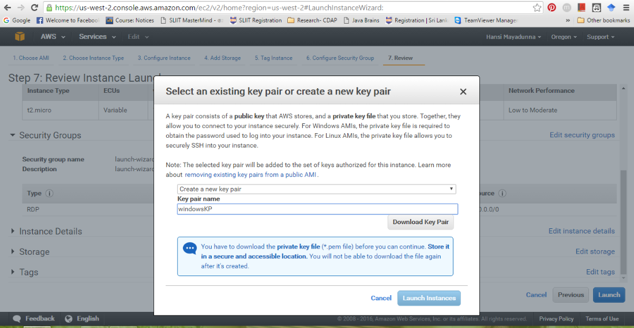

7. After download the key pair, you can launch your instance.

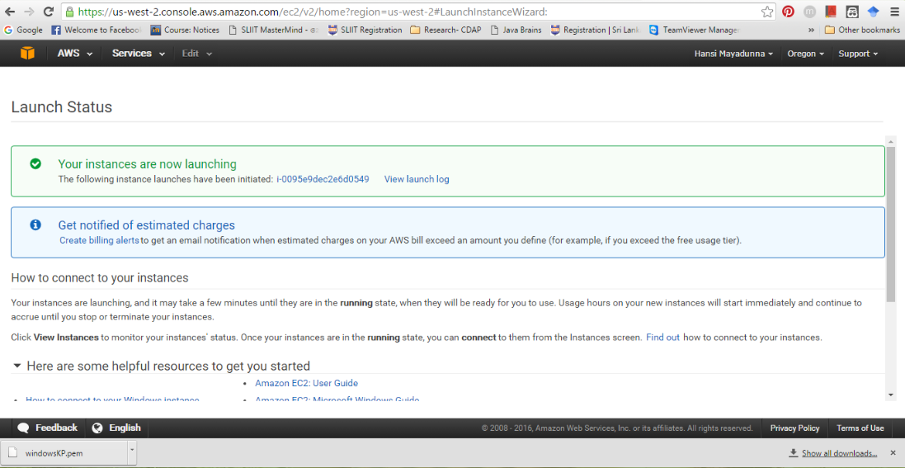

8. As seen below, the instance state is ‘running’. Before ‘running’ state the instance state is ‘pending.’  
This may take few minutes to the instance to be ready.

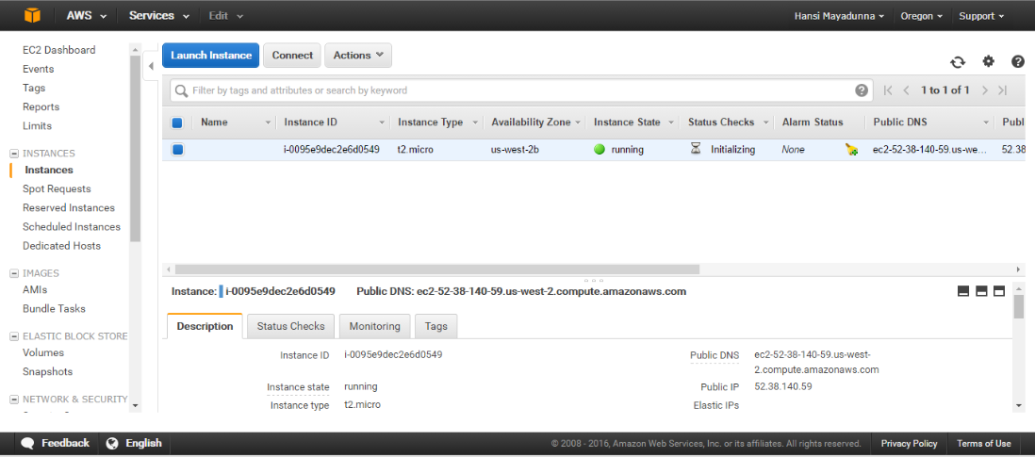

**Step 2: Connect to Your Instance**

9. When your instance is in ‘running’ state select the instance and choose ‘Connect’ to connect your instance by providing your private key, the AWS system will decrypt your downloaded private key and will check with their public key for a match.

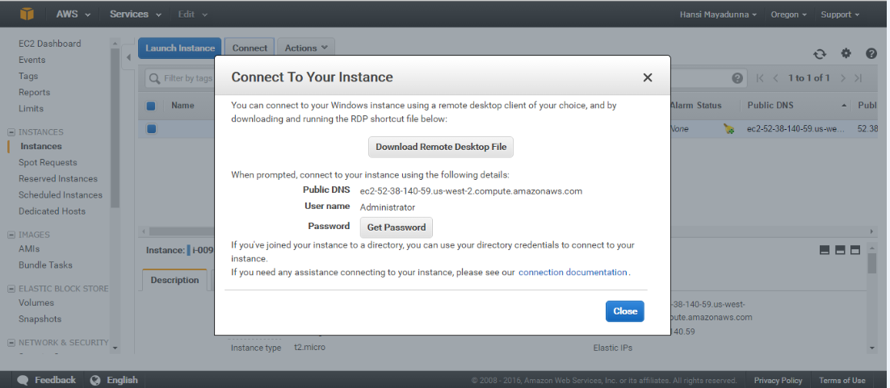

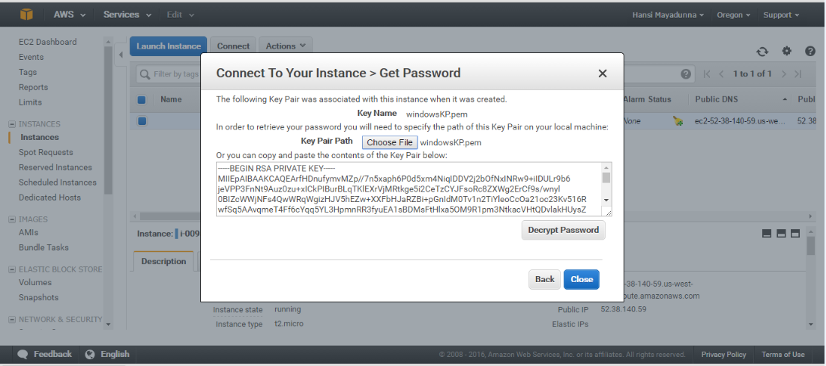

10. After confirming your key pair successfully you can open up your Remote Desktop Connection application from your host computer and then use your IP address of the instance as the computer and the password which is decrypted in previous step as the password.

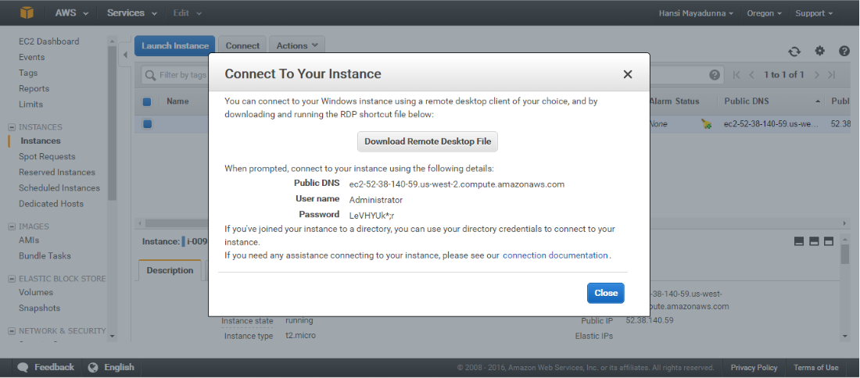

11. Choose ‘View certificate’ and get the thumbprint entry on the details tab.

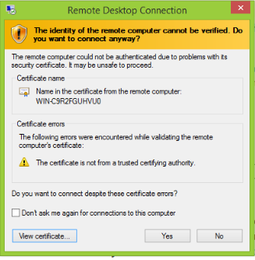

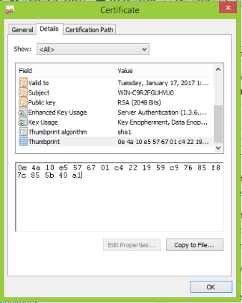

12. In the Amazon EC2 console, select the instance, choose Actions, and then choose Get System Log to verify the RDPCERTIFICATE-THUMBPRINT value matches the thumbprint of the certificate.

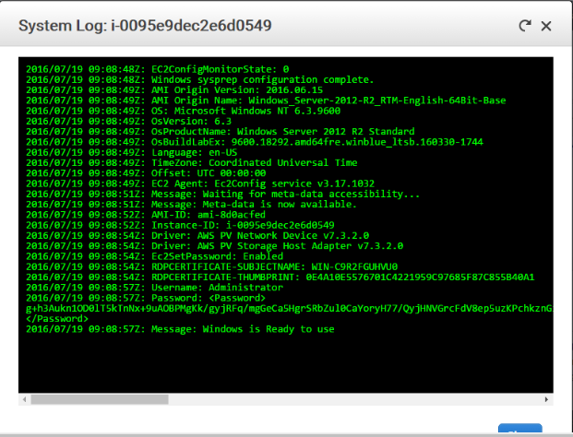

13. Then return to the Certificate dialog box, choose OK and connect the instance by Remote desktop connection.

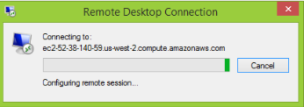

14. Now you are in a virtual windows instance and you can do any work you do with your host computer in this virtual instance as well.

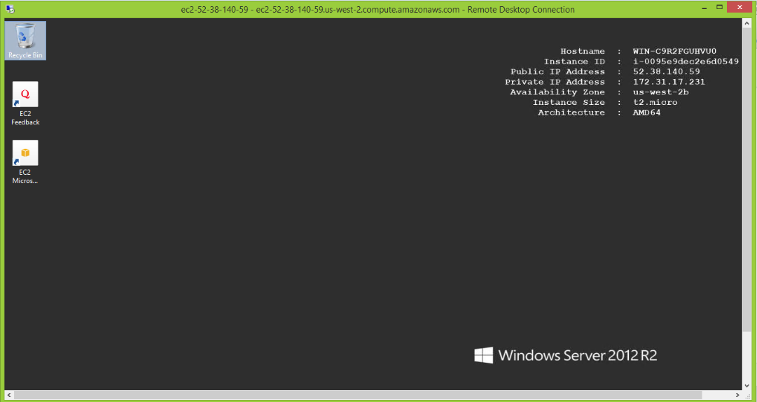

**Working with EC2 Windows instance**

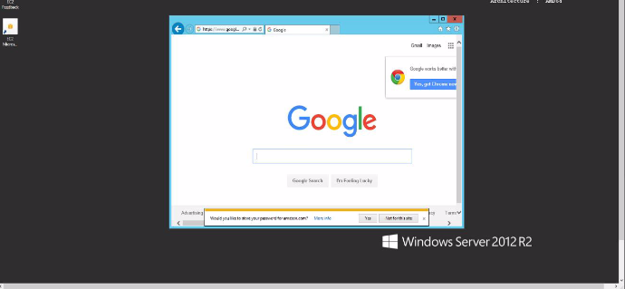

**Step 3: Clean Up Your Instance**

15. In the navigation pane, choose the instance and select actions. Then Instance state select Terminate.

Amazon EC2 shuts down and terminates your instance. After your instance is terminated, it remains visible on the console for a short while, and then the entry is deleted.

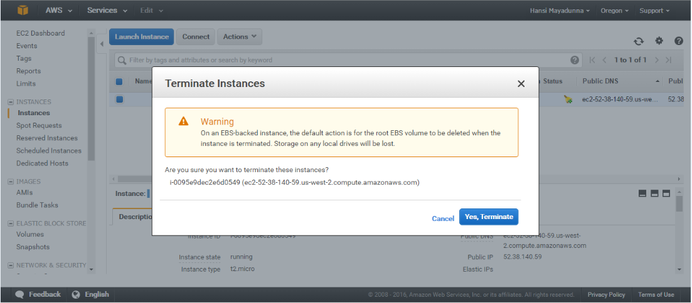

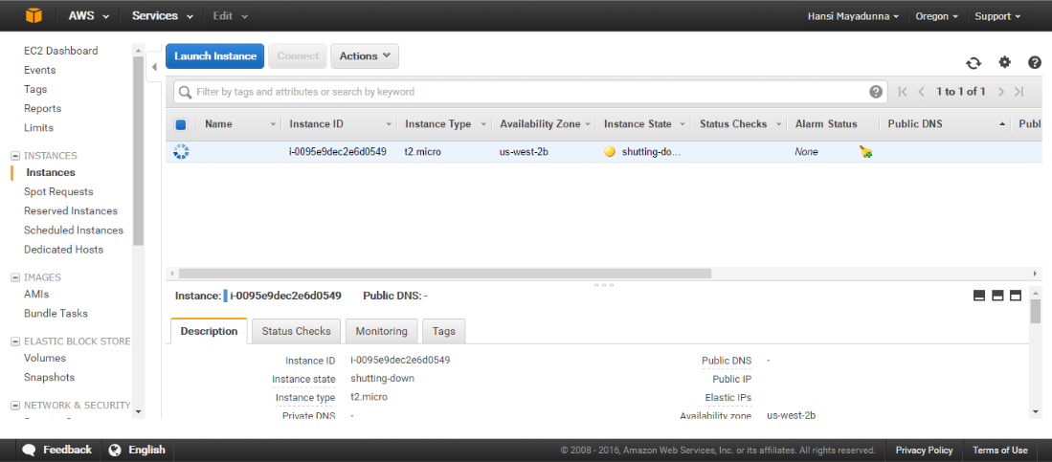

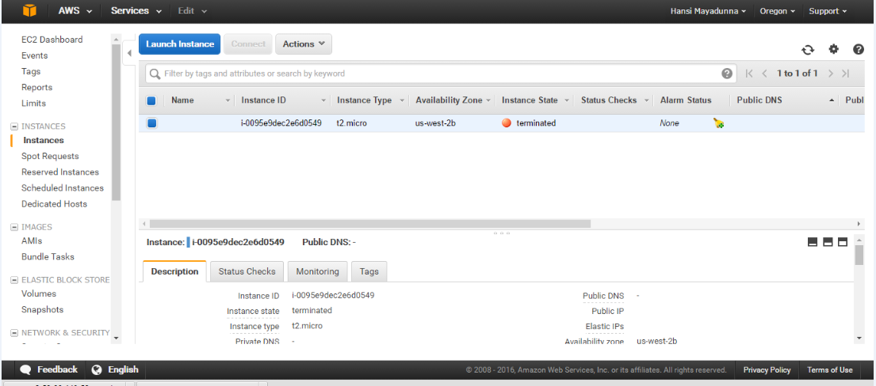

**2. How to create Amazon EC2 Linux instances?**

**Step 1: Launch an Instance**

1. Open the Amazon EC2 console at <https://console.aws.amazon.com/ec2/> and choose launch instance.

Then select the HVM edition of the Amazon Linux AMI in Choose an Amazon Machine Image (AMI) page.

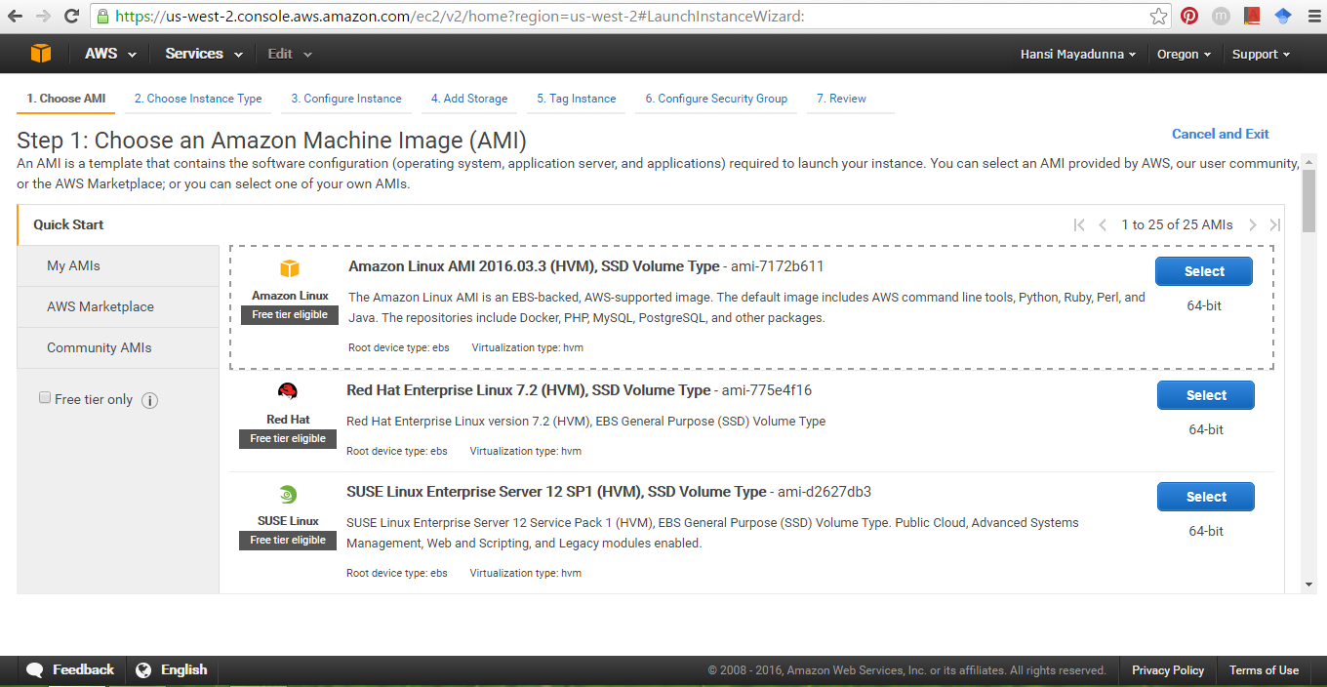

2. On the ‘Choose an instance type’ select default t2.micro type and choose ‘Review and Launch’ to let to complete other configuration settings.  
then edit security groups and launch the instance.

Then you will get an Linux instance in your instances tab.

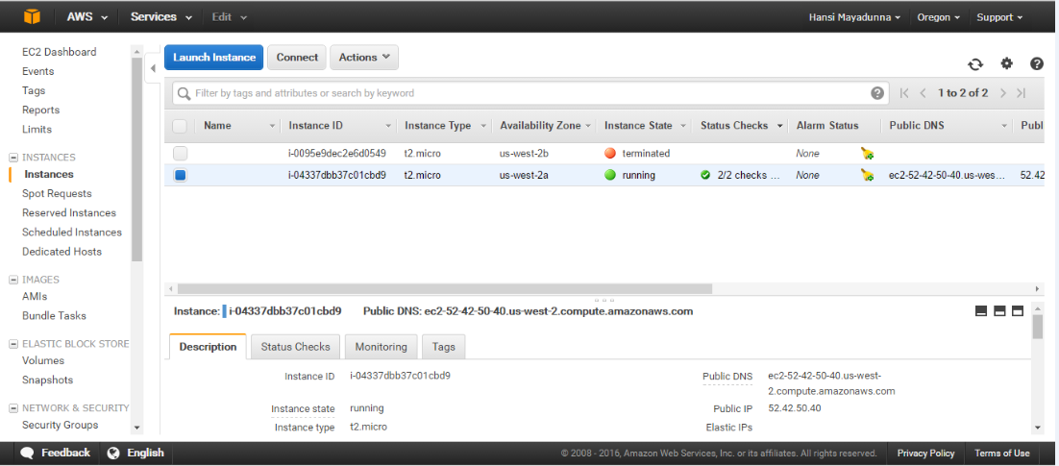

**Step 2: Connect to your instance**

3. To connect into Linux instances you just cannot connect like we did in previous windows instance example.

(Note: You will be needed two additional applications called ‘putty’ and ‘puttygen’, where putty is going to help you to connect with your instance and puttygen will help you to download and decrypt your key pair.)

4. Putty is just like your Remote Desktop Connection application, you will need to provide IP address of your instance and the decrypted password.

a. IP address :<Public DNS of your instance>

ec2-52-40-50-40.us-west-2.compute.amazonaws.com

b Password :

i. Putty does not natively support the private key format (.pem) generated by Amazon EC2. Therefore puttygen, which can convert keys to the required Putty format (.ppk). You must convert your private key into this format (.ppk) before attempting to connect to your instance using putty. Click load and find your .pem file then load it into your puttygen application then click Save Private Key which is going to be your key.

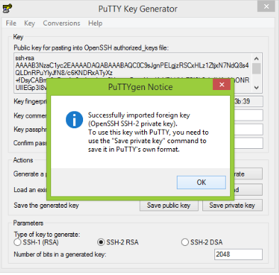

ii. Your private key is now in the correct format for use with putty. You can now connect to your instance using putty’s SSH client. Provide your IP address as we discussed previously as the host name.

iii. Go to Connection->SSH->Auth tab then browse your newly generated.ppk file and load it as the private key.

iv. Click Open, now you are connected to the instance.

**Working with linux virtual instance**

You can execute any linux command in here.

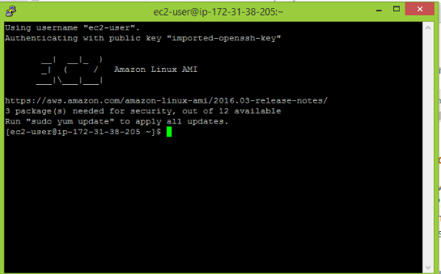

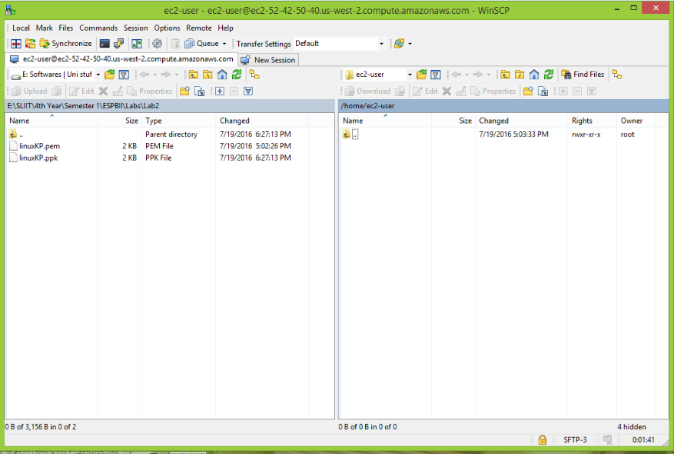

**Step 3: Clean up your instance**

In the navigation pane, select the linux instance. Go to actions> Instance state> Terminate.

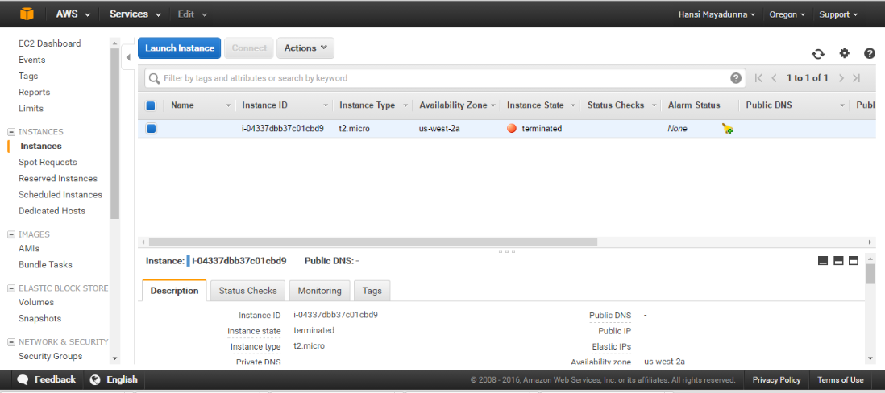

**3. How to create a DB Instance using AWS?**

1. Sign in to the AWS Management Console and select RDS component under DATABASE category.

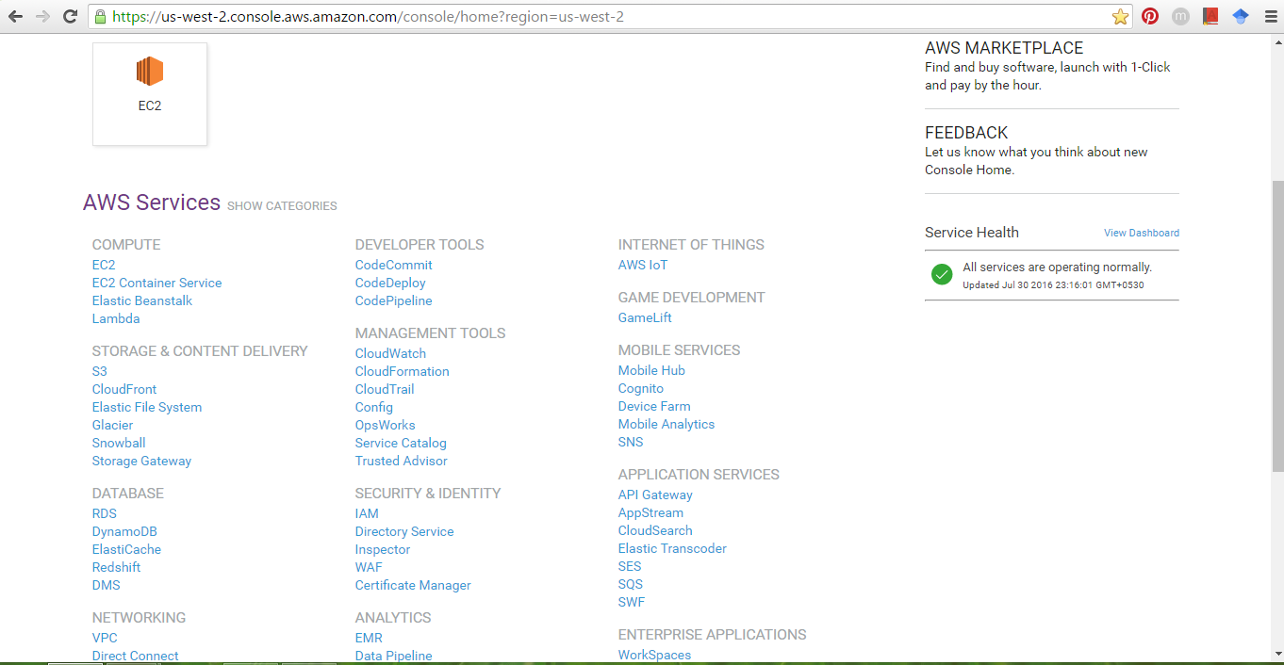

2. Then you will get an interface, in there you can start the process to launch your DB instance.

3. Then decide whether you are creating this instance for production purpose or for testing purpose.

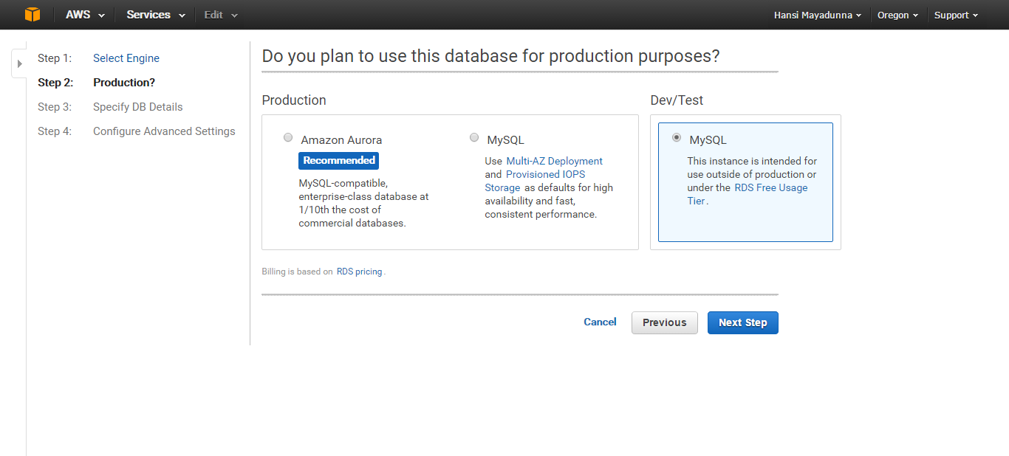

4. Then fill the details as follows.

(Note: You can decide the size of your storage for this DB instance.)

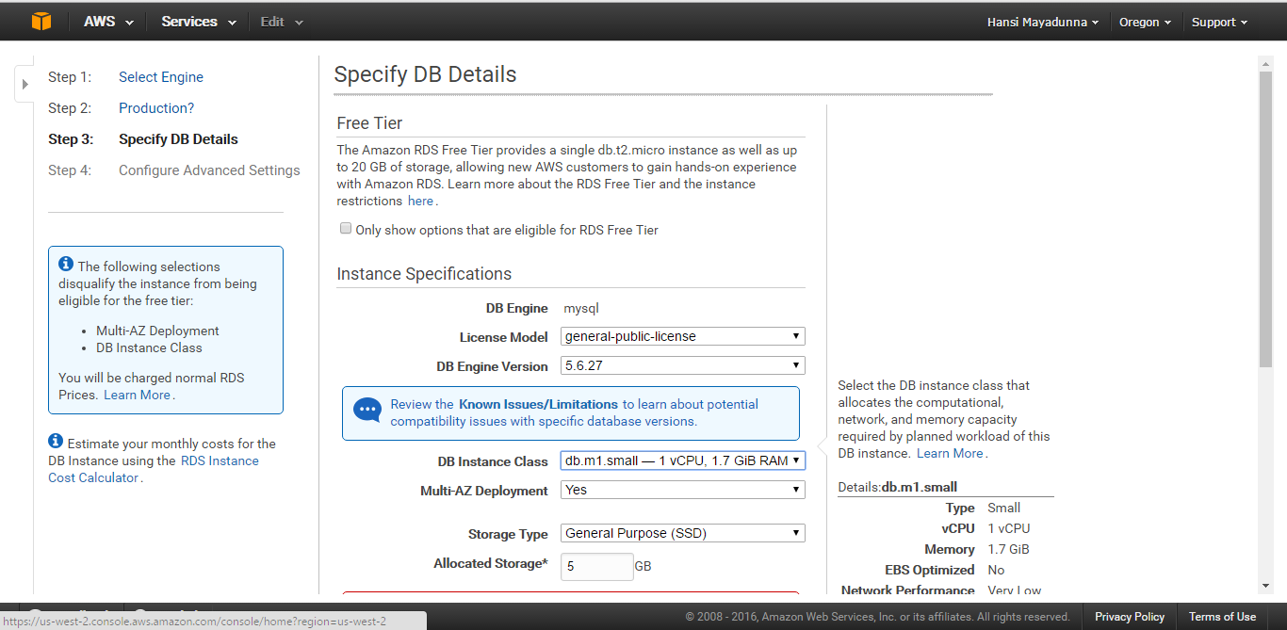

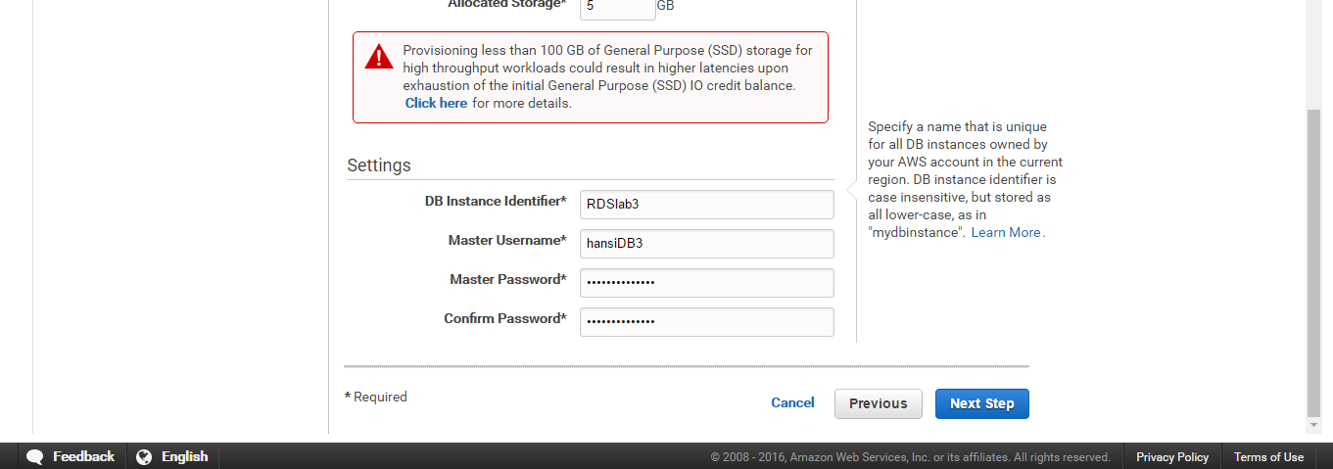

5. In the next step keep all the details as default.

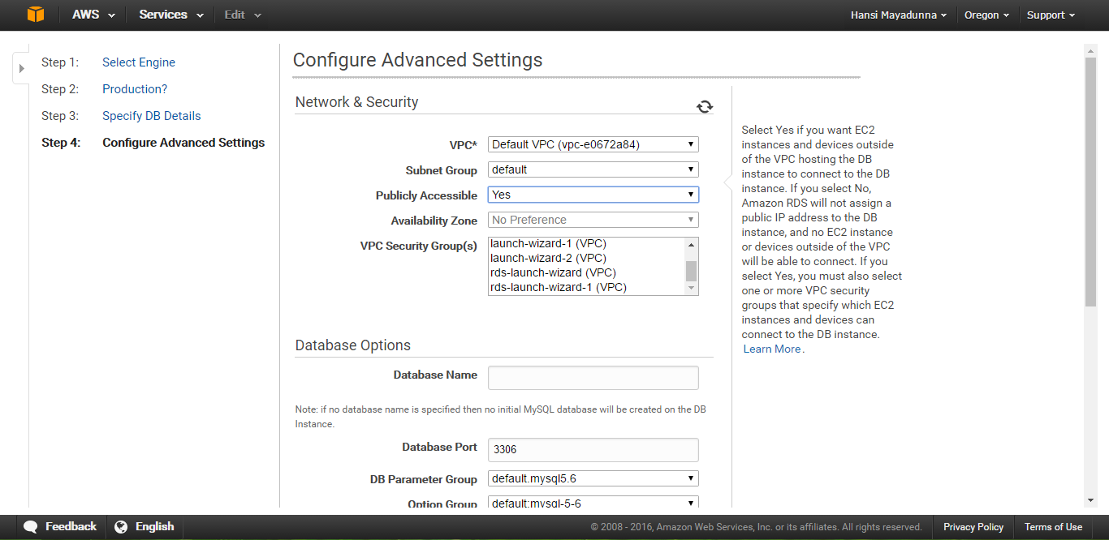

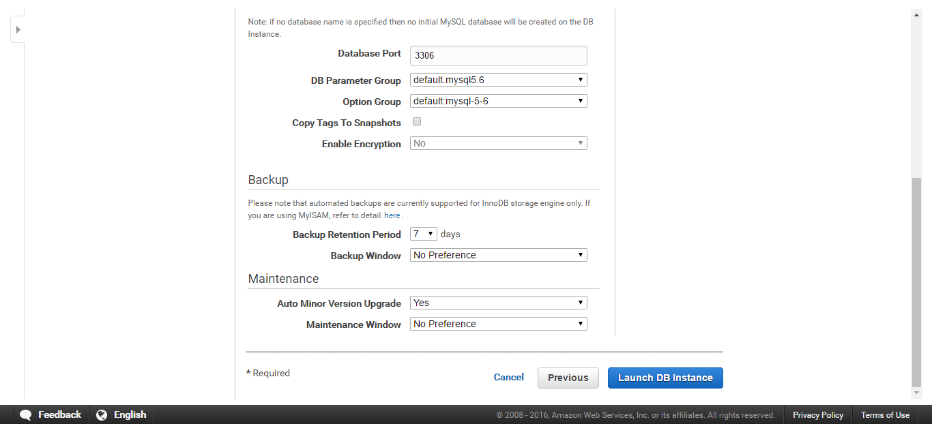

6. After completing these steps you can finally launch your DB instance by selecting View Your DB Instance.

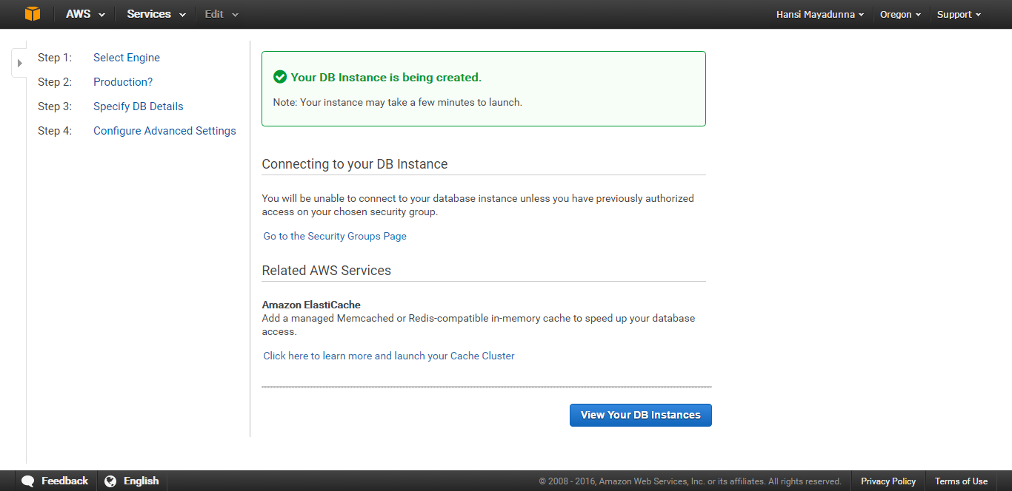

In the DB instance column, there are several states like creating -> backing up -> available. Every DB instance which is available for use has an Endpoint which is going to be the Hostname for the MySQL Workbench connection.

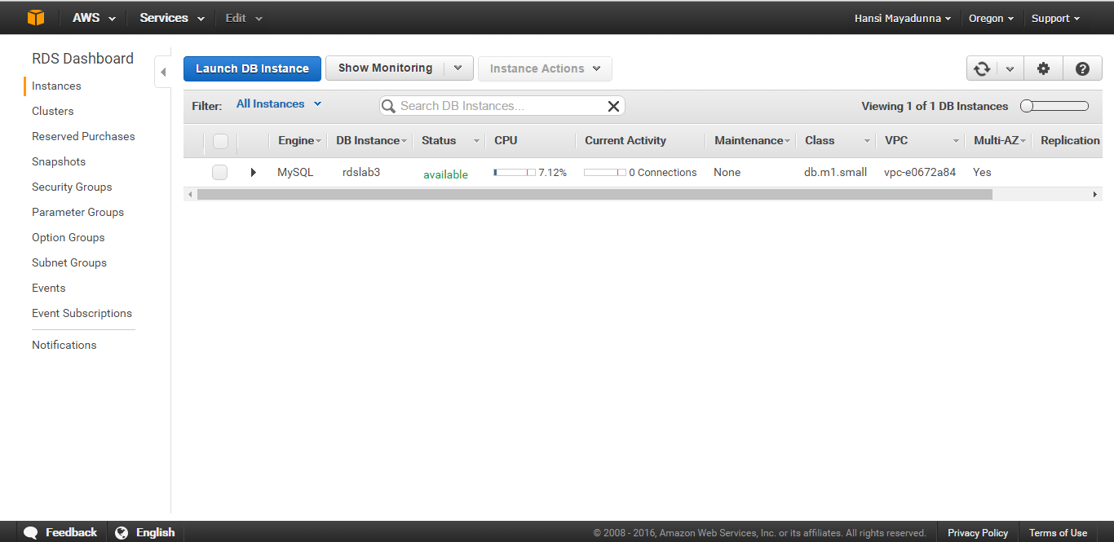

7. Copy down your endpoint address.

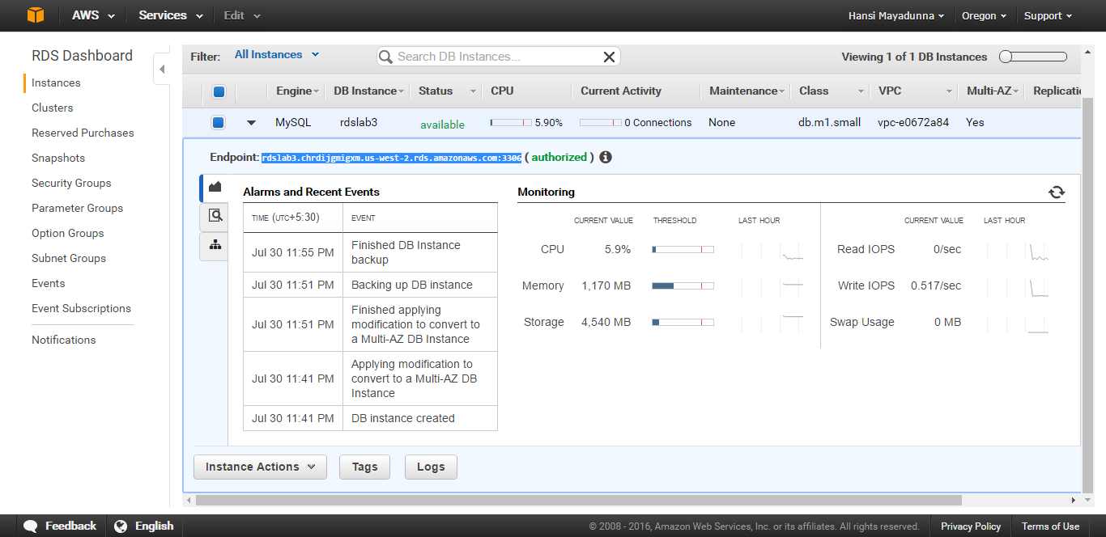

8. Then open your MySQL Workbench, and fill the details as follows.

(Note: You need to store your password in the Workbench password store that is the same password you have entered earlier in step no 4. And the endpoint name should be copied into the hostname field without the port number and the colon.)

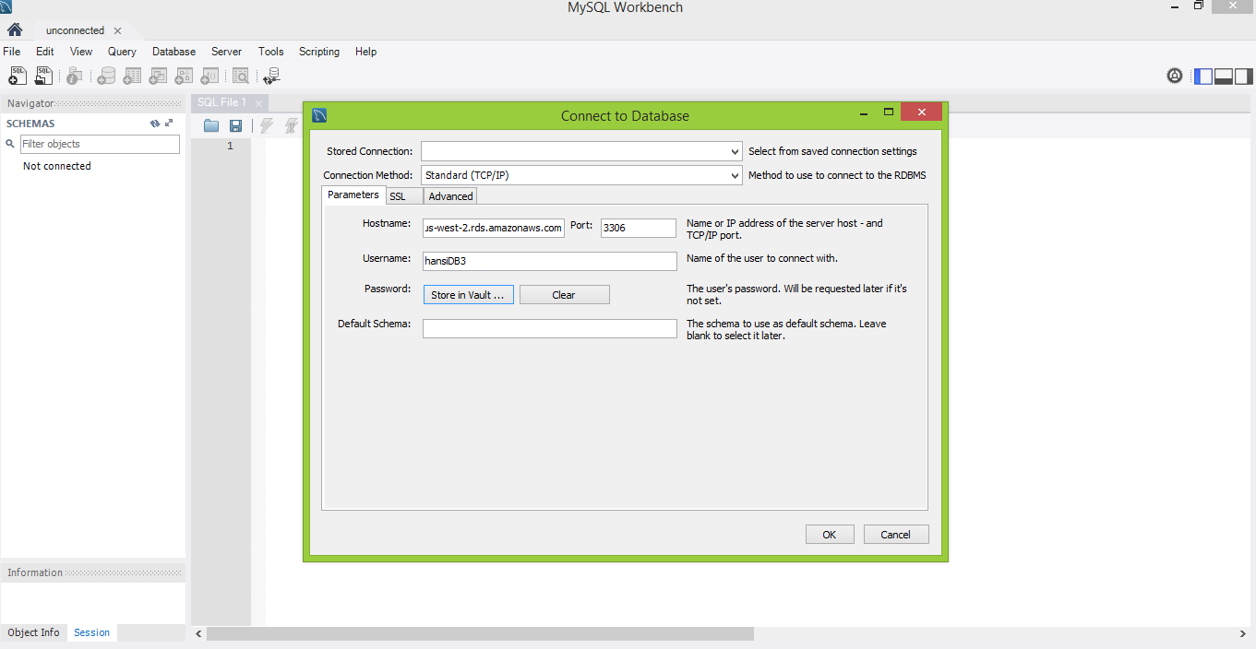

9. Then you need to connect to your newly created schema using the SCHEMA category in your Navigator bar.

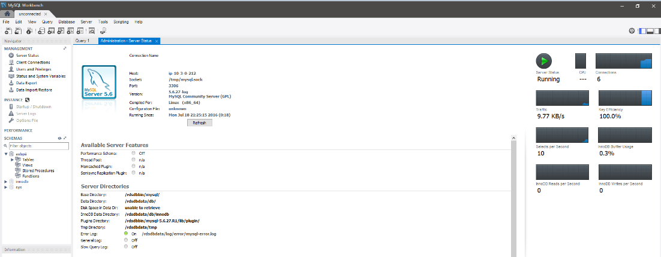

**4.References**

[1] <http://docs.aws.amazon.com/AWSEC2/latest/WindowsGuide/EC2_GetStarted.html>

[2] <http://docs.aws.amazon.com/AWSEC2/latest/UserGuide/EC2_GetStarted.html>

[3]<http://docs.aws.amazon.com/AmazonRDS/latest/UserGuide/CHAP_GettingStarted.CreatingConnecting.MySQL.html>