

SRI LANKA INSTITUTE OF INFORMATION TECHNOLOGY

[**Enterprise Standards and Best Practices for IT Infrastructure**](http://courseweb.sliit.lk/course/view.php?id=137)

**4th Year 1st Semester 2016**

Name: Sathsarani M.H.I

SLIIT ID: IT 13138882

Group Number:

Practical Session: WE Monday (June batch)

Practical Number : Lab 4

Date of Submission: 16/08/2016

Date of Evaluation : _____________________

Evaluators Signature : _____________________

**Table of contents**

1. Prerequisites……………………………………………………………….3

2. Install ESXi………………………………………………………………..3

3. Install vsphere client..…………………………………………………….13

4. references…………………………………………………………………21

**Prerequisites**

* You should be installed VMware workstation in your host machine.
* Verify that your host machine hardware is supported.

**1. Install ESXi**

You have to install the ESXi bare-metal hypervisor as the first step to creating a vSphere environment.

1. Create a new virual machine from VMware workstation.  
 Browse for the ‘VMware-VMvisor-installer’ ISO image.

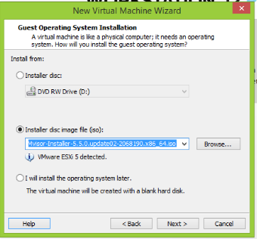

2. configure settings to create the virtual machine as follows.

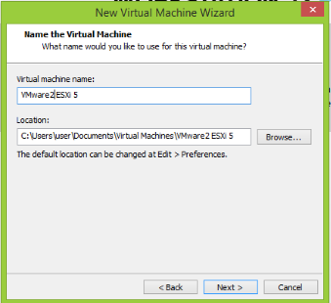 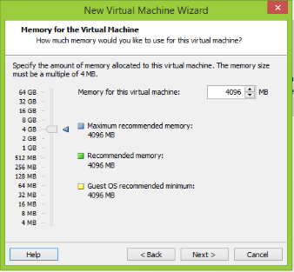

(i) (ii)

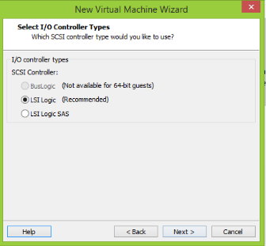 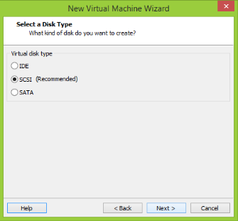

(iii) (iv)

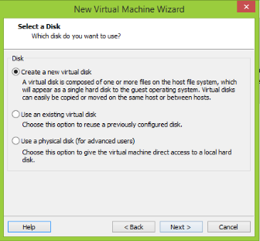 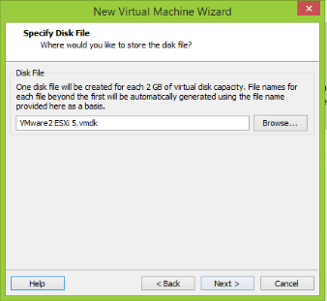 (v) (vi)

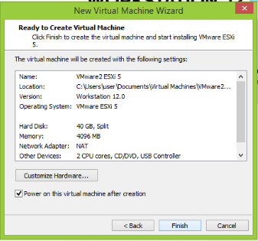

(vii)

3. Then the ESXi installer will be loaded.

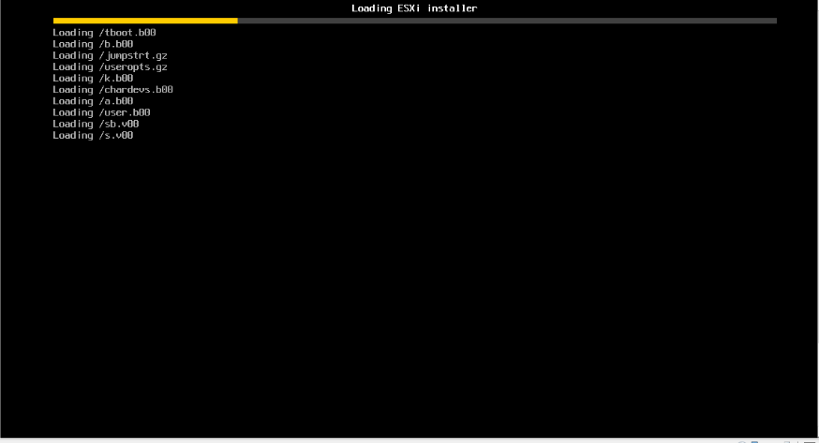

(i)

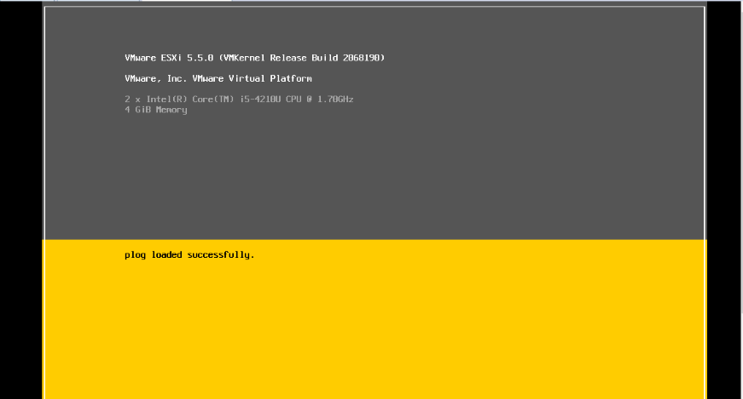

(ii)

4. You will be given to select the operations to perform as below.

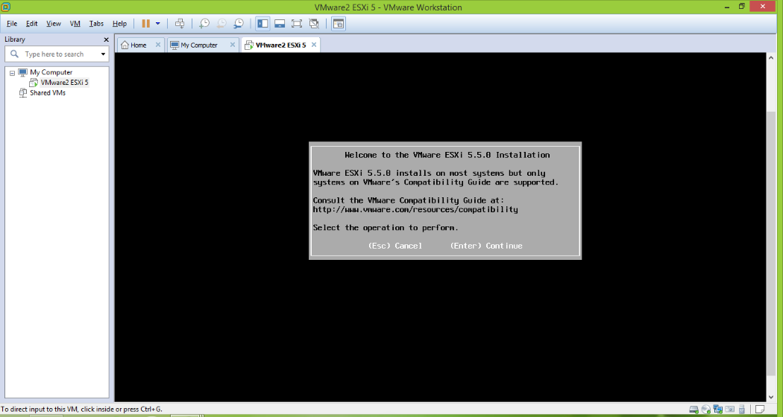

(i) Press Enter

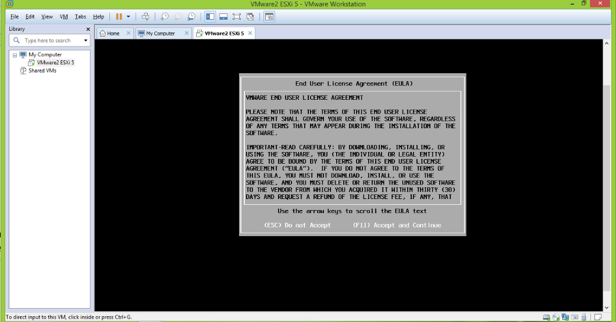

(ii) Press (F11)

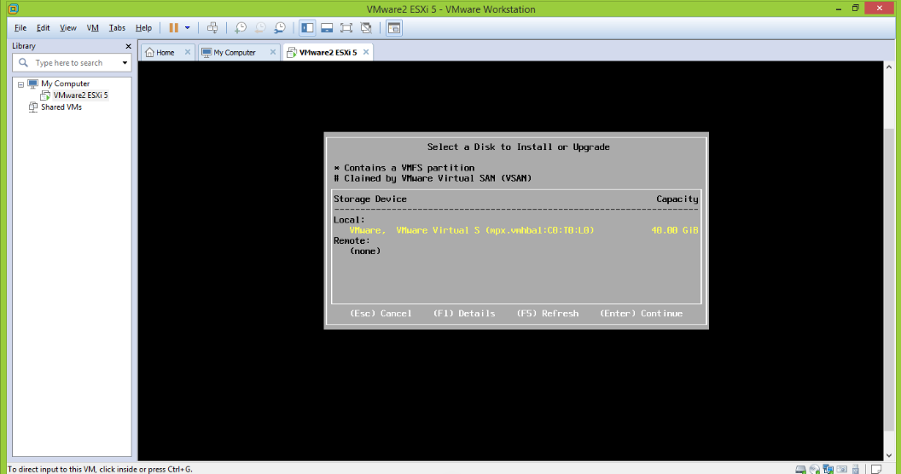

(iii) Press Enter

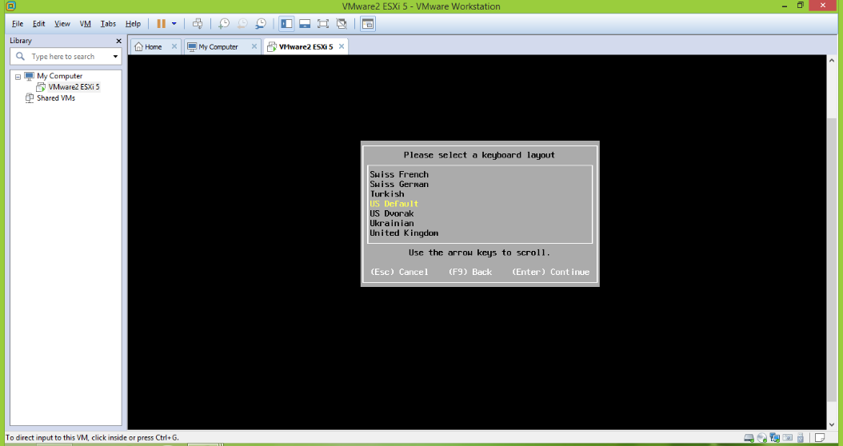

(iv) Select keyboard layout ‘US Default’ and press Enter

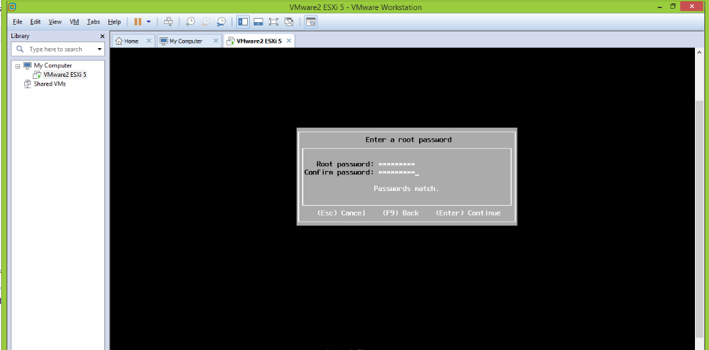

(v) Enter a root password and press Enter

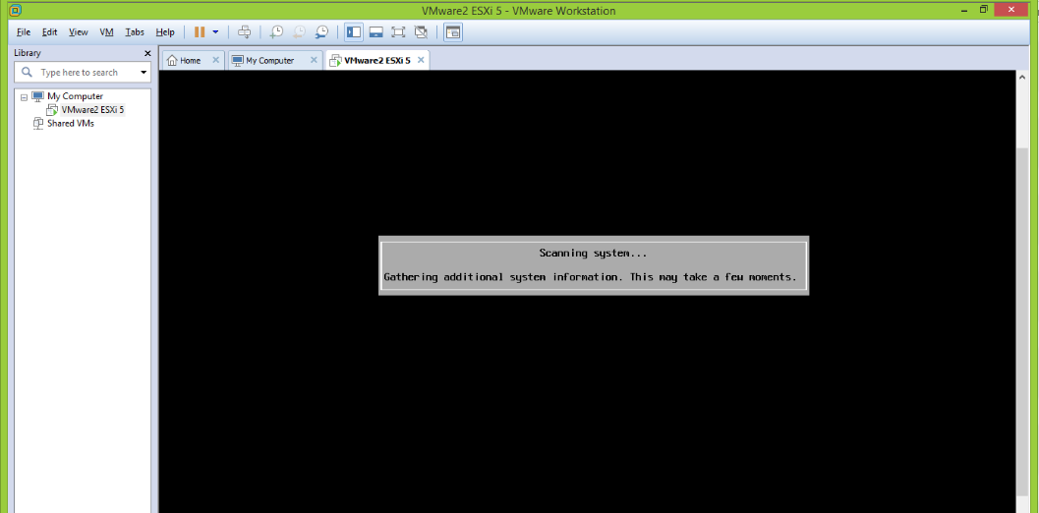

(vi)

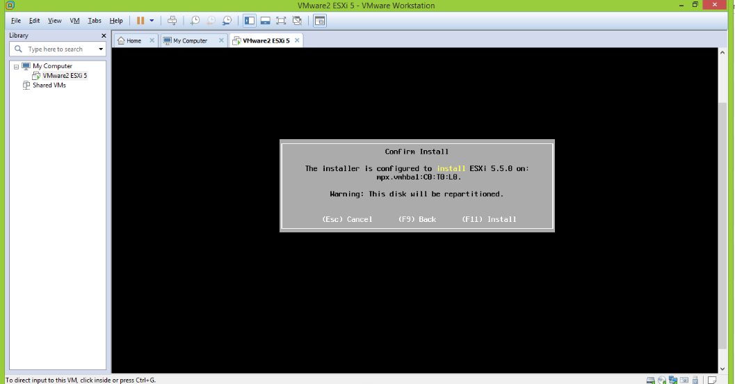

(vii) Press F11 to confirm install

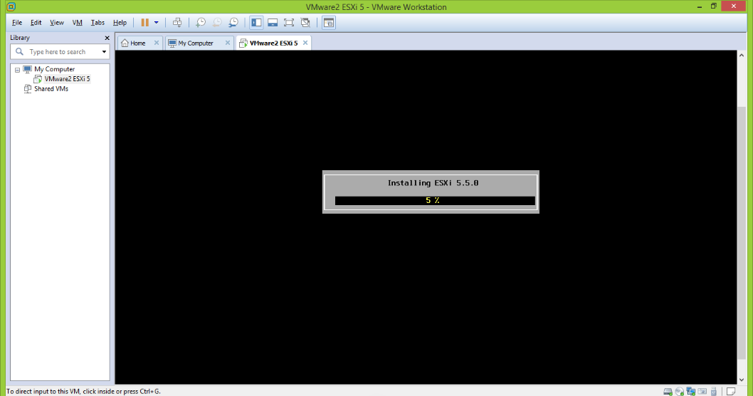

(viii) Installing ESXi 5.5.0

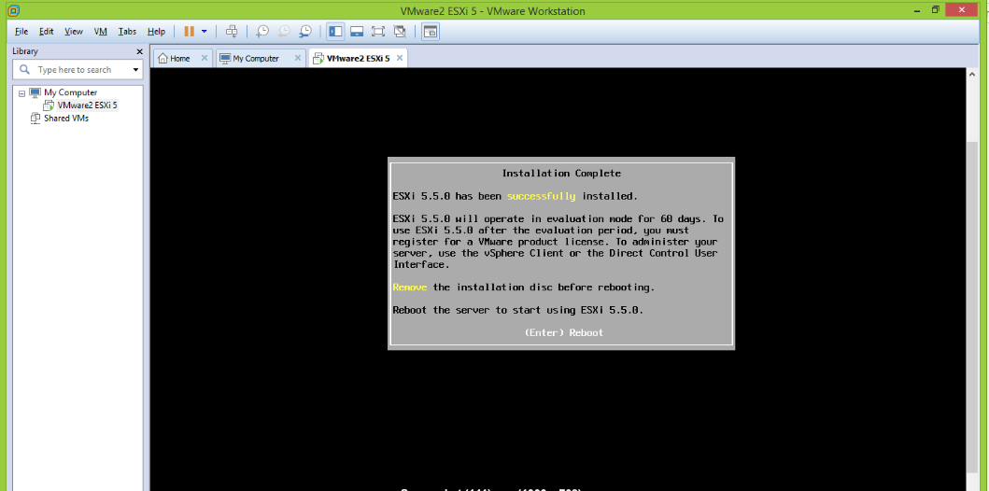

(ix) Installation complete and press Enter to reboot the server to start using ESXi 5.5.0

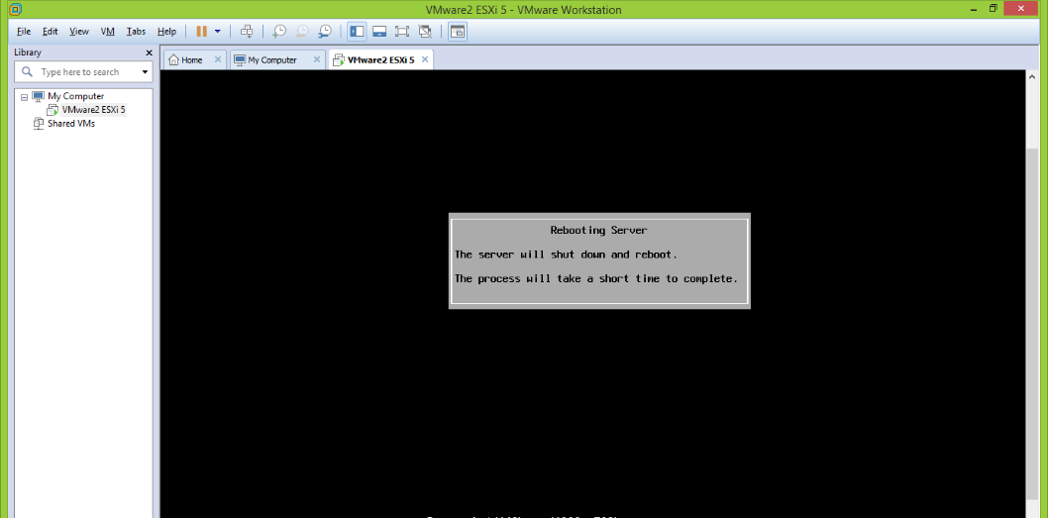

(x)

5. Then you will get a window that provided the IP address from DHCP server.

(DHCP:- Issuing IP addresses for connected networks.)

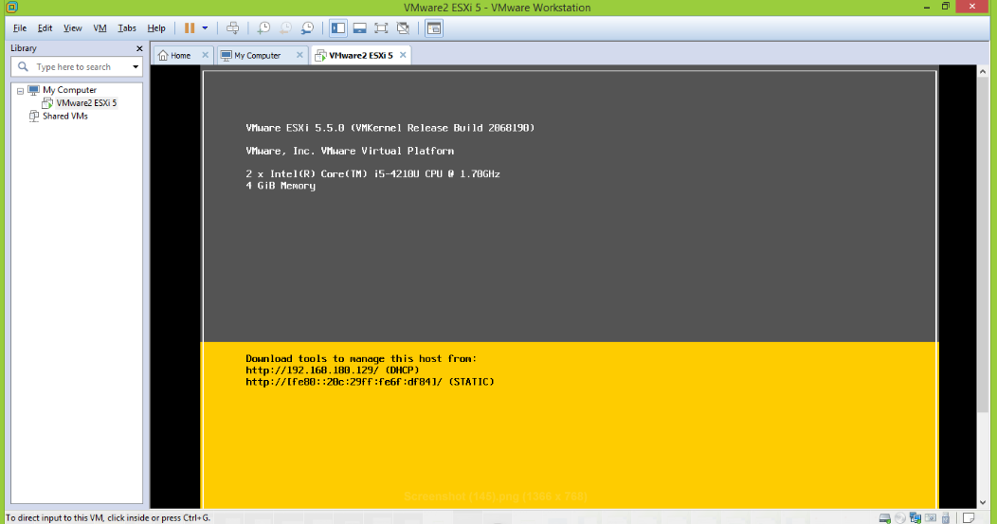

6. Copy and paste this ip address on your host machine’s web browser.

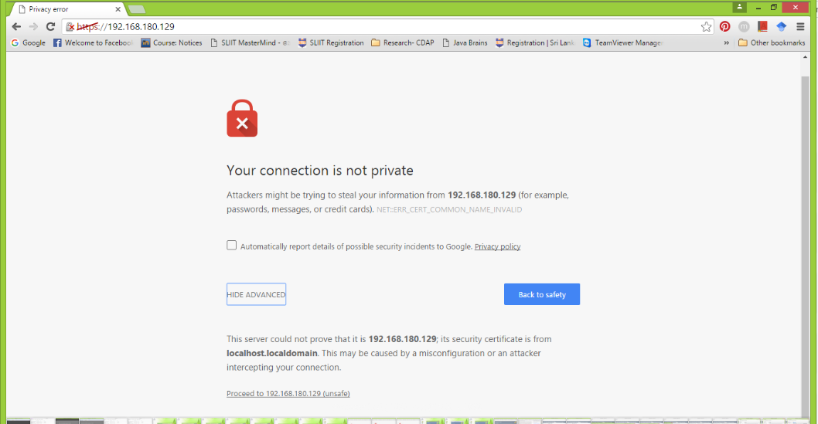

7. Proceed to the ip address and download ‘vSphere client’ from VMware ESXi welcome window.

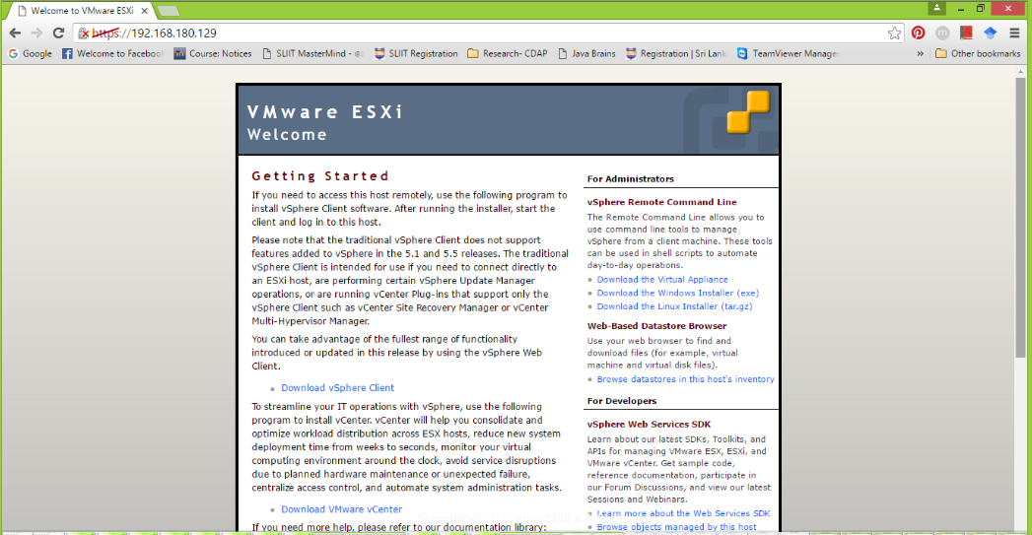

**2. Install vSphere client**

8. Then install VMware vSphere client. Perform default settings in installation.

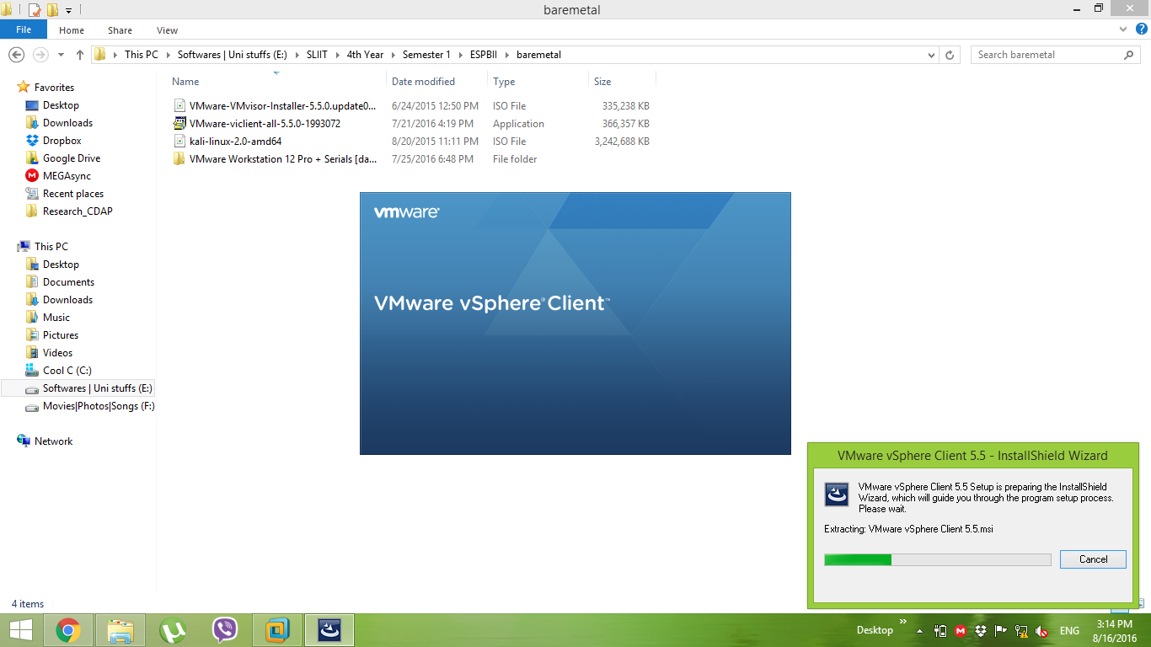

(i)

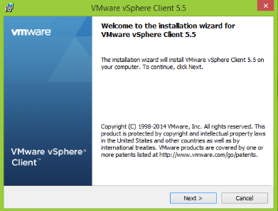 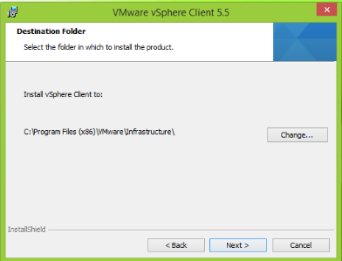

(ii) (iii)

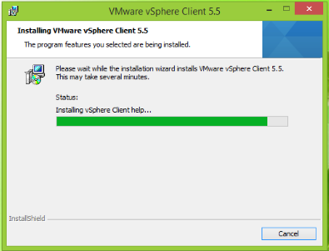 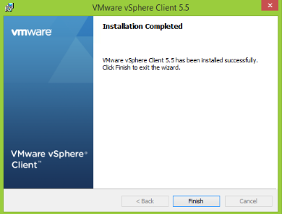

(iv) (v)

9. Open VMware vSphere client and you would have to be provided the IP address that given from DHCP in ESXi before.  
And enter the user name and password that you provided before.

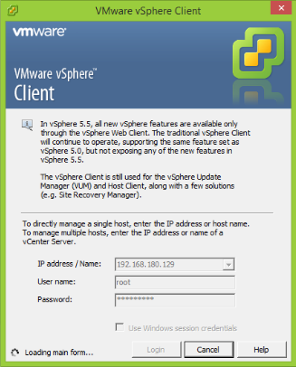

10. Upload the Kali linux ISO image to the datastore.

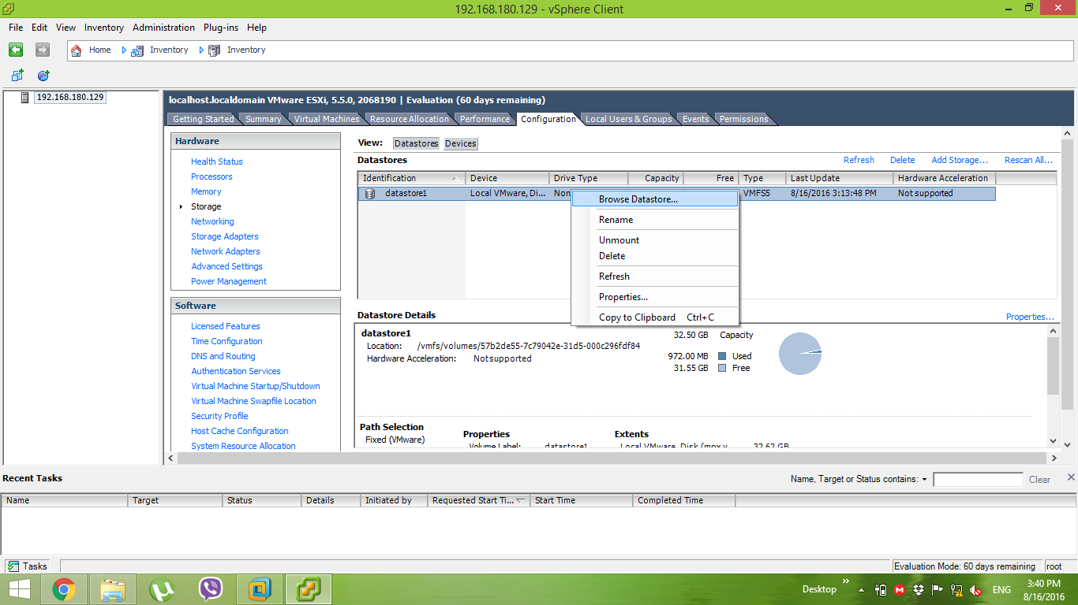

(i)

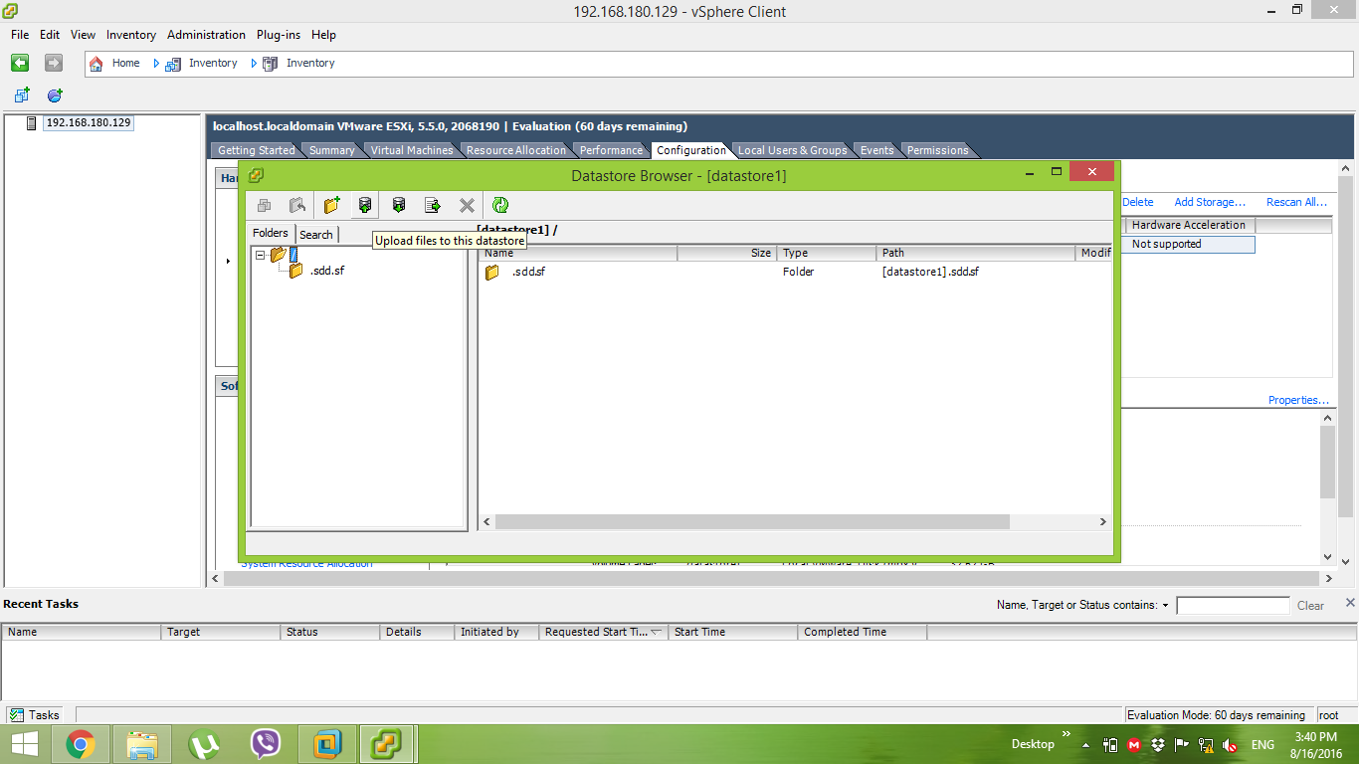

(ii)

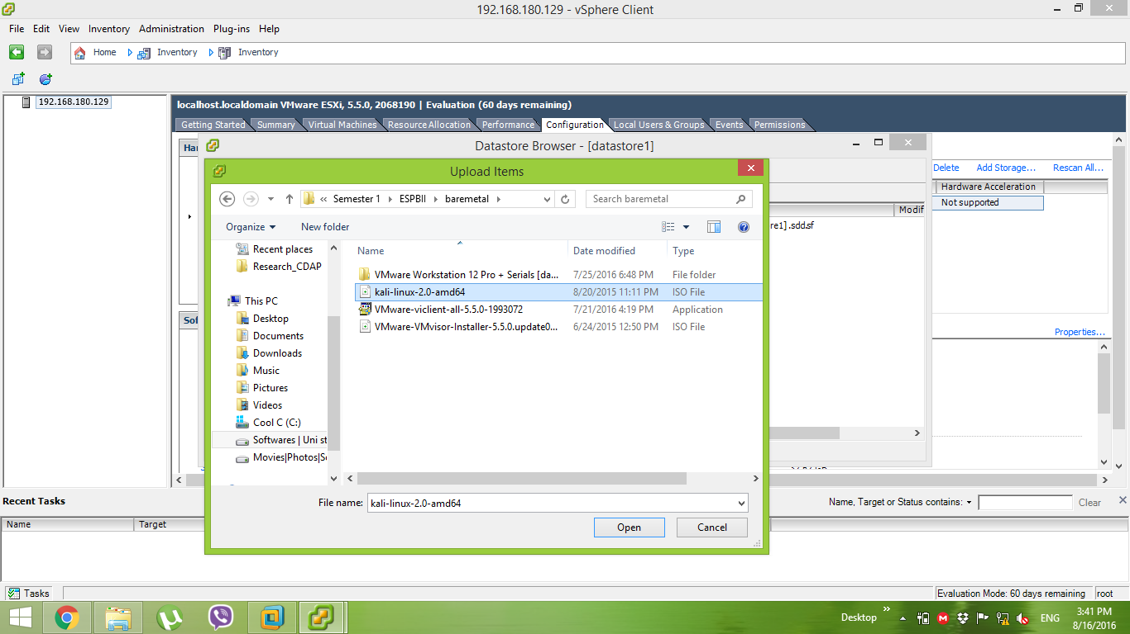

(iii)

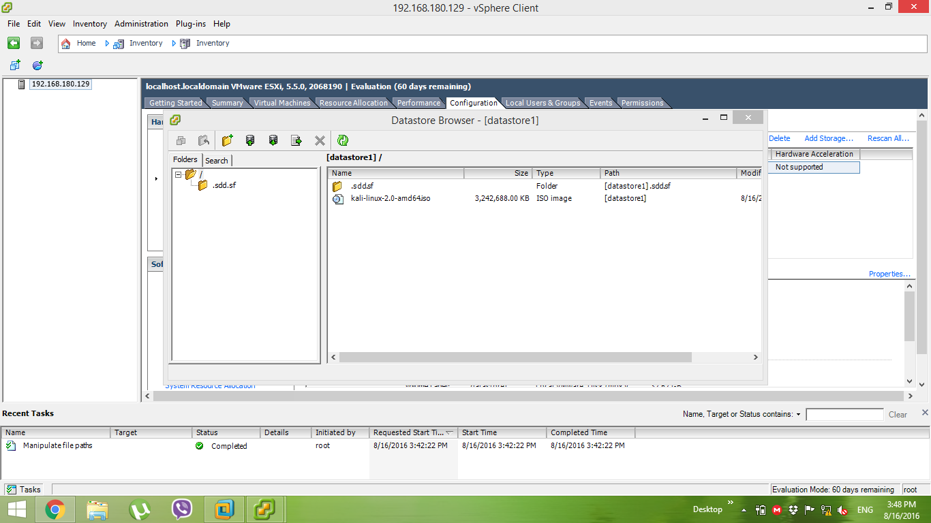

(iv)

11.Then write click on the IP and create new virtual machine.

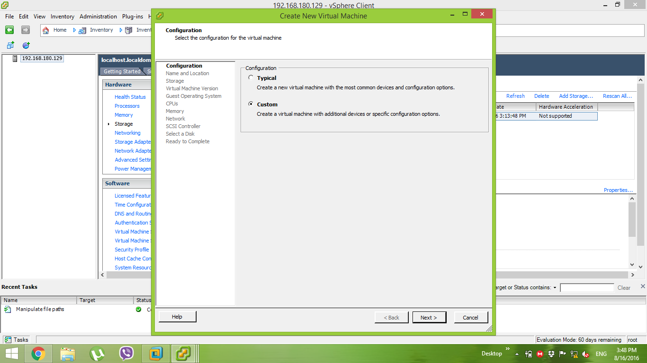

(i)

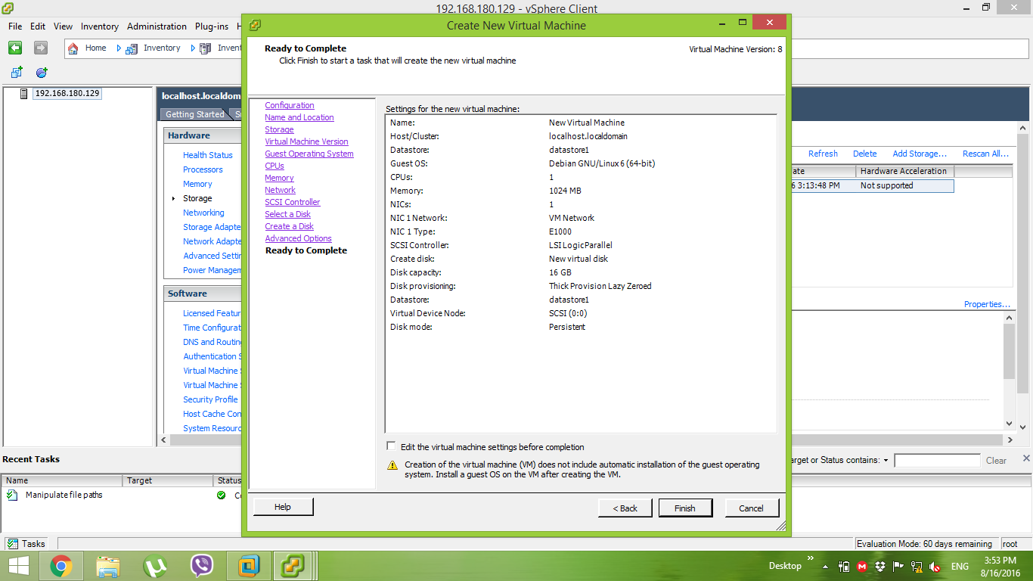

(ii)

12. Then write click on new virtual machine. Go to ‘edit settings’. Then select CD/DVD drive 1.  
 Browse the kali linux image to the data store ISO file.  
 Then you will get the Kali console.

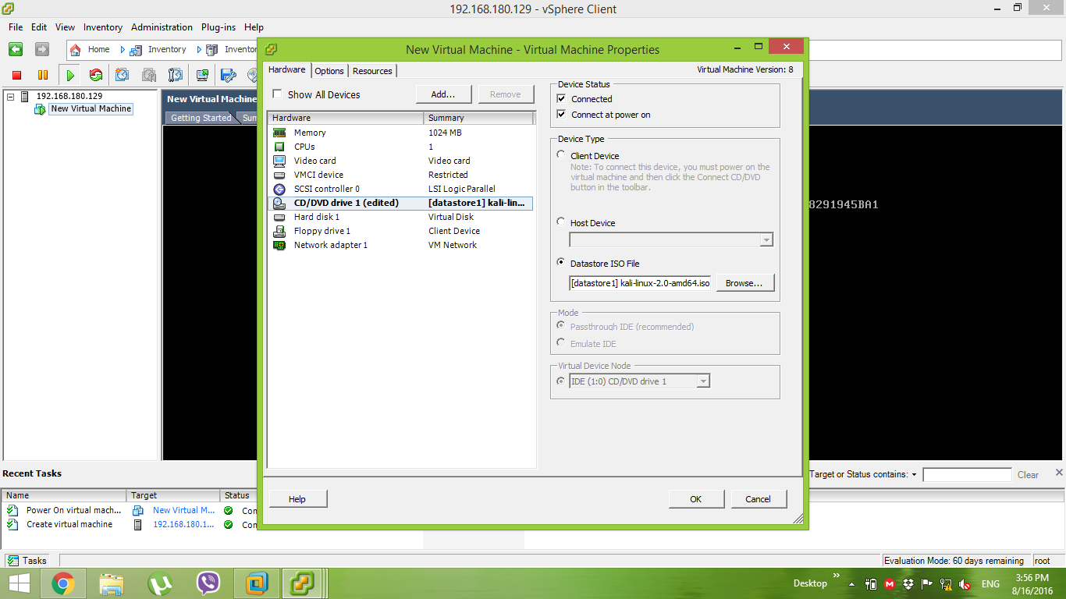

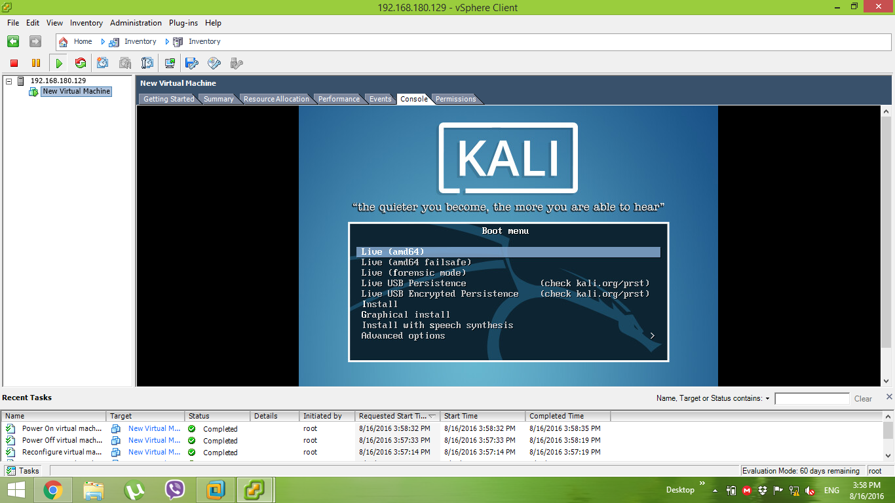

**3. References**

[1] <http://www.vmware.com/products/esxi-and-esx.html>

[2] https://www.youtube.com/watch?v=jT6HK54Brf8