HANSIGA P
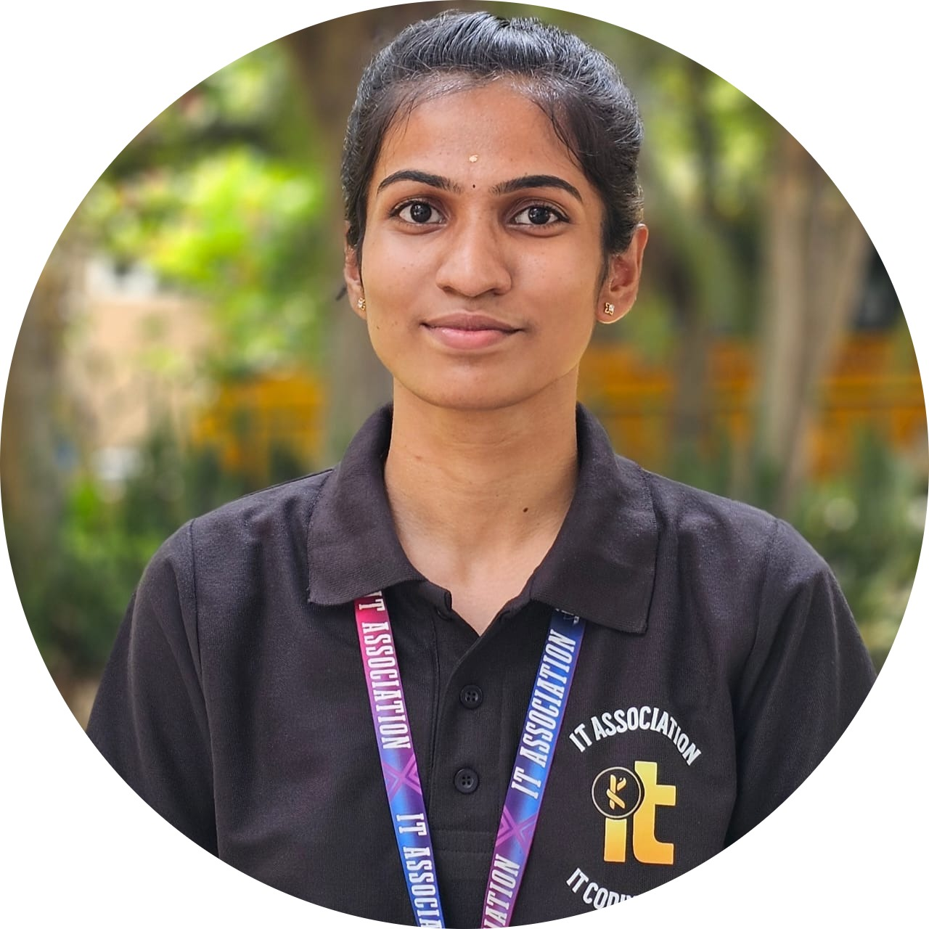
SOFTWARE
DEVELOPER

PROFILE
hansiga2105@gmail.com
+91-7538809125 
www.linkedin.com/in/hansiga/

github.com/Hansiga

EDUCATION
2023 - 2027

KONGU ENGINEERING COLLEGE, PERUNDURAI
CGPA - 8.38
2022 - 2023

RANK SCHOOL, SATHY
HSC – 82.4
2019-2020

RANK SCHOOL, SATHY
SSLC – 94.7

SKILLS
LANGUAGE: Java, C
FRONTEND: HTML5, CSS, ReactJS
BACKEND: Node.Js
DATABASE: MongoDB
VERSION CONTROL: Git,
GitHub

AREA OF INTEREST

- DBMS
- Data Structures

SOFT SKILLS

- Leadership
- Collaborative work
- Communication
- Adaptability
Keen on developing real-world applications, solving problems through coding, and continuously learning through projects and teamwork to build efficient, user-focused solutions.

PROJECTS

GATE GUARDIAN: AI DOOR LOCK
A door unlocking system using face recognition and OTP system.
GIT: github.com/Hansiga/AI-DoorLock
QUICK STAY: HOTEL BOOKING APPLICATION
Interactive MERN Hotel Booking App with Admin/User dashboards, secure login and booking management.
GIT: github.com/Hansiga/hotel-booking
HIREDASH: CAREER TRACKER
Interactive React app for managing job applications, tracking interview stages, and maintaining application details.
GIT: github.com/Hansiga/hiredash

CERTIFICATION

MongoDB Associate Developer (2024)

ACHIEVEMENTS

  - 2nd Prize – Paper Presentation of Inception Day (KEC)
  - 2nd Prize – Paper Presentation (KEC)
  - 3rd Prize – Project Presentation (KEC)

LEADERSHIP

  - Joint Secretary (IT Association-2025)
  - Executive Member (IT Association-2024)
  - Executive Member (Music and Cultural Club-2024)
  - Class Representative (2024)

