AI Assistant Coding
Assignment 1.2
Name : V. Hansika HT. No : 2303A52409 Batch: 32

Task 1: AI-Generated Logic Without Modularization (Factorial without Functions)
Scenario: You are building a small command-line utility for a startup intern onboarding task. The program is simple and must be written quickly without modular design.
Task Description: Use GitHub Copilot to generate a Python program that computes a mathematical product-based value (factorial-like logic) directly in the main execution flow, without using any user-defined functions.=
Constraint:
  - Do not define any custom function
  - Logic must be implemented using loops and variables only
Prompt:
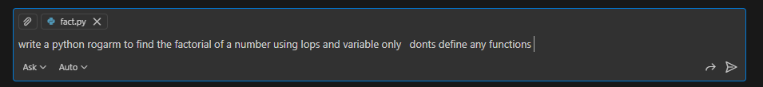
Code:
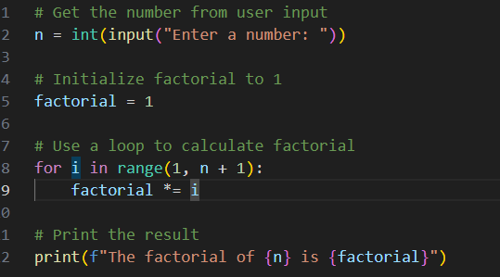
Output:
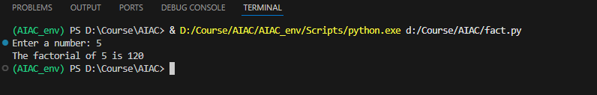
Copilot Suggestions:
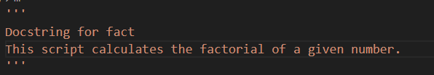
Explanation:
The code generated from compile was well structured and for beginner it was very helpful. It reduces coding time and gives code without and logical or syntax error.

Task 2: AI Code Optimization & Cleanup (Improving Efficiency)
Scenario: Your team lead asks you to review AI-generated code before committing it to a shared repository.
Task Description : Analyze the code generated in Task 1 and use Copilot again to:
  - Reduce unnecessary variables
  - Improve loop clarity
  - Enhance readability and efficiency
Hint: Prompt Copilot with phrases like
“optimize this code”, “simplify logic”, or “make it more readable”

Prompt:
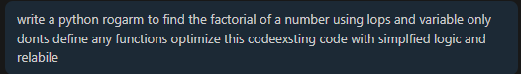
Code:
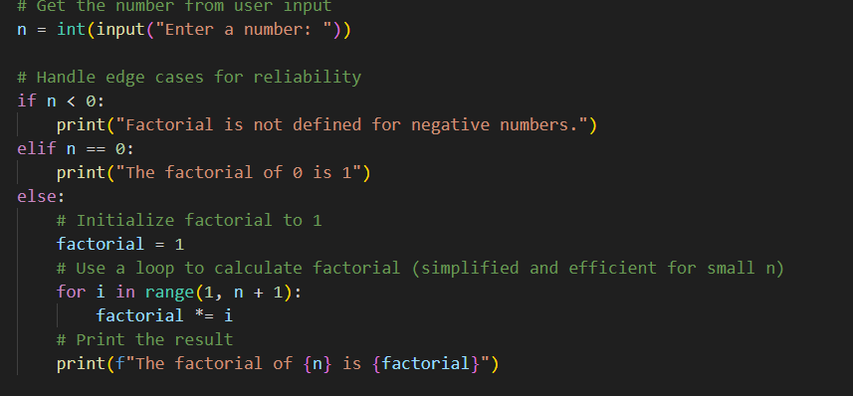
Output:
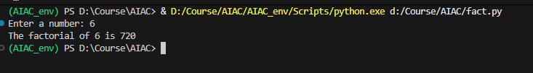
Explanation:
Compared to previous code this code was most efficient as it handles the edge case for negative and zero input

Task 3: Modular Design Using AI Assistance (Factorial with Functions)
Scenario: The same logic now needs to be reused in multiple scripts.
Task Description: Use GitHub Copilot to generate a modular version of the program by:
  - Creating a user-defined function
  - Calling the function from the main block
Constraints
  - Use meaningful function and variable names
  - Include inline comments (preferably suggested by Copilot)

Prompt:
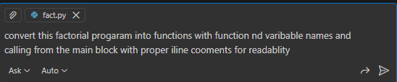
Code:
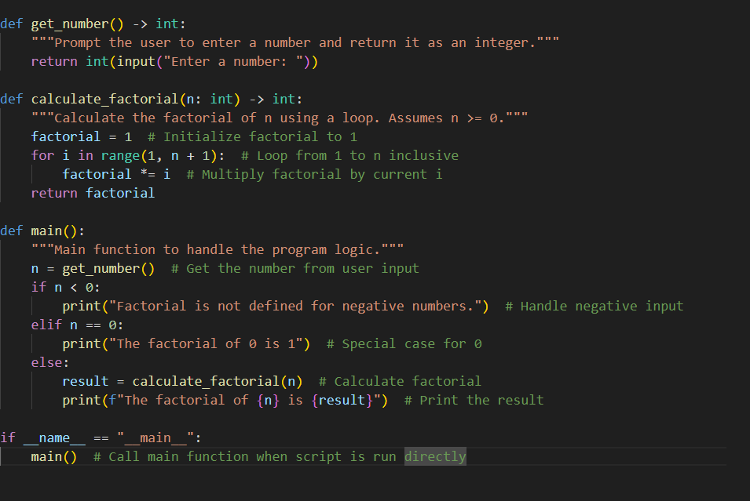
Output:
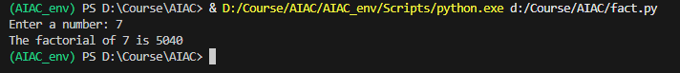
Explanation:
The code is converted into different functions with main block calling and improving readability
Task 4: Comparative Analysis – Procedural vs Modular AI Code (With vs Without Functions)

Scenario
As part of a code review meeting, you are asked to justify design choices.
Task Description
Compare the non-function and function-based Copilot-generated programs on the following criteria:
  - Logic clarity
  - Reusability
  - Debugging ease
  - Suitability for large projects
  - AI dependency risk
 | Without Functions | With Functions
Logic Clarity | Logic is written in a single flow,easy to understand but becomes unreadable as lines increases. | Logic is divided into functions, making the code to read & understand easily.
Reusability | Code cannot be reused | Functions can be reused in other programs without writing the logic again.
Debugging Ease | Debugging becomes hard as all the logic at one place | Debugging becomes easy as all the logic written multiple functions
Suitability for Large Projects | Not suitable for large projects | Suitable for large projects due to proper structure
AI Dependency Risk | Higher risk for long procedural code, hard to review or modify. | Lower risk generated in functions, easy to review & Modify.

Task 5: AI-Generated Iterative vs Recursive Thinking

Scenario: Your mentor wants to test how well AI understands different computational paradigms.
Task Description: Prompt Copilot to generate:
An iterative version of the logic
A recursive version of the same logic
Constraints :Both implementations must produce identical outputs
Students must not manually write the code first

- Expected Deliverables
Two AI-generated implementations
Execution flow explanation (in your own words)
Comparison covering:
  - Readability
  - Stack usage
  - Performance implications
When recursion is not recommended
Iterative:
Prompt:

Code:
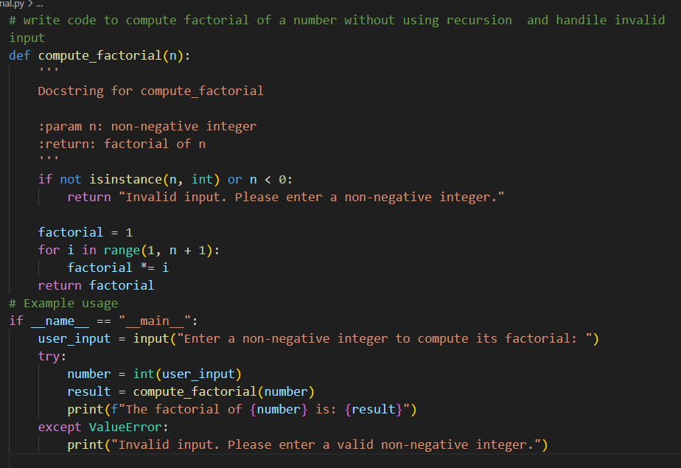
Output:
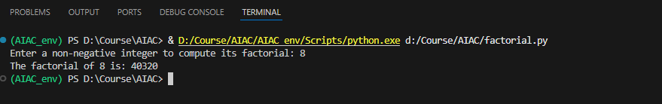
Recursive:
Prompt:
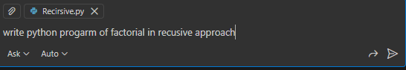
Code:
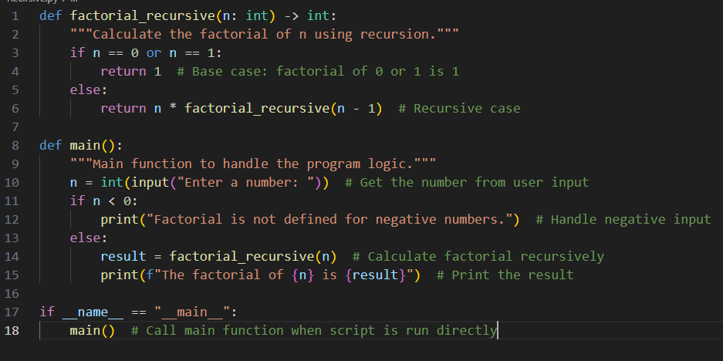
Output:
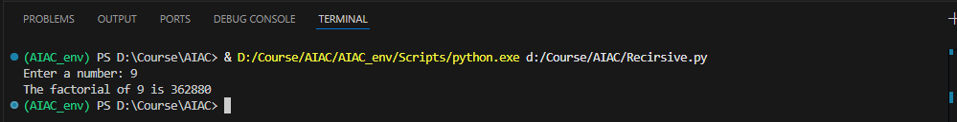

 | Iterative Approach | Recursive Approach
Readability | Easy to understand for beginners | harder for beginners due to function calls
Stack Usage | Uses constant memory | Uses call stack for each function call
Performance | Faster and more memory-efficient | slower due to function call overhead

