Game Design Document

Fill up the Following document

1. Write the title of your project.

Kids Easy Learn is going to be my app name.

1. What is the goal of the game?

There is nothing specific goal because this is an app made for kids to learn basics.

1. Write a brief story of your game?

I can say this as app for kids to make them learn basics for childhood study such as rhymes ,colours ,alphabets ,numbers ,fruits names ,shapes so on…

There will be some specific boxes for each activity so if they click on that they can do there specific activity. For little more idea please view my inspiratoion project at below page.

1. Which are the playing characters of this game?

* Playing characters are the ones which respond to the user based on the input from the user
* Cars, monkeys, dinos, wizards etc, are the playing characters in the game.

|  |  |  |
| --- | --- | --- |
| Number | Character Name | What can this character do? |
| 1 | Colors | If user clicks on the object named colors then all color will be visible one after one and color name will be pronounced in background music. |
| 2 | Shapes | In the same way shapes are going to be displayed and also be pronouncing there names |
| 3 | Numbers | In the same way numbers are going to be displayed and also be pronouncing there names |
| 4 | Alphabets | In the same way alphabets are going to be displayed and also be pronouncing there names |
| 5 | Rhymes | There will be 3 to 4 rhymes which will show text and sing the rhymes in background music |
| 6 | Vehicles | In the same way vehicles are going to be displayed and also be pronouncing there names |
| 7 | Body parts | In the same way body parts are going to be displayed and also be pronouncing there names |
| 8 | Fruits names | In the same way fruits are going to be displayed and also be pronouncing there names |
| 9 | Arrow | Arrow are appeared when a particular activity is chosen like colors then to displayed each color after one another arrow play there function. |
| 10 | Home Button | This button is used to return back the user to the main page which shows activites to select. |

1. Which are the Non Playing Characters of this game?

* Non Playing characters are the ones which don't have an action or a behaviour when the user interacts with the game.
* Hurdles, stones, bananas, coins, etc are non playing characters in the game.

|  |  |  |
| --- | --- | --- |
| Number | Character Name | What can this character do? |
| 1 | App logo | This will be just shown on the first window no interaction will be the user. |
| 2 | Any color | The color which will be displayed when the user chooses colors activity so the specific color will be presented there without any action. |
| 3 | Any shape | The same process will repeated as above |
| 4 | Any vehicle | | | |
| 5 | Any fruit | | | |
| 6 | Any number | | | |
| 7 | Any body part | | | |
| 8 | Any alphabet | | | |

Draw your imagination of this game. What does this game look like?

* Draw the game either on your computer or on paper,
* 1)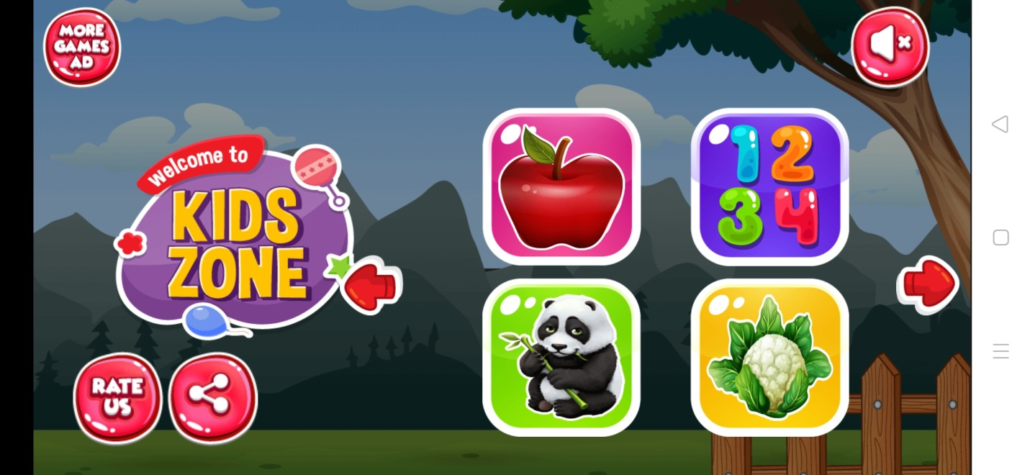
* Add images of scenes of the game to show each of the playing and non-playing characters at least once.
* 2)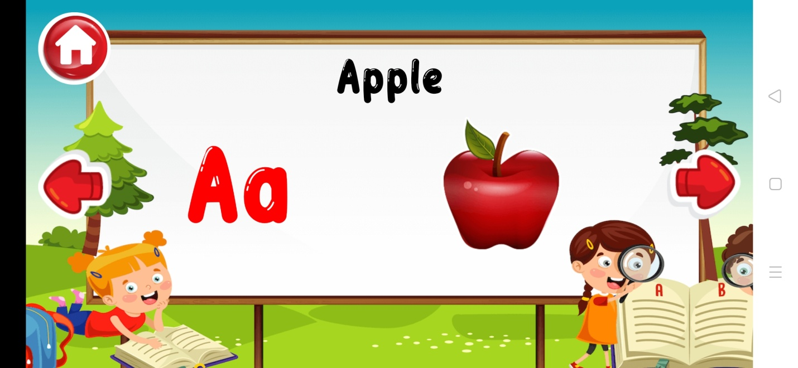
* 3)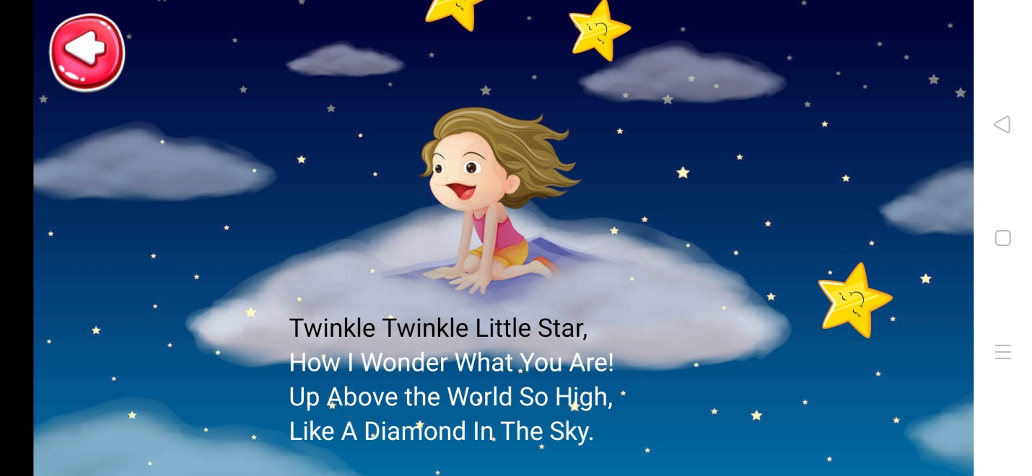

Image 1 represents the main page of the app this is just inspiration model of my app.

Image 2 represents the specific activity fruits and every fruit is being displayed like this ,the top home button is to return to the main page

Image 3 is representing rhymes activity.

How do you plan to make your game engaging?

I am planning to add attractive animations ,images ,song tracks ,phonic songs for rhymes, alphabets and son on for engagaing.