**Government of Gujarat**

**L. D. College of Engineering**



LABORATORY MANUAL

Information Technology Department

Semester IV

Object Oriented Programming - I ( 3140705 )

Year 2023-24

**Name : Hansil S. Chapadiya**

**Enrollment no. :** 230283116005

**L. D. College of Engineering**

**Ahmedabad -380015**

# Government of Gujarat

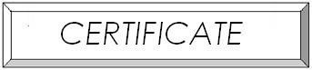

**L. D. College of Engineering**

*This is to certify that Mr./Ms.*

*Enrollment No. of Semester IV Information Technology has successfully completed the prescribed term work/laboratory work Object Oriented Programming – I (3140705) course within the four walls of L. D. College of Engineering. This is required as a partial fulfillment of the said course of Gujarat Technological University.*

*Date:*

*Course In-Charge HOD*