1. **Write a program that displays Welcome to Java, Learning Java Now and Programming is Fun.**

**Program/Solution:**

public class Main{

public static void main(String[] args)

{

System.out.println("Welcome to Java, Learning Java Now and Programming is fun.");

}

}

**Output:**

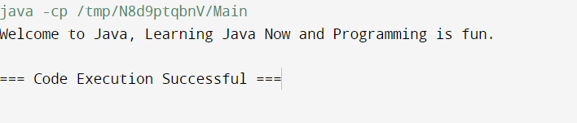

1. **Write a java program to calculate simple interest.**

**Program/Solution:**

public class Main {

public static void main(String[] args) {

SimpleInterest SI = new SimpleInterest(12, 13, 2);

System.out.println("Calculated Interest:");

System.out.println("Interest = " + SI.calculateInterest());

System.out.println("************************************");

}

}

class SimpleInterest{

double p,r,n; //p=prinipal interest, r=rate on amount, n=nuber of period

SimpleInterest(){

p=r=n=0;

}

SimpleInterest(double p, double r, double n)

{

this.p = p;

this.r = r;

this.n = n;

}

public double calculateInterest(){

return (p*r*n)/100;

}

}

**Output:**

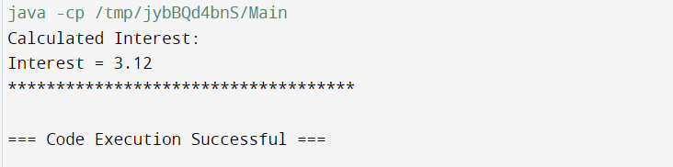

1. **Write a java program to check leap year.**

**Program/Solution:**

class Main{

public static void main(String[] args) {

LeapYear LY = new LeapYear(1990);

System.out.println("Leap Year?:");

System.out.println((LY.checkYear()?"It's LeapYear":"It's not a Leap Year"));

}

}

class LeapYear{

long year;

LeapYear(){

year = 2012;

}

LeapYear(long year)

{

this.year = year;

}

public boolean checkYear(){

return ((year % 4 == 0 && year % 100 != 0) || year % 400 == 0);

}

}

**Output:**

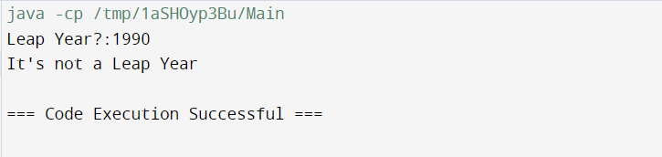

1. **Write a java program to add two binary numbers.**

**Program/Solution:**

import java.util.*; public class Add2binary{

public static void main(String[] args){ long binary1, binary2;

int i=0, carry = 0;

int[] sum = new int[20];

Scanner in = new Scanner(System.in); System.out.print("Enter first binary number: "); binary1 = in.nextLong();

System.out.print("Enter second binary number: "); binary2 = in.nextLong();

in.close();

while(binary1 != 0 || binary2 != 0){

sum[i++] = (int)((binary1 % 10 + binary2 % 10 + carry) % 2); carry = (int)((binary1 % 10 + binary2 % 10 + carry) / 2); binary1 = binary1 / 10;

binary2 = binary2 / 10;

}

if(carry != 0){

sum[i++] = carry;

}

--i;

System.out.print("Sum of two binary numbers: "); while(i >= 0)

System.out.print(sum[i--]);

System.out.print("\n");

}

}

**Output:**

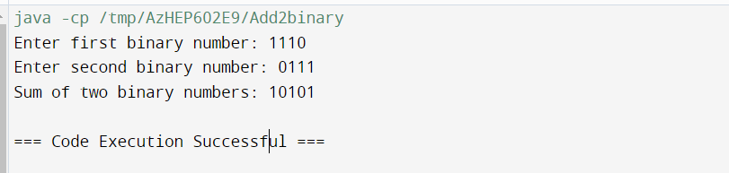

1. **Write a java program to check if a given number is Armstrong from given array.**

**Program/Solution:**

public class Practical2_EquationSolver {

public static void main(String[] args) {

Armstrong am = new Armstrong(10);

if (am.is_armstrong()) {

System.out.println(am.number + " = Armstrong Number");

}

else{

System.out.println(am.number + " = Not Armstrong Number");

}

}

}

class Armstrong {

int number;

String number_str;

Armstrong() {

number=0;

}

Armstrong(int number){

this.number = number;

this.number_str = String.valueOf(this.number);

}

boolean is_armstrong()

{

int power = this.number_str.length();

int temp = this.number;

int rem=0,arm_sum =0;

while (temp > 0) {

rem = temp % 10;

arm_sum += Math.pow(rem, power);

temp /= 10;

}

if (this.number == arm_sum) {

return true;

}

else

{

return false;

}

}

}

**Output:**

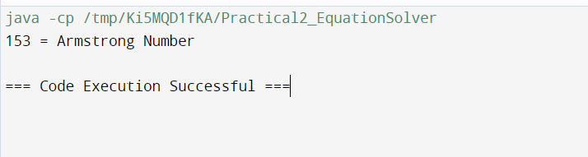

1. **Write a java program to perform bubble sort on Strings.**

**Program/Solution:**

public class StrBubbleSort

{

public static void main(String[] args)

{

String str[] = {"Hansil", "Alexnader", "Yuki", "Tony", "Peter", "Kane", "Steven", "Marc"};

String temp;

System.out.println("Strings in sorted order: ");

for(int j = 0; j < str.length; j++)

{

for(int i = j+1; i < str.length; i++)

{

//Comparing adjacent strings

if(str[i].compareTo(str[j]) < 0)

{

temp = str[j]; str[j] = str[i]; str[i] = temp;

}

}

System.out.println(str[j]);

}

}

}

**Output:**

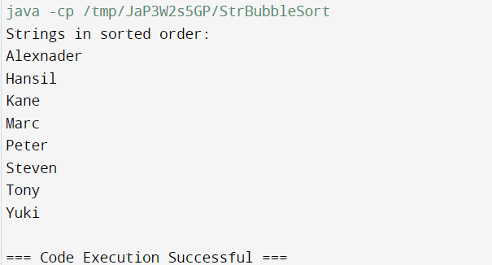

1. **Write a java program to perform different methods of string buffer class. Program:**

**Program/Solution:**

class StrBuffer{

public void sbMethods(){

StringBuffer sb = new StringBuffer(); sb.append("Hello");

sb.append(" ");

sb.append("world");

String message = sb.toString(); System.out.println(message); System.out.println(sb.reverse());

}

}

public class Test {

public static void main(String[] args){

StrBuffer s = new StrBuffer(); s.sbMethods();

}

}

**Output:**

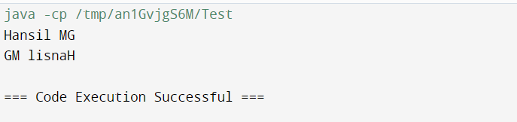

1. **Create a class named Product with instance variables MRP and QUANTITY and methods display(), setdata(). In display() method, display the instance variables value (MRP and QUANTITY). And in setdata() method set the instance variable values (MRP and QUANTITY).**

**Program/Solution:**

public class PR3_a{ private double mrp = 0;

private int quantity = 0;

public void setData(double mrp , int quantity){

this.mrp = mrp;

this.quantity = quantity;

}

public void display(){

System.out.println("MRP: "+ this.mrp);

System.out.println("QUANTITY: " + this.quantity);

}

public static void main(String[] args){ PR3_a p1 = new PR3_a(); p1.setData(90, 100);

p1.display();

}

}

**Output:**

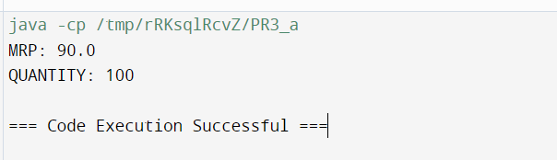

1. **Write a class named Account with instance variables Ac_No, Name and Balance and methods display(), setdata(), deposit(). In display() method display the instance variable values (Ac_No, Name and Balance). And in setdata() method set the instance variable values (Ac_No, Name and Balance) and in deposit() method the amount that the user want to deposit will be deposited.**

**Program/Solution:**

public class PR3_b {

private int acNo;

private String name;

private double balance;

public void display() {

System.out.println("Account Number: " + acNo);

System.out.println("Name: " + name);

System.out.println("Balance: " + balance);

}

public void setData(int acNo, String name, double balance) {

this.acNo = acNo;

this.name = name;

this.balance = balance;

}

public void deposit(double amount) {

if (amount > 0) {

balance += amount;

System.out.println("Deposit successful. Updated balance: "

+ balance);

} else {

System.out.println("Invalid deposit amount. Please enter a positive amount.");

}

}

public static void main(String[] args) {

PR3_b account = new PR3_b();

account.setData(123456, "John Doe", 1000.0);

account.display();

account.deposit(500.0);

account.display();

}

}

**Output:**

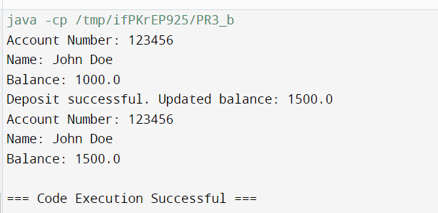

1. **Create a class named Student with static variable Enrollment no. and instance variable Name and methods display(), setdata(). In display() method, display the variables value (Enrollment no. and Name). And in setdata() method set the variable values (Enrollment no. and Name).**

**Program/Solution:**

import java.util.Scanner;

public class Practical3_ {

public static void main(String[] args)

{

Student s1 = new Student();

s1.setData(11122345, "steve");

s1.display();

}

}

class Student{

static long enr_no;

String name;

void display()

{

System.out.println("Name = " + this.name + "\nEnrollement = " + enr_no);

}

void setData(long enr_no, String name)

{

Student.enr_no = enr_no;

this.name = name;

}

}

**Output:**

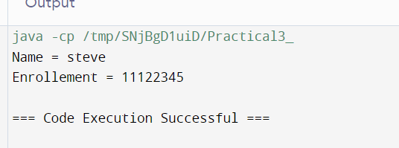

1. **Create a default constructor of class Product to print-“Welcome to Super- Market”. And Parameterized constructor to get the values of variables. (using Command Line Arguments)**

**Program/Solution:**

public class Product {

private String productName; private double price;

public Product() {

System.out.println("Welcome to Super-Market.");

}

// Parameterized constructor

public Product(String productName, double price) { this.productName = productName;

this.price = price;

}

// Method to display product details public void display() {

System.out.println("Product Name: " + productName); System.out.println("Price: " + price);

}

// Main method to test the constructors public static void main(String[] args) {

// Create an instance using default constructor Product defaultProduct = new Product();

// Create an instance using parameterized constructor if (args.length >= 2) {

String productName = args[0];

double price = Double.parseDouble(args[1]);

Product parameterizedProduct = new Product(productName,

price);

parameterizedProduct.display();

}

}

}

**Output:**



1. **Create a default constructor of class Account to print “Welcome to Bank”. And parameterized constructor to get the values of variables. (using command line arguments).**

**Program/Solution:**

public class Account {

private String name;

private double amount;

public Account() {

System.out.println("Welcome to Bank");

}

public Account(String name, double amount) {

this.name = name;

this.amount = amount;

}

public void display() {

System.out.println("Account Holder: " + name);

System.out.println("Amount: " + amount);

}

public static void main(String[] args) {

Account defaultAccount = new Account();

if (args.length >= 2) {

String name = args[0];

double amount = Double.parseDouble(args[1]);

Account parameterizedAccount = new Account(name, amount);

parameterizedAccount.display();

} else {

System.out.println("Insufficient arguments. Please provide Account holder name and amount.");

}

}

}

**Output:**

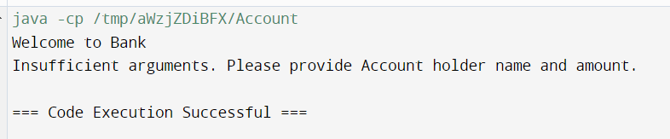

1. **Create a default constructor of class Student to print “Welcome to Student- Information system”. And parameterized constructor to get the value of variables (Enrollment no. and Name). (using Command Line Arguments)**

**Program/Solution:**

public class Student {

private String name;

private long enrollment_no;

public Student() {

System.out.println("Welcome to Student-Information System");

}

public Student(String name, long enrollment_no) {

this.name = name;

this.enrollment_no = enrollment_no;

}

public void display() {

System.out.println("Student Name : " + name);

System.out.println("Enrollment No. : " + enrollment_no);

}

public static void main(String[] args) {

Student defaultStudent = new Student();

if (args.length >= 2) {

String name = args[0];

long enrollment_no = Long.parseLong(args[1]);

Student parameterizedStudent = new Student(name,

enrollment_no);

parameterizedStudent.display();

} else { System.out.println("Insufficient arguments. Please provide Account holder name and amount.")} }}

**Output:**

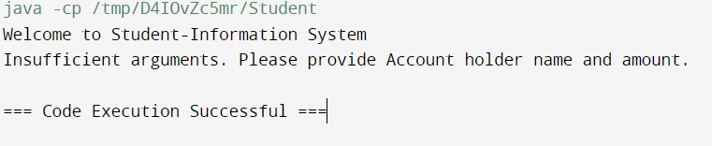

1. **Create three inherited classes named-Crockery, Household, Food-items from Product super class and inherit the instance method (display() and setdata()) and variables (MRP and QUANTITY) of super class product**

**Product.java**

public class Product{ protected double MRP; protected int QUANTITY;

protected void display(){ System.out.println("Price: " + MRP); System.out.println("Stock: " + QUANTITY);

}

protected void setdata(double MRP, int QUANTITY){ this.MRP = MRP;

this.QUANTITY = QUANTITY;

}

}

**Crockery.java**

public class Crockery extends Product{

private String type_of_product = "Crockery";

public void printType(){

System.out.println("Type of Product: " + this.type_of_product);

}

}

**Food_items.java**

public class Food_items extends Product{ private String type_of_product = Crockery";

public void printType(){

System.out.println("Type of Product: " + this.type_of_product);

}

}

**Household.java**

public class Household extends Product{

private String type_of_product = "Household";

public void printType(){

System.out.println("Type of Product: " + this.type_of_product);

}

}

**Main.java**

public class Main {

public static void main(String[] args) { Crockery c = new Crockery(); Household h = new Household(); Food_items fi = new Food_items(); c.printType();

c.setdata(999.99, 301); c.display(); h.printType(); h.setdata(89.99, 11); h.display(); fi.printType(); fi.setdata(90.92, 78); fi.display();

}

}

**Output:**

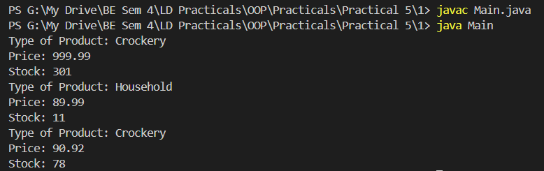

1. **Create two inherited classes named-Savings, Current from Account super class and inherit the instance method(display(), setdata() and deposit()) and variables(Ac_No, Name and Balance) of super class Account.**

**Account.java**

class Account{

protected long ac_no; protected String name; protected int balance;

protected void display(){

System.out.println("\nCustomer Name: " + this.name); System.out.println("Account Number: " + this.ac_no); System.out.println("Account Balance: " + this.balance);

}

protected void setdata(long ac_no, String name, int balance){ this.ac_no = ac_no;

this.name = name; this.balance = balance;

}

protected void deposit(long ac_no, int amount){

if(amount > 0){

System.out.println("\n\nCustomer Name: " + this.name); System.out.println("Account Number: " + this.ac_no); System.out.println("Account Balance after deposit: " +

(this.balance + amount));

}

else

System.out.println("Entered amount is negative!!!!");

}

}

**Current.java**

public class Current extends Account{

public String acc_type = "Current Account";

}

**Savings.java**

public class Savings extends Account{

public String acc_type = "Savings Account";

}

**Main.java**

public class Main{

public static void main(String[] args)

{

Savings S = new Savings();

S.setdata(202019754929001L, "Steve", 32000);

S.display(); S.deposit(202019754929L, 200);

System.out.println("Account type: " + S.acc_type);

Current C = new Current();

C.setdata(202019754929000L, "Stark", 100020);

C.display(); C.deposit(202019754929000L, 200);

System.out.println("Account type: " + C.acc_type);

}

}

**Output:**

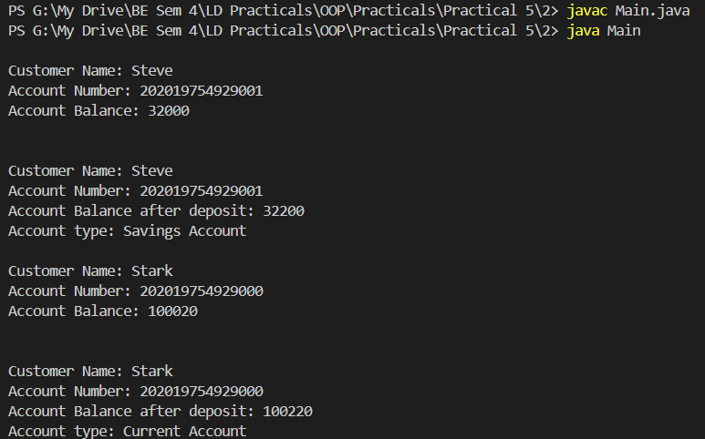

1. **Create two inherited classes named- BE, ME from Student super class and inherit the instance method (display() and setdata()) and variables (Enrollment no and Name) of super class Student and make an instance variable Entry_year and final variable duration for each of the above class.**

**Student.java**

public class Student{ long enroll_no; String name;

void display()

{

System.out.println("Enrollment number: " + this.enroll_no); System.out.println("Name: " + name);

}

void setData(long enroll_no, String name)

{

this.enroll_no = enroll_no; this.name = name;

}

}

**BE.java**

public class BE extends Student{ int entry_year;

final int duration=4;

BE(int entry_year){ this.entry_year = entry_year;

}

}

**ME.java**

public class ME extends Student{ int entry_year;

final int duration=3;

ME(int entry_year){ this.entry_year = entry_year;

}

}

**Main.java**

public class Main {

public static void main(String[] args){ BE student_1 = new BE(2020);

student_1.setData(200283116032L, "Alex"); student_1.display();

System.out.println("Entry year: " + student_1.entry_year); ME student_2 = new ME(2023); student_2.setData(230283123032L, "Rogers"); student_2.display();

System.out.println("Entry year: " + student_2.entry_year);

}

}

**Output:**

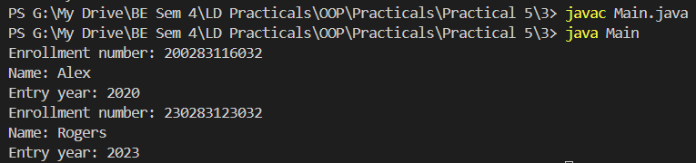

1. **Create an interface named place with method search() and variable BlockNo and implement it together on all of the above classes. Use binary I/O.**

**Pr_1.java**

interface Place{

int blockNO = 10; public void search();

}

class College implements Place{ public void search(){

System.out.println("its behind annexe building!!");

}

}

public class Pr_1{

public static void main(String[] args)

{

College c = new College();

System.out.println("What is the block no ?\n"+ c.blockNO); c.search();

}

}

**Output:**

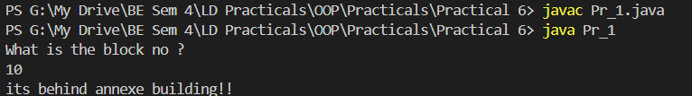

1. **Create an interface named Branch with method search() and variable IFSC Code and implement it together on all the above classes.**

**Pr_2.java**

interface Branch{

int ifscCode = 10; public void search();

}

class Bank implements Branch{ public void search(){

System.out.println("Naroda Branch, Ahmedabad");

}

}

public class Pr_2{

public static void main(String[] args)

{

Bank c = new Bank();

System.out.println("Where is the Branch located ?\n"+ c.ifscCode);

c.search();

}

}

**Output:**

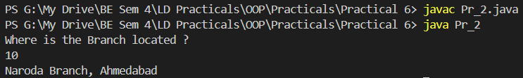

1. **Create a interface named Result with method getMarks() and variable percentage and implement it together on all the above classes in getMarks() get the marks of 3 subjects and calculate the average inside the method.**

**Pr_3.java**

interface Result{

public void getMarks(int a,int b,int c);

}

class Results implements Result{

public void getMarks(int a,int b,int c){ int total = a+b+c;

float per = total/3; System.out.println("You got "+ per +"%");

}

}

public class Pr_3{

public static void main(String[] args)

{

Results c = new Results();

c.getMarks(92,81,71);

}

}

**Output:**



1. **Define three objects for all the classes named-Crockery, Household, Food- items and store the initial values for all the objects in arraylist or collection.**

**Example: Class Crockery extends Product, implements place; Define objects of crockery -plates, cups, jug;**

**Pr_1.java**

import java.util.*; class Pr_1

{

public static void main(String[] args)

{

ArrayList<Crockery> crock=new ArrayList<Crockery>(); Crockery cro1=new Crockery();

Crockery cro2=new Crockery(); Crockery cro3=new Crockery(); cro1.plates(); cro1.details(1000,30); cro2.cups(); cro2.details(400,2); cro3.jug(); cro3.details(2000,4); crock.add(cro1); crock.add(cro2); crock.add(cro3);

Iterator itr=crock.iterator(); while(itr.hasNext())

{

Crockery ck=(Crockery)itr.next(); System.out.println("Price:"+ck.price+ " Quantity:

"+ck.quantity);

}

ArrayList<Household> house=new ArrayList<Household>(); Household ho1=new Household();

Household ho2=new Household(); Household ho3=new Household(); ho1.spoons(); ho1.details(400,12); ho2.knives(); ho2.details(500,2); ho3.stoves(); ho3.details(10000,2); house.add(ho1); house.add(ho2); house.add(ho3);

Iterator i=house.iterator(); while(i.hasNext())

{

Household ho=(Household)i.next(); System.out.println("Price:"+ho.price+ " Quantity:

"+ho.quantity);

}

ArrayList<Fooditems> food=new ArrayList<Fooditems>(); Fooditems fo1=new Fooditems();

Fooditems fo2=new Fooditems(); Fooditems fo3=new Fooditems(); fo1.butter(); fo1.details(70,1); fo2.sunfloweroil(); fo2.details(2300,1); fo3.bread(); fo3.details(100,4); food.add(fo1);

food.add(fo2); food.add(fo3);

Iterator ir=food.iterator(); while(ir.hasNext())

{

Fooditems it=(Fooditems)ir.next(); System.out.println("Price:"+it.price+ " Quantity:

"+it.quantity);

}

}

}

class Product

{

float price; int quantity;

void details( float price, int quantity)

{

this.price=price; this.quantity=quantity;

}

}

class Crockery extends Product

{

void plates()

{

System.out.println("Plates");

}

void cups()

{

System.out.println("Cups");

}

void jug()

{

System.out.println("Jug");

}

}

class Household extends Product

{

void spoons()

{

System.out.println("Spoons");

}

void knives()

{

System.out.println("Knives");

}

void stoves()

{

System.out.println("Stoves");

}

}

class Fooditems extends Product { void butter()

{

System.out.println("Butter");

}

void sunfloweroil()

{

System.out.println("Sunfloweroil");

}

void bread()

{

System.out.println("Bread");

}

}

**Output:**

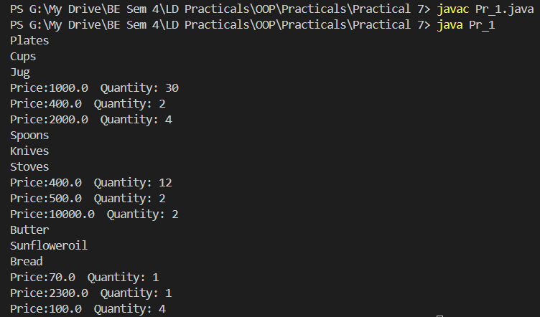

1. **Define three objects for all the classes named-Savings, Current and store the initial values for all the objects in arraylist or collection.**

**Example: Class Savings extends Account implements Branch; Define objects.**

**Pr_2.java**

import java.util.*; public class Pr_2{

public static void main(String[] args){ ArrayList<Saving> sav=new ArrayList<Saving>(); Saving a1=new Saving(); a1.details(1654354,"Moksha",866.22f,556f,8.7f); sav.add(a1);

Iterator itr=sav.iterator(); while(itr.hasNext()){

Saving sa=(Saving)itr.next(); System.out.println("\nINFORMATION OF SAVING ACCOUNT");

System.out.println("\nACCOUNT NUMBER:"+sa.acno+ "\nNAME OF ACCOUNT HOLDER: "+sa.name+"\nBALANCE :"+sa.balance+"\nDEPOSITE :" +

sa.deposite + "\nINTEREST:"+sa.interest);

}

a1.Deposite(); a1.interestrate();

ArrayList<Current> cur=new ArrayList<Current>(); Current a2=new Current(); a2.details(154534,"XYZ",874.12f,964f,6.6f);

cur.add(a2);

Iterator it=cur.iterator(); while(it.hasNext()){

Current cu=(Current)it.next(); System.out.println("\nINFORMATION OF CURRENT ACCOUNT");

System.out.println("\nACCOUNT NUMBER:"+cu.acno+ "\nNAME OF ACCOUNT HOLDER: "+cu.name+"\nBALANCE :"+cu.balance+"\nDEPOSITE :" +

cu.deposite + "\nINTEREST:" + cu.interest);

}

a2.Deposite(); a2.interestrate();

}

}

class Account{

void details(int acno,String name,float balance,float deposite,float interest){

this.acno=acno; this.name=name; this.balance=balance; this.deposite=deposite; this.interest=interest;

}

}

class Saving extends Account{ void Deposite(){

balance= balance+deposite; System.out.println("Balance after deposite:"+balance);

}

void interestrate(){

interest=(balance*interest)/percent; System.out.println("Amount of interest:"+interest);}

}

class Current extends Account{

void Deposite(){

balance= balance+deposite; System.out.println("Balance after deposite:"+balance);

}

void interestrate(){ interest=(balance*interest)/percent; System.out.println("Amount of interest:"+interest);}

**Output:**

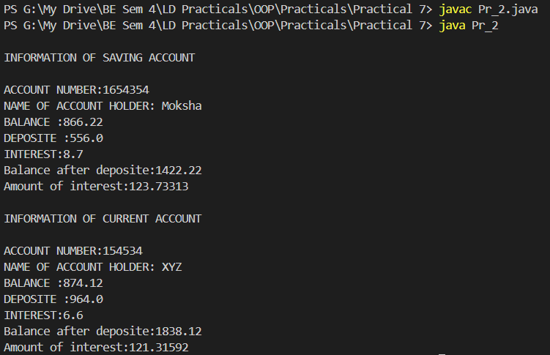

1. **Define two objects for all the classes named BE, ME and store the initial values for all the objects in arraylist or collection.**

**Example: Class BE extends Student, implements Result; Define objects of BE.**

**Pr_3.java**

import java.util.*; public class Pr_3

{

public static void main(String[] args)

{

ArrayList<BE> ba=new ArrayList<BE>(); BE be1=new BE();

be1.course(); be1.details("Steve",230283116033L,"IT"); ba.add(be1);

Iterator itr = ba.iterator(); while(itr.hasNext())

{

BE be2=(BE)itr.next();

System.out.println("NAME :"+be2.name+"\nENROLLMENT NUMBER:"+be2.enno+"\nBRANCH:"+be2.branch);

}

ArrayList<ME> ma=new ArrayList<ME>(); ME me1=new ME();

me1.course(); me1.details("Tony",230280110034L,"CS"); ma.add(me1);

Iterator it = ma.iterator(); while(it.hasNext())

{

ME me2=(ME)it.next();

System.out.println("NAME :"+me2.name+"\nENROLLMENT NUMBER:"+me2.enno+"\nBRANCH:"+me2.branch);

}

}

}

class Student

{

void details(String name,long enno,String branch)

{

this.name=name; this.enno=enno; this.branch=branch;

}

}

class BE extends Student

{

void course(){

System.out.println("\nBE STUDENT INFORMATION");

}

}

class ME extends Student{

void course()

{

System.out.println("\nME STUDENT INFORMATION");

}

}

**Output:**

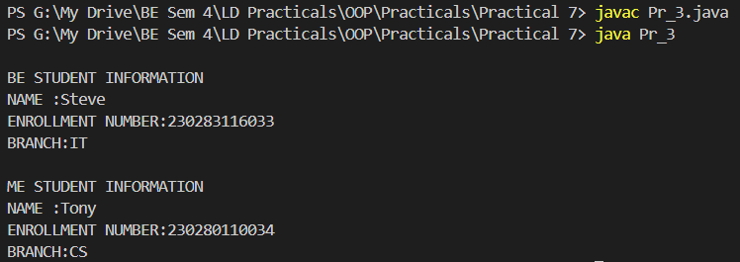

1. **Create a Package and put all the classes mentioned above in package.**

**Current.java**

package Bank;

public class Current{ public void display(){

System.out.println("Current Account\nBank: HDFC\nBranch: Surat");

}

}

**Savings.java**

package Bank;

public class Savings{ public void display(){

System.out.println("Savings Account\nBank: AXIS\nBranch: Ahmedabad");

}

}

**Practical8b.java**

//File: Practical18b.java import Bank.*;

import java.util.Scanner; class Practical8b

{

public static void main(String args[])

{

Scanner sc = new Scanner(System.in); System.out.println("Enter 1 for Savings"); System.out.println("Enter 2 for Current"); System.out.print("Enter your choice: "); int ch = sc.nextInt(); System.out.print("\n");

switch(ch)

{

case 1:

Bank.Savings cr=new Bank.Savings(); cr.display(); case 2:

Bank.Current hr=new Bank.Current(); hr.display();

break; default:

System.out.println("Invalid Choice");

}

}

}

**Output:**

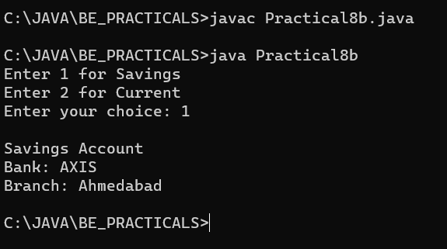

1. **Create a method named buy () in the main function performing exception handling.**

**Example: Banana = 10; Banana_Buy = 12**

**Here, Banana_Buy > Banana (throw exception).**

**Program/Solution:**

public class Main {

    private int availableQuantity;

    public Main(int availableQuantity) {

        this.availableQuantity = availableQuantity;

    }

    // Method to perform buying with exception handling

    public void buy(int quantityToBuy) {

        try {

            if (quantityToBuy > availableQuantity) {

                throw new IllegalArgumentException("Quantity to buy exceeds available quantity");

            } else {

                // Perform the buying process here

                availableQuantity -= quantityToBuy;

                System.out.println("Purchase successful! Remaining quantity: " + availableQuantity);

            }

        } catch (IllegalArgumentException e) {

            System.out.println("Exception caught: " + e.getMessage());

        }

    }

    public static void main(String[] args) {

        Main item = new Main(10); // Assuming there are initially 10 items available

        int quantityToBuy = 12; // Quantity user wants to buy

        // Attempt to buy the specified quantity

        item.buy(quantityToBuy);

    }

}

**Output:**

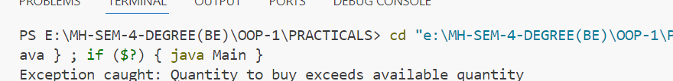

1. **Create a method named Withdraw () in the main function performing exception handling.**

**Example: Balance = 1000; Withdraw = 12000**

**Here, Balance<Withdraw (throw exception)**

**Program/Solution:**

public class Main {

    private double balance;

    public Main(double balance) {

        this.balance = balance;

    }

    // Method to perform withdrawal with exception handling

    public void withdraw(double withdrawalAmount) {

        try {

            if (withdrawalAmount > balance) {

                throw new IllegalArgumentException("Withdrawal amount exceeds available balance");

            } else {

                // Perform the withdrawal process here

                balance -= withdrawalAmount;

                System.out.println("Withdrawal successful! Remaining balance: " + balance);

            }

        } catch (IllegalArgumentException e) {

            System.out.println("Exception caught: " + e.getMessage());

        }

    }

    public static void main(String[] args) {

        Main account = new Main(1000); // Assuming there is initially $1000 balance

        double withdrawalAmount = 12000; // Amount user wants to withdraw

        // Attempt to withdraw the specified amount

        account.withdraw(withdrawalAmount);

    }

}

**Output:**



1. **Create a method named searchStudent() in the main () Function performing exception handling.**

**Example: if we search the student name and if it is present in**

**the list then it will represent the details else it will throw an**

**exception.**

**Program/Solution:**

import java.util.HashMap;

public class Main {

    private HashMap<String, String> studentDetails;

    public Main() {

        // Initialize student details hashmap

        studentDetails = new HashMap<>();

        // Populate with sample data (student name as key, details as value)

        studentDetails.put("John", "Age: 20, Grade: A");

        studentDetails.put("Alice", "Age: 22, Grade: B");

        studentDetails.put("Bob", "Age: 21, Grade: A-");

    }

    // Method to search for student details with exception handling

    public void searchStudent(String studentName) {

        try {

            String details = studentDetails.get(studentName);

            if (details == null) {

                throw new IllegalArgumentException("Student not found");

            } else {

                System.out.println("Student details for " + studentName + ": " + details);

            }

        } catch (IllegalArgumentException e) {

            System.out.println("Exception caught: " + e.getMessage());

        }

    }

    public static void main(String[] args) {

        Main mainObj = new Main(); // Create an instance of Main class

        String studentName = "Alice"; // Name of the student to search

        // Attempt to search for the student details

        mainObj.searchStudent(studentName);

    }

}

**Output:**

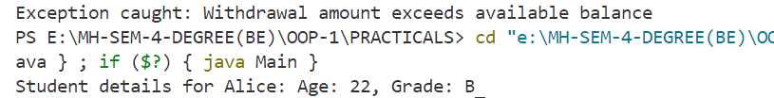

1. **Save object data in the file using File Writer class, usingparameterized constructor.**

**Program/Solution:**

import java.io.*;

// Serializable class representing student details

class Student implements Serializable {

    private String name;

    private int age;

    public Student(String name, int age) {

        this.name = name;

        this.age = age;

    }

    // Getters and setters

    public String getName() {

        return name;

    }

    public void setName(String name) {

        this.name = name;

    }

    public int getAge() {

        return age;

    }

    public void setAge(int age) {

        this.age = age;

    }

    @Override

    public String toString() {

        return "Name: " + name + ", Age: " + age;

    }

}

public class Main {

    public static void main(String[] args) {

        // Create a Student object

        Student student = new Student("John", 20);

        // File path

        String filePath = "student_data.txt";

        try {

            // Create ObjectOutputStream to write object to file

            ObjectOutputStream outputStream = new ObjectOutputStream(new FileOutputStream(filePath));

            // Write the object to the file

            outputStream.writeObject(student);

            // Close the stream

            outputStream.close();

            System.out.println("Object data saved to file successfully.");

        } catch (IOException e) {

            System.out.println("Error occurred: " + e.getMessage());

        }

    }

}

**Output:**

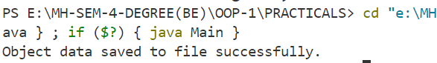

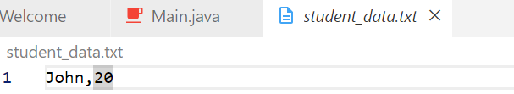

1. **Create customer class which extends thread class and contains two instance variables name, ProductName and static variable Product Quantity. For example if two customers are trying to buy the same product at once then follow**

**Program/Solution:**

public class Customer extends Thread {

    private String name;

    private String productName;

    private static int productQuantity = 10; // Initial quantity of the product

    public Customer(String name, String productName) {

        this.name = name;

        this.productName = productName;

    }

    @Override

    public void run() {

        synchronized (Customer.class) { // Synchronize on the class object to ensure atomic access to shared variable

            if (productQuantity > 0) { // Check if product is available

                System.out.println(name + " is buying " + productName);

                productQuantity--; // Decrease product quantity

                System.out.println(productName + " purchased by " + name + ". Remaining quantity: " + productQuantity);

            } else {

                System.out.println("Sorry, " + productName + " is out of stock for " + name);

            }

        }

    }

    public static void main(String[] args) {

        // Create two customers trying to buy the same product

        Customer customer1 = new Customer("Customer1", "ProductA");

        Customer customer2 = new Customer("Customer2", "ProductA");

        // Start the threads

        customer1.start();

        customer2.start();

    }

}

**Output:**

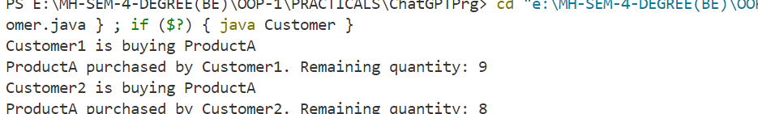

1. **Create Customer class which extends thread class and contains two instance variables name, BankName and static variable Product Balance. if two customers are trying to Withdraw from the same Account at once then then follow synchronization of two customers extending thread class.**

**Program/Solution:**

public class Customer extends Thread {

    private String name;

    private String bankName;

    private static double accountBalance = 1000.0; // Initial balance in the account

    public Customer(String name, String bankName) {

        this.name = name;

        this.bankName = bankName;

    }

    @Override

    public void run() {

        synchronized (Customer.class) { // Synchronize on the class object to ensure atomic access to shared variable

            double withdrawAmount = 500.0; // Amount to withdraw

            if (withdrawAmount > accountBalance) {

                System.out.println("Sorry, " + bankName + " has insufficient balance for " + name + " to withdraw.");

            } else {

                System.out.println(name + " is withdrawing " + withdrawAmount + " from " + bankName);

                accountBalance -= withdrawAmount; // Decrease account balance

                System.out.println("Withdrawal successful! New balance for " + bankName + ": " + accountBalance);

            }

        }

    }

    public static void main(String[] args) {

        // Create two customers trying to withdraw from the same bank account

        Customer customer1 = new Customer("Customer1", "BankA");

        Customer customer2 = new Customer("Customer2", "BankA");

        // Start the threads

        customer1.start();

        customer2.start();

    }

}

**Output:**

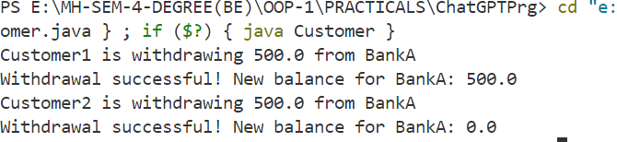

1. **Create Number class which extends thread class and create two objects a1, a2 displaying the number having even Enrollment no. and odd Enrollment no.**

**Program/Solution:**

public class Number extends Thread {

    private int enrollmentNo;

    public Number(int enrollmentNo) {

        this.enrollmentNo = enrollmentNo;

    }

    @Override

    public void run() {

        if (enrollmentNo % 2 == 0) {

            // Display even numbers

            for (int i = 2; i <= 10; i += 2) {

                System.out.println("Even Number: " + i);

                try {

                    Thread.sleep(1000); // Sleep for 1 second

                } catch (InterruptedException e) {

                    e.printStackTrace();

                }

            }

        } else {

            // Display odd numbers

            for (int i = 1; i <= 10; i += 2) {

                System.out.println("Odd Number: " + i);

                try {

                    Thread.sleep(1000); // Sleep for 1 second

                } catch (InterruptedException e) {

                    e.printStackTrace();

                }

            }

        }

    }

    public static void main(String[] args) {

        // Create two Number objects with even and odd enrollment numbers

        Number a1 = new Number(1001); // Odd enrollment number

        Number a2 = new Number(1002); // Even enrollment number

        // Start the threads

        a1.start();

        a2.start();

    }

}

**Output:**

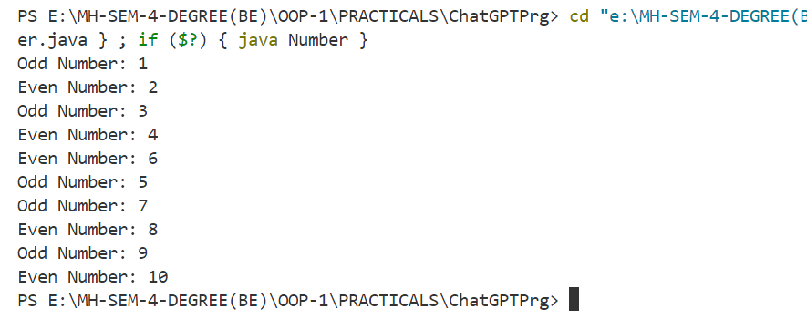

1. **Create the above system using a menu and implement it using switch statement. For example, in the above system implement the menu driven like.**

**1. For setting a value of MRP and QUANTITY for the product.**

**2. For buying a product.**

**3. For searching a product.**

**4. To delete a product from storage.**

**5. To show stored object data**

**Program/Solution:**

import java.util.Scanner;

class Product {

    private String name;

    private double price;

    private int quantity;

    public Product(String name, double price, int quantity) {

        this.name = name;

        this.price = price;

        this.quantity = quantity;

    }

    // Getters and setters

    public String getName() {

        return name;

    }

    public void setName(String name) {

        this.name = name;

    }

    public double getPrice() {

        return price;

    }

    public void setPrice(double price) {

        this.price = price;

    }

    public int getQuantity() {

        return quantity;

    }

    public void setQuantity(int quantity) {

        this.quantity = quantity;

    }

    @Override

    public String toString() {

        return "Name: " + name + ", Price: " + price + ", Quantity: " + quantity;

    }

}

public class ProductManagementSystem {

    private static Product product;

    public static void main(String[] args) {

        Scanner scanner = new Scanner(System.in);

        int choice;

        do {

            System.out.println("\nMenu:");

            System.out.println("1. Set MRP and Quantity for the product");

            System.out.println("2. Buy a product");

            System.out.println("3. Search for a product");

            System.out.println("4. Delete a product from storage");

            System.out.println("5. Show stored object data");

            System.out.println("6. Exit");

            System.out.print("Enter your choice: ");

            choice = scanner.nextInt();

            switch (choice) {

                case 1:

                    setProductDetails(scanner);

                    break;

                case 2:

                    buyProduct(scanner);

                    break;

                case 3:

                    searchProduct(scanner);

                    break;

                case 4:

                    deleteProduct();

                    break;

                case 5:

                    showStoredData();

                    break;

                case 6:

                    System.out.println("Exiting...");

                    break;

                default:

                    System.out.println("Invalid choice. Please try again.");

            }

        } while (choice != 6);

    }

    private static void setProductDetails(Scanner scanner) {

        System.out.print("Enter product name: ");

        String name = scanner.next();

        System.out.print("Enter product price: ");

        double price = scanner.nextDouble();

        System.out.print("Enter product quantity: ");

        int quantity = scanner.nextInt();

        product = new Product(name, price, quantity);

        System.out.println("Product details set successfully.");

    }

    private static void buyProduct(Scanner scanner) {

        if (product == null) {

            System.out.println("Please set product details first.");

            return;

        }

        System.out.print("Enter quantity to buy: ");

        int quantityToBuy = scanner.nextInt();

        if (quantityToBuy > product.getQuantity()) {

            System.out.println("Insufficient quantity available.");

        } else {

            product.setQuantity(product.getQuantity() - quantityToBuy);

            System.out.println("Product bought successfully.");

        }

    }

    private static void searchProduct(Scanner scanner) {

        if (product == null) {

            System.out.println("Please set product details first.");

            return;

        }

        System.out.print("Enter product name to search: ");

        String name = scanner.next();

        if (name.equals(product.getName())) {

            System.out.println("Product found: " + product);

        } else {

            System.out.println("Product not found.");

        }

    }

    private static void deleteProduct() {

        product = null;

        System.out.println("Product deleted from storage.");

    }

    private static void showStoredData() {

        if (product == null) {

            System.out.println("No product stored.");

        } else {

            System.out.println("Stored product data: " + product);

        }

    }

}

**Output:**

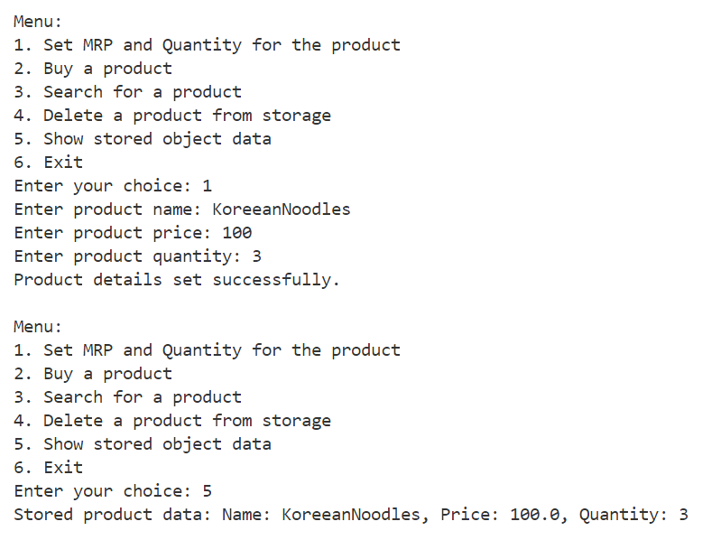

1. **Create the above system using a menu and implement it using switch statement. For example, in the above system implement the menu driven like.**

**1. For Setting a value of Ac_No,Name and Balance for the Bank**

**2. For Withdraw from a Account.**

**3. For Searching a Account.**

**4. To delete an Account from Bank.**

**5. To show stored object data**

**Program/Solution:**

import java.util.*;

class BankAccount {

    private int accountNumber;

    private String name;

    private double balance;

    public BankAccount(int accountNumber, String name, double balance) {

        this.accountNumber = accountNumber;

        this.name = name;

        this.balance = balance;

    }

    // Getters and setters

    public int getAccountNumber() {

        return accountNumber;

    }

    public void setAccountNumber(int accountNumber) {

        this.accountNumber = accountNumber;

    }

    public String getName() {

        return name;

    }

    public void setName(String name) {

        this.name = name;

    }

    public double getBalance() {

        return balance;

    }

    public void setBalance(double balance) {

        this.balance = balance;

    }

    @Override

    public String toString() {

        return "Account Number: " + accountNumber + ", Name: " + name + ", Balance: " + balance;

    }

}

public class BankManagementSystem {

    private static List<BankAccount> accounts = new ArrayList<>();

    public static void main(String[] args) {

        Scanner scanner = new Scanner(System.in);

        int choice;

        do {

            System.out.println("\nMenu:");

            System.out.println("1. Set Account Number, Name, and Balance");

            System.out.println("2. Withdraw from an Account");

            System.out.println("3. Search for an Account");

            System.out.println("4. Delete an Account from Bank");

            System.out.println("5. Show stored object data");

            System.out.println("6. Exit");

            System.out.print("Enter your choice: ");

            choice = scanner.nextInt();

            switch (choice) {

                case 1:

                    setAccountDetails(scanner);

                    break;

                case 2:

                    withdrawFromAccount(scanner);

                    break;

                case 3:

                    searchAccount(scanner);

                    break;

                case 4:

                    deleteAccount(scanner);

                    break;

                case 5:

                    showStoredData();

                    break;

                case 6:

                    System.out.println("Exiting...");

                    break;

                default:

                    System.out.println("Invalid choice. Please try again.");

            }

        } while (choice != 6);

    }

    private static void setAccountDetails(Scanner scanner) {

        System.out.print("Enter account number: ");

        int accountNumber = scanner.nextInt();

        System.out.print("Enter name: ");

        String name = scanner.next();

        System.out.print("Enter balance: ");

        double balance = scanner.nextDouble();

        accounts.add(new BankAccount(accountNumber, name, balance));

        System.out.println("Account details set successfully.");

    }

    private static void withdrawFromAccount(Scanner scanner) {

        System.out.print("Enter account number: ");

        int accountNumber = scanner.nextInt();

        BankAccount account = findAccount(accountNumber);

        if (account != null) {

            System.out.print("Enter amount to withdraw: ");

            double amount = scanner.nextDouble();

            if (amount <= account.getBalance()) {

                account.setBalance(account.getBalance() - amount);

                System.out.println("Withdrawal successful! New balance: " + account.getBalance());

            } else {

                System.out.println("Insufficient balance.");

            }

        } else {

            System.out.println("Account not found.");

        }

    }

    private static void searchAccount(Scanner scanner) {

        System.out.print("Enter account number to search: ");

        int accountNumber = scanner.nextInt();

        BankAccount account = findAccount(accountNumber);

        if (account != null) {

            System.out.println("Account found: " + account);

        } else {

            System.out.println("Account not found.");

        }

    }

    private static void deleteAccount(Scanner scanner) {

        System.out.print("Enter account number to delete: ");

        int accountNumber = scanner.nextInt();

        BankAccount account = findAccount(accountNumber);

        if (account != null) {

            accounts.remove(account);

            System.out.println("Account deleted successfully.");

        } else {

            System.out.println("Account not found.");

        }

    }

    private static BankAccount findAccount(int accountNumber) {

        for (BankAccount account : accounts) {

            if (account.getAccountNumber() == accountNumber) {

                return account;

            }

        }

        return null;

    }

    private static void showStoredData() {

        if (accounts.isEmpty()) {

            System.out.println("No accounts stored.");

        } else {

            System.out.println("Stored account data:");

            for (BankAccount account : accounts) {

                System.out.println(account);

            }

        }

    }

}

**Output:**

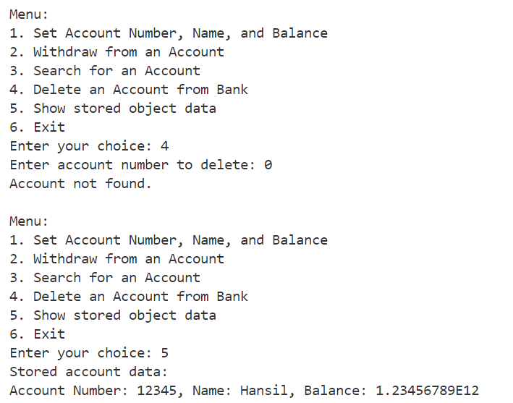

1. **Create the above system using a menu and implement it using switch statement. For example, in the above system implement the menu driven like.**

**1. Add Student details.**

**2. Update student Details.**

**3. For Searching a Student.**

**4. Delete Student Details.**

**Program/solution:**

import java.util.*;

class Student {

    private int rollNumber;

    private String name;

    private int age;

    public Student(int rollNumber, String name, int age) {

        this.rollNumber = rollNumber;

        this.name = name;

        this.age = age;

    }

    // Getters and setters

    public int getRollNumber() {

        return rollNumber;

    }

    public void setRollNumber(int rollNumber) {

        this.rollNumber = rollNumber;

    }

    public String getName() {

        return name;

    }

    public void setName(String name) {

        this.name = name;

    }

    public int getAge() {

        return age;

    }

    public void setAge(int age) {

        this.age = age;

    }

    @Override

    public String toString() {

        return "Roll Number: " + rollNumber + ", Name: " + name + ", Age: " + age;

    }

}

public class StudentManagementSystem {

    private static List<Student> students = new ArrayList<>();

    public static void main(String[] args) {

        Scanner scanner = new Scanner(System.in);

        int choice;

        do {

            System.out.println("\nMenu:");

            System.out.println("1. Add Student details");

            System.out.println("2. Update Student details");

            System.out.println("3. Search for a Student");

            System.out.println("4. Delete Student details");

            System.out.println("5. Exit");

            System.out.print("Enter your choice: ");

            choice = scanner.nextInt();

            switch (choice) {

                case 1:

                    addStudentDetails(scanner);

                    break;

                case 2:

                    updateStudentDetails(scanner);

                    break;

                case 3:

                    searchStudent(scanner);

                    break;

                case 4:

                    deleteStudentDetails(scanner);

                    break;

                case 5:

                    System.out.println("Exiting...");

                    break;

                default:

                    System.out.println("Invalid choice. Please try again.");

            }

        } while (choice != 5);

    }

    private static void addStudentDetails(Scanner scanner) {

        System.out.print("Enter Roll Number: ");

        int rollNumber = scanner.nextInt();

        System.out.print("Enter Name: ");

        String name = scanner.next();

        System.out.print("Enter Age: ");

        int age = scanner.nextInt();

        students.add(new Student(rollNumber, name, age));

        System.out.println("Student details added successfully.");

    }

    private static void updateStudentDetails(Scanner scanner) {

        System.out.print("Enter Roll Number to update: ");

        int rollNumber = scanner.nextInt();

        Student student = findStudent(rollNumber);

        if (student != null) {

            System.out.println("Enter updated details:");

            System.out.print("Enter Name: ");

            String name = scanner.next();

            System.out.print("Enter Age: ");

            int age = scanner.nextInt();

            student.setName(name);

            student.setAge(age);

            System.out.println("Student details updated successfully.");

        } else {

            System.out.println("Student not found.");

        }

    }

    private static void searchStudent(Scanner scanner) {

        System.out.print("Enter Roll Number to search: ");

        int rollNumber = scanner.nextInt();

        Student student = findStudent(rollNumber);

        if (student != null) {

            System.out.println("Student found: " + student);

        } else {

            System.out.println("Student not found.");

        }

    }

    private static void deleteStudentDetails(Scanner scanner) {

        System.out.print("Enter Roll Number to delete: ");

        int rollNumber = scanner.nextInt();

        Student student = findStudent(rollNumber);

        if (student != null) {

            students.remove(student);

            System.out.println("Student details deleted successfully.");

        } else {

            System.out.println("Student not found.");

        }

    }

    private static Student findStudent(int rollNumber) {

        for (Student student : students) {

            if (student.getRollNumber() == rollNumber) {

                return student;

            }

        }

        return null;

    }

}

**Output:**

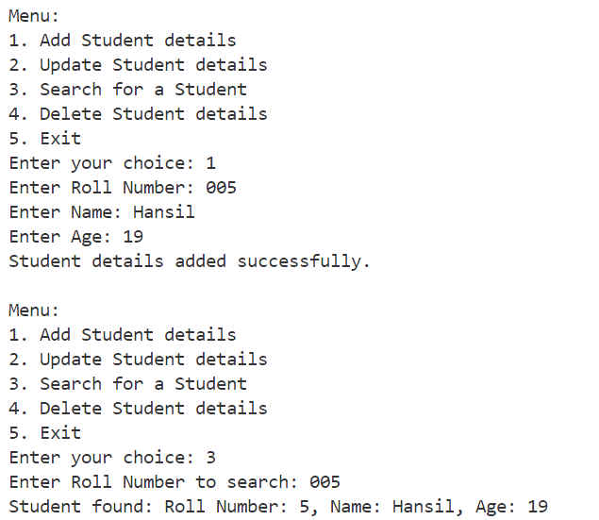

1. **Create the above system user interface of menu using JAVAFX**

**Program/Solution:**

 import javafx.application.Application;

 import javafx.geometry.Insets;

 import javafx.geometry.Pos;

 import javafx.scene.Scene;

 import javafx.scene.control.*;

 import javafx.scene.layout.GridPane;

 import javafx.stage.Stage;

 import java.util.ArrayList;

 import java.util.List;

 class Student {

     private int rollNumber;

     private String name;

     private int age;

     public Student(int rollNumber, String name, int age) {

         this.rollNumber = rollNumber;

         this.name = name;

         this.age = age;

     }

     // Getters and setters

     public int getRollNumber() {

         return rollNumber;

     }

     public void setRollNumber(int rollNumber) {

         this.rollNumber = rollNumber;

     }

     public String getName() {

         return name;

     }

     public void setName(String name) {

         this.name = name;

     }

     public int getAge() {

         return age;

     }

     public void setAge(int age) {

         this.age = age;

     }

     @Override

     public String toString() {

         return "Roll Number: " + rollNumber + ", Name: " + name + ", Age: " + age;

     }

 }

 public class StudentManagementSystem extends Application {

     private List<Student> students = new ArrayList<>();

     @Override

     public void start(Stage primaryStage) {

         GridPane gridPane = new GridPane();

         gridPane.setAlignment(Pos.CENTER);

         gridPane.setHgap(10);

         gridPane.setVgap(10);

         gridPane.setPadding(new Insets(25, 25, 25, 25));

         Label menuLabel = new Label("Menu:");

         gridPane.add(menuLabel, 0, 0);

         Button addBtn = new Button("Add Student details");

         addBtn.setOnAction(e -> addStudentDetails(primaryStage));

         gridPane.add(addBtn, 0, 1);

         Button updateBtn = new Button("Update Student details");

         updateBtn.setOnAction(e -> updateStudentDetails(primaryStage));

         gridPane.add(updateBtn, 0, 2);

         Button searchBtn = new Button("Search for a Student");

         searchBtn.setOnAction(e -> searchStudent(primaryStage));

         gridPane.add(searchBtn, 0, 3);

         Button deleteBtn = new Button("Delete Student details");

         deleteBtn.setOnAction(e -> deleteStudentDetails(primaryStage));

         gridPane.add(deleteBtn, 0, 4);

         Button exitBtn = new Button("Exit");

         exitBtn.setOnAction(e -> primaryStage.close());

         gridPane.add(exitBtn, 0, 5);

         Scene scene = new Scene(gridPane, 400, 300);

         primaryStage.setTitle("Student Management System");

         primaryStage.setScene(scene);

         primaryStage.show();

     }

     private void addStudentDetails(Stage primaryStage) {

         GridPane addGridPane = new GridPane();

         addGridPane.setAlignment(Pos.CENTER);

         addGridPane.setHgap(10);

         addGridPane.setVgap(10);

         addGridPane.setPadding(new Insets(25, 25, 25, 25));

         Label rollNumberLabel = new Label("Roll Number:");

         addGridPane.add(rollNumberLabel, 0, 0);

         TextField rollNumberField = new TextField();

         addGridPane.add(rollNumberField, 1, 0);

         Label nameLabel = new Label("Name:");

         addGridPane.add(nameLabel, 0, 1);

         TextField nameField = new TextField();

         addGridPane.add(nameField, 1, 1);

         Label ageLabel = new Label("Age:");

         addGridPane.add(ageLabel, 0, 2);

         TextField ageField = new TextField();

         addGridPane.add(ageField, 1, 2);

         Button addDetailsBtn = new Button("Add Details");

         addDetailsBtn.setOnAction(e -> {

             int rollNumber = Integer.parseInt(rollNumberField.getText());

             String name = nameField.getText();

             int age = Integer.parseInt(ageField.getText());

             students.add(new Student(rollNumber, name, age));

             Alert alert = new Alert(Alert.AlertType.INFORMATION);

             alert.setTitle("Success");

             alert.setHeaderText(null);

             alert.setContentText("Student details added successfully.");

             alert.showAndWait();

         });

         addGridPane.add(addDetailsBtn, 1, 3);

         Scene scene = new Scene(addGridPane, 400, 300);

         primaryStage.setScene(scene);

     }

     public static void main(String[] args) {

         launch(args);

     }

 }

**Output:**

