Database System Engineering and Distributed Backend Development
Course Code: 25CS1302E
Week-2
Name: T.Hansini
Roll no:2520030095

Query 1
Output:
Query 2
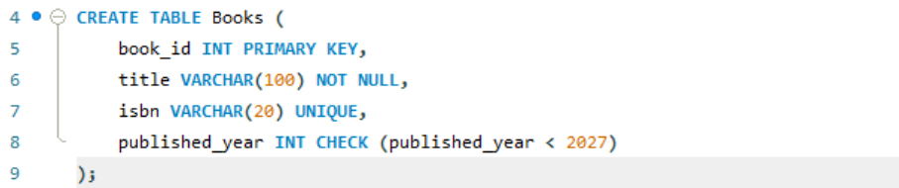
Output:

Query 3
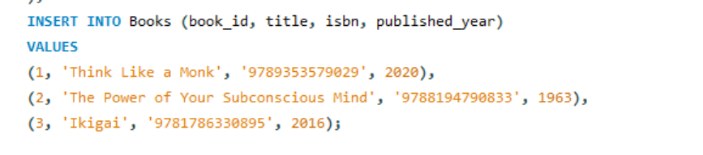
Output:

Query 4
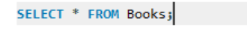
Output:
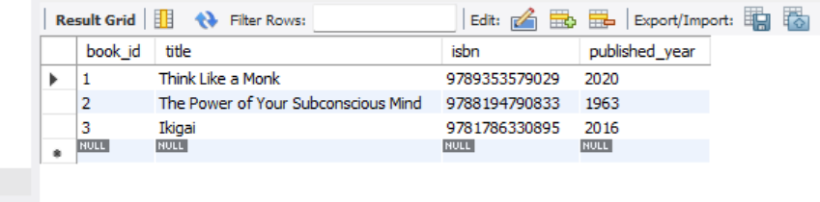

Query 5
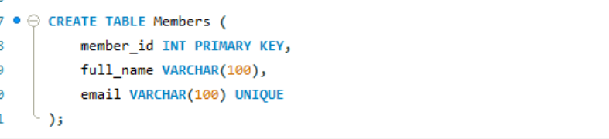

Output:
Query 6
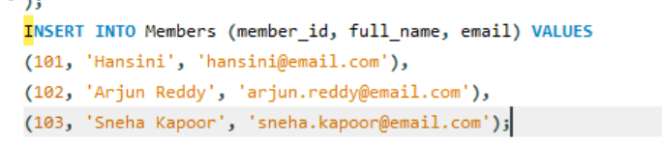
Output:
Query 7
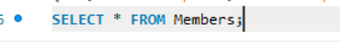
Output:
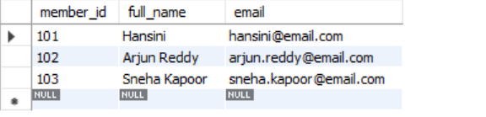

Query 8
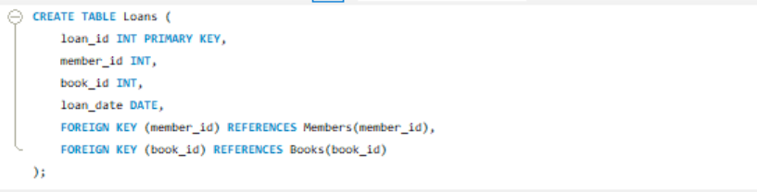
Output:
Query 9
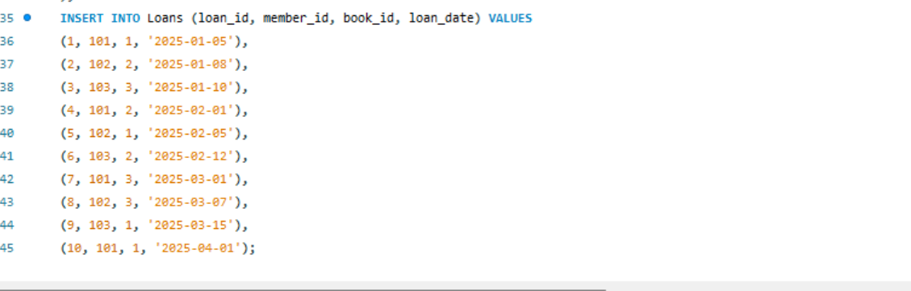
Output:

Query 10

Output:
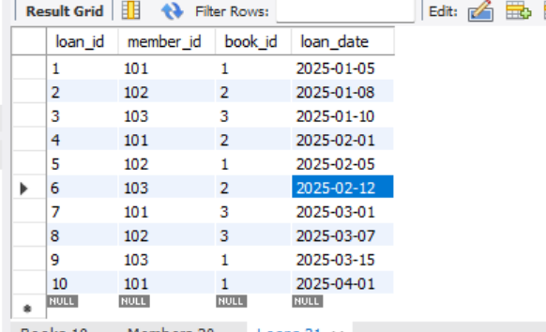
Query 11
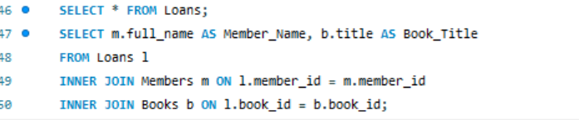
Output:
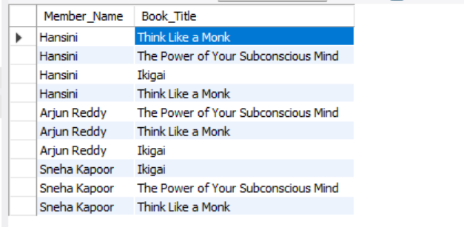
Query 12
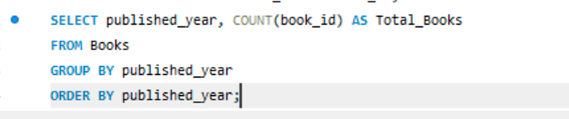
Output:
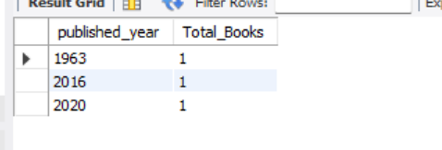

Query 13
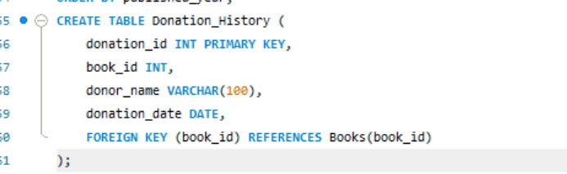
Output: 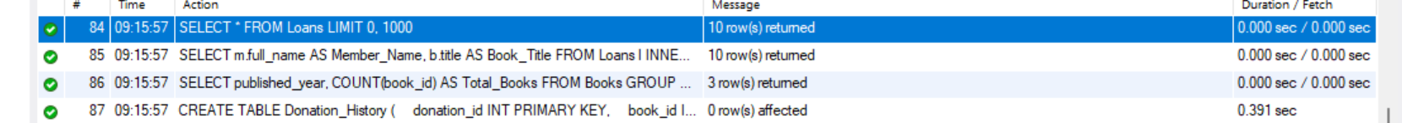

Query 14

Output:
Query 15
Output:
Query 16
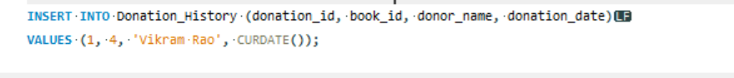
Output:
Query 17

Output:
Query 18
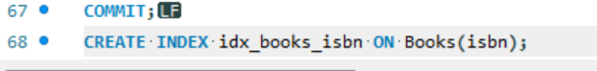
Output:
Query 19
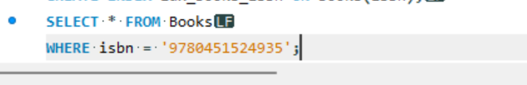
Output:

Query 20
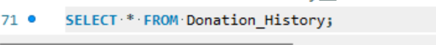
Output:

