“SKILL EXCHANGE AND MICRO LEARNING APP”
A Project Report Submitted in the partial fulfillment of the requirements for the award of the degree of
BACHELOR OF TECHNOLOGY
In
DEPARTMENT OF COMPUTER SCIENCE AND ENGINEERING
By
THIPPIREDDY HANSINI :2520030095
SAKILI POOJITHA REDDY :2520030110
DHEERAJ :2520030193
Group No: 12
Under the Esteemed Guidance of
Dr. Y Subbarayudu
Assistant Professor
Department of Computer Science and Engineering


Koneru Lakshmaiah Education Foundation (KL Deemed to be University)
DEPARTMENT OF COMPUTER SCIENCE AND ENGINEERING
Declaration
We, the undersigned students, hereby declare that the project report entitled “Skill Exchange and Micro Learning App” is a record of bonafide work carried out by us, THIPPIREDDY HANSINI - 2520030095, SAKILI POOJITHA REDDY - 2520030110 and DHEERAJ - 2520030193, under the guidance of Dr. Y Subbarayudu, Assistant Professor, Department of Computer Science and Engineering, Koneru Lakshmaiah Education Foundation (KL Deemed to be University).
This report is submitted in partial fulfillment of the requirements for the award of the degree of Bachelor of Technology in Computer Science and Engineering. The work embodied in this report is original, and it has not been copied from any other department, university or institute. Wherever the ideas, documentation or tools of others have been used, they have been duly acknowledged in the references.

THIPPIREDDY HANSINI – 2520030095
SAKILI POOJITHA REDDY – 2520030110
DHEERAJ – 2520030193
Koneru Lakshmaiah Education Foundation (KL Deemed to be University)
DEPARTMENT OF COMPUTER SCIENCE AND ENGINEERING
CERTIFICATE
This is to certify that the project report entitled “Skill Exchange and Micro Learning App” is a bonafide work done and submitted by THIPPIREDDY HANSINI - 2520030095, SAKILI POOJITHA REDDY - 2520030110, DHEERAJ - 2520030193 of Group No. 12, in partial fulfillment of the requirements for the award of the degree of BACHELOR OF TECHNOLOGY in the Department of Computer Science and Engineering, KL Deemed to be University, KLH Bachupally Campus.
The project was carried out as the project-based learning (PBL) component of the course Database Systems Engineering and Distributed Backend Development (25CS1302E) during the academic year 2026 – 2027, under the guidance of Dr. Y Subbarayudu, Assistant Professor, Department of Computer Science and Engineering.

Signature of the Guide

Signature of the Course Coordinator Signature of the HOD
ACKNOWLEDGEMENT
The successful completion of this project would not have been possible without the guidance, encouragement and support of many people. We take this opportunity to express our sincere gratitude to all of them.
We are deeply grateful to our project guide, Dr. Y Subbarayudu, Assistant Professor, Department of Computer Science and Engineering, for his valuable guidance, constructive feedback and continuous encouragement throughout the development of the Skill Exchange and Micro Learning App. His suggestions helped us to plan the work in a systematic manner and to improve the quality of the project.
We extend our thanks to the Head of the Department and the Course Coordinator of Database Systems Engineering and Distributed Backend Development for providing the academic environment, laboratory facilities and project-based learning framework that allowed us to complete this work.
We also thank the Management of Koneru Lakshmaiah Education Foundation (KL Deemed to be University), the faculty members and the non-teaching staff of the Department of Computer Science and Engineering for their cooperation and support during the project.
Finally, we thank our parents, friends and classmates for their encouragement and for the time they spent in reviewing and testing the application. We also acknowledge the effective teamwork among the three members of Group 12, which made it possible to design, implement and document this project together.

THIPPIREDDY HANSINI – 2520030095
SAKILI POOJITHA REDDY – 2520030110
DHEERAJ – 2520030193
Abstract
Learning a new skill usually requires money, time and access to a suitable teacher. At the same time, almost every student already possesses some skill – programming, design, photography, communication or another area – that another student would like to learn. Conventional courses and online platforms mostly support one-way learning, in which a learner consumes content from an instructor, and they offer little help to a student who wants to find a peer with complementary skills and compatible free time.
The Skill Exchange and Micro Learning App (branded in the interface as SkillSwap) is a web-based, database-driven platform that allows students to exchange skills with each other. A student registers, creates a skill profile listing the skills he or she can teach and the skills he or she wants to learn, and specifies the days and time ranges on which teaching and learning are possible. Other students can then be discovered through a skill-exploration page and a matches page, and a student can send a swap request that states the skill to be learned, the skill to be taught in return, the number of sessions (1, 2, 3 or 5), the preferred day and the preferred 45-minute online time slot.
The system is implemented as a single-page web front end written in HTML5, CSS3 and JavaScript, connected through a REST API to a back end built on Node.js and Express. Users authenticate with JSON Web Tokens (JWT), and passwords are stored only as bcrypt hashes. Application data – user profiles and swap requests – is persisted in a JSON file (data.json) that acts as the database for the current version. The back end contains a rule-based match-scoring function that gives 40 points for each skill-teaching/learning overlap in either direction and 10 points for each overlap in availability days, capped at 100. Socket.IO is used to broadcast real-time events when profiles are updated and when swap requests are created or updated.
This report documents the requirements, technology stack, architecture, design, implementation, features, testing, deployment, limitations and future scope of the system, based on the actual project source code. Features that are described in the project concept but are not present in the current code – such as skill-level matching, ratings and reviews, skill credits, AI-based matching, chat and video sessions – are explicitly identified as proposed or future enhancements. The project shows how a lightweight database-backed application can make peer learning more affordable, accessible and collaborative for students, and it provides a foundation that can be extended with a relational database such as MySQL and with additional trust and communication features.
Keywords: peer learning, skill exchange, micro-learning, Node.js, Express, REST API, JWT, Socket.IO, student matching.
Index
S. No. | Chapters | Topics | Page.no
Acknowledgement
Abstract
1 | Introduction | 1.1 Background  1.2 Motivation  1.3 Problem Statement  1.4 Existing System  1.5 Proposed System  1.6 Scope of the Project  1.7 Objectives  1.8 Importance of the System  1.9 Target Users  1.10 Advantages | 1-4
2 | System Requirements | 2.1 Functional Requirements  2.2 Non-Functional Requirements  2.3 Hardware Requirements  2.4 Software Requirements  2.5 Development Environment  2.6 User Requirements | 5-7
3 | Technology Stack | 3.1 Frontend Technology  3.2 Backend Technology  3.3 Database  3.4 APIs  3.5 Authentication  3.6 Libraries and Dependencies  3.7 Development Tools  3.8 Version Control | 8-10
4 | System Architecture | 4.1 High-Level Architecture  4.2 Presentation Layer  4.3 Application / Business Logic Layer  4.4 Data Layer  4.5 Communication Flow  4.6 Authentication Flow  4.7 Deployment Architecture | 11-13
5 | System Design | 5.1 Use Case Diagram  5.2 User Flow  5.3 ER Diagram  5.4 Database Schema  5.5 Data Flow  5.6 Matching Logic | 14-20
6 | Implementation | 6.1 Frontend Implementation  6.2 User Registration and Login  6.3 Profile Management  6.4 Skill Management  6.5 Skill Matching  6.6 Swap Request Management  6.7 Session Management  6.8 Ratings and Reputation  6.9 Skill Credit System  6.10 Backend Implementation  6.11 Error Handling  6.12 Security Considerations | 21-30
7 | Features | 7.1 List of Main Features  7.2 How Each Feature Works  7.3 Proposed Features (not yet implemented) | 31-32
8 | Testing | 8.1 Testing Objectives  8.2 Testing Strategy  8.3 Unit Testing  8.4 Integration Testing  8.5 Functional Testing  8.6 API Testing  8.7 Validation Testing  8.8 Performance Considerations  8.9 Security Testing | 33-36
9 | Deployment | 9.1 Development Deployment  9.2 Frontend Setup  9.3 Backend Setup  9.4 Database Setup  9.5 Environment Variables  9.6 Production Deployment | 37-38
10 | Challenges and Limitations | 10.1 Challenges  10.2 Solutions Applied  10.3 Current Limitations and Known Issues | 39-40
11 | Future Enhancements | 11.1 Planned Features  11.2 Possible Integrations and Optimisations | 41
12 | Conclusion | 12.1 Summary of the Project  12.2 What Was Achieved  12.3 Skills Learned During Development  12.4 Overall Significance | 42
13 | References | - | 43
14 | Appendices | Appendix A – Important Source Code  Appendix B – API Endpoints  Appendix C – Database Schema  Appendix D – Screenshots  Appendix E – Project Structure | 44-46

CHAPTER -1 INTRODUCTION

1.1 Background
Peer-to-peer learning is an educational approach in which learners teach and learn from one another instead of depending only on a formally appointed instructor. Research on peer tutoring in higher education has consistently described it as a way of increasing engagement, because the student who explains a concept must organise his or her own knowledge, while the student who listens receives an explanation from someone at a similar stage of learning (Topping, 1996). In a college campus, where hundreds of students study together, the range of informal skills is very wide: some students are strong in programming languages, others in user-interface design, photography, video editing, public speaking or music.
Micro-learning is the practice of learning in small, focused units that can be completed in a short time (Hug, 2005). A short 45-minute session in which one student demonstrates a single topic to another – for example the basics of Java object-oriented programming or the use of wireframes in Figma – is a natural example of micro-learning. When two students agree to teach each other one skill each, the exchange becomes balanced: each person is at the same time a teacher and a learner, and no money has to change hands.
Web technologies make such an exchange practical. A web application can store each student’s skill profile and availability, calculate how well two profiles complement each other, and manage the requests that students send to each other. The Skill Exchange and Micro Learning App applies these ideas in a student-focused platform.

1.2 Motivation
The project is motivated by several practical observations about how students learn today:
- Cost of traditional courses: professional courses and coaching for programming, design or communication skills can be expensive for many students.
- Difficulty finding suitable teachers: even when a student is willing to learn, finding someone who is able to teach a specific skill at a convenient time is difficult.
- Students already possess useful skills: most students have at least one skill that others would value, but there is no simple mechanism to offer it.
- Need for flexible learning: students have lectures, labs and assignments, so learning has to be scheduled in short sessions on specific days and evenings.
- Peer collaboration: learning from a classmate is often more approachable than learning from an expert, and it builds a collaborative campus culture.
- Availability constraints: a skill match is useful only if both students are free on the same day, which is why availability is a part of the profile in this system.

1.3 Problem Statement
Students who want to learn a new skill have limited low-cost options, and students who are willing to share their skills have no structured way to find a partner who needs them. Existing learning resources are largely one-directional, do not help a student discover a reciprocal partner, and do not consider whether the two persons are free at the same time. As a result, valuable peer knowledge remains unused.
The problem addressed by this project is therefore to design and develop a database-backed web platform in which students can record the skills they can teach and wish to learn, specify their availability, discover complementary partners through a matching mechanism, and send and track skill-swap requests.

1.4 Existing System
Learning is currently supported through classroom teaching, video-based online courses, tutorials, discussion forums and informal arrangements among friends. These approaches are useful, but, in the context of student-to-student skill exchange, they have the following limitations:
- One-way learning: content is delivered from an instructor to a learner; the learner has no opportunity to offer a skill in return.
- Difficulty in finding reciprocal partners: nothing in a typical course platform tells a learner which other student wants to learn what he or she can teach.
- Limited personalisation: the same course is offered to all learners irrespective of their existing skills, goals or free time.
- Availability is not considered: learner and teacher schedules are coordinated manually through messages, which is slow and error-prone.
- Lack of peer-to-peer exchange: informal exchanges depend on personal acquaintance and do not scale beyond a small friend circle.
- Limited session and reputation management: requests, agreed sessions and the reliability of a partner are not tracked in one place.
These limitations are described in general terms; no claim is made here about any specific commercial platform.

1.5 Proposed System
The proposed system, the Skill Exchange and Micro Learning App, is a web application that connects students who can teach each other. The student creates an account, completes a skill profile (skills to teach, skills to learn, teaching availability and learning availability), explores the available skills, and views suggested matches. A student can send a swap request to another student by choosing the skill to learn, the skill to teach in return, the number of sessions, the preferred day and one of the available 45-minute online time slots. The request is stored with the status Pending and is visible on the Requests page. All sessions are conducted online.
The current implementation uses a Node.js/Express back end that exposes a REST API, JWT-based authentication and a rule-based match-scoring function, and it stores data in a JSON file. Real-time notifications of profile and request changes are delivered with Socket.IO. Section 1.7 clearly separates the objectives that are implemented from those that are proposed for future work.

1.6 Scope of the Project

1.6.1 Within the scope of the current implementation
- Registration and login of students with department information.
- Skill profile with skills to teach, skills to learn and separate teaching and learning availability (days and a time range).
- Exploration of a set of nine pre-defined skill cards with a keyword search filter.
- Computation of a match score between students (back-end API) and presentation of suggested matches (front-end).
- Creation, listing and status update of swap requests with number of sessions, day and time.
- Dashboard with counts of skills, requests and a profile summary.
- Real-time update events using Socket.IO.

1.6.2 Outside the scope of the current implementation
- Skill-level (beginner/intermediate/advanced) based matching.
- Ratings, reviews and reputation scores; skill credits.
- A separate session-scheduling calendar with reminders.
- Chat, audio/video calling and file sharing inside the application.
- An administrator module, certificate generation, badges and leaderboards.
- Use of a relational database such as MySQL and cloud deployment.

1.7 Objectives
The objectives of the project and their implementation status, as verified from the source code, are summarised in Table 1.1.
Table 1.1: Project objectives and implementation status
No. | Objective | Status | Remarks (from source code)
1 | Smart skill matching | Implemented (back end) | Rule-based score in GET /api/matches; the front-end Matches page currently shows illustrative sample cards.
2 | Skill-level consideration | Proposed | No skill-level field exists in the profile or in the matching function.
3 | Availability matching | Implemented (days) | Overlap of teaching/learning days adds to the score; time ranges are stored but not compared.
4 | Swap request management | Implemented | Create, list and update status (Pending, Accepted, Rejected, Completed) through the API; UI creates and lists requests.
5 | Learning session management | Partially implemented | Each request records number of sessions, day, time and mode (Online); a separate session entity is not present.
6 | Trust/reputation through ratings | Proposed | No rating or review code exists.
7 | Skill credits | Proposed | No credit logic exists.
8 | Affordable peer learning | Achieved by design | The application involves no payment; students exchange skills.
9 | Student collaboration | Implemented | Swap requests and real-time events connect students.

1.8 Importance of the System
- Academic importance: it encourages active learning and strengthens the understanding of the student who teaches; it also demonstrates the use of web technologies, REST APIs, authentication and data persistence in a single project.
- Social importance: it builds a collaborative culture on the campus in which students support one another and learn across departments.
- Practical importance: it provides a low-cost way to acquire job-relevant skills such as programming and design, and it makes use of the knowledge that students already have.
- Technical importance: the project shows how a simple scoring algorithm and a small API can solve a real matching problem, and it forms a base that can be extended with a relational database and intelligent recommendation.

1.9 Target Users
The primary users are college students who want to learn and teach skills. The registration form currently offers five department options – Computer Science & Engineering, Electronics & Communication, Electrical Engineering, Mechanical Engineering and Other – so that students from different departments can take part. Faculty members and external learners are not targeted by the current version.

1.10 Advantages
- Free, reciprocal learning without the need for payment.
- Both students gain: each one learns a new skill and also reinforces the skill that he or she teaches.
- Suggestions are based on both skills and availability, which reduces the effort of searching for a partner.
- Short, focused 45-minute online sessions fit the schedule of a student.
- Simple, clean and responsive user interface that is easy for first-time users.
- Secure password storage with bcrypt and token-based API access with JWT.
- Real-time update events keep the interface synchronised with the server.
- Lightweight stack (Node.js and a JSON file) that can be installed and run quickly on any student’s computer.
- Modular REST API that can be reused with a different front end or database in the future.

CHAPTER -2 SYSTEM REQUIREMENTS
The requirements in this chapter were derived from the supplied source code (front-end file index.html, back-end file server.js, package.json, README.md and CONNECT_FRONTEND.md). Each functional requirement is marked with its implementation status.

2.1 Functional Requirements
Table 2.1: Functional requirements
ID | Requirement | Description | Status
FR-01 | User registration | A student registers with name, email, password, confirm password and department. Duplicate e-mails are rejected. | Implemented
FR-02 | Login / logout | A registered student logs in with e-mail and password and receives a JWT. Logout clears the current user in the interface. | Implemented
FR-03 | Profile creation | After registration the student completes a skill profile. | Implemented
FR-04 | Add skills to teach | Free-text skills that the student can teach are added to and removed from a list. | Implemented
FR-05 | Select skills to learn | Free-text skills that the student wants to learn are added to and removed from a list. | Implemented
FR-06 | Availability selection | Separate days (Mon–Sun) and “from/to” time ranges for teaching and for learning. | Implemented
FR-07 | Skill exploration | Nine skill cards with a live keyword search filter. | Implemented
FR-08 | Match discovery and match percentage | Back end computes a score (0–100) for every other student and returns them sorted; front-end Matches page shows match cards with a percentage. | Partially implemented
FR-09 | Send swap request | Request modal collects skill to learn, skill to teach, sessions (1/2/3/5), day and time slot. | Implemented
FR-10 | Manage requests | List of the student’s sent and received requests with status; status can be changed through the API. | Implemented (API); list in UI
FR-11 | Schedule sessions | Day, time slot and session count are stored in the request. A separate scheduling calendar is not available. | Partially implemented
FR-12 | Ratings / reviews | Students rate each other after a session. | Proposed
FR-13 | Skill credits | Credits earned for teaching and spent for learning. | Proposed
FR-14 | Dashboard | Counts of skills to teach/learn, potential matches and swap requests, skill profile and a recommended match. | Implemented
FR-15 | Real-time updates | Socket.IO events for profile and request changes. | Implemented

2.2 Non-Functional Requirements
Table 2.2: Non-functional requirements
Attribute | Requirement
Usability | Simple navigation bar (Home, Explore Skills, Matches, Requests, My Profile), clear forms, toast messages for feedback, and a responsive layout.
Performance | Pages are served as a single HTML file; API calls are lightweight JSON requests. For the expected number of student users the JSON-file store responds quickly (see Section 8.8 for limitations).
Reliability | The API returns meaningful HTTP status codes and messages for invalid input and authentication failures. Data is written to disk after every change.
Security | Passwords are hashed with bcrypt, API access is protected with JWT, and user-supplied text displayed in the request list is escaped before rendering.
Maintainability | Separation of front end and back end, a small number of well-named API routes and helper functions (loadDB, saveDB, auth, matchScore).
Scalability | The current file-based storage suits a prototype; scaling to many users requires a database such as MySQL and stateless deployment of the API.
Availability | Runs as a single Node.js process; availability in production would require process management and hosting.
Data consistency | E-mail addresses are normalised (trimmed, lower-case) and must be unique; request status is restricted to four allowed values.

2.3 Hardware Requirements
The application is lightweight. The following configuration is recommended for development and demonstration; these are recommended values and not measured minimums.
Table 2.3: Hardware requirements
Component | Minimum (recommended) | Preferred
Processor | Dual-core, 2 GHz | Quad-core or better
Memory (RAM) | 4 GB | 8 GB or more
Storage | 500 MB free (project, node_modules) | 2 GB free
Display | 1366 × 768 | 1920 × 1080
Network | Local network / internet for npm install and CDN scripts | Broadband connection

2.4 Software Requirements
Table 2.4: Software requirements (derived from the project files)
Software | Details
Operating system | Windows, Linux or macOS (any system that can run Node.js).
Runtime | Node.js (a current LTS release is recommended; package.json does not pin a version) and npm.
Back-end packages | express, cors, dotenv, bcryptjs, jsonwebtoken, socket.io; nodemon for development.
Web browser | A modern browser such as Google Chrome, Microsoft Edge or Mozilla Firefox.
Code editor | Visual Studio Code with the Live Server extension (recommended in CONNECT_FRONTEND.md).
Database | No separate database server is needed; data is stored in data.json.
Note: The project review presentation also contained slides copied from an unrelated machine-learning project (Python, NumPy, Pandas, Scikit-learn and regression models). These are not used by the Skill Exchange and Micro Learning App and are intentionally excluded from this report.

2.5 Development Environment
Table 2.5: Development environment
Item | Actual technology
Programming languages | JavaScript (front end and back end), HTML5, CSS3
Back-end framework | Express 4.x on Node.js
Front-end framework | None – plain HTML, CSS and JavaScript in a single page
Libraries | Socket.IO (server 4.8.x and client 4.8.1 from CDN), bcryptjs, jsonwebtoken, cors, dotenv
Fonts | DM Sans and Playfair Display (Google Fonts)
Database | JSON file (data.json)
Editor / tools | Visual Studio Code, Live Server, npm, nodemon (development)

2.6 User Requirements
A student who wants to use the application needs a computer or mobile device with a modern web browser and an internet or local network connection to the server. The student must have a valid e-mail address for registration, a password of his or her choice, and basic information about the skills to be taught or learned and the days on which he or she is free. No special software has to be installed on the user’s device.

CHAPTER -3 TECHNOLOGY STACK
This chapter describes the technologies actually used in the project, as identified from the source code and configuration files.

3.1 Frontend Technology
The front end is a single-page application written without any framework. The whole interface is contained in one file, index.html (about 5,800 lines), which includes the markup, the style sheet and the JavaScript code.
- HTML5: nine <section class="view"> elements – home, login, register, dashboard, completeProfile, explore, matches, profile and requests – plus a request modal and a toast element. Only one view is displayed at a time.
- CSS3: custom properties (a cream, white and sage-green palette), flexbox and grid layouts, cards, buttons and modal styling. Fonts DM Sans and Playfair Display are loaded from Google Fonts.
- JavaScript (ES6): view switching (showView), protected navigation (openProtected), skill list handling (addSkill, removeSkill, renderSkillLists), rendering of the dashboard, profile and request list, the live search filter (searchSkills), and the fetch-based API client (api).
- Browser storage: localStorage stores the JWT (skillSwapToken) and a copy of the current user (skillSwapCurrentUser).
- Socket.IO client: version 4.8.1, loaded from the Socket.IO CDN, receives real-time events.
The original prototype stored users and requests only in localStorage. The back-end integration script appended at the end of the file overrides four functions – registerUser, loginUser, saveProfile and submitRequest – so that the same forms now communicate with the server.

3.2 Backend Technology
The back end is a Node.js application using the Express web framework (server.js). It provides REST endpoints under /api, applies the cors and express.json() middleware, protects routes with a JWT-verifying middleware (auth), and attaches a Socket.IO server to the same HTTP server. The server listens on port 5000 by default (configurable through the PORT environment variable).

3.3 Database
The database in the current version is a JSON file named `data.json` with two collections: users and requests. Two helper functions – loadDB() and saveDB(db) – read and write the complete file synchronously using Node’s fs module. If the file does not exist, loadDB() creates it with empty collections.
This approach was chosen because it works immediately without installing or configuring a database server, which is suitable for a college prototype and for demonstration. The project documentation (README.md) states that the API structure can later be switched to MySQL while keeping the same front-end endpoints. A proposed relational design is given in Section 5.4.
Note: Some project-review material mentions MySQL. The supplied source code does not contain any MySQL connection or SQL statement; MySQL is therefore treated as a planned migration and not as part of the implemented system.

3.4 APIs
All endpoints are served from http://localhost:5000/api (the value of API_BASE in the front end). Table 3.1 lists the endpoints that exist in server.js.
Table 3.1: REST API endpoints
Method | Endpoint | Auth | Purpose
GET | /api/health | No | Health check; returns service name and time.
POST | /api/auth/register | No | Create a new student account; returns JWT and user.
POST | /api/auth/login | No | Authenticate with e-mail and password; returns JWT and user.
GET | /api/me | Yes | Return the logged-in user’s profile.
PUT | /api/profile | Yes | Update teach skills, learn skills and teaching/learning availability.
GET | /api/users | Yes | List all other students with their match score.
GET | /api/matches | Yes | List all other students sorted by match score (descending).
POST | /api/requests | Yes | Create a swap request to another student.
GET | /api/requests | Yes | List requests sent or received by the logged-in user.
PATCH | /api/requests/:id | Yes | Change request status (Pending, Accepted, Rejected, Completed).

In addition to the REST API, the server emits the Socket.IO events connected, profileUpdated, requestCreated and requestUpdated.

3.5 Authentication
Authentication uses JSON Web Tokens (JWT, RFC 7519). On successful registration or login the server signs a token containing the user’s id and email with the secret JWT_SECRET, valid for 7 days. The front end saves the token in localStorage and sends it in the header Authorization: Bearer <token>. The auth middleware verifies the token and rejects the request with HTTP 401 if the header is missing or the token is invalid or expired. Passwords are never stored in plain text: they are hashed with bcryptjs (10 salt rounds) and the hash is removed from every response by the publicUser function.

3.6 Libraries and Dependencies
Table 3.2: Back-end dependencies (from package.json)
Package | Version | Role in the project
express | ^4.21.2 | Web framework for routing and request handling.
cors | ^2.8.5 | Allows the browser front end (served from another origin) to call the API.
dotenv | ^16.4.5 | Loads PORT and JWT_SECRET from a .env file.
bcryptjs | ^2.4.3 | Password hashing and comparison.
jsonwebtoken | ^9.0.2 | Signing and verifying JWTs.
socket.io | ^4.8.1 | Real-time event broadcasting.
nodemon (dev) | ^3.1.7 | Restarts the server automatically during development (npm run dev).

3.7 Development Tools
- Visual Studio Code with Live Server – recommended for opening index.html (see CONNECT_FRONTEND.md).
- npm – installation of dependencies (npm install) and running the server (npm start, npm run dev).
- nodemon – automatic restart of the back end during development.
- Web browser developer tools – inspection of network calls and local storage.
API-testing tools such as Postman and diagramming tools such as Draw.io are commonly used in this course, but no Postman collection or diagram source file was included in the supplied project files; they are therefore not claimed as part of the project deliverables.

3.8 Version Control
Git and GitHub are listed as intended tools in the project review material. However, no repository metadata (such as a .git folder) was part of the supplied files, so the use of a specific repository could not be verified from the code. The team may add the repository link to this section before final submission.

CHAPTER -4 SYSTEM ARCHITECTURE

4.1 High-Level Architecture
The Skill Exchange and Micro Learning App follows a three-layer, client–server architecture: a presentation layer (browser), an application layer (Node.js/Express API with Socket.IO) and a data layer (JSON file). The flow of the system is Student → Frontend (index.html) → REST API / Socket.IO → data.json. Figure 4.1 shows the architecture.
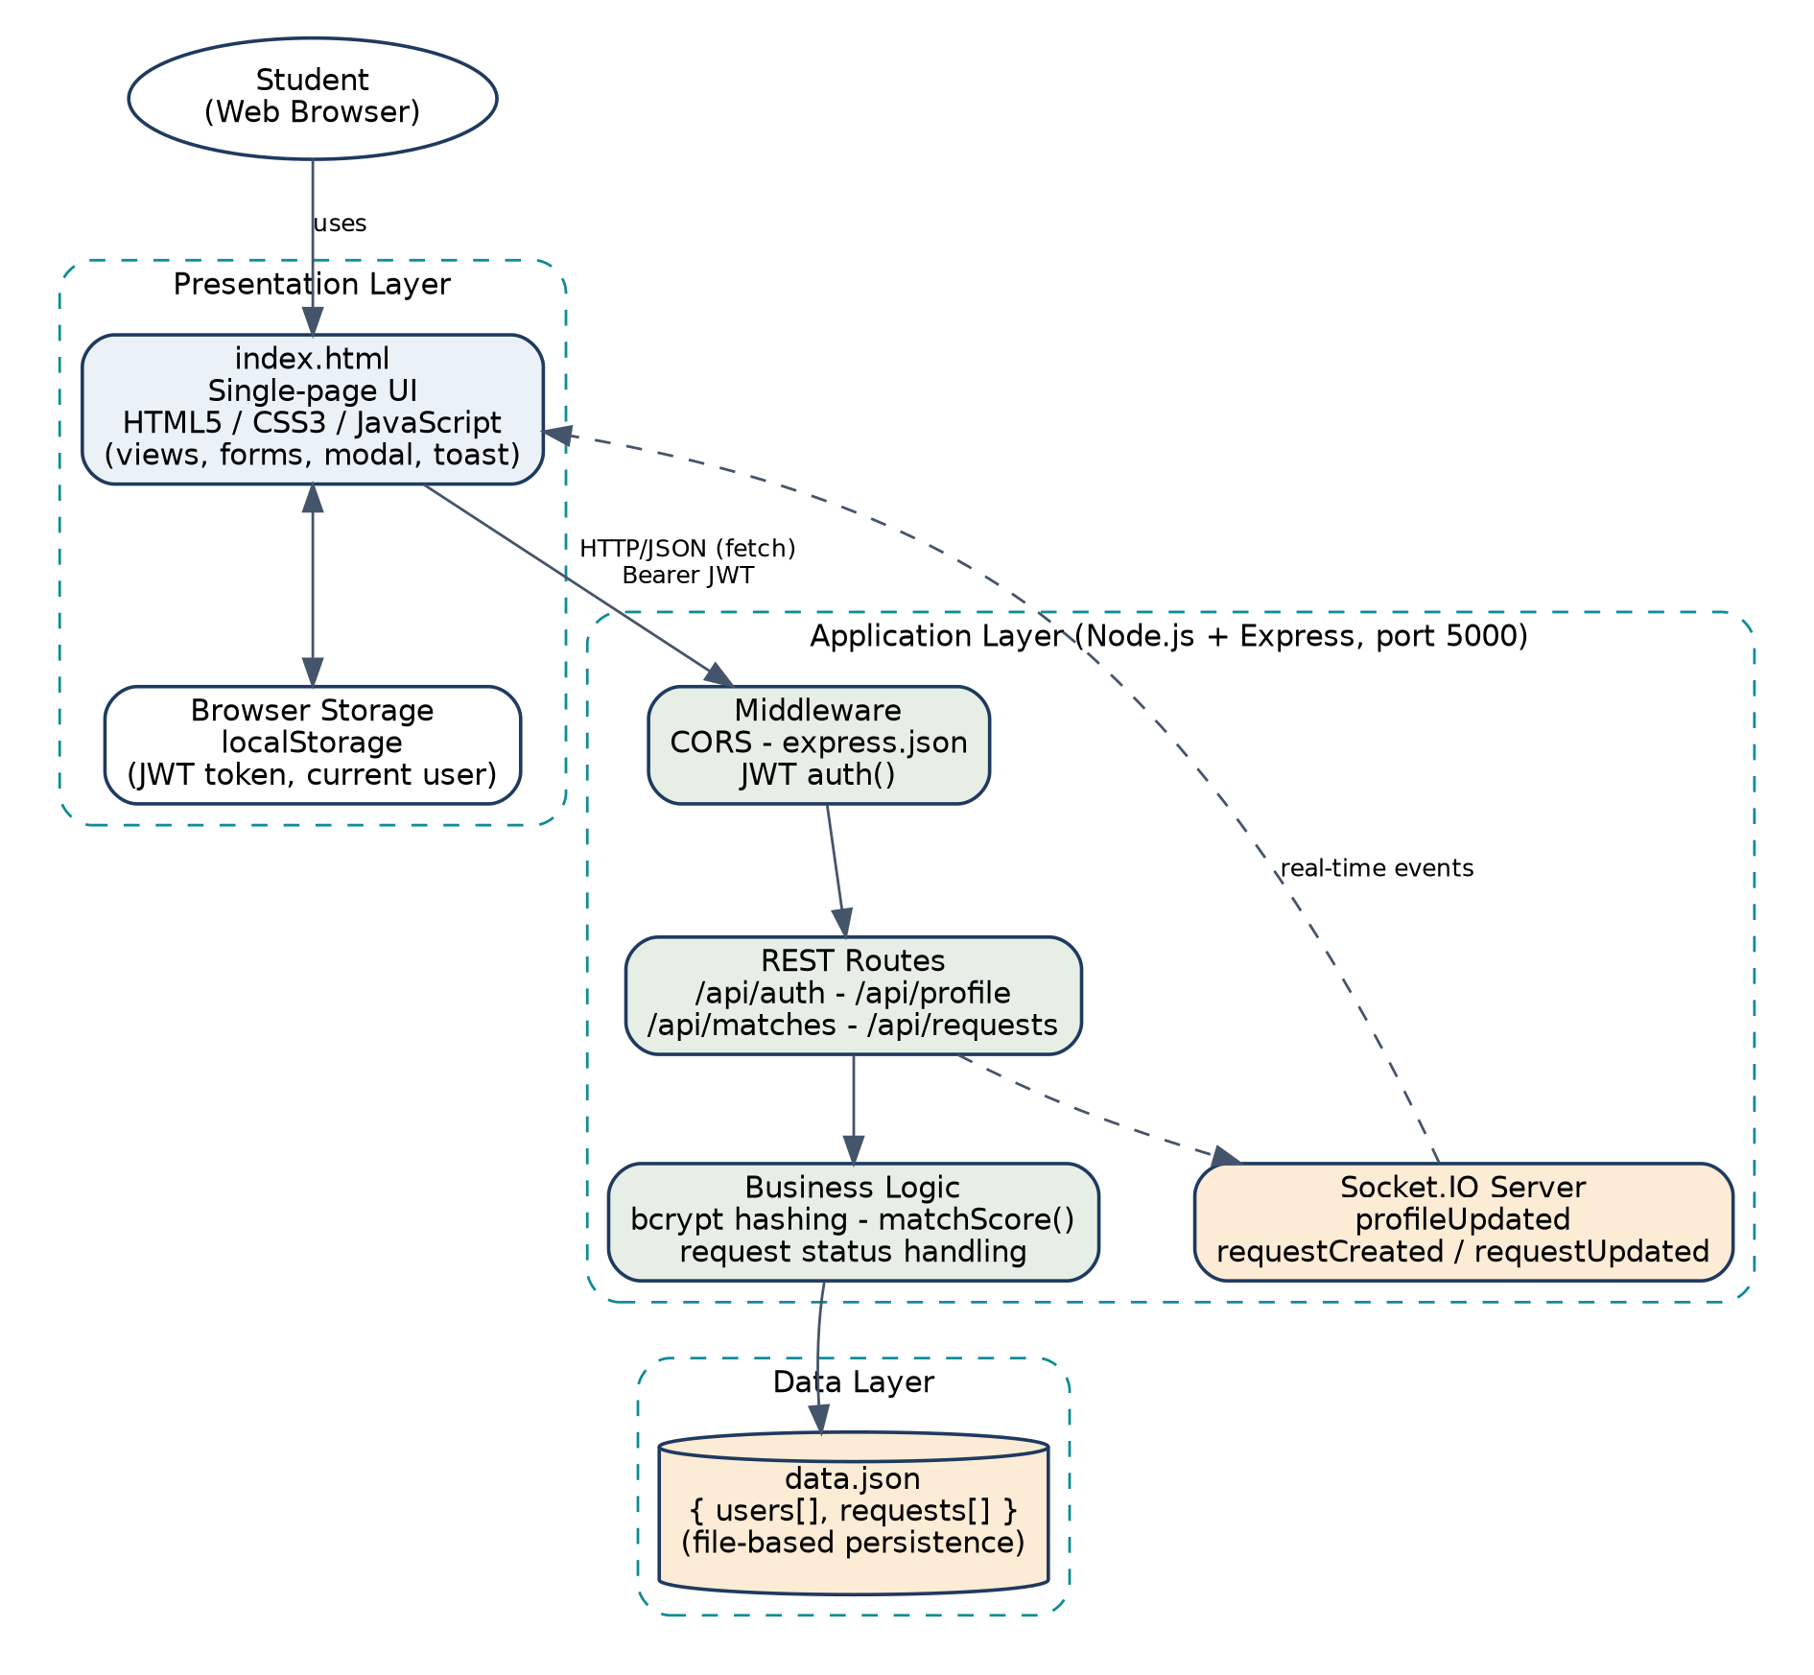
Figure 4.1: High-level architecture of the Skill Exchange and Micro Learning App

4.2 Presentation Layer
The presentation layer is the single-page index.html that runs in the student’s browser. It renders the views (home, login, register, dashboard, complete profile, explore, matches, profile and requests), the request modal and toast notifications. It holds temporary state in JavaScript variables (currentUser, requests, teachSkills, learnSkills), stores the JWT in localStorage and communicates with the server through the api() helper (based on the Fetch API) and the Socket.IO client.

4.3 Application / Business Logic Layer
The application layer is implemented in server.js. It consists of:
- Middleware: cors, express.json() for parsing JSON bodies, and the custom auth middleware that verifies the JWT.
- Route handlers: authentication (/api/auth/*), profile (/api/me, /api/profile), discovery (/api/users, /api/matches) and requests (/api/requests).
- Business logic: password hashing, token creation, the matchScore(me, other) function and request-status validation.
- Real-time component: a Socket.IO server that emits profileUpdated, requestCreated and requestUpdated events to connected clients.

4.4 Data Layer
The data layer is the file data.json, which stores one JSON object with two arrays: users and requests. Every API call that needs data reads the entire file with loadDB(), and every change is written back with saveDB(). Because the whole database is a single file, no database server is required, which keeps the prototype easy to install; the trade-offs are discussed in Chapter 10.

4.5 Communication Flow
The typical flow of data when a student sends a swap request is as follows:
- The student clicks Request Swap on a match card; openRequestModal() fills the modal with the partner’s name and the two skills.
- The student chooses the number of sessions, the preferred day and the time slot, and submits the form.
- submitRequestBackend() calls GET /api/matches to find the partner’s user id by name.
- It then calls POST /api/requests with the JWT in the Authorization header and the request details in the body.
- The server verifies the token, validates that the target student exists, creates the request with status Pending, saves it to data.json and emits the requestCreated event.
- The front end receives the response, closes the modal, shows a success toast, and reloads the request list by calling GET /api/requests.

4.6 Authentication Flow
Figure 4.2 shows how registration and login work. The same token-based mechanism protects all other API calls.
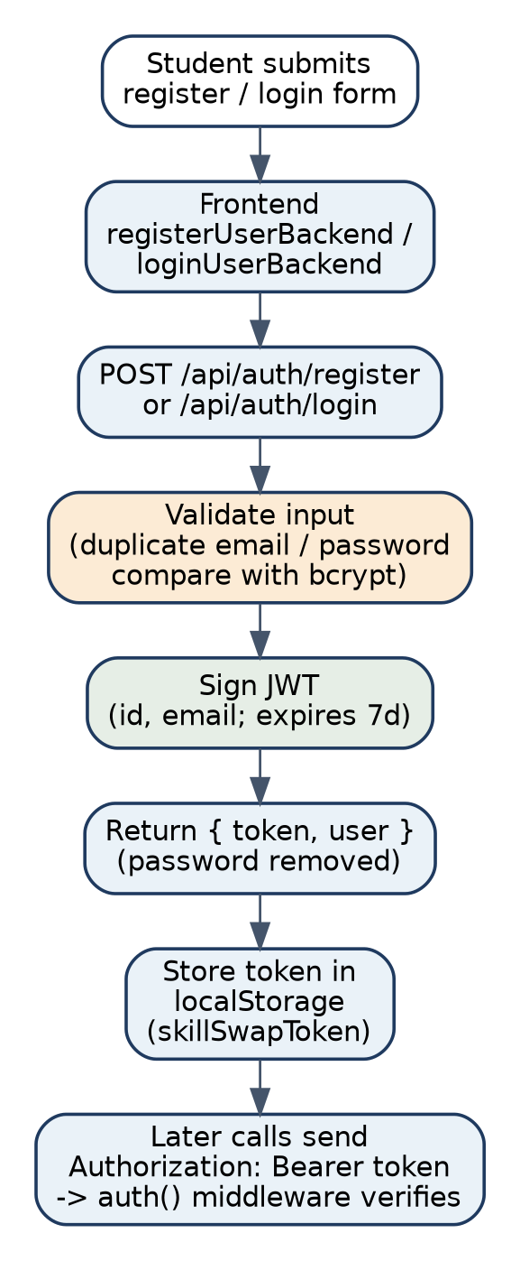
Figure 4.2: Registration / login and token usage flow

4.7 Deployment Architecture
In its present form the project runs locally: the Node.js server is started on the developer’s or demonstrator’s computer (port 5000), and index.html is opened through a local web server such as VS Code Live Server. The front end contains the fixed address http://localhost:5000/api for the API and http://localhost:5000 for Socket.IO. The project has not been deployed to a cloud or hosting service. A possible production deployment is described in Section 9.6.

CHAPTER -5 SYSTEM DESIGN

5.1 Use Case Diagram
The only actor in the current system is the Student. No administrator functionality exists in the code, and therefore no admin actor is shown. Figure 5.1 shows the use cases supported by the application.
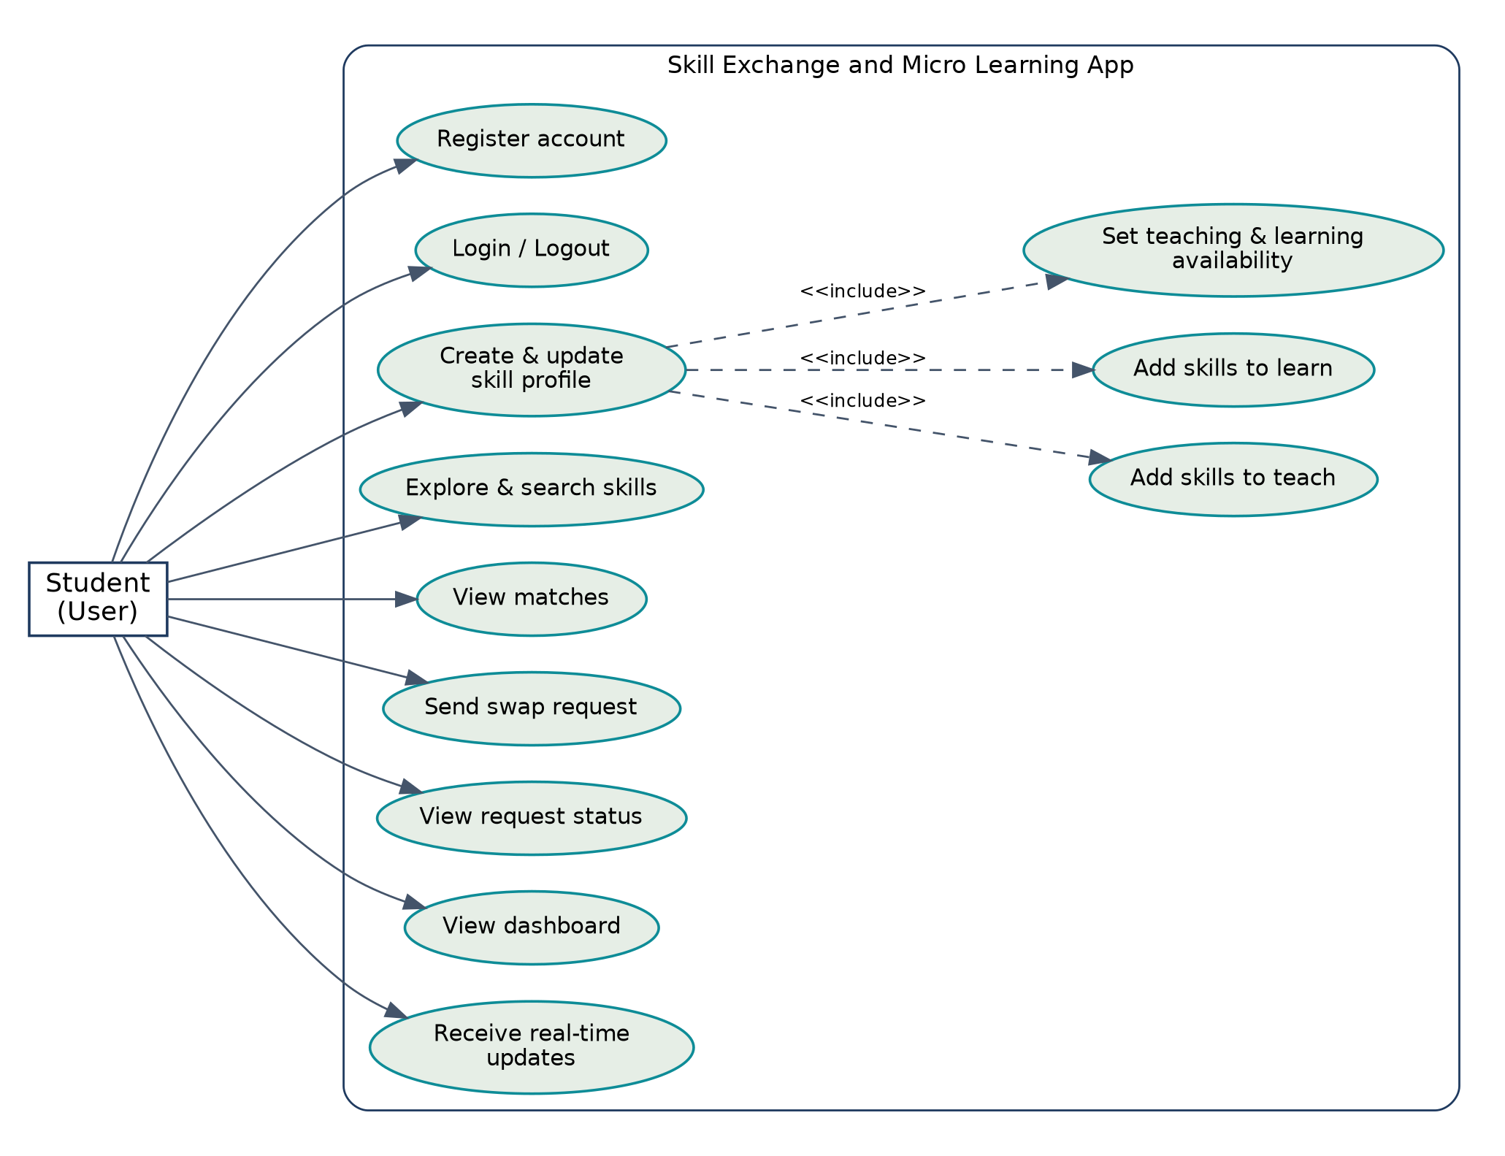
Figure 5.1: Use case diagram
Table 5.1: Use case descriptions
Use case | Description | Precondition
Register account | Student creates an account with name, e-mail, password and department. | E-mail not already registered.
Login / Logout | Student signs in to obtain a token, or signs out of the interface. | Account exists.
Create & update skill profile | Student maintains skills to teach/learn and availability. | Logged in.
Explore & search skills | Student filters skill cards by keyword. | None (cards are visible on the page).
View matches | Student views suggested learning partners with a match percentage. | Logged in.
Send swap request | Student requests a skill exchange with another student. | Logged in; partner exists on the server.
View request status | Student sees the list and status of the requests. | Logged in.
View dashboard | Student sees counts and profile summary. | Logged in.
Receive real-time updates | Interface refreshes when the server emits an event. | Browser connected to Socket.IO.

5.2 User Flow
The complete user journey in the implemented application is: Registration/Login → Complete skill profile (skills, availability) → Dashboard → Explore skills / Matches → Request Swap → Request saved with status Pending → View in Requests page. A rating step after the session is not present in the current implementation and is listed as a future enhancement. Figure 5.2 shows the flow.
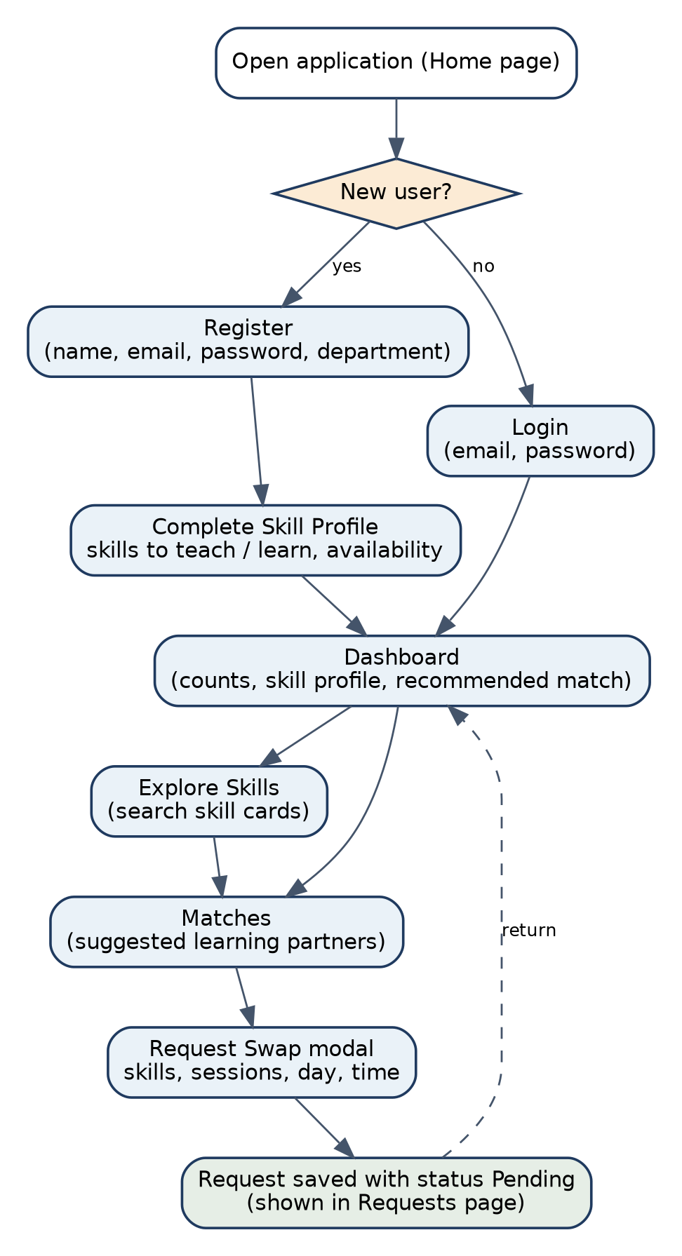
Figure 5.2: User flow diagram

5.3 ER Diagram
Because the data is stored as JSON documents, the implemented model consists of two entities, USER and REQUEST, and one embedded structure, AVAILABILITY, which is repeated twice inside each user (teaching and learning). The skill lists are stored as arrays of text inside the user document; there is no separate Skill table in the implementation. A user can send many requests and receive many requests. Figure 5.3 shows the entity–relationship diagram of the implemented data model.
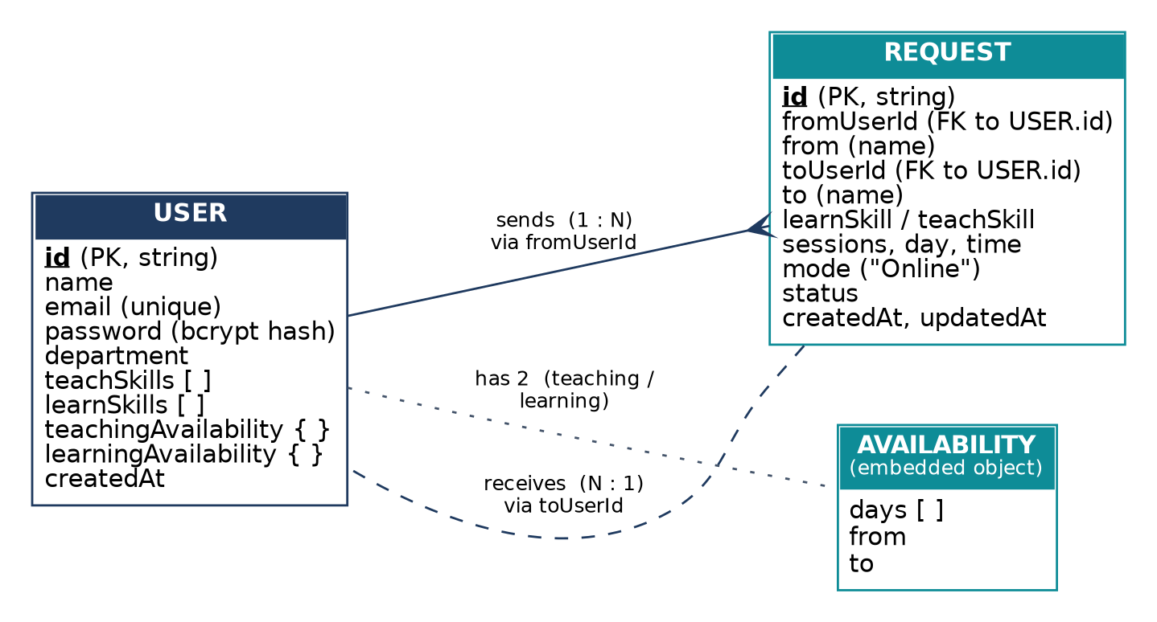
Figure 5.3: ER diagram of the implemented data model

5.4 Database Schema

5.4.1 Implemented schema (data.json)
Table 5.2: USER document (collection users)
Field | Data type | Key | Description
id | String | Primary key | Unique id generated from the timestamp (Date.now()).
name | String |  | Student’s name (trimmed).
email | String | Unique | Lower-case e-mail used for login.
password | String |  | bcrypt hash of the password; removed from API responses.
department | String |  | Department chosen at registration.
teachSkills | Array of String |  | Skills the student can teach.
learnSkills | Array of String |  | Skills the student wants to learn.
teachingAvailability | Object |  | { days: [], from, to } – days and time range for teaching.
learningAvailability | Object |  | { days: [], from, to } – days and time range for learning.
createdAt | String (ISO date) |  | Time of registration.

Table 5.3: REQUEST document (collection requests)
Field | Data type | Key | Description
id | String | Primary key | Unique id generated from the timestamp.
fromUserId | String | Foreign key → users.id | Student who sends the request.
from | String |  | Name of the sender (copied at creation).
toUserId | String | Foreign key → users.id | Student who receives the request.
to | String |  | Name of the receiver (copied at creation).
learnSkill | String |  | Skill the sender wants to learn.
teachSkill | String |  | Skill the sender offers in exchange.
sessions | String/Number |  | Number of sessions (1, 2, 3 or 5 in the form).
day | String |  | Preferred day.
time | String |  | Preferred 45-minute time slot.
mode | String |  | Always “Online”.
status | String |  | Pending (default), Accepted, Rejected or Completed.
createdAt / updatedAt | String (ISO date) |  | Creation time; last status update time.

5.4.2 Proposed relational schema for MySQL migration
For a conventional DBMS submission, the same data can be normalised into relational tables. The following design is a proposal for future migration and is not part of the current code. Skills become a separate table, the skill lists become the junction table USER_SKILLS, availability becomes one row per day, and a separate SESSIONS table can store each scheduled session, with RATINGS added when the rating feature is implemented.
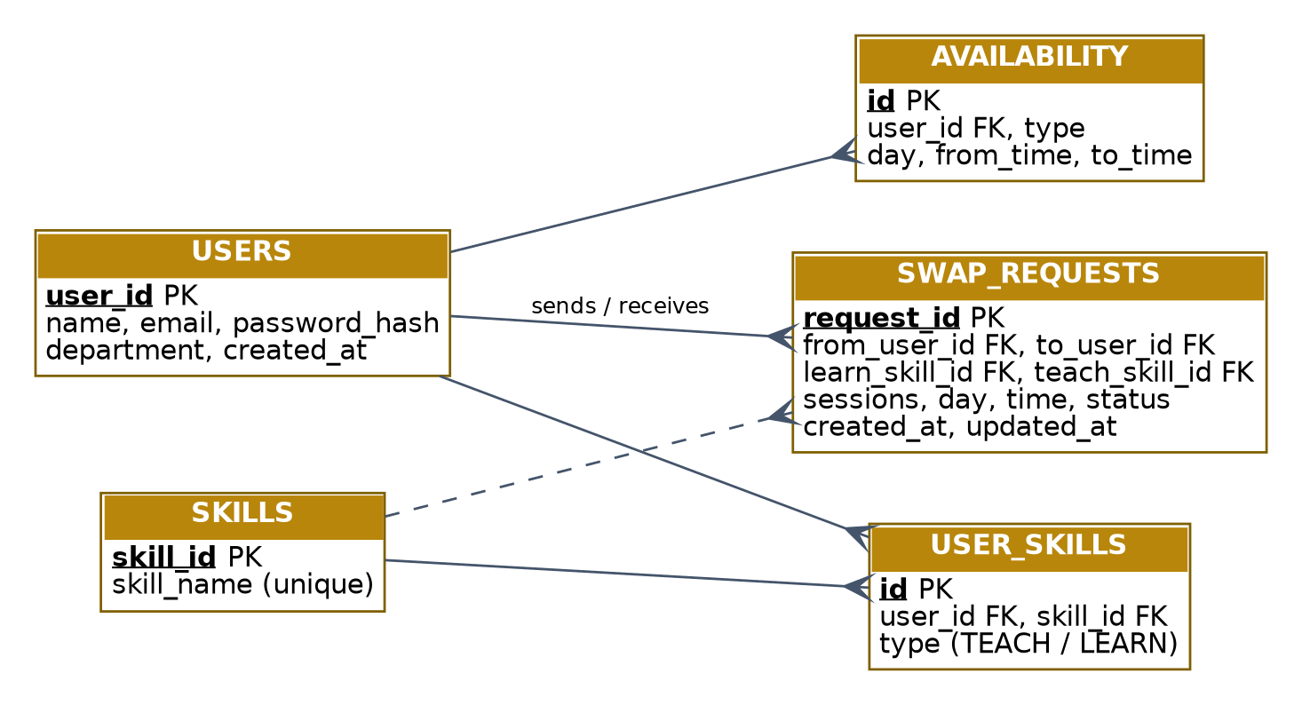
Figure 5.4: Proposed relational design (future work, not implemented)
Table 5.4: Proposed relational tables
Table | Key columns | Purpose
USERS | user_id (PK), name, email (unique), password_hash, department, created_at | Student accounts.
SKILLS | skill_id (PK), skill_name (unique) | Master list of skills; removes spelling differences between users.
USER_SKILLS | id (PK), user_id (FK), skill_id (FK), type (TEACH/LEARN) | Many-to-many relation between students and skills.
AVAILABILITY | id (PK), user_id (FK), type, day, from_time, to_time | Teaching and learning time slots.
SWAP_REQUESTS | request_id (PK), from_user_id (FK), to_user_id (FK), learn_skill_id (FK), teach_skill_id (FK), sessions, day, time, status | Swap requests between two students.

5.5 Data Flow
Figure 5.5 shows the context-level data flow diagram (Level 0), in which the whole system is a single process that exchanges data with the student and with the data store. Figure 5.6 expands it into four main processes (Level 1).
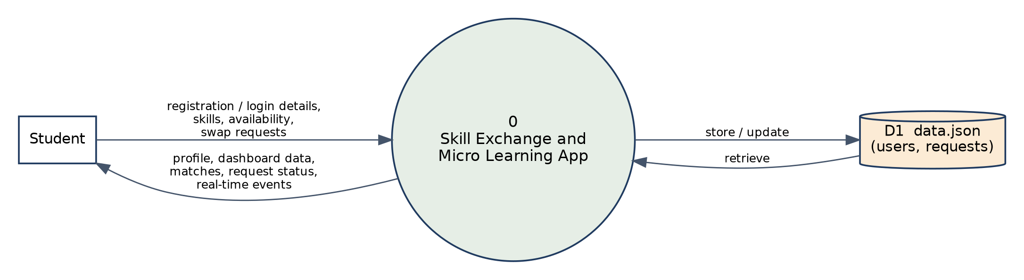
Figure 5.5: Data flow diagram – Level 0
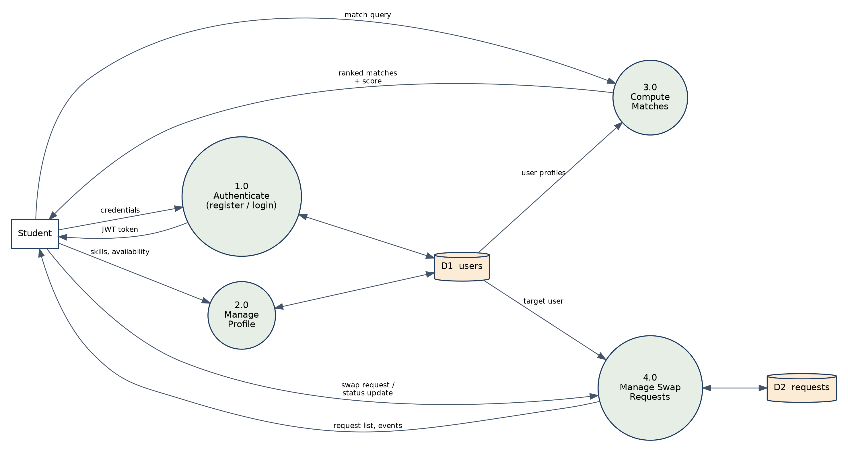
Figure 5.6: Data flow diagram – Level 1

5.6 Matching Logic
Skill matching is implemented in the back-end function matchScore(me, other). It is a rule-based scoring method; no machine learning is used. The function lower-cases all skill names and works as follows (Figure 5.7 and Table 5.5):
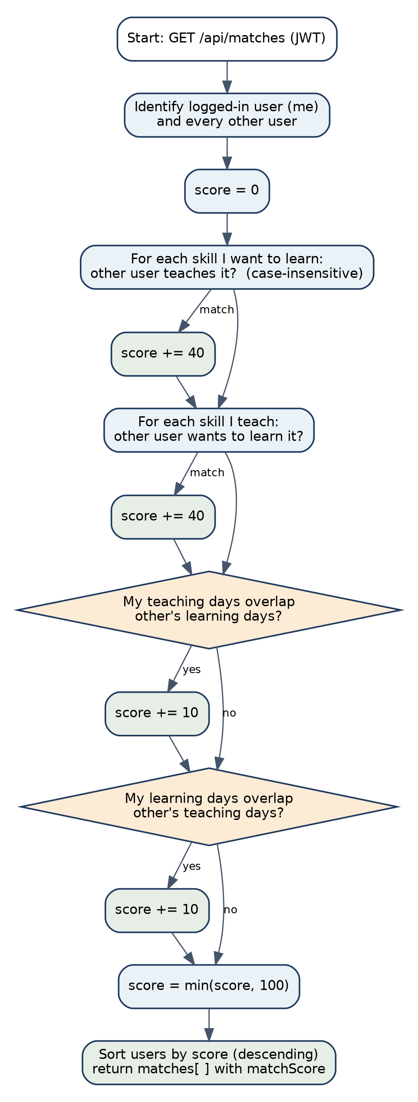
Figure 5.7: Matching workflow
Table 5.5: Match-score rules
Rule | Condition | Points | Note
1 | A skill that I want to learn is taught by the other student. | +40 for each skill | Exact, case-insensitive text match.
2 | A skill that I teach is wanted by the other student. | +40 for each skill | Exact, case-insensitive text match.
3 | My teaching days overlap the other student’s learning days. | +10 | Counted once.
4 | My learning days overlap the other student’s teaching days. | +10 | Counted once.
5 | Final score | min(score, 100) | Matches are sorted in descending order.

Worked example. During testing, one student who teaches Java Programming and Python and wants to learn UI/UX Design was compared with another student who teaches UI/UX Design and wants to learn Java Programming, both being available on Wednesday. The score was 40 (UI/UX Design taught by the other student) + 40 (Java Programming wanted by the other student) + 10 + 10 (day overlaps) = 100, which is the value returned by the API. A student whose skills did not complement the first one obtained a score of 0.
Limitations of the current logic: Skill names are free text, so “Java” and “Java Programming” are treated as different skills; skill level is not considered; and the “from/to” time values are stored but not compared – only the days are compared.

CHAPTER -6 IMPLEMENTATION
About the screenshots: All figures in this chapter were captured from the supplied application running locally (back end on port 5000) with sample demo accounts created for documentation. The names shown in the figures are demo data.

6.1 Frontend Implementation
The front end is organised as views inside one HTML file. The function showView(viewName) hides all sections and shows the selected one; openProtected(viewName) first checks whether a user is logged in and otherwise shows a toast message and opens the login view. Table 6.1 lists the views.
Table 6.1: Views of the application
View id | Page | Purpose and main elements
home | Home | Landing page with the tagline “Learn. Teach. Connect.”, a sample match card, skill categories and call-to-action buttons.
login | Login | E-mail and password form.
register | Register | Name, e-mail, password, confirm password and department.
completeProfile | Complete Skill Profile | Skills to teach/learn and teaching/learning availability (days, from/to time).
dashboard | Dashboard | Counters (skills to teach, skills to learn, potential matches, swap requests), skill profile and recommended match.
explore | Explore Skills | Search box and nine skill cards.
matches | Matches | Match cards with percentage, skills, day, time and Request Swap button.
profile | My Profile | Student information, skills and availability.
requests | Requests | List of swap requests with status.

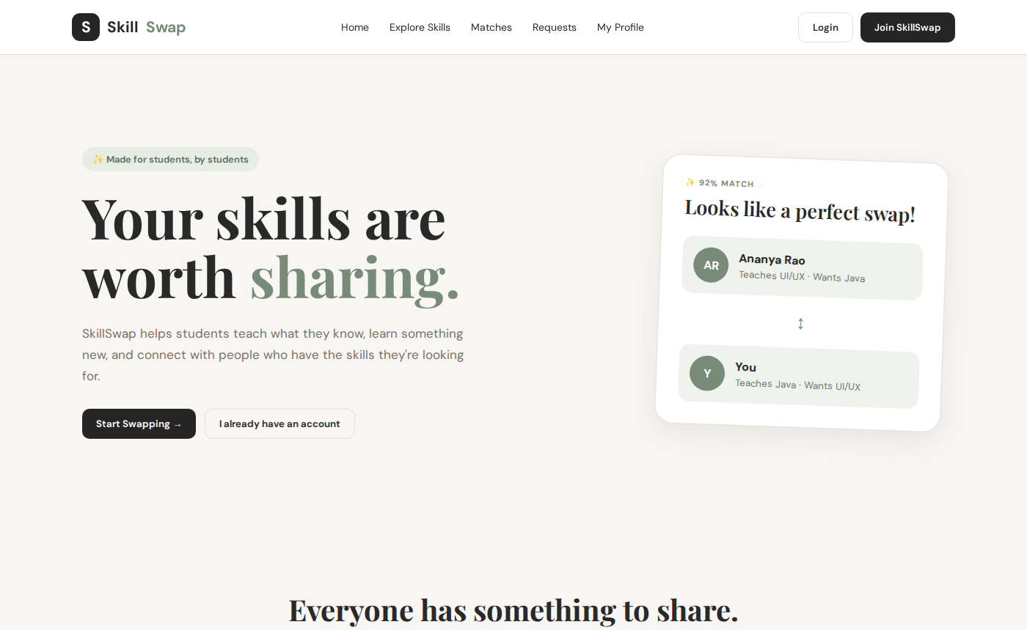
Figure 6.1: SkillSwap home page

6.2 User Registration and Login
The registration form is handled by registerUserBackend(). It checks that the password and the confirmation are equal, then sends POST /api/auth/register with name, e-mail, password and department. On success the returned token is stored in localStorage, the user object becomes currentUser, a success toast is shown and the Complete Skill Profile view opens. The login form is handled by loginUserBackend(), which sends POST /api/auth/login and opens the dashboard. Error messages from the server (for example “Incorrect email or password”) are shown in the toast.
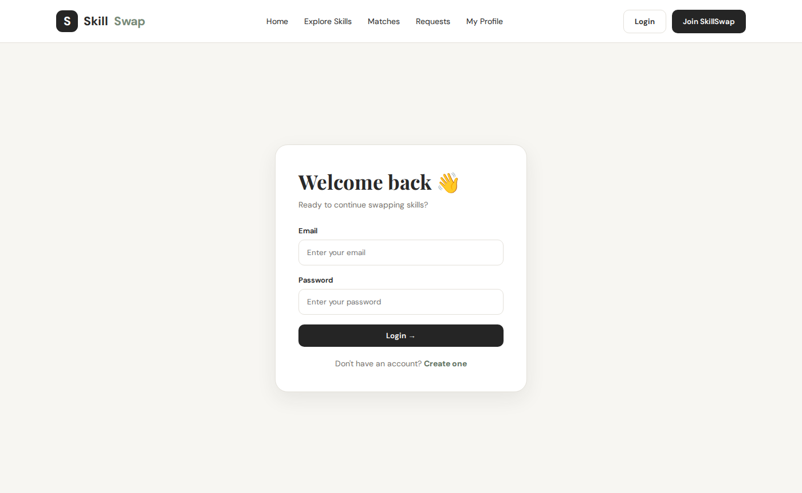
Figure 6.2: Login page
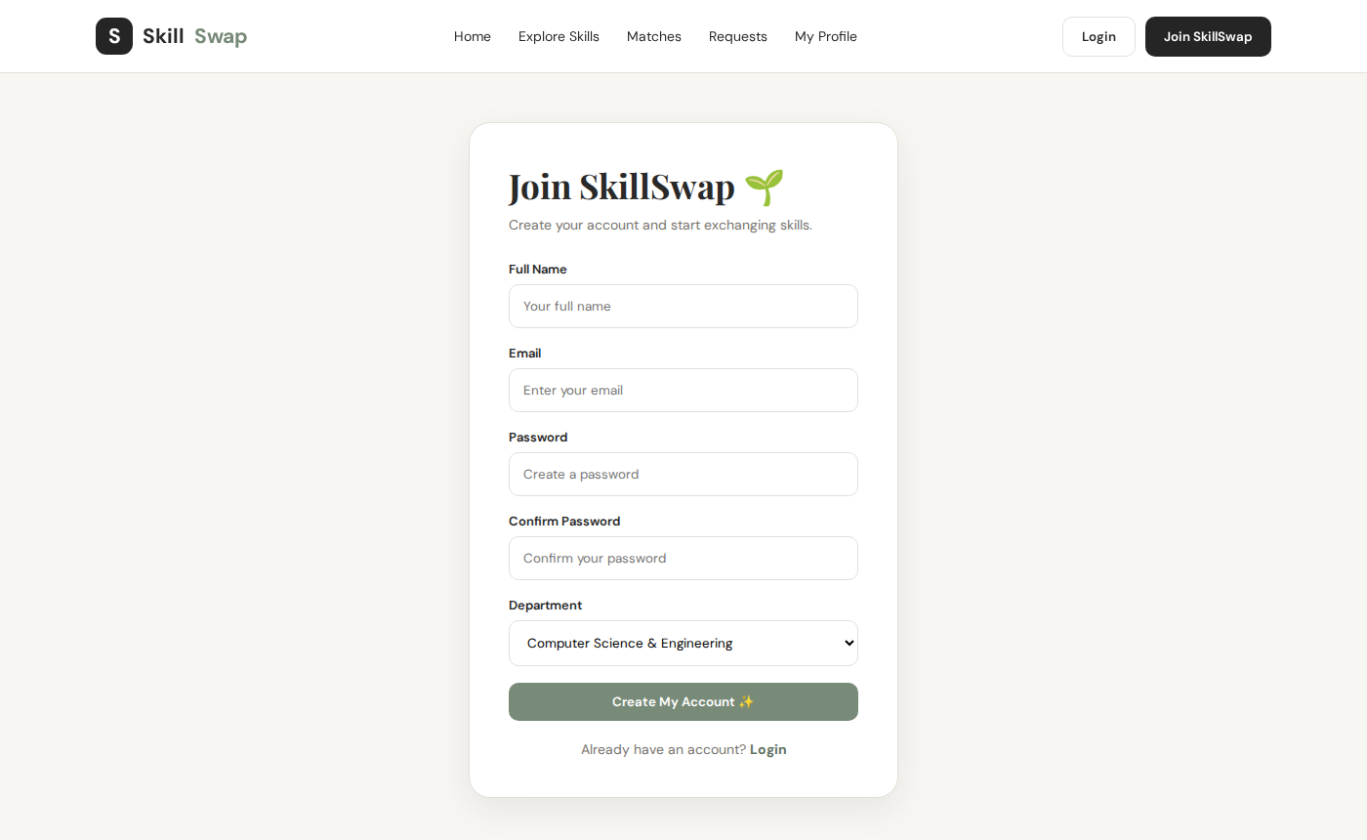
Figure 6.3: Registration page

6.3 Profile Management
After registration the student completes the skill profile. The form contains two skill lists – Skills I Can Teach and Skills I Want To Learn – to which text entries are added with an Add button (duplicates are ignored and each entry can be removed), and two availability sections, When can you teach? and When can you learn?, each with day check-boxes (Mon–Sun) and “From” and “To” drop-downs (4:00 PM to 10:00 PM). The footnote on the form states that all sessions are online. saveProfileBackend() sends the data to PUT /api/profile.
Skill level: The profile does not contain a skill-level field. Skill level and online/offline mode selection are not implemented; the application supports online sessions only.
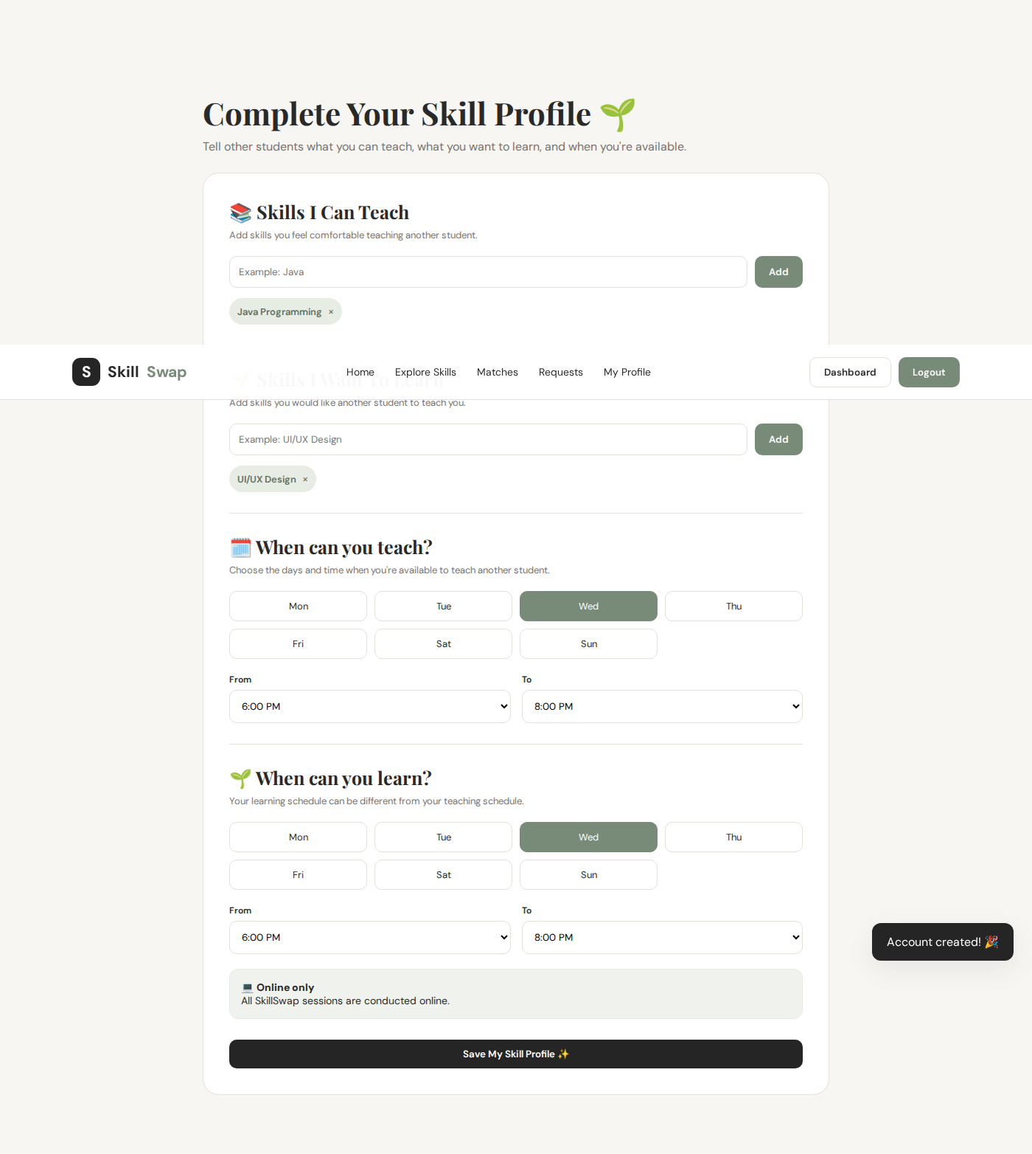
Figure 6.4: Complete Skill Profile page
The Dashboard summarises the profile with four counters, the skills in tag form and a recommended match panel. The My Profile page shows the student’s details and availability.
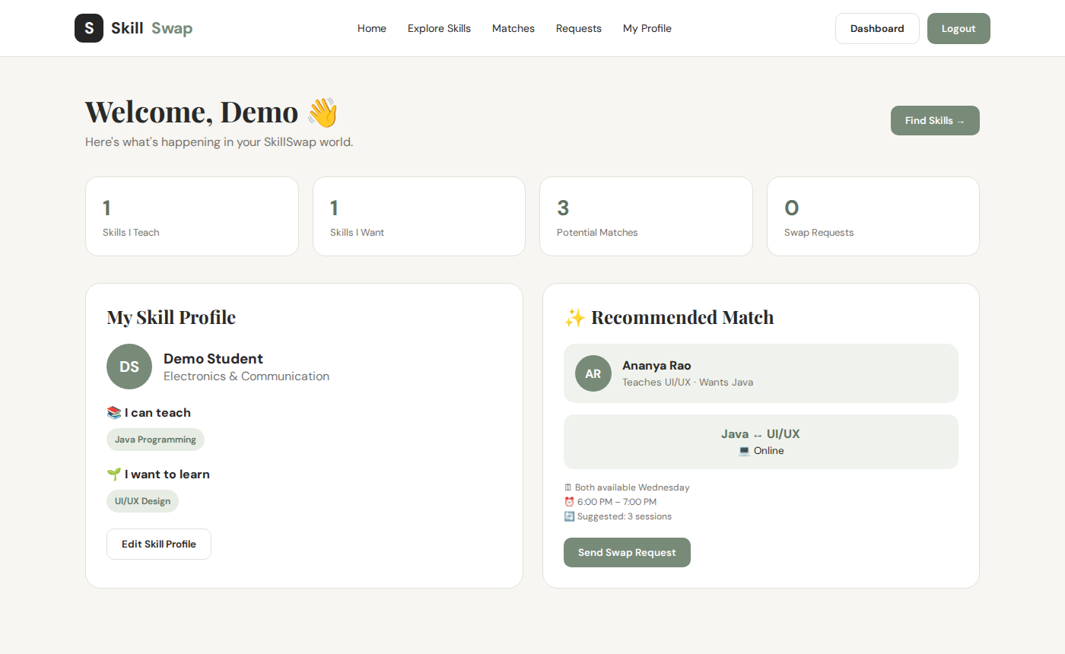
Figure 6.5: Student dashboard
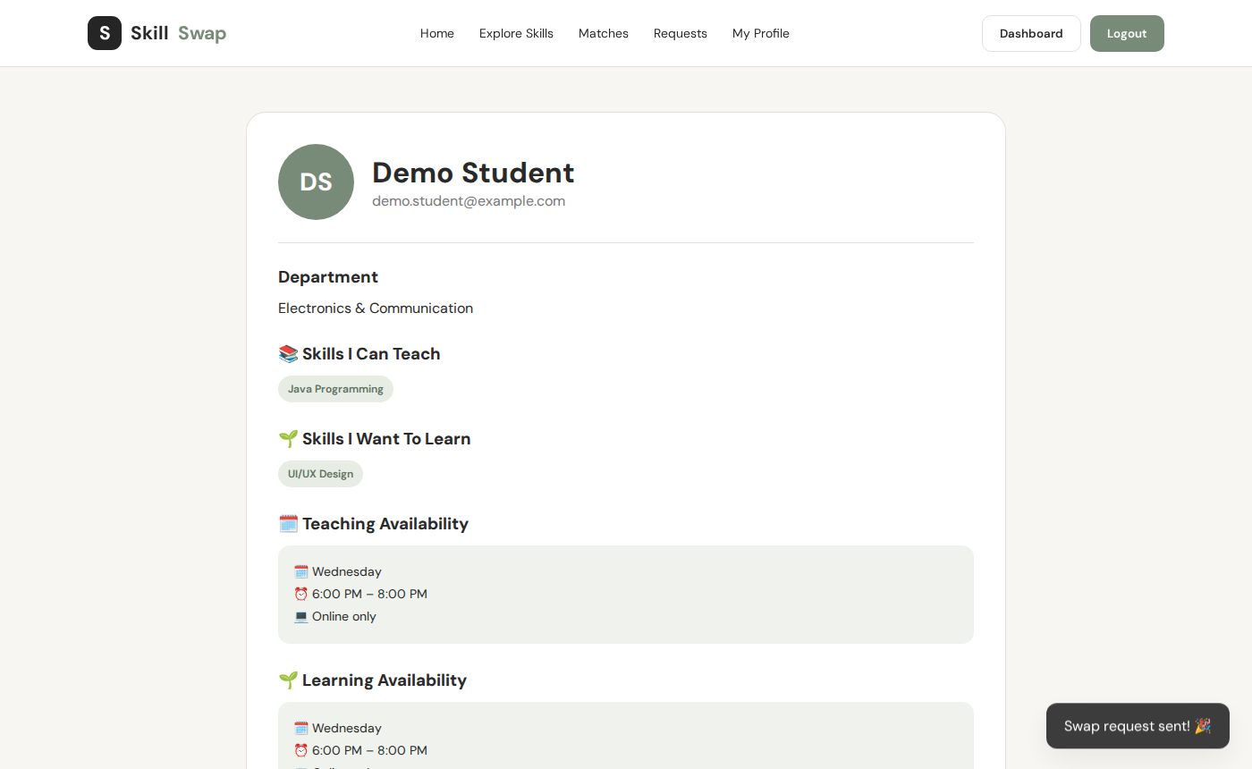
Figure 6.6: My Profile page

6.4 Skill Management
Skills entered in the profile are stored as plain text arrays. The Explore Skills page presents nine skill cards – Java Programming, UI/UX Design, Python, Photography, Public Speaking, Video Editing, HTML/CSS, Communication and Dance – each with an icon, a category label (for example Programming, Design, Creative or Communication), a short description and a Request Swap button. The search box calls searchSkills() on every key press and shows only the cards whose data-skill text contains the typed words.
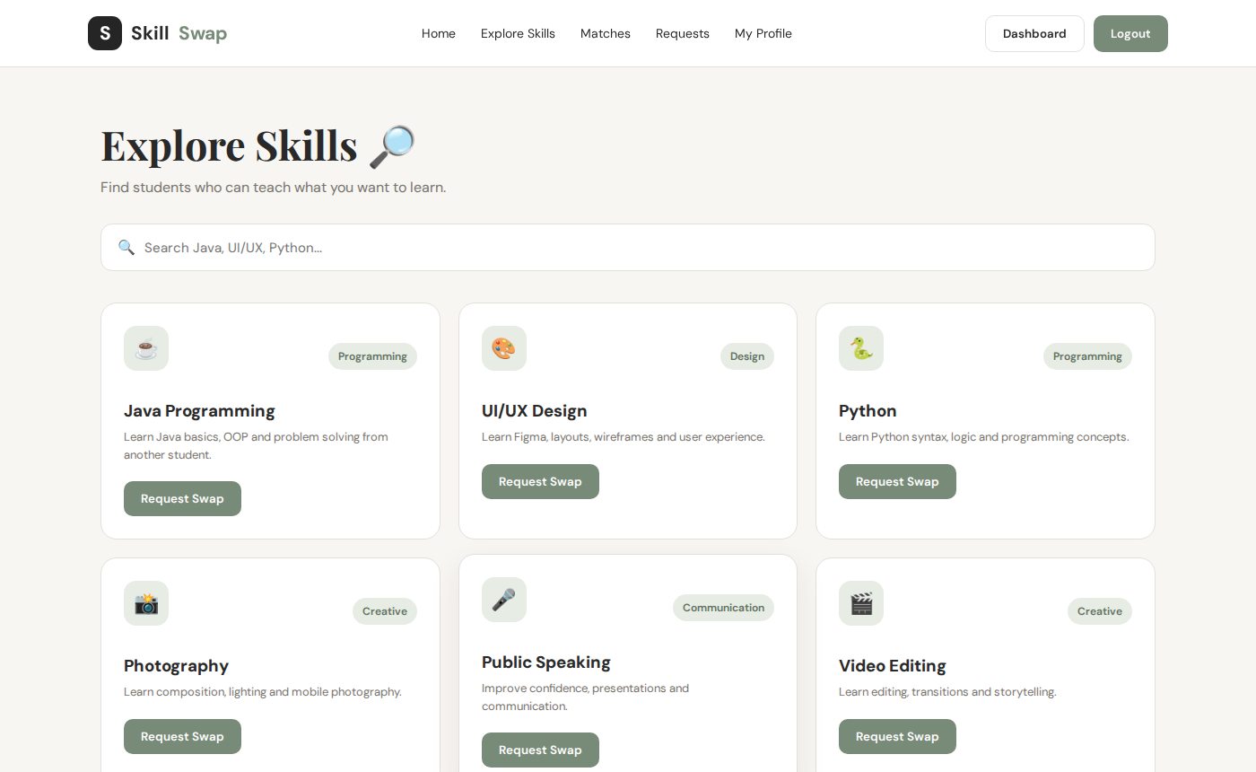
Figure 6.7: Explore Skills page

6.5 Skill Matching
The back end computes the match score for every pair of students (Section 5.6) and returns the list through GET /api/matches. In the front end, loadBackendMatches() retrieves this list and keeps it in window.skillSwapMatches; it is used to find the partner when a request is submitted. The Matches page of the supplied front end currently displays three illustrative match cards (for example Java ↔ UI/UX at 92%) written directly in the HTML; rendering the server-computed matches in these cards is a planned improvement.
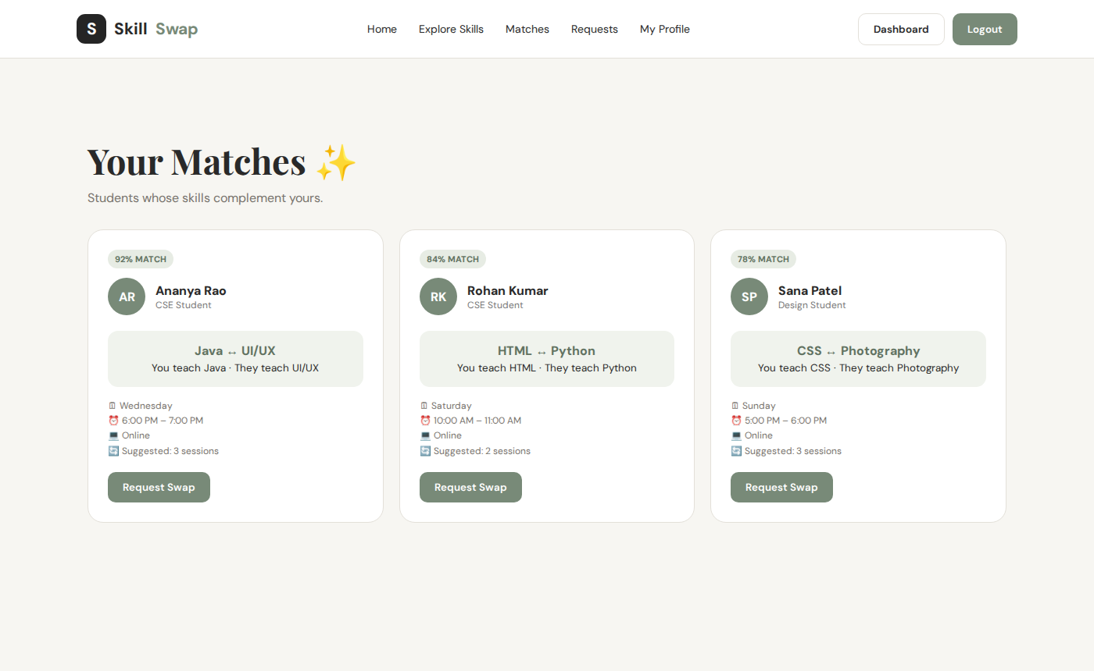
Figure 6.8: Matches page

6.6 Swap Request Management
Pressing Request Swap opens a modal in which the partner’s name and the two skills are pre-filled and read-only. The student selects the number of sessions (1, 2, 3 or 5), the preferred day (Monday to Sunday) and one of six 45-minute slots between 4:00 PM and 9:45 PM. The modal states that sessions are online and last 45 minutes. submitRequestBackend() sends the data to POST /api/requests; the server stores the request with the status Pending. The Requests page then lists each request with the partner’s name, the skill pair, number of sessions, day, time, “Online” and the status label.
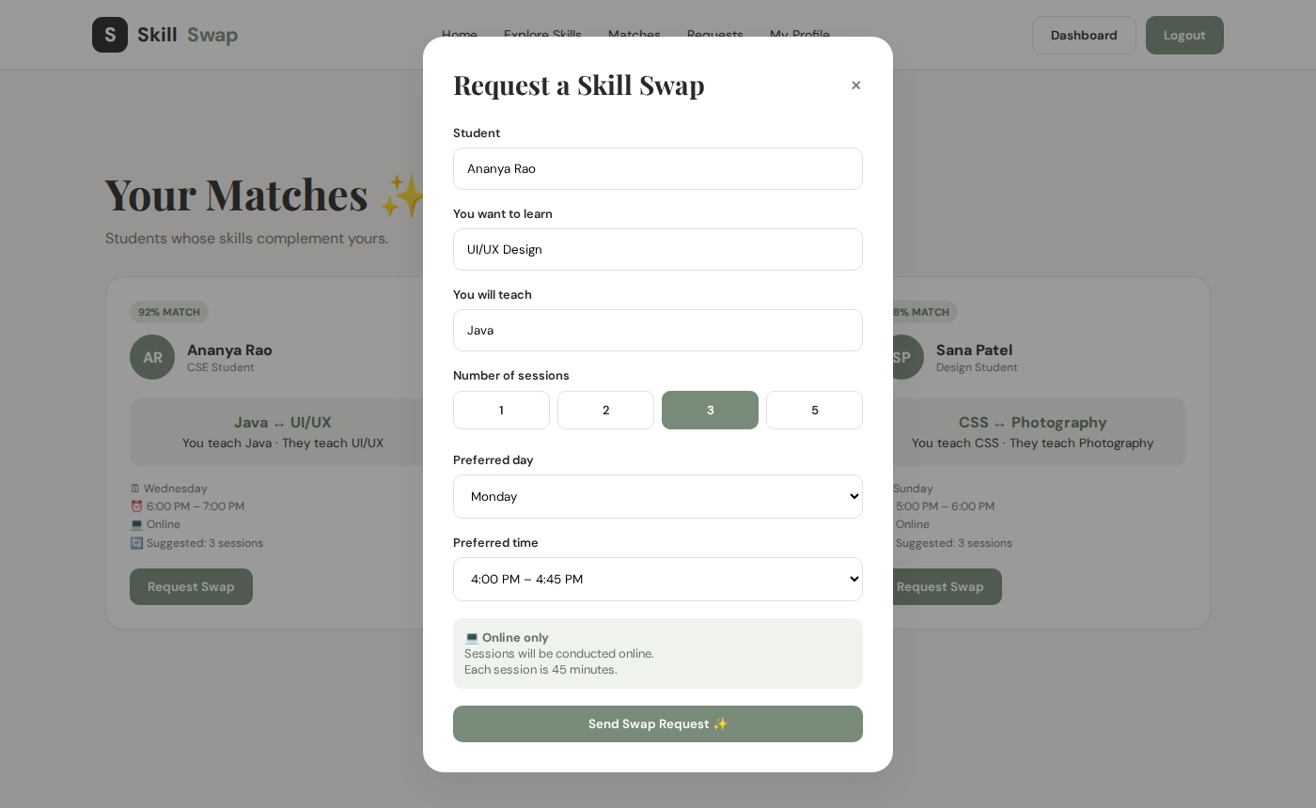
Figure 6.9: Request Swap modal
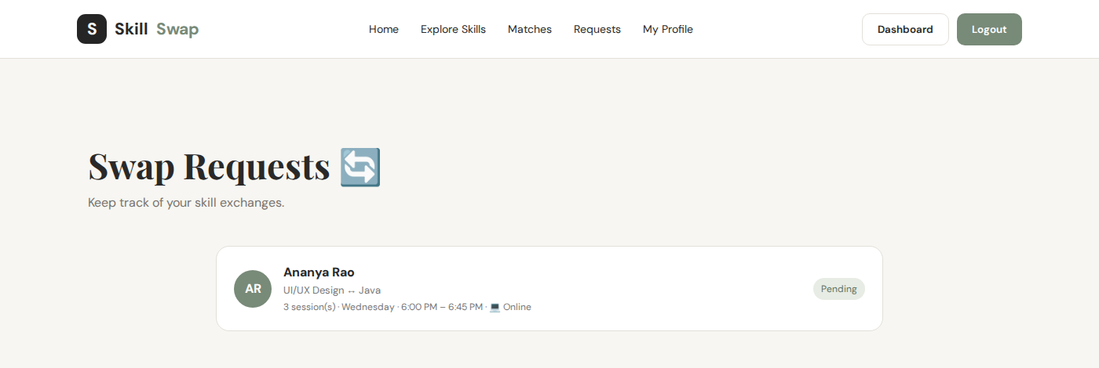
Figure 6.10: Swap Requests page
The server supports changing the status of a request to Accepted, Rejected or Completed through PATCH /api/requests/:id, and it emits the requestUpdated event so that connected browsers refresh. The supplied interface does not yet contain buttons for accepting or rejecting a request; it displays the current status.

6.7 Session Management
Session management is implemented in a basic form. Each request stores the number of sessions, the preferred day and time slot, and the mode (always “Online”). The matches page also shows a “Suggested: n sessions” text. A separate session entity, calendar view, reminders and meeting links are not implemented and are listed as future enhancements.

6.8 Ratings and Reputation
Ratings and reviews are not implemented in the supplied code; neither the database structure nor the API contains a rating field. As a proposed design, a rating (1–5) and a short review could be stored for every completed request, and the average rating could be shown on the student’s profile and used as an additional factor in the match score.

6.9 Skill Credit System
The skill-credit concept is conceptual and not implemented. A possible design is that a student earns credits for each completed teaching session and spends credits for each session learned, which would allow one-sided exchanges when the two students do not have exactly complementary skills.

6.10 Backend Implementation
The back end is a single file, server.js, which is organised as follows.

6.10.1 Configuration and helpers
The file loads environment variables with dotenv, creates the Express app and the HTTP server, and attaches Socket.IO with open CORS settings. The secret is read from JWT_SECRET; if it is missing, a development default value is used. The helper publicUser(u) returns a copy of the user without the password, and auth is the JWT middleware.
function auth(req, res, next) {
const header = req.headers.authorization || "";
const token = header.startsWith("Bearer ") ? header.slice(7) : null;
if (!token) return res.status(401).json({ message: "Authentication required" });
try { req.user = jwt.verify(token, JWT_SECRET); next(); }
catch { return res.status(401).json({ message: "Invalid or expired token" }); }
}

6.10.2 Routes
- POST /api/auth/register: validates that all four fields are present, checks that the e-mail is unique, hashes the password with bcrypt (10 rounds), creates the user with empty skills and a default availability of 6:00 PM – 8:00 PM, saves it, and returns a token and the public user.
- POST /api/auth/login: finds the user by e-mail, compares the password with the stored hash and returns a token.
- GET /api/me and PUT /api/profile: return and update the logged-in user. Only the four fields teachSkills, learnSkills, teachingAvailability and learningAvailability can be updated; a profileUpdated event is emitted.
- GET /api/users and GET /api/matches: return the other students with matchScore; matches are sorted in descending order.
- POST /api/requests, GET /api/requests and PATCH /api/requests/:id: create a request, list the requests in which the user is the sender or receiver, and update the status.

6.10.3 Database operations
All data access uses loadDB() and saveDB(), which read and write the JSON file synchronously with fs.readFileSync and fs.writeFileSync. Identifiers are generated with Date.now().toString().

6.10.4 Real-time events
When a profile is updated, a request is created or its status is changed, the server calls io.emit(...) with the event name. In the browser, connectSkillSwapRealtime() listens for these events and reloads the request list or refreshes the dashboard and profile of the current user.

6.11 Error Handling
Table 6.2: Error handling in the API
Situation | HTTP | Message returned
Missing registration field | 400 | All fields are required
E-mail already registered | 409 | This email is already registered.
Wrong e-mail or password | 401 | Incorrect email or password
Missing Authorization header | 401 | Authentication required
Invalid or expired token | 401 | Invalid or expired token
User/target student not found | 404 | User not found / Student not found
Request not found or not owned by user | 404 | Request not found
Invalid status value | 400 | Invalid status

On the front end each API call is wrapped in try … catch; the error message is shown in the toast (for example “Student not found on server. ❌”). The request list is rendered with escapeHTML() to avoid inserting untrusted text as HTML.

6.12 Security Considerations

6.12.1 Implemented
- Passwords are stored only as bcrypt hashes and the hash is removed from API responses.
- API routes (except health, register and login) require a valid JWT with a 7-day expiry.
- E-mail addresses are normalised and must be unique.
- Request status is restricted to four allowed values, and a user can only access requests in which he or she is the sender or receiver.
- User text displayed in the request list is HTML-escaped.

6.12.2 Recommended improvements
- Always set a long random JWT_SECRET in .env; the fallback value in the code is for development only.
- Restrict CORS to the real front-end origin instead of allowing all origins.
- Add input validation (e-mail format, password strength) on the server, rate limiting for login, and security headers (for example with the Helmet package).
- Allow only the receiver of a request to accept or reject it; at present the status check only verifies that the user is one of the two parties.
- Send Socket.IO events only to the concerned users instead of broadcasting them to every connected client.
- Clear the stored JWT when the user logs out, and serve the application over HTTPS in production.

CHAPTER -7 FEATURES
This chapter lists the features of the application, how they work from the user’s point of view and how they are implemented. Each feature has been verified against the source code; features that are not present are marked as proposed.

7.1 List of Main Features
Table 7.1: Features and their implementation status
No. | Feature | Status | Where implemented
1 | User registration and login | Implemented | registerUserBackend, loginUserBackend; /api/auth/*
2 | Student profile | Implemented | My Profile and Dashboard views; /api/me
3 | Skill selection (skills to teach) | Implemented | Complete Skill Profile view; PUT /api/profile
4 | Skills to learn | Implemented | Complete Skill Profile view; PUT /api/profile
5 | Skill level | Proposed | Not present in code
6 | Availability (days and time range) | Implemented | Profile form; stored in user document
7 | Skill exploration and search | Implemented | Explore view; searchSkills()
8 | Matching | Implemented (API) | matchScore(); GET /api/matches
9 | Match percentage | Implemented (API) / sample cards (UI) | matchScore (0–100); Matches page cards
10 | Swap requests | Implemented | Request modal; /api/requests
11 | Session scheduling | Partially implemented | Sessions, day and time stored in the request
12 | Ratings / reviews | Proposed | Not present in code
13 | Dashboard | Implemented | Dashboard view; updateDashboard()
14 | Skill credits | Proposed | Not present in code
15 | Real-time updates | Implemented | Socket.IO server and client

7.2 How Each Feature Works

7.2.1 Registration and login
User perspective: the student enters name, e-mail, password, confirmation and department to register, or e-mail and password to log in; after registration the profile page opens, and after login the dashboard opens. Technical description: the front end calls the authentication endpoints, the server hashes or compares the password with bcrypt, creates a JWT and returns it; the token is saved in localStorage and attached to later API calls.

7.2.2 Skill profile and availability
User perspective: the student lists the skills he or she can teach and wants to learn and ticks the days and time ranges for teaching and for learning separately. Technical description: the arrays and availability objects are sent to PUT /api/profile, stored in the user’s document and broadcast through profileUpdated.

7.2.3 Skill exploration
User perspective: the student types a word such as “py” and the page immediately shows only the matching skill cards. Technical description: searchSkills() compares the lower-case input with the data-skill attribute of each card and shows or hides the card.

7.2.4 Matching and match percentage
User perspective: the student sees partners whose skills complement his or her own, with a percentage that indicates how good the match is. Technical description: matchScore() awards points for skill overlaps and availability overlaps and limits the result to 100 (Section 5.6). The current Matches page uses illustrative cards for the layout, while the server API returns the computed scores.

7.2.5 Swap requests and session details
User perspective: the student proposes an exchange – skill to learn, skill to teach, number of sessions, day and time – and later sees it on the Requests page with the status. Technical description: the request is posted to the server, stored with status Pending, and updated by PATCH /api/requests/:id; the requestCreated and requestUpdated events keep all open browsers up to date.

7.2.6 Dashboard
User perspective: after login the student sees a welcome message, the number of skills he or she teaches and wants to learn, the number of potential matches and swap requests, the skill profile and a recommended match. Technical description: updateDashboard() fills these elements from currentUser and the loaded requests array.

7.3 Proposed Features (not yet implemented)
Skill-level selection, ratings and reviews, and skill credits are part of the project concept, but they are not present in the supplied code. They are therefore documented as proposed features in Chapters 6 and 11 and are not presented as completed work.

CHAPTER -8 TESTING

8.1 Testing Objectives
- Verify that every implemented function works as specified.
- Verify that the front end and the back end work together through the REST API.
- Confirm that invalid inputs and unauthorised requests are rejected with proper messages.
- Confirm that data is stored correctly and that passwords are never returned.
- Identify defects and limitations that need to be corrected.

8.2 Testing Strategy
The application was tested at three levels: (1) API testing of every endpoint against a locally running instance of the server with an empty database, using a small Python script that issues HTTP requests; (2) functional testing of the user interface through a headless browser run that registered a demo student, saved a profile and sent a swap request; and (3) planned manual tests for the remaining user-interface behaviours. Results in this chapter are marked “Observed” only where they were actually obtained in this way; the remaining test cases are listed with the status “Not yet executed” so that the team can complete them before submission.

8.3 Unit Testing
The project does not contain automated unit tests; package.json has only the start and dev scripts. The functions that are most suitable for unit testing are listed below, and a testing framework such as Jest could be added in the future.
- matchScore(me, other) – score for no overlap, one-direction overlap, two-direction overlap, day overlap, case differences and the cap of 100.
- publicUser(u) – the password field is removed.
- auth middleware – missing header, invalid token, valid token.
- loadDB() / saveDB() – creation of an empty database file and round-trip of data.

8.4 Integration Testing
Integration between the front end and the back end occurs through the functions api(), registerUserBackend(), loginUserBackend(), saveProfileBackend(), submitRequestBackend() and loadRequestsBackend(). During the browser run, the following chain was observed to work: registration → automatic opening of the profile page → profile save → dashboard showing the saved skills → opening of the request modal from the Matches page → request submission → request displayed on the Requests page with status Pending and the details “3 session(s) · Wednesday · 6:00 PM – 6:45 PM · Online”.

8.5 Functional Testing
Table 8.1 lists the functional test cases. In the “Actual Result” column, only observed outcomes are recorded.
Table 8.1: Functional test cases
Test ID | Module | Test case | Input | Expected result | Actual result | Status
FT-01 | Registration | Valid registration | Name, unique e-mail, password, department | Account created; token returned (201) | HTTP 201; token and user (without password) returned | Pass
FT-02 | Registration | Duplicate e-mail | Same e-mail in different case | 409 with message | HTTP 409 “This email is already registered.” | Pass
FT-03 | Registration | Missing field | Name and e-mail only | 400 with message | HTTP 400 “All fields are required” | Pass
FT-04 | Registration (UI) | Password mismatch | Different password and confirmation | Toast “Passwords do not match” | — | Not yet executed
FT-05 | Login | Valid login | Registered e-mail and password | Token returned (200) | HTTP 200; token returned | Pass
FT-06 | Login | Wrong password | Registered e-mail, wrong password | 401 with message | HTTP 401 “Incorrect email or password” | Pass
FT-07 | Logout (UI) | Logout | Click Logout | Returns to Home; navbar updated | — | Not yet executed
FT-08 | Profile | Profile update (API) | Skills and availability JSON | Saved (200) | HTTP 200; profile saved | Pass
FT-09 | Profile (UI) | Save skill profile | Add one teach and one learn skill, tick a day, save | Dashboard opens with updated counts | Dashboard opened and showed saved skills | Pass
FT-10 | Skills (UI) | Add duplicate skill | Same skill twice | Only one entry in the list | — | Not yet executed
FT-11 | Explore (UI) | Search skill | Type “py” | Only Python card visible | — | Not yet executed
FT-12 | Matching | Complementary students | Two students with opposite teach/learn skills and common day | Score 100 | Score 100 returned | Pass
FT-13 | Matching | Non-complementary students | Students without common skills | Score 0 | Score 0 returned | Pass
FT-14 | Requests | Send request (API) | Valid target, skills, sessions, day, time | Request created (201) | HTTP 201; status Pending | Pass
FT-15 | Requests | Request to unknown student | Invalid toUserId | 404 with message | HTTP 404 “Student not found” | Pass
FT-16 | Requests (UI) | Send request from modal | Select day and time, submit | Toast; request listed as Pending | Request listed with Pending status | Pass
FT-17 | Requests | Invalid status | status = “Foo” | 400 with message | HTTP 400 “Invalid status” | Pass
FT-18 | Requests | Accept request (API) | status = Accepted | Status changes | Status became Accepted | Pass
FT-19 | Sessions | Session details stored | Sessions = 2/3, day, time | Stored with request | Stored and displayed on Requests page | Pass
FT-20 | Ratings | Rate a partner | — | Rating saved | Feature not implemented | Not applicable

8.6 API Testing
The API was tested with a script that sends HTTP requests to every route; Postman was not used. The script was run on 2 October 2026 against a freshly started local server with an empty data.json. Table 8.2 summarises the observations.
Table 8.2: API test observations
No. | Request | HTTP | Observed response
A1 | GET /api/health | 200 | ok: true, service name and time
A2 | POST /api/auth/register (valid) | 201 | token and public user
A3 | POST /api/auth/register (duplicate) | 409 | This email is already registered.
A4 | POST /api/auth/register (missing fields) | 400 | All fields are required
A5 | POST /api/auth/login (valid) | 200 | token and public user
A6 | POST /api/auth/login (wrong password) | 401 | Incorrect email or password
A7 | GET /api/me without token | 401 | Authentication required
A8 | GET /api/me with invalid token | 401 | Invalid or expired token
A9 | GET /api/me (valid) | 200 | user object
A10 | PUT /api/profile | 200 | Profile saved
A11 | GET /api/matches | 200 | Complementary student: 100; other student: 0
A12 | GET /api/users | 200 | list of other users with matchScore
A13 | POST /api/requests (valid) | 201 | request with status Pending
A14 | POST /api/requests (unknown target) | 404 | Student not found
A15 | GET /api/requests | 200 | list containing the sent request
A16 | PATCH /api/requests/:id (invalid status) | 400 | Invalid status
A17 | PATCH /api/requests/:id (Accepted) | 200 | status Accepted
A18 | PATCH /api/requests/999 (unknown id) | 404 | Request not found

Observation: In test A17 the status was changed by the sender of the request. The server allowed this because it checks only that the user is one of the two parties. Restricting acceptance to the receiver is listed as a recommended improvement (Section 6.12.2).

8.7 Validation Testing
The following validations exist in the code and were verified as shown above: required fields on registration, unique normalised e-mail, correct credentials at login, token presence and validity, existence of the target student, and the four allowed request statuses. Additional validations are recommended: e-mail format and password-strength checks on the server, restriction of the number of sessions to the allowed values, and rejection of empty skill lists in a request.

8.8 Performance Considerations
No formal load testing was performed and no performance figures are claimed. By design, every API call reads the whole data.json file and each change rewrites it, so the cost of a request grows with the size of the file, and concurrent writes could overwrite each other. This is acceptable for a prototype with a small number of students; for larger use, a database with indexing and transactions (for example MySQL) is recommended.

8.9 Security Testing
Authentication-related behaviour was verified (tests A6–A8): requests without a token or with an invalid token are rejected, and wrong credentials produce a 401 response. The following security tests are recommended before any real deployment: brute-force login attempts, token expiry handling, cross-origin requests from unauthorised sites, injection of HTML in skill names, and attempts to change another student’s request. The review also identified that logout in the interface does not remove the stored JWT (Chapter 10).

CHAPTER -9 DEPLOYMENT

9.1 Development Deployment
The project is run on a local computer. The back end runs as a Node.js process on port 5000, and the front end (index.html) is opened in a browser, preferably through VS Code Live Server as recommended in CONNECT_FRONTEND.md. Both parts must run at the same time because the front end calls http://localhost:5000/api.

9.2 Frontend Setup
- Open the project folder in Visual Studio Code.
- Install the Live Server extension if it is not already installed.
- Right-click index.html and choose Open with Live Server (or open the file directly in a browser).
- Make sure the back end is running before logging in or registering.
If the older front-end file dbse1.html is used, the contents of frontend-integration.js must be pasted at the end of that file, before </body>; this file overrides registerUser, loginUser, saveProfile and submitRequest.

9.3 Backend Setup
Run the following commands in the folder that contains server.js and package.json:
npm install # installs the dependencies
npm start # starts the API at http://localhost:5000
npm run dev # (optional) starts with nodemon for auto-restart

To check that the server is running, open http://localhost:5000/api/health in the browser; it returns a JSON object containing ok: true.

9.4 Database Setup
No database server has to be installed. The file data.json is used as the database; if it does not exist, the server creates it automatically with the structure { "users": [], "requests": [] }. To reset the application, stop the server and restore this empty structure. The file contains password hashes and personal e-mail addresses of the registered users and should not be published in a public repository.

9.5 Environment Variables
The server reads two environment variables from a .env file (the supplied example file is named _env.example; the README refers to it as .env.example). Copy it to .env and set a secret value.
Table 9.1: Environment variables
Variable | Default | Description
PORT | 5000 | Port on which the Express/Socket.IO server listens.
JWT_SECRET | Development fallback in code | Secret used to sign and verify JWTs. Must be replaced by a long random value; it must never be shared or committed.

9.6 Production Deployment
The project has not been deployed to a production environment. The following is a recommended approach if it is deployed in the future:
- Host the Node.js server on a platform that supports long-running Node.js processes and WebSockets (a cloud virtual machine or a container platform), managed by a process manager such as PM2 or by the platform itself.
- Serve index.html from a static host or from the same server, and change API_BASE and the Socket.IO address from localhost to the public API address.
- Use HTTPS, restrict CORS to the front-end origin, and keep JWT_SECRET in the platform’s secret store.
- Replace data.json by a managed database such as MySQL (Section 5.4.2) and add regular backups.
- Add logging, monitoring and automated tests in a CI/CD pipeline.

CHAPTER -10 CHALLENGES AND LIMITATIONS

10.1 Challenges
The following challenges are inherent in a skill-exchange platform and influenced the design:
- Finding suitable skill partners: the number of students with exactly complementary skills is small, so the score also rewards one-directional overlaps.
- Matching accuracy: skills are entered as free text, so differences in spelling or naming reduce the number of matches.
- Availability conflicts: teaching and learning times differ for each student; the profile therefore stores them separately.
- Data consistency: moving from browser storage to a server required that user and request data be stored in one place and that names and ids be consistent.
- Authentication and security: a token-based mechanism had to be added to the originally client-only prototype.
- Scalability and user adoption: a platform of this type is useful only when enough students use it.
- Skill verification and reputation: there is no way yet to check whether a student can really teach a declared skill.

10.2 Solutions Applied
Table 10.1: Challenges and solutions applied
Challenge | Solution in the project
Data stored only in the browser | A Node.js/Express API with a JSON file as shared storage, connected by overriding four front-end functions.
Secure access | bcrypt password hashing and JWT-based authentication.
Finding complementary students | Rule-based match score on skills (both directions) and availability days.
Keeping the interface up to date | Socket.IO events for profile and request changes.
Coordinating schedules | Separate teaching and learning availability, plus day and time slot in each request.

10.3 Current Limitations and Known Issues
The following limitations were identified by inspecting the supplied code and by running the application. They are reported here honestly so that they can be corrected or explained during the evaluation.
Table 10.2: Limitations and known issues
No. | Limitation | Details
1 | Front-end matches are illustrative | The Matches page and the dashboard’s recommended match show fixed sample cards (for example “Ananya Rao”). The server-calculated matches are retrieved but not yet rendered in these cards.
2 | Requests to sample students | The request form looks up the partner by name among registered users on the server. A request to a sample card whose student is not registered fails with “Student not found on server”.
3 | No accept/reject buttons | The API supports status changes, but the interface only displays the status.
4 | Status can be changed by either party | The API does not restrict acceptance to the receiver of the request.
5 | No skill level, ratings or credits | These objectives of the project concept are not implemented.
6 | No separate session entity | Sessions are only a count, a day and a time in the request; there is no calendar or reminder.
7 | Free-text skill names | “Java” and “Java Programming” are different for matching.
8 | Time ranges not compared | Only days are compared; “from/to” times are stored but not used in the score.
9 | JSON-file database | Not suitable for concurrent use or large data; no transactions or indexes.
10 | Logout keeps the token | logout() removes the current user but not the stored JWT; on page reload the session can be restored from the token.
11 | Hard-coded server address | API_BASE and the Socket.IO address are fixed to localhost:5000.
12 | Open CORS and broadcast events | All origins are allowed, and request events are sent to all connected clients.
13 | Stray text at the end of index.html | The file ends with a stray Markdown code fence (three back-ticks) after </html>, which should be deleted.
14 | Online sessions only | No offline mode, chat or video integration.

CHAPTER -11 FUTURE ENHANCEMENTS
The following enhancements are proposed future work. None of them is part of the current implementation. Some are taken from the project review presentation (AI-based matching, mobile application, chat and video sessions, certificates, badges, leaderboards and expansion to more colleges), and others follow from the limitations identified in Chapter 10.

11.1 Planned Features
Table 11.1: Future enhancements
Enhancement | Description
Skill-level matching | Add beginner/intermediate/advanced levels to the profile and use them in the match score.
Ratings and reviews | Let students rate each other after a session and show the average rating on the profile.
Skill credits | Award credits for teaching and spend them for learning, enabling one-sided exchanges.
AI-based intelligent matching | Use recommendation techniques and skill normalisation instead of exact text matching.
Mobile application | Android/iOS application using the same REST API.
Real-time chat and video calling | Allow students to communicate and hold sessions inside the application.
Skill verification, certificates and badges | Verify skills through quizzes or peer endorsement and give certificates and badges.
Leaderboards | Recognise students who teach the most sessions.
Session calendar and notifications | Calendar integration, reminders and e-mail/push notifications.
Accept/reject interface | Buttons for the receiver to accept, reject or complete a request.
Community / multi-college expansion | Support groups, clubs and other colleges or organisations.

11.2 Possible Integrations and Optimisations
- Migrate the data store to MySQL using the relational design in Section 5.4.2.
- Render the server-calculated matches in the front end and remove the sample cards.
- Add automated tests (Jest for the back end) and a CI/CD pipeline.
- Deploy the application on a cloud platform with HTTPS and monitoring.
- Add an admin panel for moderation and usage statistics.

CHAPTER -12 CONCLUSION

12.1 Summary of the Project
The Skill Exchange and Micro Learning App addresses a common problem of student life: students want to learn new skills but have limited money, time and access to teachers, although they themselves have skills that others would like to learn. The project provides a web platform on which students create accounts, describe the skills they can teach and want to learn, state their availability, and send skill-swap requests to each other.

12.2 What Was Achieved
- A complete single-page front end with registration, login, profile, dashboard, skill exploration, matches, request and profile views.
- A Node.js/Express REST API with ten endpoints, JWT authentication, bcrypt password hashing and Socket.IO real-time events.
- A rule-based matching function that scores students from 0 to 100 based on complementary skills and overlapping availability days.
- Persistence of users and swap requests in a JSON database, with the structure ready to be migrated to a relational database.
- Verified behaviour of all API endpoints, including error cases, and of the main user flow from registration to a pending swap request.
The database plays the central role in the system: it stores the students’ skill profiles and the requests between them, and the matching and request features are all operations over this data. The project therefore demonstrates, on a small scale, the core ideas of a database-driven application – structured data, relationships between entities (users and requests), validation and secure access.

12.3 Skills Learned During Development
- Designing a single-page interface with HTML, CSS and JavaScript.
- Building REST APIs with Node.js and Express and securing them with JWT.
- Modelling data and relationships (users, requests, availability) and designing a relational schema for future migration.
- Using Socket.IO for real-time communication.
- Testing APIs, reporting limitations honestly and documenting a software project.

12.4 Overall Significance
The project shows that a lightweight, low-cost application can make peer learning more organised and accessible. The current version is a working prototype: skill levels, ratings, credits, intelligent recommendation and communication features are still to be added. With these enhancements and a production-grade database, the platform could grow into a useful learning community for students.

CHAPTER -13 REFERENCES
The references below are official documentation and standard textbooks related to the technologies and concepts used in the project.
[1] Node.js Foundation. Node.js Documentation. https://nodejs.org/docs
[2] OpenJS Foundation. Express – Node.js web application framework (Guide and API reference). https://expressjs.com
[3] Socket.IO. Socket.IO Documentation, version 4. https://socket.io/docs/v4/
[4] Jones, M., Bradley, J. and Sakimura, N. (2015). JSON Web Token (JWT). RFC 7519, Internet Engineering Task Force. https://www.rfc-editor.org/rfc/rfc7519
[5] Provos, N. and Mazières, D. (1999). A Future-Adaptable Password Scheme. Proceedings of the USENIX Annual Technical Conference.
[6] bcryptjs. bcrypt.js package documentation. https://www.npmjs.com/package/bcryptjs
[7] jsonwebtoken. jsonwebtoken package documentation. https://www.npmjs.com/package/jsonwebtoken
[8] dotenv. dotenv package documentation. https://www.npmjs.com/package/dotenv
[9] Mozilla Developer Network. Fetch API; Web Storage API (localStorage). https://developer.mozilla.org
[10] npm, Inc. npm Documentation. https://docs.npmjs.com
[11] Oracle Corporation. MySQL Reference Manual. https://dev.mysql.com/doc/
[12] OWASP Foundation. OWASP Top Ten. https://owasp.org/www-project-top-ten/
[13] Elmasri, R. and Navathe, S. B. (2016). Fundamentals of Database Systems (7th ed.). Pearson.
[14] Silberschatz, A., Korth, H. F. and Sudarshan, S. (2019). Database System Concepts (7th ed.). McGraw-Hill Education.
[15] Topping, K. J. (1996). The effectiveness of peer tutoring in further and higher education: A typology and review of the literature. Higher Education, 32(3), 321–345.
[16] Hug, T. (2005). Micro learning and narration: Exploring possibilities of utilization of narrations and storytelling for the design of “micro units” and didactical micro learning arrangements. Fourth Media in Transition Conference, MIT, Cambridge, MA.

CHAPTER -14 APPENDICES

Appendix A – Important Source Code

A.1 Match-score function (server.js)
function matchScore(me, other) {
const teach = new Set((me.teachSkills || []).map(s => s.toLowerCase()));
const learn = new Set((me.learnSkills || []).map(s => s.toLowerCase()));
const otherTeach = new Set((other.teachSkills || []).map(s => s.toLowerCase()));
const otherLearn = new Set((other.learnSkills || []).map(s => s.toLowerCase()));
let score = 0;
for (const s of learn) if (otherTeach.has(s)) score += 40;
for (const s of teach) if (otherLearn.has(s)) score += 40;
const a = new Set(me.teachingAvailability?.days || []);
const b = new Set(other.learningAvailability?.days || []);
if ([...a].some(d => b.has(d))) score += 10;
const c = new Set(me.learningAvailability?.days || []);
const d = new Set(other.teachingAvailability?.days || []);
if ([...c].some(day => d.has(day))) score += 10;
return Math.min(score, 100);
}

A.2 Registration route (server.js)
app.post("/api/auth/register", async (req, res) => {
const { name, email, password, department } = req.body;
if (!name || !email || !password || !department)
return res.status(400).json({ message: "All fields are required" });
const db = loadDB();
const normalized = email.trim().toLowerCase();
if (db.users.some(u => u.email === normalized))
return res.status(409).json({ message: "This email is already registered." });
const user = { id: Date.now().toString(), name: name.trim(), email: normalized,
password: await bcrypt.hash(password, 10), department,
teachSkills: [], learnSkills: [], /* availability, createdAt ... */ };
db.users.push(user); saveDB(db);
const token = jwt.sign({ id: user.id, email: user.email }, JWT_SECRET, { expiresIn: "7d" });
res.status(201).json({ token, user: publicUser(user) });
});

A.3 Front-end integration (index.html)
const API_BASE = "http://localhost:5000/api";
let apiToken = localStorage.getItem("skillSwapToken") || null;

async function api(path, options = {}) {
const headers = { "Content-Type": "application/json", ...(options.headers || {}) };
if (apiToken) headers.Authorization = "Bearer " + apiToken;
const response = await fetch(API_BASE + path, { ...options, headers });
const data = await response.json().catch(() => ({}));
if (!response.ok) throw new Error(data.message || "Server error");
return data;
}

registerUser = registerUserBackend; loginUser = loginUserBackend;
saveProfile = saveProfileBackend; submitRequest = submitRequestBackend;

Appendix B – API Endpoints
See Table 3.1 for the endpoint list. Sample request and response bodies observed during testing are given below (values are demonstration data).

B.1 POST /api/requests
Request body:
{ "toUserId": "<id of the other student>", "learnSkill": "UI/UX Design",
"teachSkill": "Java Programming", "sessions": "2",
"day": "Wednesday", "time": "6:00 PM – 6:45 PM" }

Response 201:
{ "request": { "id": "...", "fromUserId": "...", "from": "...", "toUserId": "...",
"to": "...", "learnSkill": "UI/UX Design", "teachSkill": "Java Programming",
"sessions": "2", "day": "Wednesday", "time": "6:00 PM – 6:45 PM",
"mode": "Online", "status": "Pending", "createdAt": "..." } }

B.2 PATCH /api/requests/:id
Request body: { "status": "Accepted" } // Pending | Accepted | Rejected | Completed
Response 200: { "request": { ..., "status": "Accepted", "updatedAt": "..." } }
Response 400: { "message": "Invalid status" }

Appendix C – Database Schema
The implemented schema is given in Tables 5.2 and 5.3 and the proposed relational schema in Table 5.4. The structure of the data file is:
{
"users": [ {
"id": "...", "name": "...", "email": "...", "password": "<bcrypt hash>",
"department": "Computer Science & Engineering",
"teachSkills": [ "Java Programming" ], "learnSkills": [ "UI/UX Design" ],
"teachingAvailability": { "days": [ "Wed" ], "from": "6:00 PM", "to": "8:00 PM" },
"learningAvailability": { "days": [ "Wed" ], "from": "6:00 PM", "to": "8:00 PM" },
"createdAt": "2026-10-02T09:15:40.502Z" } ],
"requests": [ { "id": "...", "fromUserId": "...", "toUserId": "...", "status": "Pending", ... } ]
}

Appendix D – Screenshots
The application screens are shown in Chapter 6. Table D.1 gives an index.
Table D.1: Index of screenshots
Figure | Screen | View id | Section
Figure 6.1 | Home page | home | 6.1
Figure 6.2 | Login page | login | 6.2
Figure 6.3 | Registration page | register | 6.2
Figure 6.4 | Complete Skill Profile | completeProfile | 6.3
Figure 6.5 | Dashboard | dashboard | 6.3
Figure 6.6 | My Profile | profile | 6.3
Figure 6.7 | Explore Skills | explore | 6.4
Figure 6.8 | Matches | matches | 6.5
Figure 6.9 | Request Swap modal | requestModal | 6.6
Figure 6.10 | Swap Requests | requests | 6.6

Appendix E – Project Structure
The supplied project files are organised as follows:
skillswap/
|-- index.html front end (single-page application)
|-- frontend-integration.js integration script (also appended in index.html)
|-- server.js Express + Socket.IO back end
|-- data.json JSON database (users, requests)
|-- package.json dependencies and scripts
|-- package-lock.json locked dependency versions
|-- _env.example example environment variables (PORT, JWT_SECRET)
|-- README.md back-end instructions
|-- CONNECT_FRONTEND.md front-end connection guide

