AI Powered Mutual Fund Portfolio Analysis - Investment Tracking System
A Mini Project Report Submitted in the partial fulfillment of the requirements for the award of the degree of

BACHELOR OF TECHNOLOGY

In
DEPARTMENT OF COMPUTER SCIENCE ENGINEERING
By
P Hansini – 2420030239
G Sreevarsha – 2420030241
Mani Charan Chava – 2420030545

Under the Esteemed Guidance of

Dr. Venkateswari Ketineni





K L (Deemed to be) University
DEPARTMENT OF COMPUTER SCIENCE ENGINEERING

DECLARATION

The Mini Project Report entitled “AI Powered Mutual Fund Portfolio Analysis - Investment Tracking System “is a record of Bonafide work of P Hansini – 2420030239, G Sreevarsha – 2420030241, Mani Charan Chava – 2420030545 submitted in partial fulfillment for the award of B. Tech in Computer Science and Engineering to the K L University. The results embodied in this report have not been copied from any other departments/University/Institute.

P Hansini – 2420030239
G Sreevarsha – 2420030241
Mani Charan Chava – 2420030545

K L (Deemed to be) University
DEPARTMENT OF COMPUTER SCIENCE ENGINEERING

CERTIFICATE

This is certify that the mini project based report entitled “AI Powered Mutual Fund Portfolio Analysis - Investment Tracking System” is a bonafide work done and submitted by P Hansini – 2420030239, G Sreevarsha – 2420030241, Mani Charan Chava – 2420030545 in partial fulfillment of the requirements for the award of the degree of BACHELOR OF TECHNOLOGY in Department of Computer Science Engineering, K L (Deemed to be University), during the academic year 2026-2027.

Signature of the Course Co-ordinator Signature of HOD

ACKNOWLEDGEMENT

The success in this project would not have been possible but for the timely help and guidance rendered by many people. Our wish to express my sincere thanks to all those who has assisted us in one way or the other for the completion of my project.

Our greatest appreciation to my guide, Dr. Venkateswari Ketineni, Department of Computer Science which cannot be expressed in words for his/her tremendous support, encouragement and guidance for this project.

We express our gratitude to Dr. P. Venkateshwar Sir, Head of the Department for Computer Science Engineering for providing us with adequate facilities, ways and means by which we are able to complete this project-based Lab.

We thank all the members of teaching and non-teaching staff members, and also who have assisted me directly or indirectly for successful completion of this project. Finally, I sincerely thank my parents, friends and classmates for their kind help and cooperation during my work.

P Hansini – 2420030239
G Sreevarsha – 2420030241
Mani Charan Chava – 2420030545

TABLE OF CONTENTS

S.No. | Contents | Page no.
1. | Abstract | 7
2. | Introduction | 8
3. | Literature survey | 9
4. | Problem Statement and Objectives | 11
5. | Hardware and Software requirements | 12
6. | Implementation | 13
7. | Results & Discussion | 16
8. | Conclusion & Future Scope | 18
9. | References | 19
- ABSTRACT
The AI-Powered Mutual Fund Portfolio Analysis and Investment Tracking System (branded in the application as “Mutual Fund Portfolio Tracker”) is a web-based platform that helps investors monitor and understand their mutual fund investments in one place. The system records buy/sell transactions and Systematic Investment Plans (SIPs), calculates units held, current NAV, portfolio value and profit/loss, and evaluates risk and diversification using measures such as returns, volatility and the Sharpe ratio. An interactive dashboard presents the portfolio overview, category allocation, active holdings, fund rankings and fund comparison, while an AI-based portfolio assistant generates personalised insights from historical mutual fund data.
The application follows a Service-Oriented Architecture (SOA): independent User, Fund, Portfolio, Transaction, Analysis, AI, Dataset and Notification services expose REST APIs that are consumed by a React web interface. The backend is built with Java, Spring Boot and JPA, and the frontend with React, Vite, Tailwind CSS and Recharts. A one-click demo account with a sample ₹1.1 lakh portfolio of four funds lets users explore every feature without registering; in this demo the portfolio is valued at ₹1,27,271.09 against ₹1,10,000 invested (+15.70% returns) and falls in the Low risk tier (risk score 29/100, Sharpe ratio 1.35).

Team Members:
- P Hansini – Team Lead, Roll No. 2420030239, Dept. of CSE, KLH Bowrampet Campus
- G Sreevarsha – Team Member, Roll No. 2420030241, Dept. of CSE, KLH Bowrampet Campus
- Mani Charan Chava – Team Member, Roll No. 2420030545, Dept. of CSE, KLH Bowrampet Campus
- INTRODUCTION

Mutual funds have become one of the most popular investment avenues for retail investors, particularly through monthly SIPs. As investors add funds from different fund houses and categories, however, it becomes hard to see the overall picture: how much has been invested, what the portfolio is worth today, which funds are performing well, and how risky or diversified the portfolio really is. Most investors rely on separate fund-house statements or basic tracking tools that show NAVs and returns but offer little analysis.
This project addresses that need with an AI-powered Mutual Fund Portfolio Analysis and Investment Tracking System. The system lets a user record buy/sell transactions and SIPs and then automatically derives units held, current NAV, portfolio valuation, profit/loss, category allocation and risk indicators. It analyses mutual fund performance using historical NAV data and financial features such as returns, volatility, Sharpe ratio, expense ratio and asset allocation, and ranks and compares funds so that under-performing schemes are easy to spot. An AI Portfolio Assistant adds personalised insights on top of these analytics.
The system is designed and implemented using Service-Oriented Architecture principles. Instead of a single monolithic application, the functionality is split into independent services – User, Mutual Fund, Portfolio, Transaction, Analysis, AI, Dataset and Notification – that communicate through REST APIs. This makes the system modular, easier to extend and scalable. The backend is developed using Java, Spring Boot and JPA with an H2 database, and the user interface is a React single-page application built with Vite, Tailwind CSS and Recharts.
The web application offers: (i) secure sign-in, account creation and a one-click demo account (Ananya Sharma, ₹1.1 lakh sample portfolio); (ii) a dashboard with current valuation, total profit/loss, monthly SIP outflow and calculated risk tier; (iii) Holdings, Transactions and SIP Manager screens; (iv) Risk Metrics (Sharpe), Fund Rankings and Compare Funds screens; (v) a market catalogue of All Funds and a Dataset Schema view; and (vi) a Portfolio Assistant and Profile & Settings for country, currency, risk tolerance and investment horizon.
- LITERATURE SURVEY
Before designing the system, we studied existing academic work on mutual fund performance and portfolio risk, as well as popular mutual fund tracking platforms available to Indian investors. The studies and tools reviewed below show what is already available and which gaps this project aims to fill.
1. Mutual Fund Performance: A Synthesis of Taxonomic and Methodological Issues
S. R. Das & R. K. Jain
https://www.sciencedirect.com/science/article/pii/S0970389610000704?via%3Dihub
This study classifies mutual funds and analyses their returns, fund flows and performance using different evaluation methods. It shows that fund category, returns, investor flows and risk-adjusted performance are all important when evaluating a portfolio. The work covers broad methodological issues rather than a working tool, so a practical software-based portfolio system can bring these analyses together for an individual investor.
2. The Sources of Portfolio Volatility and Mutual Fund Performance
Nima Vafai & David Rakowski
https://www.sciencedirect.com/science/article/abs/pii/S105752192300501X?utm_source=chatgpt.com
The authors analyse portfolio volatility using security-level variances and covariances. They conclude that portfolio volatility depends significantly on the relationships between the securities held in the portfolio and not only on individual securities. The analysis can be extended to different markets and to practical investor portfolio applications, which motivates the risk and diversification module of our system.
3. A Critical Analysis of Selected Mutual Funds in India
S. R. S. Prasad et al.
https://www.sciencedirect.com/science/article/pii/S2212567114002147?utm_source=chatgpt.com
This paper analyses the daily NAV data of selected Indian mutual funds using statistical performance measures. It shows that funds can be evaluated by comparing their historical NAV and performance measures. The study is limited to selected funds; future work can include more fund categories and larger datasets, which our Dataset and Fund services are designed to support.
4. Value Research Online
Online mutual fund research platform
https://www.valueresearchonline.com/my-investments/performance/?utm_source=chatgpt.com
Value Research Online provides fund research, ratings, NAV and category-wise performance data for Indian mutual funds along with a portfolio tracking facility. It is strong in research content but is a general-purpose information site; it does not expose a modular service-based design or provide AI-driven, personalised portfolio insights.
5. Morningstar India
Online fund research and portfolio analysis platform
https://www.morningstar.in/funds/?utm_source=chatgpt.com
Morningstar offers fund ratings, risk-based analysis and portfolio analysis tools for investors. Its analytics are powerful, but they are aimed at research and advisory use and many of its in-depth tools can be complex for first-time investors who only want a simple view of risk and returns.
6. Groww – Mutual Funds
Online investment platform
https://groww.in/mutual-funds?utm_source=chatgpt.com
Groww lets users invest in mutual funds, set up SIPs and view their holdings and returns in one app. It is primarily a transaction platform tied to its own investment services, so portfolio analytics such as detailed risk metrics, fund ranking and side-by-side comparison are limited.
7. ET Money
Online investment and tracking platform
https://www.etmoney.com/help/mutual-funds/portfolio-analysis/how-do-you-analyse-portfolio?utm_source=chatgpt.com
ET Money allows users to track mutual fund investments and SIPs and offers portfolio analysis and fund suggestions. It focuses on tracking and recommendations; it does not demonstrate an open, service-oriented structure where analysis, notification and AI components work as independent services.
8. Zerodha Coin
Direct mutual fund investment platform
https://support.zerodha.com/category/mutual-funds/understanding-mutual-funds/about-coin/articles/what-is-coin?utm_source=chatgpt.com
Coin is a direct mutual fund platform that supports purchases, SIPs and a holdings view. It keeps the interface minimal and offers only basic analysis of the portfolio, leaving risk and diversification evaluation to the investor.
- Problem Statement and Objectives
Problem Statement: Investors need a single, reliable system that tracks their mutual fund investments and analyses portfolio performance, risk and diversification.
Problem Description: Existing tools are fragmented and mostly basic: they make it hard to identify under-performing funds, measure risk and diversification, or compare funds against benchmarks, and they are rarely built as modular, scalable services.
Purpose of the Project: The project was initiated to give investors one place to record SIPs and transactions, view their current portfolio value and profit/loss, understand how risky their portfolio is, and receive AI-assisted insights, using an SOA-based design that is easy to extend.
Objectives:
- To collect and preprocess mutual fund, NAV, market, user holding and SIP transaction data for accurate analysis.
- To extract important financial features such as returns, volatility, risk, Sharpe ratio, expense ratio and asset allocation.
- To track user investments including SIPs, buy/sell transactions, units held, current NAV, portfolio value and profit/loss.
- To provide an interactive dashboard for viewing portfolio overview, returns, risk analysis, fund comparison and historical trends.
- To analyse mutual fund performance and provide fund ranking and comparison based on historical data.
- To implement the system as independent, REST-based services following SOA principles, with an AI assistant that generates personalised portfolio insights.
- HARDWARE AND SOFTWARE REQUIREMENTS
Hardware Requirements:
- Processor: Intel Core i3 / AMD Ryzen 3 or higher (Core i5 or higher recommended)
- RAM: minimum 4 GB (8 GB recommended)
- Storage: at least 2 GB of free disk space (SSD recommended)
- Display: standard monitor with 1366 × 768 resolution or higher
- Network: internet connection for installing dependencies and accessing the web application
Software Requirements:
- Operating System: Windows
- Backend: Java Development Kit (JDK 17 or later), Spring Boot, Spring Data JPA, Maven
- Database: H2 (in-memory, for development and demonstration); MySQL (for deployment)
- Frontend: Node.js and npm, React, Vite, Tailwind CSS, Recharts
- Development tools: VS Code / IntelliJ IDEA, Postman (API testing), Git
- Web browser: Google Chrome, Microsoft Edge or Mozilla Firefox (latest version)
- API style and data format: REST APIs with JSON
- IMPLEMENTATION
The system is implemented as a React single-page web application that talks to a Java Spring Boot backend made up of independent services:
- Frontend: React web UI built with Vite, styled with Tailwind CSS and using Recharts for charts.
- Backend: Java, Spring Boot and JPA services for users, funds, portfolios, transactions, analysis, AI, datasets and notifications, using an H2 database.
- API Integration: REST controllers expose JSON APIs that the React UI and the services use to communicate with each other.
Application flow and SOA architecture
Figure 6.1 shows the application flow. A user reaches the Login Page and can sign in as an existing user (email and password, followed by authentication), create an account as a new user (a fresh profile with an empty ₹0 portfolio, no holdings, transactions or SIPs), or continue with the Demo Account (investor Ananya Sharma, ID INV-DEMO-110K, with a ₹1.1 lakh sample portfolio). Changes made in the demo account do not affect registered accounts. All three paths lead to the User Dashboard, which is grouped into Portfolio Core (Dashboard, Holdings, Transactions, SIP Manager), Risk & Valuation (Risk Metrics, Fund Rankings, Compare Funds), Market Catalog & Data (All Funds, Dataset Schema) and Account & Insights (Portfolio Assistant, Profile & Settings).
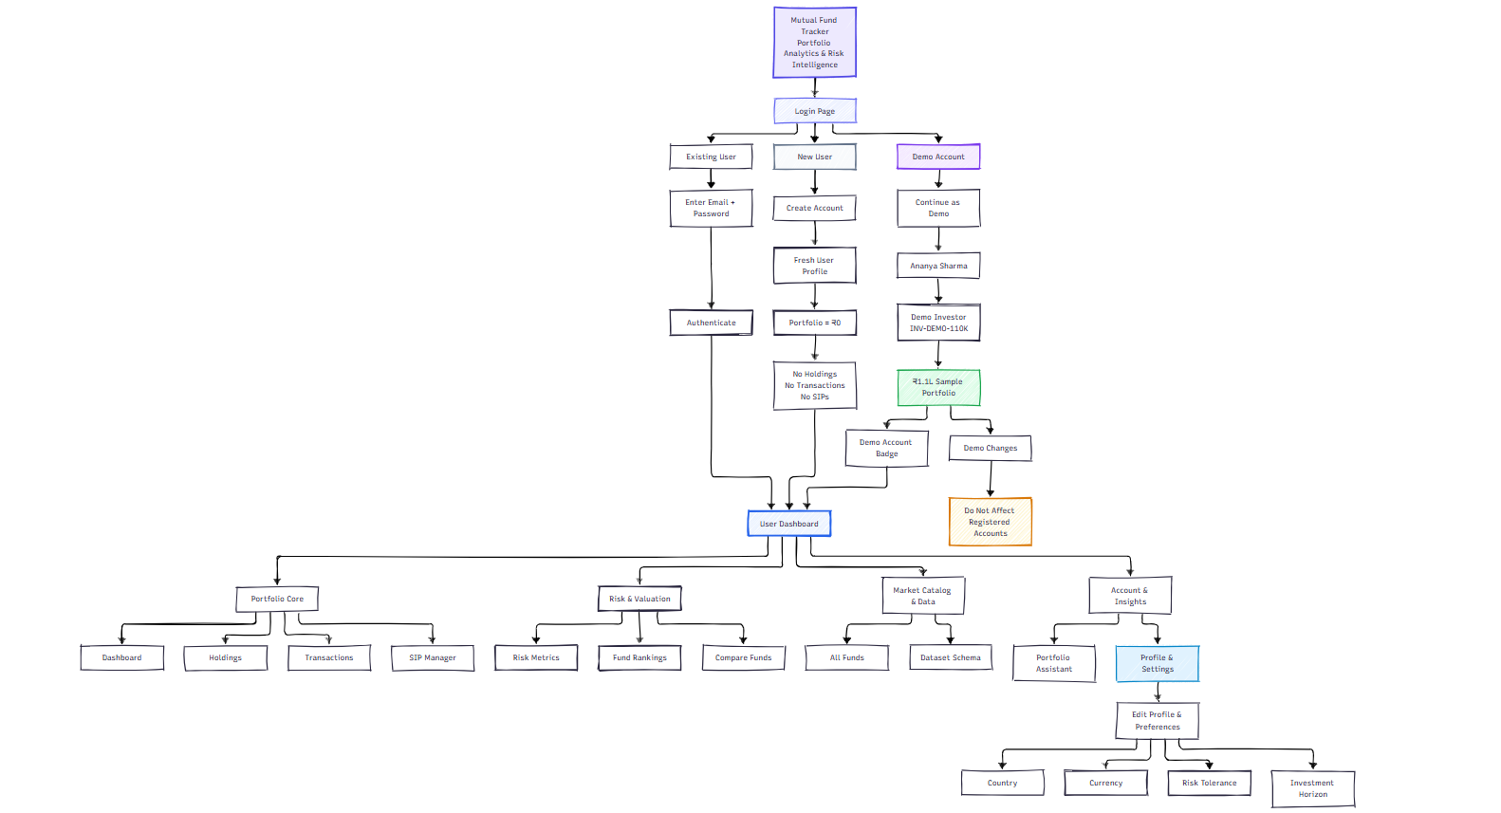
Figure 6.1: System architecture / application flow
Figure 6.2 shows the SOA architecture. The client uses the React Web UI, which calls REST Controllers. The controllers delegate to the User Service, Fund Service and Portfolio Service, each backed by its own repository (User Repository, Fund Repository and Transaction Repository), and to the other SOA services – Transaction, Analysis, AI, Dataset and Notification services.
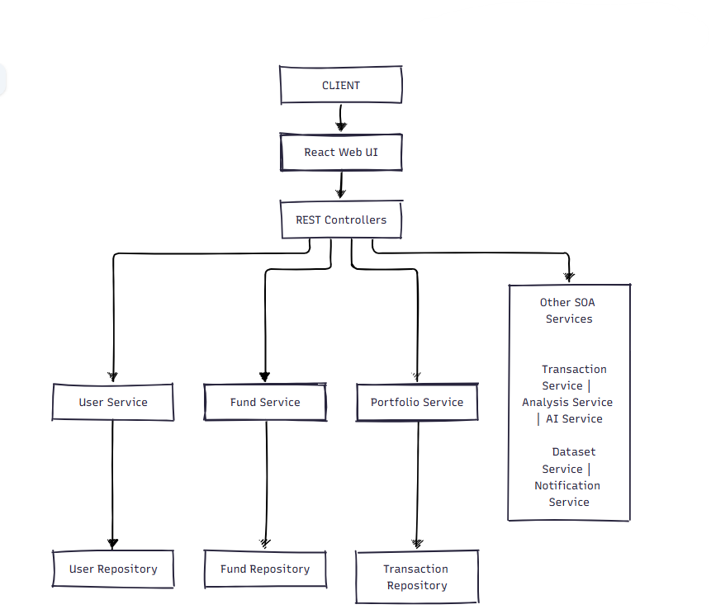
Figure 6.2: SOA architecture
1. Frontend (React, Vite, Tailwind CSS, Recharts):
Index.html:
<!doctype html>
<html lang="en">
<head>
<meta charset="UTF-8" />
<meta name="viewport" content="width=device-width, initial-scale=1.0" />
<title>Mutual Fund Analytics - AI-Powered Portfolio Tracking</title>
<meta name="description" content="AI-Powered Mutual Fund Portfolio Analysis and Investment Tracking System based on Service-Oriented Architecture (SOA)." />
<meta property="og:title" content="Mutual Fund Analytics - AI-Powered Portfolio Tracking" />
<meta property="og:description" content="AI-Powered Mutual Fund Portfolio Analysis and Investment Tracking System based on Service-Oriented Architecture (SOA)." />
<meta property="og:type" content="website" />
<meta name="twitter:card" content="summary_large_image" />
</head>
<body>
<div id="root"></div>
<script type="module" src="/src/main.jsx"></script>
</body>
</html>
Index.css:
@import "tailwindcss";

@theme {
--color-primary-indigo: #4F46E5;
--color-primary-hover: #4338CA;
--color-indigo-light: #EEF2FF;
--color-indigo-border: #C7D2FE;

--color-profit-emerald: #10B981;
--color-profit-bg: #ECFDF5;
--color-loss-rose: #F43F5E;
--color-loss-bg: #FFF1F2;

/* Aliasing legacy sage, cream, terracotta to clean Slate & Indigo so any remaining classes render in the original theme */
--color-sage-50: #EEF2FF;
--color-sage-100: #E0E7FF;
--color-sage-200: #C7D2FE;
--color-sage-300: #A5B4FC;
--color-sage-400: #818CF8;
--color-sage-500: #6366F1;
--color-sage-600: #4F46E5;
--color-sage-700: #4338CA;
--color-sage-800: #3730A3;
--color-sage-900: #0F172A;
--color-sage-950: #020617;
. . . . . … . . . . . . .

App.jsx:
import React, { useState, useMemo } from 'react';
import {
PieChart,
Wallet,
TrendingUp,
Activity,
Layers,
BarChart3,
Calendar,
Clock,
Sparkles,
Bot,
Database,
User,
Search,
Bell,
Plus,
ArrowUpRight,
ArrowDownRight,
AlertTriangle,
CheckCircle2,
Info,
ChevronRight,
Filter,
X,
RefreshCw,
Send,
Trash2,
ExternalLink,
ShieldCheck,
Scale,
LogOut,
Globe,
SlidersHorizontal,
ChevronDown
} from 'lucide-react';
import {
ResponsiveContainer,
PieChart as RechartsPieChart,
Pie,
Cell,
Tooltip,
Legend,
LineChart,
Line,
XAxis,
YAxis,
CartesianGrid
. . . . .. . . .. . . . .. . .
Main.jsx:
import { StrictMode } from 'react';
import { createRoot } from 'react-dom/client';
import App from './App.jsx';
import './index.css';

const rootElement = document.getElementById('root');
if (rootElement) {
createRoot(rootElement).render(
<StrictMode>
<App />
</StrictMode>
);
}
2. Backend (Java, Spring Boot):
AiInsightController:
package com.academic.portfolio.controller;

import com.academic.portfolio.dto.AIInsightDTO;
import com.academic.portfolio.service.AiInsightService;
import org.springframework.http.ResponseEntity;
import org.springframework.web.bind.annotation.*;

import java.util.Map;

@RestController
@RequestMapping("/api/ai")
@CrossOrigin(origins = "*")
public class {

private final AiInsightService aiInsightService;

public AiInsightController(AiInsightService aiInsightService) {
this.aiInsightService = aiInsightService;
}

@PostMapping("/insights")
public ResponseEntity<AIInsightDTO> getInsights(@RequestBody Map<String, String> body) {
String userId = body.getOrDefault("userId", "usr-default");
return ResponseEntity.ok(aiInsightService.generatePortfolioInsights(userId));
}

@PostMapping("/chat")
public ResponseEntity<?> chat(@RequestBody Map<String, String> body) {
String userId = body.getOrDefault("userId", "usr-default");
String message = body.getOrDefault("message", "");
String reply = aiInsightService.chatWithAssistant(userId, message);
return ResponseEntity.ok(Map.of("reply", reply));
}
}
MutualFund.java:
package com.academic.portfolio.model;

import jakarta.persistence.*;
import lombok.*;

import java.util.ArrayList;
import java.util.List;

@Entity
@Table(name = "mutual_funds")
@Getter
@Setter
@NoArgsConstructor
@AllArgsConstructor
@Builder
public class MutualFund {

@Id
private String id;

@Column(nullable = false, length = 500)
private String name;

@Column(length = 500)
private String schemeName;

private String category;

private String fundHouse;

private Double nav;

private String navDate;

private Double expenseRatio;

private Double aum; // In Crores

private String risk; // Low, Moderate, High, Very High

private Double returns1y;

. . . . . . .. . . . . . . . ..
MutualFundRepository:
package com.academic.portfolio.repository;

import com.academic.portfolio.model.MutualFund;
import org.springframework.data.jpa.repository.JpaRepository;
import org.springframework.data.jpa.repository.Query;
import org.springframework.stereotype.Repository;

import java.util.List;

@Repository
public interface MutualFundRepository extends JpaRepository<MutualFund, String> {

List<MutualFund> findByCategoryIgnoreCase(String category);

List<MutualFund> findByFundHouseIgnoreCase(String fundHouse);

@Query("SELECT DISTINCT f.category FROM MutualFund f WHERE f.category IS NOT NULL ORDER BY f.category")
List<String> findDistinctCategories();

@Query("SELECT DISTINCT f.fundHouse FROM MutualFund f WHERE f.fundHouse IS NOT NULL ORDER BY f.fundHouse")
List<String> findDistinctFundHouses();
}
3. API Integration:
The React frontend communicates with the backend over HTTP using JSON. Each REST controller exposes the endpoints of its service (for example authentication, funds, portfolio, transactions, SIPs, risk analysis and the assistant), and the services call one another through these REST APIs, which is what demonstrates the SOA principles. The dashboard values are computed in the backend and returned to the UI, which renders them as cards, tables and charts.
- RESULTS & DISCUSSION
The following screenshots show the working website. Each is followed by a short explanation.
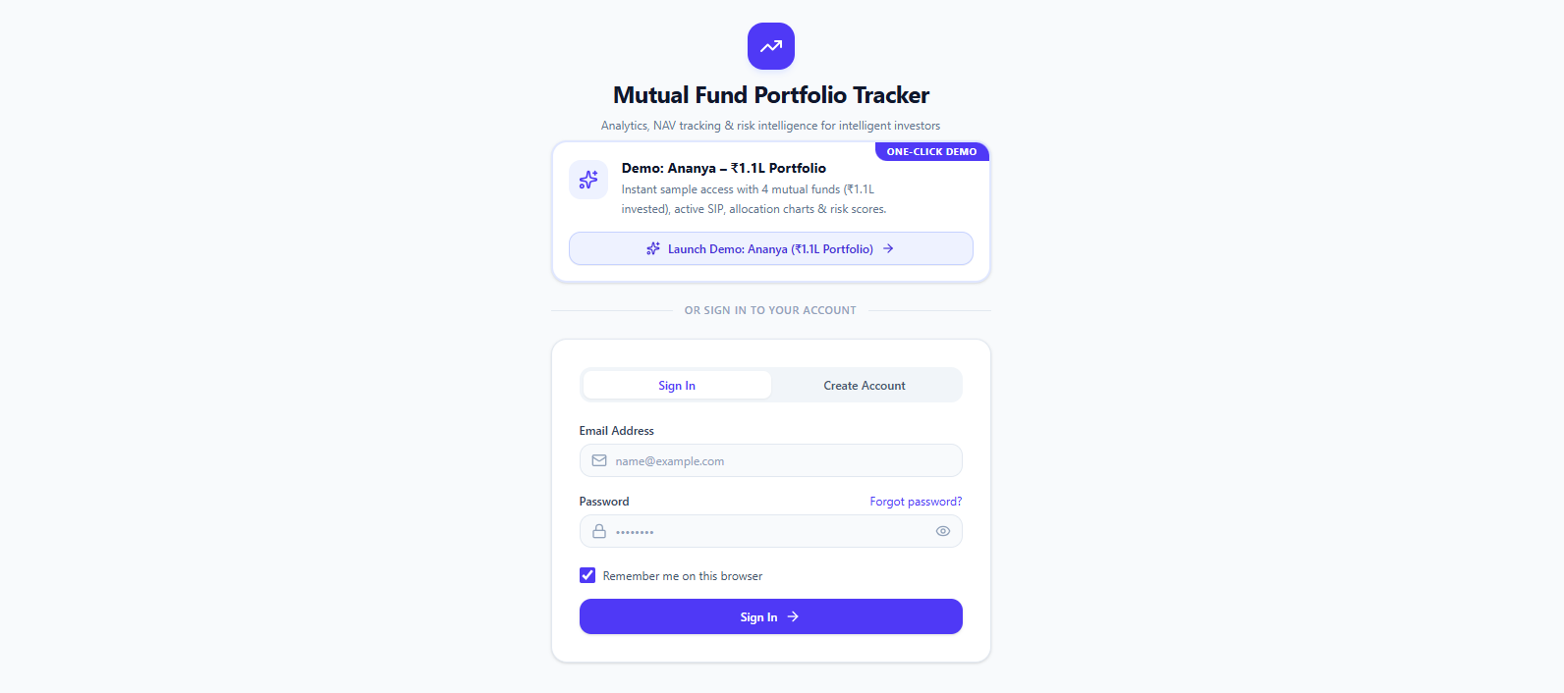
Figure 7.1: Login / Create Account page with one-click demo
The landing page of “Mutual Fund Portfolio Tracker” offers a one-click demo (Ananya – ₹1.1L portfolio with 4 funds, an active SIP, allocation charts and risk scores) or a normal sign-in. Existing users sign in with email and password, and new users can switch to the Create Account tab.
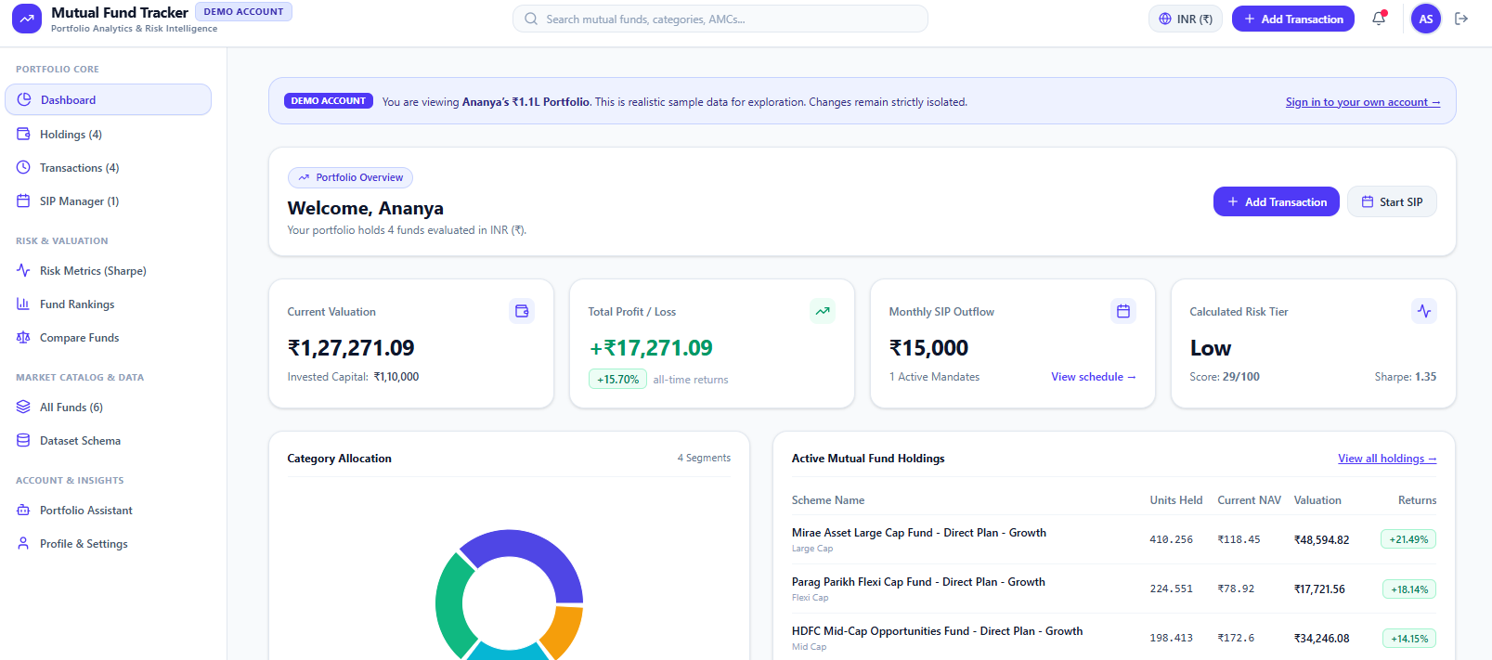
Figure 7.2: Dashboard (portfolio overview)
The dashboard shows the portfolio at a glance: current valuation of ₹1,27,271.09 on ₹1,10,000 invested, total profit of ₹17,271.09 (+15.70%), a monthly SIP outflow of ₹15,000 and a Low risk tier (score 29/100, Sharpe 1.35). It also shows the category allocation chart and the active holdings, while the sidebar gives access to Holdings, Transactions, SIP Manager, Risk Metrics, Fund Rankings, Compare Funds, All Funds, Dataset Schema, Portfolio Assistant and Profile & Settings.

The holdings visible on the dashboard are listed below. The valuation of each fund equals units held × current NAV (for example, 410.256 × ₹118.45 ≈ ₹48,594.82), and the total profit/loss equals the current valuation minus the invested capital (₹1,27,271.09 − ₹1,10,000 = ₹17,271.09, i.e. 15.70%).
Scheme name | Category | Units held | Current NAV | Valuation | Returns
Mirae Asset Large Cap Fund – Direct Plan – Growth | Large Cap | 410.256 | ₹118.45 | ₹48,594.82 | +21.49%
Parag Parikh Flexi Cap Fund – Direct Plan – Growth | Flexi Cap | 224.551 | ₹78.92 | ₹17,721.56 | +18.14%
HDFC Mid-Cap Opportunities Fund – Direct Plan – Growth | Mid Cap | 198.413 | ₹172.60 | ₹34,246.08 | +14.15%
Table 7.1: Active mutual fund holdings shown on the dashboard (demo account)
The results show that the system correctly tracks investments, valuation and returns for the demo portfolio, presents risk through a single risk tier and Sharpe ratio, and keeps the demo data separate from registered accounts.
- CONCLUSION & FUTURE SCOPE
Conclusion
This project set out to build an AI-powered system that tracks mutual fund investments and analyses portfolio performance, risk and diversification. The implemented web application meets these objectives: it manages holdings, buy/sell transactions and SIPs; computes units, NAV-based valuation, profit/loss and returns; reports a risk tier with a Sharpe ratio; shows category allocation through an interactive dashboard; supports fund ranking and comparison; and includes an AI Portfolio Assistant for personalised insights. By dividing the system into independent REST-based services (User, Fund, Portfolio, Transaction, Analysis, AI, Dataset and Notification), it also demonstrates the principles of Service-Oriented Architecture and gives investors one place to understand how their portfolio is performing and how risky it is.
Future Scope
Near term:
- Integrate live NAV data from AMFI so that valuations are updated automatically.
- Add benchmark-based comparison and more risk measures (for example beta and maximum drawdown).
- Add SIP and NAV alerts through the Notification Service (e-mail / in-app).
Medium term:
- Move the database from H2 to MySQL for persistent multi-user deployment.
- Add machine-learning based fund recommendation and NAV trend forecasting to the AI Service.
- Provide capital-gains/tax reports and downloadable portfolio statements.
Long term:
- Introduce an API gateway and containerised deployment (Docker/Kubernetes) so each service can scale independently.
- Develop a mobile application and support goal-based planning (retirement, education, etc.).
- Extend the platform to other asset classes such as stocks, ETFs and bonds, and to multiple currencies.
- REFERENCES
[1] S. R. Das and R. K. Jain, “Mutual Fund Performance: A Synthesis of Taxonomic and Methodological Issues.”
[2] N. Vafai and D. Rakowski, “The Sources of Portfolio Volatility and Mutual Fund Performance.”
[3] S. R. S. Prasad et al., “A Critical Analysis of Selected Mutual Funds in India.”
[4] Value Research Online – https://www.valueresearchonline.com
[5] Morningstar India – https://www.morningstar.in
[6] Groww Mutual Funds – https://groww.in/mutual-funds
[7] ET Money – https://www.etmoney.com
[8] Zerodha Coin – https://coin.zerodha.com
[9] Association of Mutual Funds in India (AMFI), NAV and industry data – https://www.amfiindia.com
[10] Spring Boot documentation – https://spring.io/projects/spring-boot ; React documentation – https://react.dev

