
DEPARTMENT OF CSE
PROJECT ABSTRACT SUBMISSION
COURSE: SOA PROGRAMMING AND MICROSERVICES– (24SDCS03) A.Y. 2026 - 2027
TITLE OF THE PROJECT | AI-Powered Mutual Fund Portfolio Analysis & Investment Tracking System
S. No. | University ID | Name
1 | 2420030239 | P Hansini
2 | 2420030241 | G Sreevarsha
3 | 2420030545 | Mani Charan Chava
Name of the Guide |  | Dr Venkateswari Ketineni

Abstract
The AI-Powered Mutual Fund Portfolio Analysis & Investment Tracking System is a smart financial management solution developed to simplify the way investors monitor, analyze, and evaluate their mutual fund investments. Managing a diversified mutual fund portfolio requires continuous tracking of investments, returns, risk, fund performance, asset allocation, and market movements. For many individual investors, manually collecting and interpreting this information from multiple sources can be difficult, time-consuming, and prone to errors.
The proposed system addresses these challenges by integrating Artificial Intelligence, Machine Learning, and Data Analytics into a single platform. It collects relevant mutual fund and portfolio information, preprocesses the data, and generates meaningful insights about investment performance and risk. The system can calculate important financial indicators such as total invested amount, current portfolio value, profit or loss, annualized returns, volatility, and fund-wise allocation. Machine learning techniques can further be used to identify performance patterns, compare mutual funds, classify risk levels, and generate personalized portfolio insights based on an investor's investment behavior and risk profile.
An interactive dashboard enables users to track their investments, view historical performance, analyze portfolio diversification, and receive alerts regarding significant changes in portfolio value or fund performance. Visualization techniques are used to present complex financial information in a simple and understandable manner.
By automating portfolio analysis and investment tracking, the system reduces manual effort and provides investors with a centralized platform for making informed, data-driven investment decisions. The proposed solution can be particularly useful for individual investors seeking better visibility, systematic monitoring, and intelligent insights into their mutual fund portfolios.

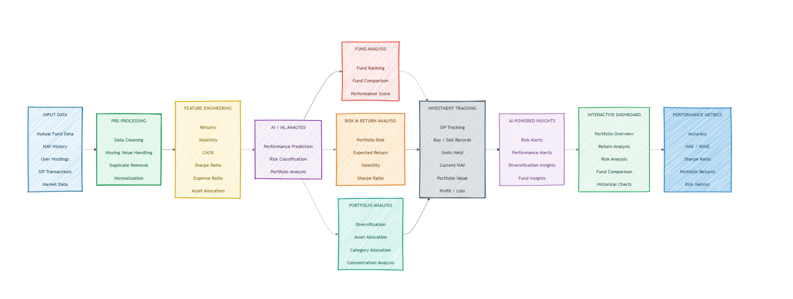
Project Architecture/Project Overview:

