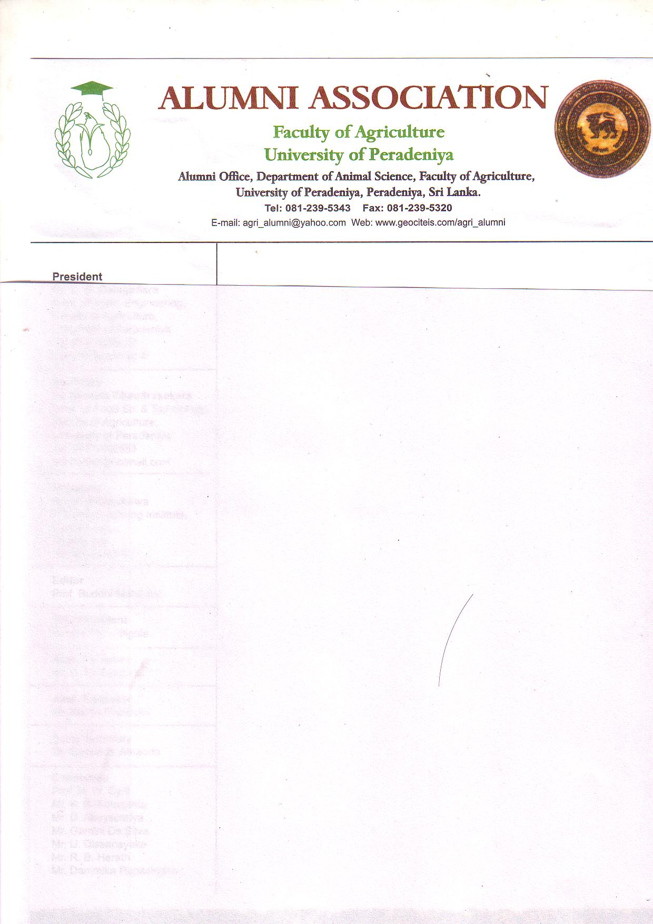

MEMBERSHIP APPLICATION FORM

**THE ALUMNI ASSOCIATION OF THE FACULTY OF AGRICULTURE**

**UNIVERSITY OF PERADENIYA**

Telephone/Fax

E mail: anuradhaj@agri.pdn.ac.lk

Web: https://www.pdn.ac.lk/alumni

Alumni Office, Department of Animal Science

Faculty of Agriculture

University of Peradeniya

Peradeniya

Life/Ordinary/Associate Member

Signature: ……………………………………………………

Date: ……………………………………………………………..

(FOR OFFICE USE ONLY)

*Details Overleaf

Signature: ………………………………………………………

Date: …………………………………………………………….

I hereby make an application to join the Alumni Association of the Faculty of Agriculture, University of Peradeniya as an Ordinary/ Associate members and I agree to abide its rules and regulations. I enclose herewith the subscription fee for current year (……………………………..)/ Life Membership.*

Field of Specialty (Discipline): ……………………………………………………………………………………………………………………………………..

Other Academic qualifications: …………………………………………………………………………………………………………………………………..

……………………………………………………………………………………………………………………………………………………………………………………..

……………………………………………………………………………………………………………………………………………………………………………………..

……………………………………………………………………………………………………………………………………………………………………………………..

Year of Graduation from the Fac. of Agric.: ………………………………

Occupation: ……………………………………………………….

Occupation: …………………………………………………………………………………………………………………………………………………………………..

Telephone: Fax: Email:

Official Address: ………………………………………………………………………………………………………………………………………………………..

…………………………………………………………………………………………………………………………………………………………

Telephone: Email:

Private Address: …………………………………………………………………………………………………………………………………………………………

…………………………………………………………………………………………………………………………………………………………

Full Name: Prof./Dr./Mr./Ms …………………………………………………………………………………………………………………………………….

……………………………………………………………………………………………………………………………………

EXTRACT FROM THE CONSTITUTION

THE ALUMNI ASSOCIATION OF THE FACULTY OF AGRICULTURE

UNIVERSITY OF PERADENIYA.

ARTICLE IV: MEMBERSHIP

1. There shall be three categories of members:
2. Ordinary Members:

Any person who is an Agriculture graduate of the Faculty

1. Associate Members:

Any graduate of a recognized University who is or has been a member of the academic staff or the Faculty.

1. Honorary Members:

Any person, who not being eligible for ordinary membership has rendered distinguished service to the Faculty, may be nominated by the Executive committee and be elected by the Association as an honorary member. The number of honorary members should not exceed twenty-five.

1. All ordinary members shall have the right to vote, to be nominated for office in the Association to propose and second the candidature for another member and receive all communications from the Secretary.

ARTICLE V. DUES OR LEVIES AND ARREARS

1. a. The subscription for life membership is Rs. 2000/=

c. The annual subscription for an associate membership shall be Rs. 500/=

d. The membership fee is subjected to alteration by the decision of an Annual or Special General Meeting.

Note. All Cheques should be crossed. “Account payee only” and made payable to the Alumni Association of the Faculty of Agriculture, University of Peradeniya.

Bank payment: BOC, Peradeniya Branch, M/S ALUMNI ASSN AGRI FAC: 1281933

SWIFT: BCEYLKLX (Please email the receipt or post)

**Please fill above “Application Form” and post it us to below address.**

**Alumni Office, Department of Animal Science**

**Faculty of Agriculture**

**University of Peradeniya**

**Peradeniya**

**Or**

**Email: the filled form and the payment receipt to** [**anuradhaj@agri.pdn.ac.lk**](mailto:anuradhaj@agri.pdn.ac.lk)

………………………………………………………………………………………………………………………………………………………………………..................

Telephone: +94 (0)81 2386002, 071-0666607

E mail: anuradhaj@agri.pdn.ac.lk

Web: <http://www.agri.pdn.ac.lk/alumini>