

USER INTERFACE DESIGN
23CSE113
ASSIGNMENT

Submitted by

Name | MUTTABATHULA HANSINI SARORA
Roll No | AV.SC.U4CSE25041
Year/Sem/Section | 1st year/Sem-2/CSE-A
Credits | 03

Submitted to

Name | Dr. RAJ KUMAR BATCHU
Department | School of Computing
Designation | Asst. Professor (SI Grade)

TASK – 1

1. AIM: To design an HTML application that is structured and user-friendly digital platform for the “Ministry of Home Affairs”.
PROGRAM:
The below one is the main program code.,
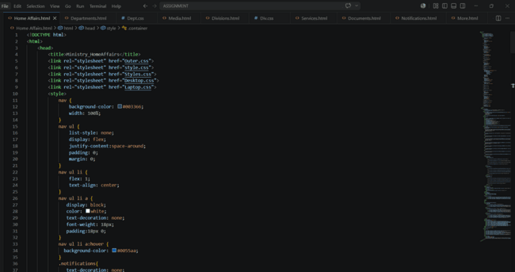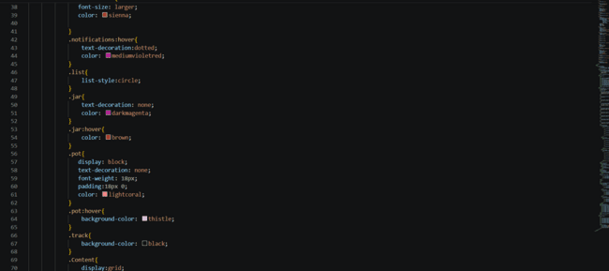
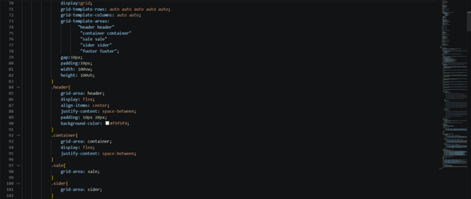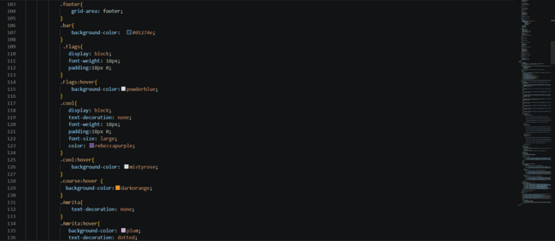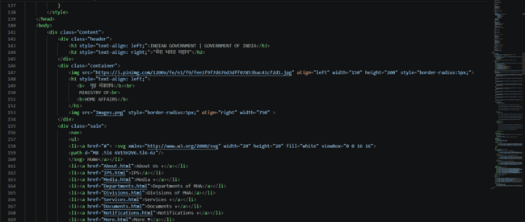
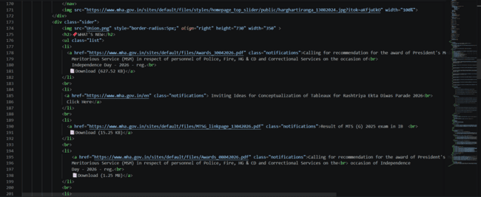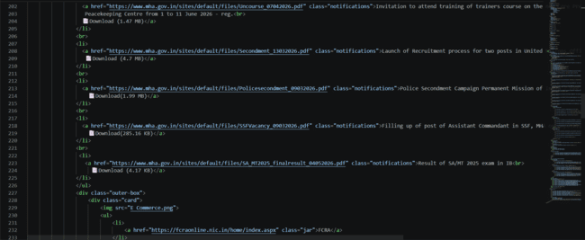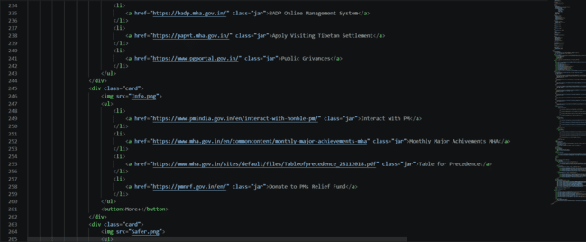
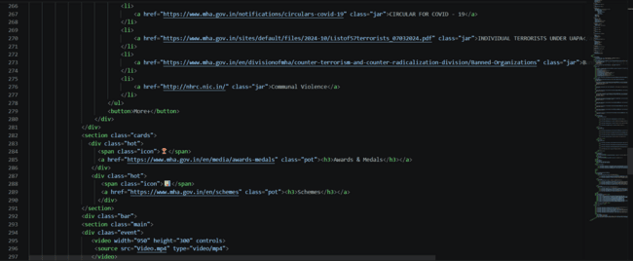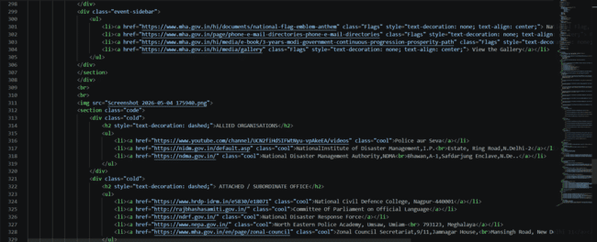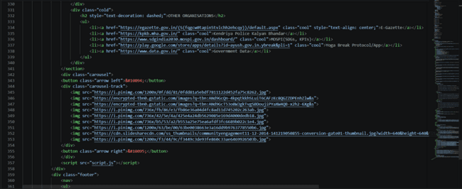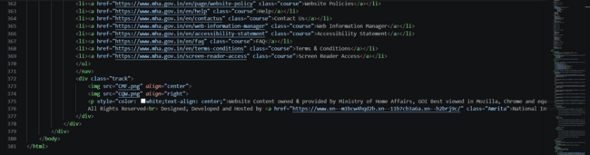
By clicking on any link in the website, it displays the content. So, the below one is the program of those content.,
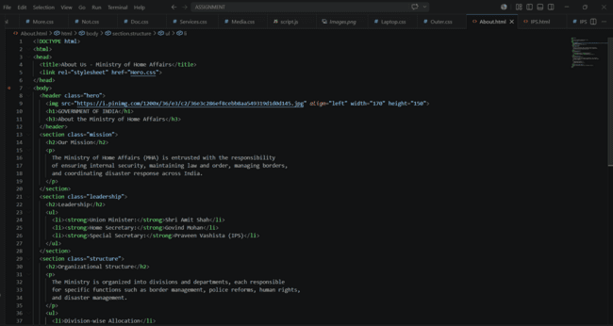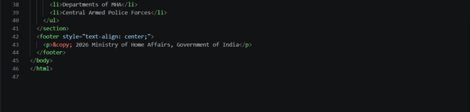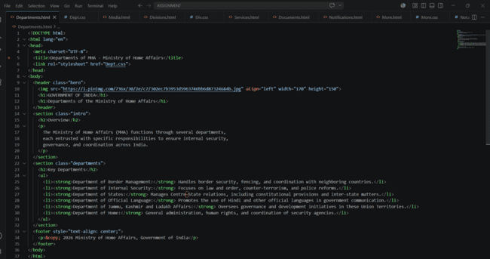
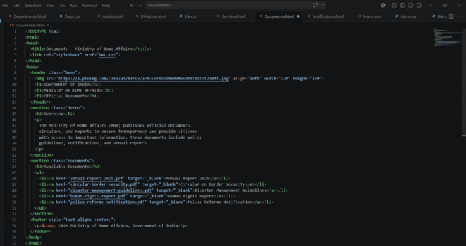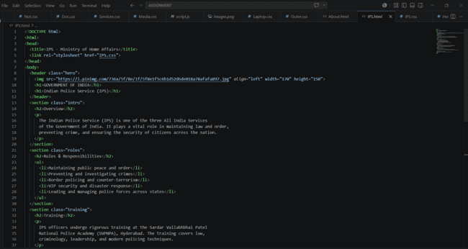

The below one are few more programs for those contents.,
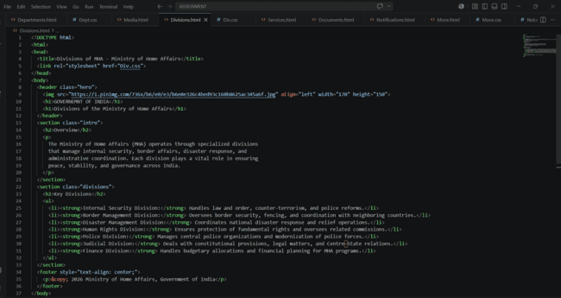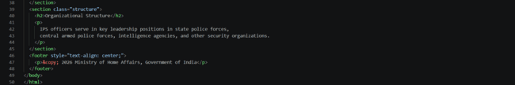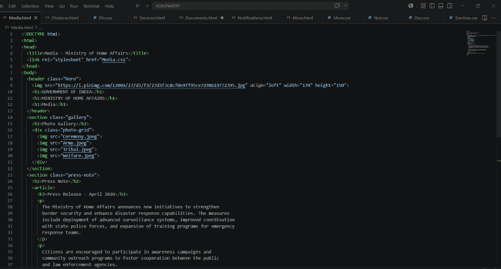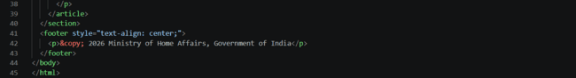

Few more programs.,
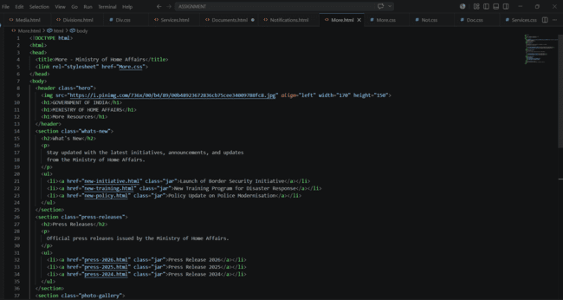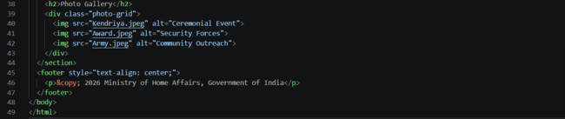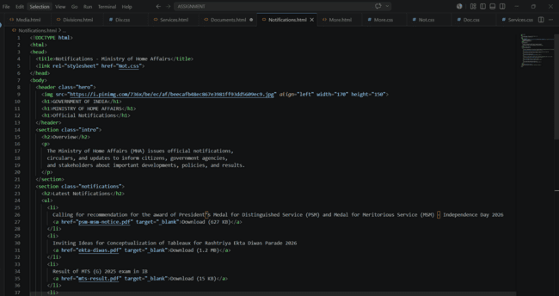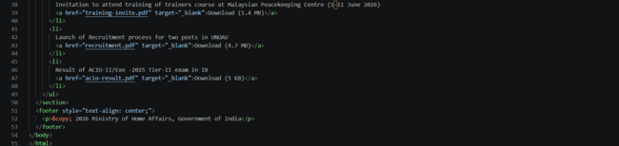
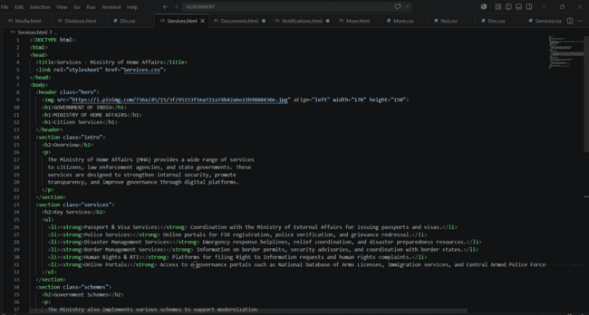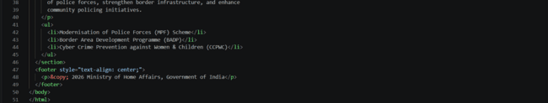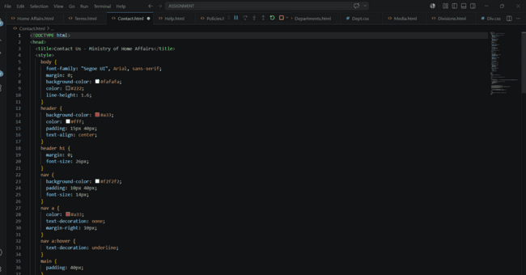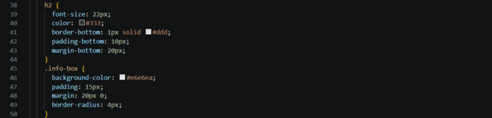
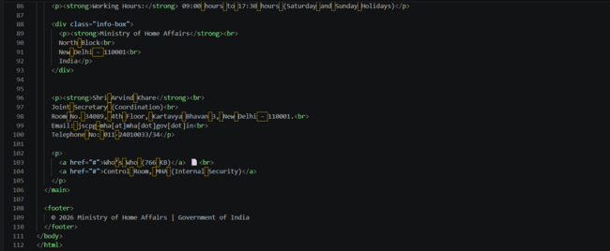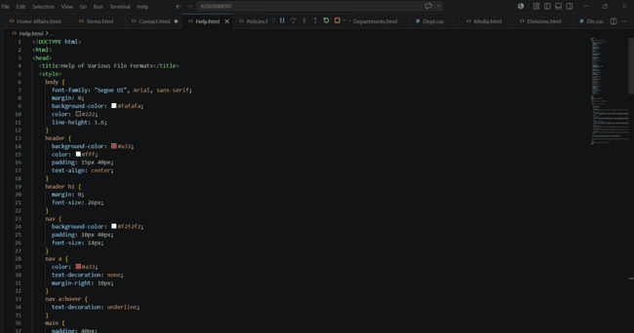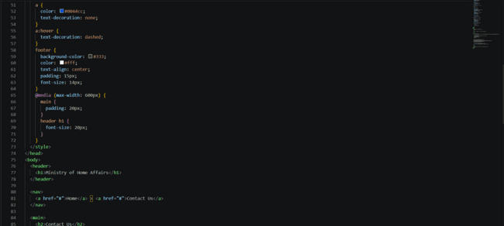

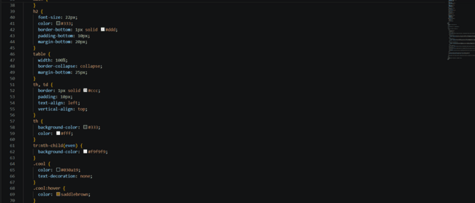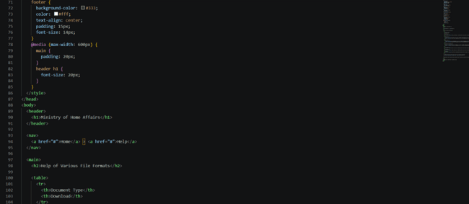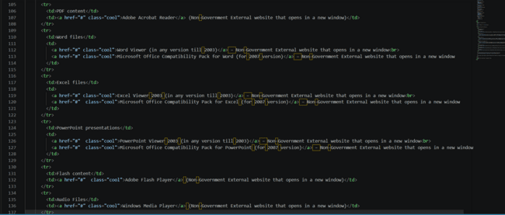
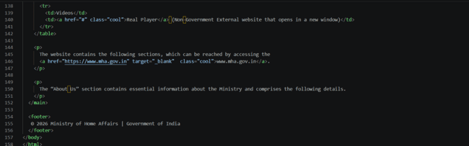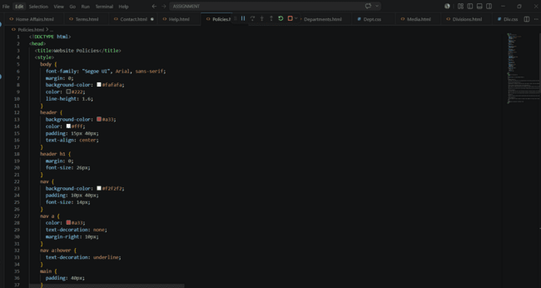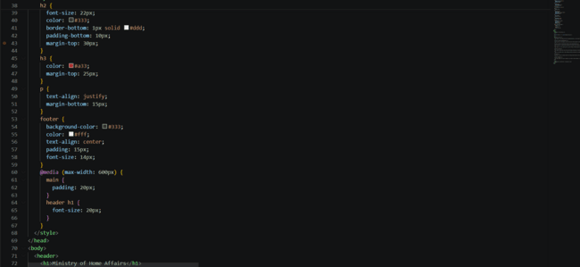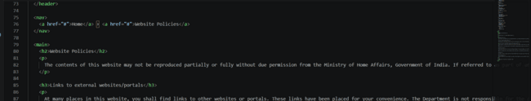
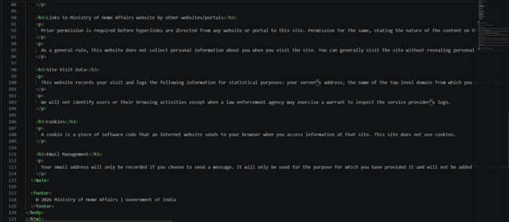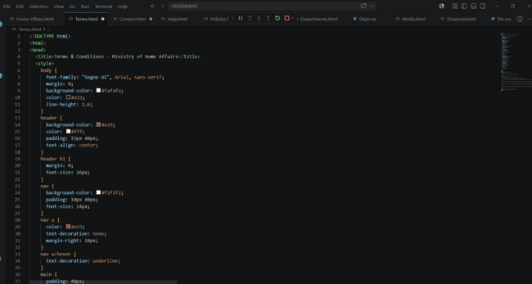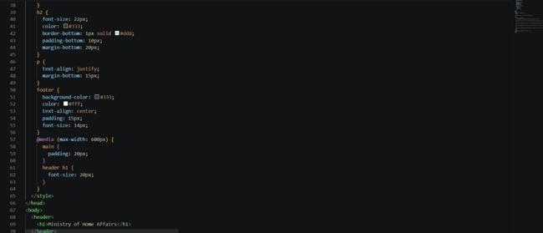
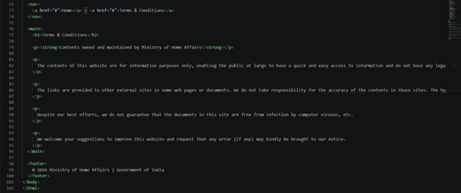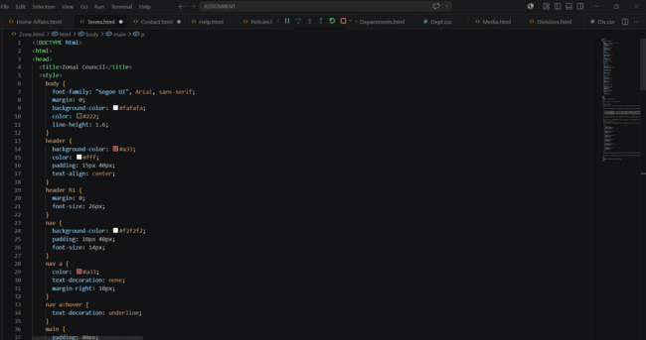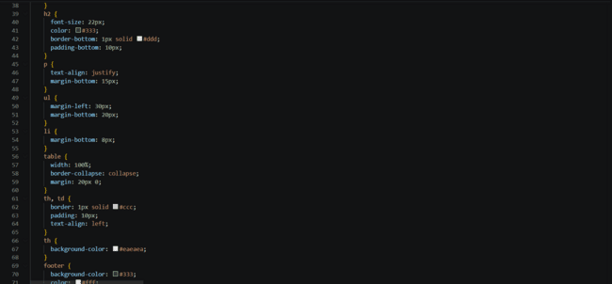
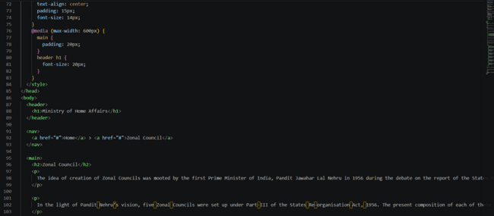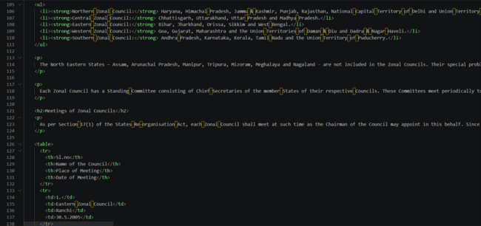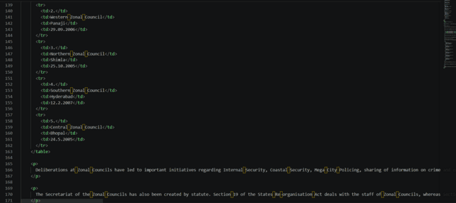

Then we have the Java Script for the program.,
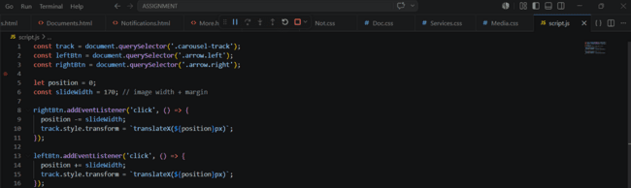

The next we have the CSS code for these programs and the main program code.,
Below are those.,
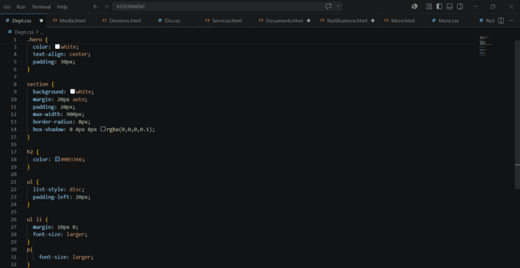
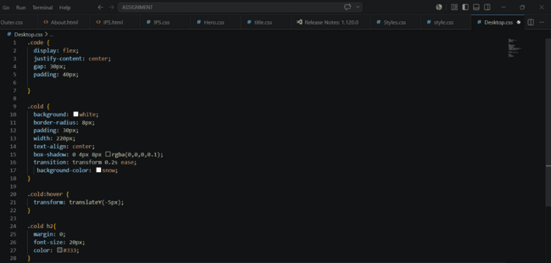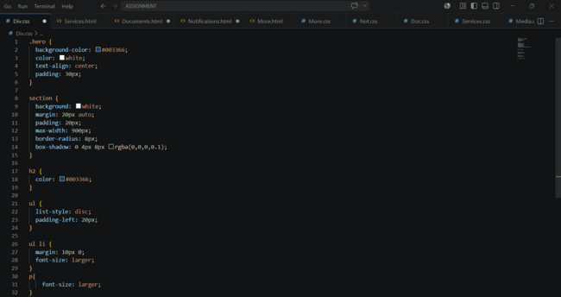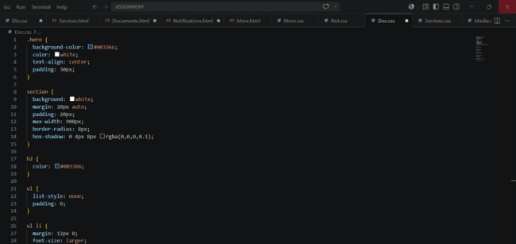
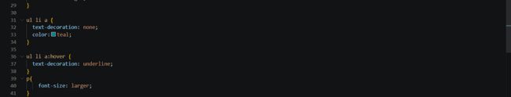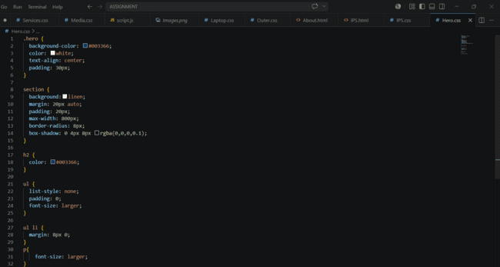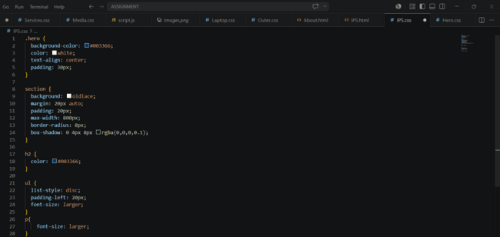

Few more programs.,
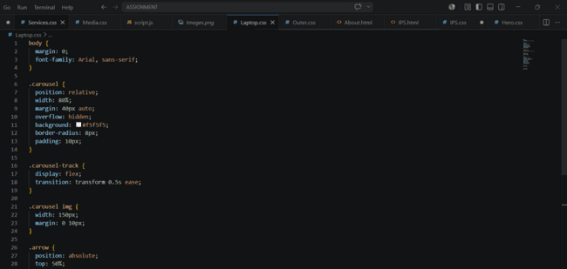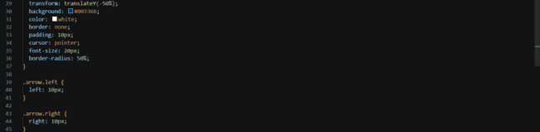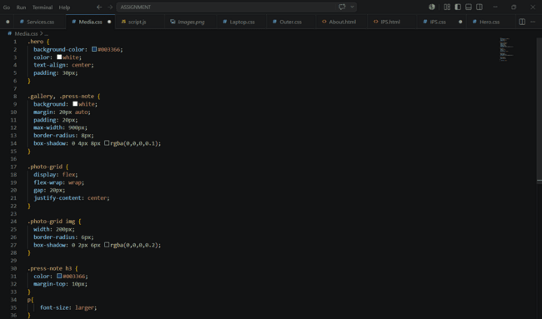
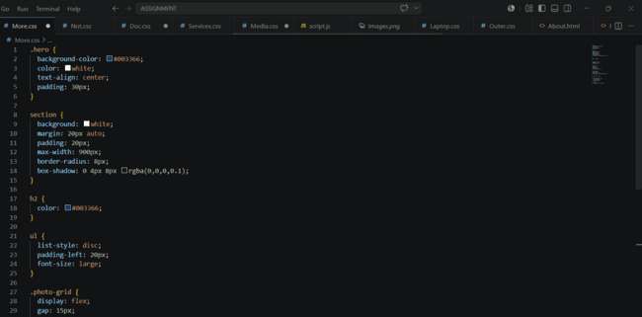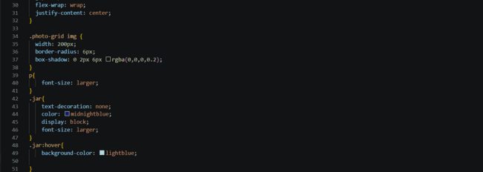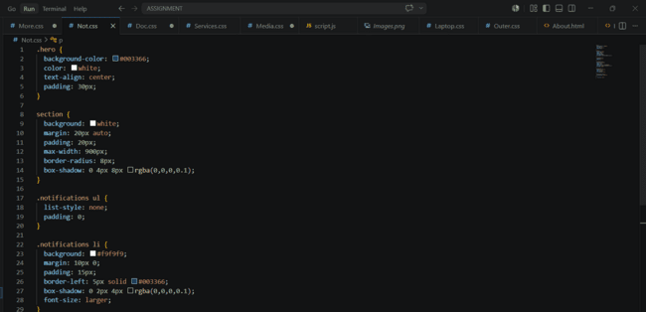
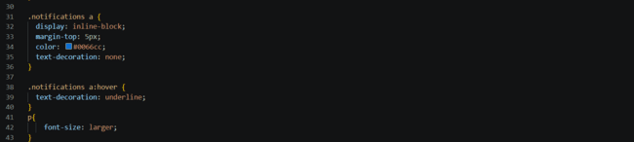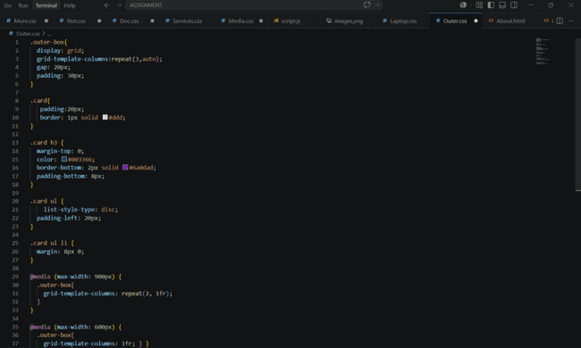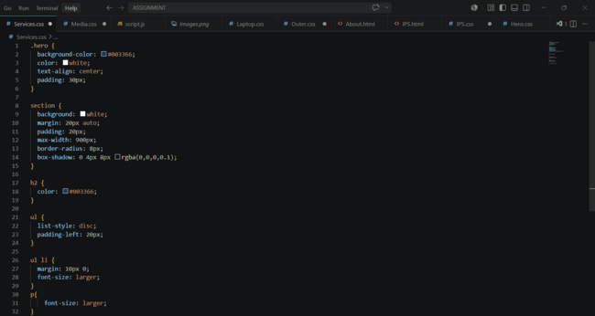

Few more for the main program.,

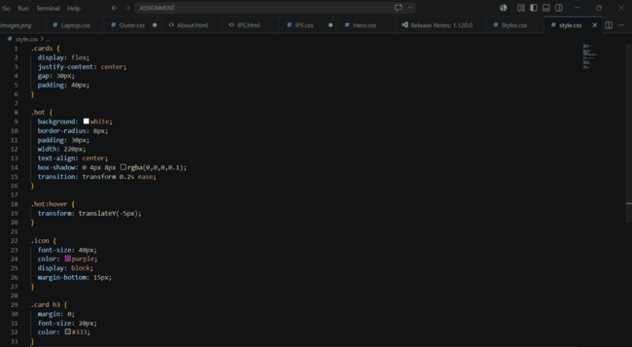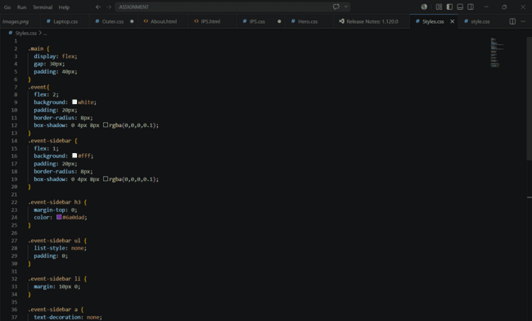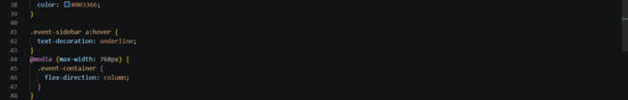

OUTPUT:
This program code is for the application of the official website of “Ministry of Home Affairs”.
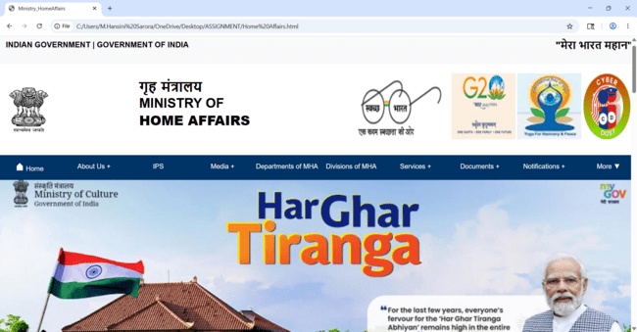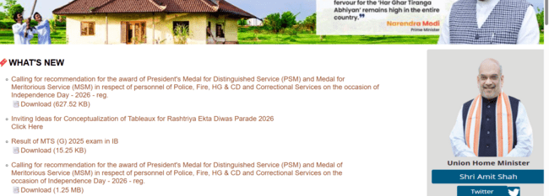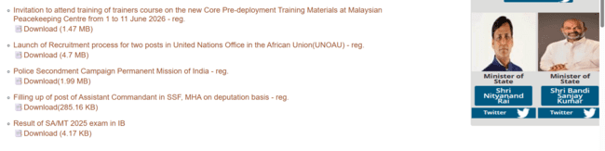

Down to the page we have more content.,

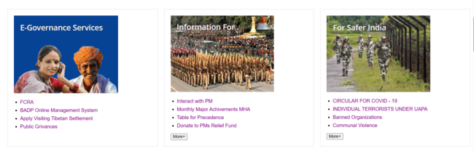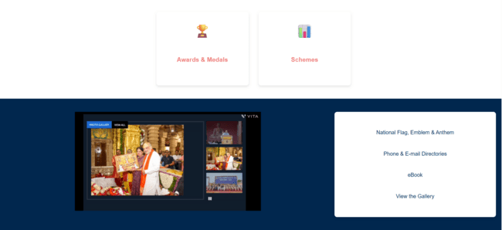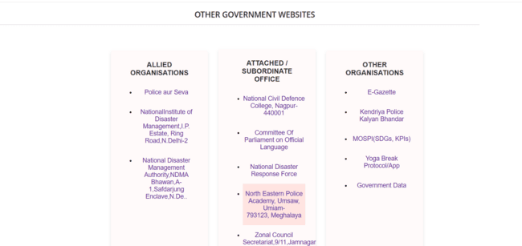
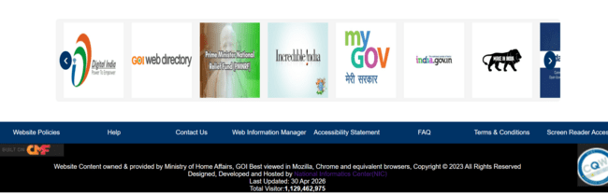
By clicking the Options provided in the website, it displays or takes us to related information or website mentioned in the official website.,

By clicking on the “About us”, the information related to it displays on other page.,

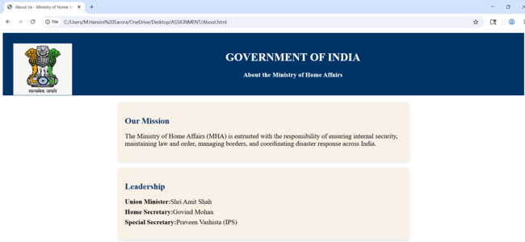

By clicking on the “IPS”, the information related to it displays on other page.,

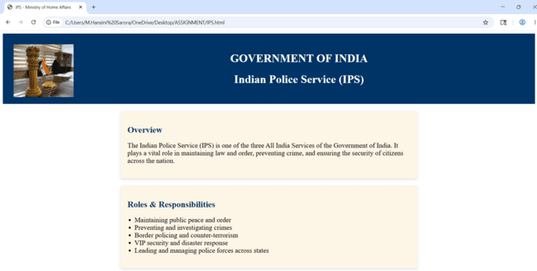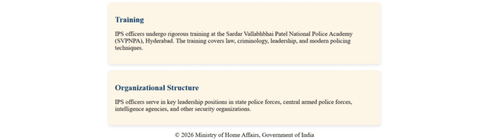

This Page gives you the information regarding the Indian Police Services in India.

By clicking on the “Media”, the information related to it displays on other page.,

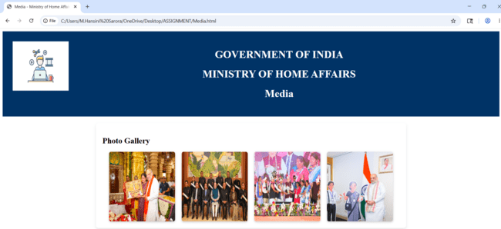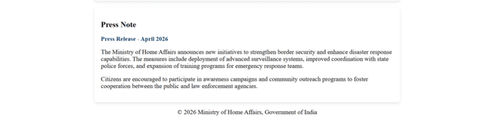

This page gives you the information regarding the media and Photo Gallery of Home Affairs.

By clicking on the “Departments of MHA”, the information related to it displays on other page.,

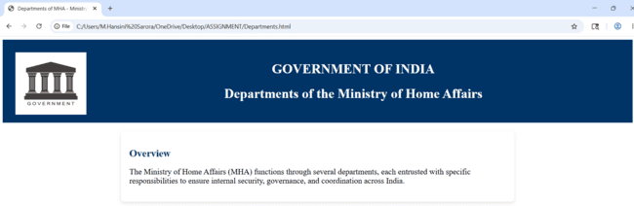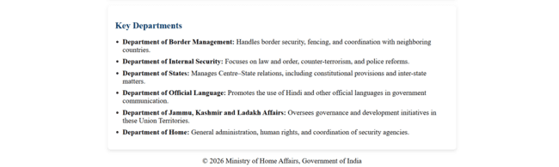

This page gives you the information regarding the Department present in Ministry of Home Affairs and its Overview.

By clicking on the “Divisions of MHA”, the information related to it displays on other page.,

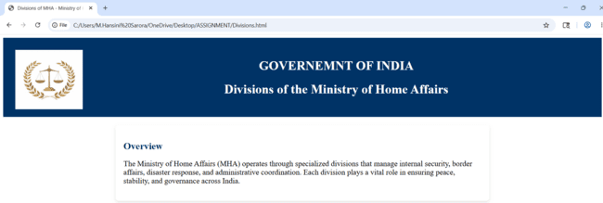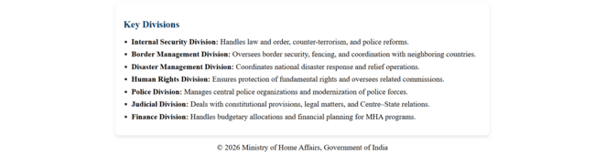

This page gives you the information regarding the divisions of Ministry of Home Affairs and its Overview.

By clicking on the “Services”, the information related to it displays on other page.,

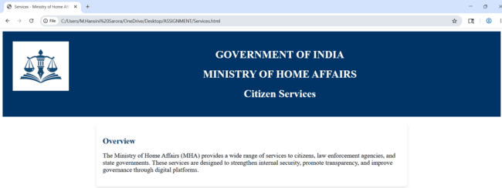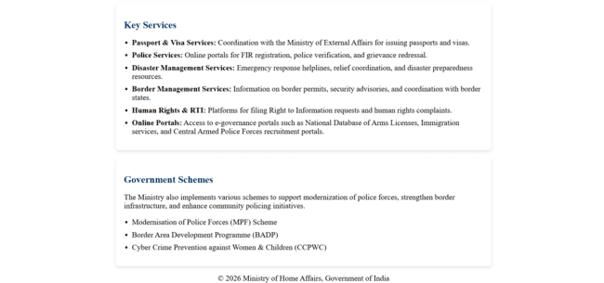

This pages gives you the information regarding the Services of Ministry of Home Affairs and its Key Services.

By clicking on the “Documents”, the information related to it displays on other page.,

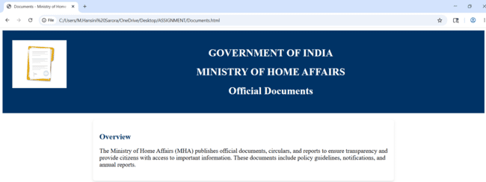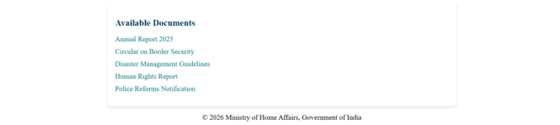

This page gives you the information regarding the Official Documents of MHA and its Overview.

By clicking on the “Notifications”, the information related to it displays on other page.,

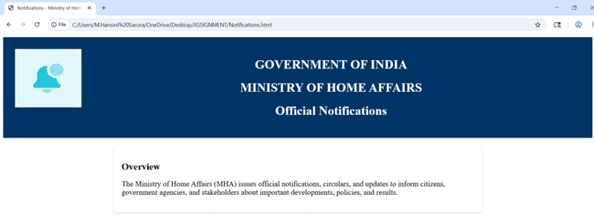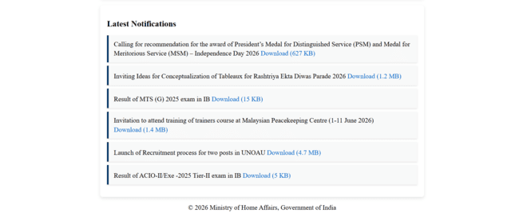

This page tells you all about the Notifications being released in the official website of MHA.

By clicking on the “More”, the information related to it displays on other page.,

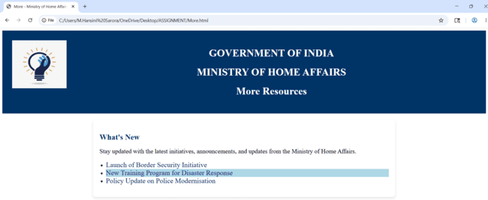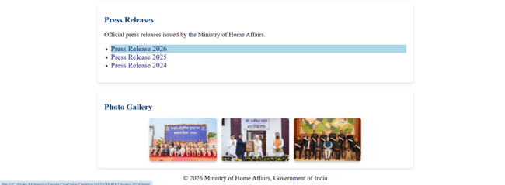

By clicking on the “What’s New” and their subtopics, the information related to it displays on other page.,

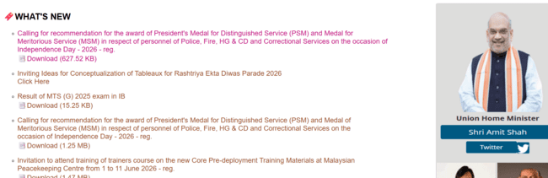
By clicking on the information down to “What’s New” it changes its font colour to let us know, on which content we clicked.,
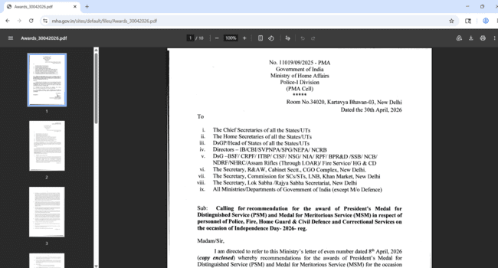
The related note in the form of PDF we can see.,
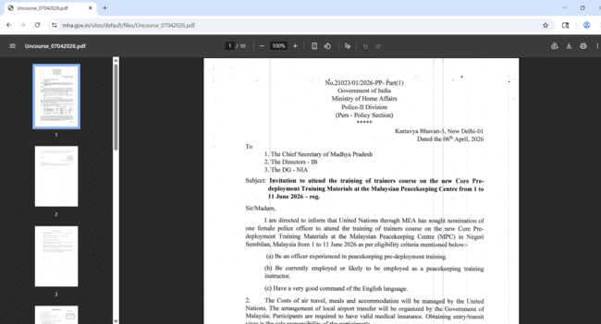
Same with all those which are in “What’s New”, where the content will be in the form of PDF.,
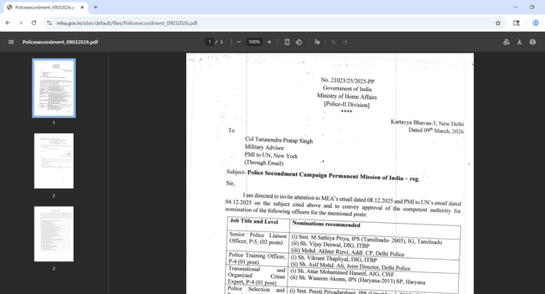

By clicking on the “E-Governance Services”, the information related to it displays on other page.,
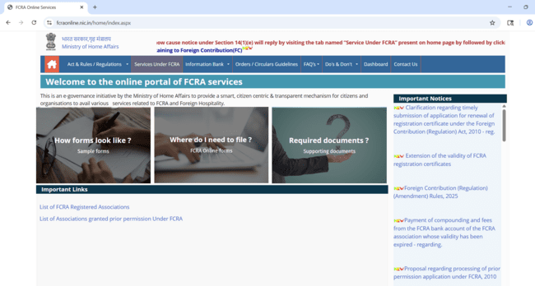

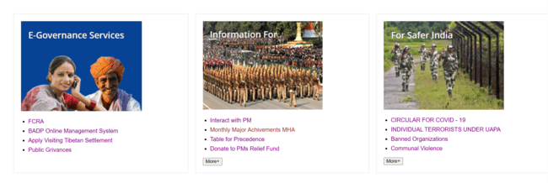
By clicking on the information down to any of the section’s it changes its font colour to let us know, on which content we clicked.,
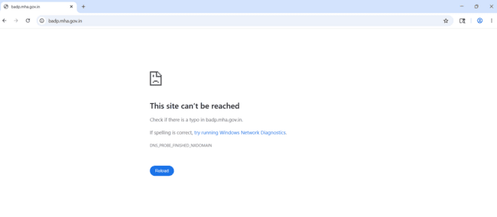
Where few sections have these problems.,
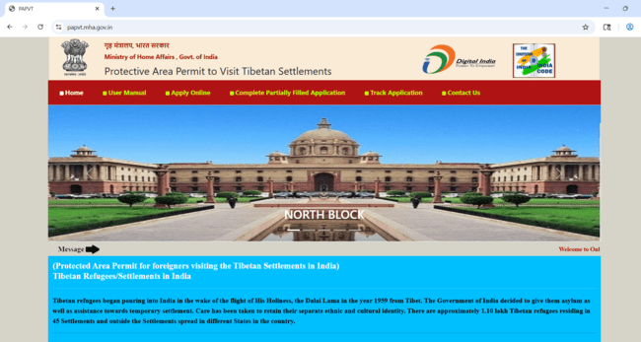
By clicking on the “Applying visting Tibetan Settlements” it takes
you to the related website linked to this.,
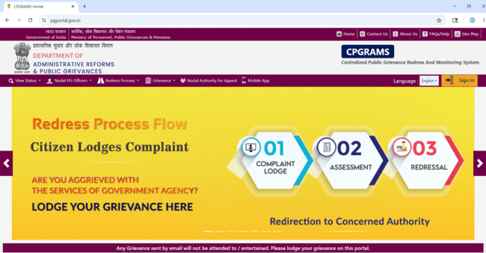
Same with few sections.,
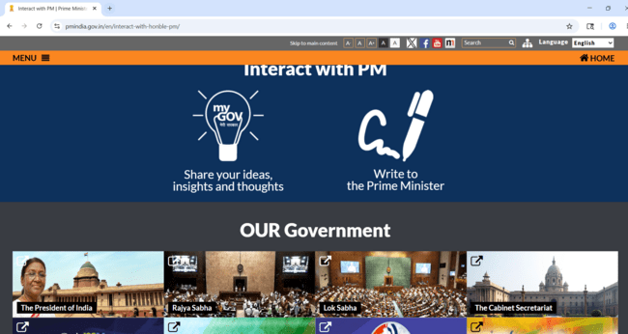
Here are few to that.,
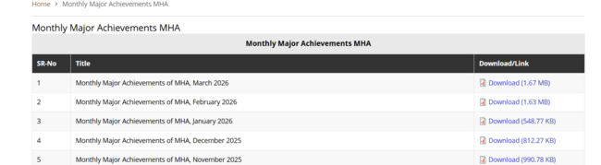
Again the note of PDF.,
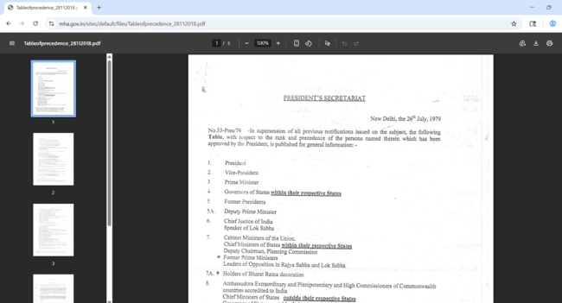
Takes to the related website linked to this.,
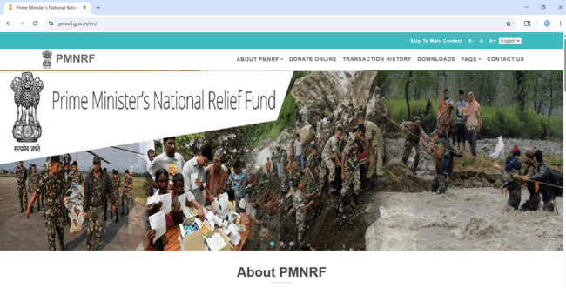

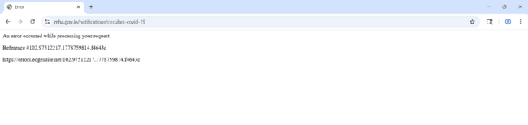
Error for few sections in the website as above.,

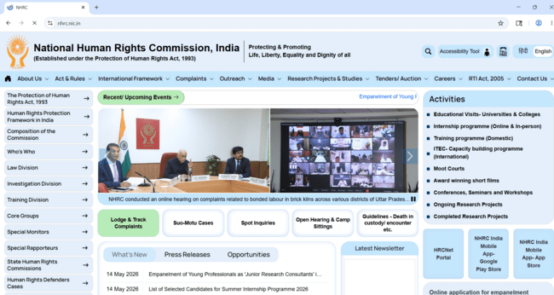
Takes you the related website as above.,



There is the slight transition while placing the cursor on them, with the change in the font colour.,

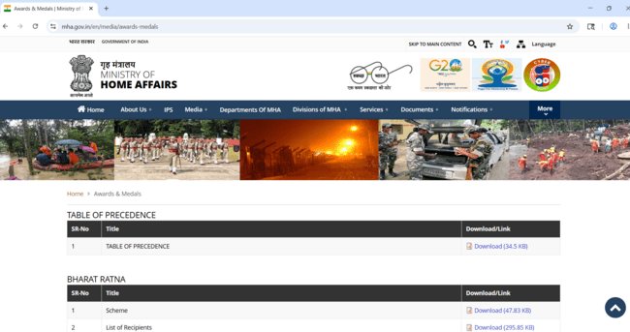
By clicking on the “Schemes”, the information related to it displays on other page.,
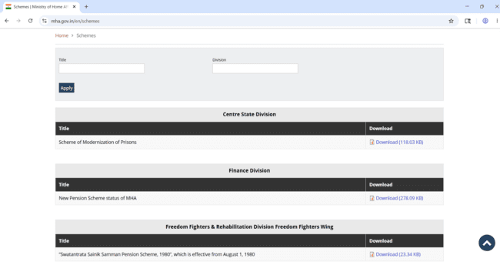

By clicking on any of the section it changes its font colour to let us know, on which content we clicked.,

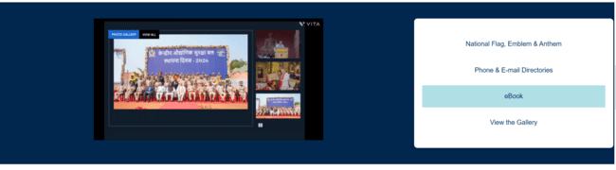
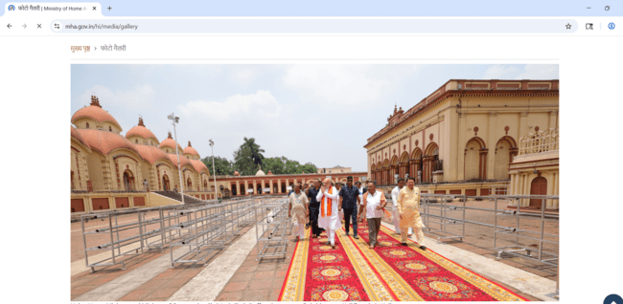
The “Gallery” section is opened.,
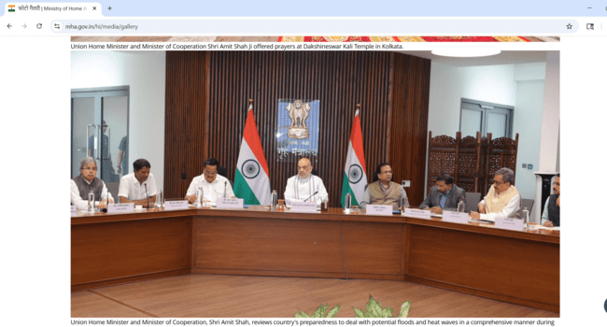
Few more, above.,
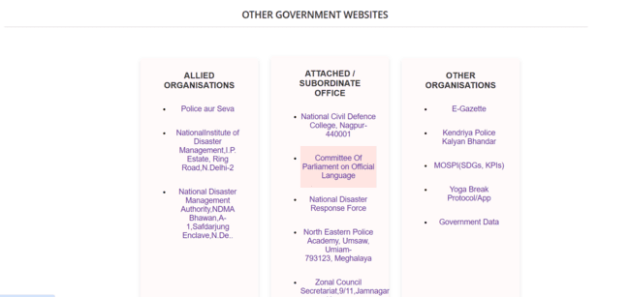
There is the slight transition while placing the cursor on them, with the change in the font colour.,
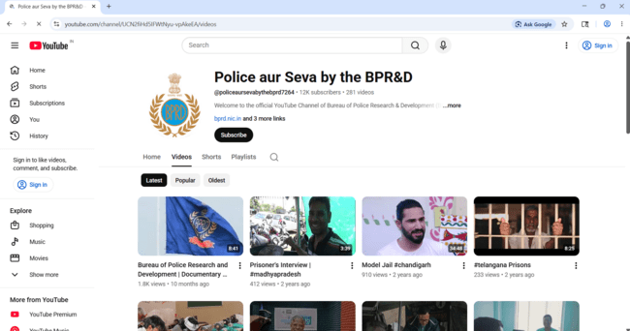
By clicking on the “Police aur Seva”, it takes you to the youtube channel related to the Police.,

By clicking on the “National Institute of Disaster Management”, it takes you to the website related to it.,

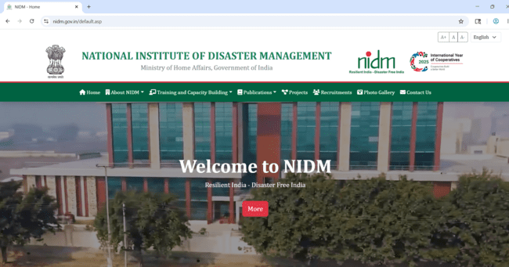

By clicking on the “National Disaster Management Authority”, it takes you to the website related to it.,

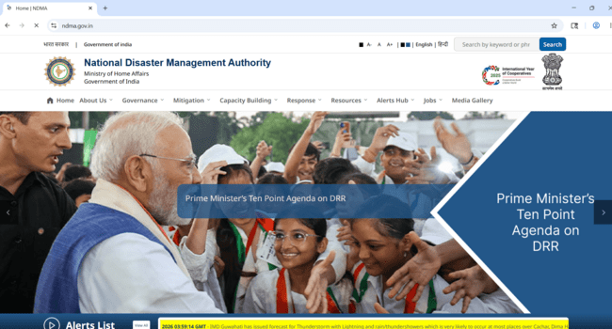

By clicking on the few section it gives error or page not found.,

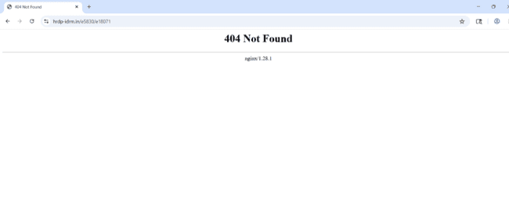
By clicking on the “National Disaster Response Force”, it takes you to the website related to it.,

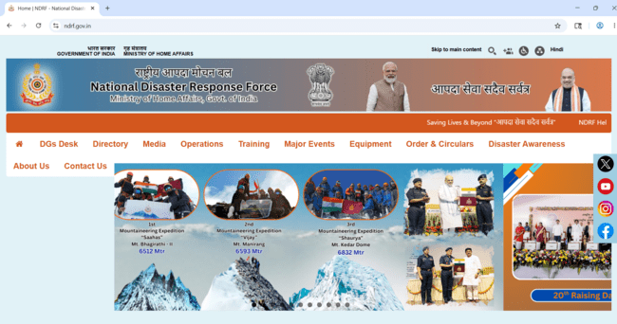

By clicking on the “North Eastern Police Academy”, it takes you to the website related to it.,

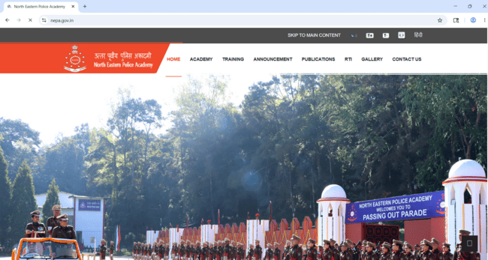

By clicking on the “E-Gazette”, it takes you to the website related to it.,
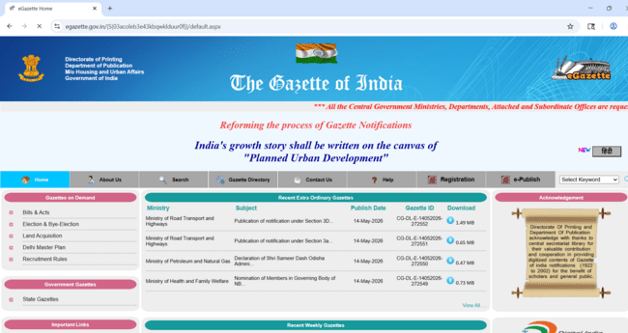

By clicking on the “Zonal Council”, it gives you the content related to it as below.,

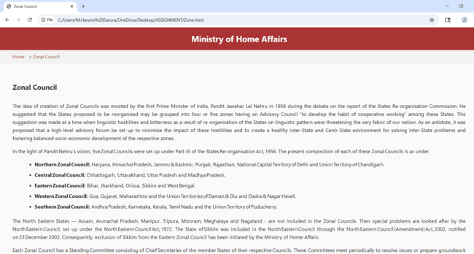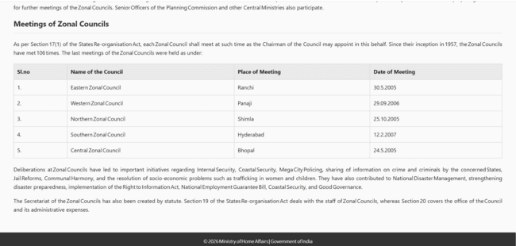

By clicking on the “MOSPI”, it gives you the content related to it.,

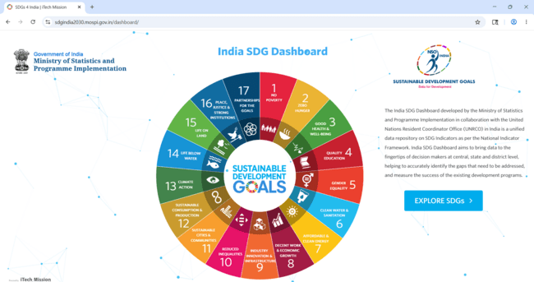

By clicking on the “YOGA BREAK”, it redirects you to it.,

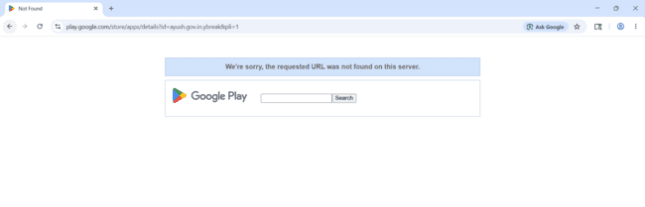

By clicking on the “Government Data”, it redirects you to the below website.,

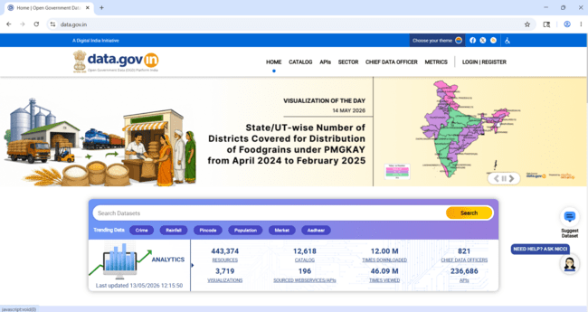

There is slight transition by clicking on the left or right arrow it gives the next or previous images in the list.,

Like the above one.,
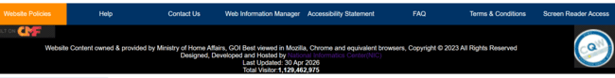
By clicking on any of the one, it gives a background colour backside to it, to know what we have clicked.,

Same in the content with Footer Section.,
By clicking on the “Website Policies”, it gives you the content related to it as below,

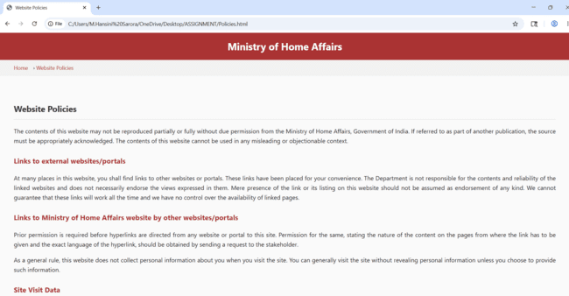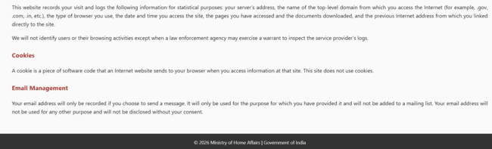

By clicking on the “Help”, it gives you the content related to it as below.,

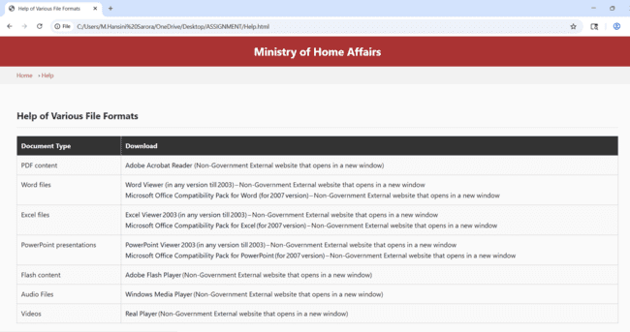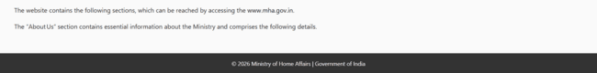

By clicking on the “Contact Us”, it gives you the content related to it as below.,

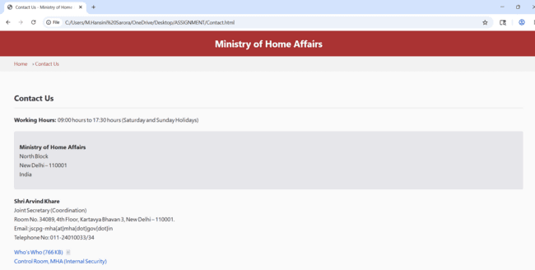

By clicking on the “Web Information Manager”, it gives you the content related to it as below.,

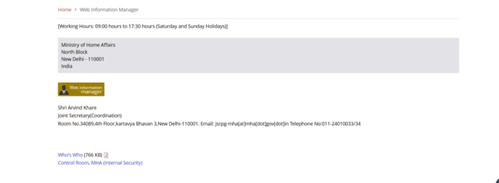
By clicking on the “Accessibility Statement”, it gives you an error.,

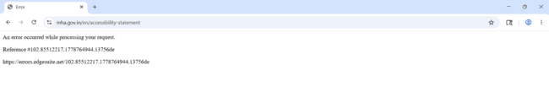
By clicking on the “FAQ”, it gives you the content related to it as below.,

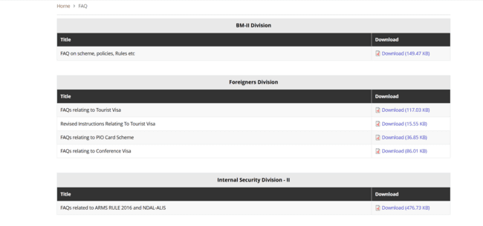
By clicking on the “Terms & Conditions”, it gives you the content related to it as below.,

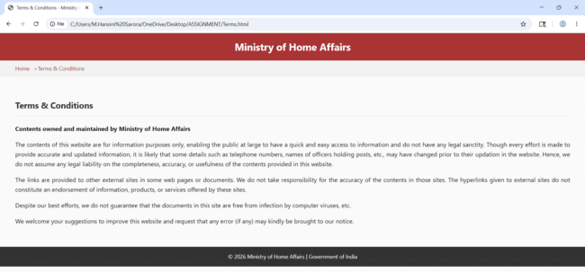
By clicking on the “National Informatics Centre”, it takes you to the website related to it.,

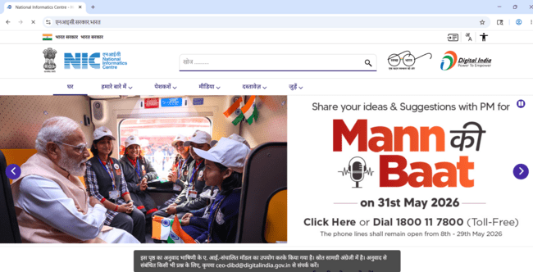

EXPLANATION OF TAGS:
- Line Breaks: <br>tag defines a line break. This is an "empty" tag, meaning it doesn't need a closing tag.
- Images: <img>. Mentions the src (source) and alt (alternative text) attributes, width, and height are provided as attributes.

Attributes are used to provide additional information about HTML elements.
The src attribute specifies the path to the image to be displayed.
- Hyperlinks: <a> (Anchor tag). Mention the href attribute which holds the URL of the page the link goes to.

<a> Tag:
- The <a> tag in HTML is called the anchor tag.
- It is used to create hyperlinks — clickable text or images that take you to another page, section, or resource.

href Attribute:
- href stands for Hypertext REFerence.
- It tells the browser where the link should go.
- The value of href can be:
  - A URL (e.g., href="https://example.com")
  - A relative path (e.g., href="about.html")

a {

color: #0044cc;

text-decoration: none;

}

a: hover {

text-decoration: underline;

}

This makes links blue and removes the underline by default, but shows an underline when you hover over them.
The Core Table Structure;
1.<table>: The wrapper element that defines the start and end of the table.
2.<tr> (Table Row): Defines a single horizontal row of cells.
3.<th> (Table Header): Used for header cells (usually bold and centered by default). These represent the titles of columns or rows.
4.<td> (Table Data): Defines a standard data cell.
5.<caption>: Provides a title or summary for the table, usually displayed directly above the grid.
In HTML, style is an attribute used to change the visual appearance of an element.
Style Attribute:
In HTML, style is an attribute used to change the visual appearance of an element.
While HTML provides the structure (like text, rows, and columns), the style attribute provides the design (like colors, fonts, and spacing).
The <nav> tag in HTML is used to define a navigation section of a webpage — it tells browsers, screen readers, and search engines that the links inside are meant for navigating the site, not just random hyperlinks.
🔑 Key Uses of <nav>
- Groups together main navigation links (like Home, About, Contact).
- Improves accessibility — screen readers can jump directly to navigation.
- Helps SEO — search engines understand site structure better.
- Keeps code organized by separating navigation from other content.
1. The <div> (Division) Element;
Think of a <div> as an invisible box. On its own, it doesn't do anything or change the look of the page. It is a "block-level" container used to group related elements together so you can style them with CSS or manipulate them with JavaScript.
- In Forms: You’ll often wrap a <label> and an <input> inside a <div> to keep them together and create spacing between different rows of the form.
- Organization: It helps break a webpage into logical sections like a header, sidebar, or gallery.
<div style = “display: flex; gap: 20px; flex-wrap; wrap;”>
Display: Activates flex box layout places child elements in a row make alignments and spacing easier.
“HTML handles structure, CSS handles design.”
CSS (Cascading Style Sheets);
CSS is the language used to style HTML documents. While HTML provides the structure (headings, paragraphs, images, links), CSS controls how those elements look — colours, fonts, spacing, layout, and responsiveness.
These are of three types;
a. Inline CSS b. Internal CSS c. External CSS
1.External CSS:
- External CSS is a way to keep your styling separate from your HTML structure.
- Instead of writing styles directly inside your HTML file, you place them in a separate .css file and then link that file to your HTML document
- An external style sheet is used to define the style for many HTML pages.
- To use an external style sheet, add a link tag in the <head> section of each HTML page.
- The <link> tag is used to connect external resources to an HTML document.
- Reusability: One CSS file can style multiple HTML pages.
<link rel="stylesheet" href="Styles.css">
“rel” attribute specifies the relationship between the current document and the linked document/resource.
2.INLINE CSS:
- Inline CSS means applying styles directly to a specific HTML element using the style attribute.
- An inline CSS is used to apply a unique style to a single HTML element.
- An inline CSS uses the style attribute of an HTML element.
- Affects only the element where it’s written.
- Instead of keeping styles in a separate file (external CSS) or in the section (internal CSS), you write them right inside the tag.
- Useful for testing or applying unique styles to one element.
3.INTERNAL CSS:
- An internal CSS is used to define a style for a single HTML page.
- An internal CSS is defined in the <head> section of an HTML page, within a <style> element.
<head>
<style>

Within this style tag, we can write color, font, the size of text, the spacing between elements, etc.

</style>
</head>
- Good for single-page projects or when styles are unique to one page.
- Unlike inline CSS (which applies styles directly to one element), internal CSS lets you define styles for multiple elements in one place, but only affects that single HTML page.
CSS Grid Layout is a powerful system for creating two-dimensional layouts in web design. It lets you define rows, columns, and named areas, while values like “auto” and “1fr” control how space is distributed.
1. display: grid;
- Turns an element into a grid container.
- Its direct children become grid items.
- Enables properties like grid-template-rows, grid-template-columns, and grid-template-areas.
2. grid-template-areas;
- Let’s you name sections of the grid and arrange them visually.
grid-template-areas:
"header header"
"container container"
"sale sale"
"sider sider"
"footer footer";
- Each grid item can be assigned with grid-area: header; etc.
- Useful for semantic layouts (header, sidebar, footer).
3. grid-template-rows and grid-template-columns;
- Define the structure of the grid.
grid-template-rows: 100px auto;
grid-template-columns: 200px 1fr;
This creates:
- First row fixed at 100px, second row adjusts automatically.
- First column fixed at 200px, second column takes up remaining space.
grid-template-columns: auto 1fr 1fr;
- Use auto when content size should dictate layout (like a sidebar that fits its text).
- Use 1fr when you want balanced, responsive columns (like main content areas).
- Combine both for hybrid layouts: fixed sidebar (auto) + flexible content (1fr).
- The repeat () function is a shorthand for defining repeated rows or columns in a grid.

- Instead of writing the same value multiple times, you can use repeat (count, size).
🔹 Example: repeat(2, 1fr)
- 2 → number of times to repeat.
- 1fr → fractional unit (each column/row takes up equal share of available space).
- So repeat (2, 1fr) means: create 2 columns (or rows), each taking equal flexible space.
4. gap;
- Defines the space between grid or flex items.
- Unlike margin, it doesn’t add space outside the container—only between items.
5. padding;
- Add’s space inside an element, between its content and border.
6. cursor;
- Controls the mouse pointer style when hovering over an element.
- Common values:
  - cursor: pointer; → hand icon (used for buttons/links).
7. Unordered lists(<ul>);
- HTML element for bullet-point lists.
- Each item is wrapped in <li>.
8. grid-area;
- Assigns item to named grid section.
Example: grid-area: header;
Java Script:
JavaScript is a programming language that makes web pages interactive, JavaScript is embedded into HTML using the <script>tag, allowing you to add features like form validation, animations, dynamic content updates, and user interaction.
• JavaScript is a scripting language used to add dynamic behaviour to websites.
There are three main ways;
1. Inline JavaScript,
Placed directly inside HTML elements using attributes like onclick, onmouseover, etc.
2. Internal JavaScript,
Written inside <script> tags within the HTML file.
3. External JavaScript,
Stored in a separate .js file and linked with the src attribute.
🔘 <button onclick>
- This is an HTML button element.
- The onclick attribute means: “When the user clicks this button, run some JavaScript code.”
📜 <script>
- The <script> tag is one of the most important elements in HTML because it allows you to add JavaScript code directly into your webpage.
- HTML tag used to include JavaScript code inside a webpage.

Where to Place <script>?
- In the <head> - runs before the page content loads (good for setup code).
- At the end of <body> - runs after the page content loads (common practice for interactive scripts).

