**Tax Automation Project:**

**Automated Tax Calculation and Tax-saving Advice, Employee Salary Management Program**

[Overview]

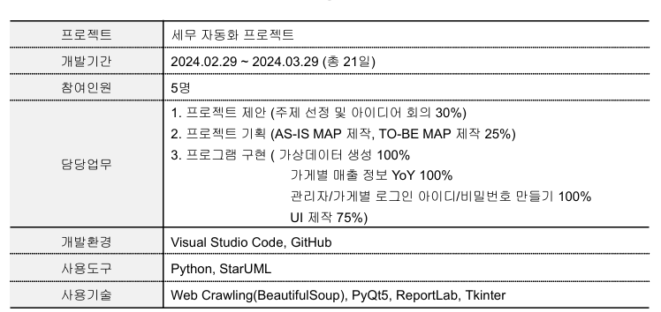

[Process]

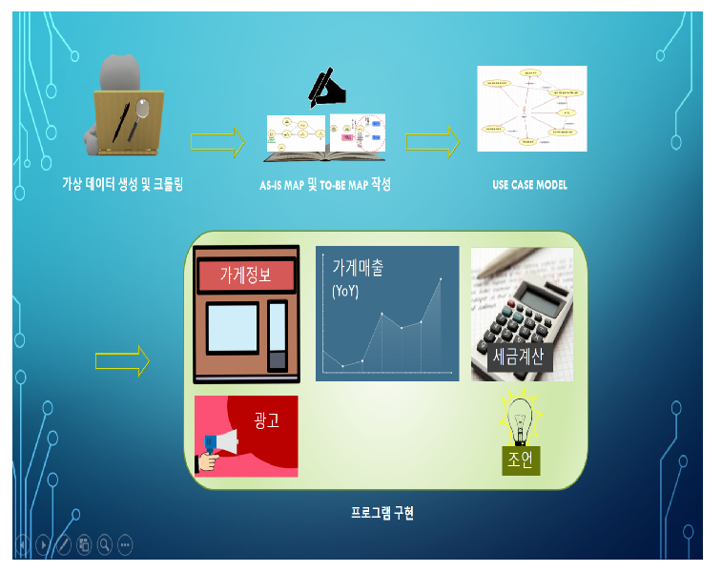

[Intermediate Deliverable]

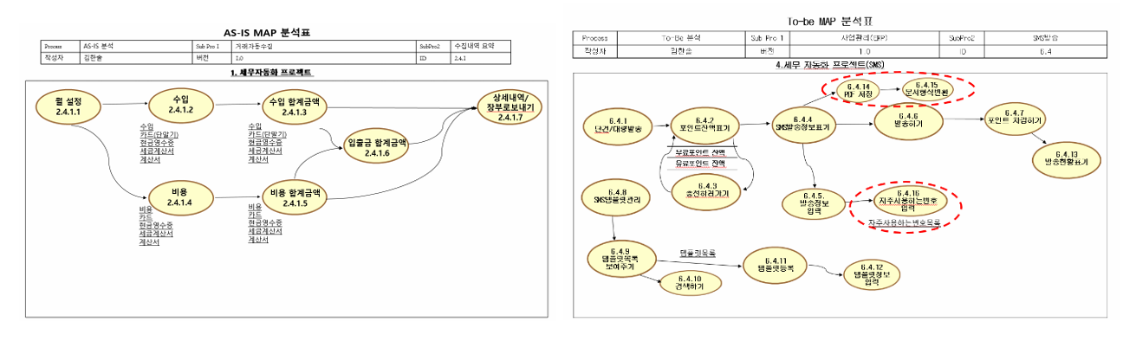

[Current Progress]

1. **Preparation of Virtual Data** (Completed)
   * Types of Information: Store name, total sales, material costs, labor costs, supplies, mortgage, donations, utilities
   * Mock website created:<https://mingihong.wixsite.com/fiveman>
   * Employee names, positions, and wages
2. **Web Crawling** (Completed)
   * Extract information from a website that stores data on each company's sales, expenses, and employee details
3. **Tax Calculation and Change Display** (Completed)
4. **Tax Calculation Using Crawled Data and Display of Changes Compared to Previous Data** (Completed)
   * Shows YoY (Year-over-Year) sales for each store
5. **Display Information Based on Account Type** (Partially Completed)
   * Code implemented for login functionality for admin accounts only
   * Login functionality for individual store accounts not implemented
6. **Tax-saving Suggestions** (Completed)
   * Recommends simple tax-saving strategies based on the calculated tax status
7. **Save Results as PDF** 
   * When the “Save as PDF” button is clicked, the results displayed on the screen can be saved as a PDF
8. **Tax Advisor Advertising** (Completed)
   * Displays 3 different tax advisor advertisements in rotation
9. **Employee Salary Management** (Not Implemented)