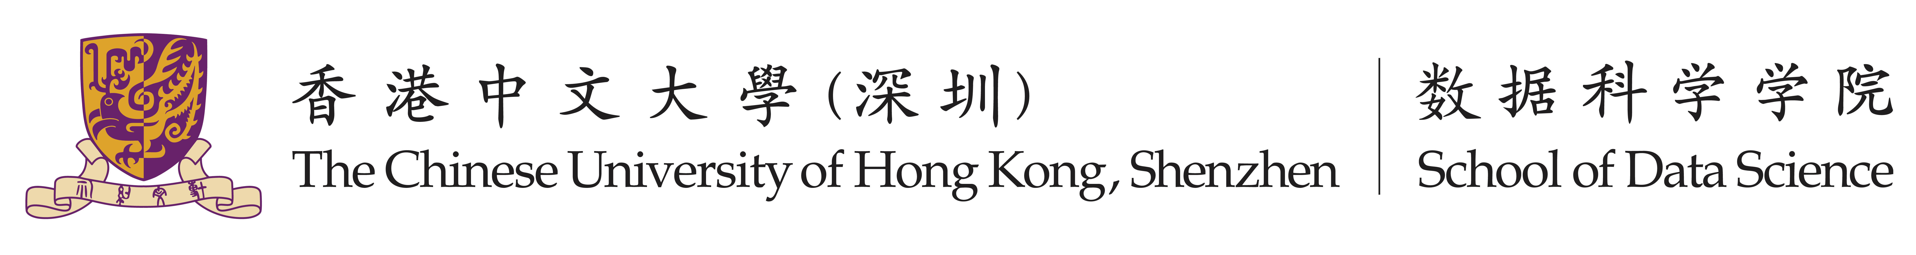

Group Project

Fundamentals of Artificial Intelligence CSC3180

Objective:

In this project, you are required to implement AI into real-world applications. The AI algorithm and application topic in this project are not limited, so you can implement on the field you are familiar with. You can choose to directly implement existing AI algorithm in your field, or you can improve current AI algorithms for your specific application. We encourage you to implement AI in creative way with interesting applications.
This is a group project. Each group should have FOUR students. In the middle of this term, each group should submit a project proposal for us to check your topic and progress. These proposals will be public to all students (anonymous) so you can compare yours with others’ proposals. In the end of this term, each group should record a presentation video and write a final report to introduce your project.

Reference Topics:

In this project, the AI algorithms and implemented applications are not limited. Below are some examples for your reference:
- Reinforcement Learning
It is a machine learning training method that take actions and learn through trial and error.
- Technologies: Neural Network, Optimization Model, etc.
- Examples: Game Player (AlphaGo), Automatic Driving, Recommendation Algorithm, etc.

- Supervised Learning
Based on the training data and corresponding labels, train a model to predict the label of test data.
- Technologies: KNN, SVM, Random Forest, Neural Network, etc.
- Examples: Disease Diagnosis, Identity Authentication, Price Prediction, etc.

- Unsupervised Learning
It can cluster data into different types based on data distribution and without priori information.
- Examples: Clustering, Cocktail Party Problem, Data Compression, Anomaly Detection, etc.

Midterm Proposal Requirements:

The proposal should include below contents:

- The application you plan to implement AI algorithm.
- The task or problem of this application.
- Work distribution of all group members.
- Schedule plan of the whole project.

Please note that the midterm proposal will be public to all students (anonymous), so you can evaluate your project workload with others if you want a high score in this course. If not submitting the midterm proposal, there will be penalty in your final group project scores.

Video Presentation Requirements (20%):

In this project, each group is required to choose one application to implement AI, and then record a video (within 8 minutes) as presentation. The video will be marked according to the following criteria:

- Creativity (10%) – Those groups who come up with creative ideas on AI implementation will obtain higher marks.
- Practicality (5%) – Those groups who successfully run a demo to show their algorithm results can have higher marks.
- Presentation Performance (5%) - Those groups present fluently and clearly can have higher marks.

Note: 1) Each group member should make some contribution to the given topic. In final,
only one mark is given to all group members.
2) In order to be fair for everyone, the other group students in the class
could join to mark the group’s presentation video besides Instructor & TA.

How to hand in:

Each group should submit their recorded video. There are three stages in this project:

Stage 1: Project Proposal on Week 8
Requirement: Each group should submit the project proposal on Blackboard (BB).

Stage 2: Presentation Video Submission on Week 13
Requirement: Each group should submit presentation video on BB.

Stage 3: Group Presentation on Week 14
Requirement: Each group should mark other groups’ presentation video.

Notes: 1) TA: Chaoxun Guo (郭超勋) (222010062@link.cuhk.edu.cn)

2) Marks distribution of the project:
Total Marks (20%) = Creativity (10%) + Practicality (5%) + Presentation (5%).

Notes:
1. This is one project. It is necessary to submit a proposal in the middle term (Week 8), since we will check your working progress. If you do not submit your proposal at this time, you will lose the mark. Please note that this mark is a reference for the whole project, and will be superseded by the final project marks.
2. You should continue to do your project after the middle term. Final mark will be given according to the assessment criteria, plus the performance from the mid-term progress check-point and whole project design, as well as presentation technique.
3. Late submission will cause lower marks.

