**CERTIFICATE**



This is to certify that Audit Course learning report entitled “STARTUP ECOSYSTEM”

Submitted by

## Hansraj Mahadev Pawar

is a Audit curse carried out b them in the third year of Engineering (A. Y. 2023-24) under the supervision of Mr. Sachin. Pande and it is approved for the partial fulfilment of the requirement of Savitribai Phule Pune University for the award of the Degree of Bachelor of Engineering (Information Technology).

Dr. A. S. Ghotkar Dr. A. S. Ghotkar Dr. S. T. Gandhe Internal Guide Head of the Department Principal

# ACKNOWLEDGEMENT

I am highly obliged to the people who have given me the much-needed guidance for the work under Audit course. First, I would like to convey a word of gratitude to my mentor, Mr. Sachin Pande for guiding us throughout project work and providing me excellent support by valuable guidance and by providing sufficient time for completion of my work. Without their immense help it would have been difficult to complete this work in time.

I am also extremely grateful to Dr. A. S. Ghotkar, Head of the Department for providing all facilities and every help for smooth progress of project work. I am thankful to the entire staff, my friend and my parents for their kind support and necessary help provided by them on time.

Hansraj Mahadev Pawar (33360)

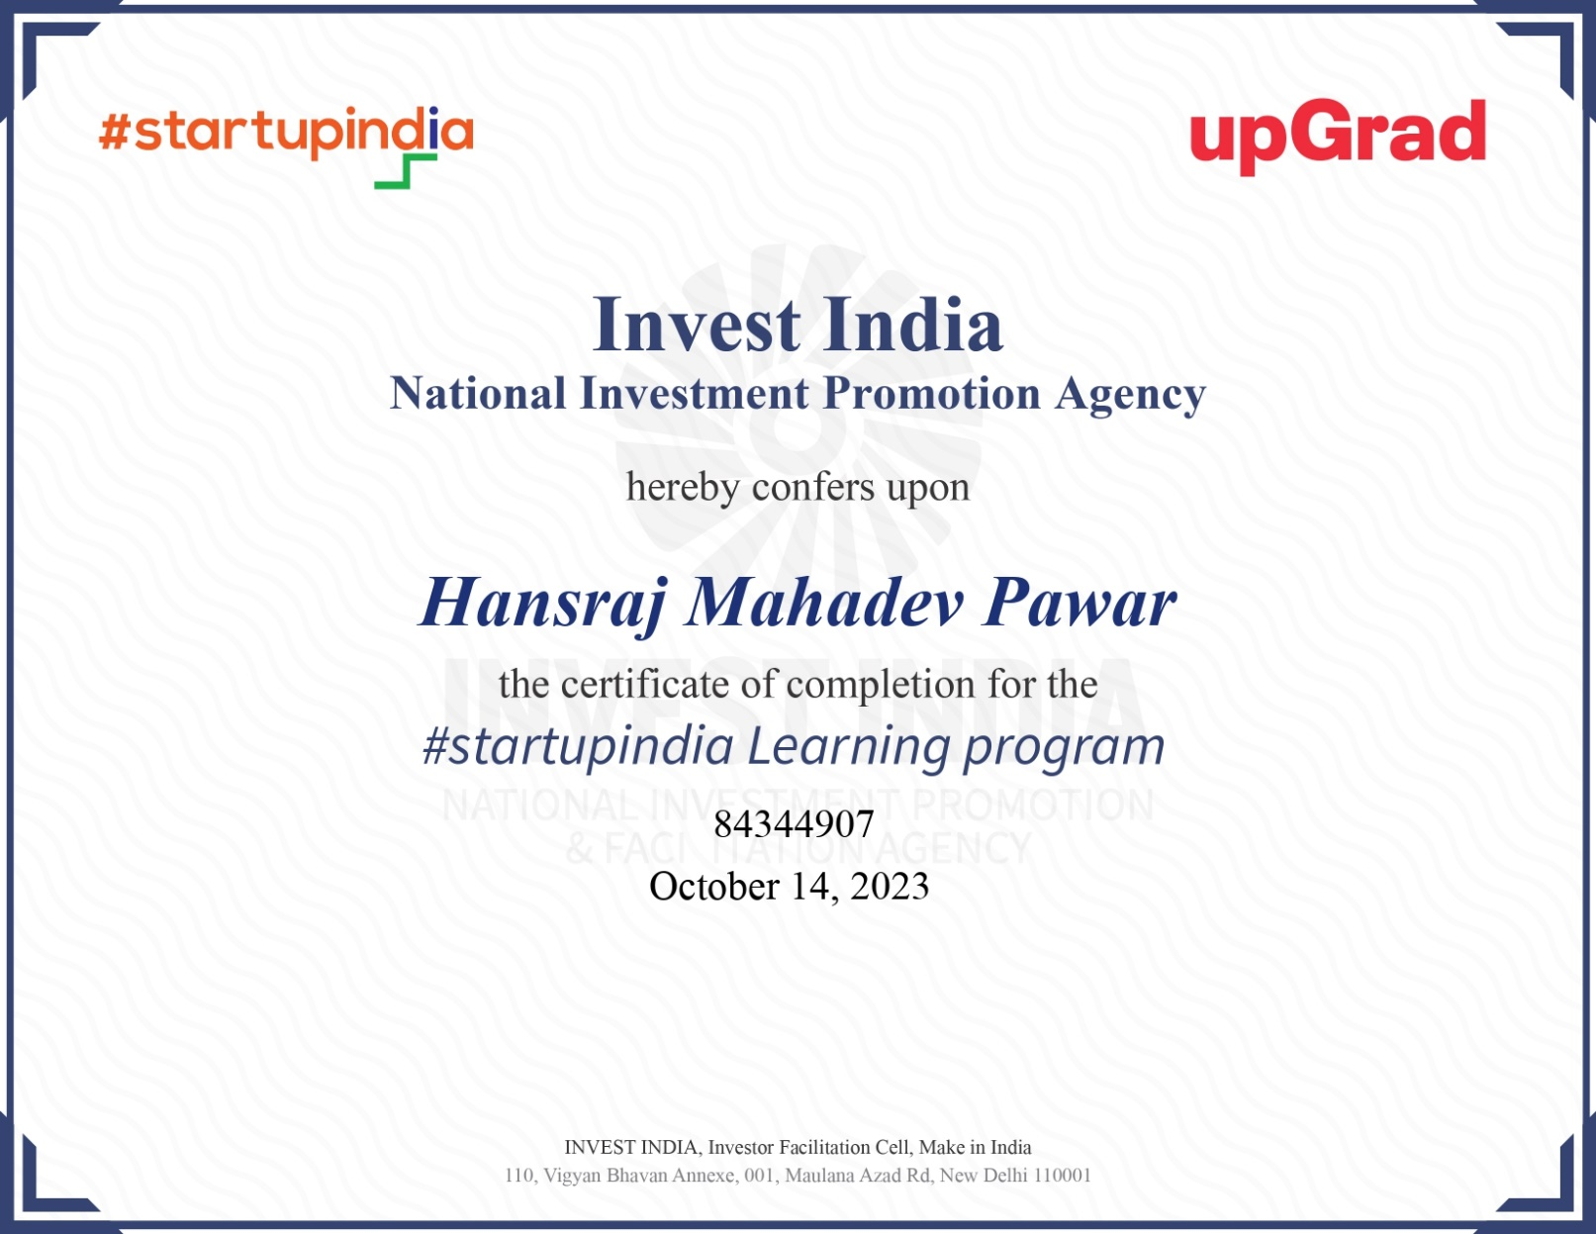

**Table of content**

1. Introduction
2. Ecosystem Overview
3. Executive summary
4. Funding and Investment
5. Startup Success Stories
6. Talent and Workforce
7. Incubators and Accelerators
8. Innovation and Research
9. Conclusion
10. References

## Introduction

A startup ecosystem is a network of people, startups, and related organizations that work together to create and scale new startups. Startup ecosystems are often formed in relatively limited areas with a center of gravity like a university or a concentration of technology companies. This ecosystem draws together key actors and stakeholders that gravitate towards growth ventures, including:

Entrepreneurs: Founders of startups who are looking to build and grow their businesses. Investors: Angel investors, venture capitalists, and other sources of funding for startups.

Mentors and advisors: Experienced entrepreneurs, business leaders, and other experts who provide guidance and support to startups.

Service providers: Lawyers, accountants, marketing agencies, and other professionals who provide services to startups.

Support organizations: Incubators, accelerators, co-working spaces, and other organizations that provide resources and support to startups.

Universities: Research institutions and educational institutions that produce talent and new technologies that can be used to create startups.

Corporations: Large companies that can provide support to startups through partnerships, investments, and other initiatives.

Startup ecosystems play an important role in the economy by helping to create new jobs and businesses, and by driving innovation. Startups are often at the forefront of developing new technologies and products, and they can help to disrupt existing industries and create new markets.

## Overview

A startup ecosystem is formed by people, startups in their various stages and various types of organizations in a location (physical and/or virtual), interacting as a system to create new startup companies.

These organizations can be further divided into categories: universities, funding organizations, support organizations (like incubators, accelerators, co-working spaces etc.), research organizations, service provider organizations (like legal, financial services etc.) and large corporations. Different organizations typically focus on specific parts of the ecosystem function and/or startups at their specific development stage(s).

People from these roles are regarded as linked together through shared events, activities, locations and interactions. As startup ecosystems are generally defined by the network of interactions among people, organizations and their environment, they can come in many types but are usually better known as startup ecosystems of specific cities or online communities (although some may say that due to social networks, the entire globe is just one bignetwork of startup ecosystems).

Start-up ecosystems are controlled by both external and internal factors. External factors as financial climate, big market disruptions and big companies transitions, control the overall structure of an ecosystem and the way things work within it. Start-up ecosystems being dynamic entities—invariably, they are initially in formation stages and once established are subject to periodic disturbances (like the financial bubbles) passing afterwards to the recovering process from some of those past disturbances.

Start-up ecosystems in similar environments but located in different parts of the world can end up doing things differently simply because they have a different entrepreneurial culture and resources pool. The introduction of non-native people knowledge and skills can also cause substantial shifts in the ecosystem functions.’

Funding and Investment

Funding and investment are two of the most important aspects of any startup. Startups need funding to cover their initial expenses, such as product development, marketing, and hiring. As the business grows, it may need additional finance to expand its operations and scale up.

There are a variety of different ways that startups can raise funding. Some of the most common methods include:

Bootstrapping: This involves the founders of the startup using their own savings and resources to fund the business. Bootstrapping is often the only option for startups in their early stages, but it can be difficult to grow a business without outside investment.

Angel investors: Angel investors are individuals who invest in startups in exchange for equity (ownership) in the company. Angel investors typically invest small amounts of money (usually less than $1 million) in startups that are in their early stages of development.

Venture capital: Venture capitalists are firms that invest in startups with high growth potential. Venture capital firms typically invest larger amounts of money (usually more than

$1 million) in startups that are in their later stages of development.

Crowdfunding: Crowdfunding platforms allow startups to raise money from a large number of individual investors. Crowdfunding can be a good way for startups to raise money in their early stages of development, but it is important to note that there are also a number of risks associated with crowdfunding.

In addition to raising equity funding, startups can also raise debt funding. Debt funding involves borrowing money from a bank or other financial institution. Debt funding can be a good way for startups to finance their growth, but it is important to note that debt funding also comes with a number of risks.

When choosing a funding method, startups need to consider a number of factors, including the stage of the business, the amount of money needed, and the risks and rewards associated with each method.

## Executive summary

Executive Summary Detailed Description

An executive summary is a concise overview of a larger document, such as a business plan, research report, or project proposal. It is typically one to three pages long and is written for busy executives and decision-makers who may not have time to read the entire document.

A well-written executive summary should include the following:

* Introduction: This section should identify the purpose of the document and provide a brief overview of the main points.
* Problem or opportunity: This section should describe the problem or opportunity that the document addresses.
* Solution or approach: This section should outline the solution or approach that the document proposes.
* Key findings or results: This section should summarize the key findings or results of the document.
* Conclusions and recommendations: This section should summarize the conclusions and recommendations of the document.

The executive summary should be written in a clear and concise style, and it should be easy to understand for readers who may not have any prior knowledge of the topic. It should also be tailored to the specific audience of the document. For example, an executive summary for a business plan would focus on the company's financial projections and market analysis, while an executive summary for a research report would focus on the study's methodology and findings.

## Startup Success Stories

Startup success stories are the stories of companies that have overcome significant challenges to achieve rapid growth and success. These stories can be inspiring and motivating for entrepreneurs, as they show that it is possible to build successful businesses, even in the face of adversity.

Here are a few examples of startup success stories:

Apple: Apple was founded in 1976 by Steve Jobs, Steve Wozniak, and Ronald Wayne. The company started out in Jobs' garage, where they developed and sold the Apple I computer. Apple went public in 1980, and it quickly became one of the most successful technology companies in the world. Apple's success is due to its innovative products, such as the Mac computer, the iPhone, and the iPad.

Amazon: Amazon was founded in 1994 by Jeff Bezos. The company started out as an online bookseller, but it has since expanded into a wide range of other products and services, including cloud computing, streaming video, and artificial intelligence. Amazon is now one of the largest companies in the world, with a market capitalization of over $1 trillion.

Facebook: Facebook was founded in 2004 by Mark Zuckerberg. The company started out as a social networking site for college students, but it has since expanded to become the world's largest social media platform, with over 2.9 billion active users. Facebook's success is due to its ability to connect people from all over the world and to provide them with a platform to share their thoughts and experiences.

Google: Google was founded in 1998 by Larry Page and Sergey Brin. The company started out as a search engine, but it has since expanded into a wide range of other products and services, including cloud computing, artificial intelligence, and self-driving cars.

Tesla: Tesla was founded in 2003 by Elon Musk. The company started out as a manufacturer of electric vehicles, but it has since expanded into solar energy and battery storage. Tesla is now one of the most innovative companies in the world, and it is leading the charge towards a more sustainable future.

## Talent and Workforce

Talent and workforce are two important concepts in the world of work. Talent refers to the skills, knowledge, and abilities that individuals possess. Workforce refers to the group of people who are employed in a particular organization or industry. Talent is essential for organizations to achieve their goals. Organizations need talented employees to develop new products and services, to improve their operational efficiency, and to provide excellent customer service.

The workforce is also essential for organizations to function. The workforce is responsible for carrying out the tasks and activities that are necessary to produce goods and services.

Talent management is the process of attracting, developing, and retaining talented employees. It involves a number of activities, such as:

* Recruitment and selection: Identifying and hiring qualified employees
* Training and development: Providing employees with the skills and knowledge they need to be successful
* Performance management: Setting and evaluating employee performance
* Career development: Helping employees to achieve their career goals
* Succession planning: Identifying and developing future leaders

Workforce management is the process of planning, organizing, and directing the workforce to achieve organizational goals. It involves a number of activities, such as:

* Workforce planning: Forecasting the organization's future workforce needs
* Scheduling: Assigning employees to tasks and shifts
* Timekeeping: Tracking employee hours worked
* Attendance management: Monitoring employee attendance and absenteeism
* Payroll: Administering employee pay and benefits

Talent and workforce management are two important processes that organizations can use to improve their performance. By effectively managing their talent and workforce, organizations can ensure that they have the right people with the right skills in the right places to achieve their goals.

## Incubators and Accelerators

Incubators are organizations that provide support to early-stage businesses. They typically offer office space, mentorship, and other resources to help startups grow and succeed. Incubators can be found in a variety of industries, including technology, healthcare, and manufacturing.

Accelerators are similar to incubators, but they are more focused on helping startups grow quickly. Accelerators typically offer a short-term program (usually a few months long) that provides startups with intensive mentorship, networking opportunities, and access to funding. Accelerators are often found in the technology industry, but they are becoming more common in other industries as well.

Both incubators and accelerators can play an important role in supporting innovation and economic growth. By providing support to early-stage businesses, incubators and accelerators can help to create new jobs and industries.

|  |  |  |
| --- | --- | --- |
| Characteristic | Incubator | Accelerator |
| Focus | Helping startups develop and validate their business models | Helping startups grow quickly |
| Duration | Typically, longer-term (1-2 years) | Typically, shorter-term (3-6 months) |
| Resources | Office space, mentorship, other support services | Intensive mentorship, networking opportunities, access to funding |
| Stage of startups | Early-stage startups with ideas or prototypes | Early-stage startups with validated business models and MVPs |

# Innovation and Research

Innovation is the process of creating new products, services, or processes. It is essential for economic growth and competitiveness. Innovation can lead to new products and services that meet the needs of consumers and businesses in new and better ways. It can also lead to new processes that make businesses more efficient and productive.

Research is the process of gathering and analyzing information to solve problems or to create new knowledge. It is essential for innovation. Research can lead to new discoveries and insights that can be used to develop new products, services, and processes.

Innovation and research are closely linked. Research can lead to new innovations, and innovations can lead to new research questions. For example, research on artificial intelligence (AI) has led to the development of new AI-powered products and services. These new AI products and services are now being used to conduct new research in a variety of fields.

Here are some examples of innovation and research:

* Developing new medical treatments: Researchers are constantly developing new medical treatments to cure diseases and improve the quality of life of patients. For example, researchers have recently developed new cancer treatments that are more effective and less toxic than traditional treatments.
* Creating new technologies: Researchers and engineers are constantly developing new technologies, such as smartphones, electric vehicles, and renewable energy sources. These new technologies can help us to live more sustainable and productive lives.
* Improving social and economic conditions: Researchers and social scientists are also working to improve social and economic conditions around the world. For example, researchers are developing new ways to reduce poverty and improve education and healthcare in developing countries.

The importance of innovation and research

Innovation and research are essential for economic growth and competitiveness. Countries that invest heavily in innovation and research are more likely to have strong economies and high standards of living.

Innovation and research are also important for solving global challenges such as climate change and poverty. Researchers are developing new technologies and solutions to help us address these challenges.

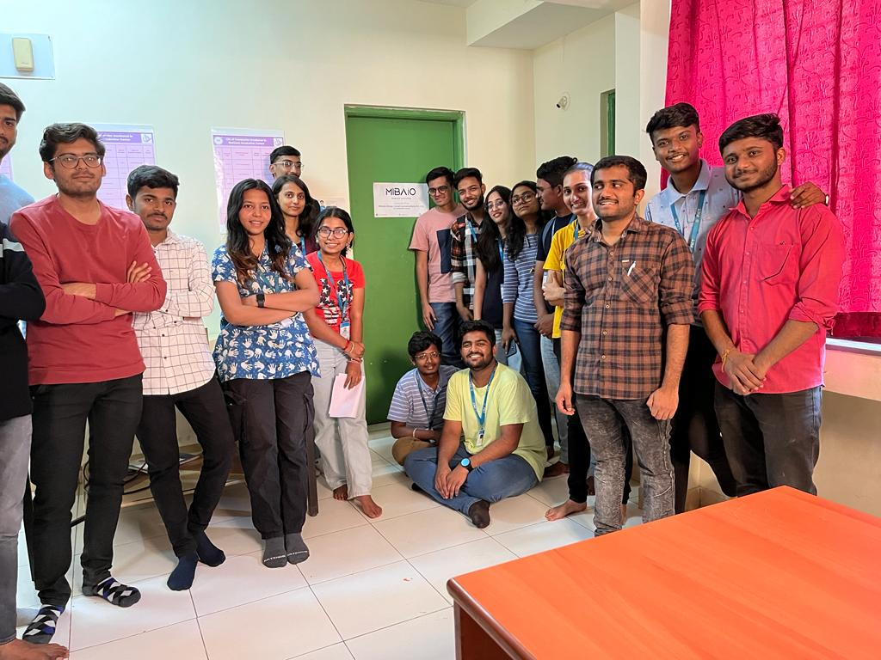

Visited Pune institute of computer technology Development Entrepreneurship Development (EDC) Cell

# Conclusion

A startup ecosystem is a network of people, organizations, and resources that support the development and growth of startups. It includes entrepreneurs, investors, mentors, accelerators, incubators, universities, and government agencies.

Startup ecosystems are important because they provide startups with the resources and support, they need to succeed. They can help startups to find funding, attract talent, and commercialize their products and services.

Startup ecosystems are also important for the economy. They create new jobs, industries, and wealth. They also help to drive innovation and economic growth.

## References

* + <https://startupgenome.com/>
  + <https://startupnation.com/>
  + <https://www.kauffman.org/>
  + <https://www.gemconsortium.org/>