**PUNJABI UNIVERSITY, PATIALA**



**PROJECT ON ONLINE RESULT MANAGEMENT SYSTEM**

**A Project Report Submitted in partial fulfillment for the award of the degree of Master of Computer Applications (2023-2025).**

**UNDERTAKEN AT: EXTECT DIGITAL**

**C-133, FIRST FLOOR, PHASE 8**

**INDUSTRIAL AREA, SAS NAGAR,160055, MOHALI**

**SUBMITTED BY*:* GURLEEN KAUR**

**Internal Supervisor(s):DR. GURPREET SINGH**

**Designation: PROFESSOR**

**External Supervisor: NARESH**

**Designation: TRAINER**

**ToDepartment of Computer SciencePunjabi University, Patiala - 147 002 May, 2025**

**Letter Head of Organization**

**Dated: 24 APRIL 2025**

**CERTIFICATE**

It is certified that the project entitled ONLINE RESULT MANAGEMENT SYSTEM is submitted in partial fulfillment of the requirements for the degree of MASTER OF COMPUTER APPLICATIONS in the Department of Computer Science, Punjabi University, Patiala. This work has been done by GURLEEN KAUR, a Bonafide student of the department, in **EXTECT DIGITAL** organization from January 2025 to JUNE 2025 under my supervision.

NARESH

**EXTECT DIGITAL**

**C-133, FIRST FLOOR, PHASE 8**

**INDUSTRIAL AREA, SAS NAGAR,160055, MOHALI**

**Letter Head of the Department of Computer Science**

**Dated: 24 APRIL 2025**

**CANDIDATE DECLARATION**

This is to certify that the project entitled ONLINE RESULT MANAGEMENT SYSTEM is my own work, carried out in EXTECH DIGITAL organization from January 2025 to JUNE 2025, under the external guidance of NARESH and internal supervision of Dr. Gurpreet Singh.

GURLEEN KAUR

**CERTIFICATE**

It is certified that the project entitled ONLINE RESULT MANAGEMENT SYSTEM is submitted in partial fulfillment of the requirements for the degree of Master of Computer Applications in the Department of Computer Science, Punjabi University, Patiala. This work has been done by GURLEEN KAUR a bona fide student of the Department.

This work is fit for the consideration of award of the said degree to her.

Dr. Gurpreet Singh.

Internal Supervisor(s)

**TRAINING IN-CHARGE**

**ACKNOWLEDGEMENT**

I take this opportunity to express my sincere gratitude to my project guide, NARESHat **EXTECT DIGITAL** for their invaluable guidance, continuous support, and expert advice throughout the completion of this project. Their knowledge and encouragement have played a vital role in shaping the practical aspects of my learning experience.

I also extend my heartfelt thanks to the management and staff of **EXTECT DIGITAL** for providing me with the necessary resources, technical environment, and professional exposure that greatly enriched this project.

Additionally, I am thankful to the faculty of **PUNJABI UNIVERSITY, PATIALA,** for allowing me to undertake this external training and for their consistent academic support.



COMPANY PROFILE

ABOUT US

**EXTECH DIGITAL** is India based leading strategic IT Company offering integrated IT solutions with the vision to provide Excellence in software solution. We at EXTECH DIGITAL bring innovative ideas and cutting edge technologies into business of customers. EXTECH DIGITAL is having rich experience in providing high technology end to end solutions in **MOBILE APP AND WEB DEVELOPMENT.**

4

PHILOSOPHY

* To impart hardcore practical quality training among students/developers about latest technologies trending today.
* To share knowledge of information security and create awareness in the market. The solution to clients' as per the International standard practices and governance.
* To support good business practices through continual employee training and education
* To equip a local team with a strong knowledge of international best practices and international expert support so as to provide practical advisories in the best interests of our clients

OUR MISSION



To Protect Client's information system by

Detecting Threats, Deterring Attacks, and provide best solution in the ever changing

Info - Security Challenges. We accomplish this by integrating our People, Process, and Technology in the most efficient way to increase value for all stakeholders

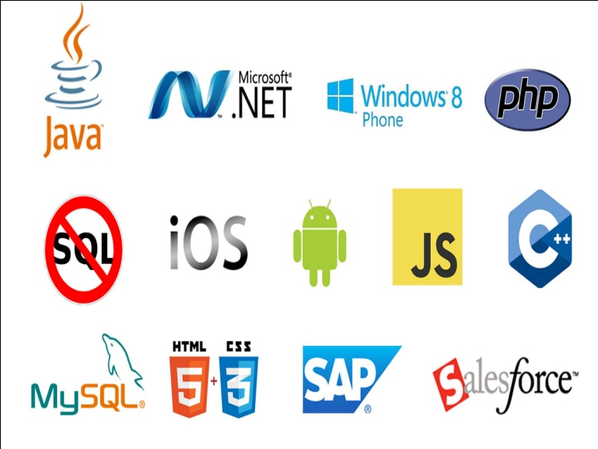OUR SERVICES

* RISK Management Services
* Quality Contro
* Business Process Re-Engineering
* Network Risk Analysis
* Software Testing
* Mobile Application Testing
* Wireless Penetration Testing
* Network Penetration Testing
* Application Security Testing

OUR SERVICES IN SOFTWARE DEVELOPMENT

We are proficient in all platforms of software Development practices — Agile, SCRUM, Lean, Waterfall, Prototype, Incremental, Iterative, and V-Model.

**Declaration**

I hereby declare that the project entitled "Online Result Management System" which is being submitted by me to the PUNJABI UNIVERSITY, PATIALA in partial fulfillment of the requirements for the award of the degree/diploma of PYTHON+DA is an authentic record of my own work carried out under the guidance of DR. GURPREET SINGH

This project has not been submitted earlier to any other institution or university for the award of any degree, diploma or certificate.

Name: GURLEEN KAUR , Roll No.: 23071271, Class: M.C.A-2ND yr,

Date: 24 APRIL 2025, University Roll no.: 217560

**ABSTRACT**

The Online Result Management System built using Tkinter provides a structured and efficient solution to handle student academic data through a multi-page desktop application. Beginning with a secure login, the application allows the input of personal and educational details, including photograph uploads and institution-specific academic data. Depending on the selected education level, different forms dynamically load to collect relevant information. Data is validated and stored securely in a MySQL database. This project replaces conventional, manual result-entry methods with an automated, GUI-based approach that boosts efficiency and accuracy while maintaining user-friendliness.

**TABLE OF THE CONTENT**

|  |  |  |
| --- | --- | --- |
| **Sr. No** | **Table of Contents** | **Page No** |
| **1** | **Title page** |  |
| **2** | **Acknowledgement** |  |
| **3** | **Declaration** |  |
| **4** | **Abstract** |  |
| **5** | **Introduction**   * Objectives * Scope * Technologies used |  |
| **6** | **System Design -**   * ER Diagrams * DFD Diagrams |  |
| **7** | **Design and Implementation**  Snapshots of the system |  |
| **8** | **Conclusion** |  |
| **9** | **Bibliography** |  |

**INTRODUCTION**

In today's digital era, managing student information efficiently is crucial for educational institutions. This project, a Tkinter-based Online Result Management System, offers a user-friendly GUI solution to streamline result data handling across schools, colleges, and universities. The system enables login authentication, student personal details entry, and education-level specific academic data collection. Designed using Python's Tkinter library, it eliminates the need for manual paperwork by allowing real-time data entry, image uploads, and integrated database storage. The project supports multi-step data collection, enhancing accuracy and operational speed for both faculty and administrators

This project is a desktop-based application created using **Python’s Tkinter** GUI toolkit, aimed at streamlining the entire academic result processing workflow. Unlike web-based systems that require internet connectivity and web hosting environments, this solution is designed to function **offline**, making it particularly valuable for institutions located in areas with limited or unreliable internet access.

The system enables a **multi-step data entry process** starting from a secure login, followed by comprehensive personal information collection, and finally, the gathering of academic details that vary according to the student's level of education (School, College, or University). At every stage, the system ensures data integrity and accuracy through built-in **validation mechanisms**, thereby reducing the likelihood of incomplete or incorrect data entries.

What makes this system notably efficient is its modular design. By leveraging Tkinter’s Toplevel window feature, the application creates a smooth, page-by-page user experience that mimics modern multi-screen applications. Users can easily transition from one form to another without restarting the program or opening separate windows using subprocesses, which ensures both system stability and usability.

Another key aspect of this project is its support for **image uploads**, allowing student photographs to be attached to their records, further enhancing identity management and personalization. The system’s visual appeal is maintained throughout with the implementation of a **modern UI theme**, consistent layout, and dark mode aesthetics that appeal to contemporary design sensibilities. The design philosophy not only improves user interaction but also creates a professional look for institutional use.

Data collected through the interface is directly and securely stored into a **MySQL database**, which acts as the backend storage system. MySQL was chosen due to its robustness, scalability, and industry-standard SQL support, which makes data retrieval, manipulation, and integration with other systems seamless. The database schema has been carefully designed to reflect the real-world relationships between different data elements such as student profiles, academic levels, subjects, and results.

This project is not just a form-based application; it is a scalable foundation for building future-ready educational software. It is engineered with extensibility in mind, allowing for future modules like:

* **Report generation and printing**
* **Performance analytics and dashboards**
* **SMS/Email result notifications**
* **Guardian/parent logins**
* **Cloud database synchronization**
* **Role-based access control (admin/staff/student)**

Ultimately, the **Online Result Management System** aims to minimize manual work, reduce error margins, and introduce a digital-first approach to academic result processing. Its development marks a step toward **paperless administration**, which is not only efficient but also eco-friendly and in line with the broader goal of digital transformation in education.

By combining the power of **Python, Tkinter, MySQL, and modular design principles**, this system provides a scalable, secure, and user-centric solution that empowers educational institutions to modernize their record management processes with minimal technical overhead.

**OBJECTIVES**

The primary objectives of this project are:

* To provide a desktop-based interface for managing student academic records.
* To create a smooth flow of data entry from login to final result processing.
* To support role-based data entry and storage into a Mysql database.
* To allow education-type-specific data collection (School, College, University).
* To ensure visual appeal and intuitive interaction through modern UI design.
* To enable photo upload features and centralized academic detail entry.
* To minimize human error and reduce administrative workload.
* To implement modular pages using Toplevel windows for better user navigation.
* To enable data validation at every stage to ensure only correct and complete data is stored.
* To provide consistent layout and design across all forms to enhance user experience.
* To allow seamless integration with MySQL for real-time data insertion and retrieval.
* To structure the system such that future features (like report printing or analytics) can be added easily.
* To encourage digital transformation in educational institutions with a secure, offline-capable solution.
* To include education-level-specific image displays (school, college, university) for enhanced UI engagement.

**SCOPE**

This system is designed for educational institutions aiming to digitalize student record-keeping without needing a web server or internet. It can be deployed in:

* Schools: Collecting basic academic information.
* Colleges and Universities: Supporting advanced metrics like percentages and semester info. The project is extendable to support features like performance visualization, admin panels, and secure report generation. Its modularity also allows integration with external database systems for result analysis and report printing.
* The project is extendable to support features like performance visualization (charts/graphs), printable mark sheets, and automated notifications.
* An admin dashboard can be integrated to allow centralized control over user roles, data verification, and result publication.
* With its modular architecture, the system allows for seamless integration with external databases or cloud-based storage, making future migration or scaling easier.
* The interface can be enhanced to support multilingual functionality in diverse educational regions.
* Backup and export/import functionality can be added to improve data portability and safety.
* A role-specific login can be expanded to support parent/guardian access for transparency in performance tracking.
* The system supports offline functioning but can be modified to sync online databases when internet becomes available, making it a hybrid solution.

This scalable and flexible design ensures that the system is not only applicable to small institutions but also adaptable to the needs of larger campuses and education boards looking to modernize their result management workflows.

**TECHNOLOGIES USED**

| **Technology** | **Purpose** |
| --- | --- |
| Python | Core programming language used for logic and interface. |
| Tkinter | GUI framework used to design the multi-page forms and layout. |
| MySQL | Backend database system used to store user credentials and results. |
| Pillow (PIL) | Used for uploading and resizing images like student photos. |
| OS module | Helps in file path handling for image uploads and other operations. |
| Top-level | Enables switching between form pages without using subprocess calls. |

**SYSTEM DESIGN:**

The design phase of the Online Result Management System bridges the gap between system requirements and final implementation. It ensures the system is functionally structured, modular, and scalable. The system has been designed to be user-friendly, efficient, and adaptable to diverse academic needs.

1. System Architecture

The application follows a modular, multi-layered architecture:

➤ Presentation Layer (Frontend)

* Built using Tkinter (Python GUI library).
* Enables multi-page forms (Login → Student Details → Education Details).
* Incorporates file/image upload, radio buttons, drop-downs, and validation.
* Uses Toplevel windows for smooth navigation without subprocesses.

➤ Application Logic Layer (Middle Layer)

* Handles:
  + Data validation
  + User input handling
  + Page transitions
  + Education-type-based logic branching (School, College, University)

➤ Data Layer (Backend)

* Connected to MySQL database using mysql.connector module.
* Stores login credentials, personal details, education data, and file paths.
* Ensures normalization, relational integrity, and data consistency.

2. System Flow Diagram

| Login | ---> | Personal Info | ---> | Education-Specific | -->|Result record|

| Screen | | Entry (Details)| | Form (School/College|

| or University) |

| Database Insertion |

| (MySQL) |

3. Database Design

* Tables:
  + users – login credentials
  + students – personal details
  + school_details / college_details / university_details – education-specific data
* Normalized design ensures no redundancy and efficient querying.

4. UI Design Principles

* Consistent Layout: Every form maintains a uniform size and styling.
* Dark Theme: Modern look and feel throughout the interface.
* Responsive Widgets: Use of grid() and pack() strategically.
* Visual Feedback: Error messages and alerts on invalid input.
* Attractive Visuals: Display of education-type-based images.

5. Security Considerations

* Passwords stored securely.
* Input validation at all form levels.
* Access control via login authentication.
* Controlled upload paths for student images.

6. Scalability and Future Enhancements

* The modular design allows easy addition of:
  + Analytics dashboards
  + Result printing functionality
  + Cloud database synchronization
  + Guardian/parent login
  + Email/SMS notifications

**DFD(DATA FLOW DIAGRAM)**

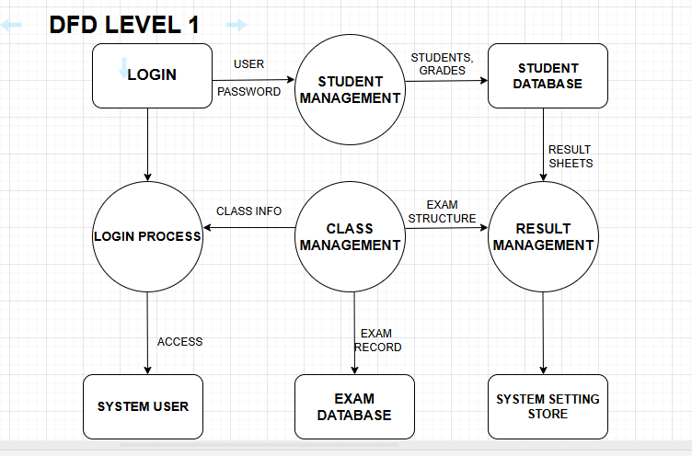

**DFD Level 0 – Context Level Diagram**

Purpose:

* Shows the entire system as one single process.
* Displays external entities that interact with the system.

Main Points:

1. Single Process:
   * The central process is "Result Management System".
2. External Entities:
   * Login
   * Class Management
   * Exam Management
   * Student Management
   * System Management
   * Result Management
   * System User
3. Data Flow:
   * Each external entity sends or receives data from the central process.
   * For example:
     + Login → Sends credentials
     + Result Management → Gets result-related data
     + System User → Interacts with all modules

**DFD Level 1 – First-Level Decomposition**

Purpose:

* Breaks the main system into sub-processes.
* Shows how each module works internally and how data flows between them.

Main Points:

1. Process 1.0 – Login Process
   * Takes Username/Password from the user.
   * Checks credential and provides Access.
   * Connects with System User.
2. Process 2.0 – Student Management
   * Manages Student Information (Add/Update/Delete).
   * Sends student marks and grades to Student Result Database.
3. Process 3.0 – Class Management
   * Manages Class and Subject Info.
   * Provides data for exam setup and result preparation.
4. Process 4.0 – Exam Management
   * Manages exam schedules and exam records.
   * Sends data to Exam Database.
5. Process 5.0 – Result Management
   * Collects data from Class, Student, and Exam modules.
   * Generates results and stores them.
   * Sends Result Sheets to users and stores in System Settings/Report Store.
6. Databases Used:
   * Student Result Database
   * Exam Database
   * System Settings Store

**ER DIAGRAM:**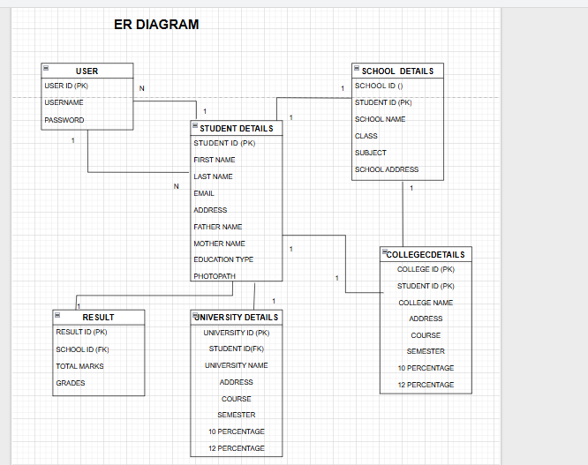

**CONCLUSION**

The **Online Result Management System** built using Python’s Tkinter offers a structured and efficient way to handle student academic data via a desktop application. Starting with secure login authentication, it provides a guided interface for personal and educational detail entry, including dynamic form loading based on the selected education level (school/college/university).

Data is validated and stored securely into a MySQL database. This GUI-based system replaces manual result handling methods, increasing **accuracy**, **efficiency**, and **user-friendliness**, while laying the groundwork for future scalability in education technology.

**BIBLIOGRAPHY**

| **Technology** | **Reference/Source** |
| --- | --- |
| **Python** | - Python Official Documentation: <https://docs.python.org>  - GeeksforGeeks Python Tutorials: https://www.geeksforgeeks.org/python |
| **Tkinter** | - Tkinter Documentation: <https://docs.python.org/3/library/tkinter.html>  - YouTube tutorials and faculty-provided notes on GUI design |
| **MySQL** | - MySQL Official Documentation: <https://dev.mysql.com/doc>  - Stack Overflow community discussions |
| **Pillow (PIL)** | - PIL Documentation: <https://pillow.readthedocs.io>  - GeeksforGeeks articles on image handling in Python |
| **OS Module** | - Python OS Module Reference: <https://docs.python.org/3/library/os.html> |
| **Toplevel (Tkinter)** | - Tkinter Toplevel Usage: https://www.tutorialspoint.com/python/tk_toplevel.htm  - Stack Overflow for best practices in page navigation |
| **HTML/CSS (Optional Web Use)** | - W3Schools: <https://www.w3schools.com>  - MDN Web Docs: <https://developer.mozilla.org> |