***Boruar Features Importances***

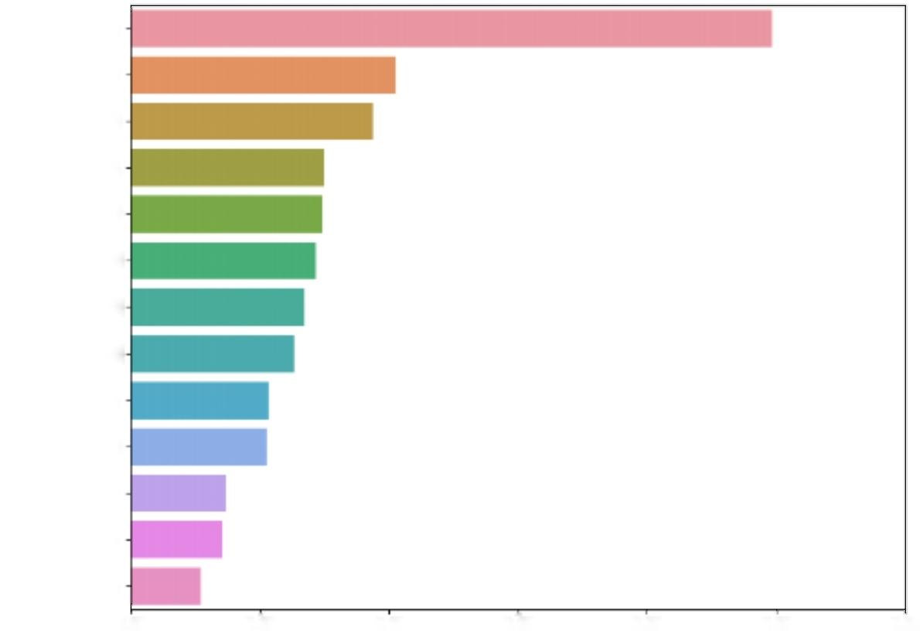

*AaDO2*

*PEF value*

*RV value*

*MVV value*

*ALT*

*AST*

*Creatnine*

*Calcium*

*HbA1c*

*ACE*

*INR*

*CYFRA21-1*

*CA19-9*

0.00 0.05 0.10 0.15 0.20 0.25 0.30

***Importances***