

Graduate School of Biomedical Engineering
Faculty of Engineering
The University of New South Wales

BIOM9541 Mechanics of the Human Body
Term 3, 2025

Final Report

Depth and Load Effects on Goblet Squat Mechanics:
A Within-Subject Analysis

Hanif Rachmadani
z5715919

Introduction
1. Background
A strong and functional lower body is not only aesthetically desirable but is also closely linked to mobility, general health, and injury prevention (MyaCare 2021). The goblet squat is a front-loaded squat variation in which the load is held against the chest to promote a more upright trunk posture, facilitating quadriceps engagement while reducing spinal shear loading (Collins et al. 2021). Given its accessibility and relatively low technical barrier, the goblet squat (and squats in general) is widely used in both fitness and rehabilitation settings (Straub & Powers 2024).
Previous biomechanical research has demonstrated that knee moments increase with both squat depth and external loading (Cotter et al. 2013). Muscle activation studies have also shown that gluteus maximus activation is substantially greater at deeper squat depths, while other thigh muscles show comparatively smaller changes (Caterisano et al. 2002). However, these investigations predominantly examine barbell back squat variations. In contrast, front-loaded squats such as the goblet squat may exhibit markedly different joint and muscle loading characteristics due to their more upright trunk posture and altered center-of-mass positioning yet remain comparatively under-studied.
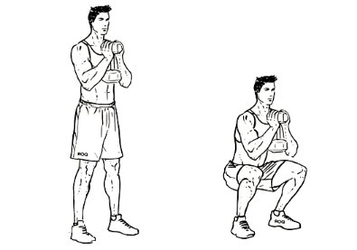
Figure 1. The Goblet Squat (WorkOutLabs.com)
2. Aim & Hypothesis
This study aims to examine how different squat depths and external loads influence lower-limb mechanics during the goblet squat, by analyzing hip and knee joint moments alongside peak activation of the gluteus maximus, vastus, and biceps femoris muscles. A single-participant repeated-trial approach was used to enable detailed mechanical profiling of how different depth-and-load combinations affect lower-limb joint moments and muscle activation for the individual subject. This allows for a personalized interpretation of mechanical demands, consistent with individualized optimization practices in rehabilitation and performance settings.
It is anticipated that deeper squat depths and heavier loads will increase hip joint moments and gluteus maximus activation, whereas knee joint moments and activation of the vastus and biceps femoris will display weaker or inconsistent depth-dependent scaling.

Methods
1. Participants & Experiment Design
One healthy male participant completed all testing sessions. Anthropometric data used for model scaling is presented in Table 1. The participant had no prior history of lower-limb injury and provided informed consent. A repeated-trial within-subject design was used to evaluate the effect of squat depth and external load on lower-limb biomechanics.
Name | Hanif
Age (years) | 26
Height (cm) | 157
Mass (kg) | 56.85
Inter-ASIS (cm) | 7.5
Ankle Width (mm) | 60.2/60.0
Knee Width (mm) | 102.1/102.2
Leg Length (cm) | 82/82
Table 1. Participant Anthropometric Data
2. Experimental Conditions
Three squat depths were tested: shallow (0–90° knee flexion), medium (90–110°), and deep (110–135°), based on depth classifications described by Straub & Powers (2024). Three external loads were used (2.5 kg, 5.0 kg, and 7.5 kg), producing nine depth-load combinations in total. Each condition was performed for three repetitions, resulting in 27 trials total.

3. Data Collection Procedure
Motion capture was performed using the Vicon Nexus system at 200 Hz for markers and 1000 Hz for force plates. Sixteen lower-limb and three torso markers were placed according to the Plug-in-Gait reference and verified in a static calibration trial. The participant performed goblet squats at a self-selected pace with each foot on a separate force plate. All depth-load conditions were completed in one session with brief (~0.5 s) rests between repetitions. Marker trajectories were then inspected in Mokka prior to processing.
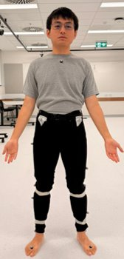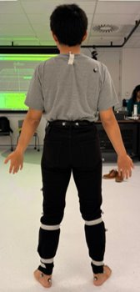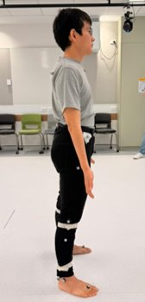
Figure 2. Static Trial Calibration (Author)

4. Data Processing Workflow
Raw .trc and .c3d files were first used to scale a modified Gait2345 model in OpenSim. A custom Python workflow was then implemented to automate the remainder of the analysis pipeline. Marker trajectories were gap-filled using SciPy linear algebra module before batch Inverse Kinematics (IK) was performed across all continuous depth-load recordings. The resulting motion files were segmented into individual trials, while ground reaction force data exported from Mokka were converted into OpenSim-compatible .mot and .xml files and synchronized with the kinematic data for Inverse Dynamics (ID). Residual Reduction Algorithm (RRA) was performed to minimize residual forces and generate a mass-adjusted model, followed by Computed Muscle Control (CMC) and subsequent analyze tool routines (joint reaction, muscle analysis, etc.) for each trial. This automated pipeline enabled consistent processing of all 27 trials with minimal manual intervention.

5. Outcome Measurements
The primary processed outcomes for this study were peak hip and knee joint moments, and peak activation levels of the gluteus maximus, vastus, and biceps femoris. All kinematic and kinetic data were normalized to 100% of the squat cycle, averaged across repetitions within each condition, and peak values were identified for each depth-load combination.

Results
1. Depth Variations
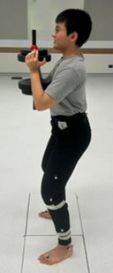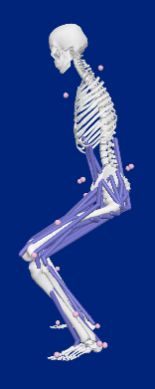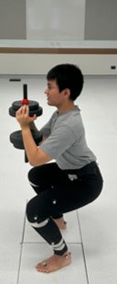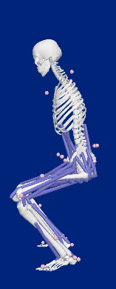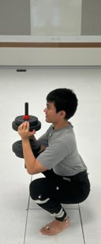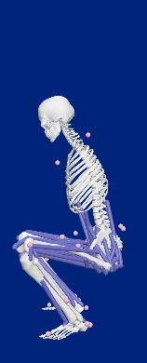
Figure 3. Real (left) and OpenSim (right) Trial Sample for Shallow, Medium, and Deep Goblet Squat
These images above illustrate the visual differences in posture between deep, medium and shallow squat depths.

2. Joint Moments
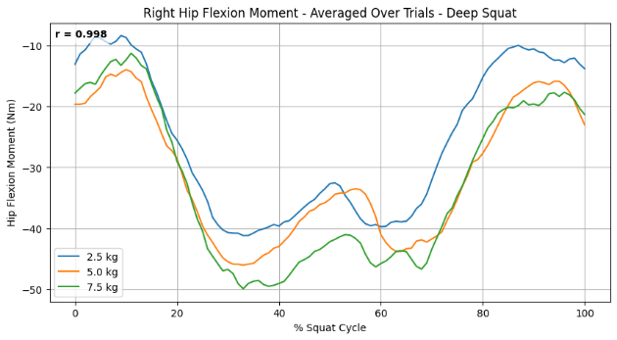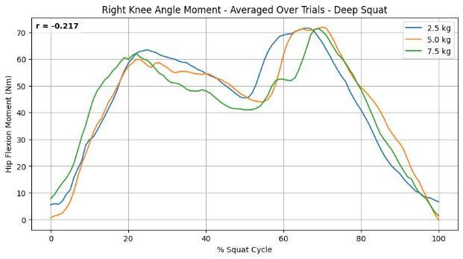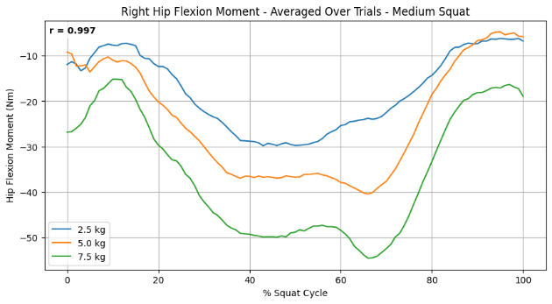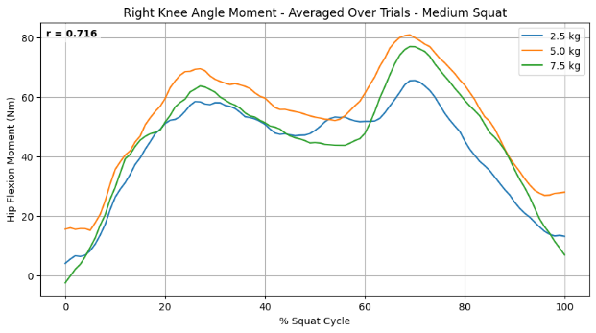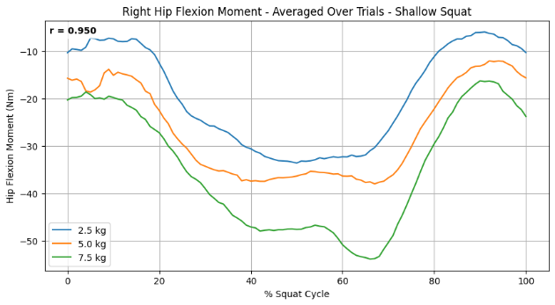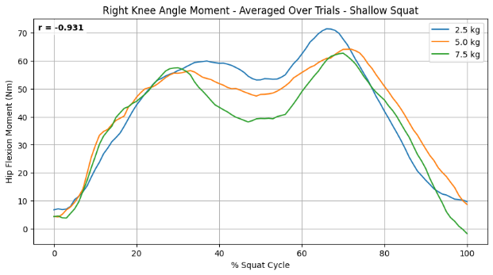
Figure 4. Averaged Normalized Joint Moments of Hip (left) and Knee (right)
Depth​ | Hip Moment​ | Knee Moment​
Deep​ | r = 0.998​ | r = -0.217​
Medium​ | r = 0.997​ | r = 0.716​
Shallow​ | r = 0.950​ | r = -0.931​
Table 2. Pearson Correlation Between Load and Absolute Peak Joint Moment​
Figure 4 shows the averaged hip and knee joint moments across all nine depth–load combinations, with corresponding correlation values presented in Table 2. Hip joint moments demonstrated very strong positive correlations with load across all depths (r = 0.95-0.998). Knee joint moments showed inconsistent trends, with a moderate positive correlation in the medium depth (r = 0.716), a weak negative correlation in the deep condition (r = –0.217), and a strong negative correlation in the shallow condition (r = –0.931).
3. Muscle Activations
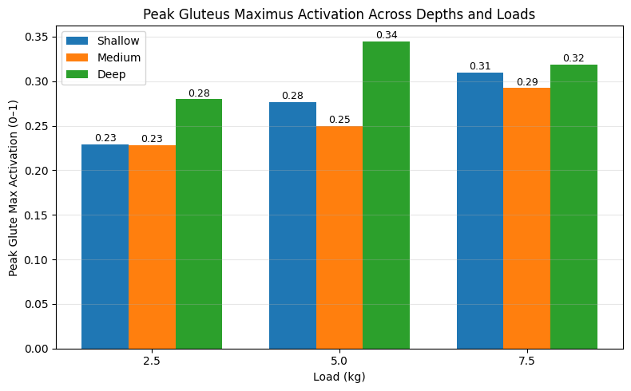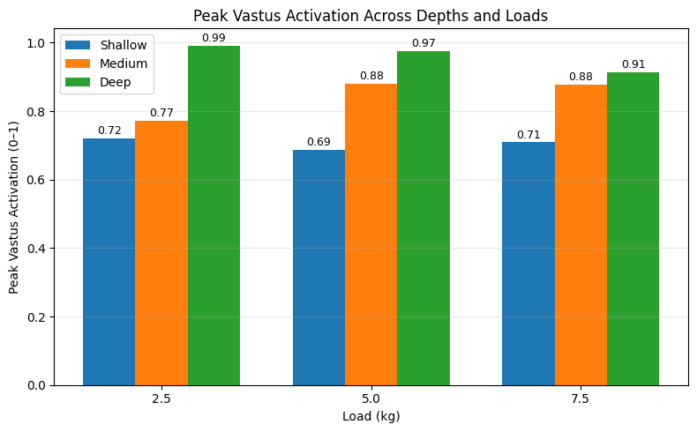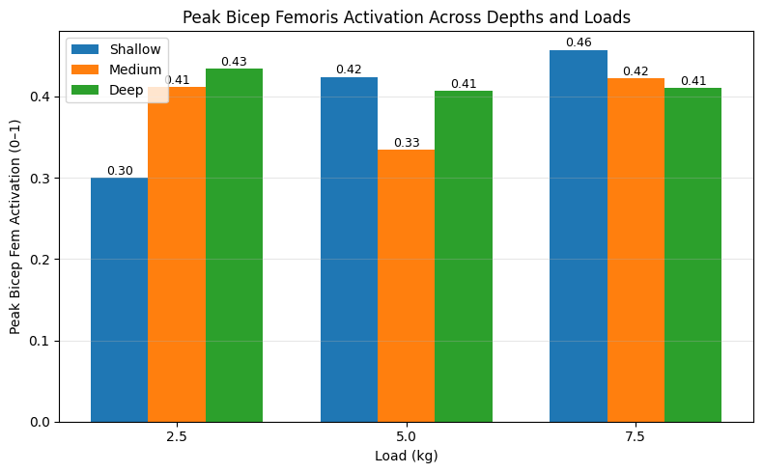
Figure 5. Averaged Peak Activations of Gluteus Maximus (top-left), Biceps Femoris (top-right), and Vastus (bottom) Across All Depth-Load Combinations.
Figure 5 shows the averaged peak activation values for gluteus maximus, vastus, and biceps femoris across all depth-load combinations. Gluteus maximus activation increased progressively across depth and load, with the highest values observed in the deep condition at 5.0 kg. Vastus activation was consistently highest in the deep condition for all loads, while medium depth also showed elevated values relative to shallow. Biceps femoris activation displayed smaller depth-related differences, though small load-related increases were observed in the shallow and medium conditions. Overall, peak activation patterns varied substantially between muscles, with gluteus maximus and vastus showing clearer scaling with depth and load compared to biceps femoris.

Discussion
1. Findings Summary
This study examined how squat depth and external load influence lower-limb mechanics during the goblet squat. Hip joint moments increased consistently with load across all depths, with the highest values in the deep squat. Knee joint moments, however, showed smaller and more inconsistent load-related changes, including weak or inverse correlations in the shallow and deep squat. Gluteus maximus and vastus activation increased with both depth and load, whereas biceps femoris activation showed minimal depth-related differences and only modest load-related increases in shallow and medium conditions. Overall, depth and load scaled hip mechanics and gluteus/vastus activation more clearly than knee mechanics or biceps femoris activation.

2. Comparison with Prior Research
The joint-moment patterns observed in this study both agree with and diverge from previous squat biomechanics research. Prior barbell squat studies have shown that knee extensor moments typically increase with depth and load (e.g., Cotter et al. 2013). In contrast, the present goblet squat data showed consistent load-related increases at the hip but smaller or inverse relationships at the knee, particularly in shallow and deep conditions. This difference likely reflects the combined effects of the front-loaded position of the goblet squat and the relatively light external loads used. Although an upright torso typically increases knee extensor demand in heavy front-loaded or back squat variations, the small forward shift in centre of mass at the loads used here was likely insufficient to increase knee moments consistently.
The muscle-activation results align more closely with existing literature. Caterisano et al. (2002) reported substantial increases in gluteus maximus activation with deeper squat depths, while biceps femoris and quadriceps activity changed only modestly. The current findings follow a similar pattern for gluteus maximus and biceps femoris. Vastus behaviour, however, was more nuanced: although activation increased consistently with depth, load-related scaling was not uniform across depths. In this study, medium and deep squats showed clearer increases with load than shallow squats. These differences may reflect both the front-loaded configuration of the goblet squat, which biases quadriceps involvement, and the modest external loads used.

3. Interpretation & Practical Implications
The depth-load patterns observed can be interpreted through changes in moment-arm lengths and centre-of-mass position. Deeper squats increase hip flexion and lengthen the hip-extensor moment arm, which explains the consistent increases in hip moments across loads and depths. In contrast, the light loads used here produced only minimal forward shifts of the centre of mass, resulting in small or inconsistent load-related changes in knee moments.
Muscle-activation patterns followed the same mechanical logic. Gluteus maximus and vastus activation increased with depth because deeper squats require greater hip and knee extensor torque to stand up. Biceps femoris activation changed little, consistent with its smaller role in producing the primary extension demands of the goblet squat. Practically, these results suggest that deeper goblet squats, even with light to moderate loads, may effectively target both gluteus maximus and quadriceps, while keeping knee demand relatively modest.

5. Limitations
This study involved a single participant and therefore cannot generalize findings to broader populations with differing anthropometrics, strength capacities, or movement strategies. The external loads used were relatively light, which likely reduced the extent to which depth and load influenced knee-joint moments and certain muscle-activation patterns. Musculoskeletal modelling also relies on assumptions regarding muscle force production and moment arms that may not fully reflect individual-specific behavior. Finally, only peak values were analyzed, phase-dependent characteristics of the movement were not examined, limiting insight into timing-related aspects of joint and muscle demand.

Conclusion
This single-participant study examined how squat depth and external load influence lower-limb mechanics during the goblet squat. Hip joint moments increased consistently with load across all depths, while knee joint moments showed smaller and more variable load-related changes. Gluteus maximus and vastus activation increased clearly with squat depth, whereas biceps femoris activation changed little across conditions.
Overall, moderate to deep goblet squats produced the highest activation of the gluteus maximus and vastus muscles, suggesting these depths may provide a more effective stimulus for both hip and knee extensors. Increasing external load further amplified these demands, although knee loading remained relatively modest at the light loads used here. While these findings cannot be generalized broadly, they may help guide within-subject optimisation of goblet squat technique by highlighting how depth and load influence joint and muscle demands in this individual.

Bibliography
WorkOutLabs.com n.d., Goblet squat illustration, viewed 26 October 2025, https://workoutlabs.com
MyaCare 2021, The link between leg strength, healthy aging and longevity, MyaCare, viewed 26 October 2020, https://myacare.com/blog/the-link-between-leg-strength-healthy-aging-and-longevity
Collins, KS, Klawitter, LA, Waldera, RW, Mahoney, SJ & Christensen, BK 2021, ‘Differences in muscle activity and kinetics between the goblet squat and landmine squat in men and women’, Journal of Strength and Conditioning Research, vol. 35, no. 10, pp. 2661–2668. https://doi.org/10.1519/JSC.0000000000004094
Straub, RK & Powers, CM 2024, ‘A biomechanical review of the squat exercise: implications for clinical practice’, International Journal of Sports Physical Therapy, vol. 19, no. 4, pp. 490–501. https://doi.org/10.26603/001c.94600
Cotter, JA, Chaudhari, AMW & Jamison, ST 2013, ‘Knee joint kinetics in relation to commonly prescribed squat loads and depths’, Journal of Strength and Conditioning Research, vol. 27, no. 7, pp. 1765–1774. https://doi.org/10.1519/JSC.0b013e3182773319
Caterisano, A, Moss, RF, Pellinger, TK, Woodruff, K, Lewis, VC, Booth, W & Khadra, T 2002, ‘The effect of back squat depth on the EMG activity of 4 superficial hip and thigh muscles’, Journal of Strength and Conditioning Research, vol. 16, no. 3, pp. 428–432.

Appendix
- Trial-averaged muscle activation profiles across the full squat cycle for three external loads (2.5 kg, 5.0 kg, 7.5 kg). Each plot is shown in landscape orientation to preserve axis readability

  - Bicep Femoris
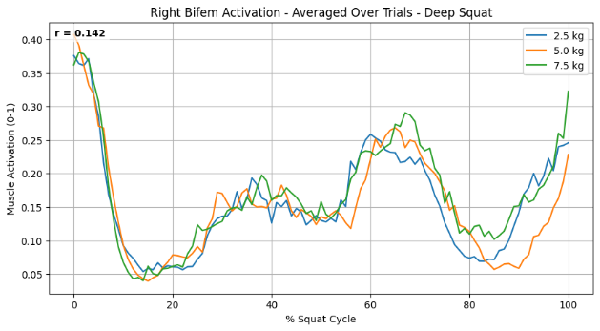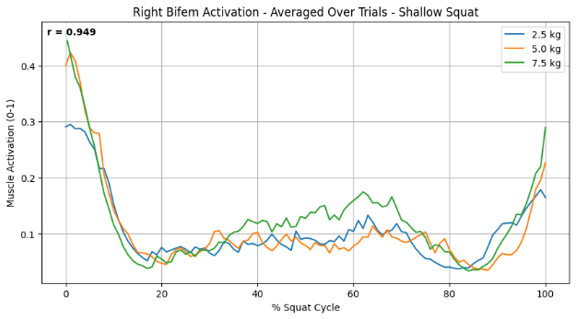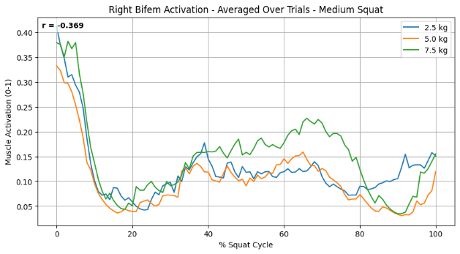

  - Gluteus Maximus
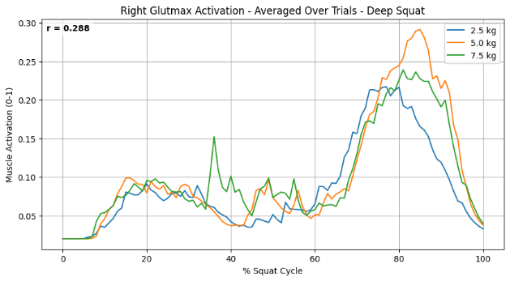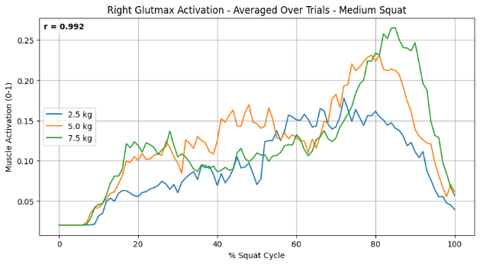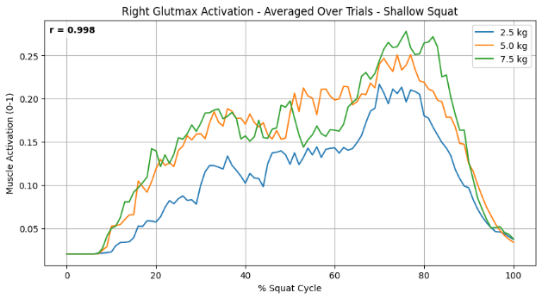

  - Vastus
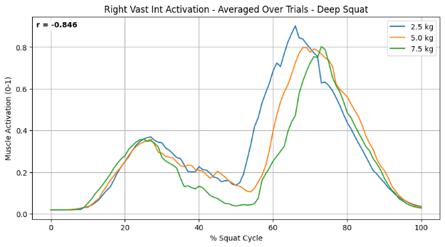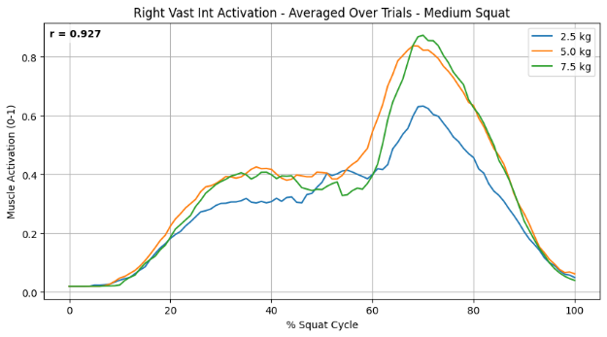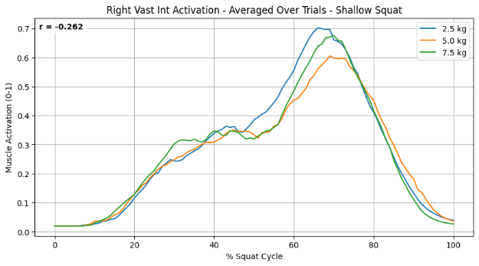

All analysis scripts & resources are also available at: https://github.com/hantuch/BIOM9541-final

