PICKREADY / IMPLEMENTATION-ALIGNED DOCUMENTATION

PickReady Technical Documentation
  - Architecture, engineering decisions, workflows, limitations and production scaling strategy
Audience: Software engineers, platform teams, security reviewers and technical operators
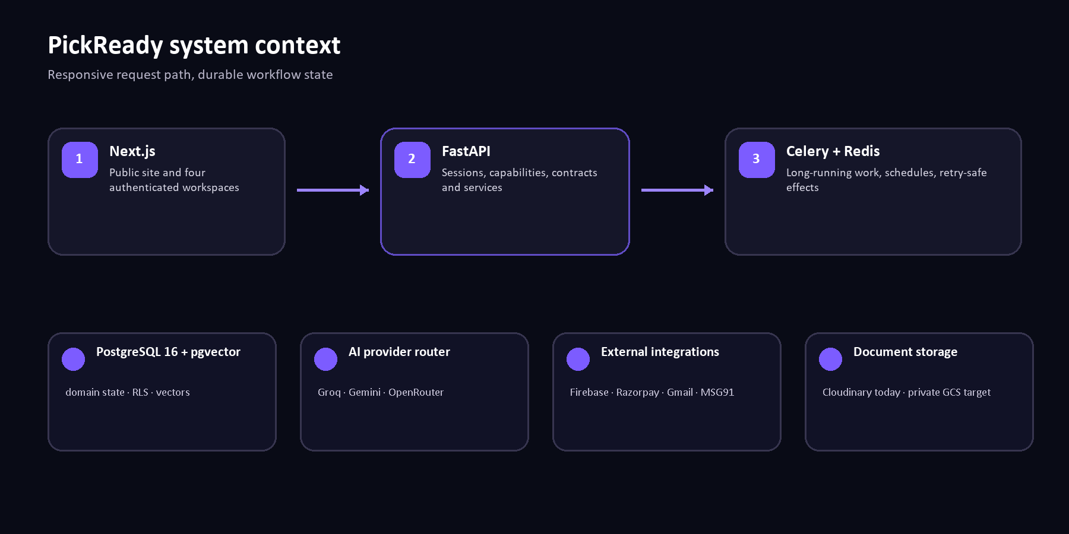
Source-of-truth policy This document records the current implementation. When prose and code differ, the running source code, migrations, tests and interfaces are authoritative.

At a glance
PickReady is a Next.js and FastAPI system backed by PostgreSQL/pgvector, Redis and Celery. It combines capability authorization with database RLS and uses durable, retry-safe workflows for AI, files, communications and billing.
Signal | What it means
Next.js + FastAPI | Typed web experience and async Python API
PostgreSQL + RLS | Durable domain state, vectors and tenant isolation
Celery + Redis | Long-running work, schedules and hot-data cache
3 AI providers | Task-aware routing with deterministic fallbacks
Source: PickReady implementation snapshot.
Status: Implementation-aligned technical specification
Authority: Source code, migrations, automated tests, runtime configuration, and shipped interfaces in this repository

1. Purpose
This document describes how PickReady is built today and the engineering path from the current credit-funded deployment to a production-grade service. It replaces older architecture prompts, API contracts, deployment notes, hand-offs, and feature specifications.
Historical documents are not authoritative. Where old intent and current behavior differ, this document records the implementation.

2. System context
PickReady is a web application with four authenticated workspaces and several public token/link workflows.

Figure: System context connecting frontend, API, workers, data and integrations. Source: PickReady implementation.
The frontend exposes a public site (including /docs) plus Provider, Company, Candidate, and Business Development route groups. The API contains shared v1 routes, current v2 workflow routes, and a small amount of backward-compatible surface.

3. Technology stack
Layer | Implemented technology
Frontend | Next.js 16.2.12, React 18.3, TypeScript
UI | Tailwind CSS, Radix/shadcn primitives, Lucide icons, Framer Motion, Recharts
Frontend state/integration | Context-based auth/session, typed fetch client, Firebase client SDK
API | Python 3.12, FastAPI, Pydantic
Persistence | SQLAlchemy async ORM, asyncpg, Alembic
Database | PostgreSQL 16 with pgvector
Queue/cache | Redis 7, Celery worker and beat
AI orchestration | Provider router plus LangGraph-style parallel workflows
Identity | Firebase Authentication plus application-issued JWT sessions
Files | Cloudinary
Payments | Razorpay Subscriptions and webhooks
Email/SMS | Gmail SMTP with STARTTLS, MSG91
Web research | Tavily
Containers | Docker; local composition through Docker Compose
API serving | Gunicorn with Uvicorn workers
Frontend serving | Next.js standalone production output
Source: PickReady source code and database migrations.
The code uses Groq, not Grok.

4. Repository structure
pickready/
├── backend/
│ ├── alembic/versions/ # Schema and data migrations
│ ├── app/api/ # FastAPI route groups
│ ├── app/core/ # Configuration, database, security, cache, instrumentation
│ ├── app/models/ # SQLAlchemy domain models
│ ├── app/prompts/ # Versioned AI prompt material
│ ├── app/schemas/ # API request/response contracts
│ ├── app/services/ # Domain and integration services
│ ├── app/workers/ # Celery configuration and tasks
│ └── tests/ # Backend unit and integration tests
├── frontend/
│ ├── app/ # Next.js route groups and pages
│ ├── components/ # Portal, workflow, and UI components
│ ├── lib/ # API client, auth, types, helpers
│ └── public/ # Static assets
├── infra/ # Compose and alternate platform deployment definitions
└── docs/ # PRD.md and ESD.md

5. Architectural principles

5.1 Domain services behind thin routes
API routes validate access and transport contracts, while services own lifecycle, assessment, matching, billing, and outreach rules. This keeps provider integrations replaceable and makes core behavior testable.

5.2 Explicit workflow state
Jobs, applications, invitations, assessments, pipeline transitions, billing events, outreach leads, and verification requests store durable states. Background retries do not rely on in-memory progress.

5.3 Tenant isolation in depth
Tenant ID filtering is reinforced by PostgreSQL row-level security. The database session sets tenant context. Provider and BD operations use an explicit bypass scope where necessary, and those paths are audited.

5.4 Capability-based authorization
Roles provide default capability sets. Per-user grants and revocations form an overlay. Business routes check capabilities rather than embedding broad role-name conditionals.

5.5 Internal numeric computation, qualitative output
Numeric matching and assessment values are stored for calculation and chart geometry. API serializers and UI components convert them into word bands. This protects the product requirement that end users do not see pseudo-precise AI scores.

5.6 Idempotent external effects
Credit-ledger mutations, Razorpay webhooks, batch work, and task completion paths use stable event keys or state guards. Re-delivery cannot create a second billable event.

6. Data architecture

6.1 Core identity and tenancy
- users and Firebase identity mapping;
- refresh/session state and workspace context;
- tenants and company profiles;
- memberships, roles, capabilities, and per-user overrides;
- staff invitations; and
- append-only audit logs.

6.2 Hiring domain
- jobs and job-description snapshots;
- candidates, resumes, reusable profile form, and application snapshots;
- job-candidate links with acquisition source;
- embeddings and matching results;
- assessment conversations, questions, messages, reports, and reuse links;
- team reviews;
- pipeline current state and append-only transition history;
- interview-stage rows;
- email logs; and
- employer-verification requests.

6.3 Commercial domain
- pricing plans;
- tenant subscriptions;
- billing transactions;
- append-only credit ledger; and
- reconciliation markers.

6.4 Business-development domain
- BD accounts and capabilities;
- leads and channel/source information;
- six progress timestamps;
- AI Reach runs and results; and
- lead-to-tenant prospect linkage.

6.5 Migration posture
Alembic migrations are additive through migration 0029. Later migrations add functional assessments, grade and permissions, profile snapshots, posting lifecycle, pipeline communications, provider operations, compliance capability, canonical JD content, BD, billing, performance indexes, and team reviews.
Production releases must run migrations as a one-off deployment job before traffic is shifted. Migrations must not run concurrently from every application replica.

7. Authentication and session design

7.1 Browser sign-in
Firebase client flows support:
- Google sign-in;
- email/password; and
- phone authentication.
The browser sends a Firebase ID token to /api/v1/auth/firebase/session. The API verifies it, resolves the user’s available workspaces, and creates application sessions.

7.2 Workspace selection
One identity may belong to more than one workspace. /select-context issues the audience and tenant context selected by the user.
Distinct JWT audiences are used for:
- provider owner;
- company;
- candidate.
BD sessions use the owner audience but carry no customer tenant context and are constrained by BD capabilities.

7.3 Session storage
Access, refresh, and session-hint values are stored in secure HTTP-only cookies. Refresh rotation and logout are server-controlled. Browser JavaScript does not need direct access to bearer tokens.

7.4 Compatibility code
OTP helpers remain in the backend, but the current interface uses Firebase. OTP code should be treated as migration debt, not as the primary authentication architecture.

8. Authorization and database isolation
Each request resolves:
- authenticated identity;
- selected workspace and JWT audience;
- tenant context, when applicable;
- membership status;
- role defaults; and
- individual grant/revoke overrides.
The resolved capability set is checked before business operations execute.
PostgreSQL RLS policies constrain tenant tables using session-local database variables. Provider read operations and BD provisioning use a deliberate bypass context. Bypass routes must remain narrow, logged, and covered by cross-tenant tests.

9. Job workflow
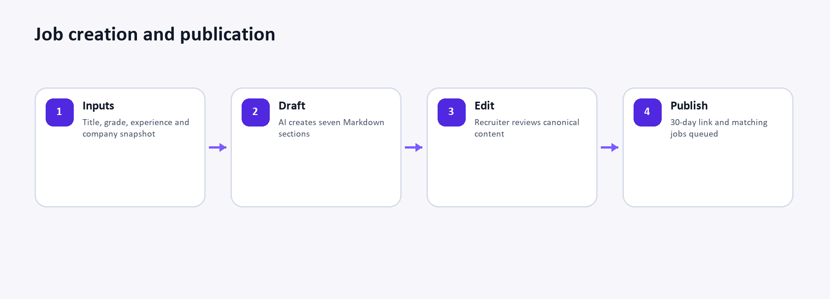
Figure: Four-stage job creation and publication workflow. Source: PickReady implementation.
The current UI always creates a draft first. A compatibility API default can publish immediately, but it is not the intended interface workflow.
Posting state is derived from publish, active-through, grace-through, archive, and renewal timestamps. Public lookup returns no job after the active window. Application editing checks the five-day grace boundary and prior application ownership.

10. Candidate intake, files, and parsing
Public application creates or updates a candidate and snapshots the reusable profile/resume onto the job-candidate relationship.
Resume storage:
- accepts PDF and DOCX;
- computes SHA-256 for content-addressed reuse;
- stores provider identifiers and metadata in PostgreSQL;
- serves files through authenticated routes;
- converts DOCX into sanitized HTML for browser preview; and
- falls back to download when inline preview is not available.
Bulk databank ingestion accepts up to 25 files and returns per-file success or error. Parsing and matching are queued once per accepted batch.
Current production storage is Cloudinary. The migration target is described in Section 24.

11. Matching architecture

11.1 Retrieval
The service obtains a candidate set from:
- BGE-M3-compatible 1024-dimension pgvector similarity;
- PostgreSQL full-text keyword retrieval; and
- candidate links already associated with the job.
The database has indexes for common tenant, lifecycle, status, and candidate-review paths.

11.2 Reranking
An LLM evaluates skills, experience, role/responsibility, and education. There is no weighting between the four (30 July 2026): each parameter is judged, graded and commented on its own terms, and Python owns the overall, which is their plain mean:
overall = (skills + experience + role_responsibility + education) / 4
The previous 0.35 / 0.30 / 0.20 / 0.15 table was removed for two reasons. The weights were surfaced to the client as “35% role-fit weighting” beside each remark, which is a number reaching a client. And a fixed weighting asserts that skills matter 2.3x more than education for every role in the product, an arithmetic the four AI comments do not perform. services/matching.py has no WEIGHTS symbol, and tests/test_scoring.py asserts its absence.
LLM dimension outputs use a constrained 1–10 range. Stored internal tiers are derived deterministically. User responses carry word labels and five comments constrained to approximately 25–30 words.
Compensation is removed from prompts. A small amount of PII-minimized historical positive-outcome context may be included, but cannot override the current JD.

11.3 Failure behavior
If provider reranking fails, retrieval results remain available. The fallback deliberately avoids assigning the highest recommendation tier. Matching requests should persist provider/fallback metadata for evaluation.

12. Assessment architecture

12.1 Bank generation
Technical questions are generated once per job and grade:
- Non-managerial: 20
- Managerial: 17
- Leadership: 15
- CXO: 12
Each question has a rubric. Schema validation and deterministic top-up guarantee the required count. Generation never approves: jobs.assessment_status starts at questions_pending_review and reaches ready_for_candidates only when both questions_approved_at and framework_approved_at are stamped. Until then the conversation and the invitation endpoint both answer 409, so nobody is mailed an assessment they cannot open. Publishing and assessment readiness are independent states: a published job takes applications and ranks them immediately.
services/ppi.generate_framework produces the job's PPI framework from the same JD: at least five Primary Skills, five Secondary Skills and five Behavioural Competencies, each with a required_level. Culture is refused at three layers — the generator prompt, the save handler, and a Postgres CHECK on job_competencies. services/ppi.generate_candidate_questions then runs per application, allocating the candidate's grade count (25/20/15/10) across the saved framework, one per competency first so nothing is graded that was never probed. Both generators are idempotent.

12.2 Invitation and conversation
The recruiter invitation endpoint:
- accepts no more than 200 candidate-link IDs;
- enforces capability and tenant ownership;
- blocks new sends when the credit balance is negative;
- creates or reuses invitation conversation records;
- queues communications; and
- returns per-candidate skipped reasons.
Starting requires a valid invitation. Messages are written one answer at a time. The full conversation is persisted for processing and audit.

12.3 Parallel scoring and synthesis
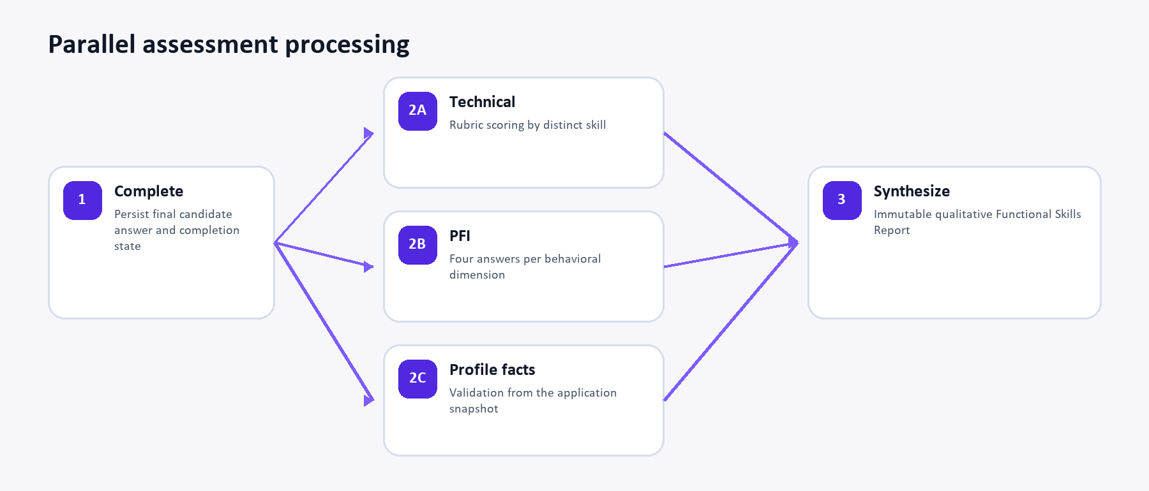
Figure: Assessment completion fans out into two parallel scoring agents, with the application validation fields flowing through unscored, before report synthesis. Source: PickReady implementation.
Two scoring agents fan out and join at synthesis, keyed on the question_key stamped on each transcript message. Technical scoring applies each question's own rubric before aggregating distinct skills. PPI scoring produces one entry per framework competency, each with a 45–50 word remark and the competency's required_level copied onto the row — copied rather than joined, because a written report is a permanent record of the criteria it was written against. validation_capture is a graph node but not a scorer: it copies the application's fields into the report shape and touches no model. Each scoring branch supports a deterministic fallback and records its scoring mode.
Assessment completion deducts one credit synchronously and queues report generation. The report write path is guarded against duplicate completion.

12.4 Report immutability and reuse
Report endpoints reject update and delete methods. A qualifying report from the most recent six-month window can supply behavioral and technical results to a new candidate-job link. Matching remains job-specific.

13. Hiring pipeline
The domain transition graph is server-enforced:
applied -> assessment_invited | shortlisted
assessment_invited -> assessment_in_progress | assessment_completed
assessment_in_progress -> assessment_completed
assessment_completed -> shortlisted
shortlisted -> interview_scheduled | offer_extended
interview_scheduled -> interview_completed
interview_completed -> interview_scheduled | offer_extended
offer_extended -> joined
non-terminal -> hold | rejected
The API normalizes the legacy offered value to offer_extended.
Interview scheduling creates an incremented round/stage record and advances the candidate when allowed. Status changes append history and update the current-state mirror in one transaction.
Some system stages remain available for workflow compatibility even when the current UI does not display them as manual dropdown actions.

14. Communications and verification

14.1 Outbound communications
Lifecycle email content is generated through the provider router with a deterministic template fallback. Gmail SMTP uses STARTTLS on port 587. Delivery occurs in Celery, and email logs preserve:
- type;
- recipient;
- subject and body;
- queued/sent/failed state;
- provider error;
- AI-generated marker; and
- human-edited marker.
Application confirmation, assessment invitation/reminder/completion, shortlist, rejection, hold, interview scheduling/completion, offer, and joined events are implemented.
The question-bank reminder task is live again: the review gate was reinstated on 30 July 2026, so a job left pending past the configured threshold mails everyone who could approve it, once per job.

14.2 Employer verification
The service creates tokenized requests, serves a public verification form, validates and stores responses, accepts parsed inbound email through an API, and supports audited override with a reason.
The repository does not include an inbound Gmail webhook/ingestion deployment. Production must connect an inbound email provider or mailbox ingestion service to the parsing endpoint.

15. Billing architecture
Razorpay Subscriptions owns external recurring-payment state. PickReady stores its plan mapping and subscription mirror. Webhook signatures are verified, and provider event IDs are deduplicated.
The credit ledger stores integer sub-units:
1 credit = 60 sub-units
completed = 60
incomplete = 20
no-show = 4
old-profile review = 3
Consumption methods require a stable idempotency key. The ledger is append-only; balance is derived and mirrored for fast display.
Celery beat reconciles invitations after the seven-day settlement window. A candidate who started but did not finish incurs 20 sub-units; a candidate who never opened after reminders incurs four. A negative balance remains valid historical state but prevents new invitations.

16. Business-development architecture
Personal and social lead routes share a service and persistence model. The source enum distinguishes LinkedIn, Google, Facebook, Instagram, X, and direct/personal data.
Six boolean progress flags store first-completed timestamps. Agreement promotion creates a prospect tenant exactly once. Unsigning archives/unlinks it; re-signing restores and reuses the link.
AI Reach modes:
- similar_to_customers: internal matching only;
- from_internet: Tavily research with plan, search, evaluate, and shape steps.
The API reports ok, unconfigured, timeout, or unavailable rather than silently presenting failed research. Confidence is serialized as words.

17. AI provider router

17.1 Current providers and models
Provider | Current model
Groq | llama-3.3-70b-versatile
Gemini / Google AI Studio | gemini-2.0-flash
OpenRouter | meta-llama/llama-3.3-70b-instruct
Source: PickReady source code and database migrations.
The router supports up to seven configured keys per provider, round-robin selection, task-specific provider order, timeouts, and circuit breaking. Database-configured keys take precedence over environment keys.

17.2 Task preference
Task | Provider order
JD generation | OpenRouter → Gemini → Groq
Technical questions | Gemini → OpenRouter → Groq
Behavioral content | Gemini → Groq → OpenRouter
Report synthesis | OpenRouter → Gemini → Groq
Email drafting | Groq → Gemini → OpenRouter
Candidate reranking | Groq → Gemini → OpenRouter
Structured extraction | Gemini → OpenRouter → Groq
Source: PickReady source code and database migrations.
Interactive and background operations have separate budgets. Failed providers are skipped until their circuit recovers.

17.3 Production recommendation
Free-tier keys and aggregator routing are useful for development but are not a production availability contract. At scale:
- Choose one enterprise, direct primary provider with contractual privacy, residency, throughput, support, and observability. Vertex AI Gemini is operationally aligned with a Google Cloud deployment; the OpenAI API is a viable direct alternative.
- Keep a second direct provider as tested failover for non-provider-specific prompts.
- Remove key rotation as a substitute for capacity planning. Use organization projects, service identities, budgets, quotas, and provisioned throughput where justified.
- Define per-task model versions and evaluation sets before upgrades.
- Redact/minimize candidate data, configure provider retention controls, and execute data-processing agreements.
- Do not send candidate PII through an aggregator unless contractual controls and subprocessor terms are accepted.
Current reference material:
- Vertex AI zero-data-retention controls
- OpenAI business data privacy
- OpenAI API data controls

18. API organization
The FastAPI application groups routes by domain:
- authentication and context;
- companies, staff, capabilities, and compliance;
- jobs and public jobs;
- candidates, profiles, files, matching, and team reviews;
- assessments and reports;
- pipeline and emails;
- billing;
- provider;
- BD and outreach; and
- public employer verification.
Some mature workflows are exposed under /api/v2, while base resources and billing remain under /api/v1; selected routes are aliased for compatibility. The generated FastAPI OpenAPI explorer is the executable route contract for a running environment.
New clients should use the route version already used by the current frontend instead of selecting a version by number alone.

19. Background processing and schedules
Celery handles:
- resume parsing and embedding;
- candidate matching;
- technical-bank generation;
- assessment scoring and report synthesis;
- email delivery and reminders;
- web-research workflows; and
- billing reconciliation.
Celery beat schedules:
- dashboard summary refresh at approximately five-minute intervals;
- credit reconciliation hourly; and
- the assessment-setup reminder task hourly, which chases jobs left pending review.
Workers must run as unprivileged processes and share the same release image/schema contract as the API.

20. Caching, pagination, and performance
Implemented controls include:
- Redis caching for hot public and dashboard data;
- a public-job cache measured in minutes;
- GZip for responses above approximately 1 KB;
- explicit pagination on candidate review and several list APIs;
- a 25-row candidate review page;
- batched resume ingestion;
- async database access;
- database indexes introduced in migration 0028;
- materialized dashboard refresh; and
- non-production request timing, SQL-query count, and Server-Timing instrumentation.
Not every list endpoint uses identical pagination. This should be standardized before high-volume onboarding.

21. Security and privacy

Implemented controls
- Firebase identity verification;
- HTTP-only application cookies;
- JWT audience separation;
- capability checks;
- tenant RLS;
- audited provider bypass;
- signed Razorpay webhook verification;
- tokenized public application/verification workflows;
- authenticated document routes;
- sanitized DOCX preview;
- PII minimization in matching prompts;
- compensation removal before matching;
- rate limiting on selected public telemetry and token endpoints; and
- append-only operational/audit records.

Critical repository hygiene issue
The working repository contains local plaintext secret material in .env, api-keys.txt, and deployment-keys.txt. No secret value should be copied into documentation or logs.
Before production:
- rotate every exposed credential;
- remove secret files from version control and developer hand-offs;
- inspect and, if required, scrub Git history;
- place runtime secrets in Google Secret Manager;
- grant secrets to service identities only;
- block secret patterns in pre-commit and CI; and
- maintain a documented rotation and incident procedure.

22. Testing and verification
The backend has unit/integration coverage for:
- session lifecycle and Firebase authentication;
- tenant staff and capabilities;
- jobs and posting lifecycle;
- candidate profile and resume flows;
- matching and matching API behavior;
- functional assessments;
- pipeline transitions;
- email delivery;
- outreach and employer verification;
- provider operations;
- BD provisioning and portal workflows;
- billing, webhook, credits, and reconciliation; and
- platform audit scenarios.
Frontend coverage includes focused Vitest tests for payload shaping and validation helpers, plus TypeScript, lint, and production-build checks.
Current gaps:
- no comprehensive browser end-to-end suite across all four workspaces;
- no load-test baseline for matching/report bursts;
- no chaos/failover tests for AI providers, Redis, email, or Cloudinary;
- no automated accessibility audit in CI; and
- no production SLO or synthetic monitoring suite.

23. Engineering challenges and implemented resolutions
Challenge | Implemented resolution | Remaining work
AI provider rate limits and failures | Task-aware routing, multiple keys, timeouts, circuit breaking, deterministic fallbacks | Enterprise quotas, evals, and provider SLAs
Semantic retrieval alone can miss exact terms | pgvector plus PostgreSQL full-text retrieval before LLM rerank | Relevance evaluation corpus and drift monitoring
Numeric AI scores imply false precision | Internal calculation with qualitative serialization | Calibrate word bands against outcomes
Retried payment/task events can double-charge | Append-only idempotent credit ledger and webhook dedupe | Reconciliation dashboards and operator tooling
Tenant leakage risk | Capability checks plus PostgreSQL RLS and audited bypass | Automated RLS policy tests on every migration
Long-running parsing and assessment work | Celery queues and durable workflow state | Queue autoscaling and dead-letter operations
Candidate data changes over time | Reusable main profile plus immutable per-application snapshots | Self-service retention and data-subject controls
Evolving specs created conflicting workflows | Current UI/API behavior selected as authority | Remove dormant compatibility paths
Rich DOCX viewing can introduce unsafe markup | Server-side conversion and sanitization | Malware scanning and isolated conversion service
Source: PickReady source code and database migrations.

24. Storage strategy

24.1 Current state
Cloudinary stores resumes and compliance documents. PostgreSQL stores references, hashes, access metadata, and domain relationships.

24.2 Production target
Use private Google Cloud Storage buckets for candidate and compliance documents:
- separate buckets or prefixes by data class and environment;
- uniform bucket-level access;
- no public object ACLs;
- short-lived signed URLs only where direct download is required, otherwise authenticated proxy access;
- default encryption, with CMEK where customer or regulatory needs justify it;
- object versioning/soft-delete policy appropriate to recovery needs;
- lifecycle rules for temporary and retention-bound objects;
- malware scanning on upload before a file becomes available;
- immutable audit metadata in PostgreSQL;
- regional placement aligned with the data-processing policy; and
- tested export/deletion workflows.
Cloudinary can remain for public marketing imagery, where transformation and CDN delivery are its strength. It should not be the long-term system of record for private candidate and compliance documents.
See Google Cloud Storage lifecycle management.

24.3 Migration approach
- Add a provider-neutral object-storage interface.
- Implement a GCS adapter and dual-write behind a feature flag.
- Backfill by content hash and verify byte size/checksum.
- Switch reads to GCS with Cloudinary fallback.
- observe, reconcile, and then disable document writes to Cloudinary;
- apply retention policy before deleting legacy objects.

25. Current deployment reality
The application is container-ready and is currently described as running against free Google Cloud credits. The repository itself contains:
- Dockerfiles;
- local Docker Compose for PostgreSQL/pgvector, Redis, API, worker, beat, and frontend;
- Railway configuration; and
- Render configuration.
It does not contain:
- Google Cloud infrastructure as code;
- a checked-in Cloud Run or GKE deployment definition;
- GitHub Actions or Cloud Build pipelines;
- environment promotion policy;
- automated migration/release jobs; or
- disaster-recovery runbooks.
Therefore the exact current Google Cloud topology is external/manual configuration and cannot be reconstructed from source alone.

26. Production deployment architecture

26.1 Recommended Google Cloud baseline
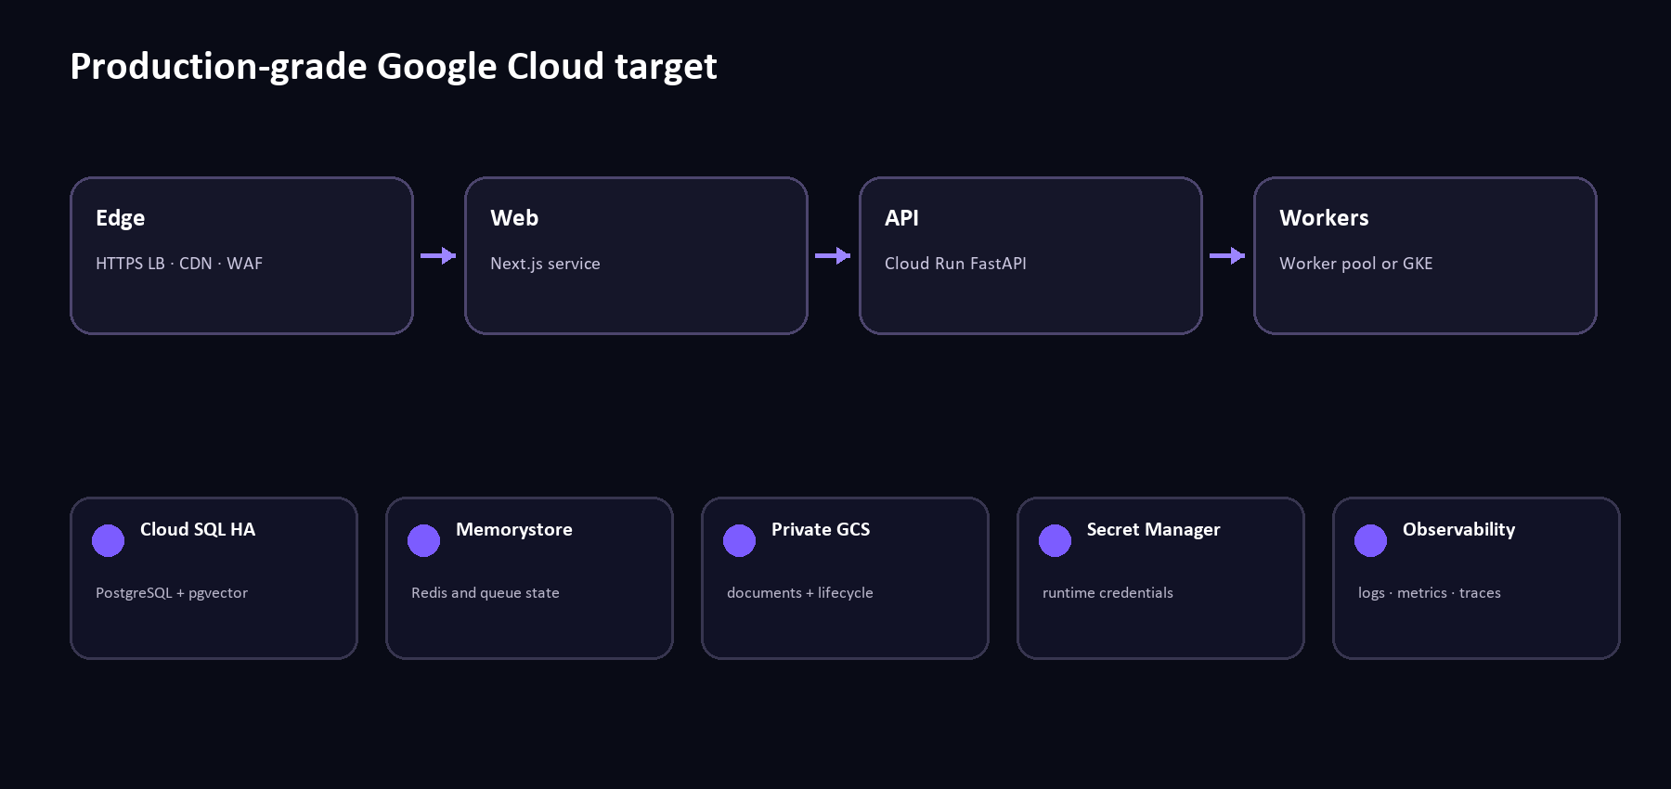
Figure: Recommended production-grade Google Cloud deployment. Source: PickReady implementation.
Recommended components:
- Cloud Run for the FastAPI service;
- Vercel or Cloud Run for the Next.js standalone frontend;
- Cloud SQL for PostgreSQL with HA, backups, point-in-time recovery, pgvector, and connection pooling;
- Memorystore for Redis;
- Cloud Storage for private files;
- Secret Manager;
- Artifact Registry;
- Cloud Logging, Monitoring, Trace, Error Reporting, dashboards, and alerts;
- Cloud Armor/WAF and rate limiting at the edge; and
- a managed DNS/certificate path.
Cloud SQL supports the vector extension required by the current design. See Cloud SQL PostgreSQL extensions.

26.2 Worker decision
Celery is a long-running pull-worker model. There are two viable production paths:
- Preserve Celery: use Cloud Run worker pools where operationally suitable, or GKE Autopilot with queue-based autoscaling and a singleton beat deployment.
- Move to managed events: replace Celery routing gradually with Pub/Sub/Cloud Tasks and Cloud Scheduler, using idempotent Cloud Run handlers.
Do not run multiple uncontrolled beat replicas. Scheduled work must have one logical issuer or a distributed lease.
Cloud Run supports autoscaled container services and worker workloads, but maximum instances must protect database connection capacity. See Cloud Run overview and Cloud Run autoscaling.

27. CI/CD and release strategy
Use GitHub Actions or Cloud Build with workload identity federation; do not store long-lived cloud keys in repository secrets.

Pull request pipeline
- secret scanning and dependency review;
- Python lint/type checks and backend tests;
- frontend lint, unit tests, type check, and production build;
- migration graph validation;
- container build;
- software bill of materials and vulnerability scan; and
- ephemeral integration tests with PostgreSQL/pgvector and Redis.

Main-branch pipeline
- build immutable images tagged by Git SHA;
- push to Artifact Registry;
- deploy to staging;
- run migrations as a one-off job;
- run API, portal, webhook, and worker smoke tests;
- require approval for production;
- deploy with canary or Cloud Run traffic splitting;
- monitor error, latency, queue, and business-integrity signals; and
- promote or roll back to the previous immutable revision.
Database changes must follow expand/migrate/contract so the old and new application versions can coexist during a rolling deployment.

28. Scaling strategy

Stage 1: Harden the current service
- move secrets to Secret Manager;
- move documents to private GCS;
- use managed Cloud SQL and Memorystore;
- add CI/CD, tracing, metrics, SLOs, backups, and alerting;
- cap Cloud Run instances against the connection pool; and
- run provider and queue failure drills.

Stage 2: Scale asynchronous throughput
- split worker queues by latency and resource profile;
- autoscale assessment, matching, resume, email, and research workloads independently;
- add dead-letter queues and replay tooling;
- cache model-independent artifacts;
- batch embedding calls where supported; and
- introduce load-shedding and tenant quotas.

Stage 3: Enterprise resilience
- multi-zone database HA and tested point-in-time recovery;
- read replicas for analytics workloads;
- regional storage and retention controls;
- blue/green or progressive releases;
- enterprise AI throughput commitments;
- formal data-processing and incident programs; and
- multi-region recovery only after recovery objectives justify its complexity.

29. Observability and operational targets
The code currently offers structured logs and development request/query timing. Production should add:
- request rate, latency, error, and saturation by route;
- SQL pool usage, slow queries, locks, and replication health;
- Redis latency, memory, evictions, and queue depth;
- task age, retry count, dead-letter count, and success rate by task;
- LLM latency, token/cost, provider, model, fallback, and schema-failure rate;
- email and SMS delivery states;
- billing webhook lag and ledger reconciliation differences;
- application, invitation, completion, and report funnel metrics; and
- storage upload, malware-scan, and download failures.
Initial SLOs should be established from measured baselines, not invented in documentation. Error-budget policy should cover API availability, candidate application, assessment progress persistence, and billing integrity.

30. Current limitations and recommended remediation
Priority | Limitation | Recommendation
Critical | Plaintext local secret files exist | Rotate, remove, scan history, and adopt Secret Manager plus CI secret scanning
High | No reproducible GCP infrastructure | Add Terraform for networks, services, identities, Cloud SQL, Redis, GCS, and monitoring
High | No CI/CD definitions | Implement the pipeline in Section 27
High | No upload malware scanner | Quarantine, scan, release, and audit every private upload
High | Cloudinary is the private-document store | Migrate through the provider-neutral path in Section 24
High | No production SLO/APM/synthetics | Add OpenTelemetry/cloud observability and business-integrity alerts
Medium | Inbound verification email is not operationally connected | Add a supported inbound-mail service and signature validation
Medium | Legacy OTP, approval, and question-bank paths remain | Inventory migrated data, deprecate routes, then remove code/schema safely
Medium | Full assessment transcript retains sensitive data | Add retention, redaction, export, deletion, and legal-hold policies
Medium | Browser E2E coverage is limited | Add Playwright journeys for each workspace and critical public links
Medium | Interview-round feedback tooling is incomplete | Add structured feedback, completion rules, and audit UI
Medium | List pagination is inconsistent | Standardize cursor/page contracts and limits
Medium | AI quality is not continuously evaluated | Add golden datasets, human review sampling, drift, bias, and fallback dashboards
Low | Development instrumentation is disabled in production | Replace with sampled production tracing and metrics
Source: PickReady source code and database migrations.

31. Brief development history
The system evolved from a three-workspace hiring MVP into a four-workspace platform with provider administration, reusable candidate profiles, invitation-gated functional assessment, qualitative reporting, posting renewal, billing credits, compliance records, employer verification, and BD lead conversion.
During that evolution, several proposals were superseded and one was reinstated. Validation is no longer a 40-question interview: it is six mandatory fields on the application form, captured before any assessment spend and never scored. The manual review gate, removed on 25 July 2026, was reinstated on 30 July 2026 and now covers the PPI framework as well as the technical bank; it gates invitations, not publishing. Firebase sessions replaced the older primary OTP concept, Gmail SMTP replaced the removed Mailtrap delivery service, and the ranking surface intentionally hides numeric scores behind four word grades.

32. Concise technical roadmap
- Security and reproducibility: rotate secrets, introduce GCP Terraform, managed storage, CI/CD, and malware scanning.
- Reliability: add SLOs, tracing, queue operations, backups, recovery drills, and enterprise AI contracts.
- Quality: build browser E2E, load tests, AI evaluation, and outcome calibration.
- Maintainability: remove dormant compatibility paths and standardize API versions/pagination.
- Enterprise scale: add retention/regional controls, enterprise identity, audit exports, and independently autoscaled workloads.

