Support Vector Machine Algorithm

Support Vector Machine is one of the most popular Supervised Learning algorithm, Which is is used for Classification as well as Regression problems.
The goal of the SVM algorithm is to create the best line or decision boundary that can segregate n-dimensional space into classes so that we can easily put the new data point in the correct category in the future. The best decision boundary is called a hyperplane.
SVM chooses the extreme points/vectors that help in creating the hyperplane. These extreme cases are called as support vectors, and hence algorithm is termed as Support Vector Machine.

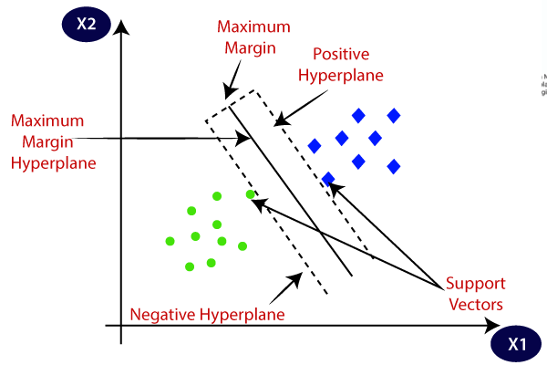

Types of SVM
SVM can be two Types:
- Linear SVM: Linear SVM is used for linearly separable data, which means if a dataset can be classified into two classes by using a single straight line, then such data is termed as linearly separable data, and classifier is used called as Linear SVM classifier.
- Non-Linear SVM: Non-Linear SVM is used for non-linearly separated data, which means if a dataset cannot be classified by using a straight line, then such data is termed as non-linear data and classifier used is called as Non-linear SVM classifier.

Support Vectors: The data points or vectors that are closest to the hyperplane and which affect the position of the hyperplane are termed as Support Vector.

Breast Cancer Detection Using SVM:
Breast cancer is the most common cancer amongst women in the world. It accounts for 25% of all cancer cases, and affected over 2.1 Million people in 2015 alone. It starts when cells in the breast begin to grow out of control. These cells usually form tumors that can be seen via X-ray or felt as lumps in the breast area.
Early diagnosis significantly increases the chances of survival. The key challenges against it’s detection is how to classify tumors into malignant (cancerous) or benign(non cancerous). A tumor is considered malignant if the cells can grow into surrounding tissues or spread to distant areas of the body. A benign tumor does not invade nearby tissue nor spread to other parts of the body the way cancerous tumors can. But benign tumors can be serious if they press on vital structures such as blood vessels or nerves.
Machine Learning technique can dramatically improve the level of diagnosis in breast cancer. Research shows that experienced physicians can detect cancer by 79% accuracy, while a 91 %( sometimes up to 97%) accuracy can be achieved using Machine Learning techniques.

Project Task
My task is to classify tumors into malignant (cancerous) or benign (non-cancerous) using features obtained from several cell images.

Ten real-valued features are computed for each cell nucleus:
- Radius (mean of distances from center to points on the perimeter)
- Texture (standard deviation of gray-scale values)
- Perimeter
- Area
- Smoothness (local variation in radius lengths)
- Compactness (perimeter^2 / area - 1.0)
- Concavity (severity of concave portions of the contour)
- Concave points (number of concave portions of the contour)
- Symmetry
- Fractal dimension ("coastline approximation" - 1)

Algorithm Steps:

Import needed Python Libraries

Let's view the data in a dataframe

Let's Explore Our Dataset

The next step is to Visualize our data

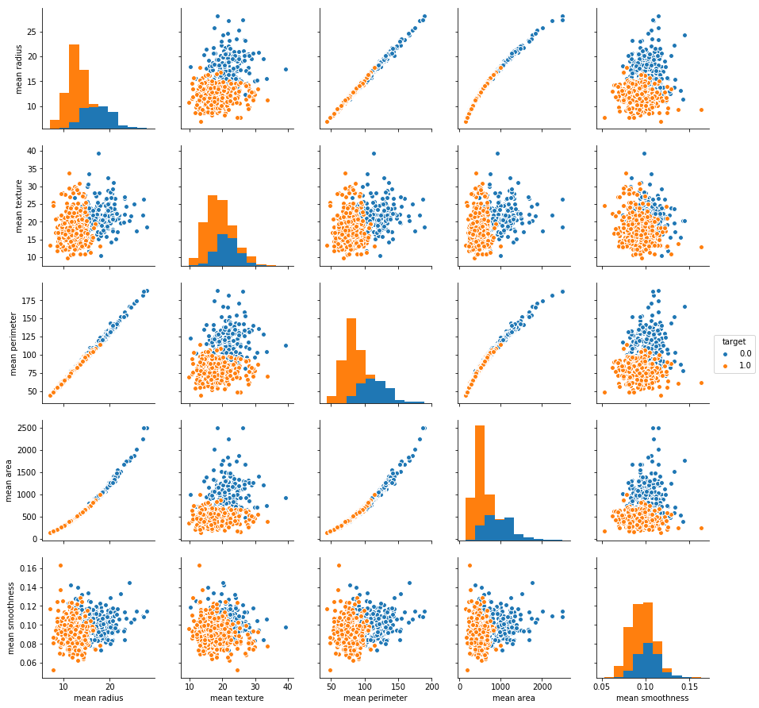

Note:
  - (Orange) = Benign (No Cancer)
(Blue) = Malignant (Cancer)

- How many Benign and Malignant do we have in our dataset?
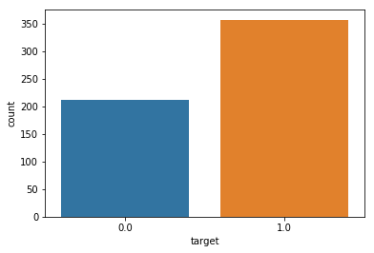

Model Training
From our dataset, let's create the target and predictor matrix
- "y" = Is the feature we are trying to predict (Output). In this case we are trying to predict wheither our "target" is Cancer (Malignant) or not (Benign). I.e. we are going to use the "target" feature here.
- "X" = The predictors which are the remaining columns (mean radius, mean texture, mean perimeter, mean area, mean smoothness, etc)

Create the training and testing data
- Now that we've assigned values to our "X" and "y", the next step is to import the python library that will help us to split our dataset into training and testing data.
- Training data = Is the subset of our data used to train our model.
- Testing data = Is the subset of our data that the model hasn't seen before. This is used to test the performance of our model.
- Let's split our data using 80% for training and the remaining 20% for testing.
- Let now check the size our training and testing data.

  - The size of our training "X" (input features) is (455, 30)
  - The size of our testing "X" (input features) is (114, 30)
  - The size of our training "y" (output feature) is (455,)
  - The size of our testing "y" (output features) is (114,)

Import Support Vector Machine (SVM) Mode

Now, let's train our SVM model with our "training" dataset.

- Next step is to check the accuracy of our prediction by comparing it to the output we already have (y_test). We are going to use confusion matrix for this comparison

The confusion matrix
The confusion matrix is a table representing the performance of your model to classify labels correctly.
A confusion matrix for a binary classification task:
 | Predicted Negative | Predicted Positive
Actual Negative | True Negative (TN) | False Positive (FP)
Actual Positive | False Negative (FN) | True Positive (TP)

- True Positive: A positive class observation (1) is correctly classified as positive by the model.
- False Positive: A negative class observation (0) is incorrectly classified as positive.
- True Negative: A negative class observation is correctly classified as negative.
- False Negative: A positive class observation is incorrectly classified as negative.

- Columns of the confusion matrix sum to the predictions by class. Rows of the matrix sum to the actual values within each class. You may encounter confusion matrices where the actual is in columns and the predicted is in the rows: the meaning is the same but the table will be reoriented.

- Let's create a confusion matrix for our classfier's performance on the test dataset.
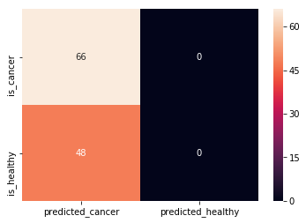

precision recall f1-score support

0.0 0.00 0.00 0.00 48
1.0 0.58 1.00 0.73 66

avg / total 0.34 0.58 0.42 114

- As we can see, our model did not do a very good job in its predictions. It predicted that 48 healthy patients have cancer.
- Let's explore ways to improve the performance of our model.

Improving our Model
- The first process we will try is by Normalizing our data
- Data Normalization is a feature scaling process that brings all values into range [0,1]
- X' = (X-X_min) / (X_max - X_min)-----> X_range

Normalize Training Data
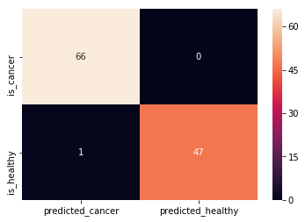

precision recall f1-score support

0.0 1.00 0.98 0.99 48
1.0 0.99 1.00 0.99 66

avg / total 0.99 0.99 0.99 114

Note: We only have 1 false prediction.

CODE

import pandas as pd
import numpy as np
import matplotlib.pyplot as plt
import seaborn as sns
from sklearn.model_selection import train_test_split
from sklearn.svm import SVC
from sklearn.metrics import classification_report, confusion_matrix

#Import Cancer data from the Sklearn library
# Dataset can also be found here (http://archive.ics.uci.edu/ml/datasets/breast+cancer+wisconsin+%28diagnostic%29)

from sklearn.datasets import load_breast_cancer
cancer = load_breast_cancer()
df_cancer = pd.DataFrame(np.c_[cancer['data'], cancer['target']], columns = np.append(cancer['feature_names'], ['target']))

X = df_cancer.drop(['target'], axis = 1) # We drop our "target" feature and use all the remaining features in our dataframe to train the model.

y = df_cancer['target']

X_train, X_test, y_train, y_test = train_test_split(X, y, test_size = 0.2, random_state = 20)

svc_model = SVC()

svc_model.fit(X_train, y_train)

y_predict = svc_model.predict(X_test)

cm = np.array(confusion_matrix(y_test, y_predict, labels=[1,0]))
confusion = pd.DataFrame(cm, index=['is_cancer', 'is_healthy'],
columns=['predicted_cancer','predicted_healthy'])

print(confusion)

sns.heatmap(confusion, annot=True)
print(classification_report(y_test, y_predict))

print("After Normalization:")

X_train_min = X_train.min()
X_train_max = X_train.max()
X_train_range = (X_train_max- X_train_min)
X_train_scaled = (X_train - X_train_min)/(X_train_range)
X_test_min = X_test.min()
X_test_range = (X_test - X_test_min).max()
X_test_scaled = (X_test - X_test_min)/X_test_range
svc_model = SVC()
svc_model.fit(X_train_scaled, y_train)
y_predict = svc_model.predict(X_test_scaled)
cm = confusion_matrix(y_test, y_predict)
cm = np.array(confusion_matrix(y_test, y_predict, labels=[1,0]))
confusion = pd.DataFrame(cm, index=['is_cancer', 'is_healthy'],
columns=['predicted_cancer','predicted_healthy'])
print(confusion)

sns.heatmap(confusion,annot=True,fmt="d")

print(classification_report(y_test,y_predict))

