(1). Delete Docker instance manualy
Links : https://www.tecmint.com/remove-docker-images-containers-and-volumes/
$ docker image #list the most recently created images
OR
$ docker image -a #list all images
$ docker rmi d65c4d6a3580 #remove a single image
$ docker rmi 612866ff4869 e19e33310e49 abe0cd4b2ebc

Docker volume:
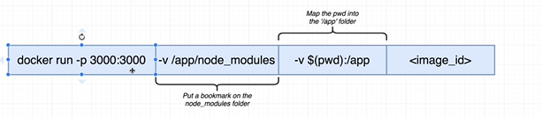

docker run –p 3000:3000 | -v /app/node_modules | -v $(pwd):/app | <image_id>

For windows use
$ docker run -p 4444:3000 -v "D:\works\docker_works\prod_grade\frontend:/app" a5a5fc9e998b
In Prectice is working only the bellow command
$ docker run -p 3000:3000 -v D:/works/docker_works/prod_grade/frontend_1/my-app_1:/app -v /app/node_modules 230fb832803b

Volume example : https://medium.com/@shakyShane/lets-talk-about-docker-artifacts-27454560384f
Test Executing :
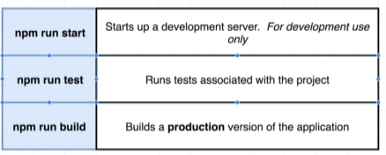
One liner to stop / remove all of Docker containers:
docker stop $(docker ps -a -q)
docker rm $(docker ps -a -q)

