Title : Machine Learning-Based Student Performance Prediction System

Abstract

Student academic performance is an important indicator of educational success and plays a vital role in improving learning outcomes. Traditional methods of evaluating student performance often rely on manual analysis of academic records, attendance, and other student-related information, making it difficult to identify students who may be at risk at an early stage. This project proposes a Machine Learning-Based Student Academic Performance Prediction System that uses historical academic, attendance, behavioral, and personal/support-related data to identify students who may require additional academic support.
The proposed system utilizes TabPFN (Tabular Prior-Data Fitted Network), a machine learning model designed for tabular data, to classify students into Good Performance and At Risk categories. The dataset is preprocessed and transformed into relevant features using academic and student-related attributes such as previous grades, study time, absences, failures, age, family support, internet access, activities, and other available factors. The final performance grade G3 is used only to derive the target class and is not used as an input feature, helping to avoid target leakage.
The model is evaluated using stratified 5-fold cross-validation and a separate holdout test set. The final system achieves 89.87% accuracy, 82.14% precision, 88.46% recall, and 85.19% F1-score on the holdout test set. In addition to prediction, the system provides an individual risk score, identifies factors associated with the prediction, presents academic trends, provides intervention recommendations, and supports what-if analysis to explore how changes in selected student attributes may affect the predicted risk.
The proposed system aims to provide a proactive, interpretable, and data-driven approach to student performance monitoring, helping educators identify students who may require timely academic support and enabling more informed intervention planning.

Datasets

Dataset | URL link
Student Performance Dataset (UCI)
  https://archive.ics.uci.edu/dataset/320/student+performance

Approach

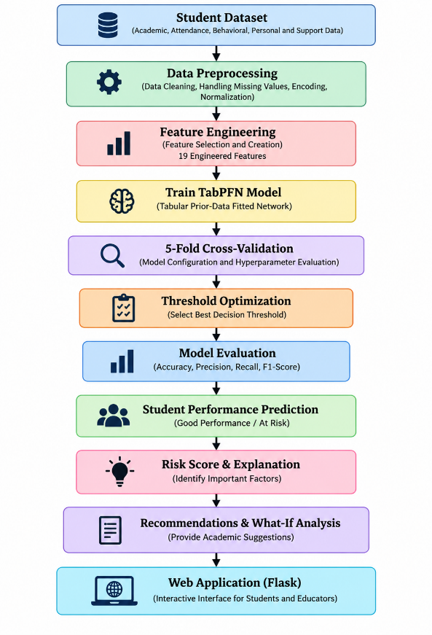

Project Group Members

S.No. | Roll.No. | Student Name
1 | 2420030285 | B.Vignesh
2 | 2420030404 | P.Karthik
3 | 2420080062 | T.Nishanth
4 | 2420090088 | H.Niranjan

