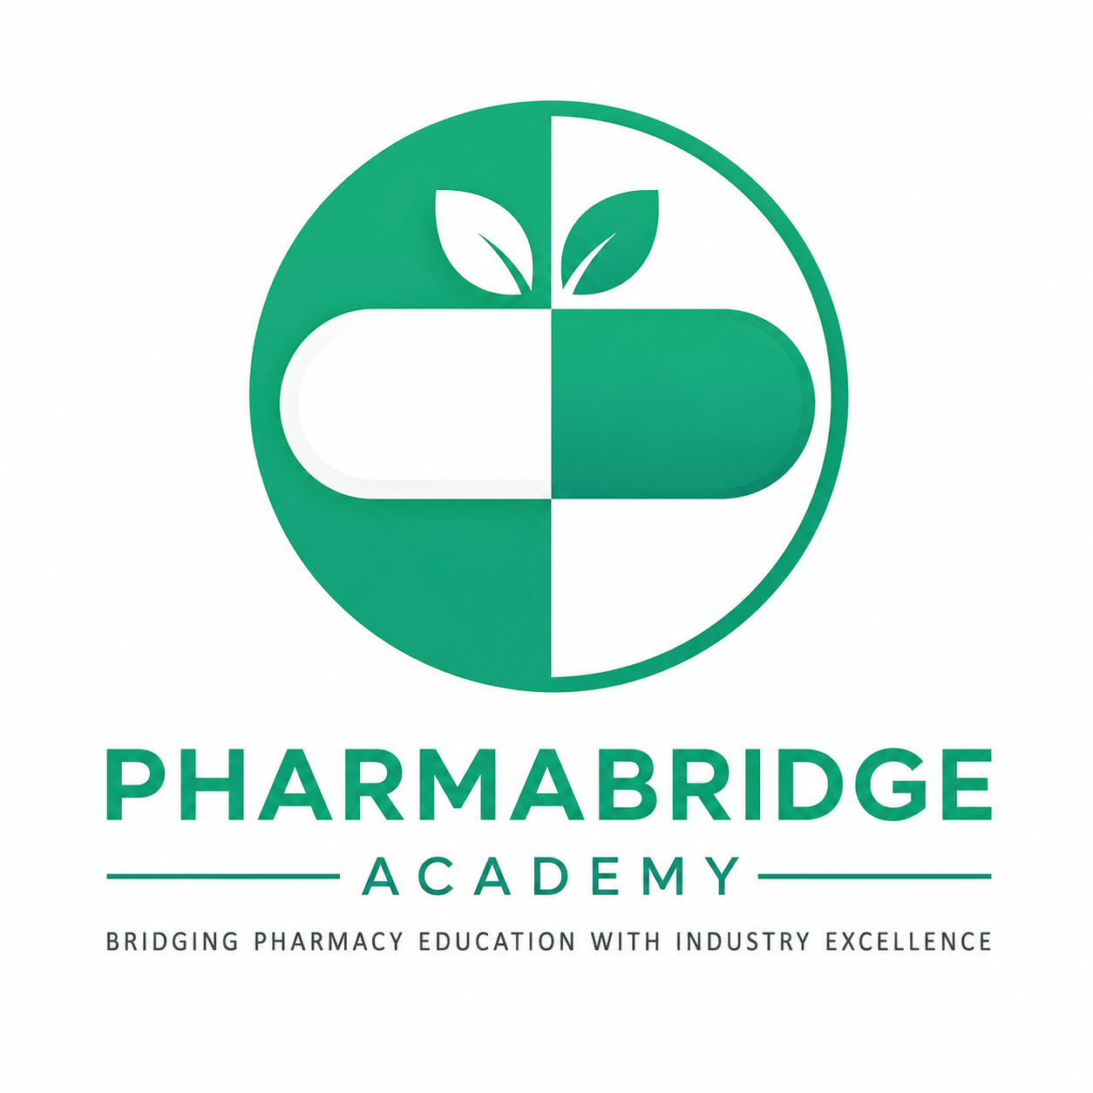
PHARMABRIDGE ACADEMY
Bridging Pharmacy Education with Industry Excellence
Pharmaceutical Industry Overview
Student Handout — Session 1 & 2
What You'll Learn
Indian & Global Pharma Industry • Types of Pharmaceutical Companies
CRO vs Sponsor vs Manufacturing • Career Opportunities

Session 1
"How does a medicine reach a patient?"

1. What is the Pharmaceutical Industry?
The pharmaceutical industry is the branch of the healthcare and life-sciences sector responsible for discovering, developing, manufacturing, testing, and distributing medicines and vaccines for human and animal use. It sits at the intersection of science, regulation, and commerce.
At its core, the industry exists to translate scientific research into safe, effective, and accessible treatments. This journey — from a molecule discovered in a lab to a tablet in a pharmacy — typically takes 10–15 years and involves multiple specialized organizations working together.
The Medicine Journey — Key Stages
- Discovery & Research: Scientists identify a disease target and a molecule that may treat it.
- Preclinical Testing: The molecule is tested in labs and on animal models for safety signals.
- Clinical Trials (Phases I–III): The molecule is tested on human volunteers and patients in controlled studies.
- Regulatory Approval: Health authorities (e.g., CDSCO in India, USFDA in the US, EMA in Europe) review data and approve the medicine.
- Manufacturing: The approved medicine is produced at industrial scale under strict quality standards.
- Distribution & Marketing: The medicine reaches hospitals, pharmacies, and patients through supply chains and sales/marketing teams.
- Post-Market Surveillance: Companies continue monitoring safety even after the medicine is available to the public.
Key takeaway: Each stage of the medicine journey is also a source of jobs — from research to regulatory to sales.

2. Indian vs Global Pharma
India holds a distinct and important position in the global pharmaceutical landscape. It is often called the "Pharmacy of the World" because of its scale in generic medicine production and vaccine manufacturing.
The Indian Pharma Industry
- Among the largest suppliers of generic medicines globally by volume, supplying to over 200 countries.
- Strong presence in vaccine manufacturing.
- Home to both multinational companies (with India offices) and domestic Indian companies.
- Cost-effective manufacturing and a large pool of skilled scientific and technical talent.
- Regulated by the CDSCO (Central Drugs Standard Control Organisation) and State Drug Control authorities.
The Global Pharma Industry
- Dominated by large research-driven multinational corporations (mainly US, Europe, and increasingly China).
- Strong focus on innovation — new molecule discovery, biologics, and advanced therapies like gene and cell therapy.
- Higher R&D spending as a percentage of revenue, though the gap with India is narrowing.
- Regulated by bodies such as the USFDA (United States), EMA (Europe), and MHRA (United Kingdom).
Comparison at a Glance
Aspect | Indian Pharma | Global Pharma
Primary strength | Generics & vaccines at scale | Innovation & new drug discovery
Cost structure | Low-cost, high-volume manufacturing | High R&D investment
Key regulator | CDSCO | USFDA / EMA / MHRA
Typical roles | Manufacturing, QA, regulatory, sales | R&D, clinical research, medical affairs

Key takeaway: These worlds increasingly overlap — many Indian companies run global trials, and many global companies have R&D or manufacturing in India.

3. Types of Pharmaceutical Companies
Not all pharma companies do the same thing. Knowing these categories helps you target the right kind of company for your interests and skills.
a) Innovator / Research-Based Companies
Invest heavily in discovering new molecules and bringing novel drugs to market. Hold patents on original products for a defined period. Roles here often require strong scientific or research backgrounds.
b) Generic Companies
Manufacture and sell medicines whose patents have expired, replicating the innovator's formulation at lower cost. India is a global leader in this category.
c) Biotechnology Companies
Develop biologic products — medicines derived from living organisms, such as vaccines, monoclonal antibodies, and cell/gene therapies. One of the fastest-growing segments globally.
d) Contract Research Organizations (CROs)
Service providers that conduct clinical trials, data management, and regulatory work on behalf of pharma and biotech companies (sponsors). They do not own the drugs they help test.
e) Contract Manufacturing Organizations (CMOs / CDMOs)
Manufacture drug products or ingredients on behalf of other pharma companies. CDMOs also assist with formulation development, not just production.
f) API (Active Pharmaceutical Ingredient) Manufacturers
Produce the raw active chemical or biological ingredient that gives a medicine its therapeutic effect, later formulated into tablets, injections, or other dosage forms.
g) Medical Device & Diagnostics Companies
Closely linked to pharma, producing devices, test kits, and diagnostic tools used alongside medicines in patient care.
Quick Reference Table
Company Type | What They Do | Example Focus Area
Innovator | Discover & develop new drugs | R&D, clinical trials
Generic | Replicate off-patent drugs | Manufacturing, ANDA filings
Biotech | Develop biologics & advanced therapies | Vaccines, antibodies, gene therapy
CRO | Run trials for sponsors | Clinical operations, data management
CMO/CDMO | Manufacture on contract | Production, formulation
API Manufacturer | Produce active ingredients | Chemical/biological synthesis

Session 1 — Key Takeaways
- The pharmaceutical industry moves a medicine through discovery, trials, approval, manufacturing, and distribution.
- India is a generics and vaccine manufacturing powerhouse; global markets lead in innovation.
- Companies specialize — innovator, generic, biotech, CRO, CMO/CDMO, and API manufacturers all play different roles.

My Notes

Session 2
"Who does what in the pharma industry?"

1. CRO vs Sponsor vs Manufacturing
Learners often confuse these three roles because they can all be involved in the same drug's journey, but they serve very different functions and require different skill sets.
Sponsor
The company that owns the drug or the trial — typically an innovator pharma company or biotech. Initiates and funds the research, holds ultimate responsibility for the drug's development, and makes the final regulatory submissions.
- Owns the intellectual property (patent) of the drug
- Funds and oversees the clinical trial or development program
- Ultimately responsible for regulatory submissions and approval
- Typical roles: clinical development lead, medical affairs, regulatory strategy, portfolio management
CRO (Contract Research Organization)
Hired by the sponsor to carry out some or all of the clinical trial work — trial design support, site management, patient recruitment, data collection, monitoring, and regulatory documentation. Does not own the drug; provides a specialized service.
- Acts as an outsourced partner, not the drug owner
- Manages day-to-day trial operations across one or many sponsor projects at once
- Specializes in areas like clinical operations, biostatistics, data management, and pharmacovigilance
- Typical roles: clinical research associate (CRA), clinical data manager, biostatistician, medical writer, regulatory affairs associate
Manufacturing (CMO/CDMO or In-House Plant)
Once a drug is approved (or even during trial production of investigational drug supplies), it must be physically manufactured — in the sponsor's own facility, or outsourced to a CMO/CDMO.
- Responsible for physical production of tablets, injectables, biologics, etc.
- Operates under Good Manufacturing Practice (GMP) regulations
- Focuses on quality control, quality assurance, and supply chain reliability
- Typical roles: production officer, quality control analyst, quality assurance executive, plant operations manager
How They Work Together — A Simple Example
A biotech company (the sponsor) develops a new vaccine candidate. It hires a CRO to run the Phase II and III clinical trials across multiple hospitals. Once the trial data supports approval, the sponsor partners with a CDMO to manufacture the vaccine at commercial scale. All three organizations are essential, but each has a distinct role.
Side-by-Side Comparison
Aspect | Sponsor | CRO | Manufacturing (CMO/CDMO)
Owns the drug? | Yes | No | No (usually)
Core function | Funds & directs development | Runs trial operations | Produces the medicine
Key regulation focus | Overall approval strategy | GCP (Good Clinical Practice) | GMP (Good Manufacturing Practice)
Example roles | Medical affairs, portfolio lead | CRA, data manager, biostatistician | QA/QC, production, plant ops

2. Career Opportunities
The pharmaceutical industry offers a wide range of career paths beyond the traditional image of a pharmacist behind a counter.
a) Clinical Research & Trials
- Clinical Research Associate (CRA) — monitors trial sites for compliance and data quality
- Clinical Data Manager — manages and cleans trial data for analysis
- Biostatistician — analyzes trial data for statistical significance and safety signals
- Medical Writer — prepares clinical study reports, protocols, and regulatory documents
b) Regulatory Affairs
- Regulatory Affairs Associate/Executive — prepares and manages submissions to authorities like CDSCO, USFDA, or EMA
- Regulatory Affairs Manager — oversees approval strategy across markets
c) Quality & Manufacturing
- Quality Control (QC) Analyst — tests raw materials and finished products for compliance
- Quality Assurance (QA) Executive — ensures manufacturing processes follow GMP standards
- Production Officer / Plant Operations — manages the manufacturing line
d) Pharmacovigilance & Safety
- Pharmacovigilance (PV) Associate — monitors and reports adverse drug reactions post-launch
- Drug Safety Officer — assesses risk-benefit profiles of marketed drugs
e) Sales, Marketing & Medical Affairs
- Medical Representative — engages with doctors and pharmacies to promote products
- Product Manager — plans marketing strategy for a drug or portfolio
- Medical Science Liaison (MSL) — bridges scientific/medical teams with healthcare professionals
f) Emerging & Cross-Functional Roles
- Health Economics & Outcomes Research (HEOR) — studies cost-effectiveness of treatments
- Regulatory/Clinical Technology roles — supporting digital trial platforms and data systems
- Supply Chain & Logistics — managing the flow of medicines from plant to patient
Reflect: Which of these roles matches your own strengths — detail-oriented, people-facing, or analytical/writing-focused?

Session 2 — Key Takeaways
- The Sponsor owns the drug; the CRO runs the trials; Manufacturing (CMO/CDMO) produces the medicine.
- Career paths span clinical research, regulatory affairs, quality/manufacturing, pharmacovigilance, and sales/marketing.
- Matching your own strengths to a functional area is a good starting point for choosing a career track.

Quick Self-Check
- Which type of company owns the drug in a clinical trial?
- True or False: A CRO manufactures medicines.
- What does GMP stand for, and where is it most relevant?
- Name one career role in Quality Assurance.

My Notes

