
PHARMABRIDGE ACADEMY
Bridging Pharmacy Education with Industry Excellence
Quality & Ethics
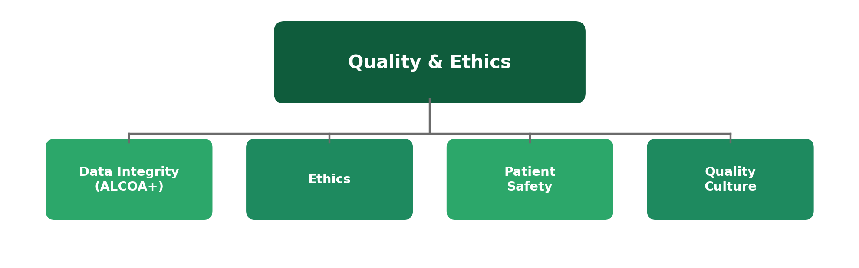

The Big Picture
Unlike most other modules in this programme, quality and ethics aren't tied to a specific department or lifecycle stage — they're expectations that apply to absolutely everyone in pharma, from a lab technician to a CEO. A single lapse in data integrity or ethics can undo years of otherwise excellent scientific work.
This overview covers the four ideas you'll be expected to understand and live by, regardless of which part of the industry you eventually join.
1. Data Integrity (ALCOA+)
Applies to: every record, in every department
Data integrity means the information a company records — trial results, batch records, lab results — can be trusted completely. ALCOA+ is the widely used framework that defines what "trustworthy data" actually looks like in practice.
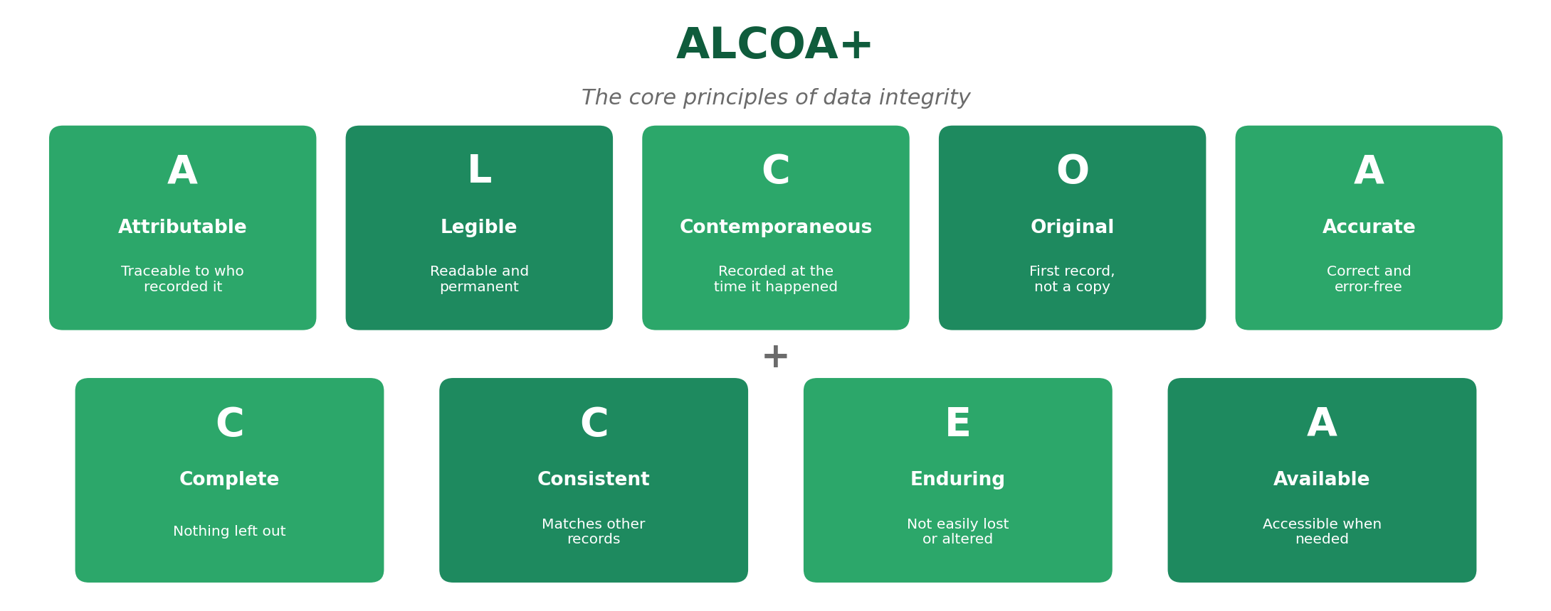
- Originally five principles (ALCOA), later expanded with four more (the "+") as records became more digital.
- Regulators check for ALCOA+ compliance during almost every inspection.
- A single altered or backdated record can call an entire dataset into question.
2. Ethics
Applies to: clinical research, and every decision involving people
Ethics in pharma is about protecting the people whose participation makes medicines possible — trial volunteers, patients, and the wider public. It means being honest about risks, respecting people's right to choose, and never cutting corners that could put someone at risk.
- Informed consent is the clearest example: participants must fully understand and agree to a trial before joining.
- Ethics committees (Institutional Review Boards) independently review trials before they can start.
- Ethical failures — even well-intentioned ones — can permanently damage public trust in an entire company or industry.
3. Patient Safety
Applies to: every stage, from Discovery to Post-Market Surveillance
Patient safety is the reason every other standard in this programme exists — GxP, documentation, regulations, and data integrity all ultimately trace back to one goal: making sure medicines help people without causing unnecessary harm.
- Safety monitoring doesn't stop at approval — it continues for as long as a medicine is on the market.
- Even small decisions, like how carefully a batch record is filled out, connect back to patient safety.
- When in doubt, the safest choice for the patient is always the right one to raise, even if it slows things down.
4. Quality Culture
Applies to: the whole organisation, at every level
A quality culture means quality isn't just a department's job — it's a shared mindset. It shows up in whether people speak up about a problem, follow procedures even when no one is watching, and treat documentation as important rather than a formality.
- Strong quality cultures encourage employees to report mistakes early, rather than hide them.
- Leadership behavior sets the tone — if managers cut corners, teams will too.
- Companies with weak quality cultures tend to have more repeat inspection findings over time.
Reflect: A good quality culture means doing the right thing even when it's inconvenient, not just when someone is checking.
Quick Reference: All Four Ideas
Topic | Core Idea | Applies To
Data Integrity | Records must be ALCOA+ compliant | Every record, every department
Ethics | Protect the people behind the data | Clinical research & human involvement
Patient Safety | The reason every standard exists | Every lifecycle stage
Quality Culture | Doing things right, not just being checked | The whole organisation

Why This Matters
Technical skills and industry knowledge get you hired, but quality and ethics are what keep an entire career — and an entire company — trustworthy. Every module before this one assumes these four ideas are already in place; without them, none of the rest holds up.
Reflect: Can you think of a moment — at school, in a job, or elsewhere — where doing the honest thing was less convenient than cutting a corner? What did you choose?

