
PHARMABRIDGE ACADEMY
Bridging Pharmacy Education with Industry Excellence
Regulatory & Compliance Basics
Student Notes — A Quick Understanding Guide
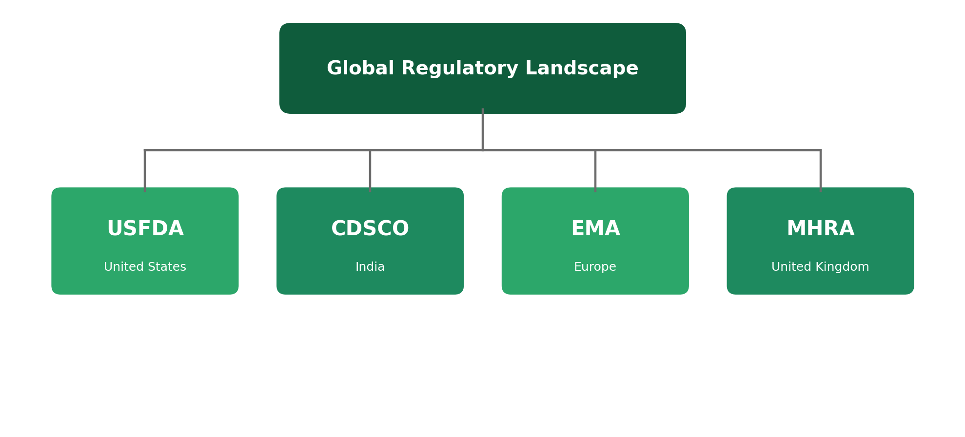
The names behind every approval and every recall.
Name: _____________________________ Batch: ______________

Why Regulations Exist
Medicines can heal, but they can also harm if they're made poorly, tested carelessly, or sold without proper oversight. Regulations exist to make sure that never happens quietly — every country has an authority whose job is to check that medicines are safe, effective, and made to a consistent standard before and after they reach patients.
This overview introduces the major regulatory bodies you'll hear about across the industry, and what a regulatory inspection actually involves. The goal is to recognise these names and understand their role — not to memorize regulations.
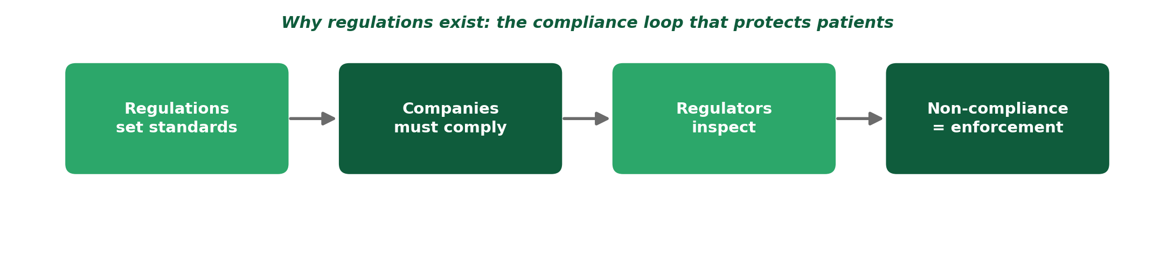
1. USFDA — United States Food and Drug Administration
Region: United States
The USFDA is the regulatory authority responsible for approving and monitoring medicines, vaccines, and medical devices in the United States. It's one of the most influential regulators globally — approval here is often seen as a mark of strong scientific rigor.
- Reviews clinical trial data before allowing a drug to be marketed in the US.
- Inspects manufacturing facilities, including many outside the US, that supply the American market.
- Can issue warning letters or halt sales if a company falls out of compliance.
2. CDSCO — Central Drugs Standard Control Organisation
Region: India
CDSCO is India's national regulatory authority for pharmaceuticals and medical devices, working alongside State Drug Control authorities. It oversees drug approvals, clinical trials, and manufacturing licenses within India.
- Approves new drugs and clinical trials conducted in India.
- Works together with state-level drug control bodies for licensing and inspections.
- Especially important given India's scale in generic and vaccine manufacturing.
3. EMA — European Medicines Agency
Region: European Union
The EMA coordinates the scientific evaluation of medicines across European Union member states. Rather than each country reviewing a drug separately, the EMA allows for a single, centralized approval that applies across the EU.
- Enables one approval process to cover multiple European countries at once.
- Works with national regulatory agencies in each EU member state.
- Also monitors medicine safety across the EU after approval.
4. MHRA — Medicines and Healthcare products Regulatory Agency
Region: United Kingdom
The MHRA is the UK's regulatory authority for medicines and medical devices. Since the UK's departure from the EU, the MHRA now operates independently of the EMA for UK market approvals.
- Approves medicines and devices for the UK market specifically.
- Conducts inspections of manufacturing and clinical trial sites.
- Monitors safety of medicines already on the UK market.
5. Inspections
Region: Global — conducted by all regulators above
An inspection is a formal visit by a regulatory authority to check that a company is actually following the rules it claims to follow — whether in a factory, a lab, or a clinical trial site. Inspections can be routine, or triggered by a specific concern.
- Inspectors review documents, walk through facilities, and interview staff.
- Any gaps found are recorded as "observations" that the company must address.
- Serious or repeated observations can delay approvals, or in extreme cases, shut down operations.
Why it matters: passing an inspection isn't about last-minute cleanup — it's about proving that good practices (GMP, GCP, GLP, and the rest) are followed every day, not just when someone is watching.
Quick Reference: Regulatory Authorities
Authority | Full Name | Region
USFDA | US Food and Drug Administration | United States
CDSCO | Central Drugs Standard Control Organisation | India
EMA | European Medicines Agency | European Union
MHRA | Medicines and Healthcare products Regulatory Agency | United Kingdom

Why This Matters
Whichever part of the industry you work in, some regulatory authority is quietly shaping how your work is done — what gets documented, what gets inspected, and what standard your output is held to. Recognising these names, and understanding that they exist to protect patients, is a foundation you'll build on throughout your career.
Reflect: If you were inspected tomorrow, which of your future work areas do you think a regulator would look at most closely?

