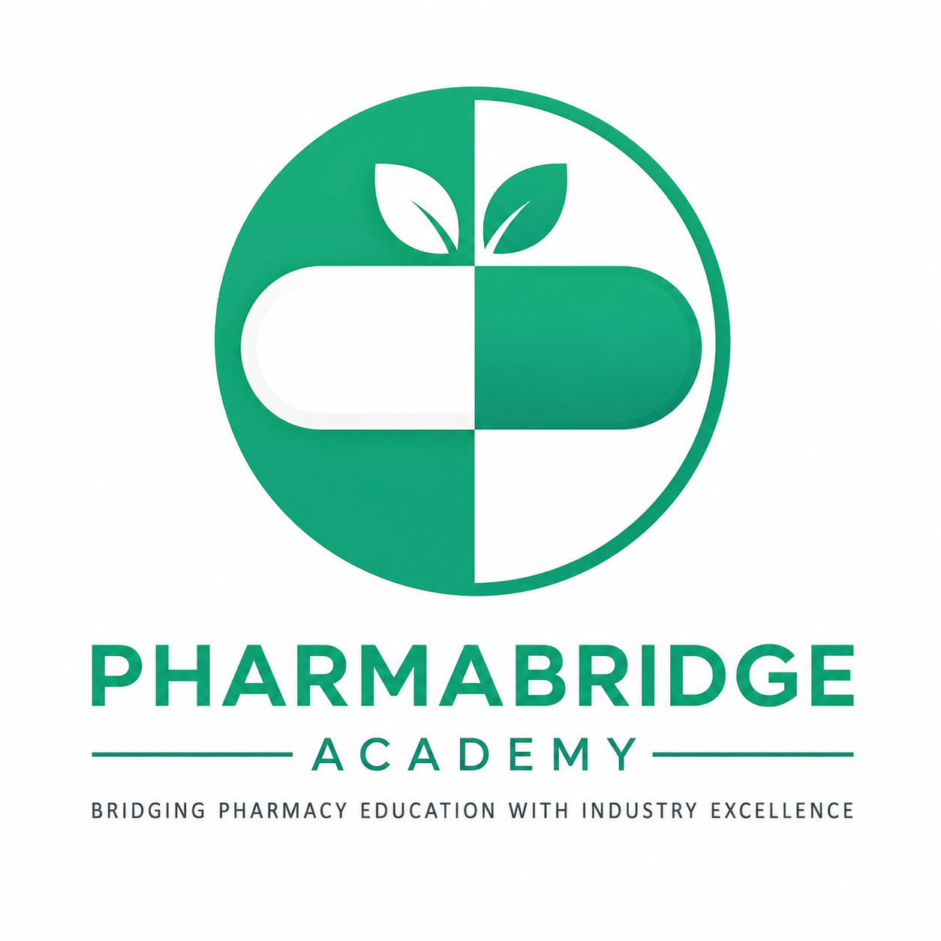
PHARMABRIDGE ACADEMY
Bridging Pharmacy Education with Industry Excellence
Drug Development Lifecycle
Student Notes — A Quick Understanding Guide
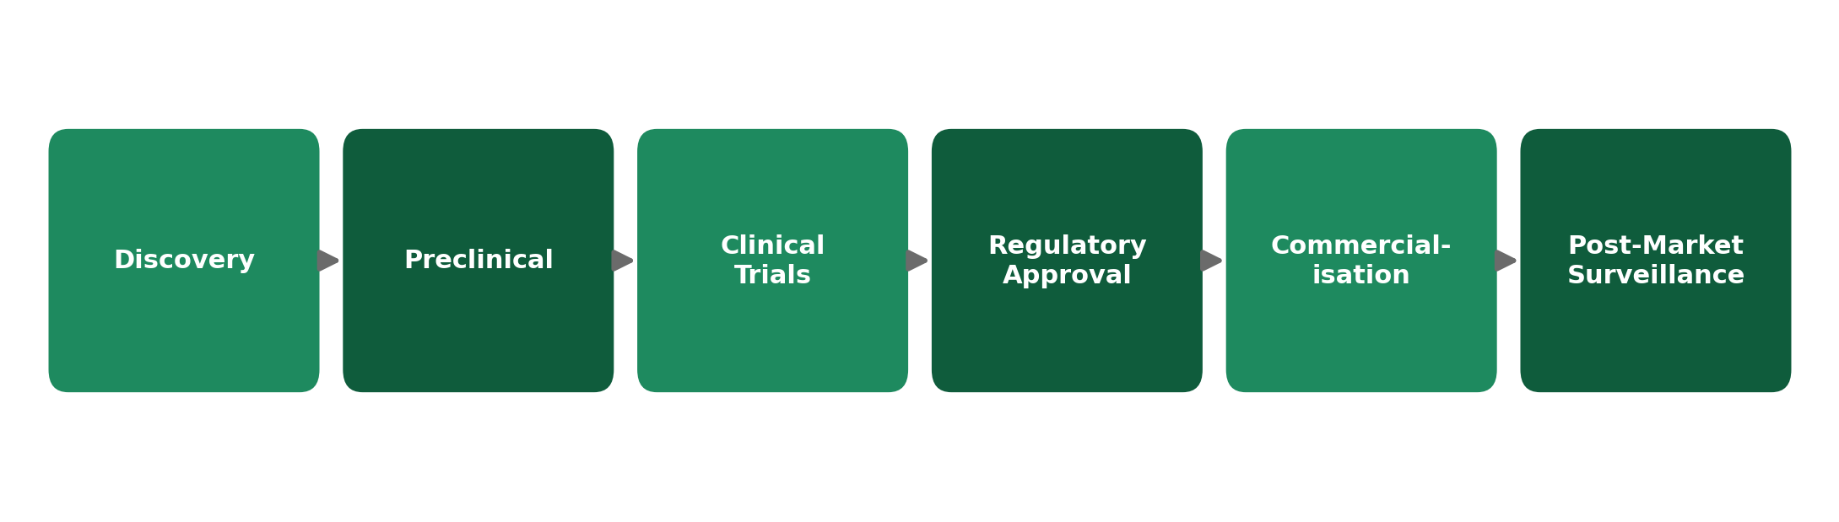
This module connects every department.
Name: _____________________________ Batch: ______________

The Big Picture
Before a medicine reaches a patient, it travels through six connected stages. No single team works alone — discovery scientists hand off to safety researchers, who hand off to clinical teams, who hand off to regulatory experts, who hand off to manufacturing and commercial teams, who hand off to the safety monitors watching the medicine after launch.
This overview is meant to build your understanding of how the whole journey fits together, not to memorize dates or technical detail. Use the diagram below as your mental map for the rest of this module.
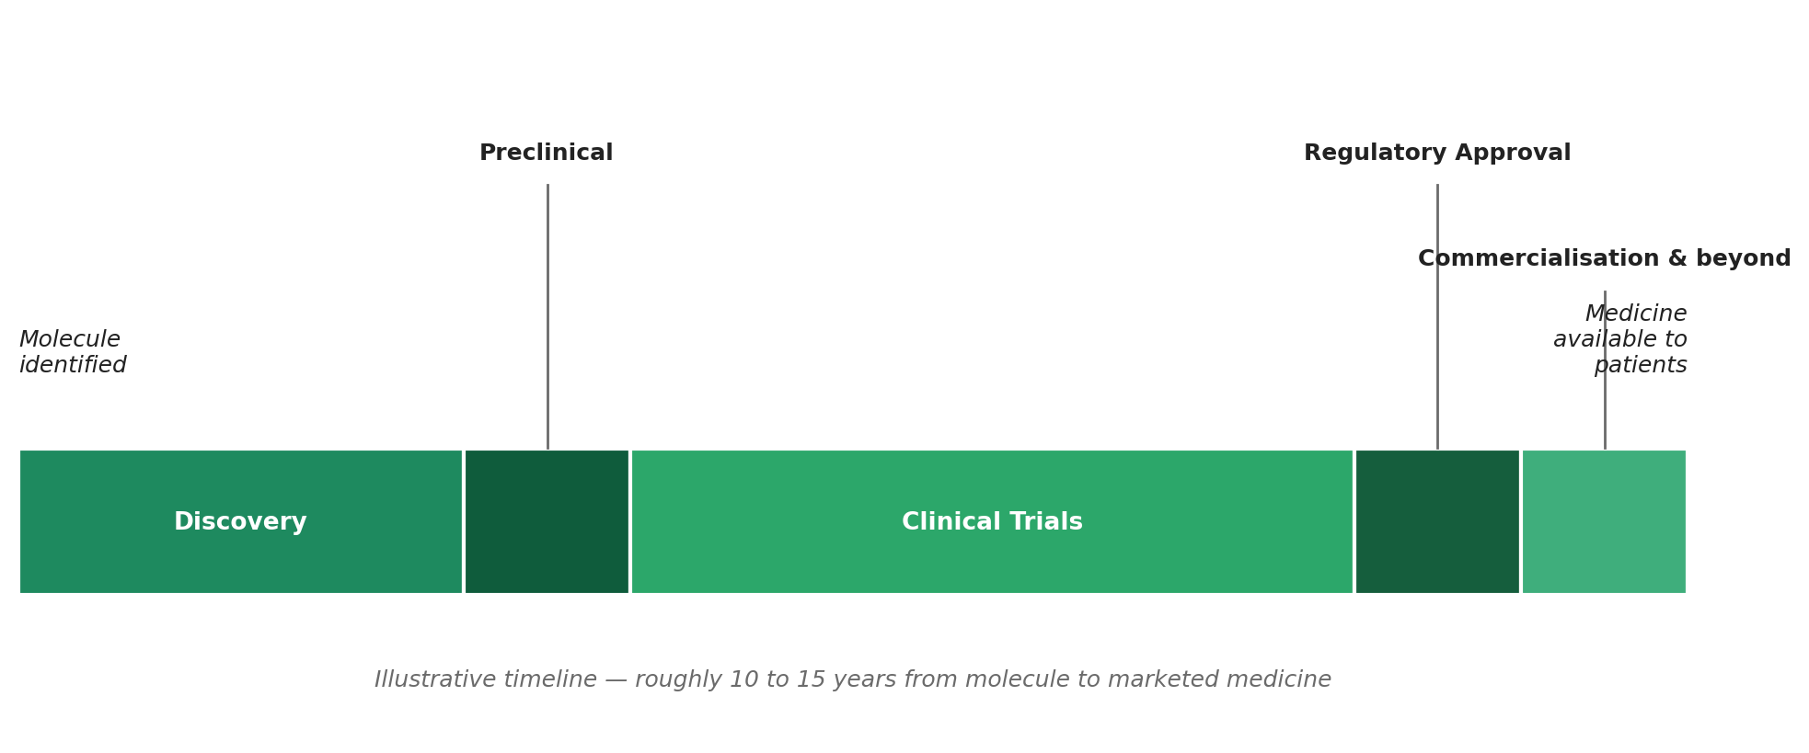
1. Discovery
Owned mainly by: Research & Development (R&D)
This is where it all begins. Scientists try to understand a disease and look for a molecule that might interact with it in a helpful way. Think of it as detective work — screening thousands of chemical or biological candidates to find the few worth pursuing further.
- Goal: find a promising molecule, not yet a proven medicine.
- Involves biology, chemistry, and lots of lab-based trial and error.
- Most candidates identified here never make it to the next stage — this is normal.
2. Preclinical
Owned mainly by: Preclinical Research / Toxicology teams
Before a molecule can be tested on people, it has to prove itself safe enough to try. Preclinical work tests the candidate in the lab and in animal models to check basic safety and how the body might process it.
- Answers the question: "Is this safe enough to test in humans?"
- Looks at early signals of toxicity, dosing, and how the body absorbs and clears the substance.
- Only candidates that clear this stage move on to clinical trials.
3. Clinical Trials
Owned mainly by: Clinical Research / Clinical Operations
This is the longest stage of the journey. The candidate is now tested on human volunteers and patients, in carefully controlled studies, usually across three phases that gradually involve more people and answer bigger questions.
- Phase I — small group, focuses on safety.
- Phase II — larger group, starts to look at whether it actually works.
- Phase III — large-scale study confirming safety and effectiveness before approval can be sought.
Why it takes so long: each phase must be completed and reviewed before moving to the next, and patient safety is checked at every step.
4. Regulatory Approval
Owned mainly by: Regulatory Affairs
Once clinical trial results look promising, the company compiles everything — all the lab data, trial results, and manufacturing plans — into a submission for national health authorities to review.
- In India, this goes to the CDSCO. Globally, bodies like the USFDA or EMA play the same role.
- Regulators independently check the evidence before allowing the medicine to be sold.
- This stage exists to protect patients — approval is not guaranteed even after a good clinical trial.
5. Commercialisation
Owned mainly by: Manufacturing, Marketing & Sales
Once approved, the medicine has to actually reach patients. This means manufacturing it at scale under strict quality standards, and building awareness among doctors, pharmacies, and patients so the medicine is actually prescribed and used.
- Manufacturing scales up production while maintaining the same quality proven in trials.
- Marketing and sales teams educate healthcare providers about the medicine.
- Supply chain teams ensure the medicine reaches hospitals and pharmacies reliably.
6. Post-Marketing Surveillance
Owned mainly by: Pharmacovigilance / Drug Safety
The journey doesn't end at launch. Even after years of trials, some rare side effects only show up once a medicine is used by a much larger and more varied population. Safety teams keep watching.
- Tracks real-world side effects reported by doctors, patients, and pharmacists.
- Can lead to updated safety warnings, or in rare cases, a medicine being withdrawn.
- Keeps the medicine safe for as long as it stays on the market.
Why This Module Connects Every Department
Notice that each stage above is "owned" by a different team. That's the real takeaway of this module: a medicine is never the work of one department. It passes through research, safety, clinical, regulatory, manufacturing, commercial, and pharmacovigilance teams — and whichever of these areas you eventually work in, you'll be one link in this same chain.
Reflect: Looking back at the six stages, which one sounds most interesting to you — and why?

