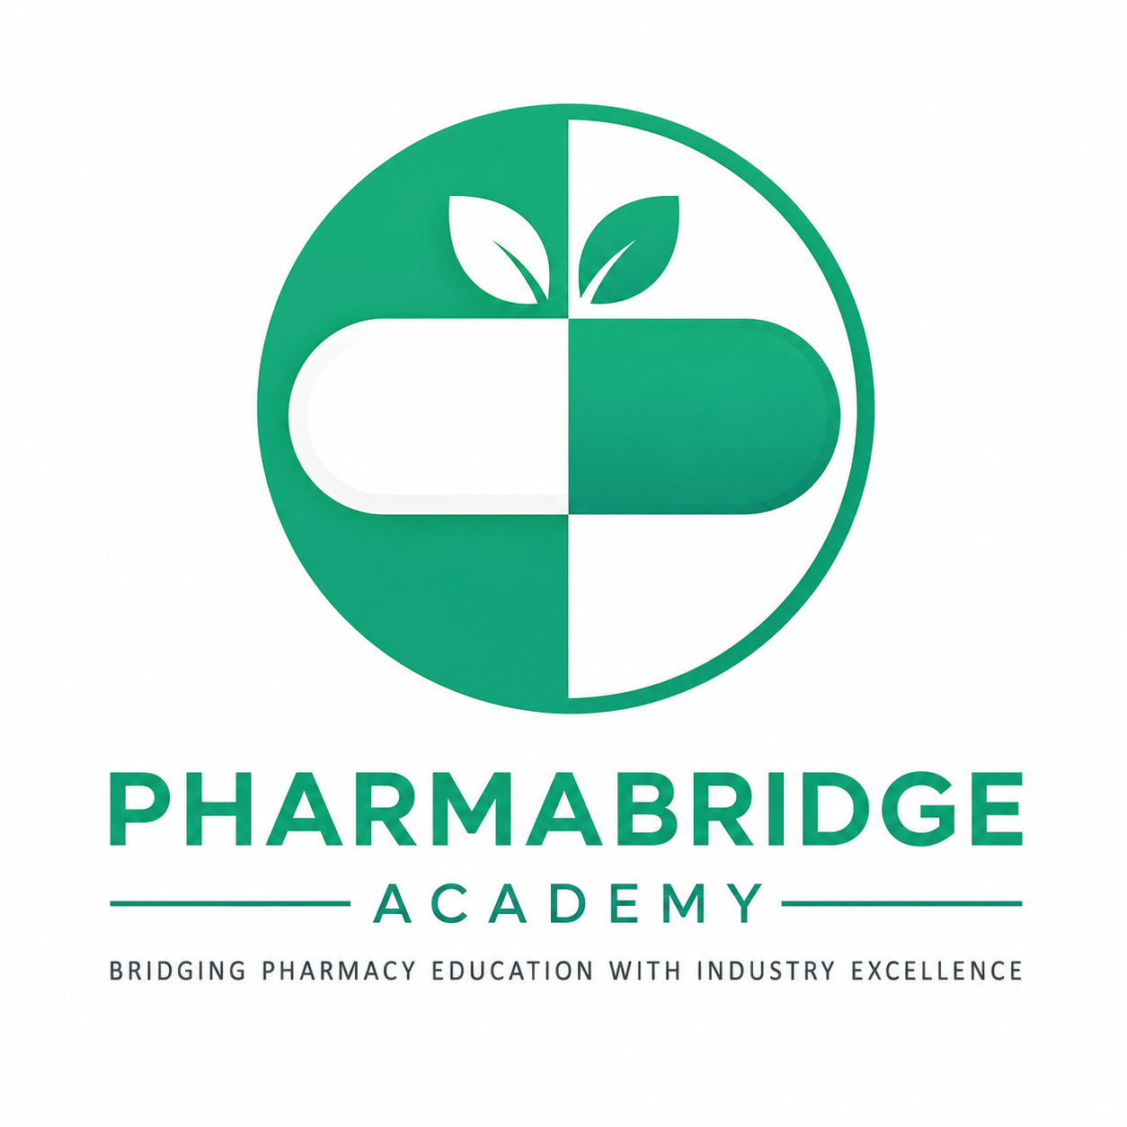
PHARMABRIDGE ACADEMY
Bridging Pharmacy Education with Industry Excellence
Career Planning
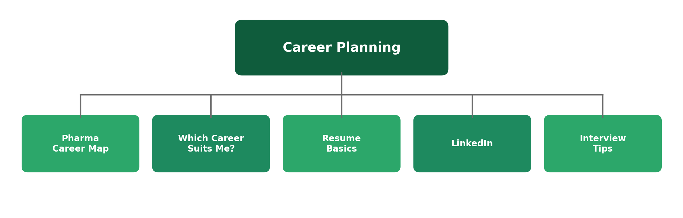

1. Pharma Career Map
Every module in this programme has touched on career paths along the way — this one pulls them together into a single map. Pharma careers roughly fall into five tracks, each connecting back to a different part of the drug development lifecycle you've already studied.
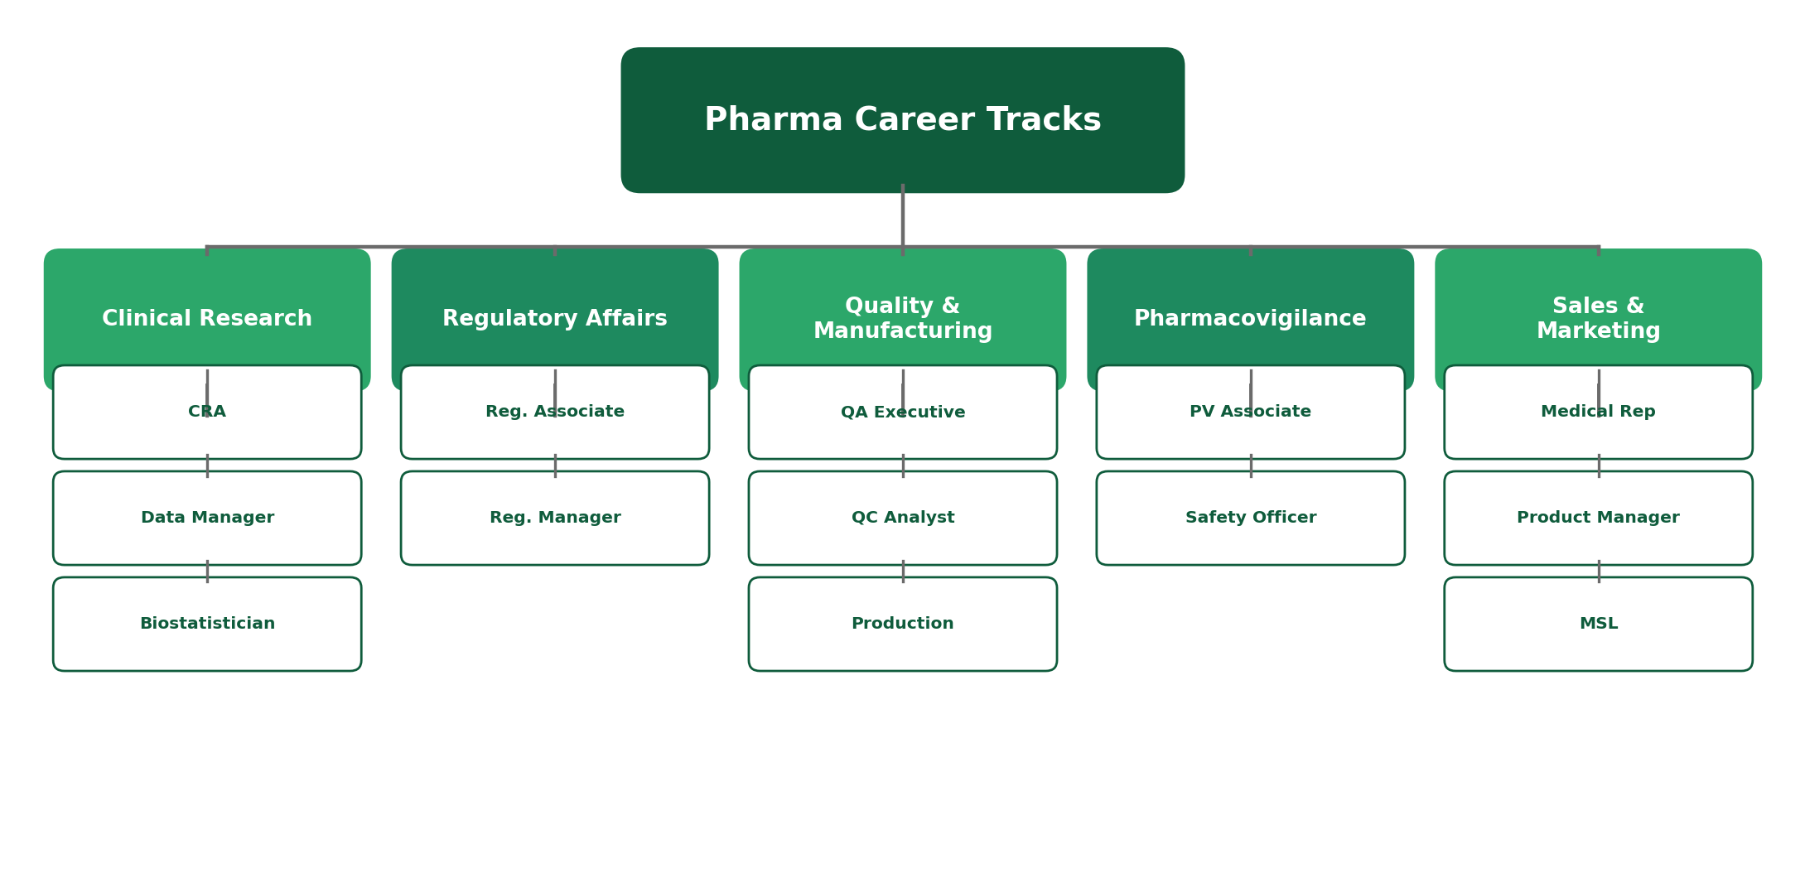
Notice that most tracks include roles at different levels — an entry-level Associate role and a more senior Manager or Lead role. Your first job doesn't need to be your final destination within a track.
2. Which Career Suits Me?
A framework, not a formula
There's no single right answer here — but reflecting honestly on how you like to work can point you toward tracks worth exploring first. Think about the kind of work that energizes you, not just what sounds impressive.
- Enjoy structured, detail-heavy work? Quality, Regulatory Affairs, and Data Management are worth exploring.
- Enjoy people-facing work and building relationships? Sales, Medical Science Liaison, or clinical monitoring roles may suit you.
- Enjoy analysis and problem-solving with numbers? Biostatistics, data management, or health economics roles are strong fits.
- Not sure yet? That's normal — many people only discover their fit after trying an internship or entry-level role.
3. Resume Basics
What actually gets noticed
A pharma resume doesn't need to be flashy, but it does need to clearly connect your education and experience to the specific track you're applying for. Recruiters skim resumes quickly, so clarity matters more than length.
- Lead with relevant coursework, projects, or internships tied to the track you're targeting.
- Use specific, active language — "analyzed clinical trial data" is stronger than "helped with data."
- Keep it to one page for entry-level roles, and proofread carefully — errors stand out in a quality-driven industry.
4. LinkedIn
Your professional presence, built early
LinkedIn is often where recruiters and hiring managers form their first impression of you, sometimes before they even see your resume. A basic, accurate, and active profile goes a long way.
- A clear profile photo, headline, and summary make your profile easy to understand at a glance.
- Following pharma companies and industry pages helps you stay current and shows genuine interest.
- Connecting with people you meet at events, internships, or through this programme builds a network over time.
5. Interview Tips
Bringing this whole programme together
By this point, you already know more about the industry than most candidates walking into an entry-level interview. The goal now is to communicate that knowledge clearly and connect it to why you want the specific role.
- Be ready to explain, in plain language, what your target track (e.g. Clinical Research, QA) actually does day to day.
- Prepare a few honest examples of teamwork, problem-solving, or time management from your own experience.
- Always prepare a few thoughtful questions to ask the interviewer — it shows genuine interest, not just readiness to answer.
Reflect: Interviewers aren't just checking what you know — they're checking whether you can explain it clearly. That's exactly what these ten modules have been building toward.
Quick Reference: Career Prep Checklist
Topic | Core Idea | Next Action
Career Map | Five main tracks, each with entry & senior roles | Pick 1–2 tracks to explore further
Career Fit | Match your working style, not just prestige | Reflect honestly on what energizes you
Resume | Clarity beats length | Draft a one-page, track-specific resume
LinkedIn | Often the first impression | Complete your profile, follow companies
Interviews | Explain knowledge clearly, ask questions back | Practice explaining your target track aloud

Why This Matters
This module is the bridge between everything you've learned and your first real opportunity in the industry. Strong pharma knowledge only becomes a career once you can present it clearly on a resume, a LinkedIn profile, and in an interview room.
Reflect: Based on everything covered in this programme, which one or two career tracks are you most drawn to right now — and what's your next concrete step toward them?

