
PHARMABRIDGE ACADEMY
Bridging Pharmacy Education with Industry Excellence
Documentation in Pharma
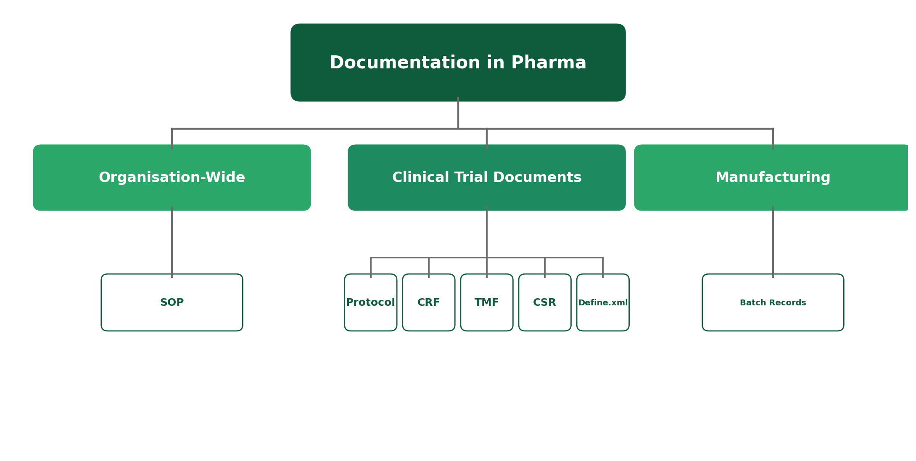

The Big Picture
Pharma runs on paperwork — but not the boring kind. Every document exists to answer one question: "Can we prove this was done correctly?" Some documents apply across the whole organisation, some exist only for clinical trials, and some belong to manufacturing.
This overview focuses on what each document is and why it exists — not on how to fill one out. Think of it as learning to recognise these names when they come up at work, not learning to write them yourself.
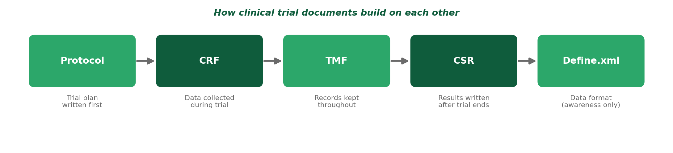
1. SOP — Standard Operating Procedure
Used mainly in: Every department, organisation-wide
An SOP is a written, approved set of step-by-step instructions for how a specific task should be done, every single time, by anyone doing it. It exists so that work doesn't depend on one person's memory or habits.
- Covers everyday tasks — from cleaning equipment to reviewing documents to handling a customer complaint.
- Anyone performing that task is expected to follow the SOP exactly, not improvise.
- Used across every department — it's the most universal document type in pharma.
2. Protocol — Clinical Trial Protocol
Used mainly in: Clinical Research
A protocol is the detailed plan for a clinical trial, written before the trial begins. It explains what the trial is testing, who can participate, what will be measured, and exactly how the study will be run.
- Written and finalized before a single patient is enrolled.
- Defines eligibility criteria — who can and can't join the trial.
- Every trial site must follow the same protocol, so results can be compared fairly.
3. CRF — Case Report Form
Used mainly in: Clinical Research / Data Management
A CRF is the form used to record each participant's data during a clinical trial — things like vital signs, symptoms, and test results — in a structured, consistent way.
- One CRF is completed for each patient at each visit or timepoint in the trial.
- Can be paper-based or, more commonly today, electronic (eCRF).
- The data entered here is what eventually feeds into the trial's results and analysis.
4. Batch Records
Used mainly in: Manufacturing / Production
A batch record is the complete documented history of how one specific batch of medicine was manufactured — every ingredient used, every step performed, every check completed, by whom, and when.
- Created fresh for every single batch produced — never reused.
- Acts as proof that the batch was made correctly and consistently with approved procedures.
- If a quality issue is ever found, the batch record is the first place investigators look.
5. TMF — Trial Master File
Used mainly in: Clinical Research / Clinical Operations
The TMF is the master collection of all essential documents relating to a clinical trial — protocols, approvals, CRFs, correspondence, and more — organized so the trial's conduct can be fully reconstructed later if needed.
- Built up continuously throughout the trial, not just at the end.
- Regulators can inspect the TMF to confirm a trial was run properly and ethically.
- Think of it as the trial's complete paper trail, kept in one organized place.
6. CSR — Clinical Study Report
Used mainly in: Clinical Research / Medical Writing
A CSR is the formal, comprehensive report written after a clinical trial ends, summarizing everything about how it was conducted and what was found — including both the results and any side effects observed.
- Written once the trial is complete and the data has been analyzed.
- Forms a core part of what gets submitted to regulators for drug approval.
- Can run to hundreds of pages, covering methodology, results, and safety findings in detail.
7. Define.xml — (Awareness Only)
Used mainly in: Clinical Data Management / Biostatistics
Define.xml is a standardized file format that describes the structure of clinical trial datasets when they're submitted to regulators. You don't need to know how to build one — just that it exists as part of how trial data gets submitted electronically.
- Acts like a "map" explaining what each column in a dataset means.
- Used specifically for electronic data submissions to regulatory authorities.
- Awareness-level only for this module — highly specialized, technical roles handle its creation.
Quick Reference: All Seven Documents
Document | What It Is | Used In
SOP | Step-by-step instructions for a task | Every department
Protocol | The plan for a clinical trial | Clinical trials (before start)
CRF | Per-patient data collection form | Clinical trials (during)
Batch Records | Full manufacturing history of one batch | Manufacturing
TMF | Master file of all trial documents | Clinical trials (throughout)
CSR | Final report summarizing trial results | Clinical trials (after)
Define.xml | Data format for regulatory submission | Data management (awareness only)

Why This Matters
Documentation is how pharma proves that everything was done correctly, safely, and consistently — it's the evidence behind every claim a company makes about a medicine. Recognising these document names, and knowing roughly where each one fits, helps you understand what colleagues and managers are actually talking about on the job.
Reflect: Which of these documents would you expect to work with most closely in the career path you're interested in?

