
PHARMABRIDGE ACADEMY
Bridging Pharmacy Education with Industry Excellence
GxP Fundamentals
Student Notes — A Quick Understanding Guide
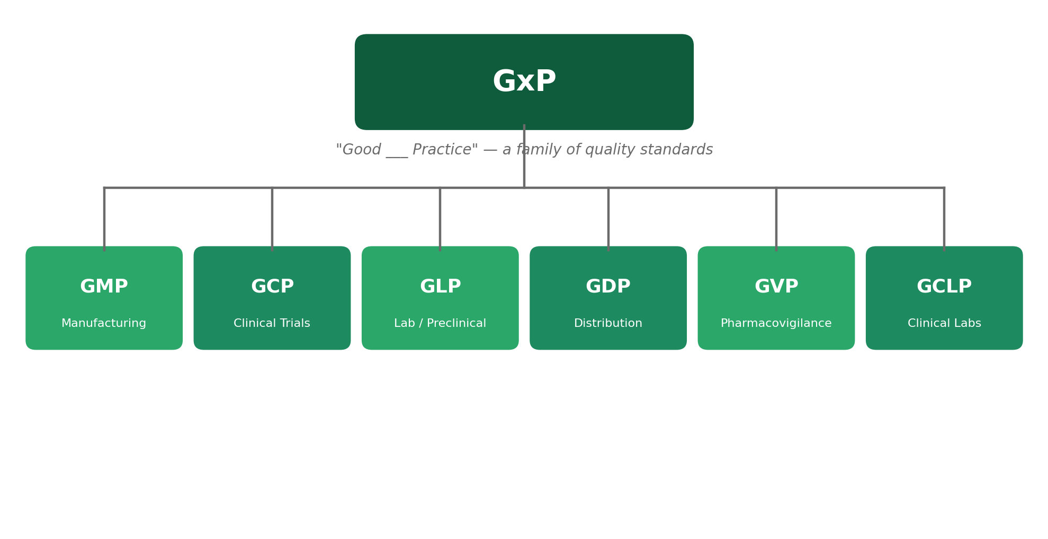

The Big Picture
GxP is not one rulebook — it's a family of "Good ___ Practice" standards that keep quality and patient safety intact at every stage of a medicine's journey. Every GxP term follows the same pattern: "Good" + an activity + "Practice." Once you know that pattern, the acronyms stop feeling like alphabet soup.
Each GxP standard applies to a different part of the journey you already know from the Drug Development Lifecycle module. This overview is meant to build your understanding of what each one covers and why it matters — not to memorize every regulation.
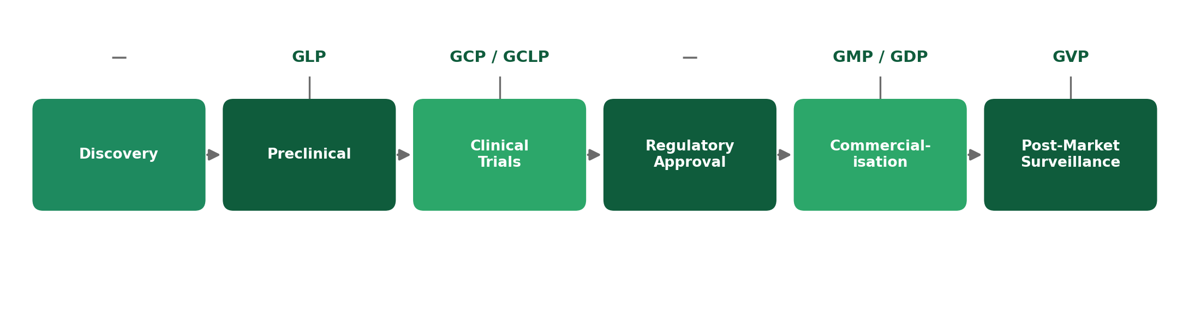
1. GMP — Good Manufacturing Practice
Applies mainly to: Manufacturing / Production teams
GMP is the set of standards that ensures every batch of medicine is made the same way, every time, with consistent quality. It covers everything from clean facilities and validated equipment to trained staff and documented procedures.
- Prevents contamination, mix-ups, and errors during production.
- Requires detailed record-keeping — if it isn't documented, it didn't happen.
- Applies at the Commercialisation stage, once a drug moves into large-scale manufacturing.
2. GCP — Good Clinical Practice
Applies mainly to: Clinical Research / Clinical Operations
GCP is the ethical and scientific standard for designing, conducting, and reporting clinical trials. It exists to protect the rights, safety, and wellbeing of trial participants while ensuring the data collected can be trusted.
- Requires informed consent — participants must understand and agree to what a trial involves.
- Governs how trial sites are monitored and how data is recorded and verified.
- Applies during the Clinical Trials stage of the drug development lifecycle.
3. GLP — Good Laboratory Practice
Applies mainly to: Preclinical / Toxicology labs
GLP governs the non-clinical safety studies done before a drug is ever tested on humans — mainly lab and animal studies. It ensures the safety data submitted to regulators is accurate, reproducible, and honestly reported.
- Focuses on how studies are planned, performed, monitored, and recorded.
- Gives regulators confidence that early safety findings aren't exaggerated or hidden.
- Applies during the Preclinical stage, before a candidate ever reaches human trials.
4. GDP — Good Distribution Practice
Applies mainly to: Supply Chain / Logistics
GDP ensures that a medicine's quality is preserved after it leaves the factory — during storage, transport, and handling — all the way until it reaches a pharmacy or hospital.
- Covers correct storage conditions, such as temperature-controlled (cold chain) transport for sensitive products.
- Prevents counterfeit or damaged products from entering the supply chain.
- Applies during Commercialisation, alongside manufacturing, as the medicine moves to market.
5. GVP — Good Pharmacovigilance Practice
Applies mainly to: Pharmacovigilance / Drug Safety
GVP governs how companies monitor a medicine's safety after it's already on the market. Since clinical trials can't catch every rare side effect, this ongoing monitoring is what keeps patients protected long-term.
- Requires companies to collect, assess, and report adverse events from real-world use.
- Can lead to updated safety labels, warnings, or in rare cases, a product being withdrawn.
- Applies during the Post-Marketing Surveillance stage, after approval and launch.
6. GCLP — Good Clinical Laboratory Practice
Applies mainly to: Bioanalytical / Clinical trial labs
GCLP is a hybrid standard — it applies GLP's rigor around data integrity to laboratories that analyze samples (like blood or tissue) collected during clinical trials. Think of it as GCP and GLP meeting in the lab.
- Used by labs that test clinical trial samples, not by the trial sites themselves.
- Ensures lab results feeding into a clinical trial are just as trustworthy as the trial data itself.
- Applies during the Clinical Trials stage, specifically to the bioanalytical work behind it.
Interview tip: If you're asked to name a GxP, GCLP is often the one candidates forget — mentioning it shows you understand how these standards overlap.
Quick Reference: All Six GxP Standards
GxP | Stands For | Applies To | Lifecycle Stage
GMP | Good Manufacturing Practice | Manufacturing | Commercialisation
GCP | Good Clinical Practice | Clinical trials | Clinical Trials
GLP | Good Laboratory Practice | Preclinical labs | Preclinical
GDP | Good Distribution Practice | Storage & transport | Commercialisation
GVP | Good Pharmacovigilance Practice | Post-market safety | Post-Market Surveillance
GCLP | Good Clinical Laboratory Practice | Clinical trial labs | Clinical Trials

Why This Matters in Interviews
GxP terms come up constantly in pharma interviews because they're the shared language of the industry — whichever department you join, you'll be expected to know which GxP standard governs your work. Being able to explain what each one covers, in plain language, signals that you understand how the industry actually operates, not just the textbook definitions.
Reflect: Which GxP standard is most relevant to the career path you're interested in — and can you explain why in one sentence?

