
PHARMABRIDGE ACADEMY
Bridging Pharmacy Education with Industry Excellence
Professional Skills
Student Notes — A Quick Understanding Guide
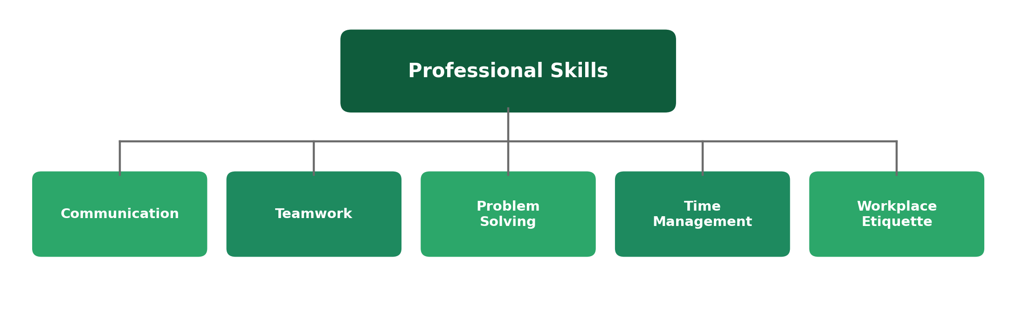
The habits that make technical skills actually land.
Name: _____________________________ Batch: ______________

The Big Picture
Pharma is a highly cross-functional industry — a single medicine passes through research, clinical, regulatory, manufacturing, and commercial teams, often across different countries and time zones. None of that works smoothly without the everyday professional skills covered in this module.
These aren't pharma-specific skills, but they show up constantly in pharma workplaces — in how a deviation gets reported, how a cross-team meeting runs, or how a tight regulatory deadline gets met without cutting corners.
1. Communication
Why it matters in pharma: precision and traceability
In a regulated industry, how you communicate is often as important as what you communicate. Vague language in an email, a report, or a meeting can lead to costly misunderstandings — or worse, a documented error.
- Written communication (emails, reports, documentation) should be clear, precise, and unambiguous.
- Cross-functional teams rely on you to explain technical topics in a way non-specialists can follow.
- Active listening matters just as much as speaking clearly, especially in cross-departmental meetings.
2. Teamwork
Why it matters in pharma: no single department works alone
As you've seen throughout this programme, a medicine passes through many hands — R&D, clinical, regulatory, manufacturing, and commercial. Strong teamwork means understanding how your work affects the next team down the line, not just finishing your own part.
- Cross-functional projects are the norm, not the exception, in drug development.
- Respecting other departments' priorities and constraints builds trust and speeds up collaboration.
- Good team players flag problems early rather than letting them become the next team's surprise.
3. Problem Solving
Why it matters in pharma: things go wrong, even in the best-run operations
Deviations, unexpected trial results, and supply chain hiccups are a normal part of pharma work — what matters is how calmly and systematically a problem gets addressed, not whether problems occur at all.
- A structured approach — understand the problem, find the root cause, propose a fix — is valued over guesswork.
- In quality and manufacturing, this often takes the form of a formal Corrective and Preventive Action (CAPA).
- Escalating a problem you can't solve alone is a sign of good judgment, not a weakness.
4. Time Management
Why it matters in pharma: deadlines are often regulatory, not just internal
Many pharma deadlines — a regulatory submission date, a trial milestone, a batch release — aren't flexible internal targets; they can have real consequences if missed. Managing your time well means your team can rely on you to hit dates without a last-minute scramble.
- Breaking larger projects into smaller milestones makes long timelines (like a multi-year trial) manageable.
- Flagging a likely delay early gives a team time to adjust — flagging it late doesn't.
- Balancing routine work (documentation, reporting) against urgent tasks is a daily skill, not a one-time lesson.
5. Workplace Etiquette
Why it matters in pharma: this is a formal, audited, relationship-driven industry
Workplace etiquette covers the everyday professional norms — how you email, how you behave in meetings, how you handle disagreement — that shape how colleagues and managers perceive you, especially in your first months on the job.
- Professional tone and courtesy matter even in quick internal messages, not just formal communication.
- Punctuality and preparation for meetings signal respect for colleagues' time.
- How you handle feedback and disagreement early in your career shapes your professional reputation.
Reflect: Small habits — replying to emails promptly, being on time, admitting mistakes early — are often what separates a good first impression from a forgettable one.
Quick Reference: All Five Skills
Skill | Core Idea | Shows Up Most In
Communication | Precision avoids costly misunderstandings | Emails, reports, cross-team meetings
Teamwork | No department works alone | Cross-functional projects
Problem Solving | Structured response, not guesswork | Deviations, CAPAs, unexpected issues
Time Management | Deadlines are often regulatory | Trial milestones, submission dates
Workplace Etiquette | Everyday habits shape first impressions | Meetings, messages, feedback

Why This Matters
Every other module in this programme covers pharma-specific knowledge — but these five skills are what let you actually apply that knowledge alongside other people, under real deadlines, in a professional environment. They're often what separates candidates with similar technical knowledge in an interview.
Reflect: Of these five skills, which comes most naturally to you, and which do you think you'll need to consciously work on?

