
PHARMABRIDGE ACADEMY
Bridging Pharmacy Education with Industry Excellence
Data & Technology in Pharma
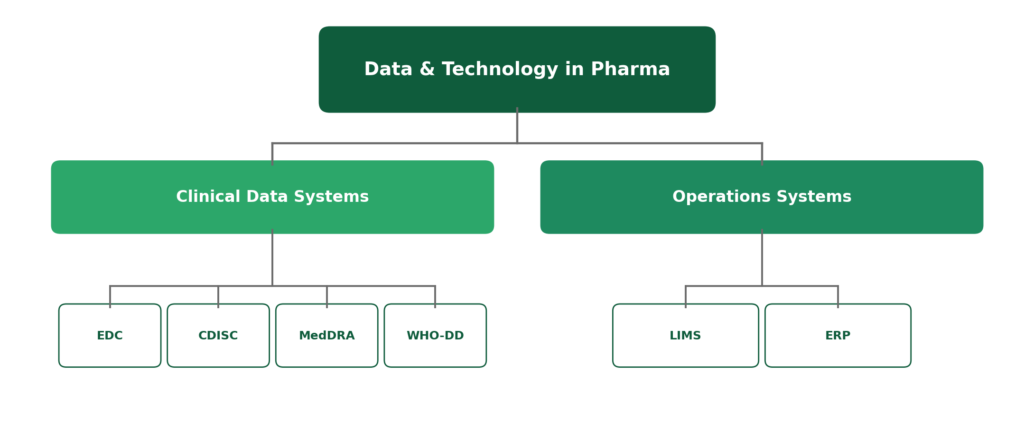

Clinical Data Flow: The Big Picture
Behind every clinical trial and every manufactured batch, there's software quietly keeping everything organized, standardized, and traceable. This module introduces the systems and standards you'll hear referenced constantly — not to teach you how to operate them, but so you recognise what they do and why they matter.
A good way to understand these systems is to follow a single piece of patient data on its journey — from the moment it's collected, to the moment it reaches a regulator.
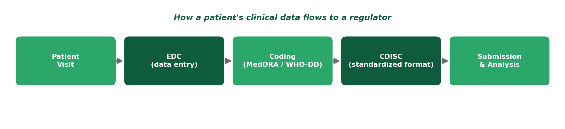
1. EDC — Electronic Data Capture
Category: Clinical Data Systems
EDC systems are the software platforms used to collect and store clinical trial data electronically, replacing paper CRFs. When a patient's data is recorded during a trial visit, it's usually entered directly into an EDC system.
- Replaces paper case report forms with electronic ones (eCRFs).
- Allows real-time data entry, validation checks, and remote monitoring by sponsors.
- The starting point for most clinical trial data before it moves anywhere else.
2. CDISC — Clinical Data Interchange Standards Consortium
Category: Clinical Data Systems
CDISC is a set of global standards that define how clinical trial data should be structured and formatted. It exists so that data from different trials, companies, and countries can all be compared and reviewed consistently by regulators.
- Standardizes how clinical datasets are organized before regulatory submission.
- Widely required by regulators like the USFDA for electronic data submissions.
- Think of it as a common language that lets regulators read data from any sponsor the same way.
3. MedDRA — Medical Dictionary for Regulatory Activities
Category: Clinical Data Systems
MedDRA is a standardized medical terminology dictionary used to code symptoms, diagnoses, and side effects reported during clinical trials and after a drug is on the market. It ensures "headache" is coded the same way everywhere, not written a dozen different ways.
- Used mainly to code adverse events and medical history in a consistent format.
- Makes it possible to spot safety patterns across thousands of trial participants.
- Widely used by both clinical research and pharmacovigilance teams.
4. WHO-DD — WHO Drug Dictionary
Category: Clinical Data Systems
The WHO Drug Dictionary is a standardized reference for coding medications — including brand names, generic names, and active ingredients — so that drug data can be compared consistently across trials and countries.
- Used to code any medication a trial participant reports taking, including concomitant medications.
- Complements MedDRA — MedDRA codes medical events, WHO-DD codes the drugs themselves.
- Maintained and updated by the World Health Organization for global consistency.
5. LIMS — Laboratory Information Management System
Category: Operations Systems
A LIMS is software used by labs to track samples, tests, and results — from the moment a sample arrives to the moment a result is reported. It's common in both quality control labs and clinical trial bioanalytical labs.
- Tracks each sample's location, status, and test results throughout its lifecycle in the lab.
- Reduces manual record-keeping errors and supports GLP/GCLP data integrity requirements.
- Used heavily in manufacturing quality control and clinical trial sample testing.
6. ERP — Enterprise Resource Planning
Category: Operations Systems
An ERP system is company-wide software that manages core business operations — manufacturing, inventory, supply chain, procurement, and finance — all in one connected system, rather than in separate disconnected tools.
- Used to plan manufacturing runs, track raw material inventory, and manage supply chain logistics.
- Connects departments so that, for example, a sales forecast can inform a production schedule.
- Common ERP platforms in pharma include SAP and Oracle, among others.
Quick Reference: All Six Systems
System | What It Is | Category
EDC | Software for capturing clinical trial data | Clinical Data Systems
CDISC | Standard format for clinical datasets | Clinical Data Systems
MedDRA | Dictionary for coding medical events | Clinical Data Systems
WHO-DD | Dictionary for coding medications | Clinical Data Systems
LIMS | System for tracking lab samples & results | Operations Systems
ERP | System for managing company-wide operations | Operations Systems

Why This Matters
These systems are what make pharma's scale possible — without standardized data formats and dictionaries, no regulator could compare results across thousands of trials, and no company could track a single batch through a global supply chain. Recognising these names helps you understand what colleagues mean when they mention them in daily conversation.
Reflect: Which of these six systems do you think you'd interact with most, based on the career path you're interested in?

