# # Exercise 1: Understand Node-RED platform

Node-RED is a programming tool for wiring together hardware devices, APIs and online services in new and interesting ways. It provides a browser-based editor that makes it easy to wire together flows using the wide range of nodes in the palette that can be deployed to its runtime in a single- click.

* **Browser-based flow editing**-
* **Built on Node.js**
* **Social Development**

# Installing Node.js

* Download Node.js from the link [https://nodejs.org](https://nodejs.org/) for windows x86 i.e 10.16.3 LTS version
* Install it locally in your system.
* Open the command prompt and display the versions of **nodejs and npm** as shown below.

![Outcome] (./nodejs.jpg)

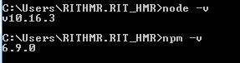

# Installing Node-red:

* Run the below command in the command console.

**npm install –g –unsafe-perm nodered**

* After complete installation run the below command and note down the address given as shown below.

**node-red**

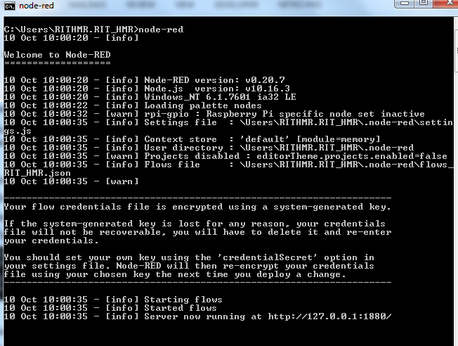



Open the browser and type the above link as **http://localhost:1880**