Nguyễn Thị Hà Như – 22635201 – TH – KTTKPM – 20/01/2026
Lab01
curl -X POST http://localhost:3000/send \
-H "Content-Type: application/json" \
-d '{"orderId":"Order #1000 send", "message":"Test"}'
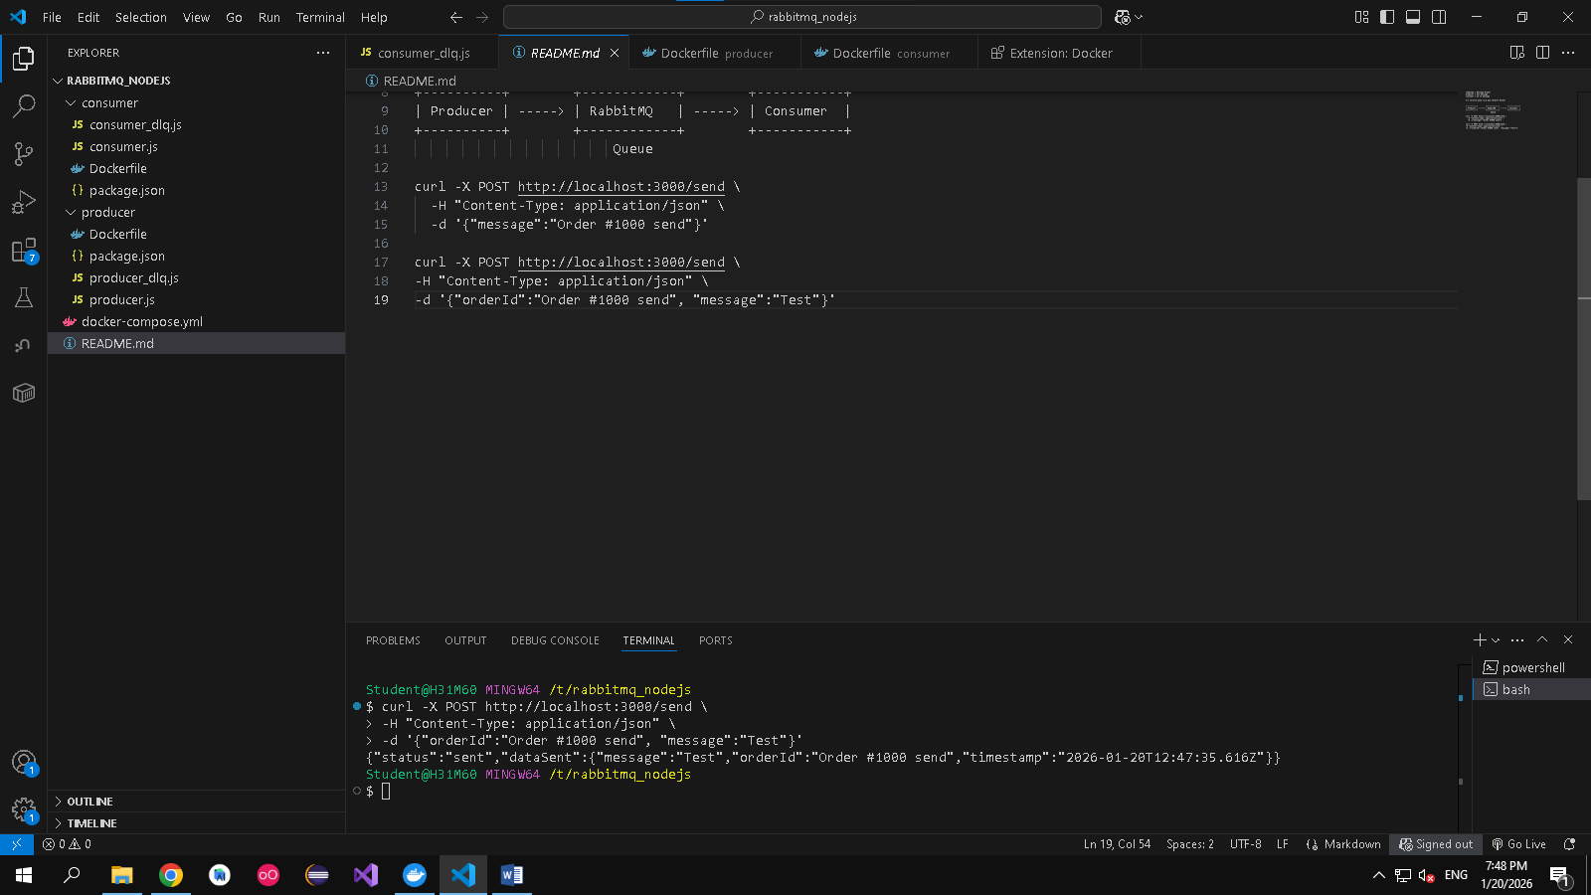
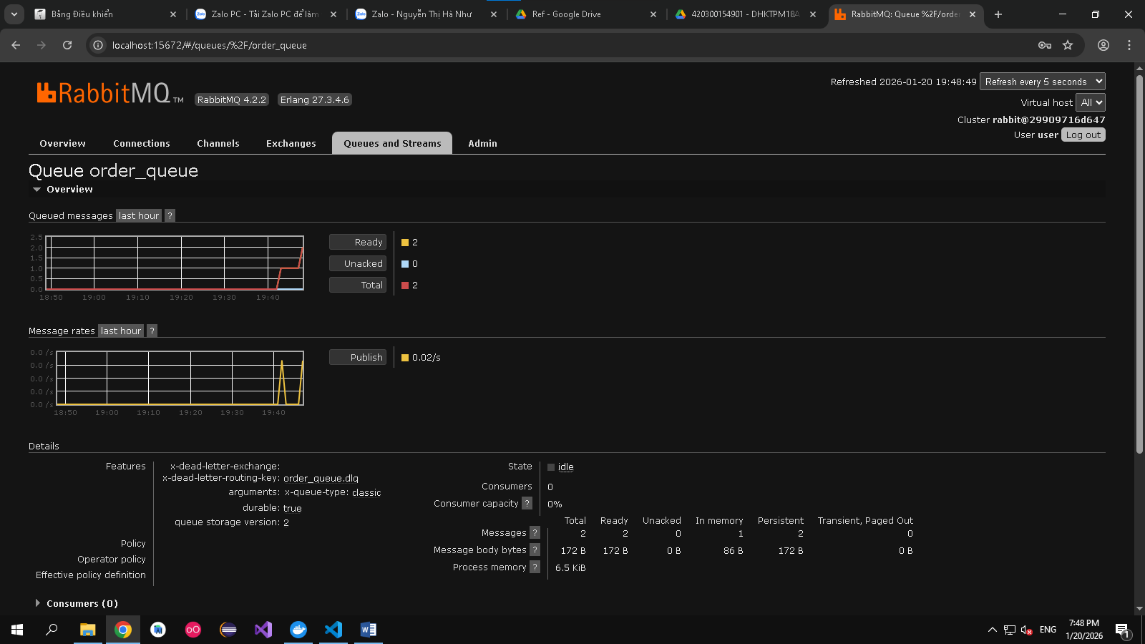
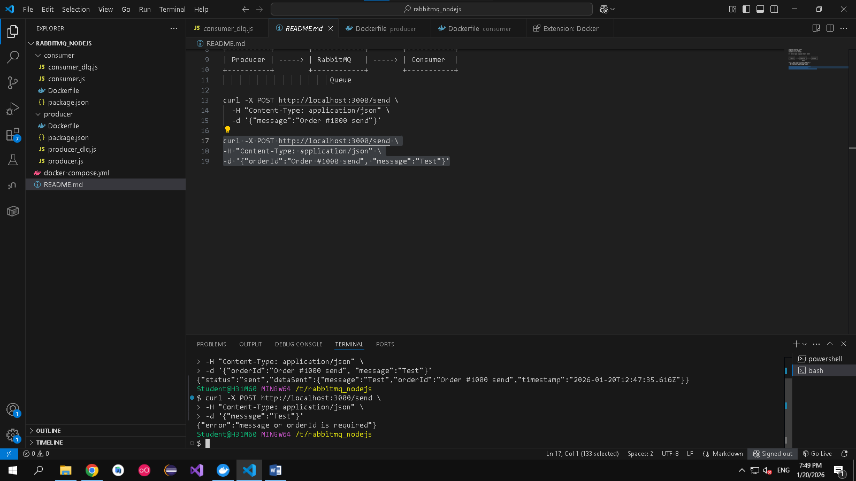
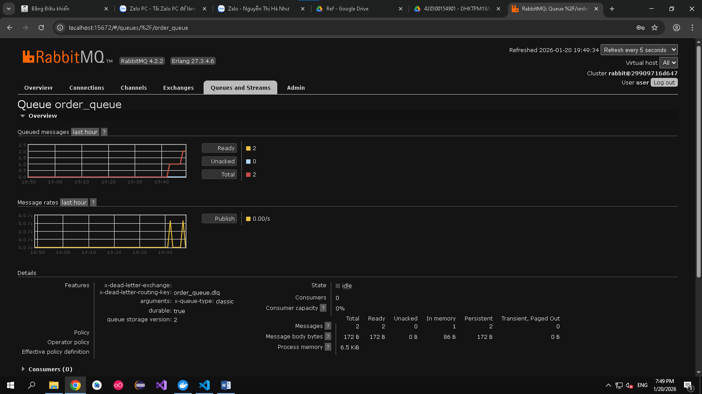

curl -X POST http://localhost:3000/send \
-H "Content-Type: application/json" \
-d '{"message":"Order #1000 send"}'
