Phần 1: Lệnh docker compose
- docker compose version
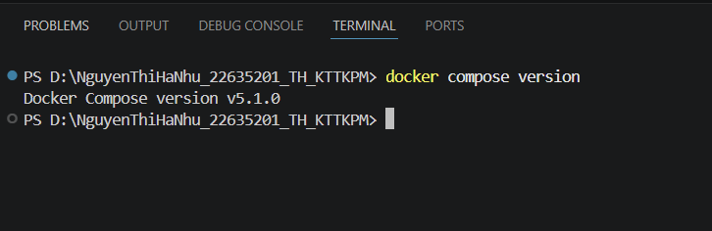
- docker compose up
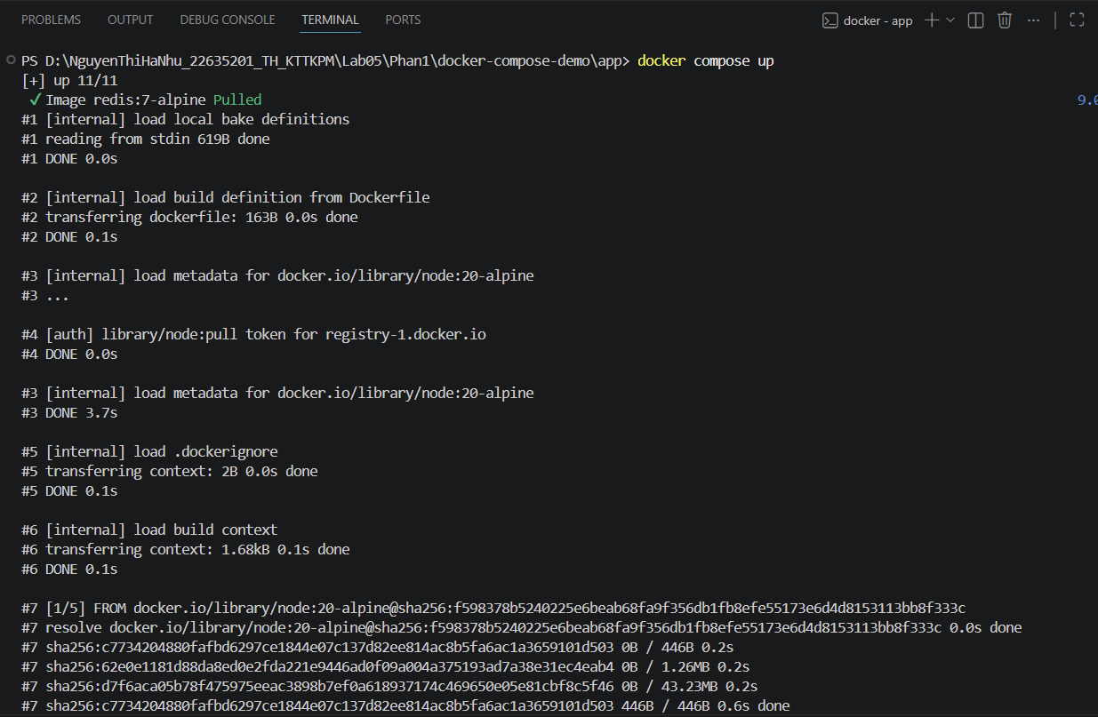
- docker compose up -d
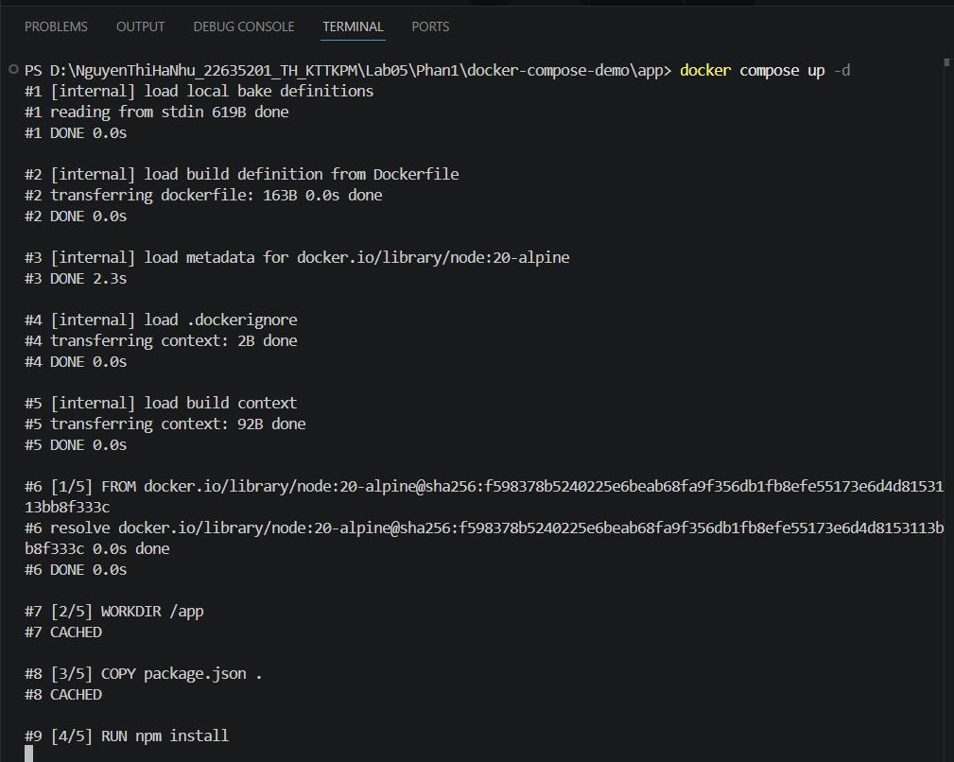
- docker compose ps
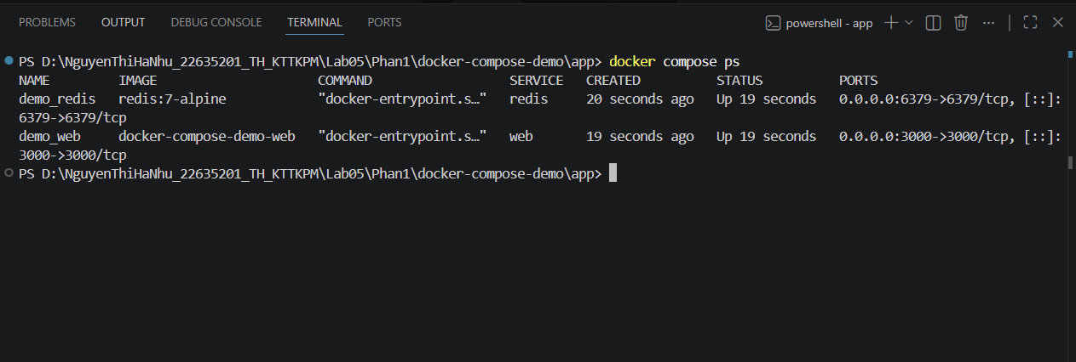
- docker compose down
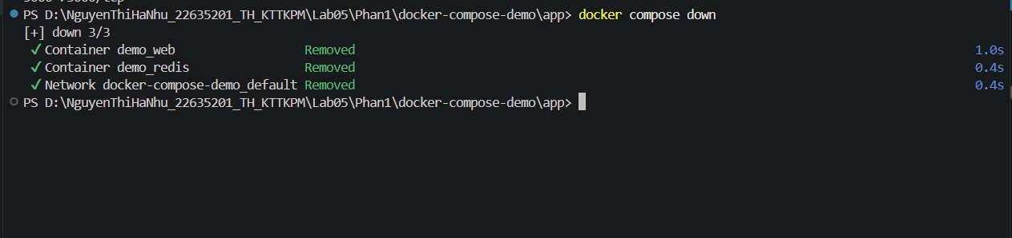
- docker compose restart
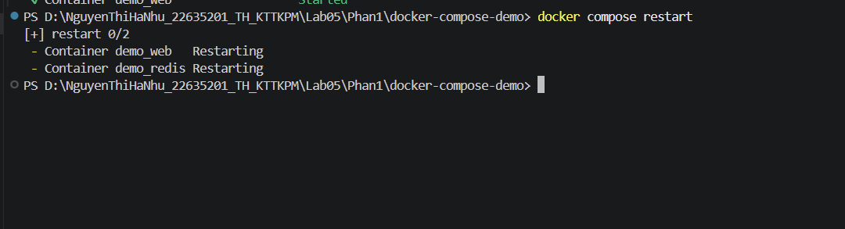
- docker compose logs -f
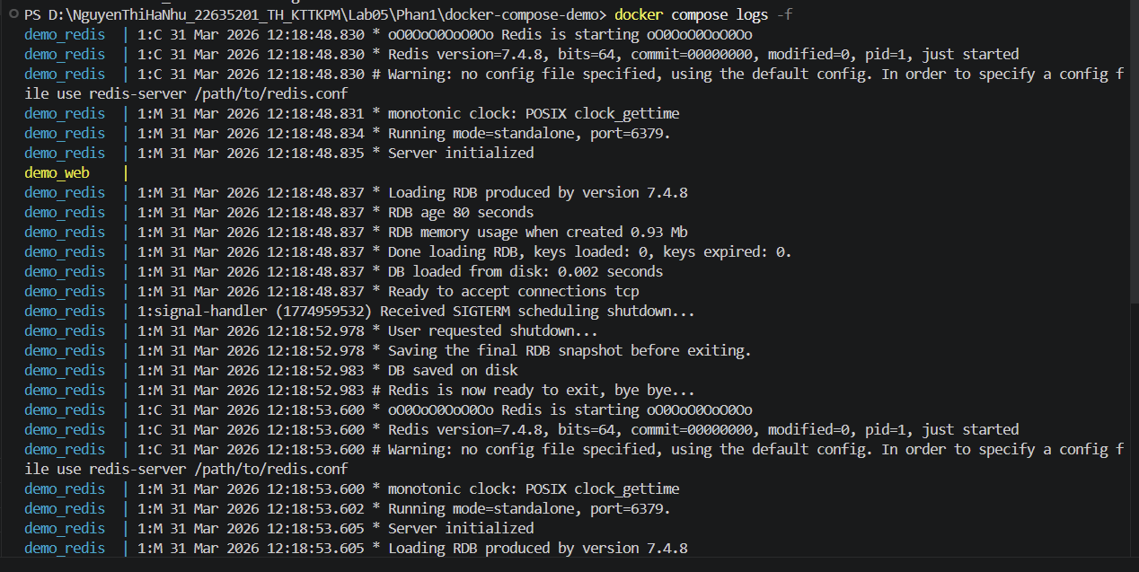
- docker compose build
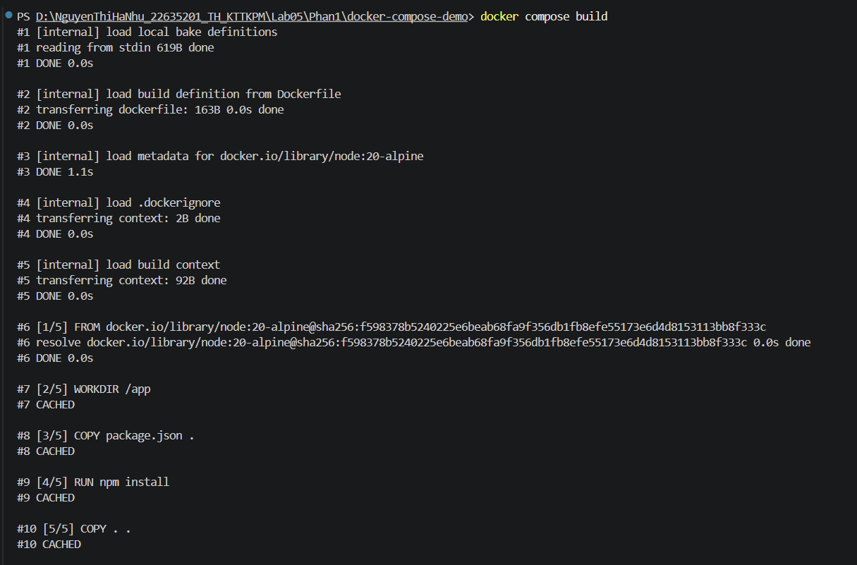
- docker compose exec <service_name> <command>
- docker compose down -v
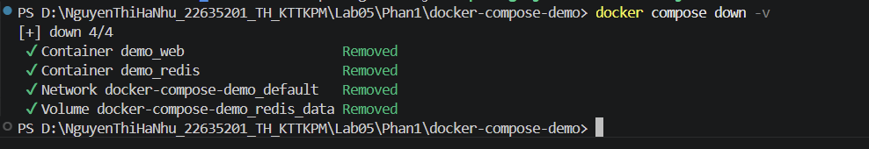
- docker compose run <service_name> <command>
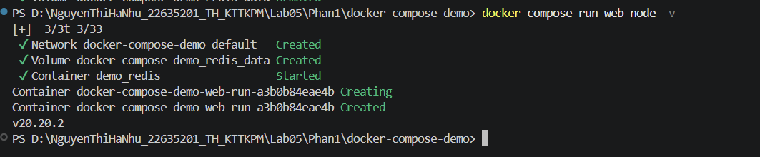
- docker compose stop web
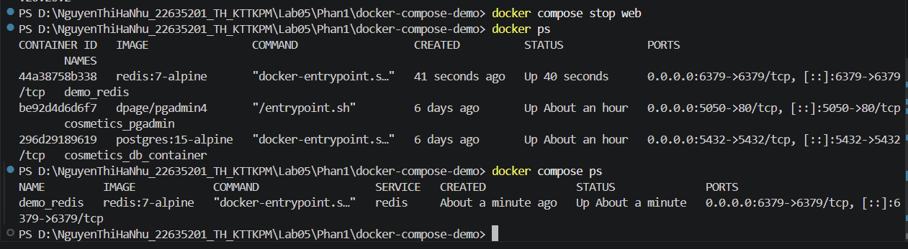
- docker compose rm web
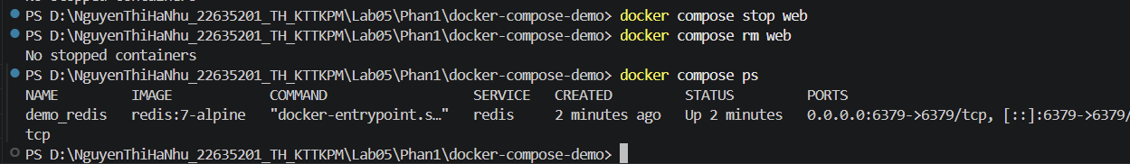
- docker compose config

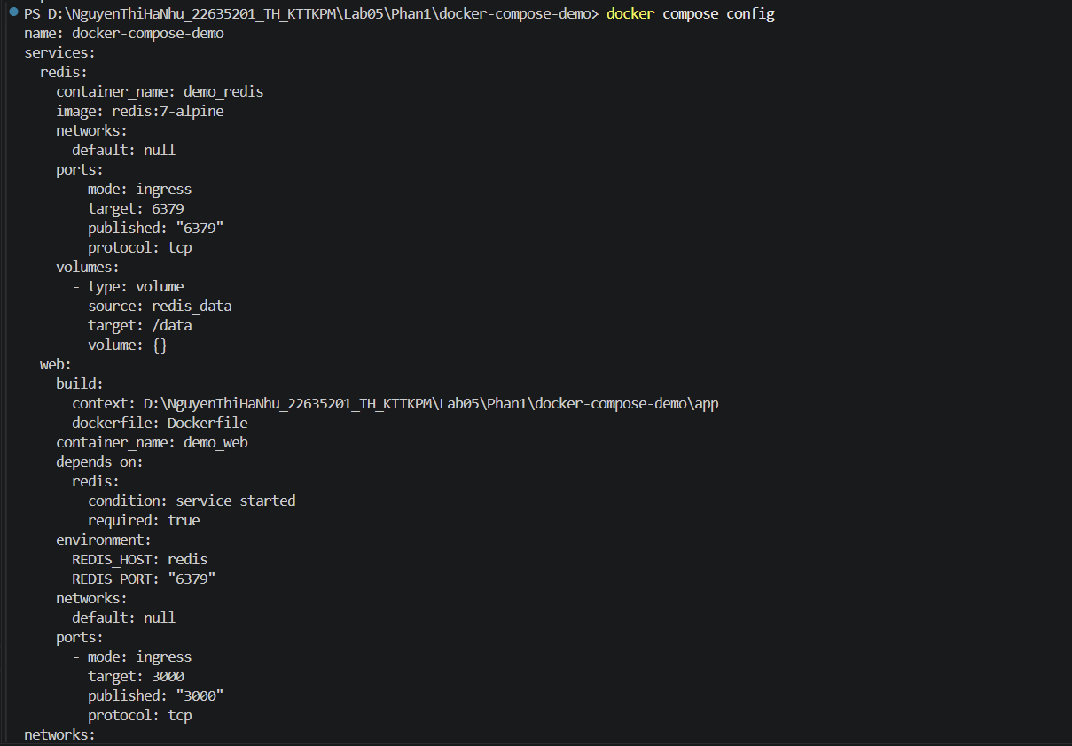
- docker compose up -d –build
