Business Requirements and Scoping
Oracle Cloud Subscription Endorsement – Core42 (Oracle Private Cloud, DRCC)
Department of Culture and Tourism (DCT) – Finance Division
Prepared for: DCT IT Team, in support of the Oracle Cloud (Core42) subscription endorsement
Date: 25 August 2026

Purpose
This document defines the business requirements and scoping for a set of DCT Finance processes that cannot be delivered within the shared Oracle ADERP (Fusion) environment, and are proposed to be built and hosted on the mapped Oracle Platform-as-a-Service (PaaS) capabilities within DCT's Core42 Oracle Private Cloud tenant (Oracle Autonomous Database and associated application/reporting services). It is provided to support the DCT IT team in endorsing the Oracle Cloud subscription from Core42.

1. Projects Budget Utilization Report
Requirement: Streamline the process of generating the “Projects Budget Utilization Report” — a consolidated view of approved budget, actual expenditure, open commitments/obligations and available funds per project, task and GL coding — with on-demand and scheduled generation, distribution and drill-down to supporting transactions.
Problem Statement: Oracle ADERP does not provide the strategic report for “Projects Budget Utilization” as required by DCT (budget-year and period-based utilization, encumbrance and fund-available views aligned to DCT’s project/cost-centre/appropriation structure). DGE is unable to fulfil this requirement because the current ADERP reporting configuration is shared across, and would affect, all Abu Dhabi Government Entities (ADGEs).
Proposed Solution: Use the mapped Oracle PaaS reporting services within the Core42 tenant to extract and reconcile core Oracle ADERP finance data (budget, AP, PO, PR, GRN and GL balances), and generate and distribute the Projects Budget Utilization Report in the format, frequency and audit trail required by DCT — without any change to the shared ADERP configuration.
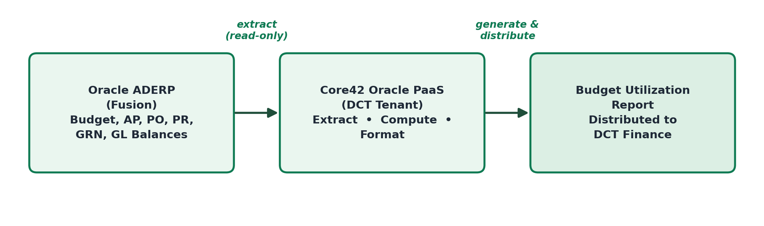
Figure 1: Process flow — Projects Budget Utilization Report (one-way, read-only extract from Fusion)

2. Freelancers Payments
Requirement: Streamline the end-to-end freelancer engagement and payment process — registration and document verification, contract/termsheet multi-step approval, budget/fund-availability check against project coding, and payment-voucher generation, tracking and invoicing — for freelancers engaged by DCT, with full visibility and audit trail.
Problem Statement: Oracle ADERP has no engagement and payment workflow tailored to DCT’s freelancer process (multi-step, role- and department/sector-specific approval chain; project/GL budget-availability checks; contract termsheet management; voucher-based payment generation and status tracking). This is a DCT-specific business process outside ADERP’s standard scope, and DGE is unable to customize the shared ADERP instance to accommodate it, as the requirement is strictly specific to DCT and does not apply across other ADGEs.
Proposed Solution: Use the mapped Oracle PaaS application and database services within the Core42 tenant to build and host a DCT-specific Freelancers process covering registration, contract/termsheet approval workflow, budget verification against Oracle ADERP project and GL data, and payment-voucher generation — fully reconciled and auditable against the ADERP financial ledger, without any change to the shared ADERP configuration.
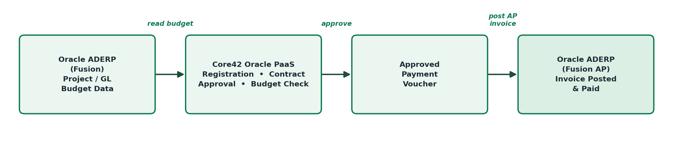
Figure 2: Process flow — Freelancers Payments (reads budget from Fusion, posts the approved invoice back)

3. Beneficiaries Payments
Requirement: Streamline the process of identifying, validating and monitoring beneficiary/third-party payments — including invoices recorded in Oracle ADERP against a generic supplier code where the true payee is not captured, and manual payments issued through the bank portal outside Fusion Payables — with duplicate-payee detection and full reconciliation to Oracle ADERP.
Problem Statement: Oracle ADERP does not capture true payee/beneficiary detail for a significant volume of AP transactions posted against a generic “Beneficiary” supplier record, so standard ADERP reports cannot show who was actually paid; it also has no visibility of payments processed manually through the bank portal outside Fusion Payables. DCT requires this visibility for reconciliation, duplicate-payment control and budget impact, and DGE is unable to amend the shared ADERP configuration to expose true-payee reporting or capture off-system payments, as this would affect all ADGEs.
Proposed Solution: Use the mapped Oracle PaaS reporting and database services within the Core42 tenant to extract Oracle ADERP AP data, enrich it with the true payee/beneficiary detail captured at invoice and site level, cross-reference bank account details for duplicate-payee detection, and maintain a DCT-hosted register to capture and reconcile manual bank-portal payments against Fusion — generating a consolidated Beneficiary Payments report, distribution and audit trail as per DCT requirements.
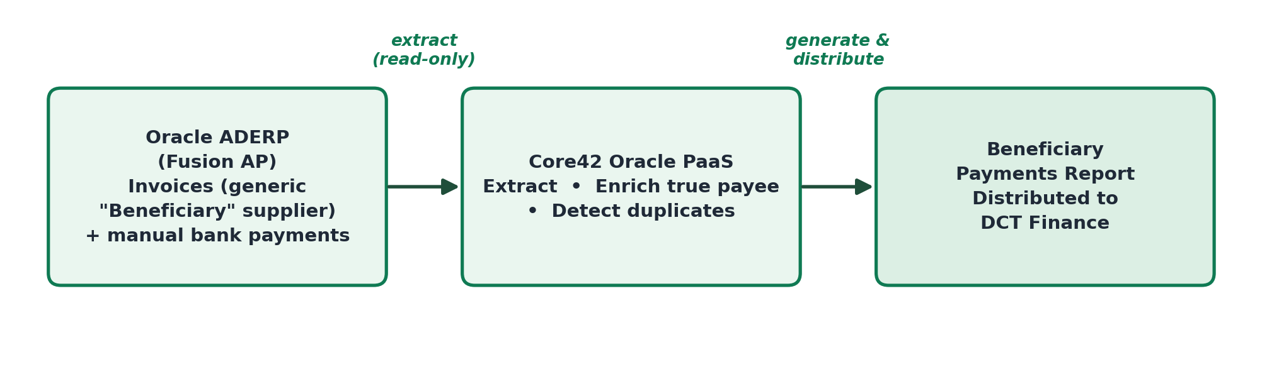
Figure 3: Process flow — Beneficiaries Payments (one-way, read-only extract and enrichment from Fusion)

Common Basis
All three processes share the same architecture pattern: Oracle ADERP (Fusion) remains the single source of truth and system of record; DCT-specific extraction, computation, workflow and reporting logic — which ADERP does not support and which DGE cannot enable at the shared-tenant level — runs on Oracle PaaS services (Autonomous Database and application/reporting tooling) inside DCT’s own Core42 Oracle Private Cloud tenant. This keeps DCT data resident within the sovereign Core42 environment, requires no change to the shared ADERP configuration used by other ADGEs, and gives DCT the report formatting, distribution and audit capability its business requires.

