SOLUTION DESCRIPTION
Retail Point of Sale
for Microsoft Dynamics 365 Business Central
A touch-screen register that lives inside Business Central. Cashiers sell from your own item list, and every sale posts as a normal sales invoice with its customer payments, so stock, VAT and the ledgers stay in one system.
Document | Description of the Retail POS module for the client
Module version | 1.0.0.0
Date | 10 November 2026
Platform | Microsoft Dynamics 365 Business Central, version 25 or later
Publisher | Hany
Object ID range | 50200 to 50249

In this document
1 What the module does
2 How a sale flows through Business Central
3 Signing in and user roles
4 The register screen
5 Working at the counter
6 The POS Manager role center
7 Receipts, items sold and payments
8 Color themes
9 Setup and administration
10 Scope of this version and possible next steps
Appendix Technical summary and object list

1 What the module does
Business Central does not include a point-of-sale function. Retail POS adds one. It gives cashiers a fast, touch-friendly register screen and gives managers a role center that shows what is being sold. Behind the screen there is no separate system: the register reads items, prices, customers and stock from Business Central, and every completed sale becomes a standard posted sales invoice.

Main benefits
- One system. Items, prices, customers, stock levels, VAT and the general ledger are the ones you already maintain. There is no interface to run and no end-of-day import.
- Quick counter work. Barcode scanning, large product tiles, a number keypad, split payments, and hold and recall of waiting customers.
- Controlled access. Each cashier signs in with a username and password. Discounts, deleting lines, cancelling a sale and discarding held receipts are limited to administrators, who can also see and recall the held sales of all cashiers.
- Visibility for managers. A dedicated role center shows today's sales, payments by type, and receipts in progress, and links to every related page.
- Your look and feel. Cashiers can choose a color theme, and managers can design new themes with a live preview.
- Safe posting. A sale is posted completely or not at all. If anything is wrong, nothing is posted and the cashier sees a clear message.

The module at a glance
Part | What it provides
POS Register | The JavaScript touch screen used by cashiers, opened from Business Central as a normal page.
Login | Username and password sign-in, administrator and cashier roles, automatic sign-out after inactivity.
Posting | Conversion of each receipt into a standard sales invoice plus customer payments, in one transaction.
POS Manager role center | Sales and payment figures for today, recent sales, and navigation to all POS and finance pages.
Management pages | Receipts, items sold, payments, and the receipt card with a link to the posted invoice.
Themes | Three ready-made color themes and an editor for your own.
Setup | Default customer and location, receipt numbering, payment methods, discount limit, users and themes.

2 How a sale flows through Business Central
Every sale is stored in Business Central while the cashier works on it. The steps below show what happens from the first scan to the posted documents.
- Sign in. The cashier signs in on the register. The username is stored on every receipt as the cashier.
- Build the sale. Items are scanned, searched for or tapped. After every click the receipt is saved in Business Central tables, so a held sale or a closed browser never loses data.
- Take payment. The cashier adds one or more payments (for example card and cash). The screen shows the amount remaining and the change to give.
- Complete the sale. Business Central creates a standard sales invoice for the receipt customer and posts it. Inventory, general ledger, VAT and customer ledger entries are the standard ones.
- Post the payments. One customer payment is posted for each payment type and applied to that invoice, against the G/L or bank account set on the payment method. Cash is applied last so that change is handled correctly.
- Finish. The receipt is marked Posted and keeps the number of its sales invoice. The receipt is shown on screen and can be printed.
All-or-nothing posting
Checkout runs as one transaction. If any step fails, for example because the stock would become negative or a posting group is missing, everything that step created is rolled back, the sale stays open on the screen, and the cashier is told why.
As an extra control the module compares the posted invoice total with the receipt total. If they ever differ, the sale is rejected and nothing is posted.

What is created in Business Central
Result | Details
Posted sales invoice | A normal posted sales invoice for the receipt customer, using the location from POS Setup. Visible in Posted Sales Invoices.
Item, value and G/L entries | Created by standard posting for the sold items, including VAT.
Customer ledger entries | The invoice and the customer payments that settle it.
Payment postings | One line per payment type, against the G/L or bank account of the payment method.
POS receipt | Stays in the POS tables as the sales record, with the invoice number, cashier, date and every line and payment.

Prices come from the item card (Unit Price, excluding VAT). VAT is calculated per VAT percentage group in the same way Business Central does, then added to the ticket total.

3 Signing in and user roles
The register always opens on a login screen. Nothing of the sale, the item list or the receipts is loaded until a user has signed in.
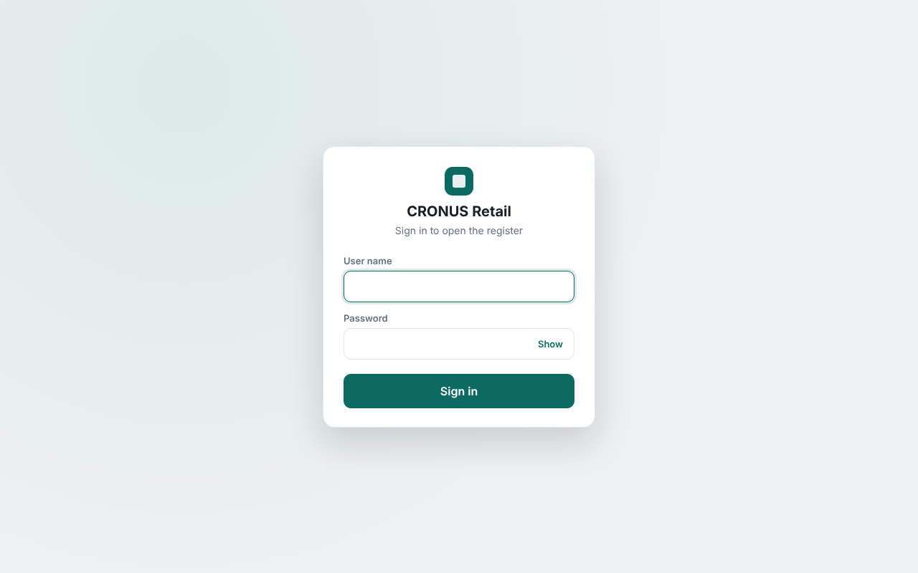
Figure 1. The login screen

POS users
Users are kept in a small table with three fields: Username, Password and Is Admin. They are created and maintained in Business Central on the POS Users page, which is available from POS Setup, the register page menu and the role center.
- The password is never stored as typed. Business Central keeps only a salted hash of it (PBKDF2 with SHA-256), so nobody can read a password from the database.
- A password has at least 4 characters. A user without a password cannot sign in.
- The first administrator is created in Business Central, not on the login screen. This avoids anyone creating an administrator from a till.
- There must always be at least one administrator. The last one cannot be deleted or demoted.
- A username cannot be renamed, because receipts refer to it. Create a new user instead.

Protection against guessing
- The signed-in user is held on the Business Central server, not in the browser, so the screen cannot pretend to be signed in. Every register action checks it.
- A wrong password is answered after a short delay, and after five wrong attempts the login is blocked for 30 seconds.
- The message never says whether the username or the password was wrong.
- After a period without activity the cashier is signed out automatically (default 15 minutes, adjustable in POS Setup, 0 turns it off). The open sale is kept and returns at the next sign-in. Automatic sign-out waits while the payment window is open.

Cashier and administrator
Function on the register | Cashier | Administrator
Scan, search and add items | Yes | Yes
Change quantities (1 or more) | Yes | Yes
Choose the customer | Yes | Yes
Hold a sale and recall own held sales | Yes | Yes
Take payments and complete the sale | Yes | Yes
Reprint the last receipt | Yes | Yes
Choose own colour theme | Yes | Yes
See the held sales of other cashiers | No (own only) | Yes (all cashiers)
Recall (take over) a held sale of another cashier | No | Yes
Give a line discount (up to the limit in POS Setup) | No | Yes
Delete a line (or set its quantity to 0) | No | Yes
Cancel (void) a sale | No | Yes
Discard a held receipt | No | Yes

For a cashier the restricted buttons are not shown at all (the minus button stops at quantity 1), and the server refuses the actions even if someone tries to send them. A cashier sees only the receipts they themselves put on hold. An administrator sees the held receipts of every cashier, with the name of the cashier who parked each one and can recall any of them to continue the sale or, for example, give a discount on it.
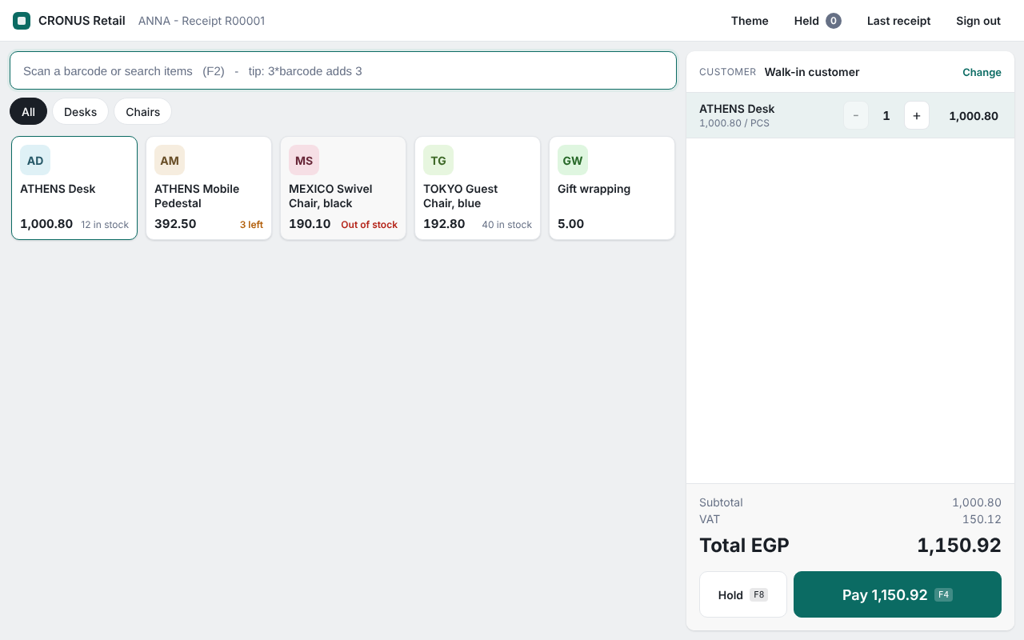
Figure 2. The register as a cashier sees it: no Cancel sale button, no discount tool and no delete-line button

4 The register screen
The register is built for speed and for touch screens. The left side is the catalogue; the right side is the current sale.
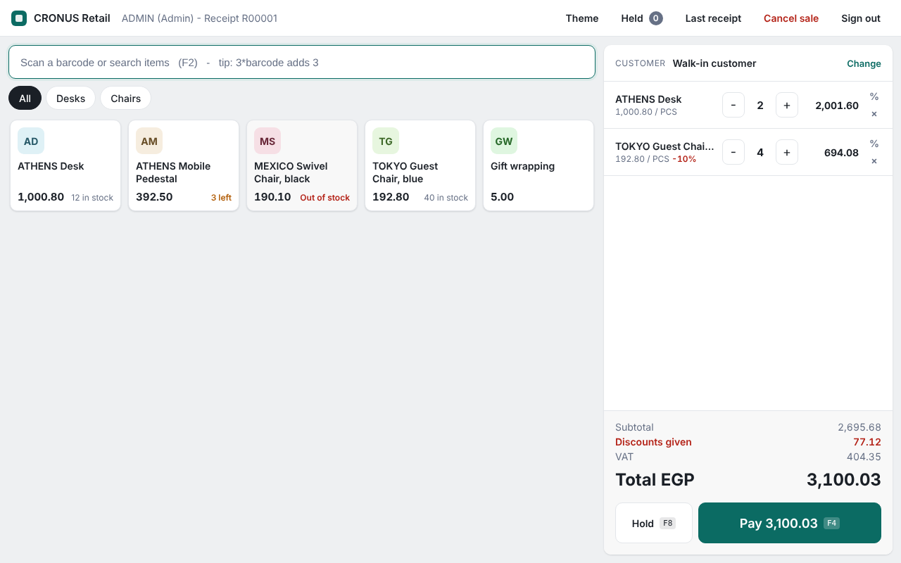
Figure 3. The register with a sale in progress (sample data, administrator signed in)
Area | What it does
Top bar | Company name, the signed-in user (with "Admin" for administrators) and the receipt number. Buttons for Theme, held receipts, Last receipt, cancel sale (administrators) and sign out.
Search box | Scan a barcode or type to search by item number, description or barcode. Press Enter to add the exact match. Typing 3*barcode adds three of the items.
Category chips | Filter the product tiles by item category.
Product tiles | One tile per item with the name, price and a stock badge: "in stock", "n left" when five or fewer remain, or "Out of stock". Tap a tile to add one.
Customer bar | Shows the customer of the sale. The default is the cash customer from POS Setup. Tap Change to pick another customer.
Sale lines | Quantity buttons (minus, plus, or tap the number for a keypad), line amount, discount and remove.
Totals | Subtotal, discounts given, VAT and the total to pay.
Hold and Pay | Hold parks the sale. Pay opens the payment window.

Keyboard shortcuts
Key | Action
F2 | Jump to the search box
F4 | Open the payment window
F8 | Hold the current sale
F9 | Choose the customer
Enter | Add the scanned item; in the payment window add a payment or complete the sale
Esc | Close the open window

5 Working at the counter

Adding items and changing quantities
Scan a barcode, type an item number or part of a name, or tap a tile. The module recognizes barcode references, item numbers and GTINs. If nothing matches exactly, similar items are shown instead. Adding an item that is already on the sale increases its quantity. Quantities can be changed freely, but removing a line (the cross button, or a quantity of 0) is reserved for administrators.

Discounts
An administrator can give a percentage discount on a line using the keypad. The highest allowed percentage is set in POS Setup; setting it to 0 switches discounts off. Discounted lines show the percentage, and the ticket shows the total discount given.
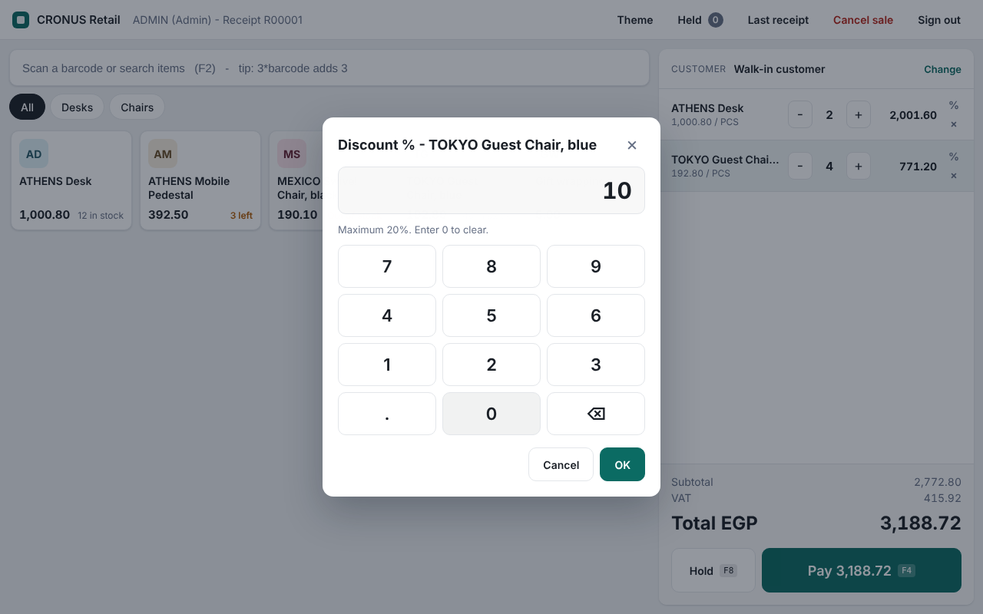  Figure 4. Entering a line discount | 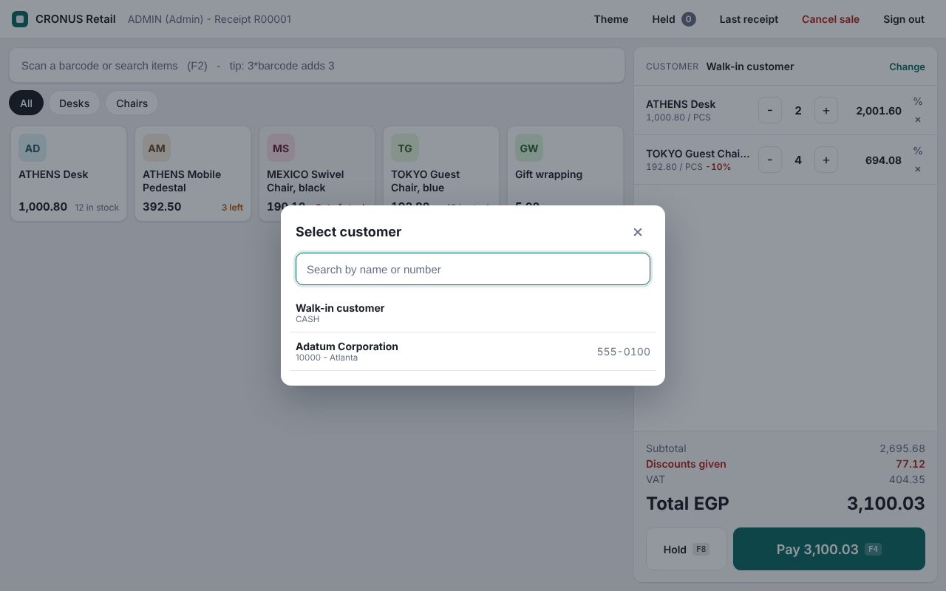  Figure 5. Choosing a customer

Choosing the customer
Every sale belongs to a customer. By default, this is the cash customer from POS Setup. To invoice a named customer, search by name or number and tap the customer. Blocked customers cannot be used.

Hold and recall
A sale can be put on hold while the customer fetches something. Held sales appear under Held, with time, customer, number of items and total. Recall brings a sale back to the screen. Held sales belong to the cashier who parked them and only that cashier can recall them. An administrator sees the held sales of all cashiers, marked with the name of the cashier, and can recall any of them. The sale then moves to the administrator, who can discount, change or complete it; the receipt keeps the name of the original cashier in the field Taken Over From. An administrator can also discard a held sale that is no longer needed.

Taking payment
The payment window shows the amount due, the payments added so far, and the amount remaining.
- Tap a payment method (for example Cash or Card) to add a payment for the amount in the entry box. The box starts with the amount remaining.
- Exact and the quick-amount buttons (for example 50, 100, 200, 500) are shortcuts for cash.
- A sale can be paid with several payments, for example part by card and the rest in cash.
- Only cash can give change. Card and other non-cash payments cannot be more than the amount due.
- Complete sale becomes available when the payments cover the total. The change to give is shown at once.
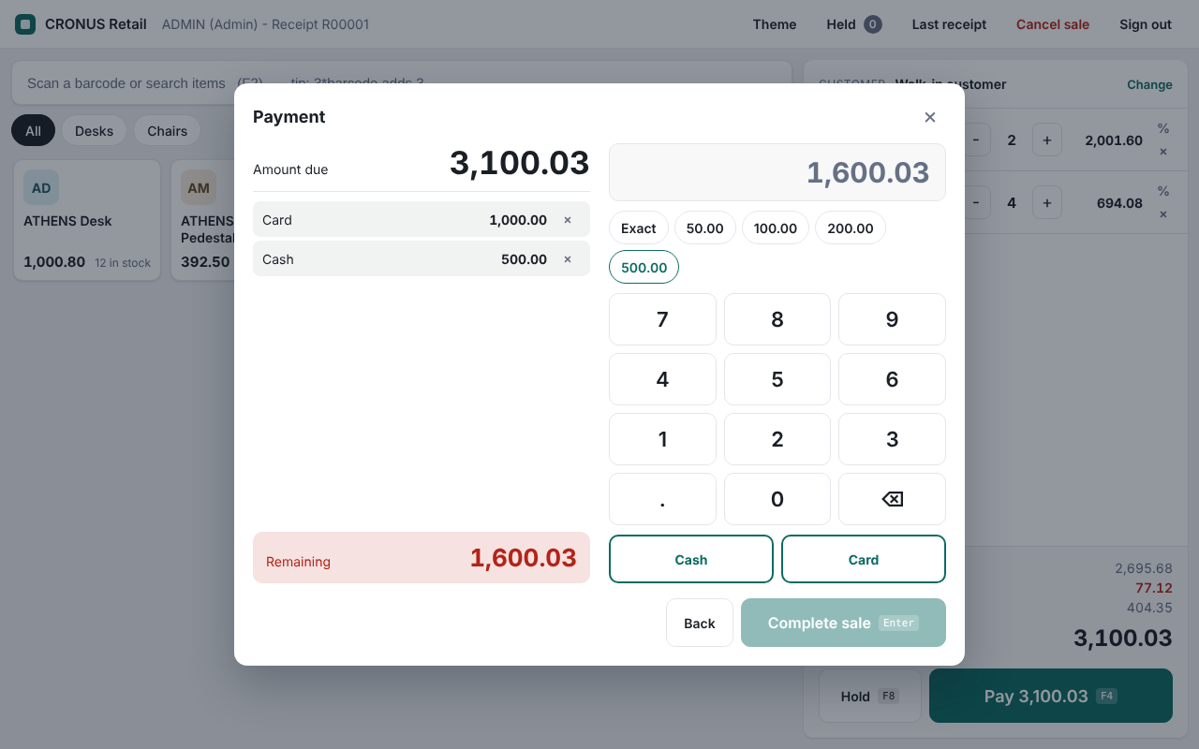
Figure 6. The payment window with a card payment and a cash payment added

Receipt
When the sale is completed, the receipt is shown with the invoice number, lines, VAT, payments and change. It can be printed straight away, and the last receipt can be reprinted later from the top bar. The receipt header and footer texts come from POS Setup.
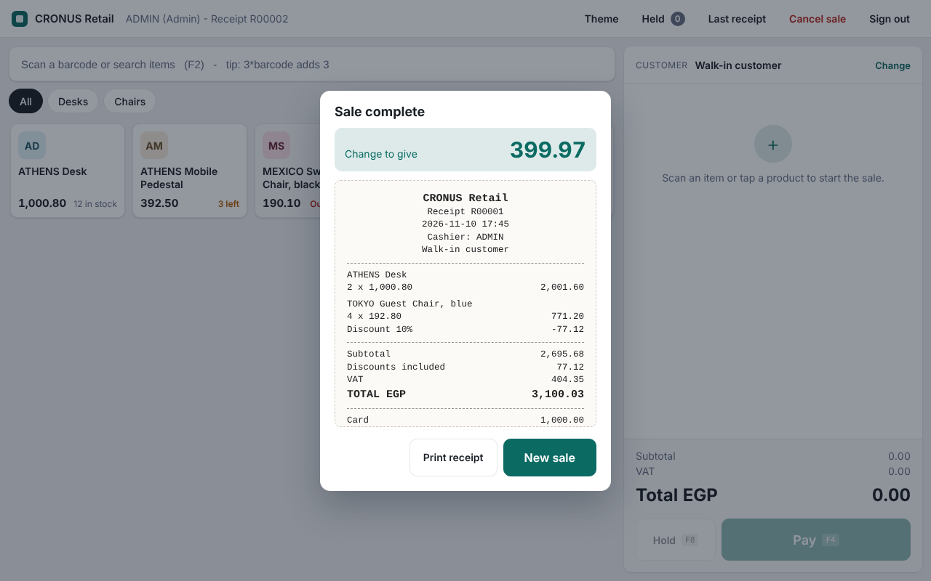
Figure 7. The completed sale with change to give and the receipt preview

Cancelling a sale
An administrator can cancel the sale in progress after a confirmation. The receipt is not deleted: it is kept with the status Voided, so the number sequence has no gaps and the cancellation can be reviewed.
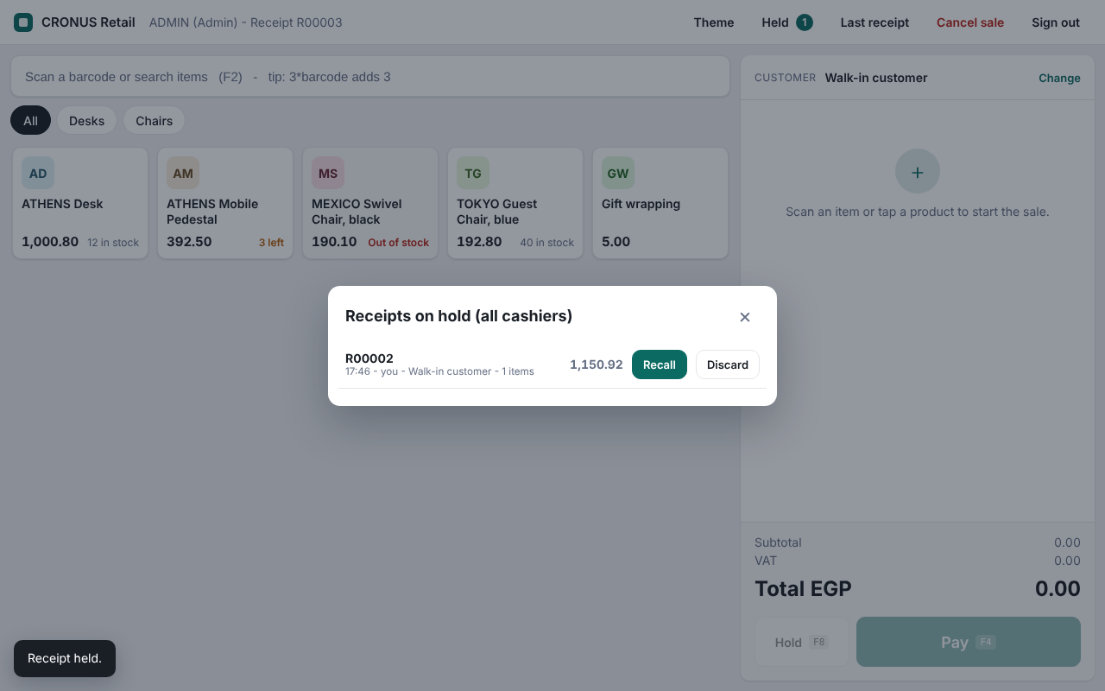  Figure 8. Receipts on hold | 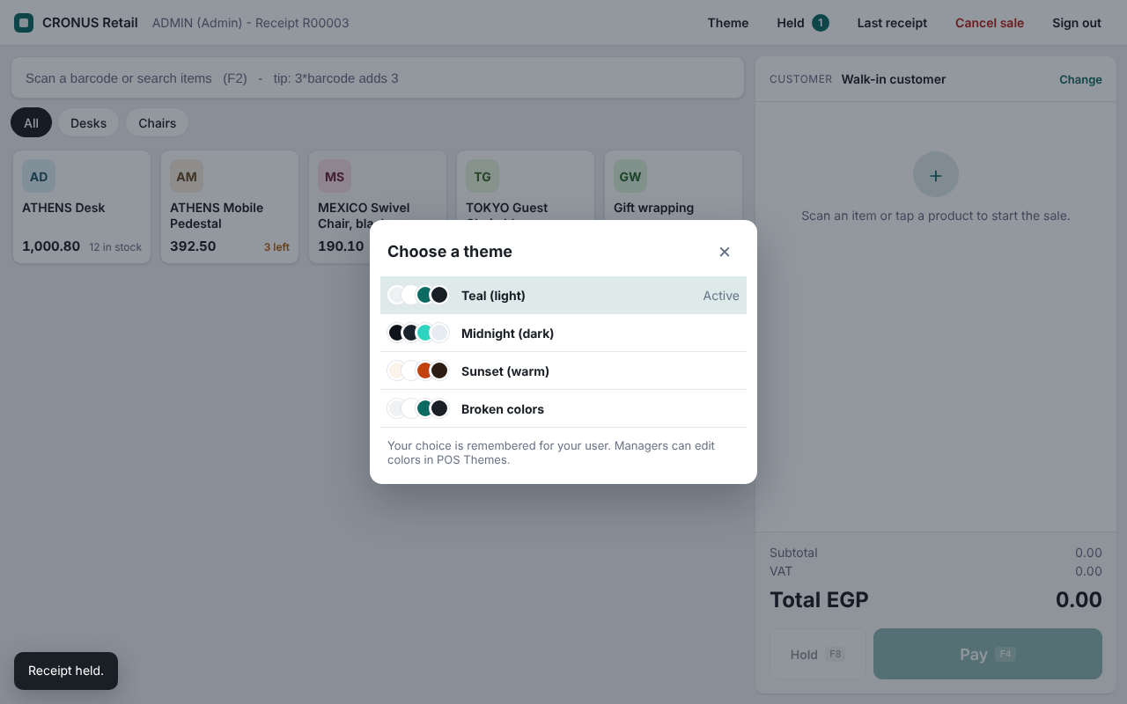  Figure 9. Choosing a theme

6 The POS Manager role center
Managers get their own role center, the profile POS Manager. It is selected in My Settings under Role Center. It brings today's trading figures and every POS and related finance page together on one start page.

Activities
The cue tiles count the current work date and can be clicked to open the matching list.
Group | Figures
Sales Today | Number of completed receipts, total sales amount, and number of cancelled (voided) sales. Includes a shortcut to open the register.
Payments Today | Amounts received in cash, by card and by other payment types.
Registers | Receipts in progress and receipts on hold right now.

Recent sales
A list of the latest completed sales with receipt number, date and time, cashier, customer, total and sales invoice number. Opening a line shows the full receipt.

Navigation
Menu | Pages
Actions | New Sale, Receipts on Hold, Items Sold, Payments, POS Receipts, Completed Sales, Customers, Items
Point of Sale | POS Register, Receipts, Receipts on Hold, Items Sold, Payments
Catalog | Items, Item Categories, Customers
Finance and stock | Posted Sales Invoices, Customer Ledger Entries, Bank Accounts, Item Ledger Entries, Chart of Accounts
POS Setup | POS Setup, POS Users, Payment Methods, Themes, Locations, No. Series

7 Receipts, items sold and payments
Every sale remains available for review. The management pages are reached from the role center and link to each other.
Page | Purpose
POS Receipts | List of all receipts with status (Open, Posted, Voided), cashier, customer, date and total. Fact boxes show the lines and payments of the selected receipt. Actions open the register, the posted sales invoice, the items sold and the payments.
POS Receipt (card) | One receipt with its general data, lines, payments and totals, and a link to the posted sales invoice.
POS Items Sold | Every sold line across all receipts, to see what is selling and at what price and discount. Opens the receipt of a line.
POS Payments | Every payment with its type and applied amount, for reconciling cash and card takings. Opens the receipt of a payment.
Recent Sales | The latest receipts, shown on the role center.

The status of a receipt tells where it is: Open (being sold or on hold), Posted (invoice and payments posted) or Voided (cancelled by an administrator).

8 Color themes
The register can be shown in different color themes, for example a dark theme for dim shops or a warm one that matches a brand. Cashiers choose their own theme with the Theme button; it is remembered for their user. The default for users who have not chosen is set in POS Setup.
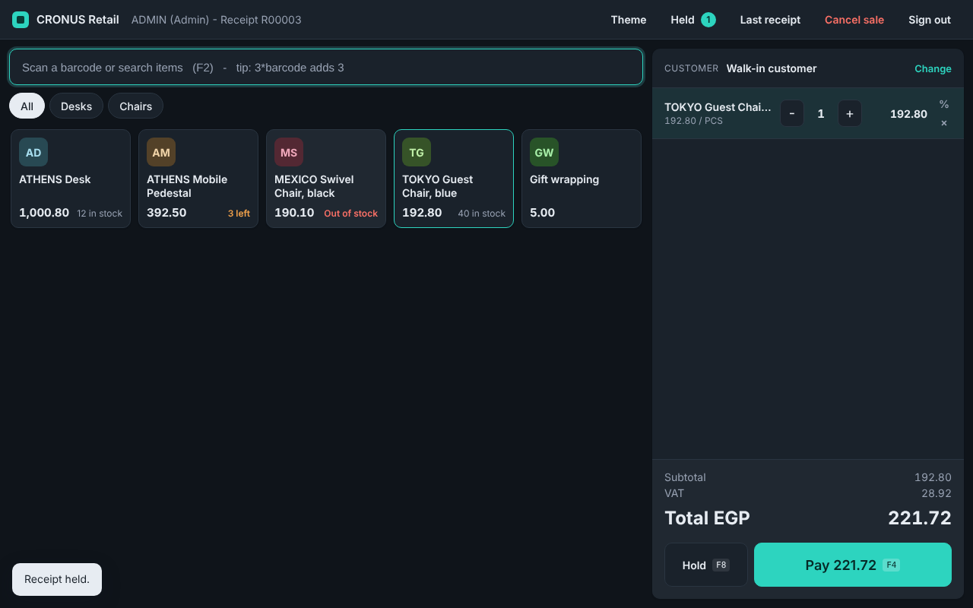  Figure 10. Midnight (dark) theme | 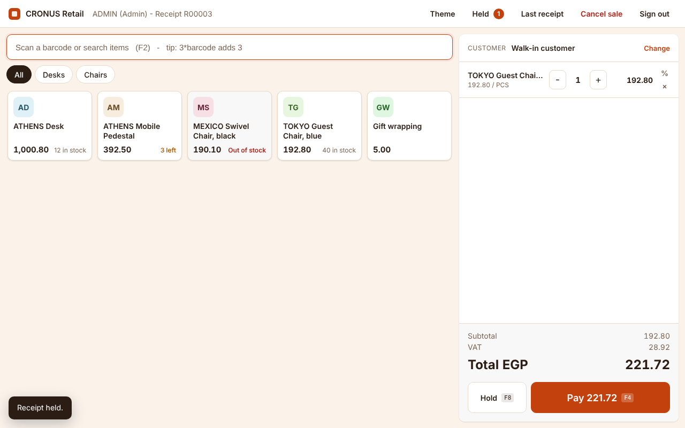  Figure 11. Sunset (warm) theme

Three themes are installed: Teal (light, the standard look), Midnight (dark) and Sunset (warm). Managers can create more on the POS Themes page.

Theme editor
A theme is defined by eight colors. The theme card shows a live miniature of the register next to the color fields, so a change can be judged at once. Colors are picked with a color picker or typed as hex values. A readability check rates the important color pairs and warns when text would be hard to read.
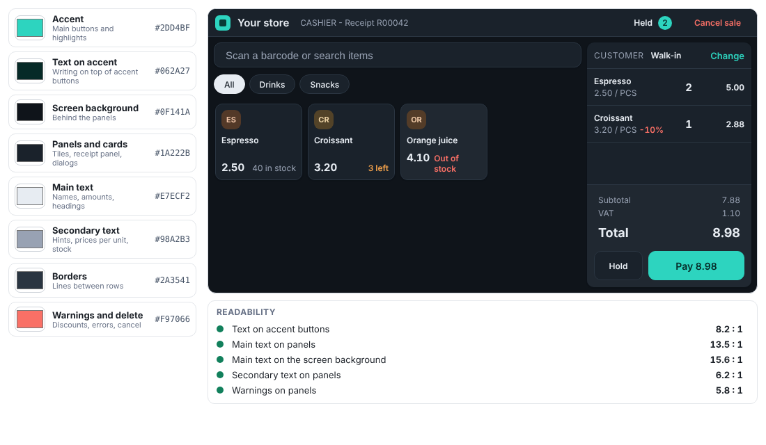
Figure 12. The theme editor: eight colors, a live preview and the readability check
Colour | Used for
Accent | Main buttons and highlights
Text on accent | Writing on top of accent buttons
Screen background | The area behind the panels
Panels and cards | Tiles, receipt panel and dialogs
Main text | Names, amounts and headings
Secondary text | Hints, unit prices and stock labels
Borders | Lines between rows and around cards
Warnings and delete | Discounts, errors and cancel

On the theme list and card, Use for Me applies a theme to the current user, Use as Default Theme applies it to everyone who has not chosen one, and Create Default Themes restores the three standard themes.

9 Setup and administration

POS Setup
Field | Meaning
Default Customer No. | The customer that cash sales are posted to. Use a customer with immediate payment terms and a VAT business posting group.
Default Location Code | The location that stock is sold from.
Receipt Nos. | The number series for receipts.
Max Line Discount % | The highest discount an administrator can give on a line. 0 switches discount off.
Product Tiles | How many items the register shows at once.
Auto Sign-out (minutes) | Sign the user out after these many minutes without activity. 0 turns it off.
Default Theme Code | The color theme for users who have not chosen their own.
Receipt Header Text / Footer Text | Texts printed at the top and bottom of the receipt. The header defaults to the company name.

If something required is missing, for example the number series, the register shows a banner at the top that says what to complete.

Payment methods
Field | Meaning
Code and Description | The name shown on the payment buttons, for example CASH and CARD.
Type | Cash, Card or Other. Only cash can give change. The type also drives the cash, card and other figures on the role center.
Balancing Account Type and No. | The G/L account or bank account that the payment is posted against, for example the till account for cash and the bank account for card.
Quick Amounts | Amounts shown as shortcut buttons, for example 50,100,200,500.

Users and permissions
Register users are maintained on POS Users. Business Central users who work with the module receive the permission set POS - ALL, which covers all POS tables, codeunits and pages. Users who complete sales also need the normal rights to post sales documents. The "Is Admin" setting of a POS user controls only the register functions listed in section 3.

Checklist for going live
- Install the extension and assign the permission set POS - ALL to the people who will use the module.
- Open POS Setup: choose the default customer and location, and the receipt number series.
- Open POS Payment Methods and create the payment methods with their balancing accounts.
- Check that items have a VAT product posting group and that the default customer has a VAT business posting group.
- Open POS Users and create at least one administrator with a password, then the cashiers.
- Switch the profile to POS Manager for managers, and review the themes if needed.
- Open POS Register, sign in and complete a test sale. Check the posted sales invoice and the customer ledger entries.

10 Scope of this version and possible next steps
This section lists what the module covers today so that expectations are clear, and what can be added in a later phase.
In this version | Not in this version
Sales to a chosen customer or the cash customer | Refunds and returns (a credit memo flow would be the natural addition)
Split payments in cash, card and other types | Shifts, till opening and cash-up counting
Hold, recall, cancel with audit trail | Price lists, campaigns and promotions (a hook exists in the code for them)
Login, roles and automatic sign-out | Several currencies (local currency only; posting date is the work date)
Role center with today's figures | Serial and lot tracked items, dimensions
Themes with editor | Self-service password change and password expiry

- Printing. Receipts are printed through the browser print dialog. For thermal receipt printers a Business Central report based receipt is the more robust option and can be added.
- Permission sets. One permission set (POS - ALL) is delivered. A narrower set for cashier-only users can be added if you want to separate duties further.
- Prices. Prices come from the item card. Price lists can be connected through the extension event provided for it.
About the screenshots
The screenshots in this document show the register with sample data and were taken from the interface preview. Names, items, prices and figures on your system will be your own.

Appendix Technical summary and object list
Item | Detail
Platform | Business Central online (SaaS), version 25 or later; runtime 14
Language | AL extension. The register screen is a JavaScript control add-in with its own style sheet.
Dependencies | None on other extensions. Uses standard Business Central codeunits for number series and password hashing.
How the screen talks to Business Central | Each click is sent to one action codeunit, which runs it in a protected transaction and returns the updated receipt. The screen holds no business data of its own.
Standard documents used | Sales invoice posting (Sales-Post) and general journal posting for customer payments
Object ID range | 50200 to 50249; objects 50200 to 50215 are in use
Installation | Creates the three standard themes. The setup record is created the first time POS Setup is opened.

Tables
ID | Name | Purpose
50200 | POS Setup | Module settings
50201 | POS Payment Method | Payment types and their balancing accounts
50202 | POS Receipt Header | One receipt: customer, cashier, status, totals, invoice number
50203 | POS Receipt Line | Sold items on a receipt
50204 | POS Receipt Payment | Payments on a receipt
50205 | POS Cue | Figures for the role center tiles
50206 | POS Theme | Colour themes
50207 | POS User Setup | Theme chosen by each user
50208 | POS User | Register users: user name, password hash, is admin

Codeunits
ID | Name | Purpose
50200 | POS Management | Receipt handling, items, prices, discounts, customers, payments
50201 | POS Json Builder | Prepares the data sent to the screen
50202 | POS Action Handler | Single entry point for every action from the screen, including session checks
50203 | POS Post Receipt | Posts the sales invoice and the customer payments
50204 | POS Theme Management | Standard themes and the theme of each user
50205 | POS Install | Installation routine
50206 | POS Session | Who is signed in, administrator check, lockout

Pages
ID | Name | Purpose
50200 | POS Register | The register screen
50201 | POS Setup | Settings
50202 | POS Payment Methods | Payment method list
50203 | POS Receipts | Receipt list
50204 | POS Receipt Card | Receipt card
50205 / 50210 | POS Receipt Subform / Payments Subform | Lines and payments on the receipt pages
50206 | POS Activities | Cue tiles of the role center
50207 | POS Recent Receipts | Recent sales on the role center
50208 | POS Sales Lines | Items sold
50209 | POS Role Center | Role center of the POS Manager profile
50211 | POS Payments | Payments list
50212 / 50213 | POS Themes / POS Theme Card | Theme list and editor
50214 / 50215 | POS Users / POS User Card | User list and card

Also included: the enums POS Receipt Status (Open, Posted, Voided) and POS Payment Type (Cash, Card, Other), the control add-ins POS Control and POS Theme Editor, the profile POS Manager and the permission set POS - ALL.

