Environment：python3 opencv(read files) numpy（Calculatation）

How to run：Run main.py

Introduction

main.py runs python file, reads files and implement algorithms, then show the output

tools.py Implements algorithms including guided filtering, mean filtering, and minimum filtering.

darkchanel.py Implements dark channel algorithm。Its process is in the process function :

First calculate the dark channel value of the entire image, and obtain the atmospheric illumination value according to the prior theorem. Use the dark channel and atmospheric illumination value to find the propagation coefficient t for each point. At this time, t is the value of each pixel of the entire image is different. And then use the guided filtering to still get the original t estimate, and then use the original t estimate to restore the original image。

Related Formulas：

Atmospheric lighting model:

the formula for the dark channel: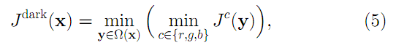

Formula for t：

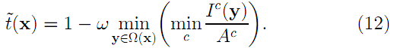

clahe.py is adaptive histogram equalization with limited contrast：

First of all, adaptive histogram equalization is an improvement based on histogram equalization. As shown in FIG. 1, it performs equalization in a local area, and then uses a sliding window to perform calculations on the whole image. Then the limitation of the equalization of the contrast is changed, and the contrast is limited by the method shown in FIG. 2.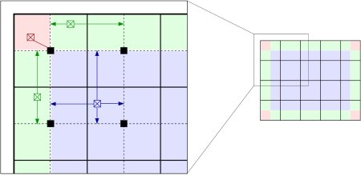

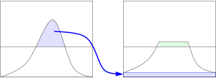

ColorAttenuation.py is an implementation of the paper "A Fast Single Image Haze Removal Algorithm Using Color Attenuation Prior" https://ieeexplore.ieee.org/stamp/stamp.jsp?tp=&arnumber=7128396, which is consistent with the dark channel. The atmospheric illumination model is used for defogging, and the t is calculated by using the following formula:

The formula for determining the depth of field using the hsv color model is:

Three values are：0.121779 0.959710 0.780245

Find the propagation t from the depth of field, and still use the atmospheric propagation model to restore the original image.