Hanyang Xiao

[xhanyang@pdx.edu](mailto:xhanyang@pdx.edu)

CS441

My work is to build a minimax AI to play Gothello game with other players. The finished AI works well as expect. I did my work mainly throughplay against negamax AI provided by Bar. The final version I implemented can beat the provided negamax AI in a high probability.

Through the study and understanding of the negamax algorithm and the minimax algorithm, it is found that they are very similar and essentially the same. So to beat him, there are two main areas that need to be improved: one is to increase the search depth, the depth becomes larger, and the search time becomes longer, so the alpha-beta pruning algorithm is added, which can perform many pruning and speed up the search process. One is to explore a better evaluation function. The current evaluation function is to subtract the number of black and white. The improvement is to consider the effect of "eyes". If it can be surrounded by "eyes", the surroundings are safer and can be adjusted to get a great score.

The current AI strategy is fixed and set in advance. In the future, it can be changed to automatic learning, starting from scratch and continuously improving according to the game data until it defeats other strategies.

How to run:

gothello-grossthello-master

Directory contains basic code (server, client, and implemented minimax AI)

1. Go to the subdirectory under this directory gothello-gthd,

Compile: javac Gthd.java

Run: java Gthd 0

This is the startup server

1. Open a new terminal and go to the gothello-grossthello-master directory

Compile: javac Grossthello.java

Run: java Grossthello black localhost 0 3

It is to start a client, where AI is the negmax provided.

Open another terminal and go to the gothello-grossthello-master directory

Compile: javac Grossthello_AI.java

Run: java Grossthello_AI white localhost 0 6

It is to start another client, where AI is the minimax to be personally implemented

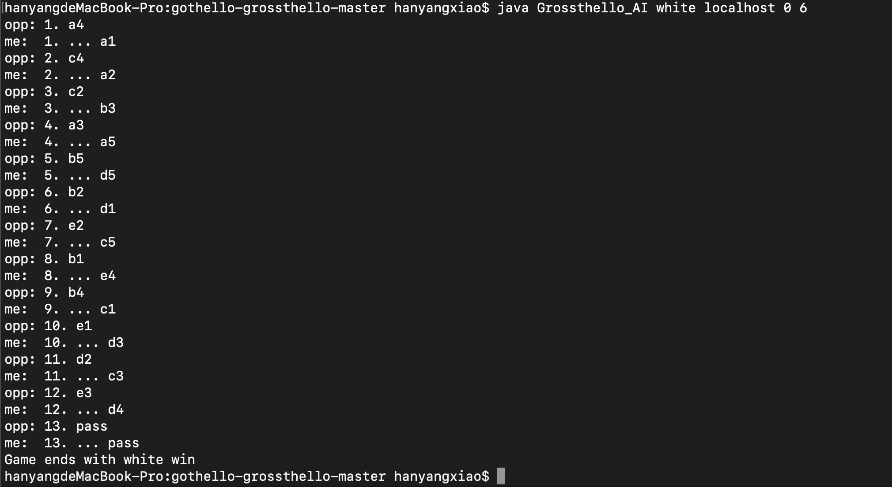

Here is the result of the game.

This time white, as the AI implemented personally, wins.

(Codes can be found in Grossthello_AI.java and WorkBoard_AI.java)