improve: first we need to delete the open benchmark and model name, because : 1: the open benchmark is unique, every time it will only have one bench mark that open
2: for model name, it only appear in first/second benchmark, for the third and other benchmarks, its identify classifier should be username of submitter. And in the benchmark show, if a user submitted serval time, we only preserve the most recent result that use submits.

Submission JSON format:
problem_id is an integer ranging from 0 to 9999.
answer is A, B, C or a, b, c (This is a multiple-choice question. The answer can only be selected from A, B, C or a, b, c).
And there should be a checking mechanism for the answer format. Please check if such a mechanism already exists. If not, please add it.

This part of the table needs to be modified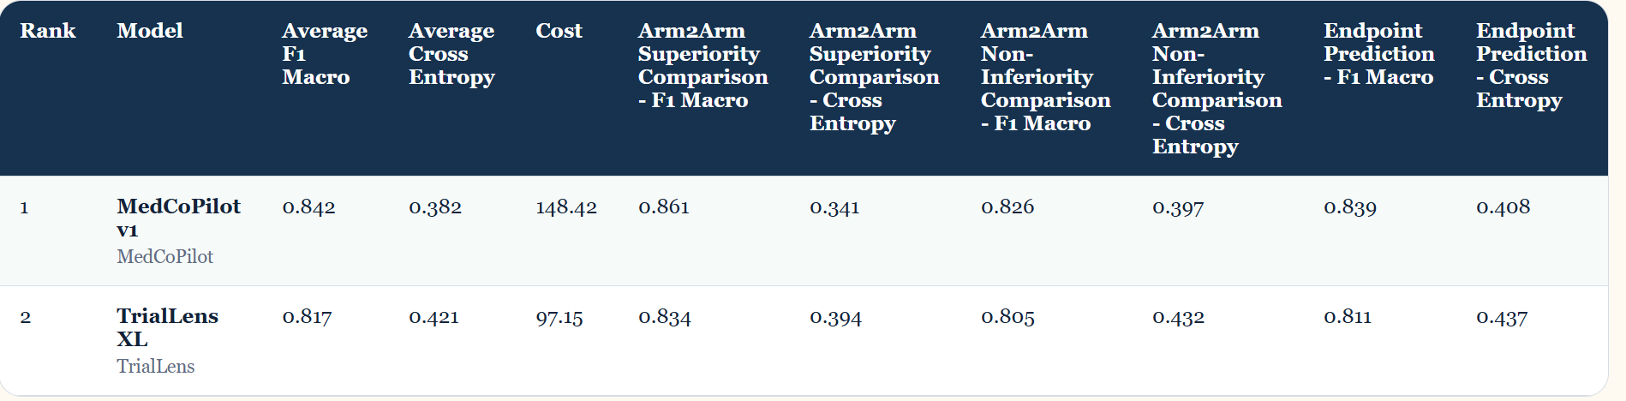
The change should be made to the following format. Specifically, the "Arm2Arm Superiority Comparison" column in the table header corresponds to two sub-columns, one being F1 Macro, Cross Entropy, and the other being Arm2Arm Non-Inferiority Comparison, which also corresponds to two sub-columns, F1 Macro, Cross Entropy, and Endpoint Prediction. Additionally, preparations should be made for adding other sub-column indicators in the future.