Update the original website file based on the reference site（https://web.archive.org/web/20250326213821/https://matharena.ai/）. Specific requirements below：

You are a senior full-stack engineer, backend engineer, product-minded system designer, and security-conscious web architect.

Build an engineering-ready MVP for a website called:

# Clinical Trial Arena

Clinical Trial Arena is an AI benchmark website for evaluating model performance on clinical-trial-related tasks.

Your job is to generate a **backend-first but full-website-capable MVP implementation** with clean architecture, secure defaults, database persistence, structured validation, benchmark browsing, leaderboard display, benchmark download/submission flow, instruction page, FAQ section, and extensible lifecycle support for future benchmark releases.

## Output expectation

Do not stop at high-level planning.
Do not only provide pseudocode.
Generate concrete, repo-quality code structure and implementation scaffolding.

The implementation should prioritize:
1. a working backend architecture
2. database-backed benchmark/submission/auth logic
3. a usable frontend MVP
4. extensibility for future benchmark cycles

---

# 1. Product Goal

Build a website where users can:

1. Sign up and sign in
2. Verify their email through a verification code
3. Browse benchmark tabs
4. Download benchmark question sets
5. Submit benchmark answers in JSON
6. Have submissions validated and stored
7. View published benchmark leaderboard/result tables
8. Read platform instructions and FAQ
9. View their own submission history
10. Continue using the site as new benchmark cycles are released every 3 months

This should be production-minded, not a toy demo.

---

# 2. Required Stack

## Backend
- Python
- FastAPI
- PostgreSQL
- SQLAlchemy ORM
- Alembic
- Redis
- Pydantic

## Frontend
- Next.js preferred (React + TypeScript)
- Simple, clean, modern UI
- Responsive layout
- Tab-based benchmark interface
- FAQ accordion UI

## Infra / Ops
- Docker / docker-compose
- Environment-variable based config
- Logging hooks
- Basic observability-friendly structure
- Include design notes for future deployment and operations using Google Cloud Console
- Architecture should be compatible with future Google Cloud based edge delivery, traffic handling, security protection, monitoring, and inspection

## Storage / Email
- Object storage abstraction for benchmark files and submission files
- Email sender abstraction
- In dev mode, email verification codes may be logged to console instead of being sent

Keep engineering-quality improvements minimal and sensible.

---

# 3. MVP Scope and Priority

## P0: Must be implemented in the MVP
- user signup/signin/signout
- email verification flow
- benchmark listing and detail APIs
- state-driven 3-tab main benchmark page
- published leaderboard/result tabs
- open benchmark download + submission flow
- submission JSON validation
- database persistence
- instruction section
- FAQ section
- user submission history
- secure auth basics
- rate limiting for risky auth endpoints

## P1: Should be scaffolded cleanly, even if simplified
- evaluation-result storage model
- object storage abstraction
- email sender abstraction
- audit logging
- benchmark lifecycle support for future quarterly releases

## P2: Can be documentation / placeholder only
- full production evaluation pipeline
- full cloud deployment config
- real email provider integration
- real object storage provider integration
- automated scheduled benchmark generation

---

# 4. Website Information Architecture

The site should include at least:

1. Home / main benchmark page
2. Authentication pages or components
3. Benchmark tab section
4. Instruction / introduction section
5. FAQ section
6. Submission flow UI
7. User submission history page or section

---

# 5. Authentication Requirements

Implement:

- POST /api/auth/signup
- POST /api/auth/verify-email
- POST /api/auth/resend-verification
- POST /api/auth/signin
- POST /api/auth/logout
- GET /api/me

## Signup fields
- username
- password
- email
- full name
- company or university name

## Verification rules
- user must verify email before being allowed to submit
- unverified users may be blocked from normal authenticated usage except verification-related actions, depending on implementation choice
- define this behavior clearly and consistently in the codebase

## Security requirements
- hash passwords securely using Argon2id or bcrypt
- never store plaintext passwords
- ORM / parameterized queries only
- add abuse protection
- add rate limiting for risky auth endpoints

## Auth implementation requirement
Use secure HttpOnly cookie-based session auth for the MVP.
Do not use insecure localStorage token auth as the primary auth mechanism.

---

# 6. Database Requirements

Use PostgreSQL and SQLAlchemy.

Persist at least:

1. users
2. email_verifications
3. auth_events
4. benchmarks
5. submissions
6. submission_evaluations
7. audit_logs

The schema should support future benchmark releases and leaderboard publication.

---

# 7. Benchmark Lifecycle Model

This platform supports recurring benchmark releases.

At any given time, the main page should typically show:
- the two most recent benchmarks with published results
- one currently open benchmark that is accepting submissions

## Seeded MVP example
The initial seeded benchmark tabs shown in the UI must be:

1. 25/02 Benchmark
2. 25/09 Benchmark
3. 26/06 Benchmark

Interpretation:
- 25/02 Benchmark and 25/09 Benchmark are completed benchmarks with published results
- 26/06 Benchmark is the currently open benchmark for submission
- 26/06 Benchmark does not yet have published final results

## Required product logic
- The first two tabs are result-display tabs and are view-only
- They must show published leaderboard/result tables
- They must not accept new submissions
- The third tab is the active open benchmark
- It should allow benchmark download and submission while open
- It should not show a final leaderboard until results are published

## Required lifecycle states
Recommended benchmark states:
- upcoming
- open_for_submission
- closed_pending_results
- results_published
- archived

## Required benchmark fields
Each benchmark should have:
- benchmark_id
- slug or stable identifier
- display_name
- benchmark_cycle_label
- state
- submission_open_at
- submission_close_at
- result_publish_at
- downloadable_question_file reference
- has_ground_truth
- is_submission_open
- is_result_published

## Important lifecycle rule
The system must be driven by benchmark state and timestamps, not by hardcoded tab position or month names.

Do not hardcode logic like “after June”.
Instead, all transitions must be based on:
- submission_open_at
- submission_close_at
- result_publish_at
- benchmark state

## Quarterly release behavior
The architecture must support this repeating cycle:
1. a benchmark opens for submission
2. users submit during the open window
3. submission closes
4. results are later published
5. that benchmark changes from submission-mode to results-mode
6. a new benchmark becomes the current open benchmark
7. the main page continues showing:
- the two latest published benchmarks
- the current open benchmark

The frontend should render tabs dynamically from API data.
However, the seeded initial dataset must produce the exact three tabs listed above.

---

# 8. Benchmark Question Source of Truth

Each benchmark must have a canonical benchmark-question manifest.

Submission validation must validate against this canonical manifest, not against frontend state.

This manifest may be stored through an object-storage abstraction or equivalent durable source, but the system must clearly define one canonical source of truth per benchmark.

---

# 9. Submission JSON Format

Submission format is JSON only.

Logical structure:

{
"benchmark_version": "25/02 Benchmark",
"answers": [
{
"problem_id": "problem_000001",
"answer": "..."
},
{
"problem_id": "problem_000002",
"answer": "..."
}
],
"total_cost": 123.45
}

## Rules
- benchmark_version required
- answers required and must be a list
- total_cost required and numeric
- total_cost must be >= 0
- each answer item must contain:
- problem_id
- answer
- answer should be treated as a string in MVP
- all problem_id values must be unique
- all problem_id values must belong to the benchmark’s canonical question manifest
- no duplicates
- no missing required problem ids
- file must be valid JSON
- file size must not exceed 5 MB

## Internal identifier rule
The payload may contain benchmark_version as a human-readable field,
but the backend must internally resolve submissions to a stable benchmark_id or slug.
Do not use display name alone as the database identity.

---

# 10. Submission Validation Service

Create a dedicated submission validation service with layered validation.

## Validation layers

### 1. Request-level validation
- authenticated user
- verified email required for submission
- file exists
- file size <= 5MB
- correct content type

### 2. File-level validation
- UTF-8 decodable
- valid JSON

### 3. Schema-level validation
- benchmark_version exists
- answers exists and is a list
- total_cost exists and is numeric
- each item has problem_id and answer

### 4. Semantic validation
- target benchmark exists
- problem ids are unique
- problem ids belong to canonical benchmark manifest
- detect missing ids
- total_cost >= 0

Use structured error responses such as:

{
"success": false,
"error_code": "INVALID_SCHEMA",
"message": "answers[12].problem_id is missing"
}

---

# 11. Submission Storage and Evaluation Model

The data model should clearly separate:

- raw user submissions
- evaluation results derived from submissions
- leaderboard display records

Recommended logic:
- `submissions` stores uploaded user answers and metadata
- `submission_evaluations` stores evaluation status and metric fields
- leaderboard APIs read from evaluation results

## Open benchmark rule
For benchmarks whose ground truth is not yet published:
- the system should accept and store submissions
- the system should not publish a final leaderboard
- submission status may be stored as:
- received
- pending_results
- or equivalent

Do not assume every accepted submission immediately has final evaluation metrics.

---

# 12. Main Benchmark Page with 3 Tabs and future update

Build a tab-based interface for benchmark browsing.

The seeded MVP must initially show exactly these 3 tabs:

1. 25/02 Benchmark
2. 25/09 Benchmark
3. 26/06 Benchmark
which looks like this:

But the frontend must still be dynamically rendered from backend benchmark data.

## Tab 1 and Tab 2 behavior
The first two tabs are historical result tabs.
They are view-only and must not allow submission.

They should display leaderboard/result tables similar in spirit to the provided reference.

### Required display columns
- Model
- Average F1 Macro
- Average Cross Entropy
- Cost
- Arm2Arm Superiority Comparison - F1 Macro
- Arm2Arm Superiority Comparison - Cross Entropy
- Arm2Arm Non-Inferiority Comparison - F1 Macro
- Arm2Arm Non-Inferiority Comparison - Cross Entropy
- Endpoint Prediction - F1 Macro
- Endpoint Prediction - Cross Entropy
Which looks like this:
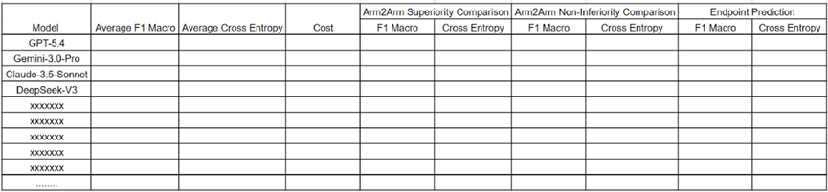

### Requirements
- backend must expose APIs for leaderboard/result data
- results for 25/02 Benchmark and 25/09 Benchmark must be sorted by Average F1 Macro descending
- architecture must preserve room for real evaluation logic
- MVP may use seeded/mock evaluation data for these published tabs

Recommended endpoints:
- GET /api/benchmarks
- GET /api/benchmarks/{benchmark_id}
- GET /api/benchmarks/{benchmark_id}/leaderboard

## Tab 3 behavior
The third tab is the current open benchmark.

For the seeded MVP example, it is:
- 26/06 Benchmark

This tab should show a submission-focused UI rather than a published leaderboard.

### Required content
Show text similar to:
- “We are actively seeking submissions to solve the 26/06 Benchmark.”
- “Download the Benchmark Questions:”
- a hyperlink to a placeholder benchmark file
- “Ready to Submit?”

### Login-dependent behavior
- if the user is not logged in, show:
- “Please log in and submit”
- if the user is logged in and verified, show the submission entry point
- if the user is logged in but unverified, guide them to complete verification

### Download link requirement
For MVP, the benchmark question download may point to a small placeholder file suitable for development/testing.
Do not generate unnecessarily large files.

### Important rule
Only open benchmarks may accept new submissions.
Published-result tabs must not accept submissions.

### About update
We should preserve the updated space/interface since after June, it will close submit and turn into the submission result show, which is a table just like table1/2 however, the column will turn into username who submit this result

## Future table update behavior:
As you can see, table 3 will close and show the result after a specific date comes, and also, table 4 will be created which has the same behavior like table 3 when it is not close yet. And after about 3 months, table 4 will close and show results just like table 3 does, and table 5 will be generated. All of this is a loop every three months.

---

# 13. User Submission History

Add a user-facing submission history page or section.

Users should be able to see their own submissions, including at least:
- benchmark name
- submission time
- submission status
- total cost
- whether evaluation results are pending or published

This should be backed by real database persistence.

---

# 14. Instruction / Introduction Section

Create a page or major page section titled:

# What is Clinical Trial Arena?

Write the actual content now.

Requirements:
- strong title
- 2–3 structured paragraphs
- clean product language
- explain what the website is
- explain what benchmark evaluation means
- explain why submissions and leaderboards are useful
- mention fair comparison
- mention benchmark versions
- mention that some benchmark results are published only after ground truth answers become available

which just look like this image:
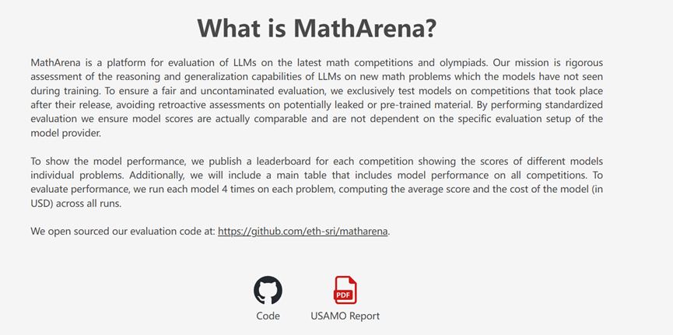

Also leave visual room for placeholder links/buttons such as:
- Code
- Report / PDF

These may be placeholders in MVP.

---

# 15. FAQ Section

Add a FAQ section after the instruction section.

It should behave like an accordion:
- title: Frequently Asked Questions
- each item collapses/expands
- collapsed state shows a “+”
- expanded state may show “×” or equivalent

Write the actual content now.

Include at least these FAQ items:
1. How exactly do you compute Average F1 Macro?
2. What does Cross Entropy mean in this table?
3. How is the cost calculated?
4. Why are some benchmarks open for submission but do not yet show results?
5. How do you validate a submission file?
6. What should the submission JSON look like?
7. Can I submit multiple times?
8. Why do some benchmark tabs have tables while others only have a submission call?
9. How can I contact the team?
10. When will the 26/06 Benchmark leaderboard be published?

The answers should be polished and suitable for a real website.
which just look like this image:
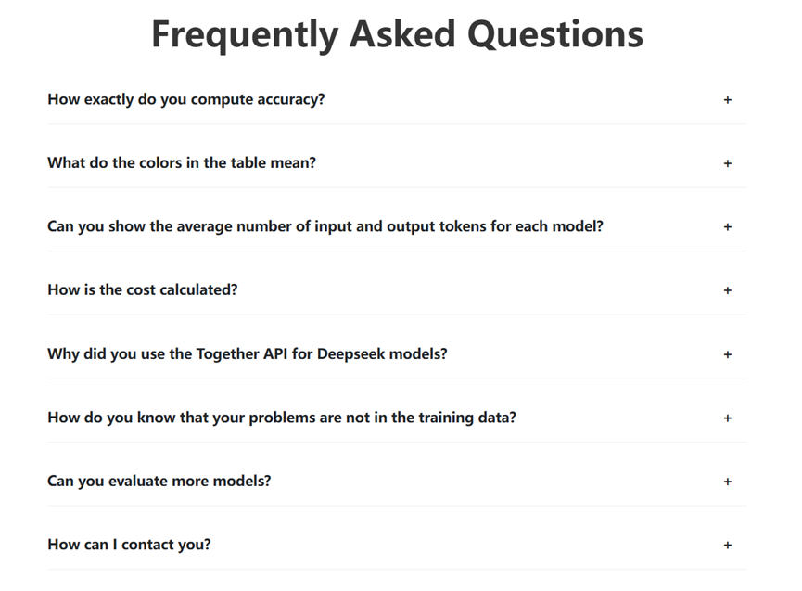
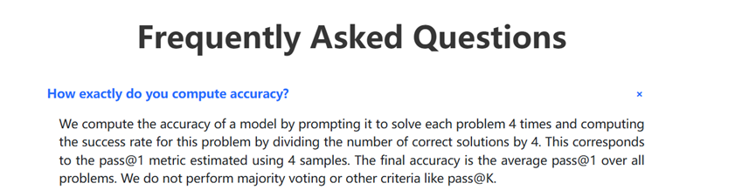
---

# 16. Frontend UX Requirements

The frontend should include:
- a clean landing/main section
- benchmark tab navigation
- published-result tables
- open-benchmark submission call-to-action
- auth forms
- submission upload UI
- user submission history
- instruction section
- FAQ accordion

Keep the UI simple, clean, modern, and functional.

---

# 17. API and Content Design Requirements

Use a clean backend structure with:
- routers
- services
- repositories or equivalent separation
- schemas
- models
- config
- security helpers

Content such as instructions and FAQ may be served through a backend content provider.
For the MVP, keep the source of this content consistent and simple.
Do not duplicate conflicting copies across backend and frontend.

---

# 18. Auditability and Logging

Add basic auditability and security-aware logging.

Track at least:
- signup events
- sign-in attempts
- verification events
- submission events
- important validation failures

Avoid logging secrets or plaintext passwords.

---

# 19. Seed Data Requirements

Seed the MVP with:
- the three benchmark records listed above
- realistic benchmark states
- placeholder downloadable file for the open benchmark
- placeholder/mock leaderboard rows for the two published benchmarks

The seeded data should allow the site to render meaningfully immediately after setup.

---

# 20. Deliverable Style

Generate:
- a clean repo structure
- backend code scaffolding
- frontend code scaffolding
- database models
- migrations
- seed logic
- API routes
- validation logic
- auth flow
- benchmark state logic
- leaderboard display support
- submission storage flow
- instruction and FAQ content
- Docker/dev setup
- concise design notes where useful

Prefer correctness, clarity, and maintainability over unnecessary complexity.

When tradeoffs are needed, choose the most practical MVP architecture that preserves future extensibility.

