|  |  |  |  |  |  |  |  |  |  |  |  |  |  |  |  |  |  |  |  |  |  |  |  |  |  |
| --- | --- | --- | --- | --- | --- | --- | --- | --- | --- | --- | --- | --- | --- | --- | --- | --- | --- | --- | --- | --- | --- | --- | --- | --- | --- |
| |  |  | | --- | --- | | For office use only | | | T1 | ________________ | | T2 | ________________ | | T3 | ________________ | | T4 | ________________ | | |  | | --- | | Team Control Number **?????** | |  | | Problem Chosen **A** | | |  |  | | --- | --- | | For office use only | | | F1 | ________________ | | F2 | ________________ | | F3 | ________________ | | F4 | ________________ | |

**2014   
MCM/ICM**

**Freeway Traffic Model Based on The Keep-Right-Except-To-Pass Rule  
Summary**

~~（理科生表述能力有限，烦请调整语句谢谢，括号内删除）~~在宏观上而言在空间上是车辆是离散的，时间上可以看作是离散的（对时间细粒度不敏感），道路的状态也是离散的（对道路细粒度不敏感）；在微观上而言，对于每一个车辆来说，他们只需关心自己和自己周围有限的对象（其他车辆，道路等）即可做出判断 ，由于道路问题在车流量变更在有限范围内的时候可以看作是周期性或者混沌型，由此可以对指定交通规则下指定负荷条件下的道路运输情况做出定量评估，我们将模型以元胞机的变种定义并运行模拟，该系统为道路交通中有关秩序、紊动 、混沌 、非对称、分形等系统整体行为与复杂现象的研究提供了一个有效的模型工具，通过对各种情况进行的模拟，我们发现靠右行车靠左超车的模式在普通负载以人类驾驶员为主的道路上相对较高，效率使用率达到43.4632%~~（一本正经的凑数，括号内删除）~~，低负载下使用对合理在但是高负载下会直接造成近32.2983%的占空率，安全性一般，然而对于通过一定算法安排的控制体系来说，该规则浪费空间现象较为严重，表现仅为，针对无中心的控制体系，我们使用抢占式规则将占用率提升到了52.3434%，同时保证了安全性（事故率低于目前人类驾驶汽车事故概率12.9/100000（引用））

Contents

**Introduction** 4

**Assumptions** 4

● 车辆分为客运型和货运型两种车辆 4

● 车辆在道路上是为有长度的长方形，宽度为整个车道，车辆前方一定范围（动态，根据车型和车速计算得到）属于限区，应当避免有车辆或障碍进入限区（有物体进入限区的行为称之为侵限） 4

● 车辆变道时原车道与待转入车道的车长部分和限区长度部分都被该车占据（宽度为这两个相邻的车道） 4

● 禁止连续变道 4

● 如果可以，车辆将保持速度在车辆自身最大速度和该路段限速的最小值，若当前车速低于这个最小值，则按照车辆的最大加速度进行加速直至达到上述最小值 4

● 若车辆行驶在超车道，将持续检查行车道或低一级车道对应位置是否会发生侵限，如果无侵限就开始向第一级车道变道 4

● 对于前方的变道车辆，在待转入车道的后方车辆不判断超车道上的车辆的变道意图，但是在变道时如果后车侵限后车会依照前述假设执行制动动作 4

● 如果发现侵限，首先检查是否可以进入超车道超车，如果不行车辆将按照固定的刹车加速度进行刹车直至侵限消失 4

● 如果车辆与其他车辆或者障碍的轮廓产生干涉，视为事故发生，这时所有涉及到的车辆对象立即销毁并在原地两端设立一个有固定实现的障碍区（模拟事故处理） 4

● 运载量按照运费计算（当年平均物流价格（元/（吨·公里）和元/（人次·公里）） 4

**Model Parameters~~（参数麻烦改一下啦(　o=^•ェ•)o　┏━┓，括号内删除）~~** 5

**Models** 5

**Model Overview** 5

**Model 1: Static Model** 7

➢ **ModelAnalysis** 7

➢ **Model Building** 8

➢ **Model Testing** 8

**Model 2:Only Inflow Model** 8

➢ **Model Analysis** 8

➢ **Model Building** 8

➢ **Model Testing** 8

➢ **Model Analysis** 8

➢ **Model Building** 9

➢ **Model Testing** 9

**Optimization Model** 9

➢ **Model Analysis** 9

➢ **Simulation Results** 10

**Sensitivity Analysis** 10

**Conclusion** 10

**Strengths and Weaknesses** 11

**Strengths** 11

**Weaknesses** 11

**References** 11

**Introduction**

在高速公路行车过程中，一般会将最右侧车道作为停车道将左侧车道作为超车道，在人类的驾驶方式中，这条规则限制了一部分灵活性而提升了行车的安全性和秩序。在某些极端环境下，该rule会导致道路运载能力低下，在高负荷状态下，系统该规则存在固定浪费的情况，占用率与最大占用率理论值存在较大差距，在低负载下，系统在该规则下表现良好富有秩序，道路中车速方差大会导致变道频繁，这会降低道路的占用率，降低运载能力上限并存在一定安全隐患，方差小时变道情况少，超车道较为空旷利用率低但是秩序度高安全性也相对较高。

在人类驾驶模拟场景中，我们观察到一个很有趣的现象，各自为政的车辆在行驶时会形成动态的拥堵区，这个拥堵区会动态的向车流方向反方向移动~~（假装我们不知道幽灵堵塞这个概念然后假装我们发现了这个概念，全文不要提起幽灵堵塞这个词谢谢🙃）~~，针对这个现象，我们提出了一个新的规则——短间距行车时，每辆车应当在同一车道最近的前后车辆的中点上。加入了这条规则后，拥堵区消失并且载荷能力得到了提升。

由于解决方案并没有使用任何绝对定位，所以对左舵和右舵驾驶都有同样的效果。

最后，我们发现由调度中心同一调控的情况下，道路的载荷能力会比人类驾驶仿真的对照组提升15.9074%，这体现了统一调度在交通运作过程中能体现巨大的作用。

**Assumptions**

* 车辆分为客运型和货运型两种车辆
* 车辆在道路上是为有长度的长方形，宽度为整个车道，车辆前方一定范围（动态，根据车型和车速计算得到）属于限区，应当避免有车辆或障碍进入限区（有物体进入限区的行为称之为侵限）
* 车辆变道时原车道与待转入车道的车长部分和限区长度部分都被该车占据（宽度为这两个相邻的车道）
* 禁止连续变道
* 如果可以，车辆将保持速度在车辆自身最大速度和该路段限速的最小值，若当前车速低于这个最小值，则按照车辆的最大加速度进行加速直至达到上述最小值
* 若车辆行驶在超车道，将持续检查行车道或低一级车道对应位置是否会发生侵限，如果无侵限就开始向第一级车道变道
* 对于前方的变道车辆，在待转入车道的后方车辆不判断超车道上的车辆的变道意图，但是在变道时如果后车侵限后车会依照前述假设执行制动动作
* 如果发现侵限，首先检查是否可以进入超车道超车，如果不行车辆将按照固定的刹车加速度进行刹车直至侵限消失
* 如果车辆与其他车辆或者障碍的轮廓产生干涉，视为事故发生，这时所有涉及到的车辆对象立即销毁并在原地两端设立一个有固定实现的障碍区（模拟事故处理）
* 运载量按照运费计算（当年平均物流价格（元/（吨·公里）和元/（人次·公里））

**Model Parameters~~（参数麻烦改一下啦(　o=^•ェ•)o　┏━┓，括号内删除）~~**

**Table 1.**

|  |  |  |
| --- | --- | --- |
| Parameter | Meaning | Unit |
|  | temperature of water in the bathtub |  |
|  | temperature of adding hot water |  |
|  | temperature of wall surface of the bathtub |  |
|  | time of adding water |  |
|  | the moment of water began to overflow |  |
|  | heat dissipation coefficient of bathtub wall |  |
|  | the flow of hot water into the bathtub |  |
|  | Boltzmann constant | - |
|  | radiation coefficient of water |  |
|  | radiation coefficient of bathtub wall |  |

**Models**

**Model Overview**

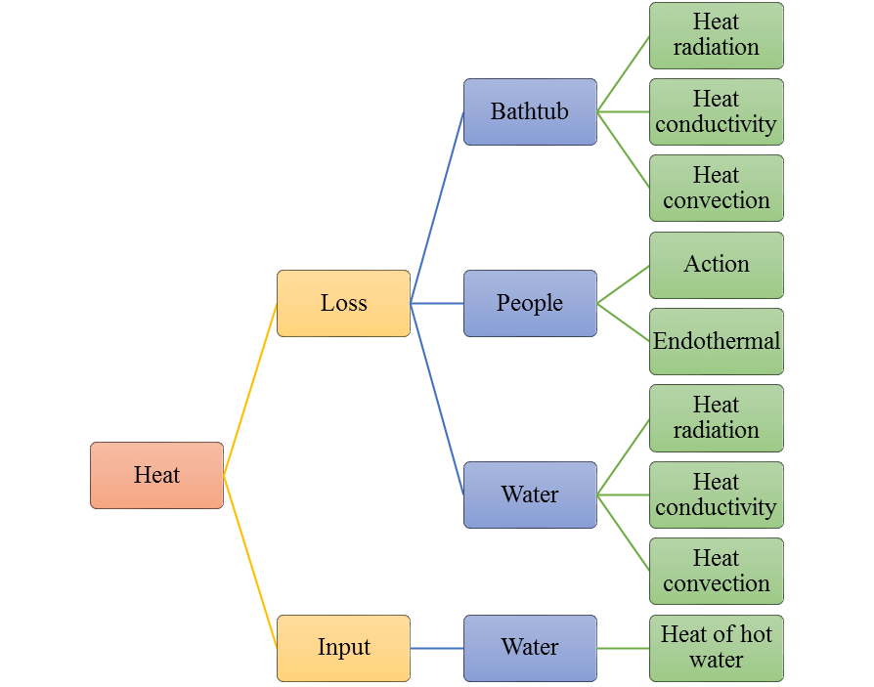

**Figure 1.**The total energy change of water in the bathtub.

Model Overview

We divide the bath process into three phases. They correspond to three models. Model 1:Static Model、Model 2:Only Inflow Model、Model 3：Equal flow imports and export Model.

* First, we consider the system in natural state thermal energy conversion. Energy losses including water circulated by heat and lead to sporadic bath heat and energy loss. The specific energy loss method is shown in Figure 1. On this basis, we build the Model 1.
* Temperature decrease gradually. When the man feels cold, he turns on the tap. Allows the water to flow into the bathtub of hot water. **But at the moment the bathtub water damage did not reach the overflow outlet.**Model 2. only need to add hot water inflow of heat can be on the foundation of the Model 1. Of course, we cannot ignore quality flow into the bathtub.
* Finally, when the water in the bathtub reaches the height of the overflow, a new energy change is created. That is the energy of the water flowing out. Our model three is based on the model two to account for the loss of energy.

Our three models can description of the whole process of bathing. We can also solve mission temperature as close as possible to the initial temperature of the strategy.

According to the survey, common materials for acrylic bathtub, we selected the common parameters are as follows:

**Table 2.**

Model Parameters

|  |  |  |
| --- | --- | --- |
| **Parameter** | **Meaning** | **Value** |
|  | initial temperature | 312 |
|  | ambient temperature | 289 |
|  | surface area of the bathtub’s upper surface | 0.66 |
|  | surface area of the all inner wall of the bathtub | 2.29 |
|  | thickness of bathtub wall | 0.02 |
|  | overflow height of bathtub | 0.48 |
|  | volume of the initial water in the bath tub | 0.21 |
|  | the average volume of thehuman body inthe bathtub | 0.06 |
|  | the average area of the human body into the bathtub | 1.45 |
|  | maximum capacity of bathtub | 0.3168 |
|  | the quality of initial water in the bathtub | 210 |
|  | the quality of water in bathtub when overflowing | 256.8 |
|  | heat dissipation coefficient of water | 300 |
|  | heat thermal conductivity of bathtub’s wall | 0.19 |
|  | density of water | 1000 |
|  | the temperature of feeling cold | 305 |
|  | specific heat capacity of water |  |

**Model 1: Static Model**

* **ModelAnalysis**
* **Model Building**
* **Model Testing**

**Parametric hypothesis**

**Model simulation and result**

**Result Analysis**

**Model 2:Only Inflow Model**

* **Model Analysis**
* **Model Building**
* **Model Testing**

**Parameter hypothesis**

* The temperature of feeling the cold is ;

**Model simulation and result**

**Result Analysis**

**Model 3：Equal Flow Import and Export Model**

* **Model Analysis**
* **Model Building**
* **Model Testing**

**Parameter hypothesis**

* The moment of water began to overflow: 
* The temperature of water began to overflow: 

**Model simulation and result**

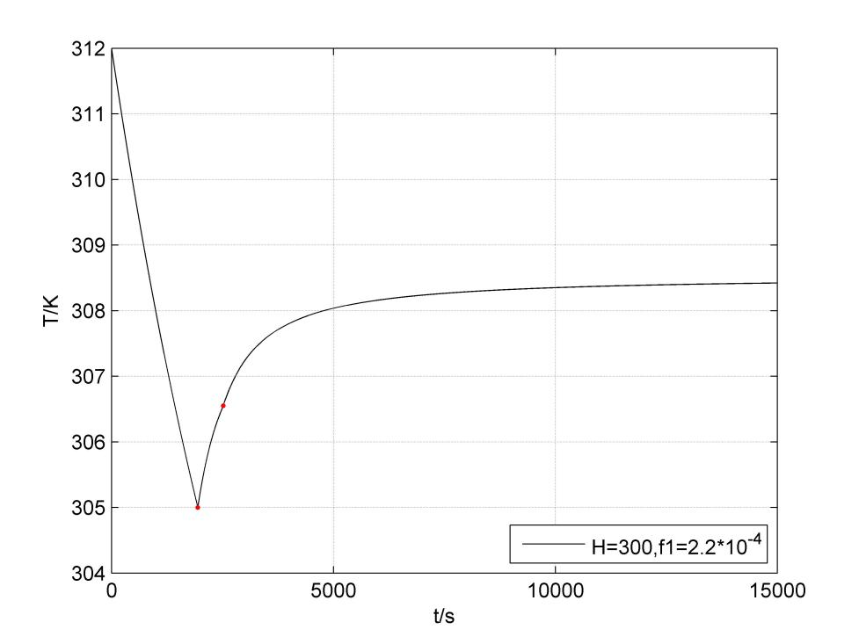

**Figure 9.** The simulation and result of Model 3

**Result Analysis**

From the **Figure 9.** we can found that the results are similar to Model 2. They are the first rapid heating, with the temperature rise temperature rise rate gradually slowed down.The final water temperature tends to be a lower than the value of the inflow temperature.We choose a large flow, the same as the initial temperature of the water to heat. Obviously, the result is not ideal. It not only has not reached the ideal temperature, but also the heating rate is very low. Therefore, we consider the next higher than the initial temperature of the water to heat.

**Optimization Model**

* **Model Analysis**
* **Simulation Results**
* **Optimization Strategy**

**Sensitivity Analysis**

* **Influence of the bathtub shape**
* **Influence of bath volume**
* **Influence of human volume**
* **Influence of human shape and temperature**
* **Influence of human motion on Strategy**
* **Analysis of the influence of soap bubbles**

**Conclusion**

**Strengths and Weaknesses**

**Strengths**

* Through this model, we can get a control object (water temperature at a certain time) making it maintains a strong degree of balance (i.e., the sensitivity of each variable is almost zero) of the better control strategy.

**Weaknesses**

* We don't have enough necessary data to validate the model.

**References**

**Appendix**