**ARAB ACADEMY FOR SCIENCE & TECHNOLOGY COLLEGE OF ENGINEERING & TECHNOLOGY**

**Department: Computer Engineering Course : Advanced Programming Course Code: CC 319**

**Sheet #1 “Control Statements and Arrays”**

1. Write a console application that reads 2 integers and prints whether the first is multiple of the second. Ex: if user inputs 15 & 3, the first is a multiple of the second, but if user inputs 2 & 4, the first is not a multiple of the second.  
   **(5 MINUTES)**
2. Write a console application that calculates the squares and cubes of numbers from 0 to 10 and print them in a table. **(5 MINUTES)**

|  |  |  |
| --- | --- | --- |
| Number | Square | Cube |
| 0 | 0 | 0 |
| 1 | 1 | 1 |

1. Write a console application that reads in N integers **(that represent students marks)** and places them in an arrayand then determines:
2. Maximum mark
3. Average mark
4. Number of A+ students (90-100)

**(The program shouldn’t accept degree less than zero or greater than 100).  
(15 MINUTES)**

1. A number is in its expanded form when it is expressed as the sum of the

products of its digits and the place value of each digit in the number. For example, 13023 can be expressed as (1 x 10000) + (3 x 1000) + (0 × 100) + (2 × 10) + (3 × 1). Write an app that reads in a five-digit integer and shows its expanded form. If the number is not five digits long, display an error message, and allow the user to enter a new number. [Hint: Use the remainder and division operators to pick off the number's digits one at a time, from right to left.] **(15 MINUTES)**

**Assignment**

1. Use a one-dimensional array to solve the following problem: Write an app that inputs five numbers, each of which is between 10 and 100, inclusive and display the complete set of unique values input by the user.
2. Write an app that asks the buyer to enter the price of three items, calculates an applicable 10% discount on the items, and displays the net amount payable.
3. Write an app that inputs one number consisting of five digits from the user, separates the number into its individual digits and displays the digits separated from one another by three spaces each. For example, if the user types in the number 42339, the app should display

4 2 3 3 9

1. Identify and correct the errors in each of the following pieces of code. [Note: There may be more than one error in each piece of code.]

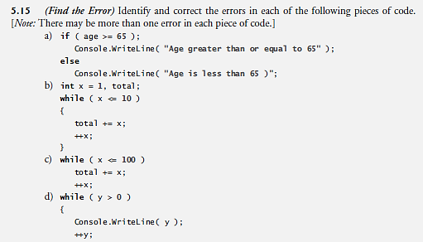

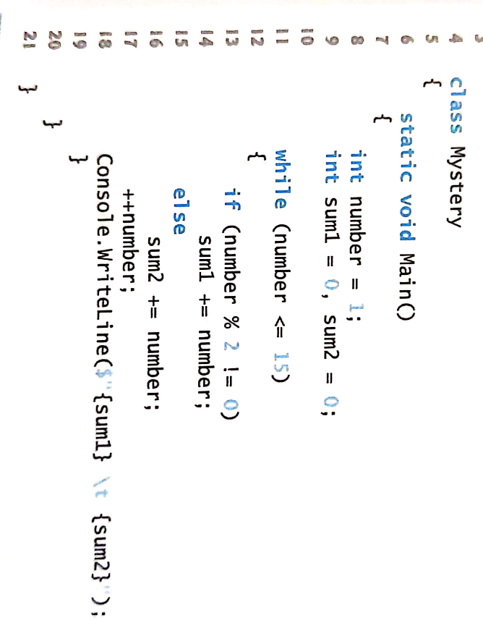

5. What does the following app display?