# 022 - Hanz Po

# Recipe Assistant

Recipe assistant is a program that reads recipes and presents them to users. To start, choose one of the options on the menu.

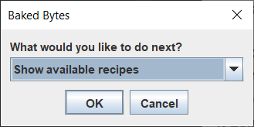

## Show available recipes

This option will show all recipies currently available for the user

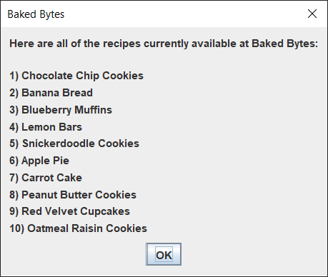

## Print a recipe

This option will ask which recipe to open, and will print it out to the user

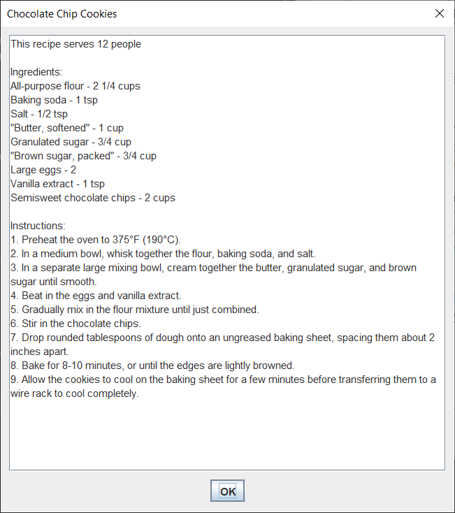

## Print a recipe with serving size

Same as the previous option, but will instead generate ingredients based on serving size

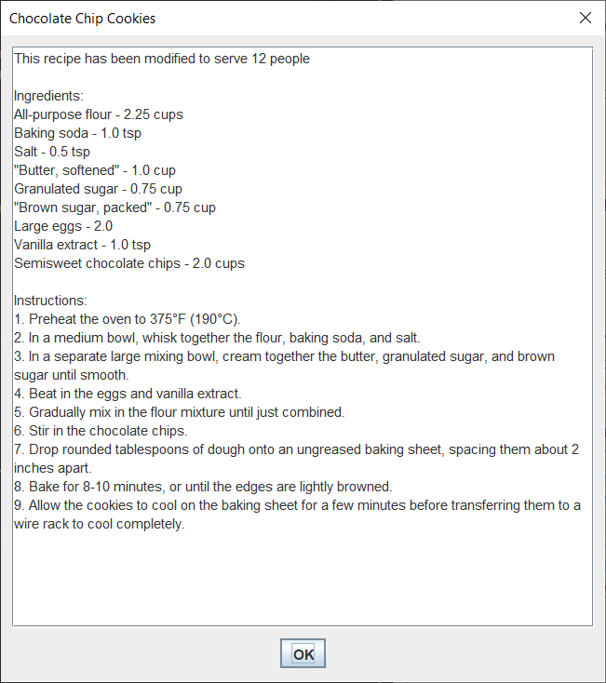

## Convert units in recipe

Allows user to convert units in any recipe

## Create a recipe

Allows the user to create their own recipe. Saves to the csv file

## Delete a recipe

Allows the user to delete any recipe

## Add recipe to shopping list

Adds ingredients of any recipe to shopping list

## View shopping list

Shows user their shopping list

## Clear shopping list

Clears the shopping list

## I have dietary restrictions

Deletes recipes based on dietary restrictions specified by the user

## Exit the program

Exits the program