TECHNICAL REPORT
ESG Chunk Dataset and
2,000-Chunk Handoff
Current build status, sample design, validation, and review guide
Dataset | esg_3b1c0196c0f9
Chunk version | esg_chunk_v3
Report date | 31 July 2026
Audience | Technical review team

17,329  CURRENT CHUNKS | 2,000  HANDOFF ROWS | 18  ESG TOPICS | 0  VALIDATION ERRORS

Technical summary
The new chunk dataset is built and internally aligned. It uses contiguous_v2 sectioning, esg_chunk_v3 chunking, and esg_embed_ctx_v2 embedding context. Every live chunk has an exact page citation. The vector manifest matches the current chunk set. The vector database has not been rebuilt, so search will not use this build until that final load is run.
Bottom line: The text, sections, chunks, citations, embedding inputs, and manifest are current. The remaining system step is rebuilding the vector database after human review or approval.

Current dataset status
Item | Current state
Dataset ID | esg_3b1c0196c0f9
Sectioning | 9,819 sections • contiguous_v2
Chunking | 17,329 chunks • esg_chunk_v3
Embedding context | 17,329 rows • esg_embed_ctx_v2
Token bounds | 51–500 BGE tokens in the live dataset
Citations | 17,329 exact page citations
Vector manifest | Rebuilt for all current chunks
Vector database | Not rebuilt yet

Live chunk statistics
These figures describe all 17,329 current chunks. Token counts use the final BGE embedding input, including the metadata prefix and table context when present.
402  MEDIAN TOKENS | 8,005  ONE-PAGE CHUNKS | 9,324  MULTI-PAGE CHUNKS | 13,394  NARRATIVE CHUNKS

Token length
Min | P25 | Median | Mean | P75 | P90 | Max
51 | 222 | 402 | 352.6 | 482 | 494 | 500

Token-size buckets
Final BGE token count | Chunks
51–100 tokens | 433 chunks
101–250 tokens | 4,676 chunks
251–400 tokens | 3,516 chunks
401–500 tokens | 8,704 chunks

Structure and page span
Measure | Value
Reports / companies | 202 reports / 110 companies
Sections | 9,819
Chunks per report | Median 72; P90 155; max 358
Sections with one chunk | 6,175
Sections with more than one chunk | 3,644
Page spans | 8,005 one-page; 8,046 two-page; 1,278 three-or-more-page
Adjacent chunk pairs with source overlap | 6,052 of 7,510 pairs
Median chunk characters | 1,676; P90 2,431; max 2,901

Chunk type and review tier
Measure | Value
Normal chunks | 16,926
Short evidence chunks | 403
Narrative | 13,394
Layout-sensitive | 3,650
Noise | 285
Exact citation status | 17,329 verified exact

Handoff scope
The handoff contains 2,000 unique chunks from 188 reports and 105 companies. It covers all 18 ESG topics. The sample includes 1,715 narrative chunks and 285 layout-sensitive chunks. Reporting years are 2023 (1,041 chunks), 2024 (944), and 2025 (15).
Measure | Value
Token range | 58–500 BGE tokens; median 350
Token-size buckets | 65 at 51–100; 647 at 101–250; 417 at 251–400; 871 at 401–500
Page span | 931 chunks span more than one page
Report cap | No report contributes more than 15 chunks
Exact citations | 2,000 of 2,000

Topic distribution
The sample gives every ESG topic at least 30 chunks, then allocates the remaining rows in line with topic size. Human capital has the most rows, followed by supply-chain ethics and environmental content.
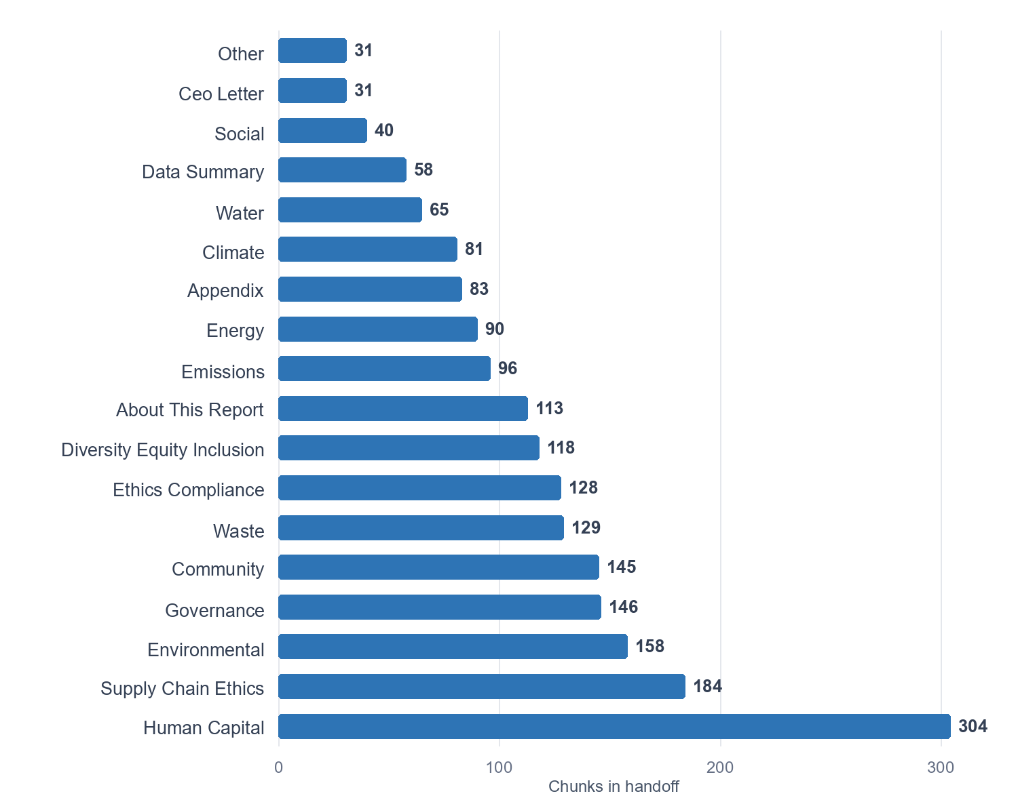
Figure 1. Chunks in the 2,000-row handoff by ESG topic.

Topic allocation detail
Exact counts for the handoff and the safe pool used during sampling.
ESG topic | Handoff | Safe pool
Human Capital | 304 | 1,666
Supply Chain Ethics | 184 | 951
Environmental | 158 | 792
Governance | 146 | 724
Community | 145 | 714
Waste | 129 | 621
Ethics Compliance | 128 | 613
Diversity Equity Inclusion | 118 | 555
About This Report | 113 | 528
Emissions | 96 | 427
Energy | 90 | 387
Appendix | 83 | 347
Climate | 81 | 336
Water | 65 | 238
Data Summary | 58 | 198
Social | 40 | 89
Ceo Letter | 31 | 38
Other | 31 | 35

Validation results
All five row-level checks passed for every selected chunk. The checks compare the package with current chunk files, parsed source spans, embedding context, and manifest state. There are no duplicate chunk IDs and no reported validation errors.
Check | Passed | Expected | Status
Chunk SHA-256 | 2,000 | 2,000 | PASS
Embedding text | 2,000 | 2,000 | PASS
Exact citations | 2,000 | 2,000 | PASS
Manifest state | 2,000 | 2,000 | PASS
Parsed-source span | 2,000 | 2,000 | PASS

What this proves: The package is internally consistent and traceable to parsed source text. Human review is still needed to judge reading order, sentence boundaries, metadata meaning, and table usability.

Sampling method
- Use deterministic seed 20260731.
- Give each topic a minimum of 30 chunks.
- Allocate remaining rows in line with topic size.
- Keep the narrative and layout-sensitive mix inside each topic.
- Limit each report to 15 chunks.
- Exclude noise and held rows.

Limits
This is a designed review sample, not a simple random sample. Review results should not be used as a raw statistical defect rate. Some section titles are table fragments. Reviewers should focus on whether chunk_text is readable and can support a cited answer. Layout-sensitive chunks may place a number farther from its label than the source page did; flag it only when meaning is lost or changed.

Review instructions
- Open review_template.csv.
- Read chunk_text and its metadata.
- Set review_status to pass or fail.
- For a failure, add a short issue_type such as order, cutoff, metadata, or table.
- Add a short note that explains the problem.
- Return both chunk_id and chunk_text_sha256.
Important: chunk_id can change after a rebuild. chunk_text_sha256 is the stable text fingerprint. Returning both fields lets earlier review work carry forward when the text is unchanged.

