

PROJECT SYNOPSIS

Project Title

Submitted By: Muhammad Hanzala Bin Rehan
CMS ID: 461738

Other Group Members:
Names: | CMS IDs:
Muhammad Abdullah Waleed Ahmed Janjua | 459244
Khadija Faisal | 467936
Muhammad Hamdan Ishfaq | 455881

April 25, 2026

Contents
- Executive Summary 2
- Project Description 3
  - Introduction and Motivation . . . . . . . . . . . . . . . . . . . . . . . . . 3
  - Existing Research (3-5 relevant papers) . . . . . . . . . . . . . . . . . . . 3
  - Problem Statement . . . . . . . . . . . . . . . . . . . . . . . . . . . . . . 4
    - Research Questions . . . . . . . . . . . . . . . . . . . . . . . . . . 4
  - Research Gap Identification . . . . . . . . . . . . . . . . . . . . . . . . . 4
  - Solution Statement and Research Objectives . . . . . . . . . . . . . . . . 4
    - Research Objectives . . . . . . . . . . . . . . . . . . . . . . . . . 4
- Methodology 5
  - Materials: Data Collection and Preprocessing . . . . . . . . . . . . . . . 5
    - Data Collection and ethical considerations . . . . . . . . . . . . . 5
    - Data Labeling/procedure of data screening . . . . . . . . . . . . . 5
    - Data Preprocessing . . . . . . . . . . . . . . . . . . . . . . . . . . 5
  - Methods . . . . . . . . . . . . . . . . . . . . . . . . . . . . . . . . . . . . 5
    - Work Packages (WPs) . . . . . . . . . . . . . . . . . . . . . . . . 6
  - Model Architecture/Conceptual framework . . . . . . . . . . . . . . . . . 6
  - Justification of Selected Methodology . . . . . . . . . . . . . . . . . . . . 7
  - Novelty of the Work . . . . . . . . . . . . . . . . . . . . . . . . . . . . . 7
  - Validation and Performance Metrics . . . . . . . . . . . . . . . . . . . . . 7
- Evaluation 8
  - Evaluation Metrics . . . . . . . . . . . . . . . . . . . . . . . . . . . . . . 8
  - Evaluation Methodology . . . . . . . . . . . . . . . . . . . . . . . . . . . 8
  - Preliminary Results/Pilot testing . . . . . . . . . . . . . . . . . . . . . . 8
  - Comparative Analysis . . . . . . . . . . . . . . . . . . . . . . . . . . . . 8
- Implementation Timeline 9
  - Gantt Chart . . . . . . . . . . . . . . . . . . . . . . . . . . . . . . . . . . 9
  - Major Tasks and Deliverables 10
  - Plan for Dissemination 10
    - Target Conference 10
    - Target Journal 10
Appendices 12
Appendix A: List of Abbreviations 12
Appendix B: Additional Materials 12

Executive Summary
Workplace harassment through inappropriate speech — slurs, intimidation, and derogatory remarks — remains a persistent compliance challenge. Existing solutions depend on audio surveillance (privacy-invasive) or human reporting (reactive and inconsistent). This project proposes a passive, audio-free system that detects inappropriate speech from existing CCTV infrastructure using Visual Speech Recognition (VSR).
The system applies VSR to lip regions extracted from CCTV footage, transcribes detected speech, and flags inappropriate content via an NLP classifier. It is structured as a three-worker distributed pipeline: frame extraction and lip detection → VSR inference → content flagging and report generation. The research component comparatively evaluates LipNet and AV-HuBERT for accuracy and inference efficiency in an edge-constrained deployment context.
Limited scope of this project delivers a functioning end-to-end prototype on a controlled dataset, a comparative benchmark of the two VSR architectures, and a flagging pipeline. Expected outcomes include quantitative WER benchmarks, flagging precision/recall on a curated test set, and a reproducible system architecture for audio-free speech monitoring.

Project Description

Introduction and Motivation
Organisations are legally and ethically obligated to provide safe workplaces, yet the real-time detection of inappropriate spoken language remains unsolved in practice. Audio surveillance raises serious legal and privacy concerns and is impractical in many jurisdictions. Written complaint systems are entirely reactive. Neither approach provides automated, continuous monitoring.
Visual Speech Recognition — decoding speech from lip movements — offers a compelling alternative. CCTV infrastructure is already present in most workplaces, and VSR requires no audio capture, significantly reducing the privacy footprint. Advances in deep learning have brought VSR accuracy from ~45% (HMM-era) to over 95% on controlled benchmarks, making the technology plausible for real-world deployment.
The practical motivation is compliance automation: providing HR departments with auditable, timestamped logs of flagged speech without invasive audio recording. The research motivation is understanding whether current VSR models — specifically LipNet and AV-HuBERT — are accurate and fast enough for this application within the constraints of a four-week prototype.

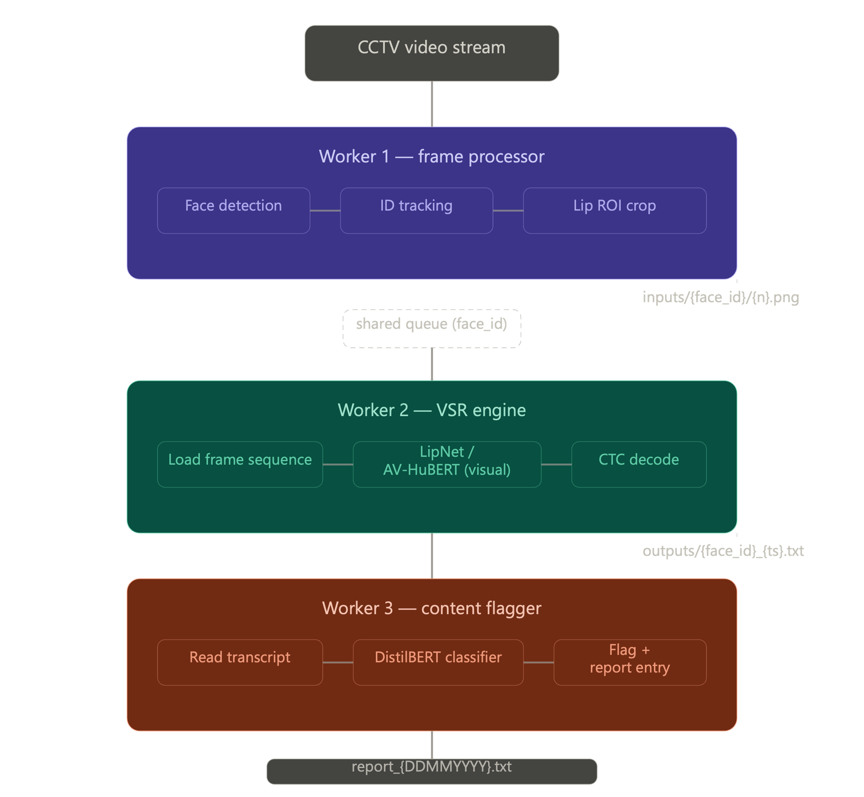
Figure 1: Application (Pipeline) Overview

Existing Research (3-5 papers)
LipNet (Assael et al., 2016 — arXiv:1611.01599) LipNet was the first end-to-end sentence-level VSR model, combining spatiotemporal convolutional networks (STCNNs), a bidirectional GRU, and CTC loss. It achieved 95.2% sentence accuracy on the GRID corpus, outperforming expert human lipreaders at the time. Its architectural simplicity and moderate parameter count make it the most tractable baseline for this project. The key limitation is that GRID is a highly controlled, frontal-view, constrained-vocabulary dataset; real-world generalisation is unproven.
AV-HuBERT (Shi et al., 2022 — arXiv:2201.02184) Meta's AV-HuBERT adapts BERT-style self-supervised pre-training to audio-visual speech. It masks multi-stream video input and predicts iteratively refined multimodal hidden units, achieving 26.9% WER on LRS3 (433 hours of diverse in-the-wild video). For this project only the visual stream is used. AV-HuBERT represents the current accuracy ceiling for VSR; its transformer backbone is, however, computationally heavy — a critical constraint for edge deployment.
HMM/SVM Baselines (Matthews et al., 2002; Zhao et al., 2009) Matthews et al. used Active Appearance Models (AAM) with an HMM classifier, achieving 44.6% accuracy on AVLetters. Zhao et al. reached 58.85% using spatiotemporal Local Binary Patterns (LBP) with SVMs. These results establish the pre-deep-learning baseline, contextualise the magnitude of progress, and motivate the shift from handcrafted features to learned spatiotemporal representations.
Deep Lip Reading (Chung & Zisserman, 2016 — "Lip Reading in the Wild") Chung and Zisserman trained a deep CNN-LSTM architecture on the BBC LRW dataset (500 word classes, in-the-wild video), achieving strong word-level accuracy and demonstrating that CNNs can learn robust visual features directly from raw pixel sequences at scale. This work bridges the gap between HMM-era methods and the sequence-prediction approach of LipNet.
Leveraging Visemes for VSR (Soleymani et al., 2023) This paper demonstrates that incorporating viseme-level supervision into AV-HuBERT fine-tuning reduces WER by 9.1% relative on Persian VSR benchmarks. More relevantly, it highlights that phonetically ambiguous lip shapes (visemes) are a fundamental bottleneck in VSR accuracy — a limitation that must be acknowledged when interpreting flagging confidence scores in the proposed system.
  - Problem Statement
No existing system provides automated, real-time detection of inappropriate workplace speech without audio capture. Current VSR models are either insufficiently accurate for unconstrained video (LipNet) or computationally too heavy for deployment alongside CCTV hardware (AV-HuBERT). There is no published end-to-end architecture combining VSR with inappropriate speech classification in a workplace surveillance context.
    - Research Questions
- Can LipNet and AV-HuBERT produce transcriptions of sufficient quality from CCTV-simulated lip footage to enable downstream inappropriate speech detection?
- How do the two architectures compare on transcription accuracy (WER) and inference speed under the same hardware conditions?
- Can a three-worker distributed pipeline process facial sequences at a throughput that supports near-real-time monitoring?
- What precision and recall does the end-to-end system achieve when flagging a curated set of inappropriate speech samples?

Research Gap Identification

The VSR literature is dominated by controlled conditions:

frontal-facing, well-lit, single-speaker video with constrained vocabularies (GRID) or clean broadcast speech (LRS3-TED). In-the-wild CCTV conditions — oblique angles, variable lighting, partial occlusions, compressed video streams — remain underexplored. Additionally, no prior work connects VSR output to inappropriate speech classification in any surveillance context. The specific task of detecting slurs, threats, and derogatory speech from lip movements is entirely novel. This project also surfaces a practical gap: there is no published benchmark of LipNet versus AV-HuBERT under matched conditions on simulated CCTV footage.

Solution Statement and Research Objectives

SafeSpeak is a three-worker distributed pipeline that extracts lip regions from CCTV video, transcribes detected speech using adapted VSR models, and classifies transcriptions for inappropriate content — producing timestamped flagging reports without audio capture.

Research Questions:
- Implement and evaluate LipNet and AV-HuBERT (visual stream only) on a common VSR test set and on simulated CCTV footage.
- Build and integrate Worker 1 (face tracking + lip ROI extraction), Worker 2 (VSR inference), and Worker 3 (NLP-based content flagging) into a functioning end-to-end pipeline.
- Quantify the accuracy–speed trade-off between LipNet and AV-HuBERT under matched inference conditions.
- Evaluate end-to-end flagging performance (precision, recall, F1) on a curated inappropriate speech test corpus.

Methodology

Materials: Data Collection and Preprocessing

Data Collection and ethical considerations
Training and evaluation use two publicly available datasets: GRID corpus (34 speakers, 1,000 sentences each, frontal-facing, constrained vocabulary — used for LipNet baseline reproduction and benchmarking) and LRS3-TED (433 hours of diverse in-the-wild English speech — used for AV-HuBERT visual inference evaluation). Both are established academic benchmarks with no personal data concerns.
CCTV conditions are simulated using a standard webcam mounted at a fixed oblique angle (~30°) in a controlled indoor setting. A small number of consenting volunteers (team members) recite sentences from the GRID vocabulary in front of the webcam — no external participants are recruited, no dedicated dataset is curated, and no footage is retained beyond the evaluation session. Face IDs within the pipeline are pseudonymised session tokens. This is minimal-risk in-lab testing requiring only standard department sign-off.

Data Preprocessing
Lip region extraction uses dlib's 68-point facial landmark detector to identify the mouth region. A 96×96 px crop is taken, centred on the midpoint of the upper and lower lip landmarks, converted to grayscale, and normalised to zero mean and unit variance per sequence. Frame sequences are fixed at 75 frames (3 seconds at 25 fps); shorter sequences are zero-padded, longer sequences are split with a 50% overlap. For the in-house CCTV test set, no additional augmentation is applied during evaluation — footage is used as-is to reflect realistic conditions.

Proposed Model Architecture/Conceptual framework
The project implements two VSR inference paths within Worker 2:
Path A — LipNet: The published STCNN-GRU-CTC architecture is reproduced using the open-source implementation. The model is evaluated directly (without retraining) on the GRID test split to confirm baseline reproduction, then evaluated on the in-house CCTV test set.
Path B — AV-HuBERT (visual only): The pre-trained AV-HuBERT model from the official Meta repository is used in inference-only mode (no fine-tuning, given the four-week scope). The visual encoder is extracted; audio input is zeroed out. The model is evaluated on the same test sets.
Worker 3 uses a DistilBERT-based binary classifier fine-tuned on the 400-sentence labelled corpus to flag inappropriate speech from VSR transcriptions OR Use keyword Search for it.
    - Work Packages
WP | Task | Duration
WP1 | Environment setup; dataset download and verification; lip extraction pipeline (Worker 1) | Week 1
WP2 | LipNet baseline reproduction and GRID evaluation; AV-HuBERT visual inference setup | Week 2
WP3 | In-house CCTV test set recording; DistilBERT classifier training (Worker 3); pipeline integration | Week 3
WP4 | End-to-end evaluation; comparative analysis; write-up | Week 4

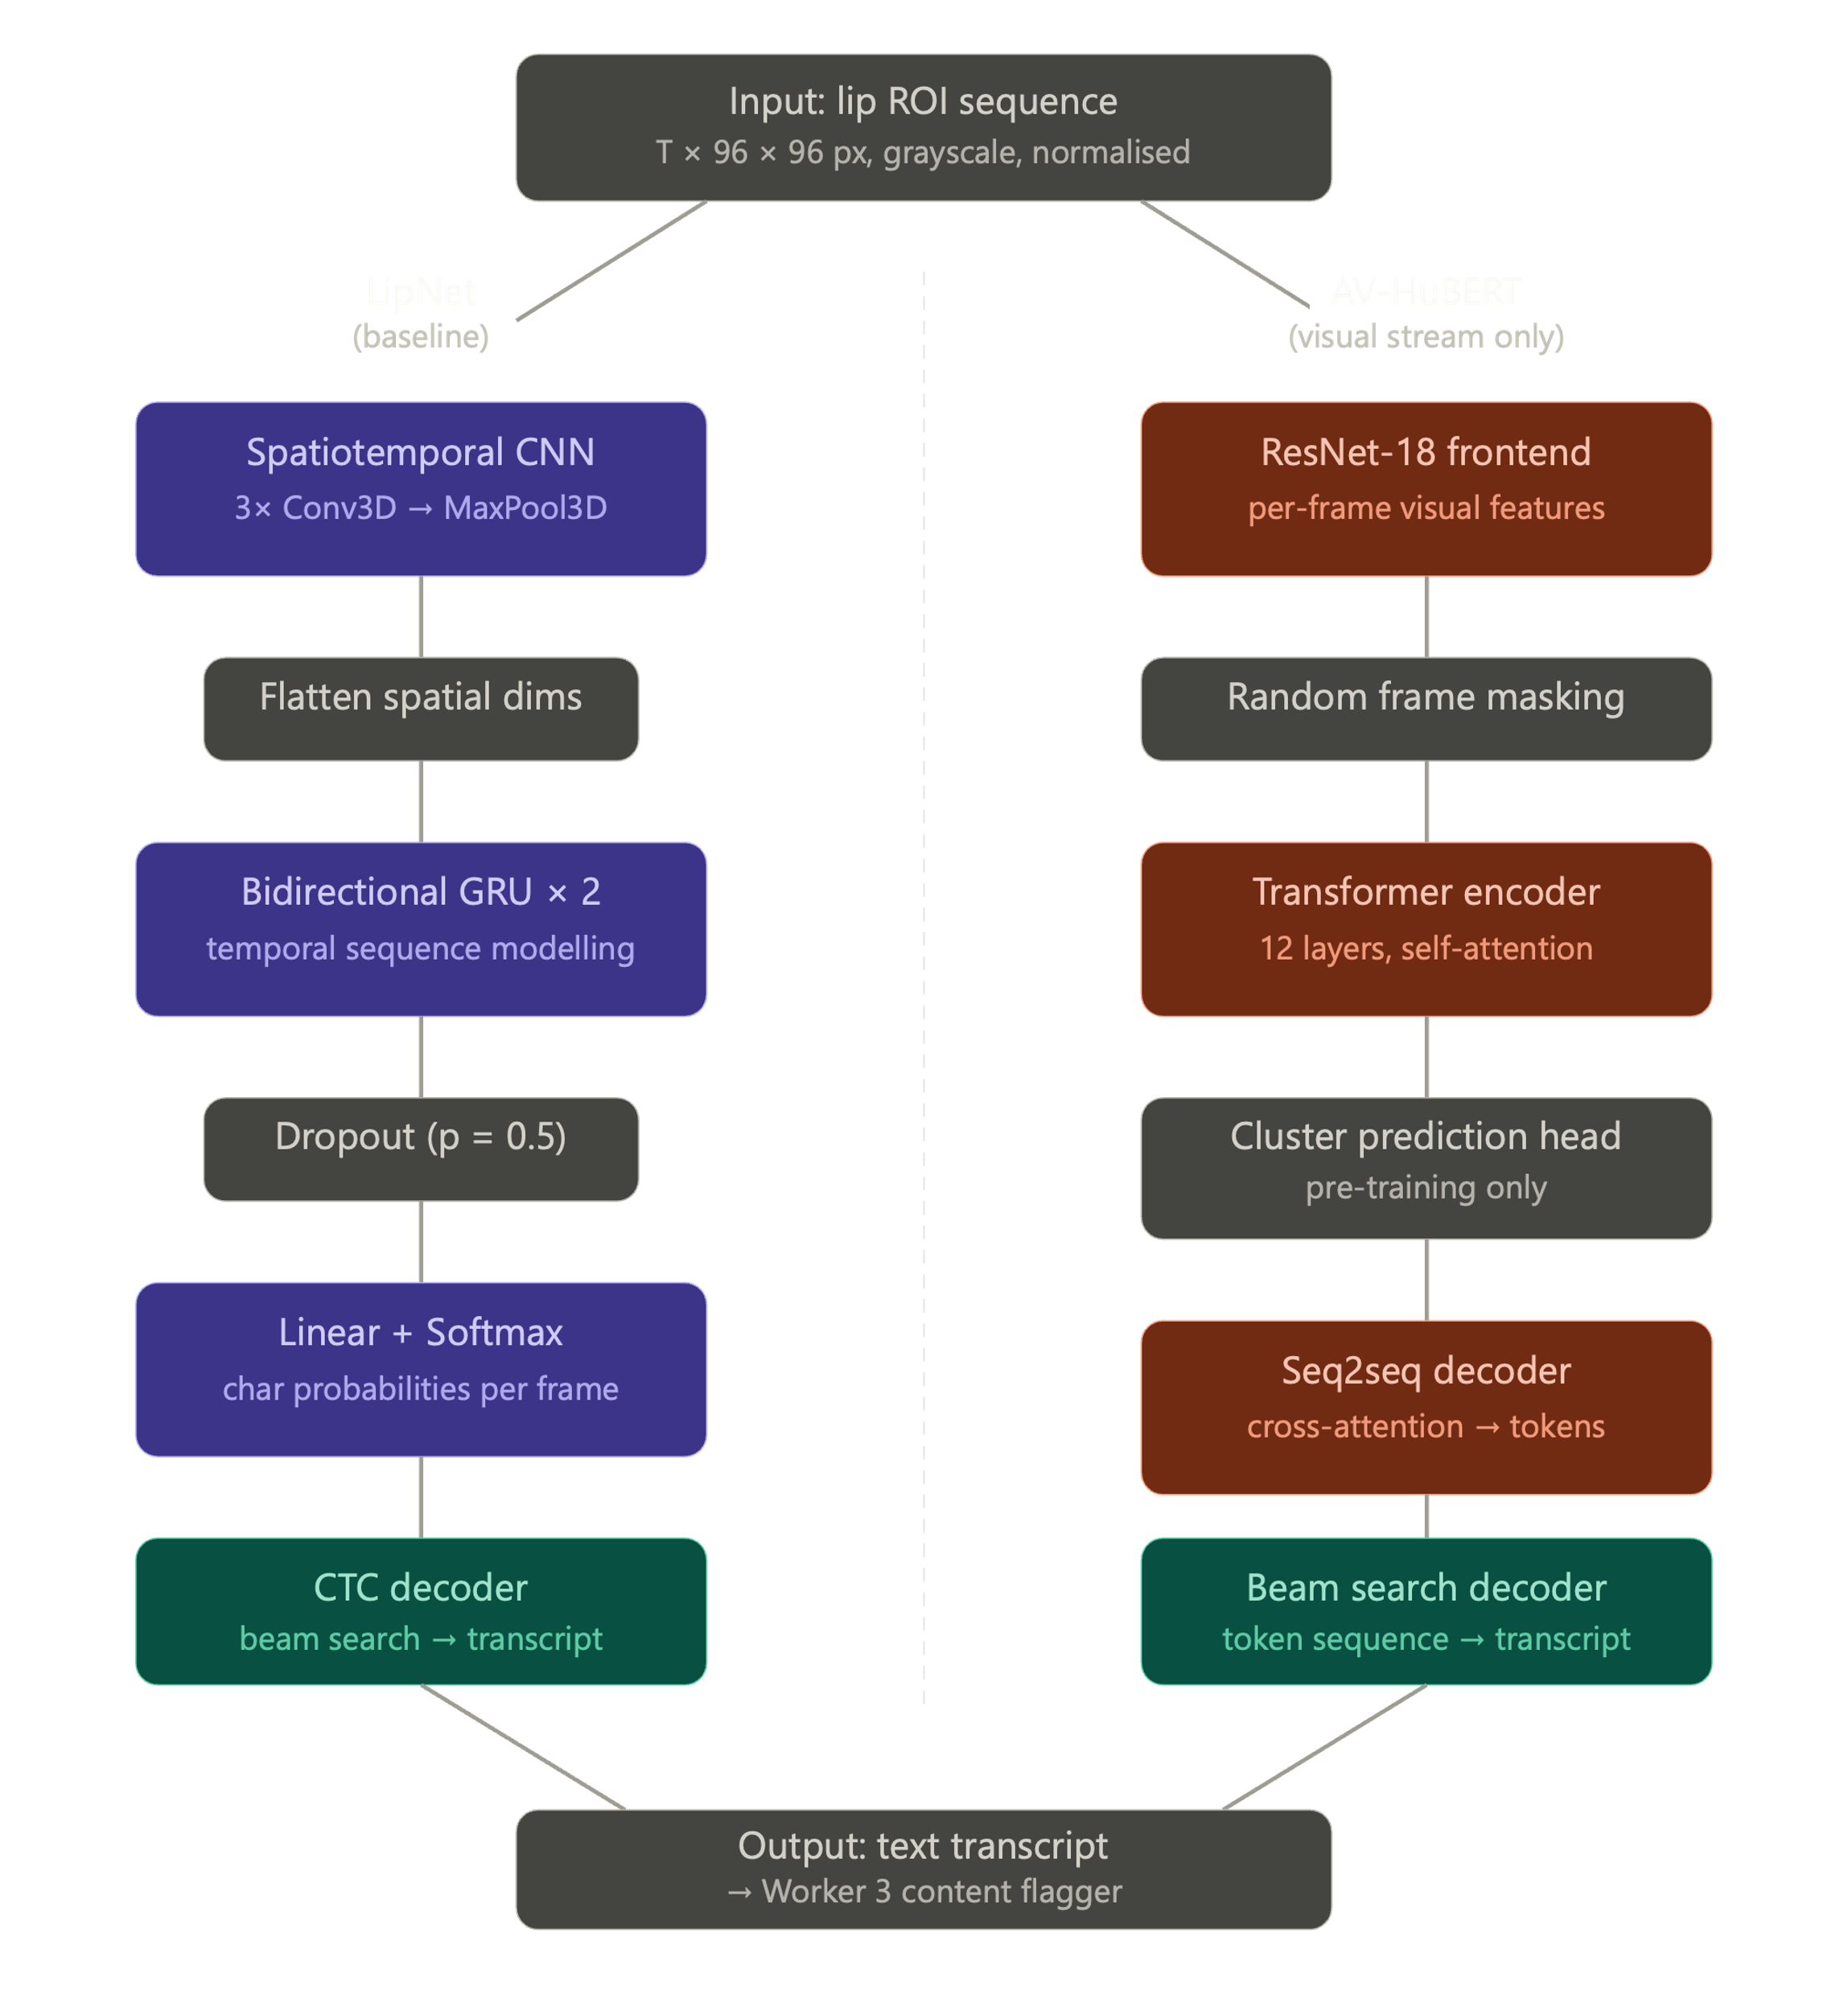
Figure 2: Model Architecture/Conceptual framework

Model Architecture / Conceptual Framework
The system operates as three asynchronous workers sharing a filesystem and a queue:
Worker 1 (Frame Processor) Reads video stream → detects faces via RetinaFace → tracks face IDs across frames → extracts 96×96 lip ROI per frame → writes to inputs/{face_id}/{n}.png → adds face_id to shared queue.
Worker 2 (VSR Engine) Dequeues face_id → loads frame sequence from disk → runs LipNet or AV-HuBERT visual stream → decodes transcript via CTC/beam search → writes to outputs/{face_id}_{DDMMYYYY:HHMM}.txt → deletes input frames.
Worker 3 (Content Flagger) Monitors output directory → reads transcript → runs DistilBERT binary classifier → if flagged, appends to report_{DDMMYYYY}.txt with face ID, timestamp, transcript excerpt, and confidence score.
The 15-minute interval rounding in the output filename allows grouping of transcripts by monitoring window for batch review.

Justification of Selected Methodology
LipNet is selected because it is the canonical sentence-level VSR baseline: well-documented, open-source, and lightweight enough to run on standard hardware. It provides a reproducible lower-bound reference.
AV-HuBERT is selected because it is the current state-of-the-art visual-only VSR model, providing the accuracy ceiling. Using the pre-trained model in inference mode (without fine-tuning) is appropriate for the four-week scope and consistent with transfer learning practice.
DistilBERT is selected for Worker 3 because it is a compact, fast text classifier well-suited to binary sentence classification with a small training corpus (400 sentences), and fine-tuning requires only one to two hours of compute.
The three-worker distributed architecture is chosen for modularity: each worker can be developed, tested, and replaced independently, and the file-based interface between workers requires no inter-process communication framework.

Novelty of Work

This project is the first to combine VSR with inappropriate speech classification in an end-to-end workplace surveillance pipeline. Prior VSR work focuses exclusively on transcription accuracy; the application to content moderation and HR compliance is new. The specific pipeline architecture — lip extraction, silent transcription, NLP flagging — and the curated inappropriate speech evaluation corpus are original contributions. The comparative benchmark of LipNet versus AV-HuBERT on simulated CCTV footage (as opposed to clean benchmark datasets) is also novel.

Performance Metrics for Validation/Evaluation
- WER on in-house CCTV test set on at least one model.
- Flagging F1 on an inappropriate speech test corpus
- End-to-end latency — transcript available within 30 seconds of a 3-second utterance completing
- Evaluation
  - Evaluation Metrics
Metric | Definition | Target
Word Error Rate (WER) | (S+D+I)/N on reference transcripts | ≤ 15% on GRID, ≤ 40% on CCTV set
Character Error Rate (CER) | Character-level analogue | Reported for both models
Precision (Flagging) | TP / (TP + FP) | ≥ 0.80
Recall (Flagging) | TP / (TP + FN) | ≥ 0.70
F1 (Flagging) | Harmonic mean of P and R | ≥ 0.75
Inference Time | Seconds per 75-frame sequence | Reported; no hard target
  - Evaluation Methodology
VSR evaluation is conducted on three splits: (1) GRID test split (34 speakers held out from LipNet training data — for baseline reproduction), (2) LRS3 test split (for AV-HuBERT reference performance), and (3) the simulated CCTV test set (20 sentences per speaker, 3 speakers, both appropriate and inappropriate content). Both models are evaluated on identical sequences under identical hardware.
Classifier evaluation uses a held-out 20% split (80 sentences) of the 400-sentence labelled corpus. A confusion matrix, precision, recall, and F1 are reported. The classifier's dependency on VSR transcription quality is assessed by injecting synthetic WER-equivalent errors into the test transcripts and measuring the degradation in flagging F1.
  - Comparative Analysis
The primary comparison is LipNet vs. AV-HuBERT (visual) across:
- WER on GRID (controlled, frontal)
- WER on in-house CCTV set (oblique, uncontrolled)
- Flagging F1 when each model's transcriptions feed into the same DistilBERT classifier
- Inference time per sequence on the same hardware
The hypothesis is that AV-HuBERT will achieve lower WER on the CCTV test set due to its larger pre-training corpus and transformer attention, but at the cost of higher inference latency — producing a clear accuracy–speed trade-off. LipNet is expected to degrade more severely on oblique footage due to its shallower spatiotemporal feature extraction.
- Implementation Timeline
  - Gantt Chart
 | Task | W1 | W2 | W3 | W4
WP1: | Environment & Worker 1 | ████
WP2: | LipNet + AV-HuBERT inference |  | ████
WP3: | CCTV test set + Classifier |  |  | ████
WP3: | Pipeline integration |  |  | ████
WP4: | Evaluation & benchmarking |  |  |  | ████
WP4: | Write-up |  |  |  | ████
  - Major Tasks and Deliverables
Deliverable | Due
Worker 1 functional (face tracking, lip ROI extraction) | End of Week 1
LipNet GRID baseline reproduced (WER confirmed) | End of Week 2
AV-HuBERT visual inference running on same test set | End of Week 2
In-house CCTV test set recorded and labelled | Mid of Week 3
DistilBERT classifier trained and integrated (Worker 3) | End of Week 3
End-to-end pipeline demo (all three workers) | End of Week 3
Full evaluation results (WER, F1, latency) | Mid of Week 4
Final synopsis / report submitted | End of Week 4
  - Plan for Dissemination
    - Target Conference
Interspeech 2026 — for the VSR benchmarking and adaptation contribution; or the CVPR 2026 Workshop on Fine-Grained Visual Recognition if the computer vision framing is prioritised.
    - Target Journal
IEEE Transactions on Information Forensics and Security (TIFS) — for the workplace surveillance and content moderation application angle, should the results warrant a full journal submission.

References
Y. M. Assael, B. Shillingford, S. Whiteson, and N. de Freitas. LipNet: End-to-end sentence-level lipreading. arXiv preprint arXiv:1611.01599, 2016.
B. Shi, W.-N. Hsu, K. Lakhotia, and A. Mohamed. Learning audio-visual speech representation by masked multimodal cluster prediction. In International Conference on Learning Representations (ICLR), 2022.
W.-N. Hsu, B. Bolte, Y.-H. H. Tsai, K. Lakhotia, R. Salakhutdinov, and A. Mohamed. HuBERT: Self-supervised speech representation learning by masked prediction of hidden units. IEEE/ACM Trans. Audio Speech Lang. Process., 29:3451–3460, 2021.
I. Matthews, T. F. Cootes, J. A. Bangham, S. Cox, and R. Harvey. Extraction of visual features for lipreading. IEEE Trans. Pattern Anal. Mach. Intell., 24(2):198–213, 2002.
G. Zhao, M. Barnard, and M. Pietikäinen. Lipreading with local spatiotemporal descriptors. IEEE Trans. Multimedia, 11(7):1254–1265, 2009.
J. S. Chung and A. Zisserman. Lip reading in the wild. In Asian Conference on Computer Vision (ACCV), pp. 87–103, 2016.
H. Laux, E. Mededovic, A. Hallawa, L. Martin, A. Peine, and A. Schmeink. LiteVSR: Efficient visual speech recognition by learning from speech representations. In Proc. IEEE, 2024.

