Computer Architecture Lab
(EL-2012)
LABORATORY MANUAL

Fall 2026

(Lab#02)

Implementation of Combinational Circuits using Verilog Gate & Dataflow Level Modeling

Student Name: _______________________________ Roll No: ________________________ Section: ______

Date performed: _________________________, 2026

MARKS AWARDED: ________ / 10

Signature and date of Instructor: _________________

____________________________________________________________________________________________________________________________________________________________

NATIONAL UNIVERSITY OF COMPUTER AND EMERGING SCIENCES, ISLAMABAD

Prepared by: | Fasih Ahmad |  | Version: 5.1
Verified by: | Dr. Nasir Ali Shah |  | Updated: Fall 2026

Learning Objectives:
Verilog Gate Level and Dataflow Level Modeling of Combinational Circuits.

Tool Used:
ModelSim Starter Edition 10.5b

Introduction
In the previous lab we learnt that a Hardware Description Language, abbreviated as HDL, is a language used to describe a digital system. For example, a network switch, a microprocessor, or a memory, or a simple flip-flop. This means that, by using an HDL, one can describe any (digital) hardware at any level. VHDL is an HDL. And so is Verilog.
In this lab, we will first discuss some basic constructs and syntax in Verilog, which provide the necessary framework for Verilog programming. Then we learn about the different data types available in Verilog. Then, we move on to learn about the module and port declarations from the Verilog point of view.

Always write keywords using lowercase letters. Verilog is a case sensitive language. For example:

input wire // wire is a keyword
input WIRE // WIRE is not a keyword

Number Specifications:

We can use two types of number specification in Verilog:
- Sized numbers
The format for writing sized number is: <size>’base format><number>
- The size specifies the number of bits in the number. It is written in decimal only.
- The base format is used for representing which base we use to represent our number. Legal base formats are binary(‘B or ‘b), decimal(‘d or ‘D), octal(‘O or ‘o) or hexadecimal(‘h or ‘H).
- The number is specified as consecutive digits from 0,1,2,3,4,5,6,7,8,9,a,b,c,d,e,f. Only a subset of these digits is legal for each base. Let’s see the legal digits for each base.
4'b1111 // 4-digit binary number
12'habc // 12-bit hexadecimal number
16'd255 //16-bit decimal number
16'hDEF //16-bit haxadecimal number. Uppercase legal for number specification

- Un-sized numbers
Numbers without <size> have a default size of 32 bits. The default size differs depending on the machine and simulator. When no base is specified, it is decimal by default. For example:

23456 //32-bit decimal number by default
'h5c //32-bit hexadecimal number
'o21 //32-bit octal number

Note: It is recommended to use sized numbers. As a designer, we always thrive to use our memory allocation efficiently to build efficient hardware.

X or Z values:
For representing ‘unknown’ and ‘high impedance,’ Verilog uses x and z. These are important for modeling real circuits. An x or z sets four bits in the hexadecimal base, three bits in the octal base, and one bit in the binary base. For example:

12'h13x //12-bit hex number; 4 least significant bits unknown
6'hx //6-bit hex number
32'bz// 32 bit high impedance number

Comments:
For describing or documenting a model, we use comments. This part of the code will be skipped during execution. For example:
c = a+b // values of a and b are added and result is stored in c
We can write comments in two ways. When we want to skip one full line during execution, we specify the comment using //. Verilog jumps from that point to the end of the line.
To write multiline comments, we start with /* and end it with */.
We can see how comments are used in Verilog:
//This is a one-line comment
/* this is a
multi-line comment */
/*this is /*not a */ legal comment */
//Note:- Multi-line comments cannot be nested
/*this is a // legal comment */
//one-line comments can be embedded in multi-line comments

Wire:
The keyword wire is the most commonly used net in modeling circuits. When used in the code, it exhibits the same property as an electrical wire used for making connections. For example, we can declare wire by describing a simple AND gate in Verilog:

module and_gate;
input wire A,B;
output wire C;
assign C = A & B;
endmodule

Registers:
Isn’t that hardware registers made from flip flops. In Verilog, the term register means a variable that can hold value. It can retain value until another value is placed. Unlike a net, a register does not need a driver. It doesn’t need a clock as hardware registers do. Register datatype is commonly declared using the keyword reg. You can revise the previous lab to reinforcement of the concept of registers.
Module declaration:
The module forms the building block of a Verilog design. A module definition always starts with the keyword module and ends with endmodule. The components except for the module, module_name, and endmodule are mixed and matched according to what our design demands.
Module Instantiation:
There are two approaches in design: Top-down and Bottom-up approach.
In the top-down approach, we build the top-level block and identify the sub-blocks until we come to leaf-cells, which cannot be divided further. In the bottom-up approach, the leaf cells are first designed, then the lower blocks, which is then combined to form the top-level blocks.
Let’s say we need to build a full adder. When we use the top-down approach, we first design the full adder using two half adders, and then we design the half adders using logic gates. The bottom-up approach suggests that we design the half adder from the logic gates and then build the full adder using these half adder blocks.
In short, we have understood we can build a top-level module from lower-level modules and vice-versa. To do that, Verilog has provided us with a feature-Module Instantiation. This enables us to nest lower modules to form a top-level module. This feature is mostly used in Gate-Level Modeling.
You will get a better idea with the example of describing a full adder:
The Full-Adder:
To build a full adder, we need two half adders. Hence, let’s build a half adder using gate primitives. First, as for any Verilog code, we declare the module and ports:
module ha(sum,carry,a,b);
input a,b;
output sum,carry;
......
endmodule
A half adder requires an XOR gate for summing two inputs and an AND gate to generate carry. Hence using gate primitives, we write as
xor(sum,a,b);
and(carry,a,b);
Now, we can use this to build a full adder from the ha module referring the logic diagram:
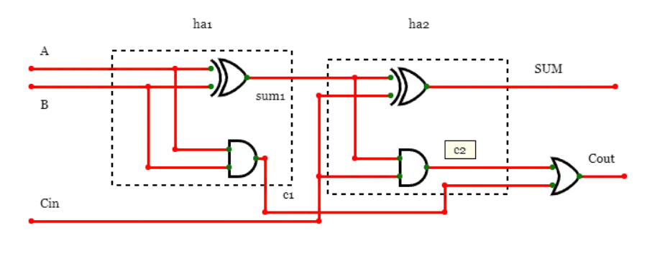
Figure 1: Full Adder using two Half Adders

As usual, carry out the module and port declaration:
module fa(SUM,Cout,A,B,Cin);
input A,B,Cin;
output SUM, Cout;
....
endmodule
Now let’s instantiate the ha module to the full adder module:
ha ha1(sum1,c1,A,B);
ha ha2(SUM,c2,sum1,Cin);
or(Cout,c1,c2);
Have you noticed something?
When we instantiated, we connected the ports in the fa module the same order as the ports declared in the ha module. This is what we call instantiation by port order. There’s another way of nesting to modules. Let’s see how we can connect the same ha modules to build fa module using this style:
ha ha1(.sum(sum1), .carry(c1), .a(A), .b(B));
ha ha2(.sum(SUM), .carry(c2), .a(sum1), .b(Cin));
or(Cout, c1, c2);
Unlike the former, this style doesn’t mind if the order is messed up. But, we have mentioned the names of all the physical connections related to both modules. Hence, this style is called instantiation by port name.
Data Flow Modeling:
A half adder in Verilog using data flow modeling is implemented using the assign keyword to define continuous assignment for the sum () and carry () equations. This method describes the circuit's functionality rather than its gate structure.
module half_adder_dataflow (
input a, b,
output sum, carry
);
// Data flow equations using continuous assignment
assign sum = a ^ b; // Sum is XOR of inputs
assign carry = a & b; // Carry is AND of inputs
endmodule
Key Features of Data Flow Modeling:
- Syntax: Uses the assign statement.
- Operator ^: Performs XOR for the sum.
- Operator &: Performs AND for the carry.
- Functionality: Ideal for combinational circuits, expressing logic directly.

Lab Tasks:

Instruction:
- You need to perform all tasks.
- Write and embed code for each task.
- Creation of a Logisim circuit for each of the following tasks is mandatory.
- Write Verilog Code for Half Adder and Full adder using Gate level and Dataflow level modeling. Simulate it by writing testbench.

- Write Verilog code of 3x8 Decoder using Gate level and Dataflow level modeling simulate the results by writing testbench.

- Write Verilog code of 8x1 multiplexer using Gate level and Dataflow modeling. Simulate the results by writing testbench.

