Computer Architecture Lab
(EL-2012)
LABORATORY REPORT

Fall 2026

(Lab#03)
Apply Behavioral-level Verilog to Design and Simulate Combinational Modules

Student Name: Hanzala Saeed Roll No: 24i-6535 Section: CE-A

Date performed: 9/1/2026

MARKS AWARDED: ________ / 10

Signature and date of Instructor: _________________
Lab Instructors: Dr. Nasir Ali Shah, Engr. Fasih Ahmad

______________________________________________________________________________________________________________________________________________________

NATIONAL UNIVERSITY OF COMPUTER AND EMERGING SCIENCES, ISLAMABAD
Prepared by: | Fasih Ahmad |  | Version: 1.0
Verified by: | Dr. Nasir Ali Shah |  | Updated: Fall 2026

Task 1:

Description:
I made a 4-bit adder/subtractor with Verilog. A control signal tells the circuit whether to add or subtract. I used XOR gates to flip the operand only when subtraction is needed and I fed this flipped data as a carry-in for the subtraction. I wrote a testbench to run through input combinations and check both results. I ran the simulation in ModelSim. I also checked the design in a Logisim circuit.
Code:
//4 Bit adder and subtractor with control input
module addSub(result,A,B,select);
input [3:0] A;
input [3:0] B;
input select;
output reg [3:0] result;

always @*
begin
if(select==0)
result=A+B;
else
result=A-B;
end
endmodule

module testAdderSubtractor();
reg [3:0] A;
reg [3:0] B;
reg select;
wire [3:0] result;

addSub uut(result,A,B,select);

initial
begin
A=4'b0011; B=4'b0001; select=0;
#50 A=4'b0101; B=4'b0010; select=0;
#50 A=4'b0110; B=4'b0011; select=1;
#50 A=4'b1000; B=4'b0010; select=1;
#50;
end

endmodule
Output:
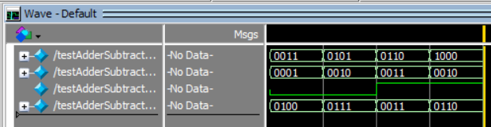

Task 2:

Description:
I built a 2x1 multiplexer. The select line tells the device whether to output an AND or an OR of A and B. I wrote a testbench to run all combinations of A, B and Select and record the output. I simulated the design in ModelSim. I also ran a Logisim circuit to validate the result.
Code:
//2x1 MUX
module mux2x1(y,a,b,select);
input a;
input b;
input select;
output reg y;

always @*
begin
if(select==0)
y=a&b;
else
y=a|b;
end

endmodule

module testMux2x1();
reg a;
reg b;
reg select;
wire y;

mux2x1 uut(y,a,b,select);

initial
begin
a=0; b=0; select=0;
#50 a=0; b=1; select=0;
#50 a=1; b=0; select=0;
#50 a=1; b=1; select=0;
#50 a=0; b=0; select=1;
#50 a=0; b=1; select=1;
#50 a=1; b=0; select=1;
#50 a=1; b=1; select=1;
#50;
end

endmodule
Output:
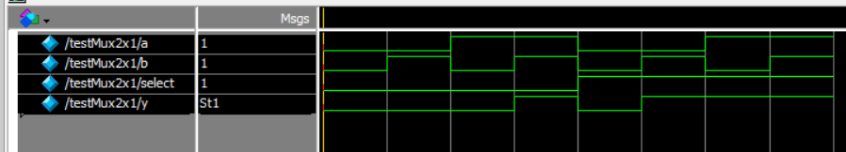

Task 3:

Description:
I made a 2-bit comparator. It compares two 2-bit numbers and tells if they are equal if A is greater or if A is less than B. I wrote a testbench that covered every input pair to confirm the equal, greater and less outputs. I simulated the design in ModelSim. I built the same circuit, in Logisim and checked it.
Code:
module comparator2bit(A,B,equal,greater,less);
input [1:0] A;
input [1:0] B;
output equal;
output greater;
output less;

assign equal = (A==B);
assign greater = (A>B);
assign less = (A<B);

endmodule

module testComparator2bit();
reg [1:0] A;
reg [1:0] B;
wire equal;
wire greater;
wire less;

comparator2bit uut(A,B,equal,greater,less);

initial
begin
A=2'b00; B=2'b00;
#50 A=2'b00; B=2'b01;
#50 A=2'b01; B=2'b00;
#50 A=2'b01; B=2'b01;
#50 A=2'b10; B=2'b01;
#50 A=2'b01; B=2'b10;
#50 A=2'b10; B=2'b10;
#50 A=2'b11; B=2'b10;
#50 A=2'b10; B=2'b11;
#50 A=2'b11; B=2'b11;
#50;
end

endmodule
Output:
