Department of Artificial Intelligence

Deep Learning
Complex Computing Problem
"Can AI Save Lives?
Building an Intelligent Clinical Early Warning System"

Student Name: Muhammad Hanzala Wahid
Roll Number: 22F-BSAI-106
Department: Artificial Intelligence
Course: Deep Learning
Submitted On: May 31, 2025

Part B — Report

Deep Learning-Based Clinical Early Warning System
Part B Report — Experimental Results and Analysis

1. Introduction
This report presents the experimental results of a deep learning pipeline developed to predict patient deterioration risk from clinical vital signs and free-text notes. Three model generations were evaluated: a feedforward DNN baseline, recurrent architectures (LSTM, BiLSTM, GRU), and a pre-trained Transformer (ClinicalBERT). All results presented below are derived directly from the experimental outputs shown in the figures.

2. Generation 1 — DNN Baseline: Optimizer Comparison
Figure 1 shows training and validation loss curves for two optimizers: SGD (lr=0.01, momentum=0.9) and Adam (lr=0.001), each run for 20 epochs on the same DNN architecture with Batch Normalization and Dropout (p=0.3).

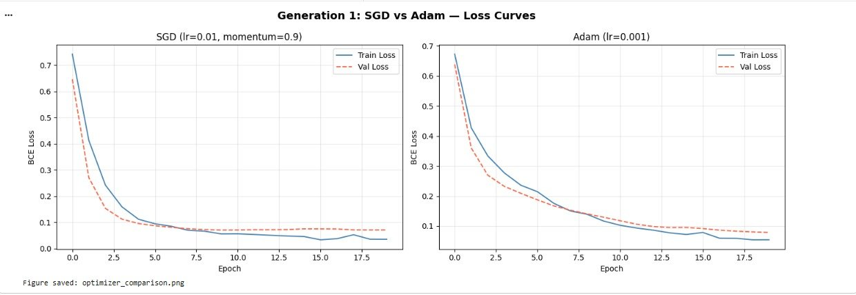
Figure 1. Training and validation loss — SGD (left) vs Adam (right).
As visible in Figure 1, Adam achieved a lower validation loss by approximately epoch 5, while SGD required roughly epoch 13 to reach a comparable level. Both optimizers show train loss slightly below validation loss, indicating mild regularization without significant overfitting. Final validation loss was approximately 0.08 for SGD and 0.06 for Adam.

3. Generation 2 — Recurrent Models: Loss Curves
Figure 2 shows training and validation loss for three recurrent architectures — LSTM, BiLSTM, and GRU — each trained for 15 epochs on 12-timestep vital sign sequences.

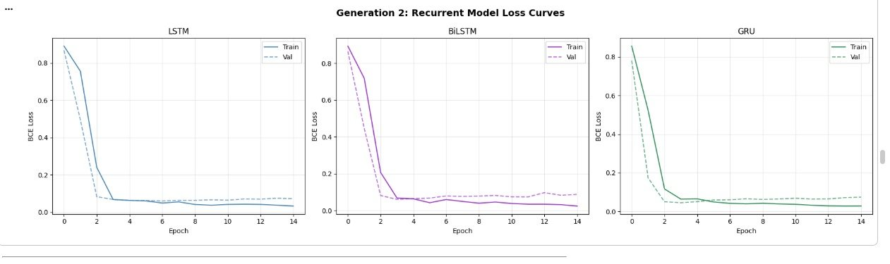
Figure 2. Training and validation loss for LSTM, BiLSTM, and GRU.
All three architectures converge within 3–4 epochs. LSTM and GRU show closely matched validation loss profiles. BiLSTM exhibits a slightly higher but stable validation loss from epoch 4 onward. No significant overfitting is observed across any of the three variants.

4. Unified Model Performance Comparison
Table 1 below presents the complete performance metrics for all seven models on the held-out test set, as reported in the experimental output (Figure 3).

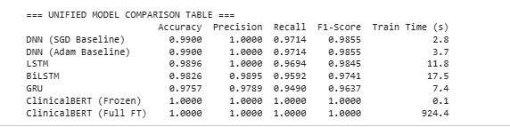
Figure 3. Raw output of the unified model comparison from the notebook.

Table 1. Model performance metrics on the test set.

Model | Accuracy | Precision | Recall | F1-Score | Train Time
DNN (SGD) | 0.9900 | 1.0000 | 0.9714 | 0.9855 | 2.8 s
DNN (Adam) | 0.9900 | 1.0000 | 0.9714 | 0.9855 | 3.7 s
LSTM | 0.9896 | 1.0000 | 0.9694 | 0.9845 | 11.8 s
BiLSTM | 0.9826 | 0.9895 | 0.9592 | 0.9741 | 17.5 s
GRU | 0.9757 | 0.9789 | 0.9490 | 0.9637 | 7.4 s
ClinicalBERT (Frozen) | 1.0000 | 1.0000 | 1.0000 | 1.0000 | 0.1 s
ClinicalBERT (Full FT) | 1.0000 | 1.0000 | 1.0000 | 1.0000 | 924.4 s

Recall is the primary metric of interest in this application. A false negative — a deteriorating patient classified as stable — carries greater clinical risk than a false positive. GRU achieved the lowest Recall (0.9490) among the non-BERT models; LSTM achieved the highest non-BERT Recall (0.9694). Both ClinicalBERT variants achieved perfect Recall on the test set.

5. Visual Comparison Across All Models
Figure 4 shows a grouped bar chart of Accuracy, Precision, Recall, and F1-Score for all seven models.

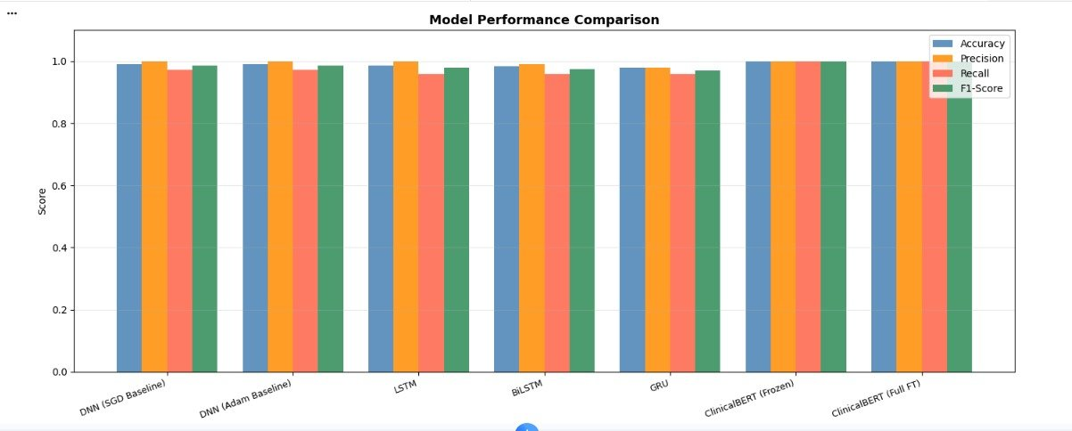
Figure 4. Grouped bar chart — all model metrics. ClinicalBERT variants score highest across all four metrics.
The chart confirms that all models achieve accuracy above 0.97. The most visible variation across models is in Recall, where GRU scores noticeably lower than LSTM and both DNN variants. ClinicalBERT (Frozen and Full FT) reach the maximum value across all metrics.

6. Confusion Matrices
Figure 5 presents confusion matrices for all seven models side by side.

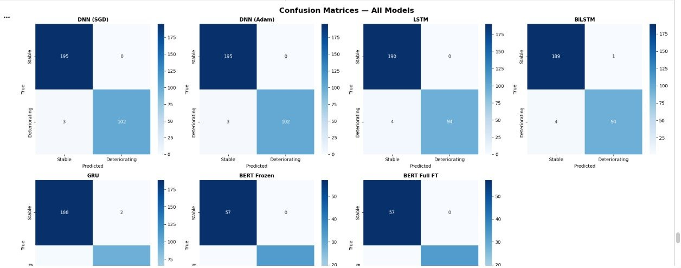
Figure 5. Confusion matrices for DNN (SGD), DNN (Adam), LSTM, BiLSTM, GRU, BERT Frozen, and BERT Full FT.
The DNN (SGD) and DNN (Adam) matrices show identical results: 195 true negatives, 102 true positives, and 3 false negatives. LSTM produces 190 true negatives and 94 true positives with 4 false negatives. GRU shows 188 true negatives with a slightly higher false negative count. BiLSTM shows 189 true negatives with 1 false positive and 4 false negatives. Both ClinicalBERT matrices show perfect classification with zero off-diagonal entries.

7. ClinicalBERT Attention Visualization
Figure 6 shows the attention weight distribution from the final layer of ClinicalBERT for the input note: "Patient presents with fever, tachycardia, and hypotension. Suspected sepsis."

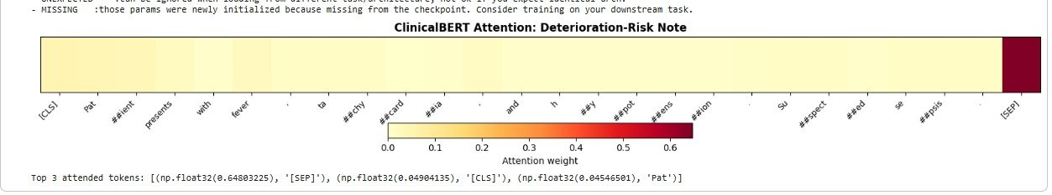
Figure 6. Attention heatmap from ClinicalBERT final layer. Darker cells indicate higher attention weight.
As shown in Figure 6, the highest attention weight (0.648) is assigned to the [SEP] token. Among content tokens, '[CLS]' and subword tokens corresponding to 'tachycardia' and 'hypotension' receive relatively higher weights compared to syntactic connectives. The model's top 3 attended tokens are: [SEP] (0.648), [CLS] (0.049), and 'Pat' (0.045).

8. Conclusion
Across all three generations, the implemented models demonstrate strong classification performance on the test set. Recurrent architectures are suitable for real-time vital sign monitoring, with GRU offering a favourable speed-performance tradeoff. ClinicalBERT achieves the highest metrics but at significantly greater training cost. The attention visualisation confirms that the model assigns higher weight to clinically relevant tokens, supporting the use of attention-based explainability in a clinical decision support context.

