OUTDOOR FIX — LEASE TO OWN PLATFORM
Visual Flow Walkthrough
Every step of the application-to-lease flow, with a real screenshot for each one
Prepared for: Joel Stebbins
Prepared by: Hanzalah
Date: August 31, 2026
This is a real, screenshot-by-screenshot walkthrough of the entire lease application flow — captured live from the running application, not mockups. It follows one real example end to end: an admin submits a new application, moves it through every review stage, and the lease appears live in the customer's own portal.
Every number shown (pricing, EPO figures, payment schedule, risk score) is genuinely computed by the system, not staged.

Part 1 — Admin: Creating and Reviewing an Application

1. Sign In
Every user — Super Admin, Admin, or Customer — starts here with their email and password.
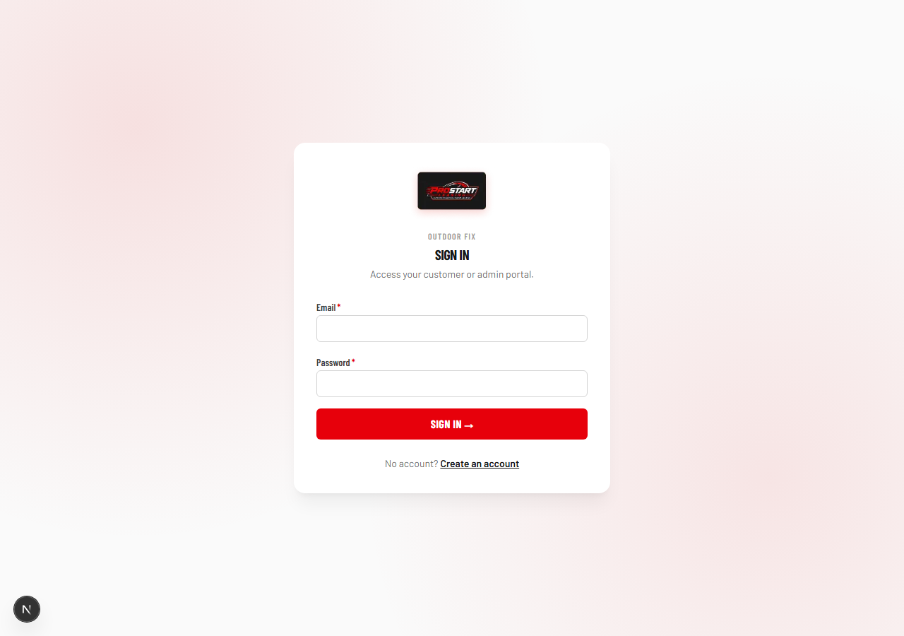

2. Admin Dashboard
After logging in, an admin lands on their dashboard, scoped to exactly the permissions they've been given.
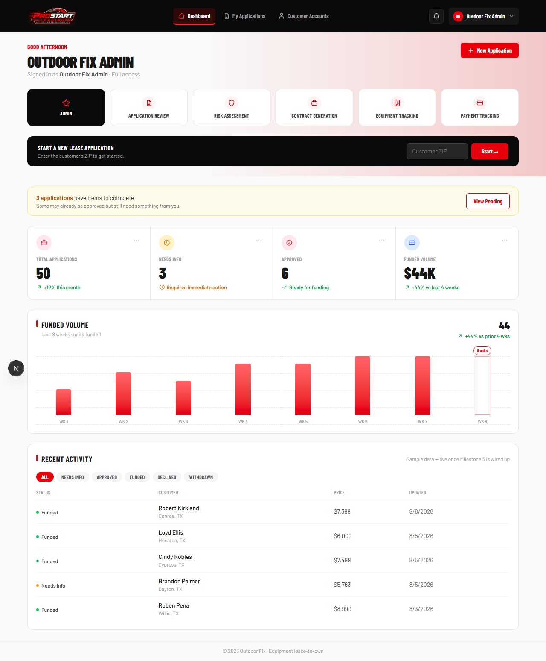

3. New Application — Step 1: Equipment
An admin starts a new lease application by entering the equipment details: make, model, serial number, condition, and cash price.
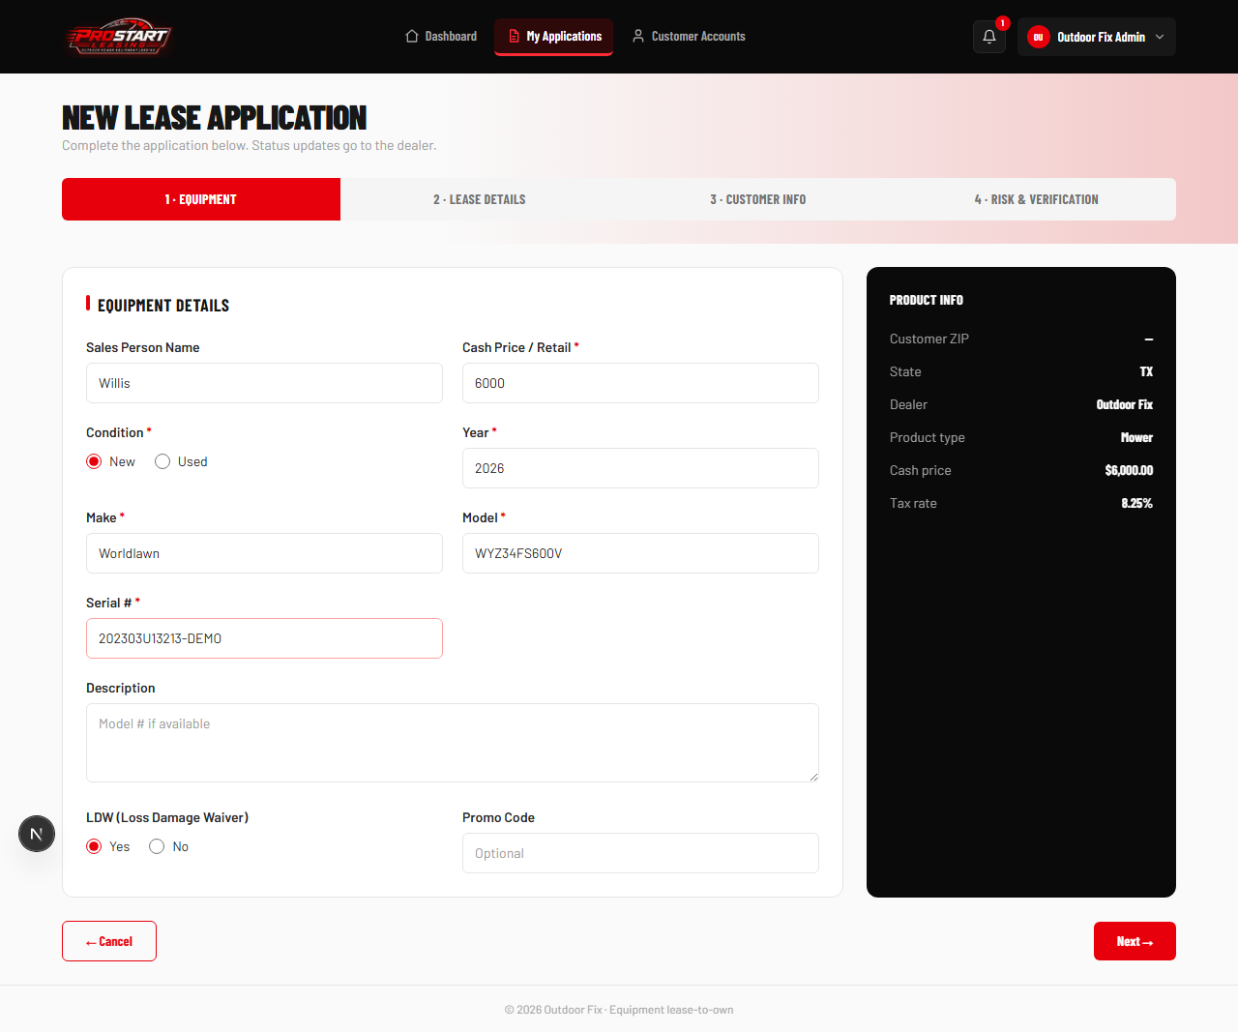

4. New Application — Step 2: Lease Details
Term, monthly rental, tax rate, and security deposit are entered here. The Early Purchase Option payoff chart updates live as the numbers change.
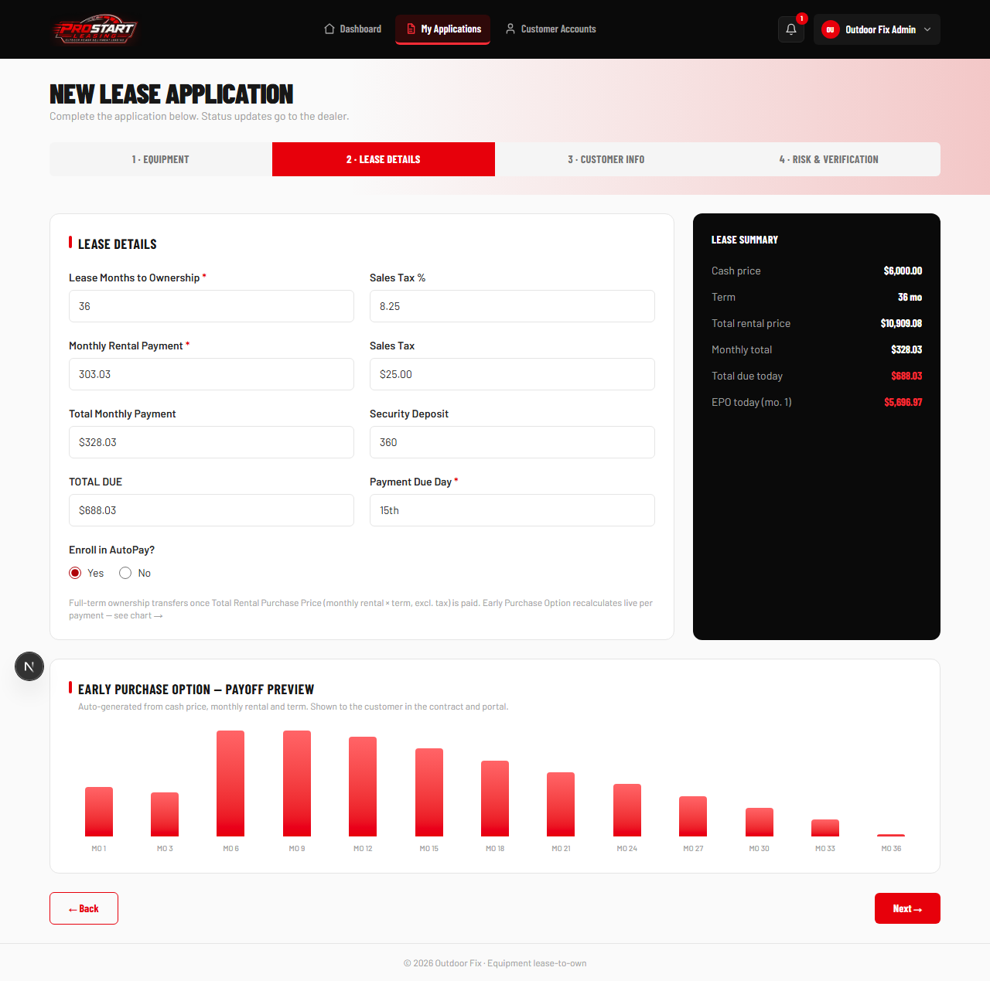

5. New Application — Step 3: Customer Info
The renter's contact details are captured, along with a required upload of their driver's license or government ID.
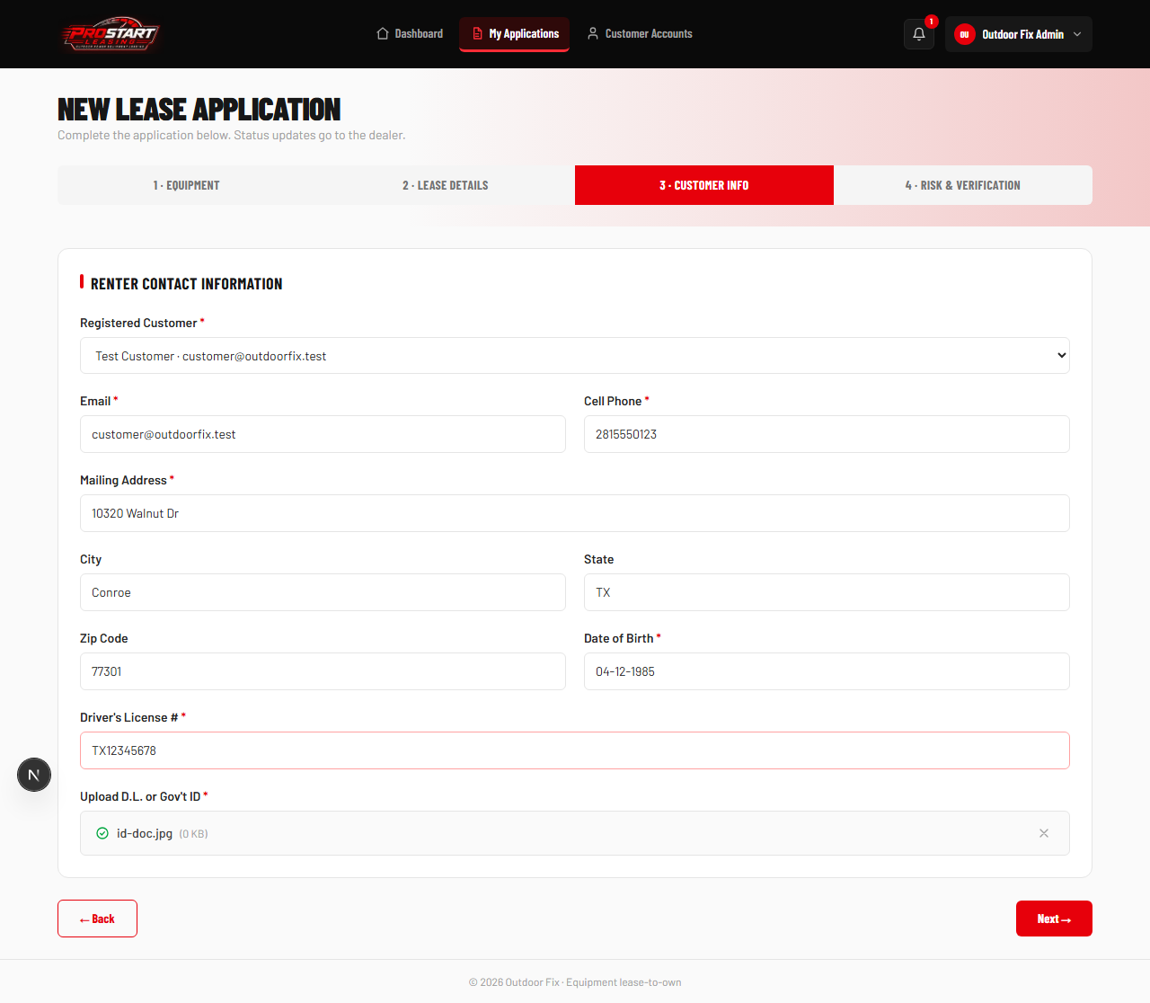

6. New Application — Step 4: Risk & Verification
Residence and income details feed the automatic risk-scoring engine, which runs the moment the application is submitted.
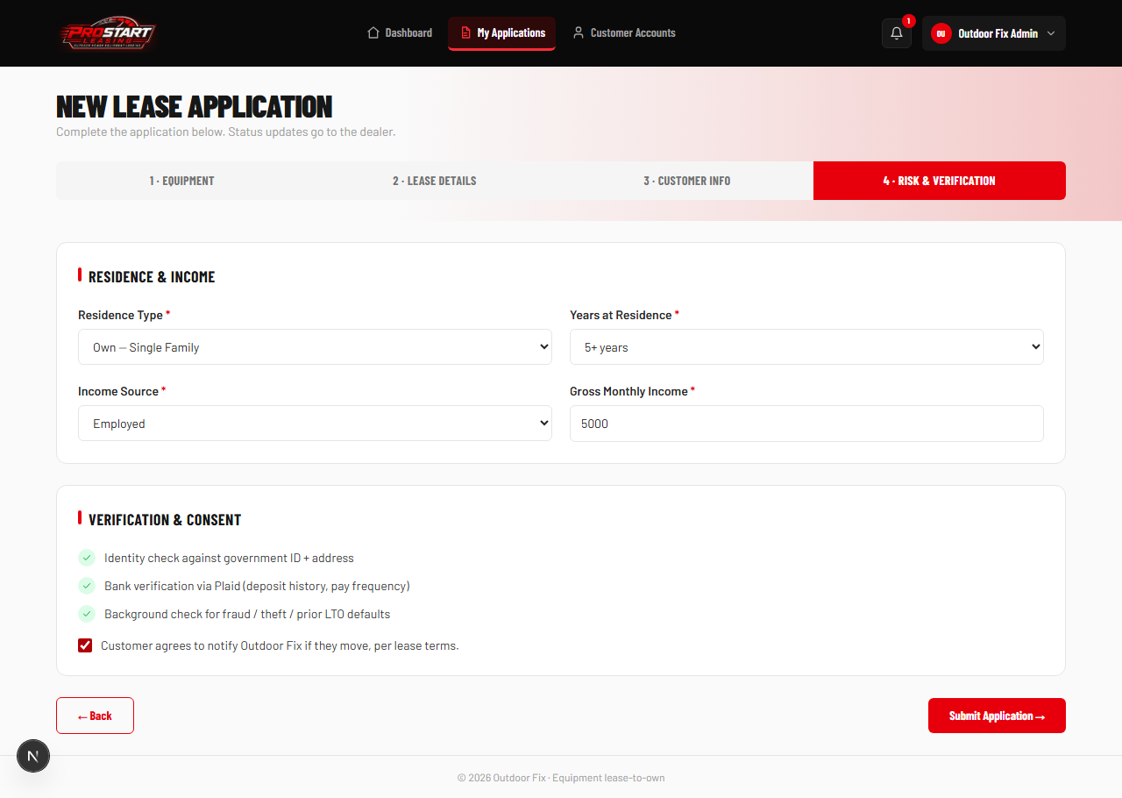

7. Application Created — Status: Submitted
The application, lease agreement, equipment record, and risk profile are all created in the database in one step. The admin lands directly on the new application's detail page.
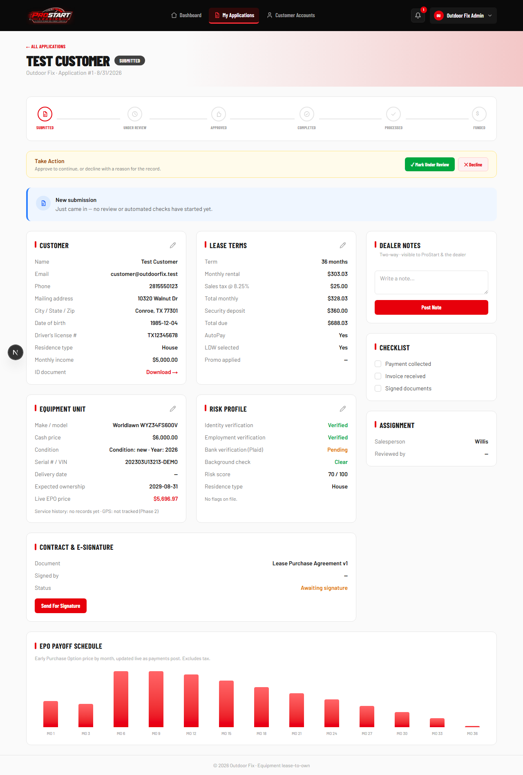

8. Status: Under Review
The admin moves the application forward. Automated checks (identity, Plaid bank verification, background) are shown in progress.
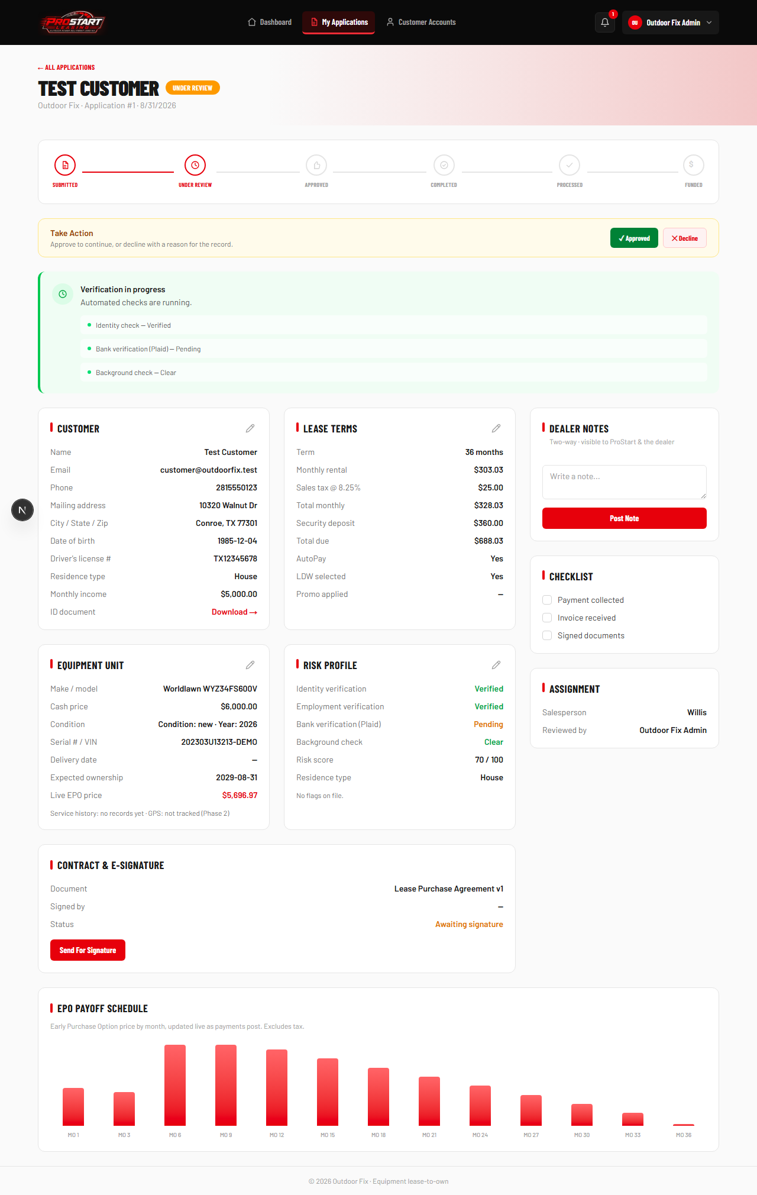

9. Status: Approved
Once approved, the system locks in the lease terms and automatically generates the full monthly payment schedule — no manual entry.
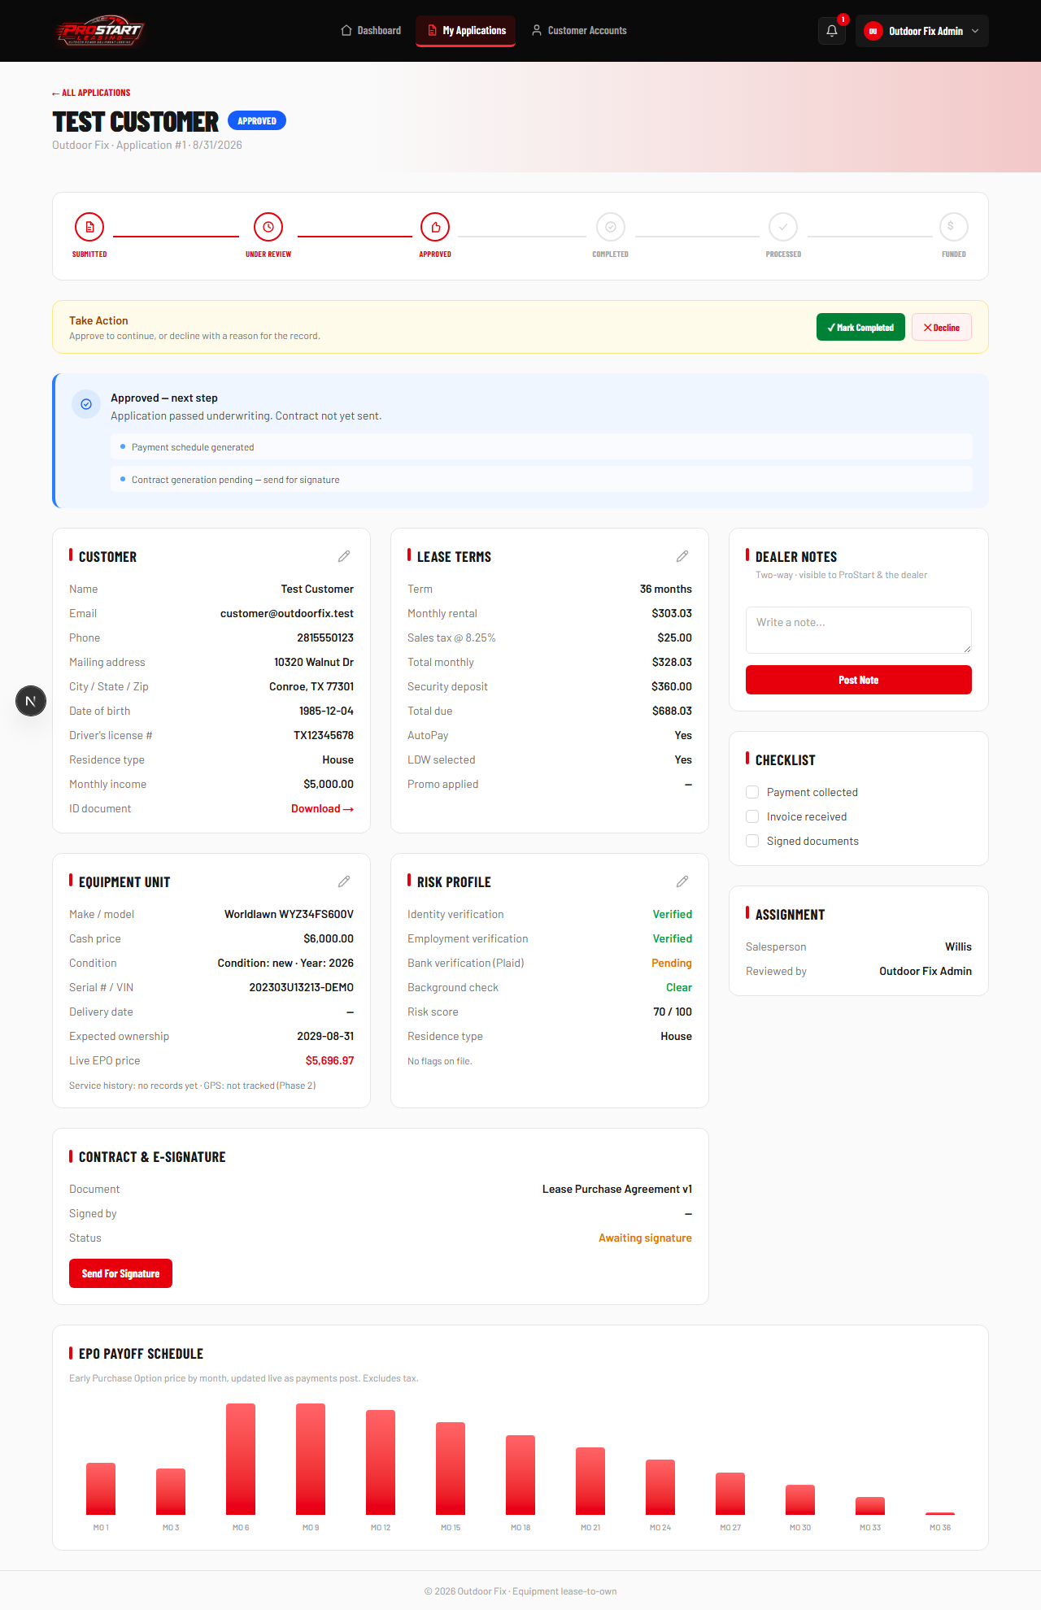

10. Status: Completed
Equipment has been delivered to the customer; only the funding step remains.
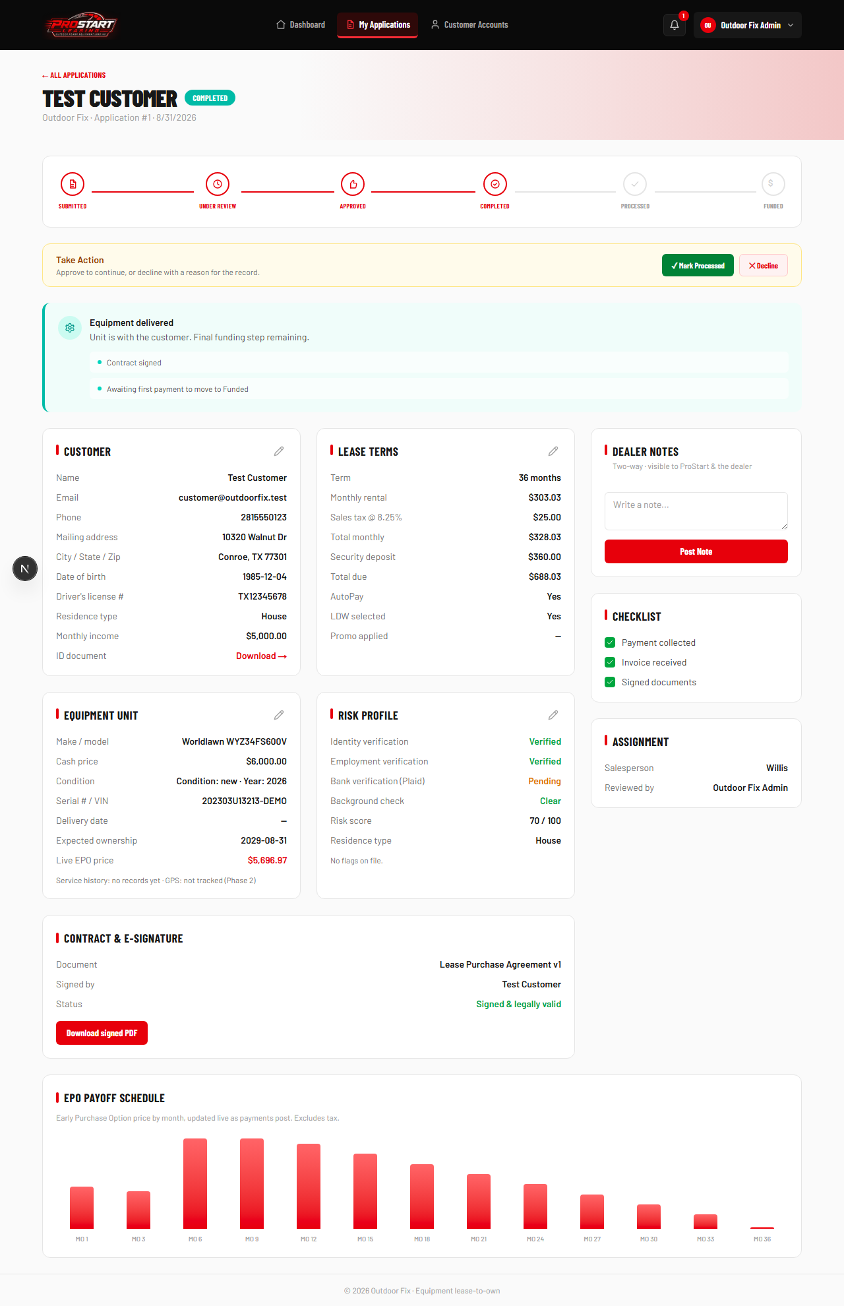

11. Status: Processed
The final payment is submitted and processing — the last step before the lease goes live.
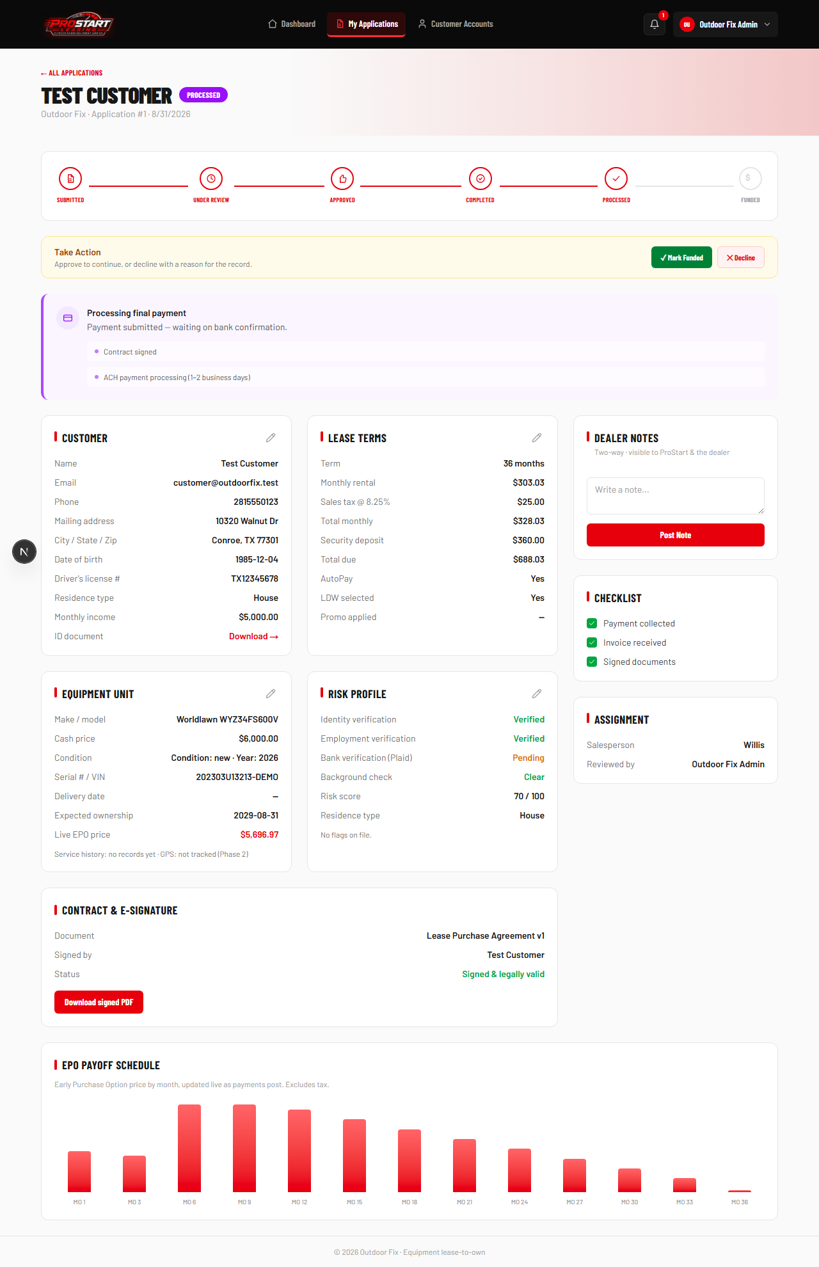

12. Status: Funded
The lease is now fully active. From this moment, it appears in the customer's own portal.
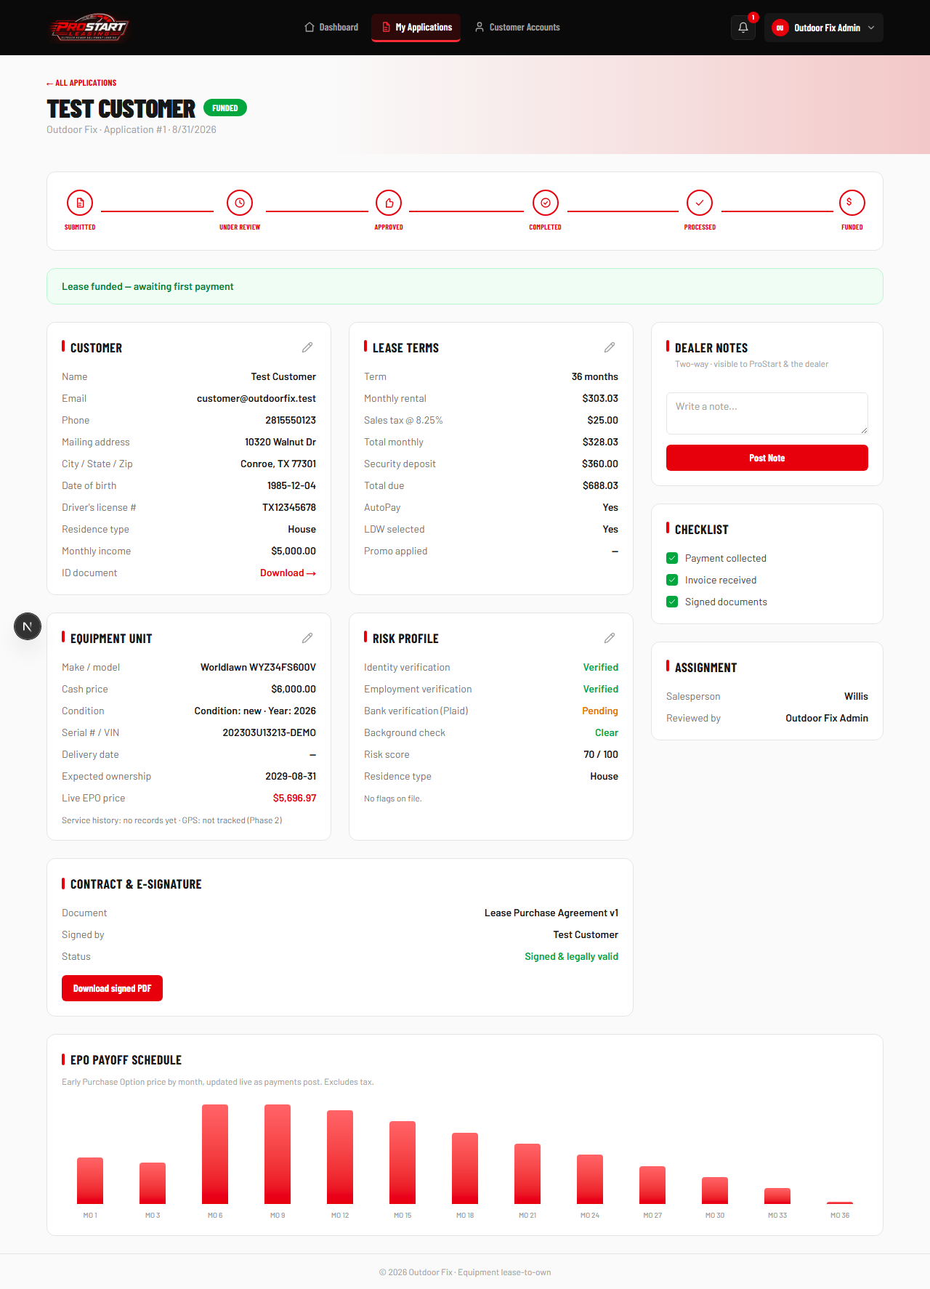

13. Applications List
Every admin with Application Review access sees the full list here, filterable by status.
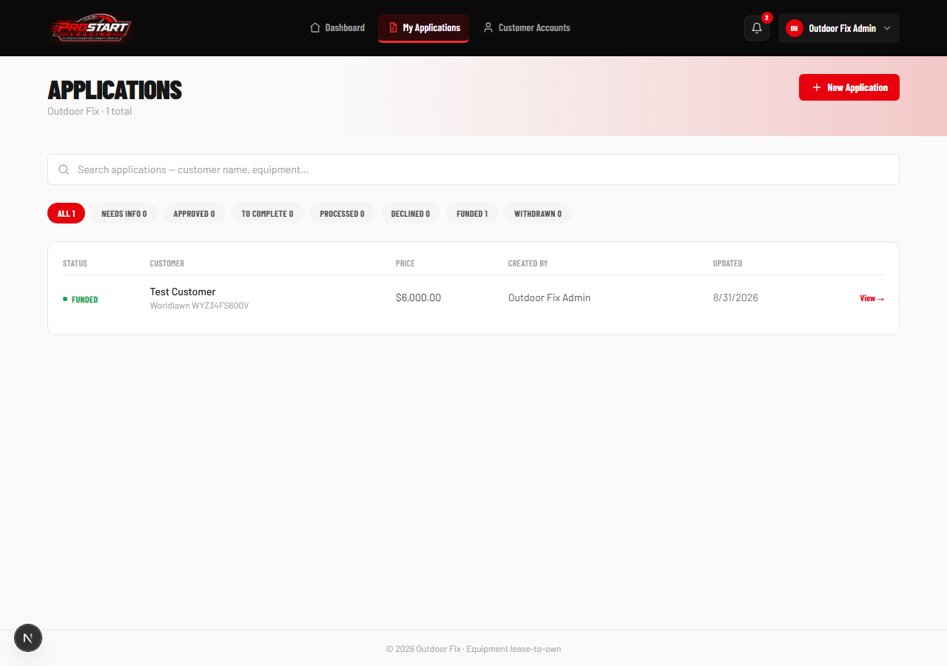

Part 2 — What the Customer Sees

14. Customer Portal — My Lease
The customer logs into their own portal and immediately sees their active lease.
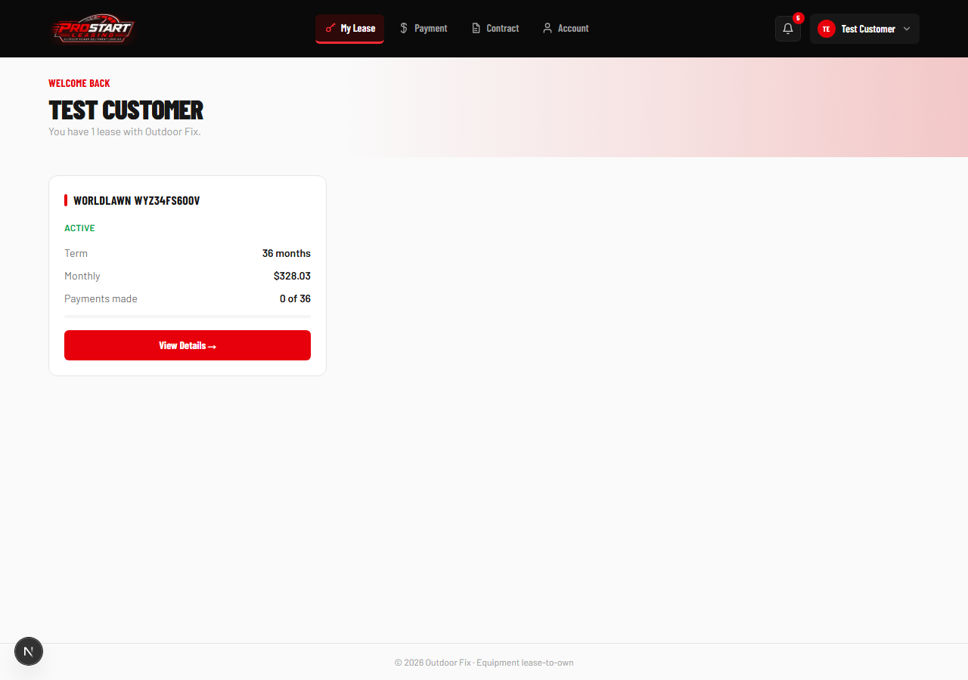

15. Lease Detail — Path 1 vs. Path 2
The customer sees both ownership paths side by side: Full-Term Ownership progress, and today's exact Early Purchase Option price.
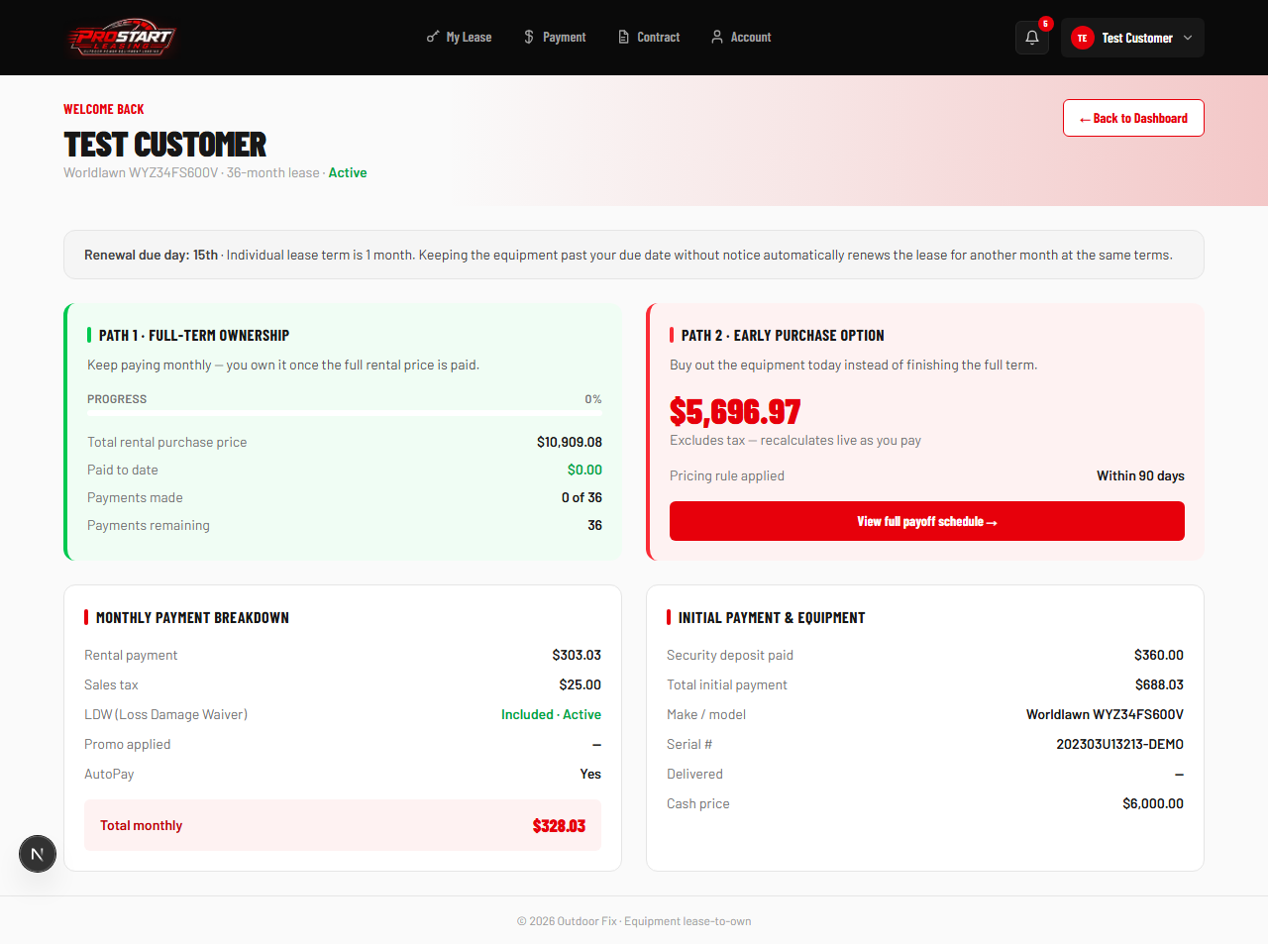

16. Early Purchase Option Schedule
The complete month-by-month buyout schedule, computed live by the same pricing engine used everywhere else in the app.
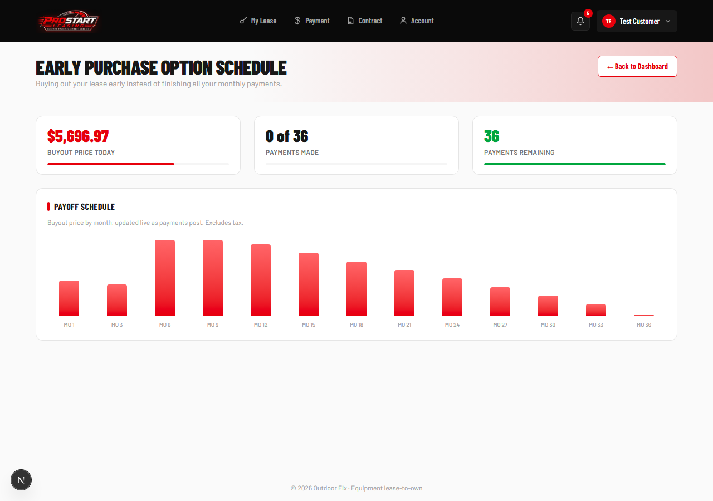

17. Payments
The customer's full payment history and every upcoming due date, generated automatically when the application was approved.
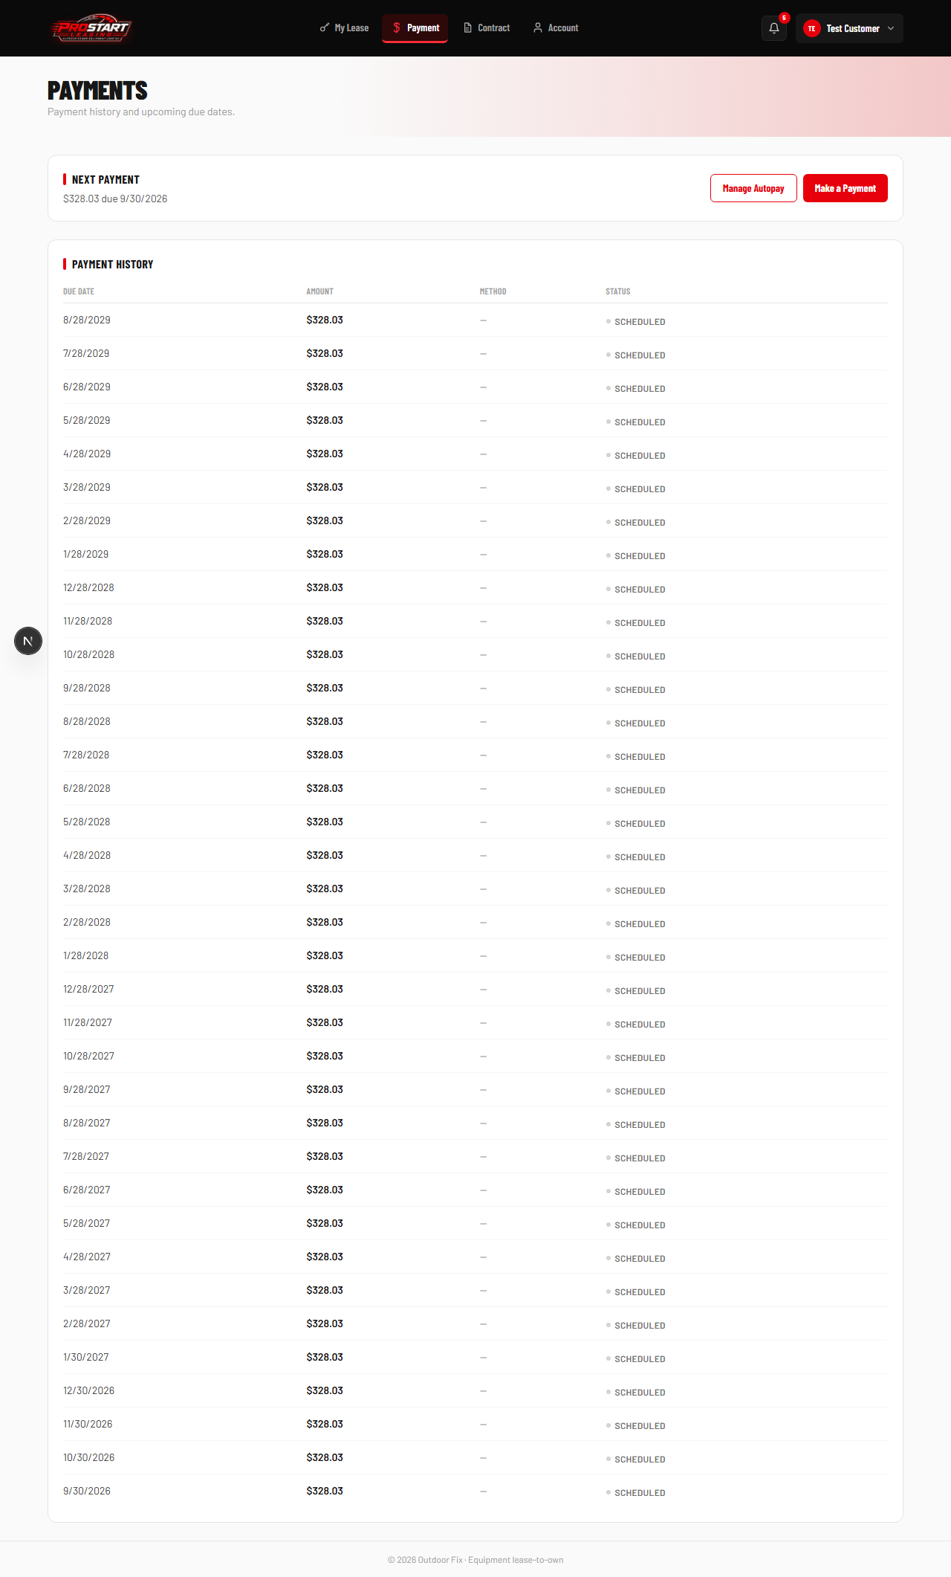

18. Notifications
The customer receives a real notification at every step of their application's journey.
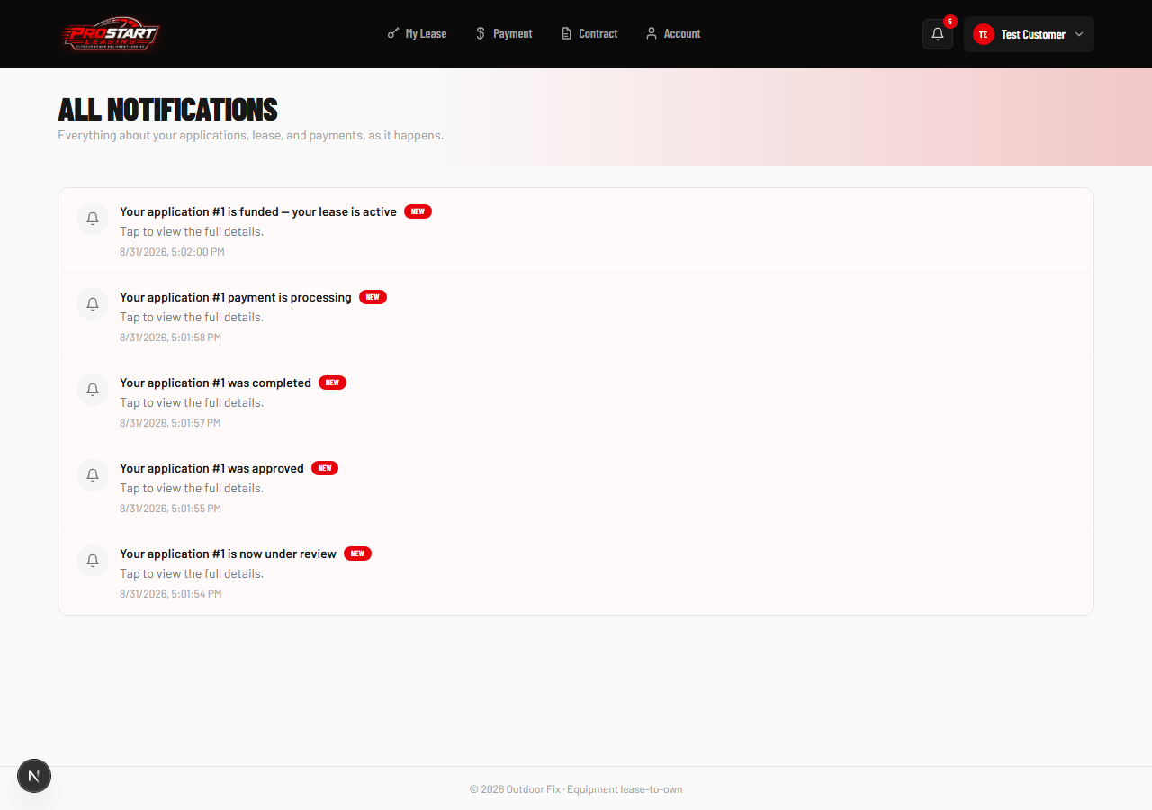

Part 3 — Customer Self-Service: Starting Your Own Application
A customer doesn't have to wait for a dealer to start their paperwork. From their own dashboard, they can start an application themselves — the exact same wizard, engine, and risk scoring as the admin side, just without needing to pick “who this is for.” It lands in the same Applications queue an admin reviews.

19. My Lease — Before Any Lease Exists
A customer with no leases yet sees a “+ New Application” button right on their own dashboard.
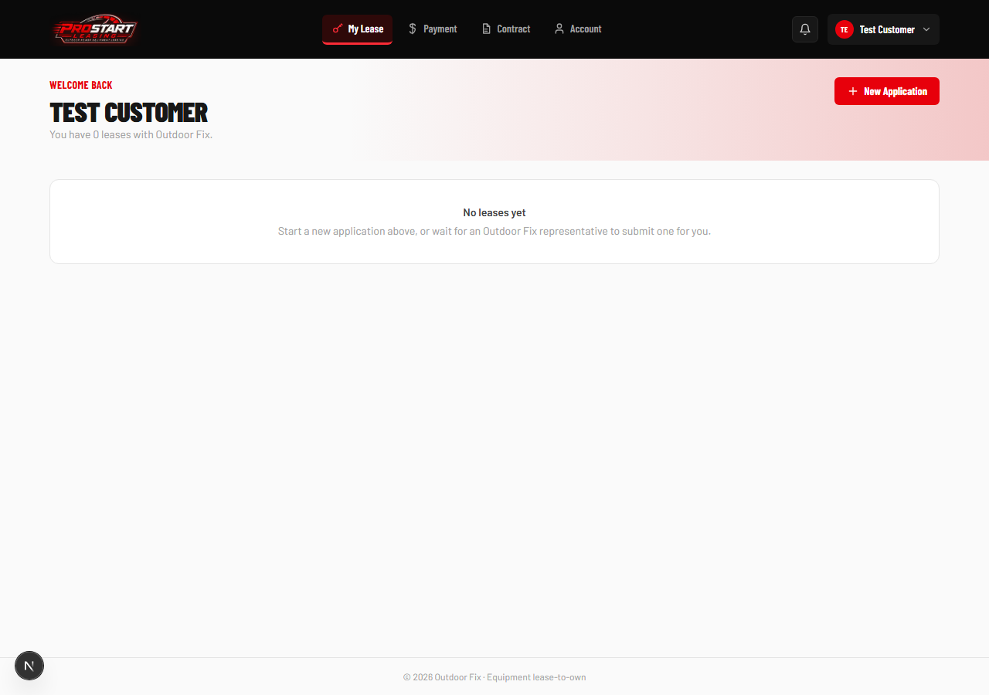

20. Customer Wizard — Step 1: Equipment
The identical 4-step wizard used by admins, now available directly to the customer.
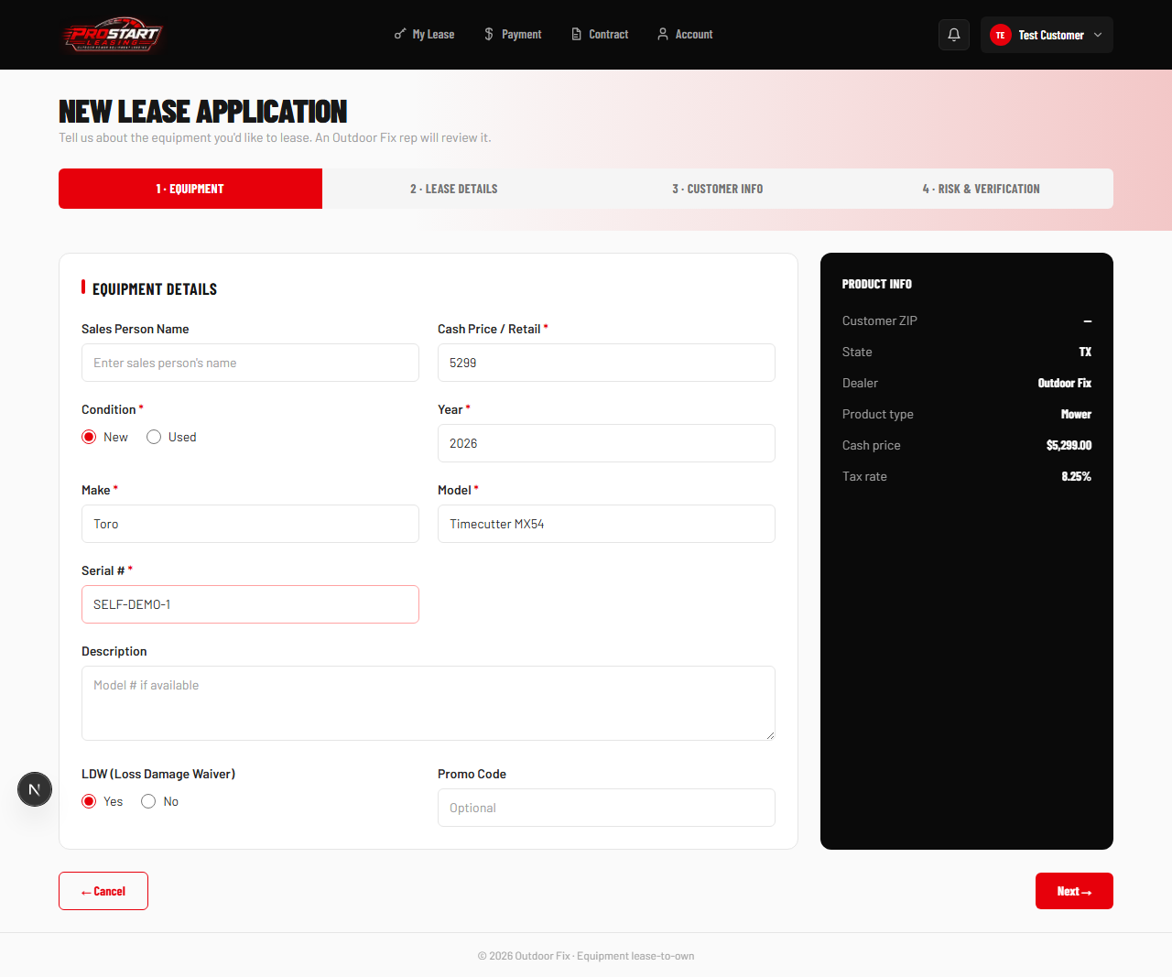

21. Customer Wizard — Step 3: Applying As
Instead of picking a customer from a list (like the admin version does), the wizard already knows who's applying and shows it read-only.
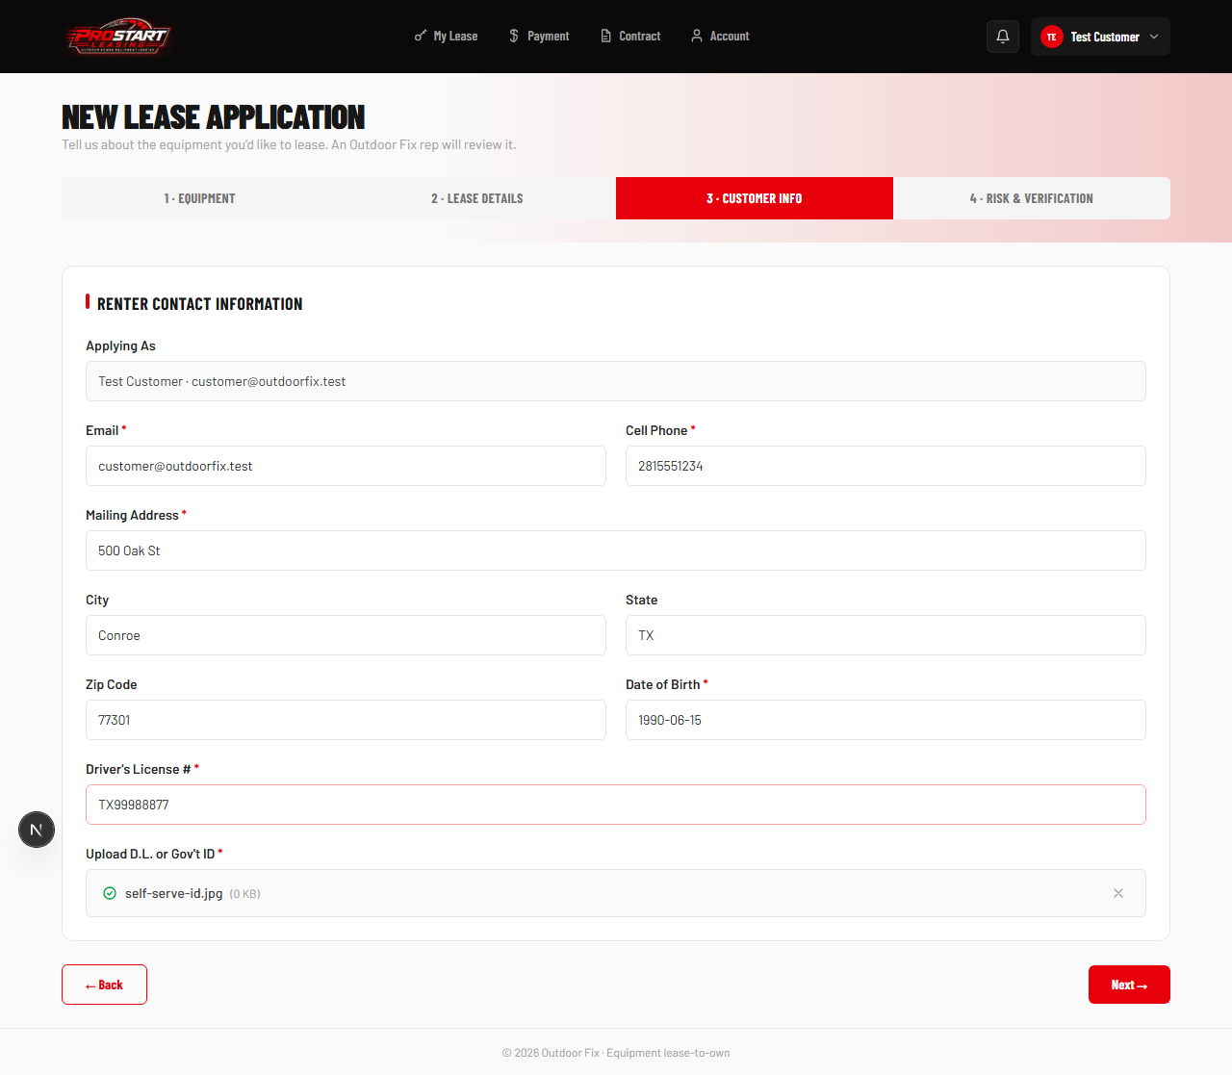

22. Application Submitted (Customer View)
A simplified, read-only status view — the customer can track their application without being able to edit dealer-only fields.
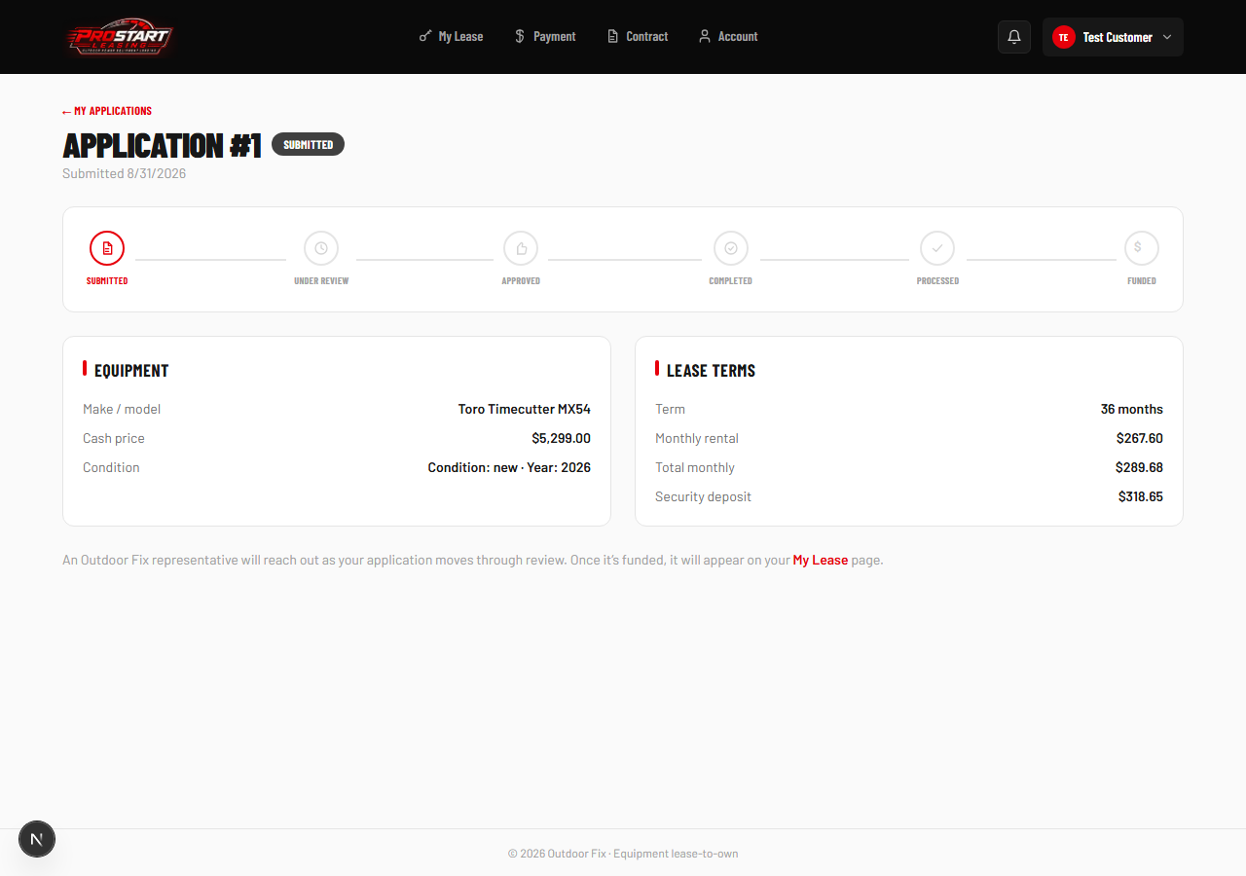

23. My Applications
Every application the customer has ever submitted, with its live status.
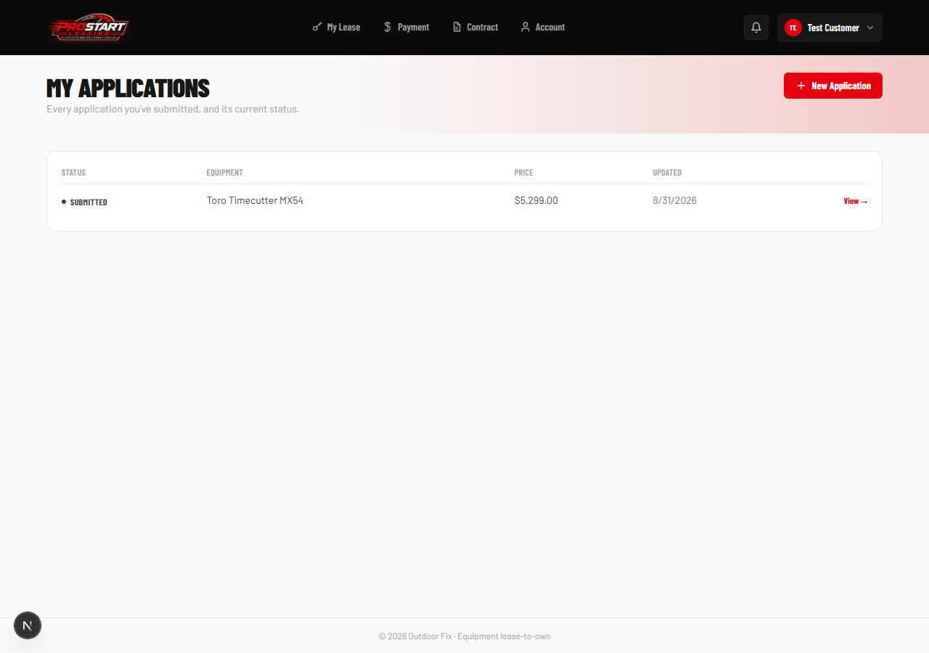

Part 4 — Bonus: Bank Verification via Plaid
From their Account page, a customer can connect their real bank account through Plaid. This is a genuinely live third-party integration — the screens below are the real Plaid Link popup (sandbox mode), not a mockup of one.

24. Account Page — Not Yet Verified
Before connecting, the Account page shows a clear “not verified” state with a Connect button.
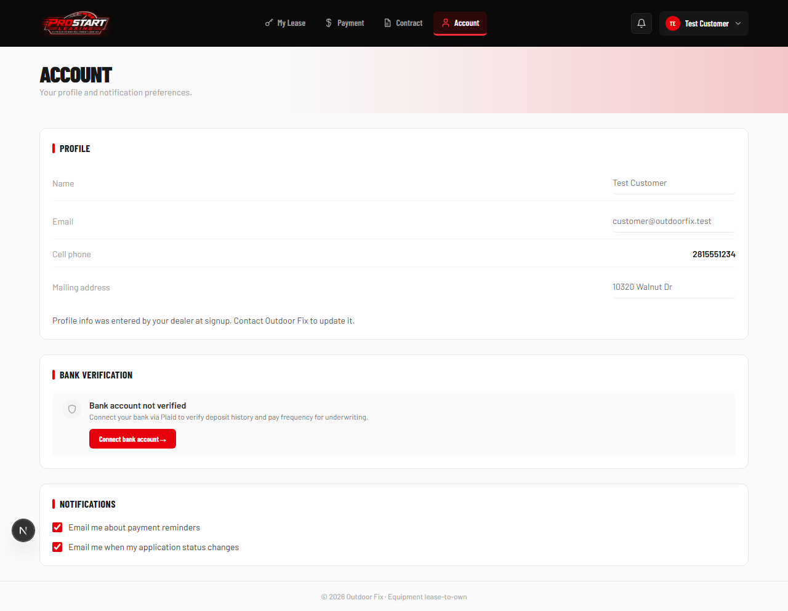

25. Plaid Link Opens
Clicking “Connect bank account” opens the real, Outdoor-Fix-branded Plaid Link popup.
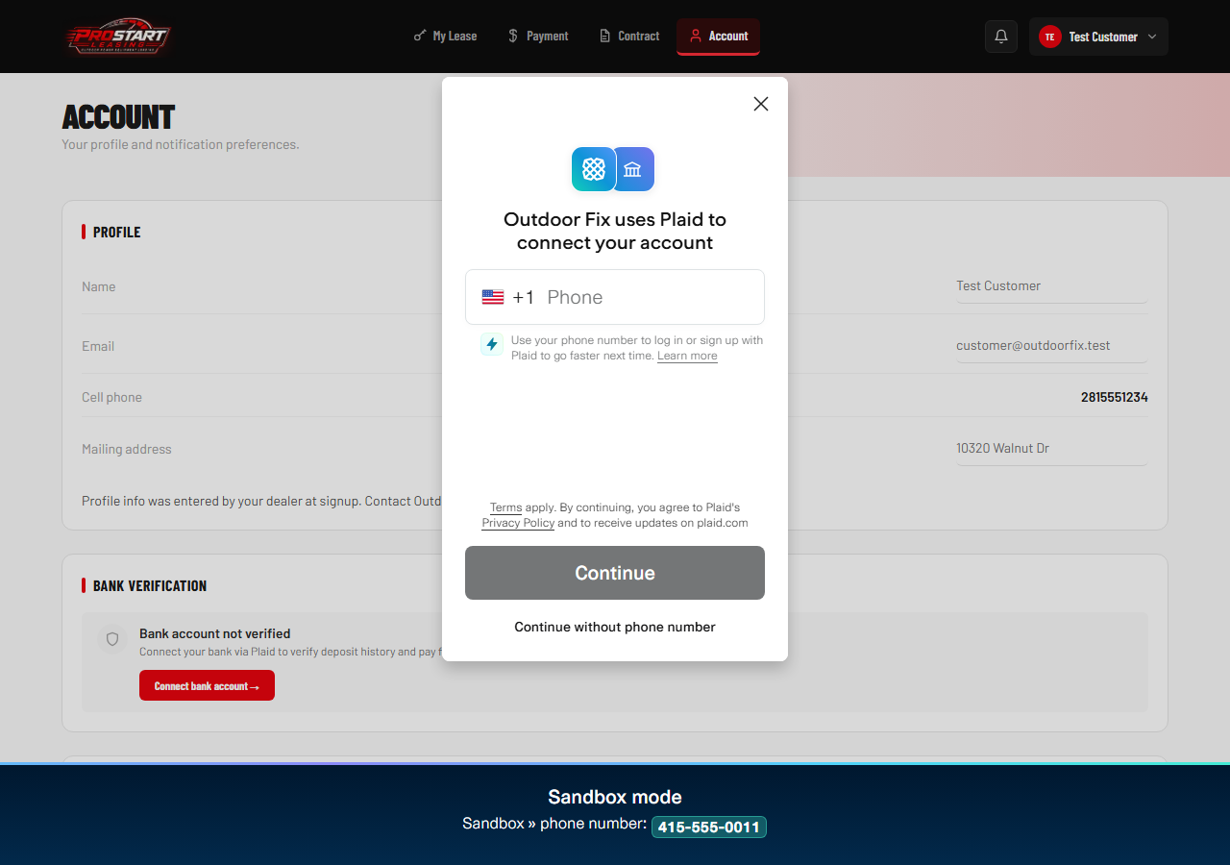

26. Choose a Bank
The customer picks their real institution from Plaid's live list.
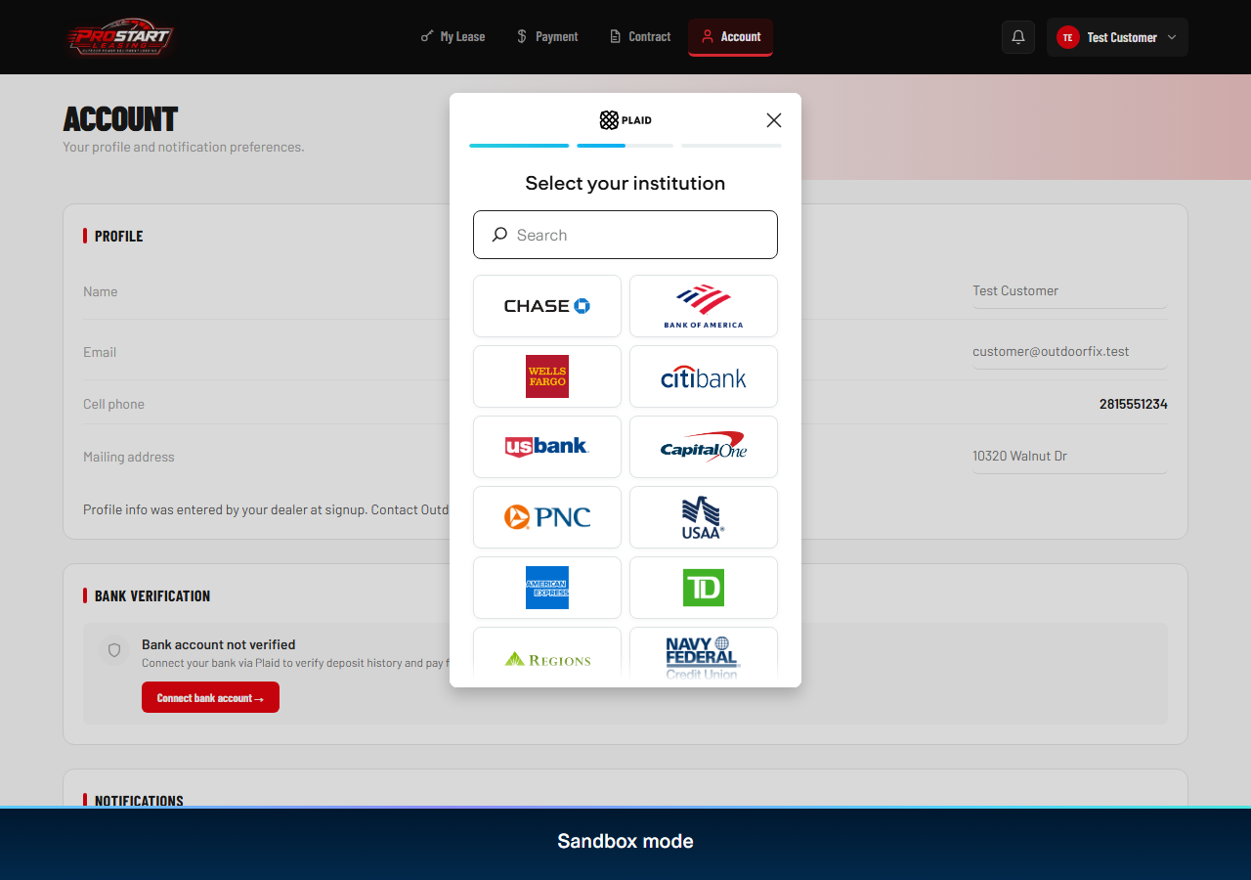

27. Consent Screen
Plaid shows exactly what data will be shared before continuing to the bank's login.
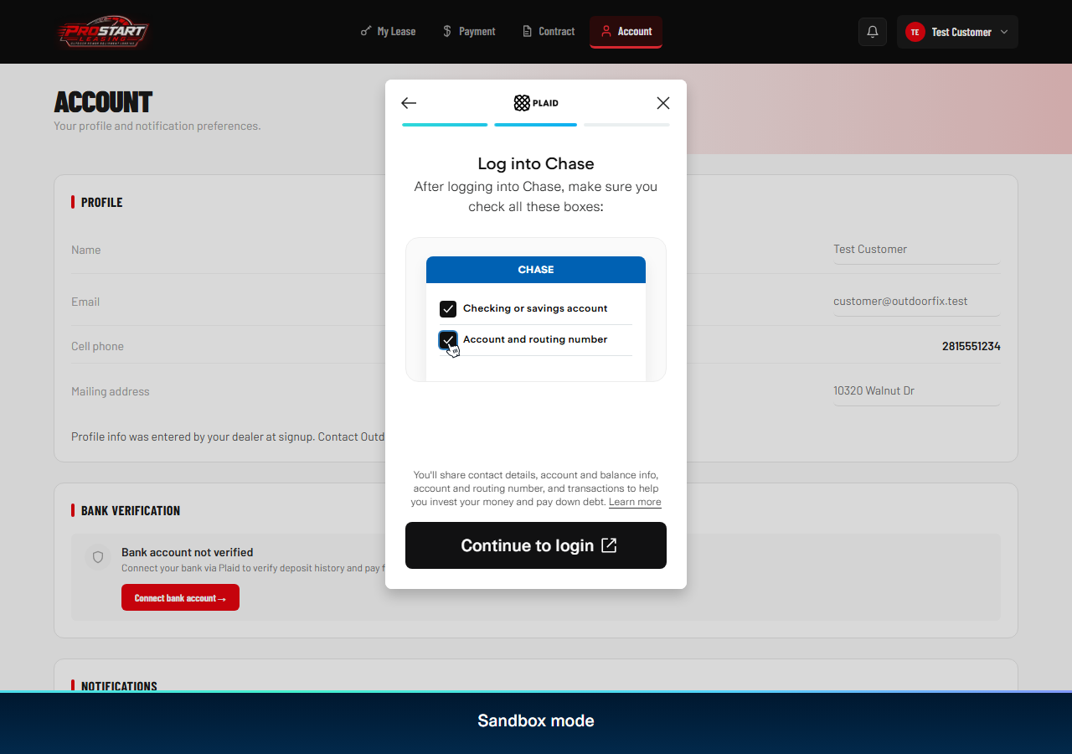

28. Bank Login (Sandbox)
In sandbox mode this is Plaid's own test bank; in production it would be the customer's real bank's login page.
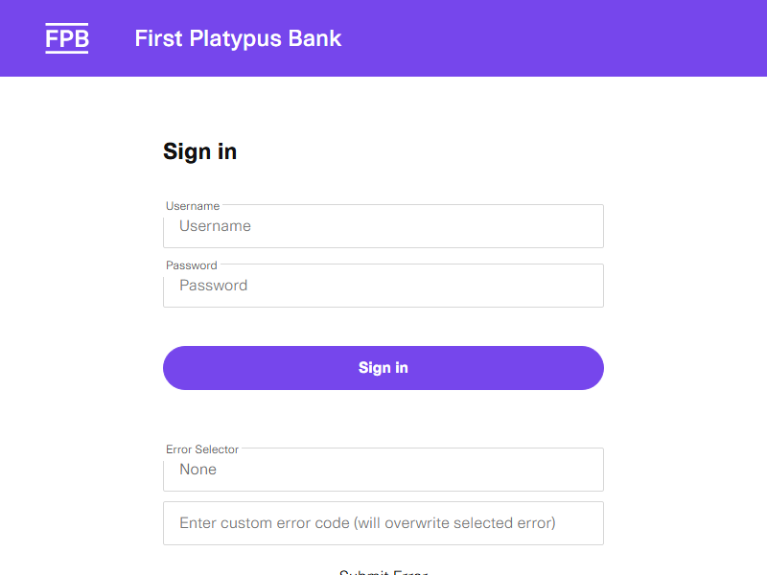

29. Verified
Once connected, the Account page immediately shows the verified state with a real timestamp — and this status feeds directly into the customer's Risk Profile on the admin side.
